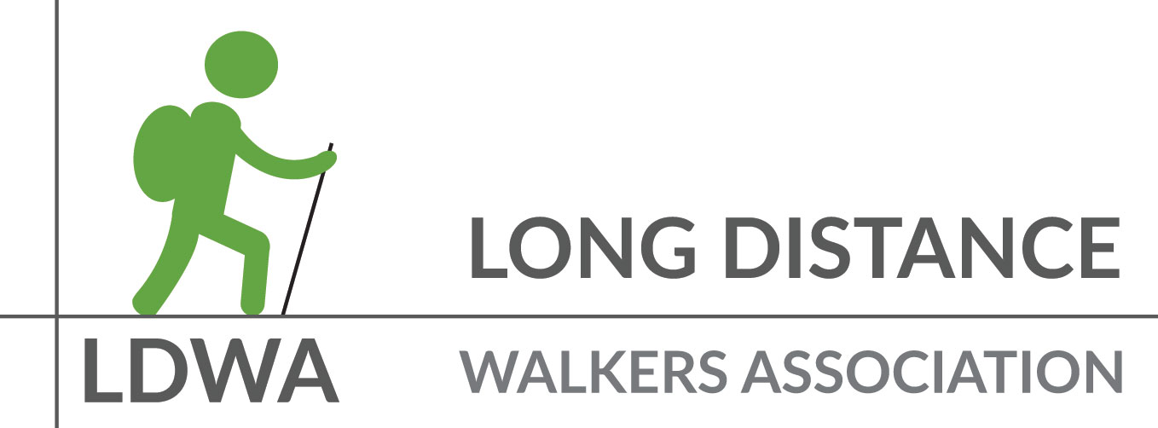
Covid Safe LDWA Local Group Walks
Frequently Asked Questions – for LDWA Local Groups and Walk Leaders

My group is planning to restart walks – is there anything we need to do differently?
If you choose to restart group walks, the following must be done:
- In Wales, there is a legal requirement to complete a ‘Check List’ for each walk. Whilst not legally required in England and Scotland, it would be considered best practice to use the ‘Check List’. The form can be downloaded from the Toolkit. After the walk, the ‘Check List’ must be uploaded to the LDWA Event Register.
- Walks can be advertised by LDWA bulk email / LDWA Local Group Social Media or on the Local Group website and priority should be given to primary members of a Local Group. People who wish to attend the social walk must register with the walk leader in advance and not simply turn up on the day.
- As the walk has been organised under the LDWA name, the Local Groups must register the social walk on the LDWA server. This can be done in advance, or once the walk has been completed. This is in order to assist with LDWA insurance requirements.
- Local Groups must keep a record of who attended the walk and upload the details to the LDWA Event Register.
- The group sizes will vary depending on the nation in which the walks are held. As at 28.07.20, the group sizes including walk leaders can be:
- 30 in Wales
- 15 in Scotland from a maximum of 5 households
- 6 in England
- Local Groups must follow the government guidelines on physical distancing.

Why do I need to complete a ‘Check List’?
You don’t. It is not a legal requirement but might be considered to be ‘best practice’ that demonstrates that due diligence has been considered.

Should we keep contact details for NHS Test & Trace?
Yes. By uploading the details of who attended the social walk, the LDWA will be able to provide details of who might need to be contacted by NHS Test & Trace.
Walk leaders should advise walk attendees that their details might be shared with NHS Test & Trace.
If you are asked to provide walk contacts for NHS Test and Trace, please let the LDWA NEC know: groups@ldwa.org.uk

Should we plan and publish our next walk programme?
We do not recommend planning a three or six month walk programme, or distributing printed programmes. We need to be flexible in our planning – you may find that fewer walk leaders are available, or that plans need to change at short notice.
Think about organising a rolling walk programme instead, so that walks can easily be added and advertised at short notice. You could also organise pop-up walks to give walk leaders more flexibility.

Can we car-share or take public transport to the start of walks?
The latest government advice is to minimise the use of public transport, and to avoid car-sharing with anyone outside of your household or social bubble – except for essential journeys, when an alternative cannot be arranged.

Can we organise a staggered walk, with several small groups setting off at different times?
This is not a type of walk that is to be encouraged. It might be the case that the two walking groups come together and the legally permitted number of people who can gather in public might be breached.

A better alternative might be for Local Groups to organise two completely separate routes from the same start location that start at different times in order to avoid the prospect of meeting.

Alternatively, Local Groups might wish to organise social walks that start in completely different locations on the same days.

Another option might be to organise social walks on different days in order to provide an opportunity for more members to participate in the new walking programme.

The Ramblers have just announced that in England they are now permitting 30 people to walk together. Why is the LDWA not doing this?

The LDWA NEC has kept in close contact with the Ramblers and was made aware that an application was going to be made to the Department for Digital, Culture, Media & Sport (DCMS) in order to start social walks with a greater number of attendees. The NEC has engaged with the Local Groups representatives and there was no consensus to see social walk numbers increasing. In addition, the NEC liaised with DCMS who clearly advised that an application by the LDWA as a National Governing Body would not be given accreditation. The NEC is now aware of further guidelines that might enable walking for up to 30 people to commence as a Community Activity. But, any decision taken will also need to be mindful of the ethical and moral responsibilities that come with enabling larger groups of people to walk together at a time when COVID infection rates are rising again.

