Setting up an event in PACER

Setting up an event in PACER is a 5-stage process:-
- Configuring the event - (defining routes, CPs etc)
- Setting up the certificate
- Uploading entrants’ details from Fabian4
- Printing Route Cards
- Event documentation

- Configuring the event

You must be registered to access PACER at the Event Administration level. If you are not yet registered you should contact the Event Organiser who will arrange this for you.

Once registered logon to the LDWA/Admin page using your normal LDWA membership details.

Select PACER to view the full list of Surrey events.

All Surrey’s Challenge events are cyclic so rather than starting from scratch it’s easier to simply duplicate a previous event and edit the copy to suit.

For example if you were setting up a Winter Tanners then duplicate a previous year by tapping which opens a copy at the Configuration level.

The various PACER screens do provide helper text to assist the setup process. Use these to supplement the step-by-step guide below.

On the Configuration screen:-

In Event Details

- rename the copy using the protocol ‘Event Name Year’
- untick both Show Full Results & Show Follow Participants (The latter should be enabled once the event is populated allowing supporters time to set up Follow Participants.)

In Routes

- no changes should be required here

In Checkpoints (a list of ALL Checkpoints & Number Checks used across the event)


- edit the names, GRs (grid references) and opening times as required - these details are available from the Event Organiser. NB Full Name should = Short Name + any additional info like location/GR/opening times etc


- if necessary, add any additional CPs/NCs by tapping

- tap

- select CPs/NCs for each route then use drag & drop to reorder

- Surrey only awards certificates for completions, which means there is no need to specify distances other than for the start and finish

- tap to complete the process, exiting to the Summary screen which shows the CP/NC arrangement for each route. Make a visual check returning to the Configuration screen for any edits.

During the event it is this screen that gives the Event Organiser, usually incarcerated at Event Control, an overview, in real-time, of the progress of the event and highlights the underlying significance of using PACER.

PACER is not used to record progress on Marshals’ Walks’ but simply as a means of formally recording the results and printing certificates. Setting up a Marshals’ Walk is identical to setting up the Event itself but is simplified by only the Start & Finish & distances being specified. There is no need to set up intermediate CPs since Marshals’ Walks employ, at most, informal support along the way.

2. Setting up the certificate

This is probably the most tedious part of the setup process although it’s made simpler since Surrey events only award certificate for completions. They are not awarded to retirees which means there is only one certificate to setup per event.

Given your event started life as a copy of a previous, the incorporated cert will of course reflect that year & will require updating.

Certificates for all Surrey events have the same basic structure:
- an image
- an textural overlay of the edition, name & date of the event
- text with embedded data links [[ ]] which PACER completes when the certificate is printed

It is only the overlay (edition, name & date) that requires updating. Using the Winter Tanners (WT) as an example the process is the identical for all Challenge Events:-
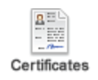


- tap then


- select the existing image and delete it

- in the menu bar tap to reveal the Browse/Upload Files window


- locate and open the Event_Docs folder (eg WT_Docs). Scroll to the bottom to locate Generic Cert

- select, then Manage/Download & open the doc —>



- edit the text overlay to reflect the current event, eg —>

- now take a screenshot of the page to just include all its features - image, text and any logos, saving the image to your machine as a JPEG with the name EventYY_image eg WT26_image


- close the Browse/Upload Files window to return to the certificate screen

- focus the cursor above the text & tap (Insert/Edit Image)


- tap in this window, open the Event Folder (eg WT) & Upload your image

- then tap to add its path as ‘Source'


- in Dimensions, with Constrain proportions checked, set the height of the image (the first box) to 678 & tap OK to insert the image into the cert. Scroll down for a visual check that the Image & text appear all on one page.

- tap to complete the Event Setup!

Checking the certificate setup

As yet PACER does not feature a certificate preview facility. The workaround - to check that the cert prints OK - is to add a ‘test’ participant to the event, give them a start & finish time, change their status to ‘Finished’, return to the Certificates screen & select ‘Download to PDF’ to view a PDF of the actual cert. Return to Configure Certificates screen if you need to make any adjustments. If you do this, do remember to remove all such test participants before uploading the cohort of actual participants.

Setting up the certificate for the Marshals' Walk follows the same process but rather than using the Generic_Cert, use MW_Generic_Cert.

3. Uploading entrant/participant details

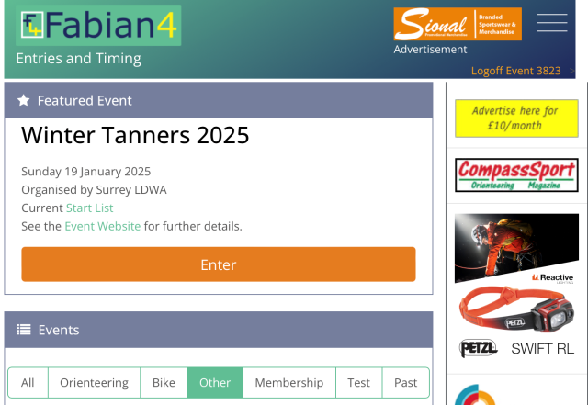
Surrey uses Fabian4 (F4) for online entry to its Challenge Events & to export entrants’ details. This requires ‘logon’ access to F4 at Administrator level. Contact the Event Organiser (or delegate) for the required URL.

The process is as follows:-

- after the event has closed access F4 using the ‘logon’ URL, to give a screen like this —>


- BEFORE exporting ensure that the Amendments switch in the Control Panel is disabled to prevent any further changes/amendments after export. This may have already been set by the Event Organiser. But CHECK before exporting:-

- press (menu) & select Admin/Control Panel


- in the Competitor Amendment Control Parameters tap & deselect (unclick) the Enable Competitor Amendments (Master Switch)

- tap then Home & wait for an hour or so to allow any recent amendments to work through

Exporting entrants’ data

- press (menu) & select Admin/Export

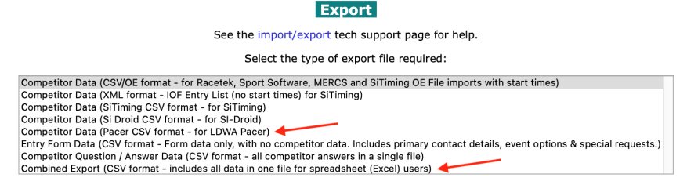
2 exports are required:-

- a custom export, PACER csv format - for LDWA PACER

- a Combined Export

- select each in turn & tap Generate File to download

- the Combined Export csv contains comprehensive data for each entrant & will be required by the Event Controller. (Email this later with other docs)

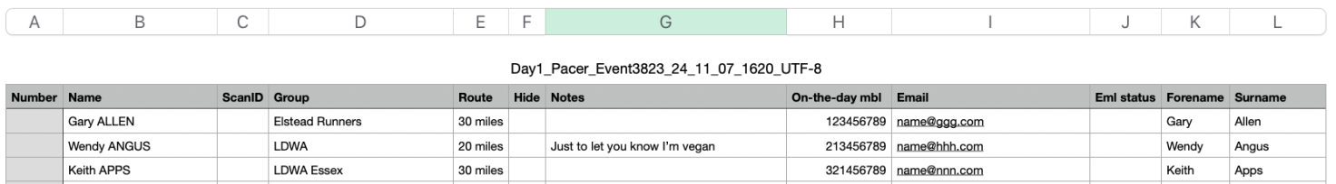
- the Custom Export csv is a pre-formatted export of data compatible for upload to PACER. The exported csv looks like this —>
Columns A-I, along with their order & headings, are mandatory for PACER. Columns J onwards are ignored by PACER but included to support the bulk emailing of certificates after the event.
Prior to upload, open the Custom Export csv and:-

- check for duplicate names. If found then re-check that all details match on the combined export - which indicates that the person has entered twice - remove one of the entries on the Custom Export. If other details indicate different people but with same name then manually add a unique identifier (eg Town or Postcode for eg) to label when printed.
- check that the surname (in column L) is not preceded by a middle name initial since this upsets the sort order and makes the task at registration unnecessarily difficult. If found, edit to shift the initial to follow the forename (column K). RESORT, ascending on column L to return the data to alphabetic order.
- column E must be purely numeric. Remove ‘miles’ ‘kms’ if necessary
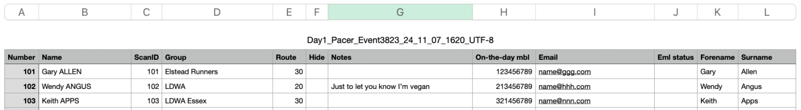
- number columns A & C (Number & Scan ID) sequentially from 101 —>
- save the file as a csv. Note: if you have edited the participants list in Excel on a Windows machine then you must save the file as CSV (Macintosh) (*.csv) NOT the default .csv Excel offers. The latter format will not be accepted by PACER.



- open the event in PACER


- tap then then to give —>
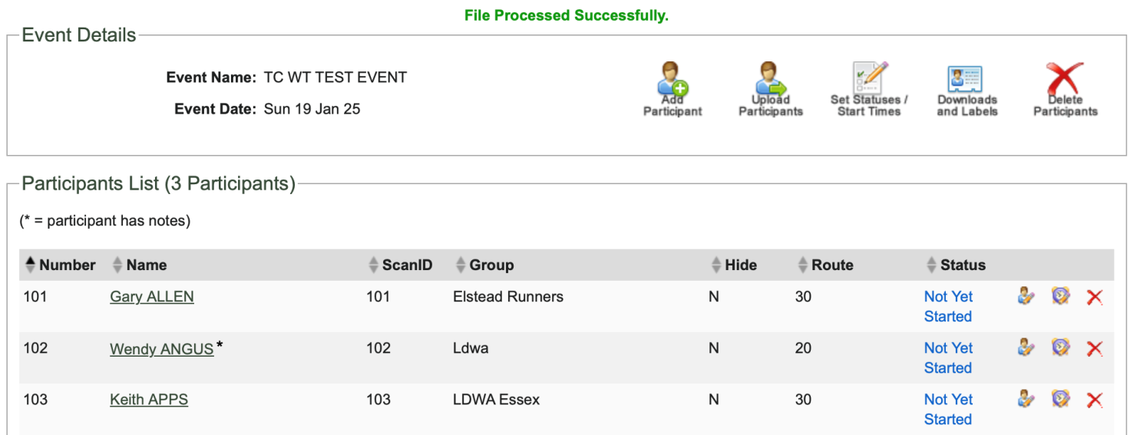
- now entrants are uploaded, enable (tick) Show Follow Participants on the Configuration screen which allows supporters to set up this feature.

4. Printing Route Cards (Labels)
There are 2 options, Print from PACER or outsource the process (preferred).


4.1 Printing from PACER

- on the Participants screen tap

- in Participant Labels PDF, set the emergency phone number for the event (usually that of the event controller)


- select Label with Barcode / ScanID as label type.

- tap & print a test page on plain paper. Use the Offsets & printer settings to align this sheet to correctly overlay the sheet of labels.

- once satisfied print the labels onto LP21/63 MWP (Matt White Polyester) label sheets. Unlike paper labels, Polyester labels are waterproof and require no further protection. Labels are available from www.labelplanet.co.uk & white plastic cards from eBay

- stick the labels to cards & arrange in boxes ready for registration.
- If necessary mark any same-name labels with a unique identifier eg Town or Postcode

4.2 Outsourcing (First4Numbers)
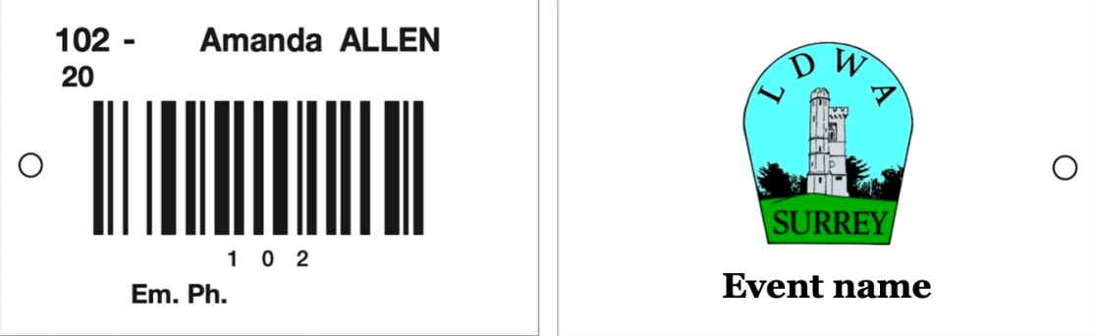
The preferred solution since it saves considerable time and effort over the PACER option. Surrey has designed a template to cover all its Challenge Events. On one side appears data and on the reverse the Surrey Logo and event name:-
The Route Card is credit card size - 85.6mm x 53.98mm
The process is as follows:
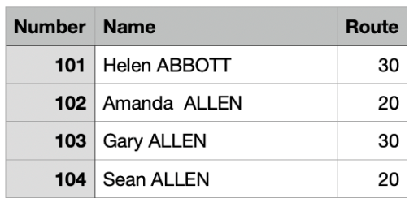
- duplicate the PACER upload file and delete all columns other than Number, Name & Route:-

- email your printing request to Fist4Numbers at design@first4numbers.co.uk with the following attachments:-
  - the 3-columb csv
  - the Event Name - for the reverse of the card eg 47th Winter Tanners
  - the Em. Ph. Number for the event printed on each card
  - a jpg of Surrey Group Logo
  - the delivery address for the cards

- Its advisable to confirm the card size at 85.6mm x 53.98mm, the Em. Ph. Number is the same for all cards and ask them to ensure the invoice references Surrey, LDWA

Turn around is very fast - around 3-4 days.

JPEGS of both the logo and the Route Card Template con be

downloaded from the PACER folder using the insert/edit tool

5. Event documentation

Key individuals require emailed copies of documentation as follows:-

 | Combined Export from F4 | Participants Sheet PDF* | CP Access Codes** | PACER manual timing sheets***
Organiser |  | ✔
Event Controller | ✔ | ✔ | ✔
Checkpoint PACER Marshals |  | ✔ | ✔ | ✔

The Event Organiser & Event Controller are often the same person.

*Download the Participants Sheet PDF from the Labels screen, select All Participants.


**CP Access codes are auto generated by PACER at setup & available

from the screen.

***An xlsx PACER manual timing sheet for the manual recording of numbers as backup can also be downloaded from the PACER Folder.

