


Grapevine Newsletter 13

Welcome.

To the Vermuyden LDWA Spring Newsletter
Sorry for the missing newsletters last year, I think most here know why.
Plenty occurring this year, read on for our first forage into Lower Washburn area on Decagon one walk (find the walk report online or on our Facebook page)
The Ouse Walk returns this Summer!
And along with The Decagon series of walks our Monthly Group walks are a little shorter than usual to tempt a few newbies out.
Happy wanderings whatever you have planned this year.

Upcoming Group Social Walks

Sunday 9th February
Denby Dale Round Walk – Joint with Calderdale LDWA
14 mls

Sunday 16th March
Sheffield Round Walk
15 mls

Sunday 27th April
The Penistone Boundary
16mls

Sunday 18th May
The Dunford Round
18 mls

Annual Long Walk

It has been Eleven years since Roy T lead Compo's Way Walk for us, in 2014 we rekindled the annual long walk series and have completed since:

The Bradford Ringway

The Opencast Way

The Three Feathers

The Pride of the Peak

Bell Major Walk

Bingley Parish Boundary Walk

Compo’s Way along with Them Pirates

As well as some historical Long Walks

The North Yorkshire Moors Wobble

The Three Moors Walk
I am taking on board any ideas for the 2025 Annual Long Walk, come find me out and about with any ideas (ed)

Other Walk News

The past days of yor are probably the glory days of Vermuyden (South Yorkshire) LDWA

But the old adage use us or lose us is more prevalent now than ever before
I keep a register of participants (ed we are all meant to keep a register) yes, I know but I like to average out how many attend our walks.

The last two years we averaged 8 over a years’ worth of stuff
Last year we dropped to 6

Sometimes it is just the two on the Vermuyden Committee and the leader

@VermuydenLDWA

We at Vermuyden LDWA have embraced the Social Network and have a presence on line to rival most LDWA groups.

Our Facebook page relays recent walk reports and other group related events.
www.facebook.com/groups/706018186227802/
Our Pinterest account collects The Elsecar Skelter certs (historical to present). Any churches we pass en route during group walks (thanks to Linda W) our knowledge of churches has grown extensively, any Waymarks and Fungi we pass also en-route.

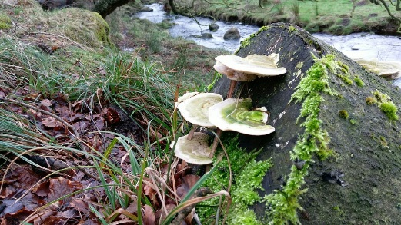
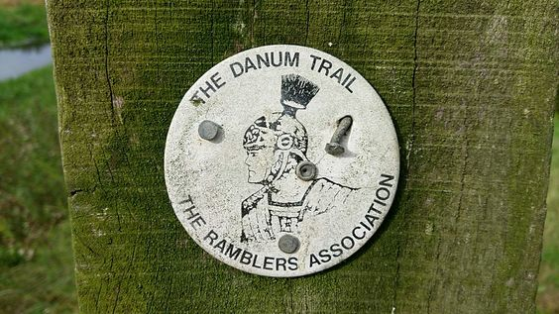
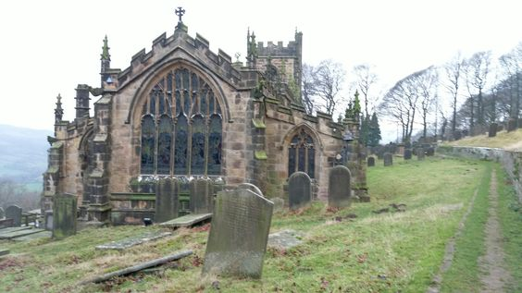

Our Pinterest feed can be found @VermuydenLDWA

AGM News

Jan 2025 saw the walk secretary along with a couple of members for a breakfast date at The Kings Chamber, Thorne.

Aaron opened proceedings with congratulating yet another year with whatever you achieved in 2024.

Thanking all walk leaders for the commitment to leading walks meant we had a full calendar in 2024

I believe the clubs funds are in a healthy position.

No-one came forward to fill any of the vacant positions, so moving into 2025 we have.
- Chair – Vacant
- Secretary – Vacant
- Treasurer – Peter Poppy
- Walk Secretary – Aaron Hookway

Aaron will continue to do the best he can to keep us moving forward.
2025 Decagon series of walks
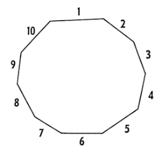
I had this bonkers idea to walk 10 anytime challenge walks from February to November 2025 to celebrate my half century and not out.
So
February 1st comes along with The Aggin Stone Amble (Short Route)
Here we are a’top of Trough End
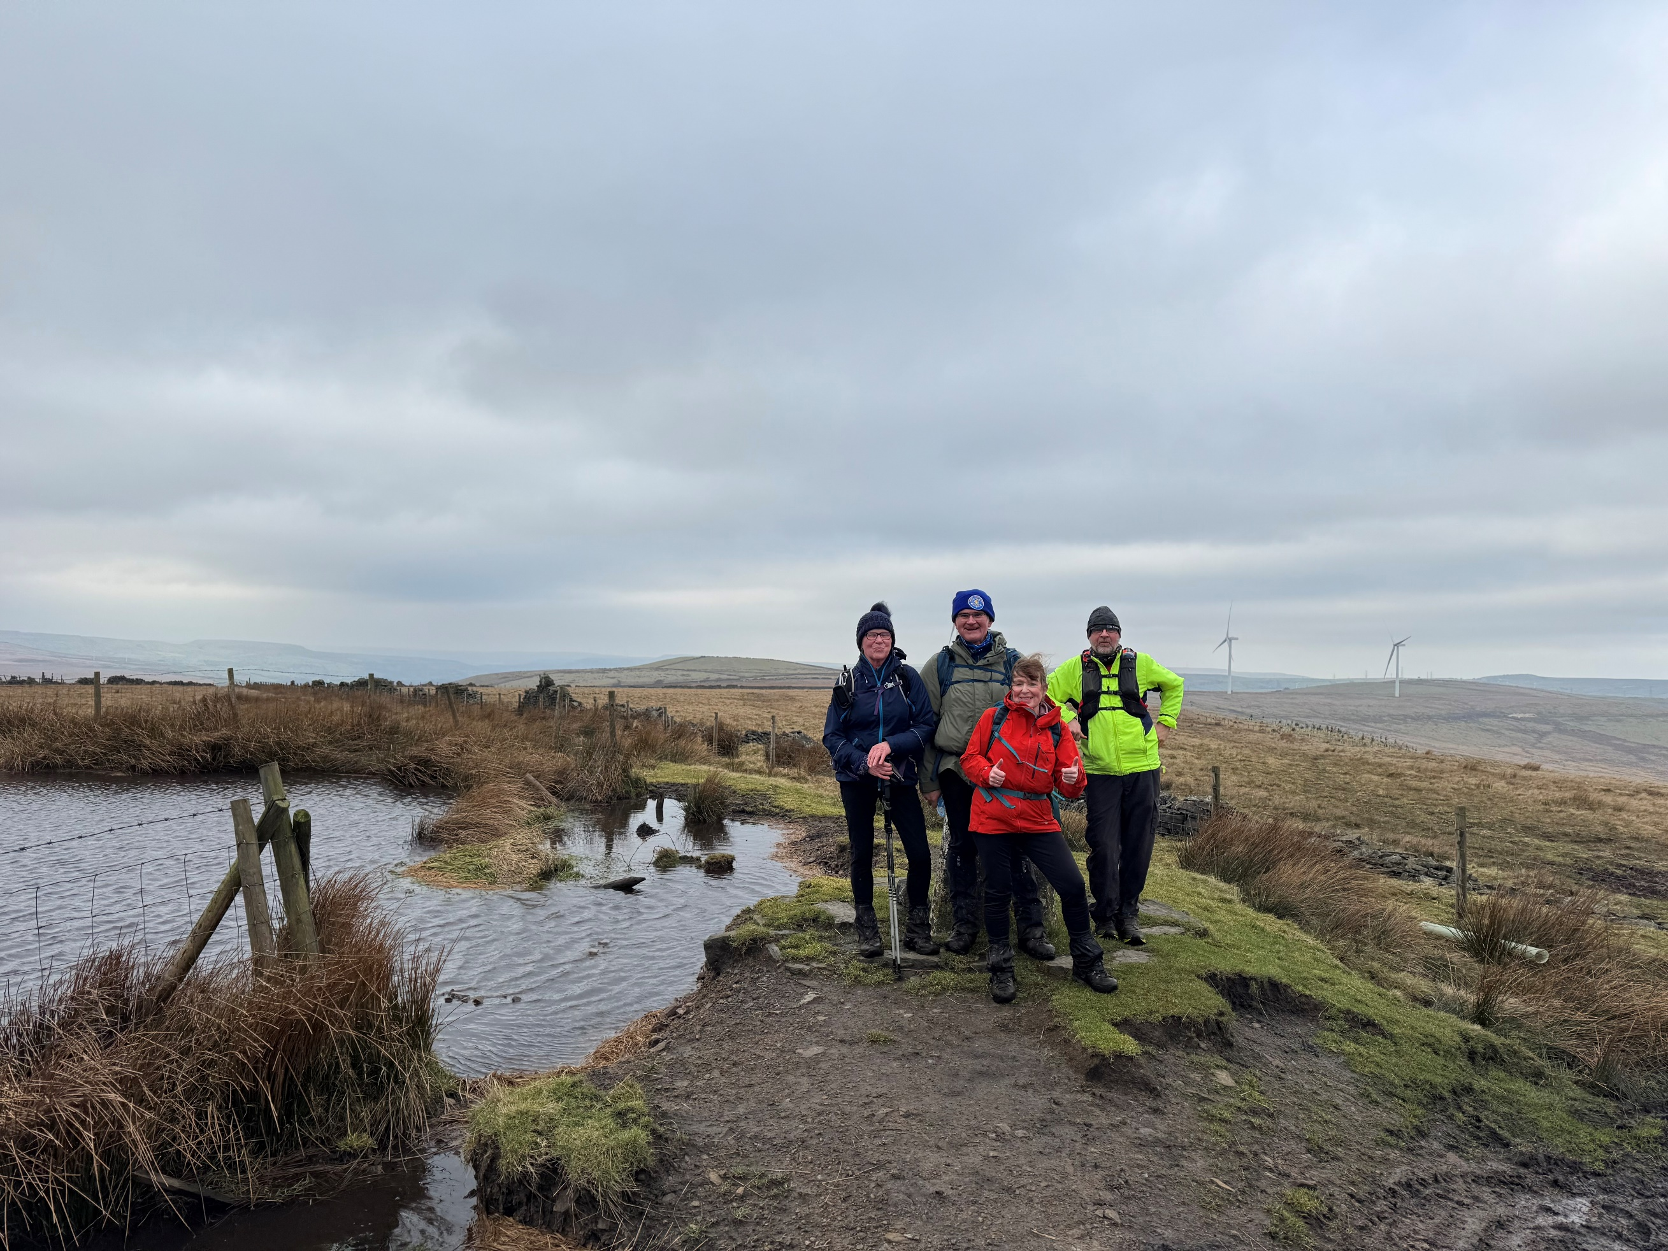
Just before the wheels fell off



So…

Now in stone…lol

One – February Aiggin StONE Amble (short route) 21 mls
(This one was an adventure and a half, find the walk report on us webpage or on our Facebook Page)

Two – March Yorkshire Ridings TWO Hundred Furlongs 25 mls

Three – April Yorkshire THREE Peaks Challenge 24 mls

Four – May FOUR Trigs Traipse 27 mls

Five – June The New FIVE trig Points Walk 18 mls

Six – July The SIX Trigs Challenge Walk 26 mls

Seven – August Cavendish Twenty SEVEN mile Circuit 27 mls

Eight – September Lancashire Figure of EIGHT 22 mls

Nine – October Otley NINE Leagues 27 mls

Ten – November TEN Reservoirs Walk 22 mls
(This may turn into Tennyson 20)

About social walks

This piece of writing answers some questions you may have if your either a newbie long distance walker or haven't been on a Vermuyden Group social walk before, our walks programme is arranged on a monthly basis (with a few ad hoc walks) and we aim to make our walks programme varied with both local and more distant start venues. Our policy is to make them social rather than competitive events and we do take account of the slower walker. We usually arrange a pub stop at lunchtime as part of this policy. All are welcome to join us!

What is a Social Walk?
A social walk is a Group walk solely for the enjoyment of the members as a social event, and led by one of the Group. A social walk is the opportunity to meet the Group members, so come along and try one.

What happens on a Social Walk?
The walks are usually on a Sunday and usually start at 8:30am. Note that we really mean it when we say "start at 8:30am". If you turn up late, we will have gone. Unless you let the walk sec know and we will of course hang on for you.

Typically we walk until approx.5pm stopping for elevenses in the morning and sometimes a short stop late afternoon. (We stop for a longer break at lunchtime). Often we stop at a pub (no more 2hr stops mind you! A nice ¾ hr. stop for ladies convenience and drink something other than water nowadays!) We don’t issue walk descriptions, ask the leader whose contact details will be on the website for details. The distance will be around 18 to 20 miles, a bit shorter in the middle of winter, but the walk description online will tell you how long it is.

I've never walked twenty miles before. How will I cope?
Most reasonably fit people can walk twenty miles. You may suffer the next day and find it a bit tough the first time, but after a few goes it will become easy. If you have any doubts, try walking 12 miles in four hours and see how you do.

What about the weather?
The walk will happen whatever the weather (we are not made of sugar). The leader will adjust the route to the prevailing conditions if too severe.

Is there a charge?
No. You are automatically a priority member of the Vermuyden Group if you are an LDWA member living in S York’s, and all social walks are free to all and everyone.

Will I be left behind?
No. The leaders will know how many are on the walk, and will wait for the slowest walkers to catch up every time there is the possibility of going wrong.

Do I need to phone beforehand?
No, but phone the leader/walk sec if you have any questions.

Do I need a map?
No, but it doesn't hurt to bring one along if you have one.

(Many thanks to the Dorset group for the idea of these notes).
And Finally

CHAIRMAN | SECRETARY | TREASURER | WALK COORDINATOR
 |  | Peter Poppy | Aaron Hookway
VermuydenLDWA@hotmail.com |  | 07963 985229 | 07541624209
6b Plantation Rd
Thorne, Doncaster
DN8 5EA

http://www.ldwa.org.uk/Vermuyden
Again I have cobbled this newsletter together as yet another stab at giving the group a bit of a leg up.

I am thinking of putting it together as I input the Strider details 3 times a year.

If anyone wishes anything adding just send me details.

Aaron

