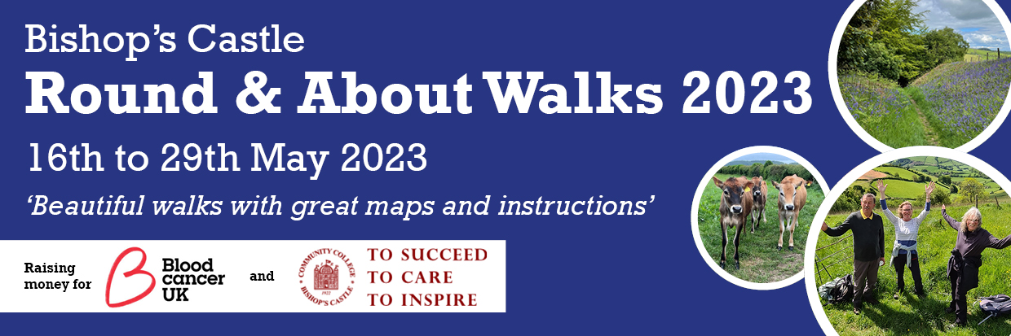
This circular Ramble (23 miles) runs between Bishops Castle and Clun, taking in Bury Ditches, the Walcot Estate and bits of the Shropshire Way and Offa’s Dyke. It divides into a fairly gentle Amble (10 miles), more challenging Scramble (13 miles) and shorter distances if you choose.
“the best marked route, by far, we have ever been on”.

How to Take Part
- The cost to enter is £10 per person.
- A family entry is £20 for 2 related adults and up to 4 children
- Under 16s are free with an accompanying adult
For full information and to apply, follow the following link:
https://ccbcshropshire.com/ccbc-friends-roundandabout/

You will receive detailed maps with full directions in roughly 3-mile sections to your email address. The routes will be marked thoroughly with arrows during the period that the walk runs.
Entry is open between March 1 and May 16. You decide when to walk between May 16 – 29, on which route or routes and with whom.
You provide your own refreshments and, most importantly, are responsible for your own safety.

Our Aims:
Our first aim is for you to enjoy the walking and the scenery. Our second aim is to support our two chosen charities: Blood Cancer UK and The Community College Bishop’s Castle.
If you feel able to get sponsorship or make a larger donation, you will sustain vital life-saving work, give our students the support they deserve, and make us very happy.
Please give your friends the link.

