OXON 20 2023 Important Information.

We hope you enjoy this year’s Oxon 20 at – Longburrow Hall in Stokenchurch.
Parking is available from 06:15, approx 750yds from the Walk HQ, please allow sufficient time to arrive and register AT THE HALL BEFORE proceeding (allow 10 mins) to the start AT STOKENCHURCH GREEN (see map and directions below): 20 mile walkers and runners 09:00. Please note the CP opening times, entrants arriving early will not be allowed in. If you expect to complete the course at over 6mph please inform the Help desk at registration.
Car Parking.
As spaces are limited please car share if possible. We have the use of two car parks, both off the M40/A40 from junction 5 into Stokenchurch, please park as directed by the marshals. For directions use HP14 3SX on your SatNav or GR SU756964 on your OS map.
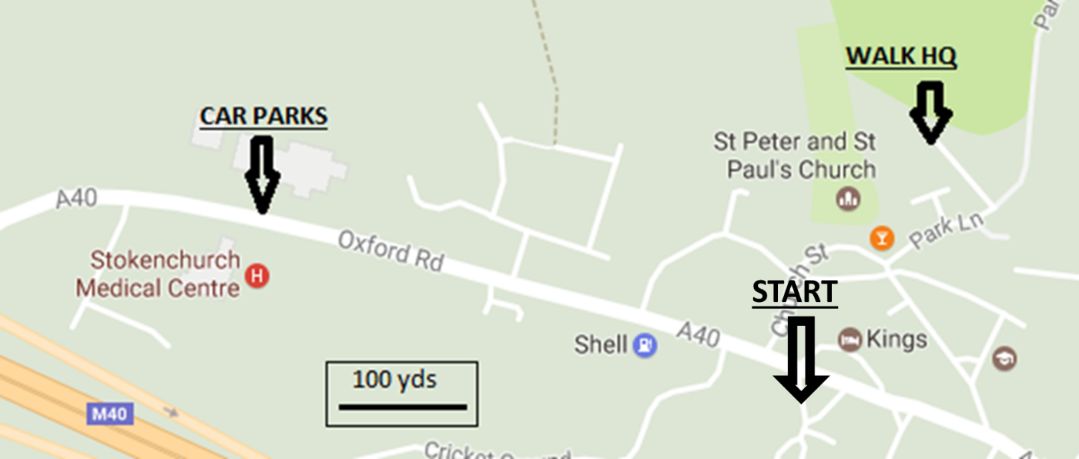MAP
Registration.
YOU MUST REGISTER AT THE HALL BEFORE STARTING . Ensure we have the correct course and details recorded. There will be a mass start for the 20 route and any last minute information or changes to the route will be notified at the briefing a few minutes before the start
For the event.
Please ensure that you have printed out, and brought with you, a copy of the route description as there will not be any available on the day. Also you must have the required maps, a mug, suitable clothing, a basic first aid kit, a charged and switched on mobile phone and sufficient food and drink to allow you to get between the checkpoints. To retire you must notify the Checkpoint if at a checkpoint or notify HQ via phone if elsewhere.
Emergency Phone on the event No: 07931 561419

OXON 20-2023 Route Description

Place names: Italics = name or path number can be seen from route
CAPITALS = name appears on O.S. Landranger 165/175 (1:50,000)
Abbreviations: ahd=ahead: B=bear: bld=building: BW=bridleway: CB=compass bearing (magnetic): cont=continue: CW=Chiltern Way: encl=enclosed: F=fork: fld=field: fllw(ing)=follow(ing): FP=footpath: FPS=FP sign: GT=gate: GR=O.S. grid ref: immed=immediately: junc=junction: K/G=kissing GT: L=left: LHS/RHS=L/R hand side: m=mile: opp=opposite: OW=Oxfordshire Way: R=right: RD=road: RW=Ridgeway: SP=Signpost(ed): ST=stile: TK=track: thru=through: T=turn: wd=wood: WM=waymark(ed) (often white arrows): X=cross/across: yds=yards
All GRs are SU xxxxxx unless stated

Directions to Start : Leave hall through car park and turn R back into Stokenchurch. At the Royal Oak, turn 2nd L passing the Old Croft House. At the end of the line of houses, TR on Kings Row. Pass by the Kings Hotel Car Park and cross the A40 AT THE PEDESTRIAN CROSSING, obeying the marshals. Assemble around the bus shelter to the R of the crossing.
Start Stokenchurch Green. GR 760 963.
1. X grassy area heading west, heading for gap in houses (quiet please!). TL on lane to swing round LHS of cricket pitch. Ahd to join path which rises to cross M40. Soon join TK thru houses, ahd to T junc and TL. After 70yds TR at FPS onto Mill Lane. Ahd onto FP to X RD and cont on Mill Lane thru industrial estate. X small RD and ahd on TK for 200 yds. At end of TK, through grey GT to R of Wormsley Estate sign. Ahd on faint TK (CB 260 deg), keep R of nearest power pole, down thru fld, X ST and TL.
GR 747 962
2. Follow WM thru wd, eventually descend to cross RD with No public access signs to R and L. Over ST and climb through fld. X ST into wd, climb to meet TK near top and BL. Swing R to descend to path junc, where ahd downhill on path L23. At bottom, X ST, BL across fld, thru AND SECURING deer GT, around garden & thru further GT to RD. GR 738 956
3. TL on RD for 35 yds, then TR thru gap in hedge & thru K/G (L23). X fld uphill thru 2nd GT (enter Wormsley Estate) & ahd (CB280) to top of hill thru K/G. Enter wds & keep ahd for 700 yds ignoring paths to R then L. Ahd at X TKs in clearing under wires then 20 yds later BL on narrow path (L23) & cont to reach southern end of COWLEAZE WOOD car park GR 725 956
4. Take second FP on L thru small wooden bollards. Ahd on path running parallel to RD. Cont to RD and TL for 30 yds passing Portobello Tower. X RD at house to X ST (FPS), X fld diagonally (CB250). X ST & TK, fllw white WM to go thru/past K/G then downhill on path. BL in dip to reach K/G marked with white arrow. Thru K/G & immed BR on WM. Ahd for 800 yds on RHS of wds, eventually joining TK from L to pass thru GT. Ahd 500 yds on grassy TK, as TK bears R go ahd thru trees & GT to RD. TR on RD for 500 yds to X TKs (RW). TL on RW and ahd 800 yds to parking area GR 698 940
5. Ahd to X RD and cont on RW (SP:Nuffield) for 950yds. X RD with CARE at postbox ahd and after 20yds BL at Copas Farms BW/FP onto FP on RHS of fld. Follow to fld corner to leave fld and reach X TKs. Take RW opposite, passing Ridge Farm. Ahd on RW for 1250 yds, ignoring BW to R, to reach RD. GR 681 922

6. X RD and cont on TK (RW). After 350 yds, ahd keeping to main TK on Swans Way (leaving RW). After 800 yds, as TK swings sharply R, keep ahd on FP into trees. BT at post on RHS of wd for 850yds to reach small parking area. GR 666 914
7. Ahd to RD and TR. Ahd facing traffic SINGLE FILE for 700 yds. BR off road at bend onto TK (CW: Ewelme 1). Up hill, ahd onto TK at house to reach RD. TR on RD passing church to your L. At the end of the graveyard, TL on FP, descend onto lane and ahd to RD (The Street) where TR. Ahd 200 yds past junct to CP on R
CP1 Ewelme Village Hall GR 644 916, Opens 10.20 Closes 13.50, 9.1 miles
As there are walkers on the 40 heading various directions from here, please follow these directions NOT those ahead of you.
8. TL out of hall, pass junct, and ahd up The Street. As main RD bears R, cont ahd (SP: Ewelme Down). Ahd 350 yds, past school and playing fields. Ignore turning for CW and ahd ½ R thru small car park. Thru 2 K/Gs at end of car park and along LHS of fld. Eventually BR to X fld, at end thru K/G. TL on RD for 20yds (ignore path opp), then BR on TK, rapidly merging with TK for Down Farm House. After reaching this, ahd on main TK for 350 yds to reach X TK/paths, with open fields to R and L and WM post on R. GR 663 906
9. Ahd uphill at X TKs (40s go R). Ahd 350 yds to TL onto FP/BW before Private Property. Thru trees, along RHS of hedge, then into trees again to merge with and BR onto TK. Ahd at X TKs, and after 1000 yds pass Gardeners Cottage to reach St Botolphs Church GR 683 902
10. TR into churchyard at sign. EMERGENCY WATER AVAILABLE (tap on church) Swing on path round RHS of church, leave at GT and TL on WM into trees where soon to X Lane. Ahd on WM on RH side of fence. Thru GT then uphill, keeping R of circular enclosure. Thru K/G at top and ahd on CW, ignoring all paths to R, 700yds to reach RD. TR 250 yds into Cookley Green. At T junct after 30mph sign, ahd on grass (passing No Parking sign and bench). After 20yds, B 1/2R to X centre of green in direction of bus shelter, where X RD with great care. TL on grass behind shelter, leading eventually to R verge of RD. TR on TK (CW). Ahd to end of houses after 300 yds, then TL over ST. Down to gap in hedge and X ST to cont in same direction. X fld (CB 095) to RD. TR 550 yds to reach
CP2 Russells Water Village Hall. GR 709 898 Open 11.00 Closes 16.20 13.7 miles
As there are walkers on the 40 heading various directions from here, please follow these directions NOT those ahead of you.
11. TL outside hall then L again to pass to L of duck pond. Ahd on widest TK, ignore CW and Kiln Cottage turnings, eventually Xing common. reach GT before abandoned barn, where TL (PS 23) on FP and descend thru wd for 400 yds to reach path junc with PS20. TR and ahd thru wds. After 400 yds, TL on PS22. Ahd downhill 800 yds to join TK, becoming lane. Ahd passing entrance to Pishill Church. EMERGENCY WATER AVAILABLE (tap just inside and to R of GT) GR 727 899

12. Ahd downhill on lane to T junc with RD. TR for 40yds on RD, then L on TK at Pishill Farmhouse & immed after garden TR thru GT on encl FP (PS6). Uphill for 350yds to X lane, Swing R around GT into the LH of 2 flds, then ahd 300 yds downhill on RHS of this fld with line of young lime trees on R to reach X TKs in valley. Ahd uphill on TK for 900yds. When TK swings R, TL thru metal K/G (FPS) to X fld (CB040), thru 3 more GTs. Keep on FP to R of lawn & thru GTs (pls close) on R of Saviours & X RD to bus shelter. GR 743 909

13. Ahd on lane opposite (SP: Turville/Fingest). After 130 yds, reach X RD before Rose Farmhouse, TL and immediately TL again on BW, (maybe obscured by parked cars) (CB 0). Do not take the metalled lane. After 30 yds, cont ahd on less obvious path, picking up blue WMs. After 250 yds emerge on grass to bear L of The Barn Cafe to join TK at corner/sharp bend. Ahd under wires to R of Clovers and ahd on winding TK downhill through wood to join gravel TK and reach RD in valley bottom at sign for Spinney Farm. GR 747 919

14. X RD, up steps and bear immed R then L then ahd to cross ST into fld. X fld (CB 20) to K/G and ahd to X lane. Ahd thru K/G, up thru fld, X ST and thru Arthur Harris’s K/G. Up to path T-junct, where TL. Follow path uphill, eventually joining TK then lane. Ahead on lane for 500 yds, ignoring FPs to L and R. Immed after Ibstone Cottage TL on BW. BR at Farside Cottage. X TKs keeping to FP at entrance to Bellows Cottage. Ahd on LHS of common (Ib Stone to your R), at end BL into trees and keep L. At junct with GT (ignore), TR (CW) then at next junct TL (CW) to pass pond. Cont to RD and TL along RD for 200 yds to reach Mile House GR 749 943

15. TR thru GT on CW, that we will follow to end. Thru GT and ahd on WMs. At bottom, thru K/G and TL up LHS of fld. TL at WM into trees and cont uphill. TL at junct to go thru metal GT. Up LHS of fld to go thru GT then 2 flds and gates to L of farm. After second GT, TR on CW, ahd to and X Lane, going thru GT opp. X fld to R of trees, merge with another path at GT, down LHS of fld (CW), and thru GT into and thru wooded valley. Up on encl FP then LHS of fld to reach metal GT. Thru and TR on encl FP. After going thru a final GT, BL under M40. Up to junct and then ahd on Coopers Court Road. Ahd & thru ‘No Entry’ roadsigns, to main RD. TR to X RD at crossing. TR on opp pavement then L to go by hotel car park. At end cont on paved FP to RD, where TL. Just before Royal Oak TR into Park Lane, cont ahd to TL into Longburrow Hall and don’t forget to register at the FINISH.
WELL DONE! 20.9 miles (2600ft ascent)

