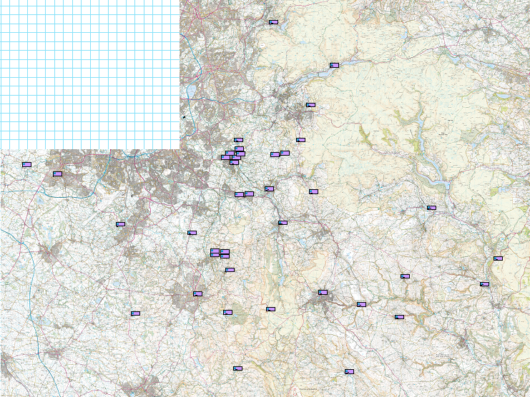

Walk Starts Locations 2025

(Excluding Chester and Hartington)

