South Manchester Chair’s Report 2025
We have had another successful year. Steve Osborne has continued as the Secretary, Bridget Knight the Treasurer and John Braide the Walks Secretary. We have 325 members assigned to South Manchester, however, the number of members who are active on the social walks programme and volunteering is nearer 30.
The group has a healthy balance in our account as the Treasurer’s report (below) shows.
Challenge Event.
We held a second running of our challenge event, The Signpost Challenge on 19th October. The event was full (200 entries) and 150 completed the challenge – 92 on the longer route (24 miles) and 58 on the shorter route (17 miles). There were two retirees. We had a fine morning but a wet afternoon. Participants were very complimentary about the checkpoint food and the efficient running of the event. Thank you to all the volunteers who helped on the day, and especially to Helen Gray for the immense amount of work she has put into coordinating the event. The event in 2026 will be on Sunday 18th October. Please put the date in your diaries.
Social Walks
It has been another busy year with 48 social walks in the calendar. We have had a higher proportion of longer walks

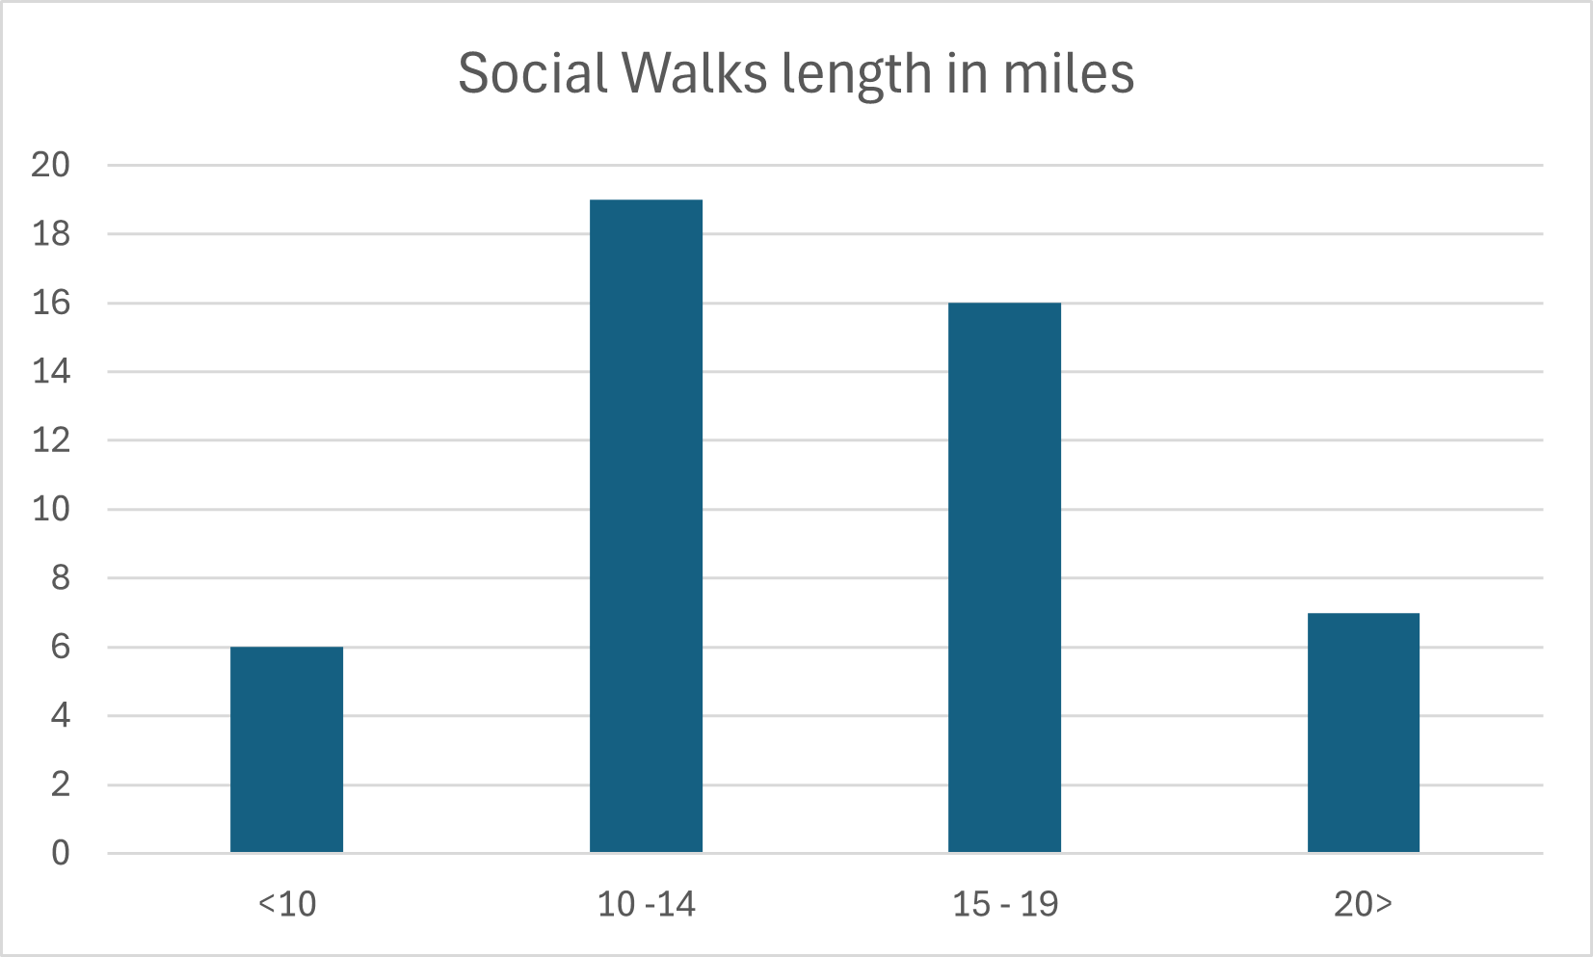
We had 15 members who have led walks. This is a very encouraging spread of walk leaders. Elaine led her first walk in November. Dave Wright, David Allen, Elaine Weinbren, Michael Magee and David Clift, Duncan Smith, Helen Gray, Steve Millward, John Braide and Peter Whitehead have all led walks of over 17 miles.
Dave G. | 8
Dave W. | 7
John B. | 6
Peter W. | 5
Michael & David C | 4
Brian G. | 3
Mark W. | 3
Bridget K. | 2
David A. | 2
Helen G. | 2
Steve O. | 2
Duncan S. | 1
Elaine W | 1
Quentin B | 1
Steve M. | 1

The numbers attending walks have generally been ten or less with only three walks with more than 15 (and one of those was a joint walk with Irregulars and one was the Christmas walk). Whether this is a good or bad trend is matter of dispute. Personally, I find numbers between 5 and 15 perfectly acceptable and even walks with fewer than five can be very enjoyable. Another welcome trend this year has been that we have had more women walkers than ever before.
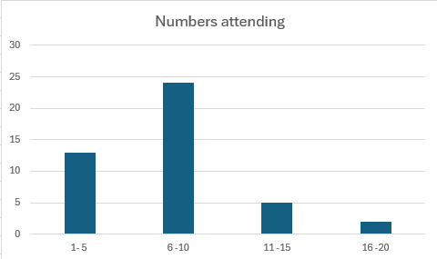
Record keeping has been much improved and there are only four walks for which I don’t have data. We continue to send our programme to Strider (unlike some other local groups) but this does necessitate agreeing the programme early which can be a deterrent for some leaders. Walks can be added to the website after the Strider deadline, but our practice does create pressure on John Braide our walks secretary, who has, once again, done a brilliant job in chasing potential walk leaders.
The Hundred
The results sheet of the Flowers of Suffolk Hundred does not record the local group of finishers, but Helen Gray on her first hundred finished in under 40 hours. Frank Tonge achieved CP6 and Nick Ham reached CP9.
Gareth Phillips led a small group of members who managed the Breakfast Stop. We need volunteers to man the breakfast stop in 2026 for the Honeypot Hundred in West Kent.
Other Activities
Dave G and Steve O. attended the Local Groups Week-end at Leamington Spa in November. This was a lively and useful event which can help us improve our group by learning from other local groups.
Fleeces. Free fleeces with the South Manchester badge embroidered on them have been offered to volunteers who have contributed significantly to the group’s activities (and who do not already have one).
ICE tags. In case of emergency tags will be made available to all South Manchester members who have attended social walks in the last two years. You will be asked to provide your emergency contact details to John Braide. Information will be circulated and announced at the AGM.

Treasurer’s Report
SOUTH MANCHESTER LDWA
Financial Statement Year ending 30.11.25
Opening Balance | 1718.69
Income Received | 3966.43
Payments Made | 2440.75
Closing Balance | 3244.37
Bank balance | 3244.37
Difference | 0
notes
invoice for signpost challenge HQ not yet received | approx £200

