Hadrian’s CelE2bration
2026 marks the Europe-wide celebration of the E2 European Long Distance Path.
The E2 route spans approximately 4,850 km (3,010 miles) from Galway, Ireland, to the Mediterranean coast of France, passing through several countries including Scotland,
England, Belgium, Luxembourg, and France. In 2025 a variant was added that extends the E2 to John o’Groats, although the Irish section is unofficial as yet.

Throughout the year, organisations from countries along the route will be putting on celebratory events.

Northumbria Long Distance Walkers Association will be hosting a very special walk on Saturday 1st August 2026. This walk will be based on the Hadrian’s Wall Path and Pennine Way National Trails along the most iconic and picturesque stretch of Emperor Hadrian’s northern boundary to the Roman Empire built in AD122, which is now coincident with the Traquair to Middleton-in-Teesdale section of the E2.

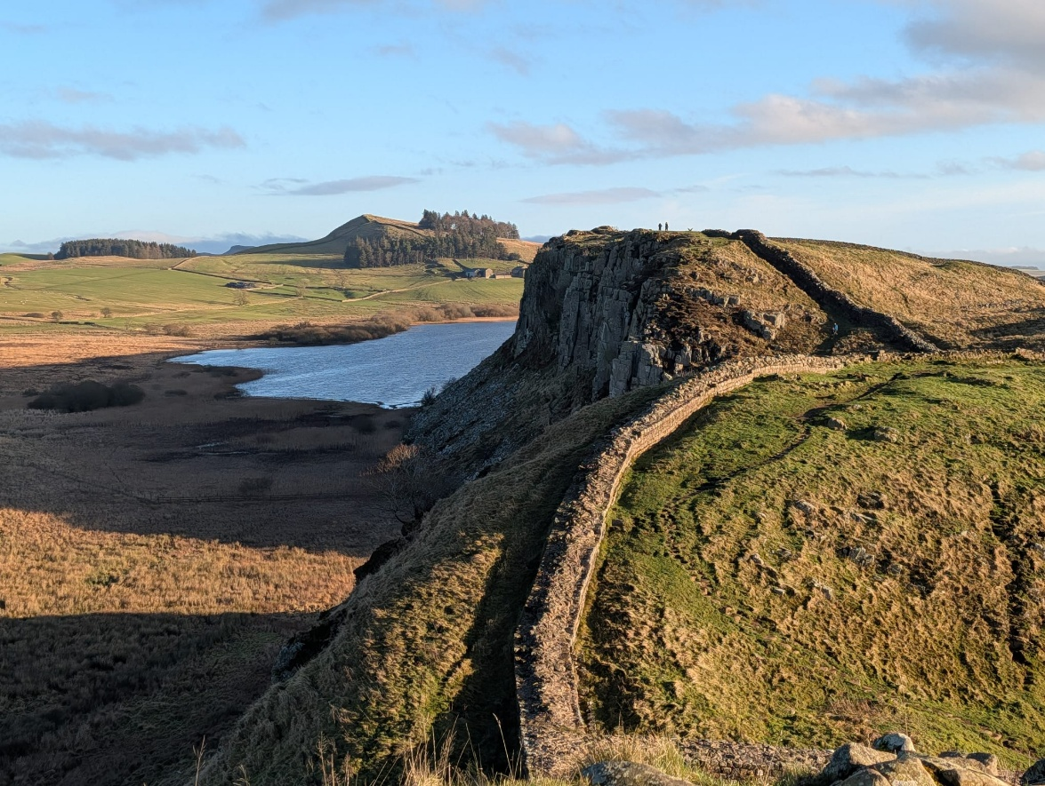
(photo: Alan Yeats)

The walk is circular, 29km (18 miles) in length with 950m (3,135) feet of ascent.

Starting and finishing in the Tyne Valley town of Haltwhistle. 8:30am start. Start of the walk and free parking at the leisure centre/swimming pool car park, post code NE49 9DP, grid reference NY703642. Please look on the Northumbria LDWA website,
http://www.ldwa.org.uk/Northumbria in the future events section nearer the time of the walk for exact details of how to get to this car park.
There is Haltwhistle Railway Station on the Tyne Valley line, which is only 0.5km from the start of the walk.

The route takes us from Haltwhistle up the Haltwhistle Burn, crossing the military road and the Vallum to gain access to Hadrian’s Wall itself at turret 42B, near Cawfields. For several miles we are then on the most spectacular section of Hadrian’s Wall Path with extensive views in all directions, until we reach Verovicium or Housesteads Fort. We will pass through the famous landmark of Sycamore Gap, known for its iconic sycamore tree that stood next to Hadrian’s Wall, symbolising natural beauty and cultural heritage.

Our return journey to Haltwhistle is via the impressive Vindolanda. Vindolanda is a significant Roman auxillary fort located just south of Hadrian’s Wall, known for its archaeological treasures, including the Vindolanda writing tablets.

The walk leader will be Paul Nellist, contact details: phone +44-7495-929777 or email walks.northumbria@ldwa.org.uk

Dogs are welcome to join us on this walk as long as they are kept on leads at all times.
Please bring and carry your food and fluids for the day.

As well as members of Northumbria LDWA, we are inviting all members of all the other local LDWA groups to join us on our E2 celebration walk. Indeed, non-LDWA members are also welcome. Hopefully, we may even see some walkers from other European countries joining us on the day.

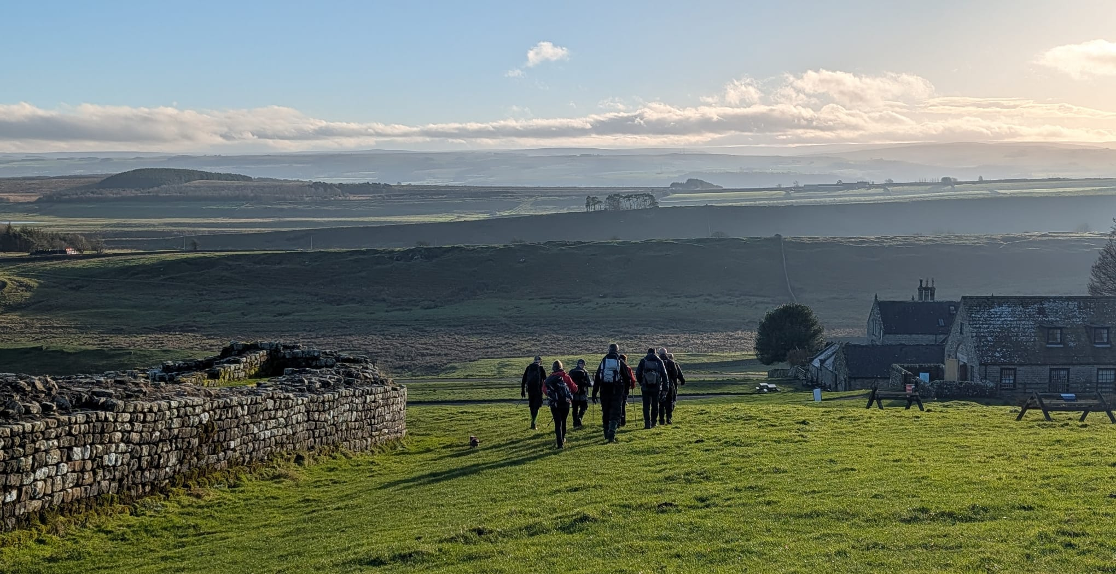
(photo: Alan Yeats)

