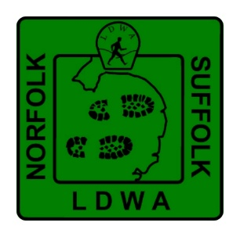
Norfolk and Suffolk Group LDWA
Expenses claim form (v1 June 2026)

Guidance: Please read the guidance on our website page Norfolk & Suffolk LDWA - Claiming Expenses.

This provides information on the amounts you can claim such as mileage rates and caps, also any time limitations.
It is your responsibility to adhere to these guidelines, and any claim received that is not in line with these may be disregarded. Ensure all the information given is correct, especially your bank details, as no liability can be accepted for incorrect information.
This is a Microsoft Word document. You should save a version on your own device and type directly into the form. If you choose to print, please write clearly.

Submission: Claims should be submitted to the Treasurer no later than three weeks after the relative event or expense.

Receipts: Receipts (or scans if using email) should always accompany claims except where none are available, e.g. car travel.
Settlement: Claims are settled as quickly as possible and payment is made electronically, so please provide your bank details on the claim form and advise if they have changed since your last claim.
Please submit your claim together with receipts (if applicable), either by post, email or in person to:
Jon Inett, Treasurer Norfolk and Suffolk Group LDWA
Address - 13 Mallow Close, Attleborough, Norfolk, NR17 1XZ.
Email - jon1965@runbox.com / treasurer.norfolkandsuffolk@ldwa.org.uk
Expenses / event details |  | Date of expense
Details of claim |  |  | £ | p
Total amount claimed
Date of claim | Sort code
Signature | Account
Email | New details since last claim Yes / No
Name | For office / Treasurer use only
Address & postcode | Date paid
Address & postcode | Account paid from
Address & postcode | Accounts code

