Trip 16 - 23 July 2023 in the Lake District
You are invited to join Ron Williamson in this, good value trip to the beautiful Lake District
Ron has booked a camping barn for a group of 8 people and currently has some vacant spaces for this week in mid July
### NB as this event is not exclusively for LDWA members, it is not being run under the auspices of the LDWA and you will not be covered by LDWA insurance etc ###

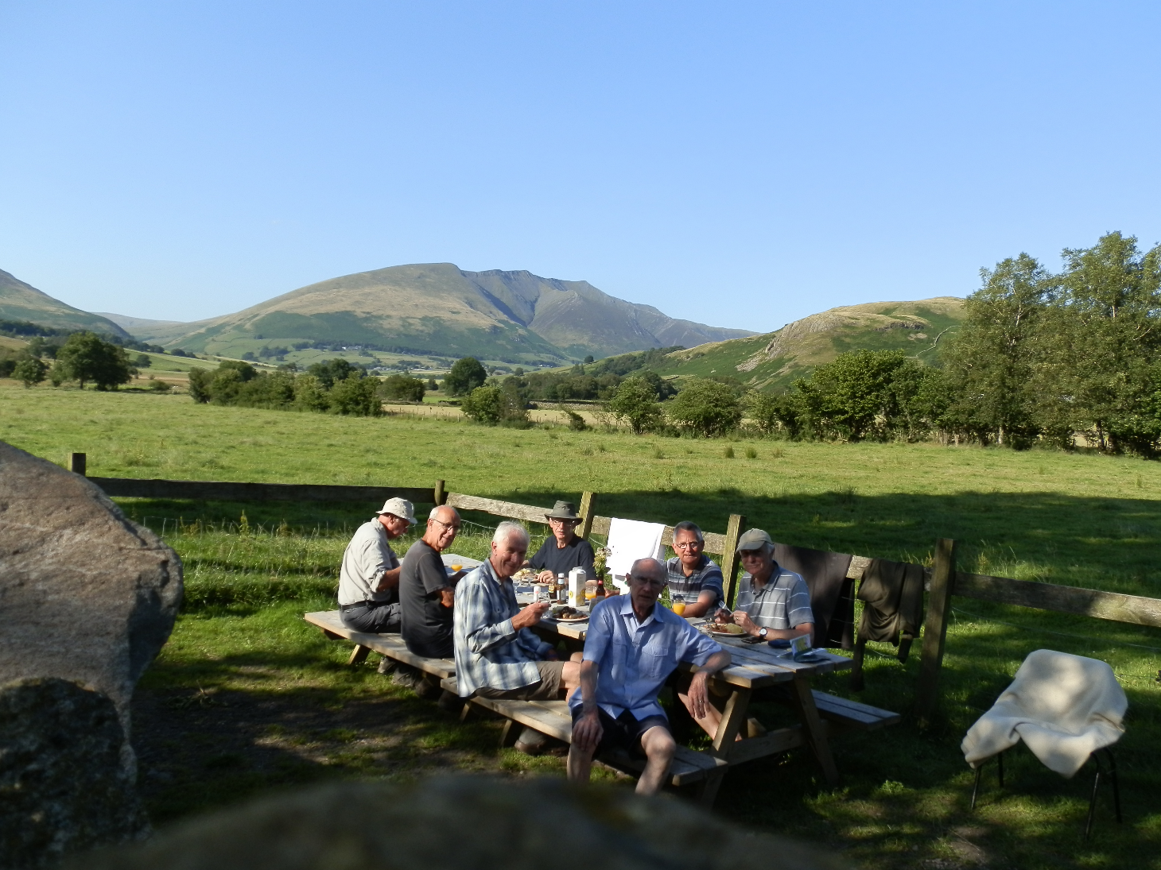
Causeway Foot Farm - lovely!

Dates and location:
Dates confirmed as Sunday 16 - Sun 23 July. Based 2 miles from Keswick on Ambleside Rd in the north Lakes
Cost:
The cost will be £200 for the week or £30 per night, including bed and all meals (though you'll be asked to help with the cooking and washing up)
Accommodation:
Registered Lakeland Barn (See www.causewayfoot.co.uk/camping-barn for details)
Accommodation is advertised for 16 but we restrict it to 8/9.
Transport:
Ron can pick up from Penrith rail station or Keswick bus station.
More details:
Foot path to fells passes door and regular bus service 555 from farm gate.
We will be walking every day choose one of two routes, or do your own thing at least one of the walks will be leisurely, with actual routes decided daily.
To register an interest and for further details, please contact Ron Williamson by email at: ronwilliamsonuk@gmail.com or by phone at: 01702 587128

Special note:
As this event is not exclusively for LDWA members, it is not being run under the auspices of the LDWA and you will not be covered by LDWA insurance etc

