Radwinter to Beeleigh Abbey

A long-distance walk following a medieval route-way through the heart of Essex

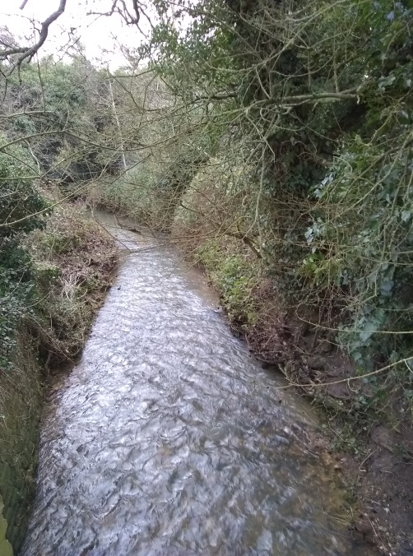
This recently published booklet is based on a historical reference documenting that in the Middle Ages corn was transported by water from the village of Radwinter (near Saffron Walden) to Beeleigh Abbey, at Maldon, via the Rivers Pant and Blackwater (actually one and the same river). In the present day it is not possible to make this journey by boat, but this entire stretch of river valley can be walked, following mainly public footpaths and minor roads. Sometimes the path goes alongside the riverbank, but often takes a route well away from the valley bottom, making for a varied journey, across meadows, fields and farmyards, through churchyards, past watermills and into some of the most attractive small towns and villages in Essex each with its own distinct character.
River Pant at Radwinter
The main aim of this booklet is to create an enjoyable walk, but it also tries to convey something of what it must have been like to make this journey in the medieval period either by river or on foot. The booklet comprises a route narrative, sketch maps and observations on what the medieval traveller may have encountered and what can be seen in the present day. The route is 40miles long (64km) and is divided into four stages of roughly equal length.
The booklet retails at £5 and is available from: The Art Place, Meadows shopping centre, Chelmsford; Harts Books, Saffron Walden; Between the Lines bookshop, Great Bardfield; Red Lion Books, Colchester; Brick Lane Bookshop, London. It is also available from tourist information centres at Saffron Walden, Bishop’s Stortford, Witham, and Maldon, and from the author, Helen Walker, via email at walker1956@btinternet.com.

