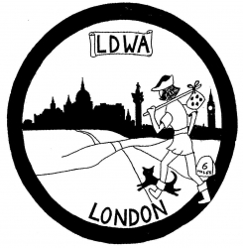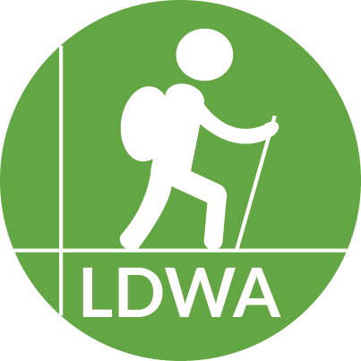
LDWA LONDON
PARENTAL CONSENT FORM FOR CHALLENGE EVENTS

For accompanied children aged 11 to 16 years:
I .................................................................................... (name of parent/guardian)
Being the parent/legal guardian of ....................................................... (name of child) aged ...... years, hereby give my permission for her/him to participate in the 8th Capital Challenge on 6th April 2024.
This young person will be accompanied at all times by ................................................ who is her/his ........................................ (relationship to child).
For a young person aged 16 or 17 who is not accompanied by an adult please complete this section (otherwise delete):
I hereby give permission for my child to participate in this event unaccompanied and give my permission for her/him to be transported back to event HQ in the vehicle of a volunteer marshal should this be deemed necessary.
I understand that in the event of any problems concerning an unaccompanied minor arising the marshal on the spot or the event organiser will always try to contact the parent/guardian by telephone as soon as possible and will persist until successful.
In the meantime I give permission, should the need arise, for the administration of emergency first aid and/or medical treatment.
My telephone number during this event is:
(Name) .............................................. Phone no. ..........................................
(Name) .............................................. Phone no. ..........................................

Signed ............................................................................... Date ................................

