LDWA Lakeland Group Annual Report
This report has been written in lieu of our usual AGM meeting, following a similar format to the usual AGM agenda.

Like many other local groups we have postponed our AGM for up to 1 year because of the COVID 19 situation. We hope this report helps to keep you informed about the activities of the group this year. We invited members to raise queries or make suggestions during September. We have not had anything so far, but you are all still welcome to contact us with your thoughts or queries.

Report from Chairman
In mid-March I encountered Covid lockdown in Spain so I flew home to be locked down in the U.K. Here the lockdown was not so severe, as we were allowed out for exercise whenever we wanted, unlike in Spain where specific age groups had specific allowable exercise times.
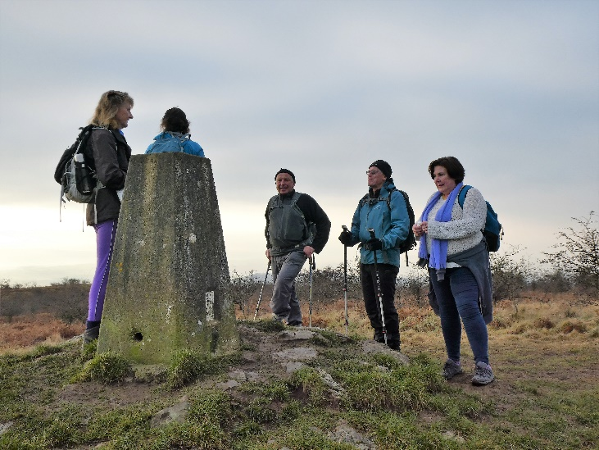
Figure 1 New Year's Day on Hutton Roof
I won’t dwell on the negatives of lockdown, not least of all the curtailment of large scale social and challenge walks, but instead be grateful for the amazing spring weather which we were blessed with. For those of us fortunate not to live in built up urban areas, it was a time to discover new local footpaths, leave the car at home and experience the strange phenomenon of walking along almost deserted roads.

Even after two decades of living in my area, I still managed to discover new paths, and covered many miles on sunny afternoons & evenings walking along quiet country lanes with almost zero traffic noise. Evenings were spent with friends socially distancing on the local Golf course enjoying picnics, quietly watching the local wildlife. Eventually the road traffic returned, with the accompanying noise, and that eerily quiet world was lost, possibly forever.

Organised challenge walks, with manned check points, refreshments and dry indoor changing facilities still seem a long way off, but instead are being replaced by anytime challenge walks, to be walked solo or with a small group of friends, and when the weather forecast is favourable. Lakeland Group have decided not to try to offer That’s Lyth on 31 January with outside only checkpoints – for obvious reasons! But we are working up a plan for an alternative “That’s Lyth Anytime” challenge, with a different route to offer something fresh in our area for LDWA members and you will all be emailed about that in due course. It will open for entries with bookings via SiEntries on 12 December – an alternative Christmas present perhaps (B 01 Nov update awaiting NEC thumbs up for these Anytime Challenges).

I’m in the very fortunate position of writing this from Spain again, where the weather is more clement, walking is permitted and I’m increasingly wearing out my trail shoes.

Let’s hope our AGM in 2021 will be in the real world of gathering together, enjoying a walk, food and a chat, and reminding ourselves how fortunate we are to have 2020 in the rear view mirror. Happy walking and sincere wishes that you and yours stay healthy.

Secretary’s Report
It has seemed a very strange year communicating with everyone via the bulk email more than I have seen people! And even attending my very first zoom meeting on a computer with no mike and no camera, so I was very much a ‘silent partner’.

That’s Lyth challenge event was a great success for us in January of this year. But we then had to cancel several things one after the other.

The first victim was our Spring in Lakeland brand new 50 mile event. A lot of work went into this, our first attempt at a 50 mile event, and we are keen to see it through to fruition in 2021. Many of the entrants carried their funds over to enter next year so that is encouraging. The Coronavirus situation less so, but we await advice from government and our LDWA National Committee. Current outline guidance for challenge events suggests we will only be allowed to offer places to 150 of the 289 carried forward, so I definitely feel a headache coming on, deciding what/who to drop (most likely the 18 mile route). Rules look likely to mean little or no refreshments provided at outside checkpoints, with marshals able to offer only hot or cold water, toilet facilities and of course checking you through. You will be encouraged to eat your own packed lunches away from the checkpoints to avoid crowding. It’ll be different that’s for sure. As we write, we are delaying ‘opening’ entries until 01 January. And all this will depend on whether village halls are prepared to offer us an outside base, and if Staveley are receptive to this influx of walkers.

We then had to cancel: Part 3 of our walk on the Southern Upland Way; our week away helping with Y 100 Sir Fynwy in Crickhowell; and our joint holiday with West Yorkshire in Jersey and Guernsey. This felt like a lot of unpicking the knitting, and was quite soul destroying to be honest, but our health has to come first, and these trips are all carried forward to 2021 which is something positive!

As of Thursday 5 November, we have a second English lockdown for four weeks which means no social walks are possible, and the NEC will update us after 02 December. Since July it has been tricky but possible, to plan social walks. With the exception of people from Tier 3 locations, we have been allowed by Sport England to walk in England in groups up to 30 people with an LDWA COVID risk assessment, which in Lakeland translated into leaders who are usually happy with around 10 or 12. We have been allowed to walk with 6 or less with no risk assessment, and we are more than happy to welcome leaders who would like to do that, once the new lockdown relaxes. We are lucky to have lots of remote corners to go for a walk and we do need to look after our mental health

We will continue to keep you posted via the bulk email system about the (hopefully) relaxing of the English second lockdown after 02 December. And once walks can recommence, in whatever revised remit Sport England allow, we will send a bulk email for each walk with an update if anything changes. Rather than a full programme, walks will come out in dribs and drabs, and maybe quite last minute for you to jump aboard, but we feel that is better than trying to do ‘best laid plans’ which get changed.

The walk planned by Ian Dyer for 21 November is of course cancelled/postponed. Huge thanks to Ian for sticking with leading for us as he has suffered more than his share of thwarted plans and keeps smiling! (Clap for Ian).

If you have a nice, peaceful, remote walk in mind, nothing to impact on mountain rescue, do get in touch with us and we will log the idea for when we can start again.

Social Walks Report
After last year’s AGM we had successful December and January social walks around Loops 2 and 3 of the Spring in Lakeland 50 event route. At the December meeting we had mince pies and hot chocolate at the end and after the January one we had a belated Christmas meal. Both these ‘feeding stations’ were very welcome, as we had also enjoyed a good soaking on both the walks.

And as irony usually delivers, the perfect weather arrived on the scheduled weekend of the actual event, only to be thwarted by Coronavirus! We then had a gap of 4 months with no walks. Our plans for walking from Coniston, Pendle and the Dales Way were all thwarted by either flooding or Coronavirus. It started to feel like if the virus didn’t get you the water would!
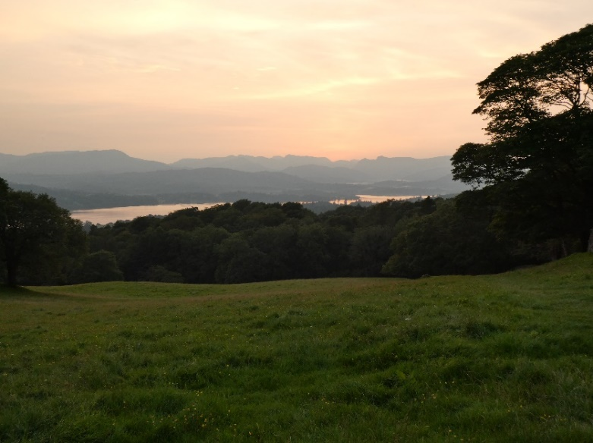
Figure 2 Sunset over Windermere

July saw us walking again (hoorah), initially with a programme of evening walks for a maximum of six people which went well. The evening programme included Hampsfell, Troutbeck, Orrest Head, Levens Park, Warton and Farleton Fell. Thank you to our leaders for these lovely walks. Our most successful programme of evening walks for a few years, because people were just so keen to get out.

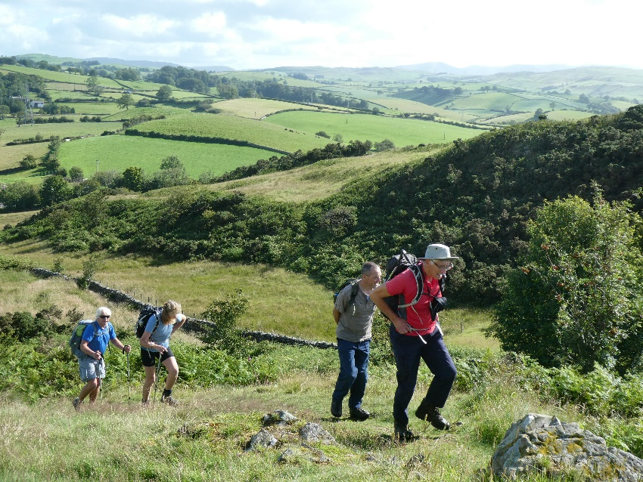
Figure 3 Climbing The Helm
Day walks were also recommenced later in July with a maximum of six people. We have walked from Ravenstonedale into the Howgills, had a walk East of Kendal encountering our first shouty farmer (amusing), a day walk from Sedburgh, Silverdale from Warton and an all-girl walk over Fairfield Horseshoe. And the 1 August Keswick weekend did make it in the end with brilliant, and safe accommodation. Thanks to all our leaders. Members have enjoyed walking, albeit in smaller groups, and for at least two people these have been their first trips out in the car to enjoy a walk, and indeed a post walk pint outside the pub! This is good for confidence and morale.

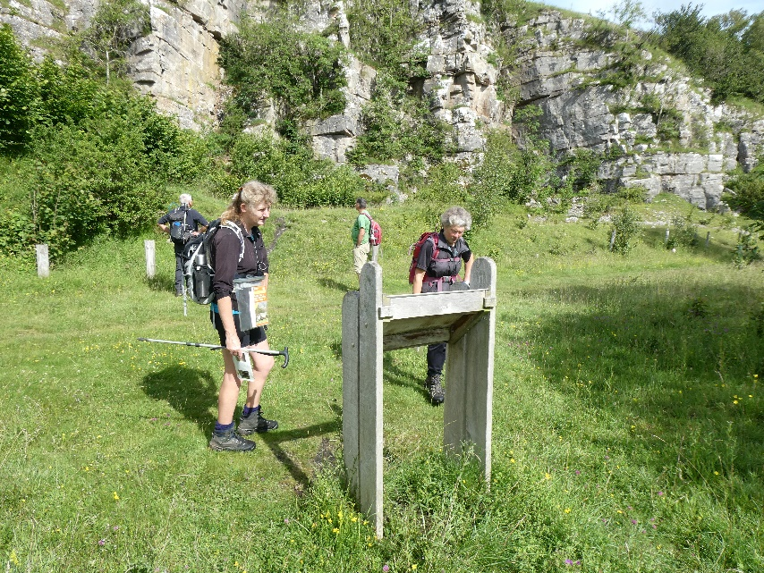
Figure 4 Exploring Flora and Fauna, Smardale
Our recent October walk from Coniston was impacted by the weather (third time for this leader) but we finally got it done on 24 October.

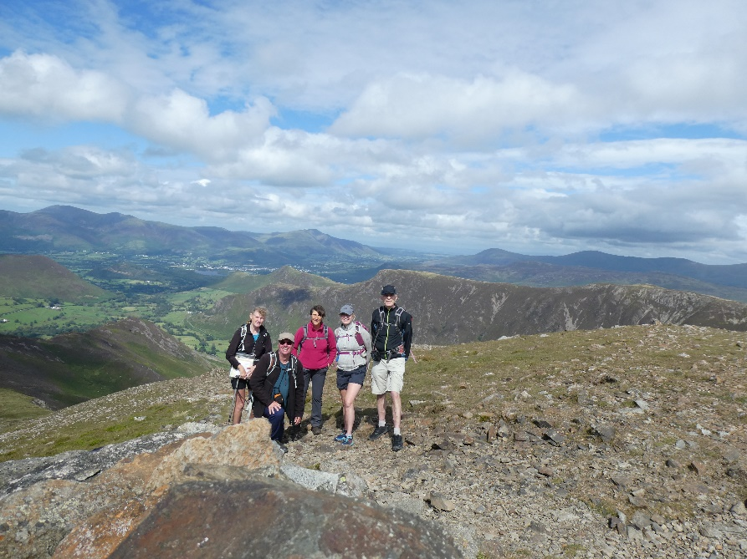
Figure 5 Happy Days in Keswick - Hindscarth

We continue to load our walk register onto the national LDWA database after each walk, which complies with the insurance and now COVID requirements. We also have logged covid risk assessments where required.

Update re Challenge Events
At the time of writing this report we are still awaiting final official confirmation from the LDWA National Executive committee about rules for COVID safe challenge events. Zoom meetings have been held, seeking our input and both myself and Tony Willey attended. Both our events are impacted, as outlined in our Chairman’s report:

- That’s Lyth which was scheduled to proceed on Sunday 31 January - Cancelled
- Spring in Lakeland 50 17 and 18 April 2021– Decision by 01 January 2021.

The staggered entry system allowing LDWA members to enter our challenge walks 1 month before non-members was introduced last year to make sure LDWA members get a place on events. This move, together with an enhanced preferential rate for LDWA members has worked well.

Finance Report (Accounts to 30 September 2020 attached)
Our accounts continue to be in a healthy state despite Covid-19. We have almost
£10000 in accounts with Cumberland Building Society, but this includes £5500 from
288 entrants to Spring in Lakeland 50 who opted to carry their entry forwarded to
2021. We have also carried forward around £800 in costs for SIL50.
We responded to the NEC appeal for fund raising to accumulate a reserve for major IT
developments in future years. Non-members have paid only a little extra to enter our
events in the past, but we have now standardised on a 50% premium for non-
members. We applied it on That’s Lyth resulting in a payment of £806 to the fund. The
event made a surplus of £1200, almost identical to the previous year.
We have used this surplus to fund the usual meal at our AGM and very welcome tea
and mince pies at the end of a wet SIL50 social walk. We have also purchased some
very stylish Lakeland Group t-shirts - if only we had a suitable occasion to wear them!
We made a donation of £300 to Cumbria Wildlife Trust and passed on £300 from SIL50
entrants who opted to donate their entry fees. This brings the total donations made
since the group was formed in 2014 to £8500. The committee would welcome
suggestions for donations to be made in the coming yea
Our accounts continue to be in a healthy state despite Covid-19. We have almost £10,000 in accounts with Cumberland Building Society, but this includes £5500 from 288 entrants to Spring in Lakeland 50 who opted to carry their entry forwarded to 2021. We have also carried forward around £800 in costs for SIL50.

We responded to the NEC appeal for fund raising to accumulate a reserve for major IT developments in future years. Non-members have paid only a little extra to enter our events in the past, but we have now standardised on a 50% premium for non-members. We applied it on That’s Lyth resulting in a payment of £806 to the fund. The event made a surplus of £1200, almost identical to the previous year.

We have used some of this surplus to fund the usual meal at our AGM and very welcome tea and mince pies at the end of a wet SIL50 social walk.

We have also purchased some very stylish Lakeland Group T-shirts for event volunteer marshals - if only we had a suitable occasion to wear them! We made a donation of £300 to Cumbria Wildlife Trust and passed on £300 from SIL50 entrants who opted to donate their entry fees. This brings the total donations made since the group was formed in 2014 to £8500.

The committee would welcome suggestions for charity donations to be made in the coming year

Any Other Business
If anyone wishes to ask us anything, raise any questions, feel free to email Lakeland@ldwa.org.uk. We will respond to you ASAP.

We would like to thank you all for your resilience and understanding this year. Stay well, keep smiling, and keep in touch with us.

Do post some pictures of your local walking on our Lakeland LDWA facebook page to brighten up everyone’s day.

Never has so much been done by so few to achieve so little (well, you have to laugh).

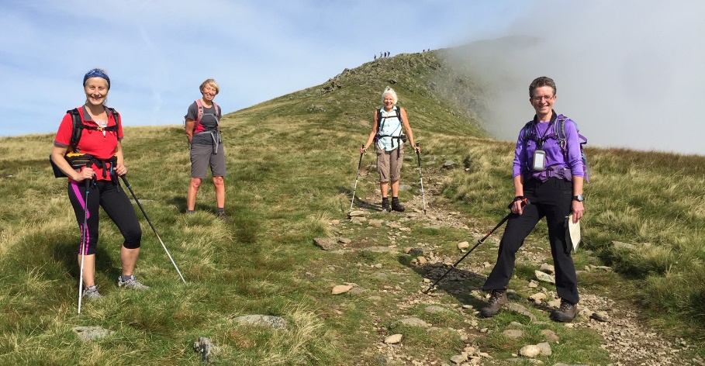
Figure 6 All Girl Band "The Fairfields"

