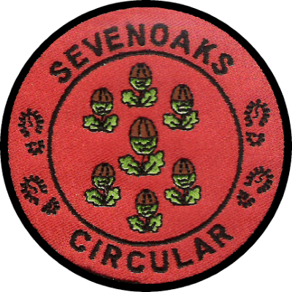

47th Sevenoaks Circular Walk
Sunday 17 March 2024
Final Details
The Kent LDWA Group look forward to welcoming you to the 47th Sevenoaks Circular Walk on Sunday 17th March. Full details of the event including Route Description and GPX files can be found on the Kent Group website.
Before The Walk
If you have special dietary requirements (other than vegetarian) you should plan to carry your own food/drink. Alternatively, if your food is clearly labelled, we will try, where possible, to take your food to the checkpoint, ready for when you arrive. There will be vegan hot food available at the end of the walk.
You are advised to wear suitable footwear and clothing and carry a map. A compass will be essential. Also, a torch and reflective clothing are required if you expect to finish after 17:30. All entrants are to finish by 19:00
Navigation
OS Explorer map 147 covers the whole route. Electronic versions of maps can be used.
Please ensure that you bring a copy of the route description with you as there will be no copies available at
Whilst GPX files are provided for all routes, these are for reference and back up. The Route Description should be considered as the definitive guide to the route.
Please bring your own mug as there will be none available on the event.
Dogs are not permitted on this walk
On Arrival
If you are arriving by car, please follow the directions of the Marshals who are supervising the parking arrangements.
Please enter the building to the rear and it would be appreciated if you do NOT wear muddy footwear or bring mud into the hall.
Please check in at the registration area where you will be asked to provide a mobile phone number in case of an emergency during the event. This information will be destroyed as soon as the event is over. If you wish to appear as 'anonymous' on the Public Results, please indicate this at the time of registration.
Tea, coffee and biscuits will be available before the start of the event - you will need to provide your own mug at the start/finish and during the event as none will be provided.
The event will start from 8:00 with the 30 and 22 mile walkers going at this time. Fast walkers 4mph+ and runners will be allowed to leave any time up to 10.00, but you must plan your day to tie in with the check point opening and closing times. Let the check in desk know as you are leaving so your start time can be recorded. Check points will not open earlier than stated and likewise will close at the advertised times below. 15 mile walkers will go at 10.00
The opening/closing times of the checkpoints are as follows:
CP1 (30 & 22 mile routes only) Knockholt Village Hall (8.1 miles) opens 10.00 and closes 11.30
CP2 (30 mile route only) Knockholt Village Hall (15.5 miles) opens 11.45 and closes 13.40
CP3 (30, 22 & 15 mile routes) Ide Hill Village Hall (23.8 miles, 16.4 miles & 9.2 miles respectively) opens 11.30 and closes 16.30
All are to finish by 19.00
The closing time for each checkpoint will be adhered to and the decision of the checkpoint leader and event organiser will be final.
Checkpoints
Please ensure that at each checkpoint you give your Walk Number to the appropriate Marshal.
Missing any of the number checks may lead to disqualification.
Please dispose of your litter in the receptacles provided or take it home (discarding items along the route risks the reputation of the event and landowners refusing use of their land).
Hot drinks and cold food will be available at all three checkpoints
Retirements
If you need to retire, please do so at a checkpoint where we can arrange transport to get you back to the finish. If you are forced to retire elsewhere, please call one of the emergency numbers on your route description so that arrangements can be made to pick you up. Should you decide to retire yourself and make your own way to the finish or simply go home, please ensure you call us so that we can account for you.
At The Finish
Please remove or cover all muddy footwear before entering the building and check in with the
Finishing Marshals.
There will be hot food available at the end of the event.
Badges will be available for purchase at the cost of £3.00 each.
On behalf of the Kent Group, we hope that you enjoy your day, and we look forward to welcoming you to future Kent LDWA Challenge Events.

