Social Walks Secretary’s Report
19th January 2026

My fourth year in this role! Wow, how time flies when you are retired and having fun!
What a fabulous year it has been, celebrating our 50th anniversary, and as I promised you Georgie and Carol – our special celebration bunting, saw plenty of action throughout the year.

We wanted to mark our 50th year, with a variety of celebratory, social walking events, and from the many lovely comments the committee have received, I think we can say that we did that with flying colours.
From the fizz reception at the start our Weekend Away to Selworthy, the delicious Epping Fryer fish & chip train ride, our Lawn Green Bowling escapades – with a magnificent afternoon tea, the yummy ice creams along the Clacton coastline, the epic St Peter’s Way in a day event – with buffet breakfast and afternoon tea – being essential fuel stops! The post walk drinks – on the Autumn Hobble, the luscious Christmas lunch and quiz, to our annual Secret Santa mulled wine and tasty seasonal snack feast. A big thank you, to our lovely organisers and walk leaders, for your contributions in making our dedicated celebration events so successful. These events were subsided by E&H for our members to enjoy. We have a glorious photographic record, on our website and Facebook page.

As well as the above mentioned 50th events, we had yet again, another wonderful calendar of social walks. We went in search of coffee, mince pies, bluebells, the composer Gustava Holst, the artists of Great Bardfield - the work of Eric Ravilious, Lorna Doone, Maggie and David’s stunning new house, and many more full day walks, no matter what the weather decided to throw at us.
All thanks to our lovely walk leaders, we rely on you generously giving us so much of your time, in the planning of our social walks.
Where to next in 2026? Can you think of a walk you would like to go on, which includes an added interest - non walking activity - that we could investigate together? We would love to hear your suggestions.
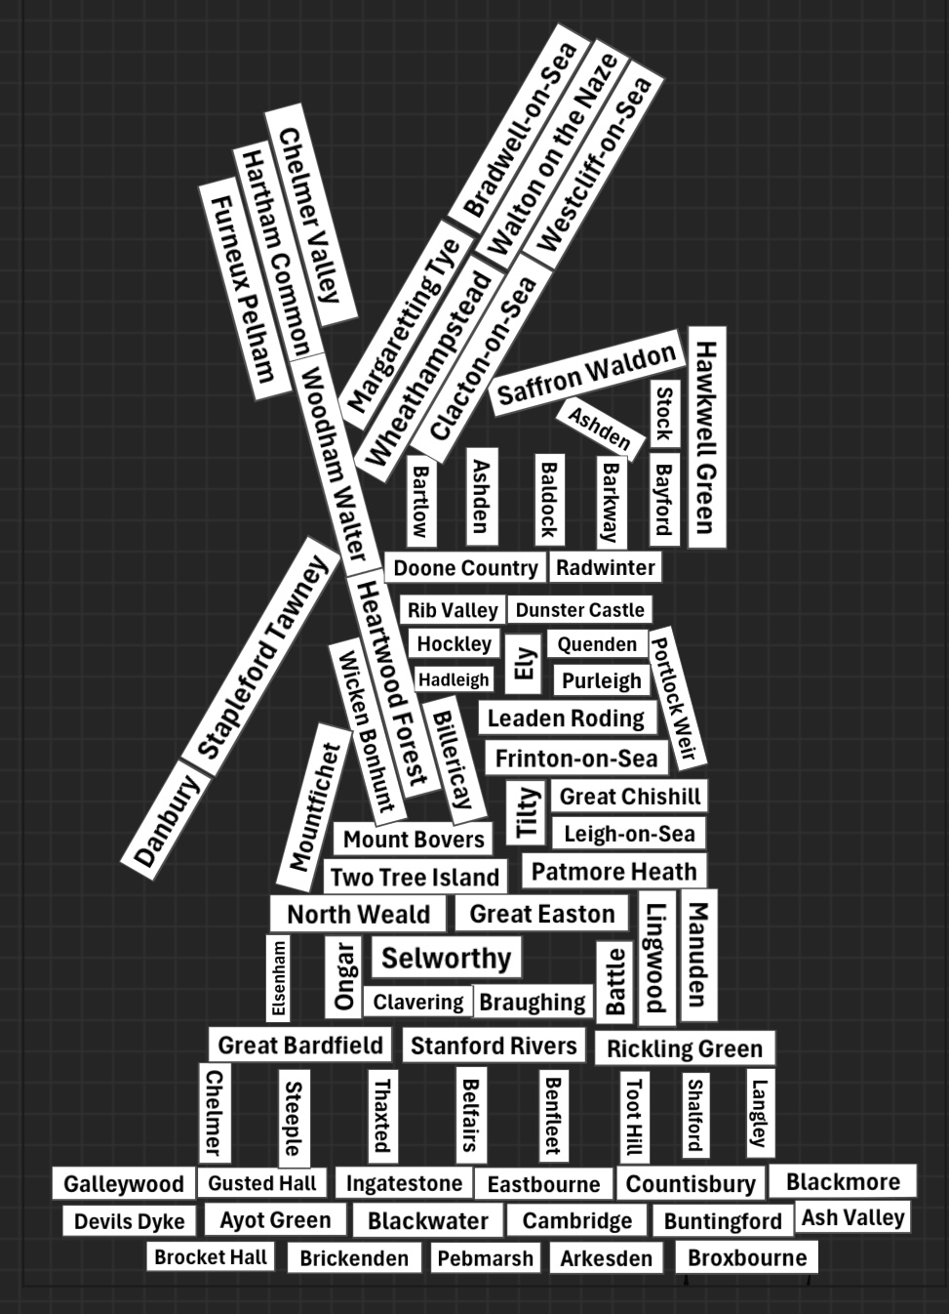
During 2025 we walked through so many beautiful villages and glorious countryside, which place did you enjoy the most?

At the end of March 2025, we had fantastic weather on our Away Weekend down in Exmoor, staying at Holnicote House, Selworthy. With a sparkling reception, making the start of this four-day walking tour, even more special. We started on the Friday afternoon, with a local figure of 8 walk, led by yours truly from the Hf house. It was noted that not everyone made it round the second loop, as several in our party, decided that they’d prefer to sit and enjoy the sunshine, and who can blame them, it was a glorious afternoon. They were also the first to check in and make a beeline for the welcome afternoon tea and scone! The Friday excitement did not stop there, with Lizzie’s Big Quiz after our delicious evening meal.
On the Saturday, we had a tremendous 17-mile coastal walk, from North Hill near Minehead to Porlock Wier, looping back along a different route. A big thank you to John Cheshire and Peter Tremain, for this stunning walk.
Another big thank you, goes to the lovely Cornwall and Devon LDWA group, for two spectacular Lorna Doone walks on the Sunday. Especially to the leaders Tim Ryan and Eva for the separate 14- and 20-mile walks. We all really enjoyed the fantastic scenery, many steep hill climbs, and great company, on yet another blue-sky day.
The final Monday walk, of our lovely weather weekend away, was a circular one from Dunster Castle.
Thanks to the intrepid walkers who came out with me, an interesting start, but all accounted for and no one was left behind on the scramble! Thanks to everyone for your company over the weekend. Seeing so many happy smiling walkers, makes all the organisation worthwhile.

When I advertised this year’s Shropshire trip, all the places were snapped up straightaway, with sourcing extra rooms the first organisational hurdle! We have 39 walkers booked in the Hf Longmynd House, Church Stretton, at the end of March 2026, so fingers crossed for equally beautiful weather this year. They call it ‘Little Switzerland’ so I am guessing there will be a few hill climbs?

Talking of Hf Holidays, I was both surprised and pleased that their group manager Paige, asked if we would like to be the first walking group, to feature in their newly styled quarterly magazine! They thought that our 50th anniversary was remarkable, and they send me a list of ‘interview’ questions to answer on behalf of our group. The questions about our weekends away, I could easily answer but not those relating to our past 50 years of walking! Many thanks to Richard Haynes, Jackie Burnett, and Bill Bowers for their historical input. If you missed it first time round, the finished article was published in Hf Holidays - Spring 2025 issue.

Now for some social walk stats, since and including our last AGM, we have held: -
A total of 35 Social walks covering approximately 640 miles, with over 564 participants, giving an average of 16.1 walkers, and 18.3 miles per event (including weekend, midweek, and marshal's walks).
Compared with last year’s stats, the average number of walkers and miles covered increased on average by 3 walkers and 1 mile, per event. In total, there were 9 less walks overall, but then again, it was a busy year with 4 challenge events, plus ‘St Peter’s Way in a day’, as well as all the 50th anniversary events.

As always, on everyone’s behalf, I would like to say a massive ‘thank you’ to our amazing walk leaders. Your contribution is invaluable. Thank you, to those leaders who have already booked in a date to lead a walk this year. If you haven’t got round to it yet, I have the calendar list with me if you want to bag a date today. Remember, if you are finding it hard to locate a free car park, we have a small budget, for a village hall car park donation, if needed.

The New Social Walks Register form, introduced last year, with its extra column for walkers to write in their ICE – ‘In Case of Emergency’ contact phone number, or to state where it can be found - by another person (eg. in rucksack, wallet, phone), I am pleased to say has been universally accepted by our Walk Leaders and only take a few extra seconds to fill in per person. Please remember to take the register with you, or take a photograph of it, just in case an accident does occur. To protect walker’s confidential contact information, that section is removed, and not stored onto the LDWA website.

Our social walks calendar will always rely on new people coming forward to lead walks, as well as those who have led many times before. If you haven’t led a social walk yourself, don’t be shy, how about taking up the challenge? There are lots of very experienced leaders within our group, who would be pleased to mentor/ advise those wishing to do this for the first time. Links to helpful information and forms, can be found at the top of the ‘Available Walk Dates’ page on our website.

The E&H cosy neckwear giveaway and photographic competition was another way making our 50th anniversary even more memorable. It has been fabulous, to see all our walkers both wearing and using their cosy neckwear, with pride, far and wide and in so many different situations and locations. It was great that so many of you joined in the photo fun. Kirsteen and I had quite a job on our hands, judging all the entries.
A massive well done to our 2025 photo competition winners: -
‘Most joyous’ photo winner was Fiona Sutherland, captured crossing the finish line of a 24-hour race, having covered over 80 miles! Using our E&H neckwear as a cooler, by soaking it with water!
‘Most novel usage’ photo winner was Richard Haynes, for his Gruffalo’s Nose photo and poem. His photo of the E&H moon landing was also brilliant but sadly disallowed, for obvious reasons!
‘Most far flung’ photo winner was Kerry Clark, for walking the steepest street in Dunedin, New Zealand.
With an extra prize awarded for ‘Best Photo’ to Ginny Powell, wearing her E&H neckwear underwater, when diving, because it was freezing cold down there!

To continue the photo fun into 2026, I am pleased to announce the categories for this year’s E&H cosy neckwear competition.
‘Best E&H cosy neckwear photo taken within the county of Essex’
‘Best E&H cosy neckwear photo taken within the county of Hertfordshire’
‘Most intrepid sporting activity undertaken whilst wearing your E&H cosy neckwear’
1 prize for each category - a £15 Cotswold voucher plus free entry to one of our challenge walks in 2027.
To enter, send your photo/s to me – essexandherts.walks@ldwa.org.uk
Stating your full name, category entered, when and where the photo was taken.
Entry deadline 1st December 2026.

Well, that’s all from me. Lizzie Bridge.

