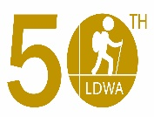
Thank You For Taking Part In The Weekend Of The Big Walk In
Celebration Of The LDWA’s 50th Year Anniversary
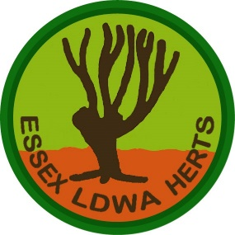
Local Group: ____________________________
Name: _____________________________________
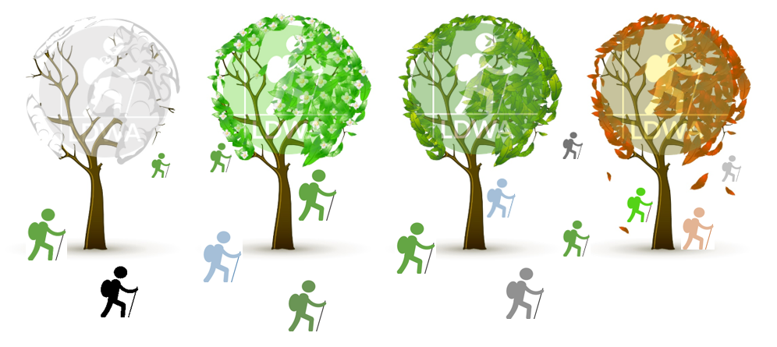
17th, 18th & 19th June 2022

