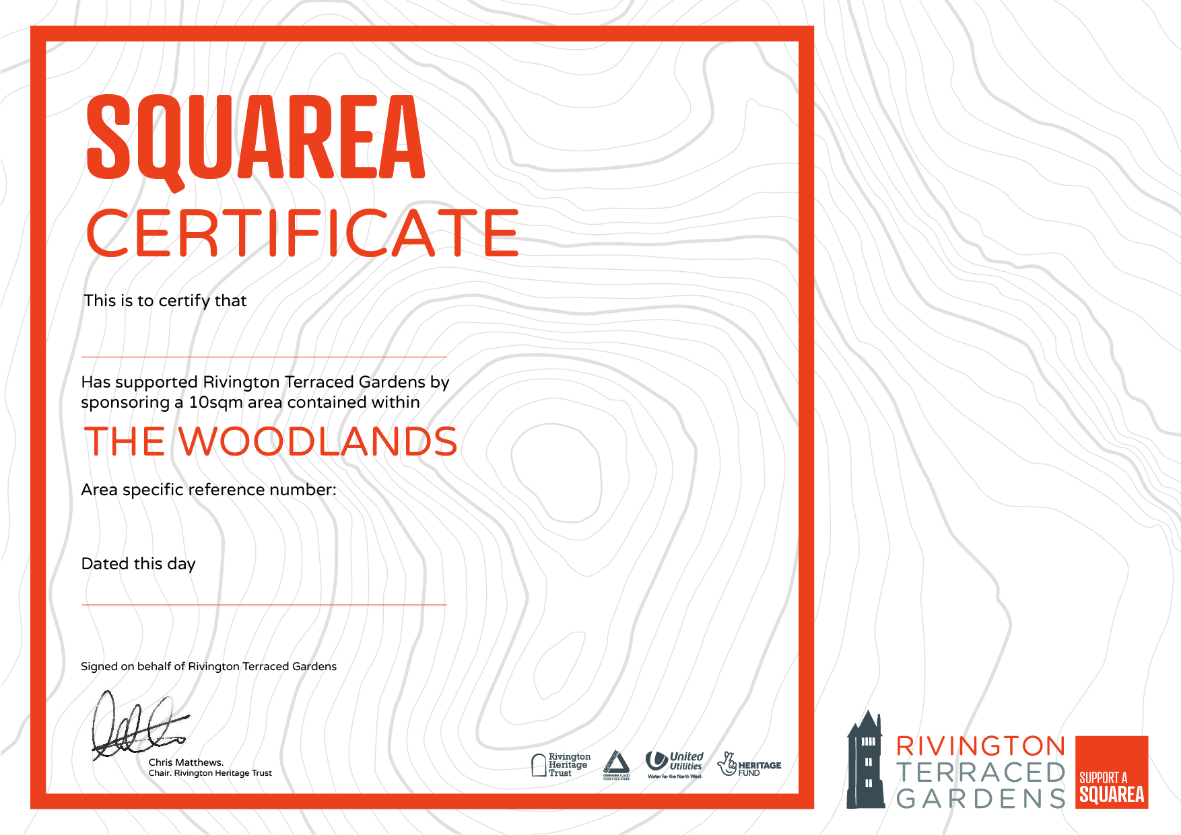

22nd January 2021

East Lancs Long Distance Walkers Assoc

W 0057