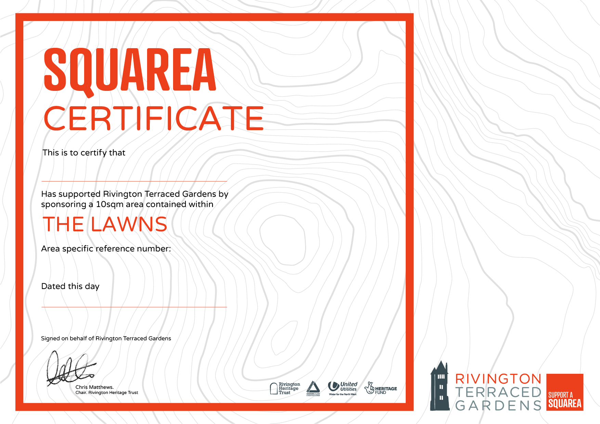

East Lancs Long Distance Walkers Assoc.

22nd January 2021

L 0022