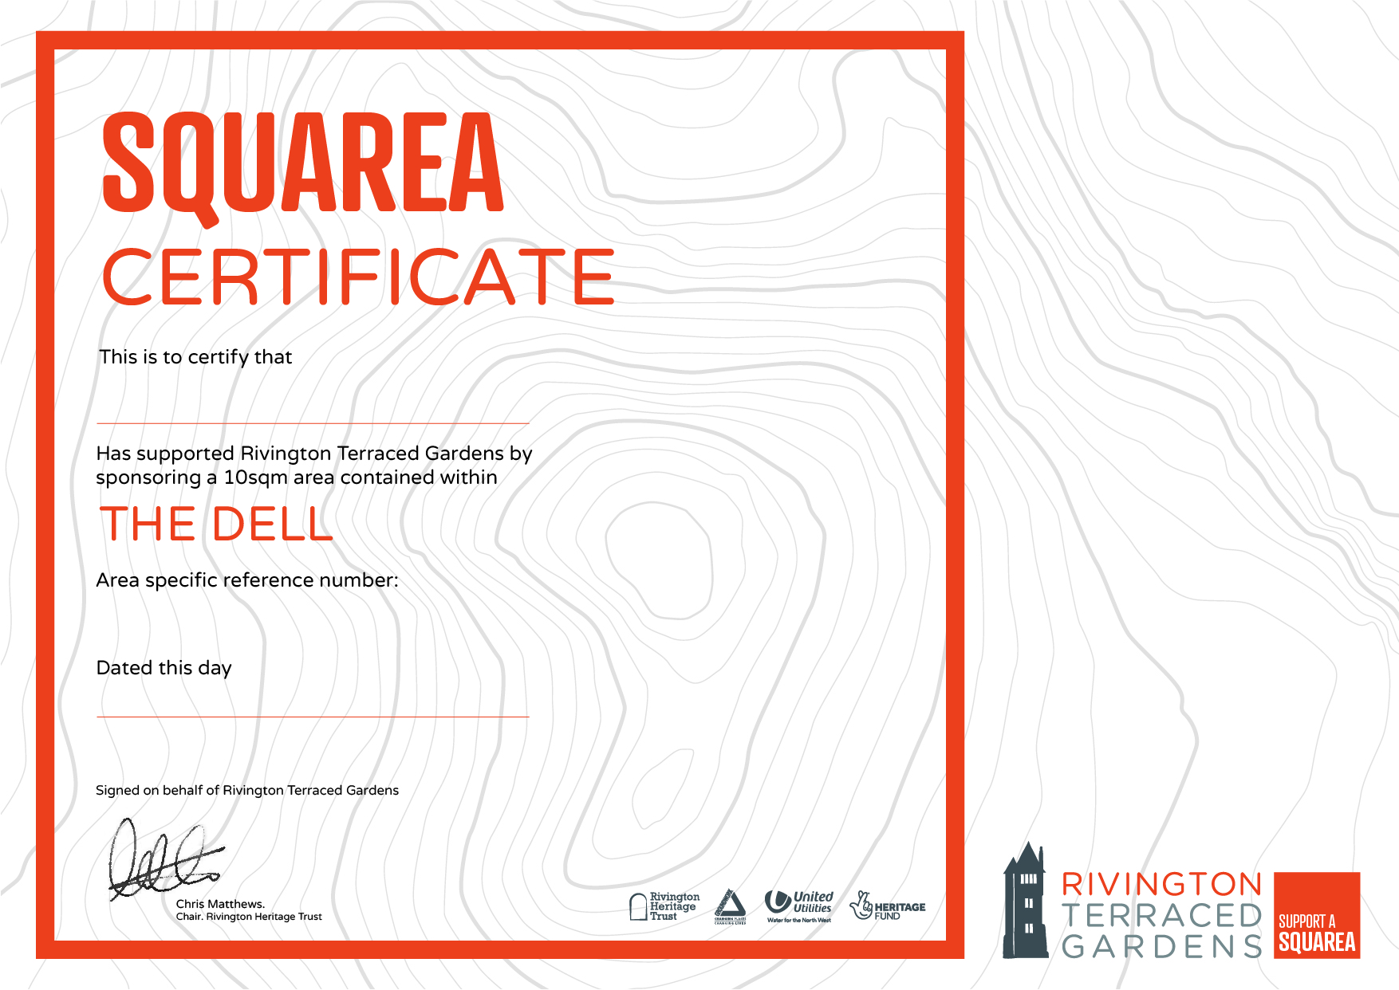

East Lancs Long Distance Walkers Assoc

22nd  January 2021

D 0099