Dorset LDWA – Dorset Doddle 2026 (v02.1) Route Description and notes.

Warnings:
Unfenced cliffs. Take extreme care by cliff edges and stay as far away as possible. Due to erosion parts of the route are close to the cliff edge.
Descents. Take great care with stone steps on descents. Some are in poor condition with uneven steps and protruding metal spikes and are slippery when wet. Care also descending on loose stones, and when wet on chalk paths and grass.
Trip hazards include vegetation, tree roots, stubs of old fence posts and deep cracks due to dry weather.

EMERGENCY TELEPHONE No. 0752 666 3749 (Note some stretches of route have no signal.)
AH Ahead  BL / BR Bear Left / Right  CB Compass Bearing  FP Foot Path | GR Grid Reference  L / R Left / Right  LMG Large Metal Gate  RD Road | SP Sign Post(ed)  SMG Small Metal Gate  SWG Small Wooden Gate  Thru through | TK Track  TL Turn Left  TR Turn Right  X Cross

SECTION 1. WEYMOUTH CLOCK TOWER TO LULWORTH VILLAGE HALL 18.0km (11.2 miles)

(1.1) Go NNE along promenade for 1.2km. At end of buildings, BR onto concrete promenade beside the beach. At the end of promenade, AH up Bowleaze Coveway (Ignore Public FP SP. GR SY 696 815). After pub car park TR onto grass and uphill (CB 080º) towards Lookout café. Continue roughly parallel with coast, aim for L end of long white building.
(1.2) TL on pavement beside car park to RD (ignore blue SP ‘coast path’), TR to end of RD. Continue on gravel path. GR SY 706 821.
(1.3) AH on track with bushy fence on L. X 2 fields to BR at finger post to far RH corner, kissing gate in hedge. TL onto cliff top path (coast path) towards Osmington Mills. Beware leaning trees in woods. AH on coast path to RD. TR on RD to reach Smugglers Inn. Toilets on right before “Smugglers Inn” sign.

Manned Clipper A on RD (No Refreshments) 4.7 miles completed. GR SY 735 817. Open 9.15 – 10.40

(1.4) Down steps to pass to L of Smugglers Inn, (SP coastal path Ringstead). Thru kissing gate. AH thru 2nd kissing gate to follow coastal path on cliff top 1.2km to Ringstead joining gravel TK in front of houses. In 100m swing L between houses on TK (Ringstead). GR SY 751 814
(1.5) TR by toilets and AH on RD, then gravel TK, eventually becoming FP thru bushes, to join tarmac TK for 150m. As TK bends L, AH beside wooden fence (SP White Nothe, not SP Coast Path, White Nothe). In 130m X concrete TK and thru gate, AH on FP up thru furze bushes to gate on cliff top. AH on FP to White Nothe cottages. GR SY 773 809.
(1.6) Pass to R of cottages, (SP Lulworth), with the White Nothe and ditch to your R. AH on cliff top path to obelisk. 25m past obelisk, fork R on FP (SP Lulworth) down into Middle Bottom, then AH on cliff top FP over 3 summits to Durdle Door. GR SY 806 803.
(1.7) At chalky TK to “Door” TL. AH up TK for 400m (50m short of car park on summit) to TR thru gate and follow paths along hill, over summit & down to Lulworth Cove, public toilets available. AH thru car park, exit car park via entrance and X RD. TL along upper access RD then AH onto tarmac path for 250m to reach lane. TL and X RD (care) into RD opposite (Church road) in 100m TL into Village Hall Checkpoint (last building on left)

CP1 Lulworth Village Hall. GR SY 823 806. 18.0km (11.2 miles) completed. Open 10.00 – 13.00
SECTION 2. LULWORTH VILLAGE HALL TO KIMMERIDGE BAY 10.6km (6.6 miles)

(2.1) Leave Checkpoint and TR to retrace your steps to main RD &TR. In 10m X RD into lane opposite (Bindon RD). In 100m TR thru SMG & fork L up steps. Thru SWG & AH (CB140) uphill on steep chalk path for 30m then steep grass path. Follow steepest path, ignoring X dirt paths. Path swings L and less steep between gorse to reach fence. TR uphill to range control gate. GR SY 829 803
(2.2) Thru gate - Stay between Yellow range-marking posts AT ALL TIMES. AH on TK, past radar post. AH on chalk TK Take L fork thru SMG to L of cattle grid to hilltop flagpole. AH on ridge to the end of hill, continue AH on landward slope through SWG. Down to Arish Mell. Up Flowers Barrow BL to SWG by LMG and enter Earthworks, following range markers along cliff top, thru bank by large blank notice board, then in 30m at sign stone (Whiteways) & notice board AH Through gap & AH on TK for 1 mile on ridge passing Trig & tall post on hill, descend on TK to SWG by LMG. GR SY 881 810

(2.3) TR. Sign stone (Tyneham Church) Descend on TK to RD, TR & BL on RD thro Car Park (black SP GR SY 882 802 (Toilets) into trees at Green Sign (Toilets) AH thru SWG, AH uphill on TK at top Thru SWG. TR & in 10m TL on cliff top, At ‘No Vehicles’ sign, just before cattle grid, fork R thro SWG and fork R again (SP Kimmeridge Bay) onto path around side of hill and descend to gate.GR SY 892 796

(2.4) BR to follow range markers down with sharp R then sharp L down to cliff top path. AH, through several gates, path eventually becoming track through range control gate. Past oil well, TR on tarmac RD. At left bend, TR onto grass (before buildings) on cliff top to find FP passing between cliff & cottage gardens. Descend to X footbridge and up steps. AH on cliff top to Checkpoint at far end of carpark.
CP2 Kimmeridge Bay Car Park. GR SY 909 791. 28.6km (17.8 miles) completed. Open 11.00 - 15.30.

SECTION 3. KIMMERIDGE BAY to ST. ALDHELM’S HEAD 7.1km (4.4 miles)

(3.1) AH on cliff top to FP between bushes, through 2nd car park, past toilet block, outside water tap available, on L, to TR down TK. (SP Coastal path). In 100m TL on path up steps (SP Coast path), to cliff top beyond Clavell Tower. AH with care for 5km. Note risk of deep cracks in the path and trip hazards in bushy areas. Path descends Houns Tout, over stile & turns inland (SP St. Aldhelms Head 2.25 mile) GR SY 951 772.

(3.2) Descend to X field & X stile to tarmac track. TR then BL on grassy TK beside fence-line. AH for 900m X stiles beside 2 gates to pass between houses to RD. TR down RD for 90m.

CP3 Hill Bottom. GR SY 963 778. 35.7km (22.2 miles) completed. Open 11.45 – 17.30

SECTION 4. HILL BOTTOM TO SWANAGE (Finish) 14.7km (9.1 miles)

(4.1) TR (SP St. Aldhelm’s Head) over bridge, thru gate then BL up FP (SP St Aldhelm’s Head). AH on coast path to St Aldhelm’s Head Coastwatch station. Follow coast path past metal sculpture. AH on FP (SP Winspit 1 mile) down to cliff top path. In 1.4km L thru SMG marked “Alternative Coast Path (avoiding cliff edge)” In 400m R thru SMG and L round Winspit quarry edge. WARNING - NARROW PATH, SLIPPERY IN WET. Descend steps. GR SY 976 761.

(4.2) At the bottom TR for 25m, TL by ‘National trust’ sign. Follow coast path signs up steps to cliff top FP. In 800m above Seacombe the FP veers inland to TR thru gate & down steps in trees. GR SY 984 768.

(4.3) At bottom TR back towards sea. Keeping fence to R, AH X small stone bridge, up hillside onto cliff top FP. AH on cliff top path for 2.8km, fence always to R. (At times path splits to X wet-weather streams) After a 300m stretch of bushy scrub, BR at milestone, (SP Durlston 1.5 mile), to pass beneath lower nautical mile tower. AH on cliff top FP for 1.6km pass to R of the lighthouse and follow rocky FP down between cliff and lighthouse and up steps to join good FP with wall on R. AH 300m with cliff top wall on R. At viewing area on R, TL up wide way. TL up tarmac with castle wall on R and water taps on L. AH 30m to front of castle entrance.

Manned Clipper Point B. 29.2 miles completed. GR SZ 034 773. Open 14.00 – 20.15.

(4.4) BR up steps (SP Coast path) into woods on coast path, soon descending thru trees, continue for 1.1km. Where path splits TL (SP Coast path avoiding steps) to RD, TR on RD GR SZ 032 779.

(4.5) TR into 1st side RD (Bell Vue Rd), AH to top corner TR into park (SP Swanage 1), thru trees then BL down grassed area to bottom L corner. Continue downhill on RD, X main RD to seafront. TL on seafront, then AH on RD beside beach. After RD leaves beach AH on RD for 900m. AH thru No Entry signs & TL to All Saints Church.

The finish. All Saints Church GR SZ 030 801. 50.4km (31.3 miles) completed. Closes 21.00.
Well Done. If you are tired, have a rest before you drive! Have a safe journey home.

Dorset Doddle notes 2026

1. Start. To relieve congestion on Weymouth Esplanade we will be again using a rolling start.
- Registration will open at 08:00 on Weymouth seafront.
- Participants may start between 08:30 and 09:00. Runners at 9:00
- All participants will be issued a tally at registration, which must be scanned prior to leaving by the starter at Jubilee Clock on Weymouth Esplanade (GR SY 681 795)

2. Retiring. If you need to retire, please do so at a checkpoint. We will provide transport from all checkpoints to the finish, but you may have to wait until the checkpoint closes. If you are unable to reach a checkpoint, please ring the emergency number or let another walker know and someone will come to your aid. Do not leave the event or wander off-route without informing the organisers.

3. Checkpoints. Please ensure your name is recorded. Checkpoint teams have been instructed to enforce opening and closing times. Enforced Cut Off Times – Checkpoint 1 (11.2 miles) 13.00, Checkpoint 2 (17.8 miles) 15:30 & Checkpoint 3 (23.7 miles) 18:00 If you have not passed thru the checkpoints by the given times you will be retired from the event and in due course transported to the finish at Swanage.

4. Checkpoint 1 (Lulworth)
A reminder that the Lulworth Checkpoint is at the Village Hall (GR SY 823 806). The route is marked in blue
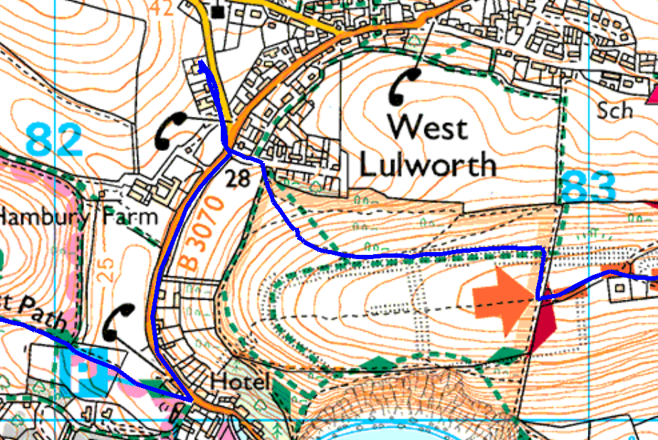
Check Point 1

5. Food and Drinks. Checkpoints will offer drinks, and will offer light snacks, but you should carry your own drink and food. A vegetarian meal will be provided at the finish. Entrants must bring their own mug for drinks and should carry a water container and extra drinks if the weather is hot.

6. Dogs. Sorry No Dogs are allowed on this event.

