Dorset LDWA – Dorset Doddle 2022
Instructions and Route Description
AT THE CHECKPOINTS, when you arrive, ensure your name is recorded. Take notice of checkpoint open and closing times, as this will be enforced! IN CASE YOU HAVE TO RETIRE - Please retire at a checkpoint to await transport to Swanage. If you are unable to reach a checkpoint please ring the emergency number or let another walker know and someone will come to your aid.
Do not leave the event or wander off-route without informing the organisers.

Enforced Cut Off Times – Checkpoint 1 (11.6 Miles) 1pm, Checkpoint 2 (18.2 Miles) 3.30pm & Checkpoint 3 (22.8 miles) 5.30pm. If have not passed through the checkpoints by the given times you will be retired from the event and in due course transported back to the finish at Swanage.

Warnings: Stay away from cliff edges. Take care with uneven stone steps on descents. Dry weather has caused widespread cracking along the route so be careful.
EMERGENCY TELEPHONE No. 07743 576 921 (Note some stretches of route have no signal.)
AH Ahead  BL Bear Left  BR Bear Right  CB Compass Bearing |  | FB Field Boundary  FP Foot Path  GR Grid Reference  L Left | R Right  RD Road  SP Sign Post(ed)  TK Track | TL Turn Left  TR Turn Right  WM Waymark  X Cross
WEYMOUTH CLOCK TOWER TO OSMINGTON MILLS 8km (5 Miles)
0.1 | Go NNE along promenade for 1.2km. At end of buildings, BR onto concrete promenade beside the beach. At the end of promenade, AH up Bowleaze Cove way, Ignore Public FP SP. GR SY 696 815
0.2 | After pub car park, TR onto grass and uphill (CB 080º) roughly parallel with coast, aim for left end of long white building when visible. TL on pavement beside car park to RD, TR to end of RD.  GR SY 706 821.
0.3 | AH on track with bushy fence on L. X 2nd field to BR at finger post to kissing gate, TL onto cliff top path (coast path) towards Osmington Mills. When path enters wood, beware low branch. As Osmington Mills comes into view, X stile in LH fence. At RD, TR to reach Smugglers Inn. Toilets on right before “Smugglers Inn” sign, Manned Clipper Point on RD (No Refreshments), GR SY 735 817. Opens 9.15am – closes10.40am
OSMINGTON MILLS to LULWORTH CHURCH 10.3km (6.4 Miles)
1.1 | Down steps to pass to L of Smugglers Inn, (SP coastal path Ringstead). Through kissing gate. AH through 2nd kissing gate to follow coastal path on cliff top 1.2km to Ringstead joining gravel TK in front of houses. In 100m swing L between houses on TK (Ringstead). GR SY 751 814
1.2 | TR by toilets and AH on RD, then gravel TK, eventually becoming FP through bushes, to join tarmac TK for 150m. As TK bends L, AH through gap (SP White Nothe, not SP Coast Path, White Nothe). In 130m X concrete TK and thro' gate, AH on FP up through furze bushes to gate on cliff top. AH on FP to White Nothe cottages. GR SY 773 809.
1.3 | Pass to R of cottages, (SP Lulworth), with the White Nothe and ditch to your R. AH on cliff top path to obelisk. 25m past obelisk, fork R on FP (SP Lulworth) down into Middle Bottom, then AH on cliff top FP over 3 summits to Durdle Door. GR SY 806 803.
1.4 | At chalky TK to “Door” TL. AH up TK for 400m (50m short of car park on summit) to TR thro' gate and follow paths along hill, over summit & down to Lulworth Cove, public toilets available. AH thro’ car park, exit car park via entrance and X RD. TL along upper access RD then AH onto tarmac path for 250m to reach lane. TL and X RD (care) into RD opposite (Church road) in 150m TR through wooden gate into church yard and Checkpoint 1 GR SY 823 807. Open 10.00am – Closes 1pm
LULWORTH CHURCH to KIMMERIDGE BAY 10.9km (6.8 miles)
2.1 | Leave Checkpoint and TL to retrace your steps to main RD, TR in 10m X RD into lane opposite (Bindon RD). In 100m TR thro'2 gates & AH up hill on path (CB140). Follow path as it swings L to contour hill for 300m to reach fence. TR uphill to range control gate. GR SY 829 803
2.2 | Through gate - Stay between Yellow range-marking posts AT ALL TIMES. AH on TK, past radar post. – beware cattle grid hidden in overgrown grass. AH on chalk TK Take L fork (SP Bindon Hill) to hilltop flagpole. AH on ridge to the end of hill, continue AH on landward slope. Down to Arish Mell. Up Flowers Barrow to gate by 5-bar gate and enter Earthworks, following range markers along cliff top. thro' first bank, then in 30m TR thro' first gap in second bank on right, immediately thro' gate & descend steeply to Worbarrow Bay. GR SY 871 797.
2.3 | At bottom X wooden footbridge. In 20m TL uphill on TK. In 15m TR up steps. AH (SP Kimmeridge) to gate. AH up cliff top path for 1.6km. Just before cattle grid, fork R thro wooden gate and fork R again (SP Kimmeridge Bay) onto path around side of hill to gate.GR SY 892 796
2.4 | BR to follow range markers down to cliff top TK. AH, through range control gate. Past oil well, TR on tarmac RD. At left bend, TR onto grass on cliff top to find FP passing between cliff & cottage gardens. Descend to X footbridge and up steps. AH on cliff top in car park to Checkpoint 2  GR SY 909 791. 28.9km (18.2 miles) completed. Open 11am – Closes 3.30pm.
KIMMERIDGE BAY to HILL BOTTOM 6.9km (4.3 Miles)
3.1 | AH on cliff top to FP between bushes, through 2nd car park, past toilet block, outside water tap available, on L, to TR down TK. (SP Coastal path). In 100m TL on path up steps (SP Coastal path), to cliff top beyond Clavell Tower. AH with care for 5km to descend long flight of stone steps. Note risk of deep cracks in the path, also trip hazards in bushy areas. Where path splits choose the inland option. GR SY 950 773.
3.2 | 70m below end of 'long' steps X stile on L (SP Coast Path Diversion). Proceed (CB 10º) away from coast thro’ field on FP (SP coast path, Hill Bottom), (do not follow path ‘To Beach’) for 300m to X stile by gate (SP Coastal Path). AH 25m to tarmac. TR then BL on grassy TK beside fence-line. AH for 900m crossing stile beside gate to pass between houses to RD. TR down RD for 50m to Checkpoint 3 GR SY 962 777. 36km (22.5 miles) completed. Open 12pm – Closes 5.30pm
HILL BOTTOM to Durlston Castle 11.1km (7.4 Miles)
4.1 | From Checkpoint, return back towards sea, BL up track, thro' gate then BL up FP (SP St Albans Head). AH on coast path to St Aldhelm’s Head (GR961754) pass round coast guard hut & past metal sculpture. AH on FP (SP Winspit 1 mile) down to cliff top path. At Winspit FP round quarry edge. WARNING - NARROW PATH, SLIPPERY IN WET. Descend steps. GR SY 976 761.
4.2 | At the bottom TR for 25m, TL by high ‘Private Property’ sign. Follow main FP thro' bushes & up, round edge of 1st field, exiting at kissing gate onto cliff top FP towards Seacombe. Above Seacombe the FP veers inland to TR through gate & down steps in trees. GR SY 984 768.
4.3 | At bottom TR back towards sea. Keeping fence to R, AH X small wooden bridge, up hillside onto cliff top FP. AH on cliff top path for 2.8km, fence always to R. (At times path splits to X wet-weather streams.) After a 300m stretch of bushy scrub, BR at milestone, (SP Durlston 1.5 mile), to pass beneath lower nautical mile tower. AH on cliff top FP for 1.6km pass to R of the lighthouse and follow rocky FP down between cliff and lighthouse and up steps to join good FP with wall on R. AH with cliff top wall on R for 300m. At viewing area on R, TL up wide way. TL up tarmac with castle wall on R and water taps on L. AH 30m to manned Clipper Point in front of castle entrance. GR SZ 034 773. 47.2km (29.5 miles) completed. Opens 2pm – Closes 8.15pm.
Durlston Castle to SWANAGE & Finish 4.2km (2.2 Miles)
5.1 | BR up steps (SP Coast path) into woods on coast path, soon descending thro' trees, continue for 1.1km. Where path splits TL (SP Coast path avoiding steps) to RD, TR on RD GR SZ 032 779.
5.2 | TR into 1st side RD (Bell Vue Rd), AH to top corner (SP on L side of RD). TR into park, through trees then BL down grassed area to bottom L corner. Continue downhill on RD, X main RD to seafront. TL on seafront, then AH on RD beside beach. After RD leaves beach AH on RD for 900m. AH through No Entry signs by All Saints Church to TL to All Saints Church GR SZ 030 801. 52.5km (32 miles) completed. Closes 9pm. THE FINISH - Well Done  If you are tired, have a rest before you drive! Have a safe journey home.
Dorset Doddle update 2022
1 | Start  To relieve congestion on Weymouth Esplanade and at Bowleaze we will be again using a rolling start for the 2022 Dorset Doddle.  - Registration will open on Weymouth seafront at 08:00  - Participants may start between 08:30 and 09:00  - All participants will be issued a tally at registration, which must be scanned prior to leaving by the starter at Jubilee Clock on Weymouth Esplanade (GR SY 681 795)
2 | Check Point 1 (Lulworth)  A reminder that the location of the Check Point at Lulworth has moved to the Church gardens at GR SY 823 807. The new route is marked in blue  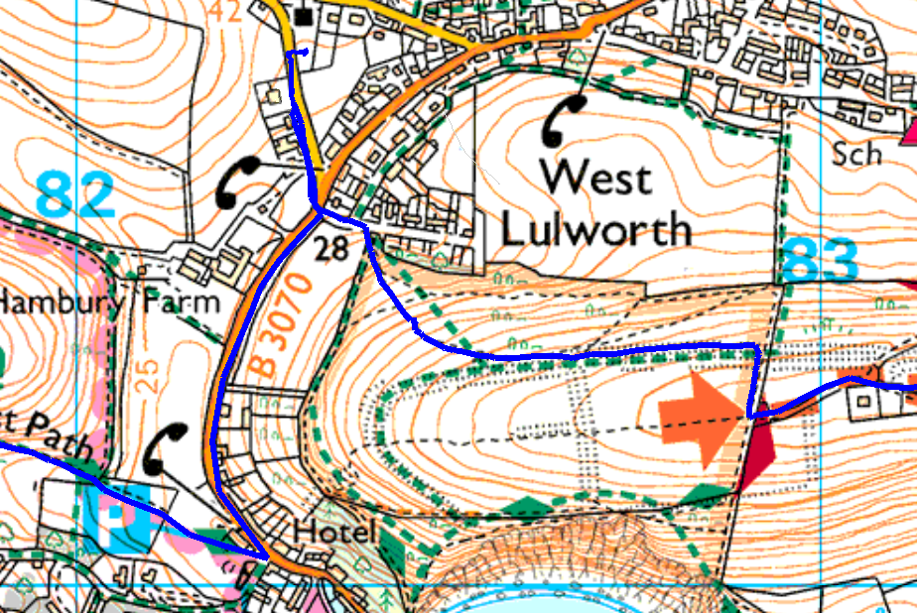  Check Point 1
3 | Checkpoints will offer drinks, and some will offer light snacks, but you should carry your own food. A meal will be provided at the finish. Entrants should bring their own mug for drinks, and it is strongly recommended to carry a water container and extra drinks if the weather is hot.
4 | Checkpoint teams have been instructed to enforce opening and closing times.
5 | If you need to retire please do so at a checkpoint. We will provide transport from all checkpoints to the finish, but you may have to wait until the checkpoint closes. If you retire somewhere other than a checkpoint, please let us know so we know that you have retired.
6 | Sorry no Dogs are allowed on this event.

