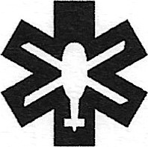

THAMES VALLEY
AIR AMBULANCE
Thames Valley Air Ambulance
Stokenchurch House,
Oxford Road,
Stokenchurch,
Bucks HP14
0300 999 0135
Long Distance Walkers Association

10th July 2024
Dear Long Distance Walkers Association
I'm writing to let you know that Thames Valley Air Ambulance has received your kind donation of f200.00. This is an amazing amount of money, thank you so much.
Thanks to people like you we have been able to make huge developments in Pre-Hospital Emergency Medicine. Our teams have at their fingertips the latest life support kit such as a compact chest compressor which allows us to continue treatment at the same time as keeping the heart pumping. We carry blood on board for on scene transfusions and a hospital level blood analyser which can give vital information in seconds. We have hand held ultrasound machines, able to show internal injuries at the roadside.
2023 was our busiest year on record, with 3,293 callouts. We would like to say a huge thank you for being with us every step of the way and for joining us in doing everything in our power to protect, save and revive lives.
Kind regards
Aimee Lewis
Community Fundraising Assistant

