Celebrating BBN’s 40th Anniversary 1983 – 2023
Northampton Round

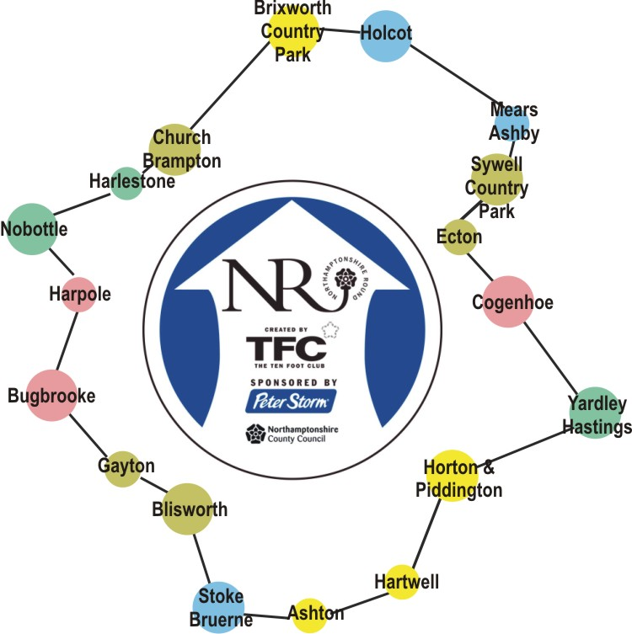

18th May 2023 – Piddington to Stoke Bruerne
15th June 2023 – Cogenhoe to Piddington
13th July 2023 – Holcot to Ecton
10th August 2023 – Church Brampton to Holcot
24th August 2023 – M1 near Bugbrooke Mill to Church Brampton
14th September 2023 – Blisworth to M1 near Bugbrooke Mill
12th October 2023 – Stoke Bruerne to Blisworth

