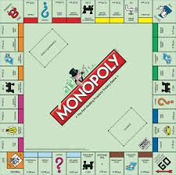 | 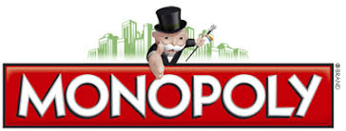
BBN MONOPOLY WALK
SUNDAY 10TH OCTOBER 2021
From Euston/St Pancras Station

As well as collecting all the properties, we need 3xChance and 3xCommunity Chest
Ideas for Chance – Lottery, Casinos, Mama Mia, Betting Shop
Ideas for Community Chest – Charity Shop, Hospital, Police Station, Library, Museum
There will be a prize for the most imaginative suggestion for both Chance and Community Chest, so keep your eyes peeled.
The Properties
Euston Road  Kings Cross Station  Pentonville Road  The Angel, Islington  Liverpool St Station | About an hour’s walk to Liverpool St Stn. Then a break. Free toilets.
Whitechapel Road  Fenchurch St Station  In Jail  Old Kent Road  Go | Toilets 50p by the Tower of London  Old Kent Road is the only property south of the Thames, so we’ll go over Tower Bridge, about 30 mins to OKR, then head northwest again.  Early lunch break in the Red Cross Gardens. Just before the Gardens there is a Costa on Borough High Street for coffee/toilets if needed. The group will walk on to the Gardens, and the leader or backmarker will wait for anyone who want to dive into Costa. It’s about 5/6 mins walk to the Gardens, so OK to carry coffee.
Electric Company  Water Works  Go to Jail  Fleet Street  Income Tax  Free Parking  Bow Street  Strand  Northumberland Avenue  Whitehall  Trafalgar Square | There are free toilets about 1¼ to 1½ miles after the lunch break  There are also toilets in Trafalgar Square (“small charge”)  Short break here if needed.
Pall Mall  Leicester Square  Coventry Street  Marlborough Street  Regent Street  Vine Street  Piccadilly  Bond Street  Mayfair | Mid-afternoon break in Mount Street Gardens - but no coffee or toilets here. (Approx 1½ miles to Marylebone Stn toilets)
Park Lane  Super Tax  Oxford Street  Marylebone Station | Marylebone is our last property. We’ll celebrate with a break, free toilets, coffee etc.
After Marylebone Station it is approx 30/35 mins via The Regent’s Park to Euston/St. Pancras/
Kings Cross. (Or, of course, there is the tube/bus)

