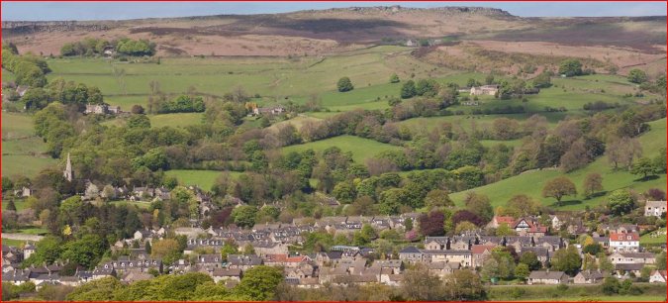
BBN walking Holiday
Hathersage Itinerary
The walking weekend is centred at Hathersage that takes its name from the Old English for “Haefer’s ridge” - now known as the four-mile long gritstone escarpment of Stanage Edge. Hathersage is forever associated with the legendary medieval outlaw Robin Hood’s faithful lieutenant, Little John, who was allegedly born and was buried in the village. You can visit his grave between two clipped yews just outside the church door in the churchyard. Once the centre of a thriving needle and pin making industry, Hathersage was also an important centre for mill and grindstone making, and the unfinished and abandoned remains of these stones are still to be found scattered at the foot of the edges.
Hathersage has strong literary connections too. Charlotte Bronte’s best friend at school was Ellen Nussey, whose brother was vicar of Hathersage. In 1845, Charlotte stayed at the vicarage with Ellen for about three weeks to prepare for the return of the vicar and his wife from honeymoon. During her stay Charlotte took the opportunity to explore, walking on the moors and visiting many of the houses scattered around the area. Her famous novel ‘Jane Eyre’ was set in Hathersage. She used the name of the landlord of the George Inn, a Mr Morton, who greeted her when she first arrived, as the name for her fictitious village.
Our main walks are on Saturday and Sunday, with an introductory walk Friday afternoon and a departing walk Monday morning through to the afternoon. Walks will vary in length, going through the villages and along the escarpments around Hathersage and Hope Valley. The walks form part of the BBN social calendar and will be lead in a similar manner.
This leaflet gives information about the walks and the starting points. If anyone has difficulty in getting to the start points or is delayed please contact Roy Carter 07784208997.
Accommodation will need to be obtained in Hathersage or in the surrounding area.
There are Guest Houses, B&B’s, Rental Properties, Campsites and local Youth Hostels.
Walks are on OS Explorer Maps OL24 & OL1 ‘The Peak District - White & Dark Peak Area’.
It’s 115 miles from Milton Keynes to Hathersage and will take around 2½ hours to drive. The direct route being: M1 north to J29 > A617 to Chesterfield > A61 north > west through Chesterfield suburbs > north-west on B6051 > B6054 > A6187.

Day 1: Hathersage – Friday 28th August – 1:30pm – 9 miles – Elbow Grit

The walk starts from the George Hotel in Hathersage and heads east on the A6187 to take the High Lees footpath up to Fiddler’s Elbow onto Burbage Rocks. Good views as we traverse the escarpment to Burbage Bridge and onward to Owler Tor and Mother Cap to reach Millstone Edge. Taking a path through the millstone quarries to Bolehill, we descend to the station at Grindleford for afternoon tea. Then down to the river Derwent to follow the Derwent Valley Heritage Way to Leadmill Bridge, as we gently walk back into Hathersage.

Explorer Map 0L1 & OL24 Grid Ref: SK 229 815 Postcode: S32 1BB

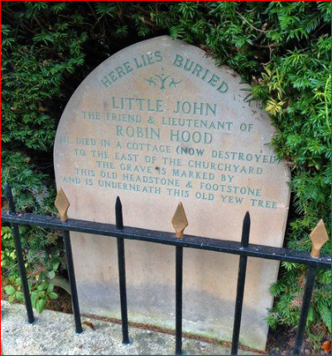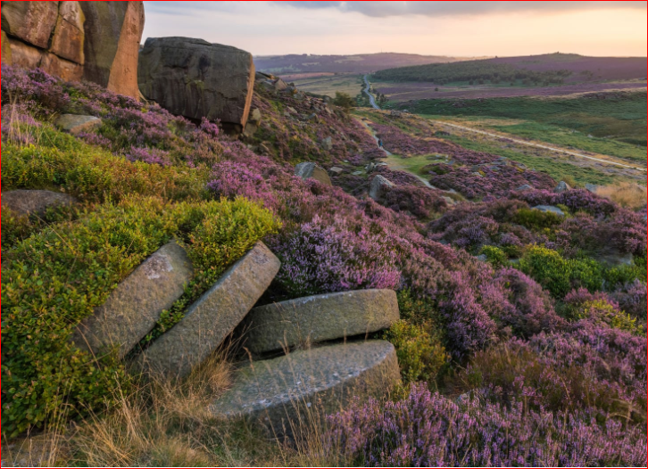

Little John’s grave Millstones on Burbage Rocks

Hathersage is famous for its links to the legend of Robin Hood, with second-in-command, Little John, reportedly having been buried in the graveyard of St Michael’s church. After the Great Exhibition orders for needles and pins (made from wire produced in Sheffield) industrialised the village. Grinding Mills grew rapidly and it was said that a wire drawer was easy to identify because they had several missing fingers. More seriously the working conditions for ‘grinders’ were life threatening; few lived over 30 years of age and dust from the revolving millstones, got into their mouths and lungs until they contracted the dreaded ‘grinders’ disease’.

Parking Information:
There is some parking around the George Hotel and in the side streets but not on the Main Road.
Pay & Display parking is available in Odd Fellows Road, S32 1DD.
£5 for 4 hours

Start Time 1:30pm
From The George Hotel Hathersage
S32 1BB

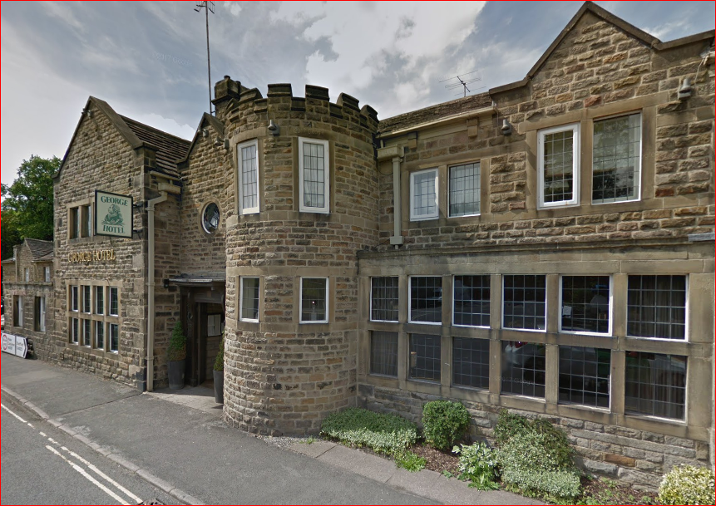

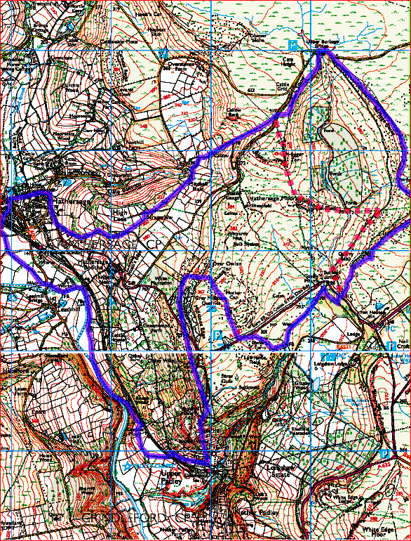

Day 2: Hathersage – Saturday 29th August – 9:30am – 17 miles – Edges & Dales

The walk starts from Hathersage Station to catch 09:45 train to Grindleford (single is £2.70). From here we ascend through Nether Padley onto the spectacular “Edges” of Froggatt, Curbar and Baslow to reach Wellington’s Monument. Descending through Calver for a morning break we head up Coombs Dale and over into Middleton Dale. From here it’s a small distance into the plague village of Eyam for lunch. In the afternoon we ascend Eyam Edge into the secret valleys of Bretton and Abney Clough. Then onto Offerton Moor and down to the stepping stones to cross the river Derwent (there’s an alternative). It is then just a short distance into Hathersage.

Explorer Map 0L24 & OL1 Grid Ref: SK 232 811 Postcode: S32 1DR
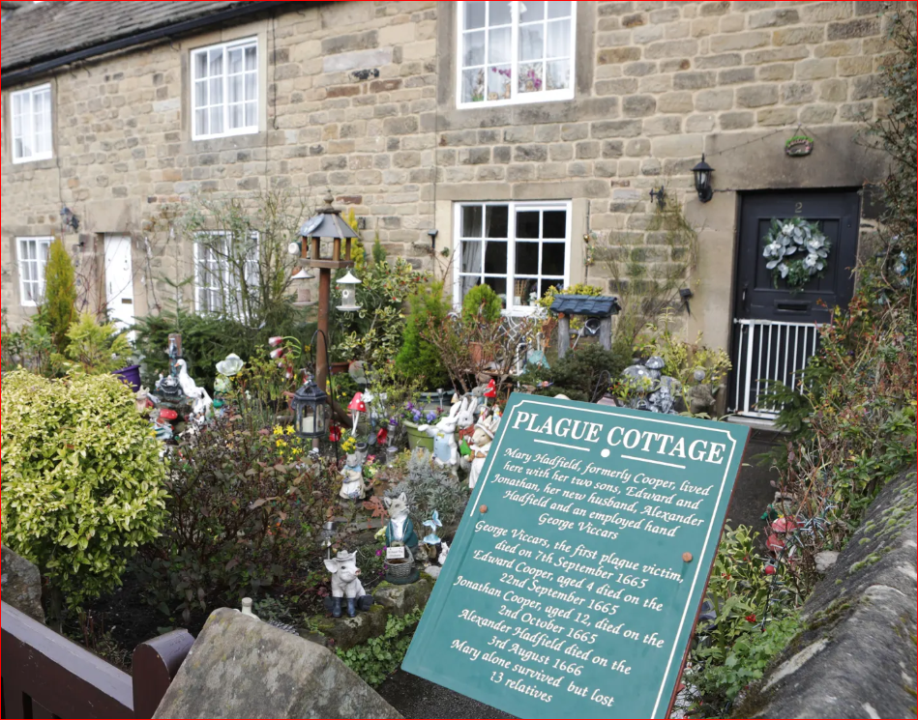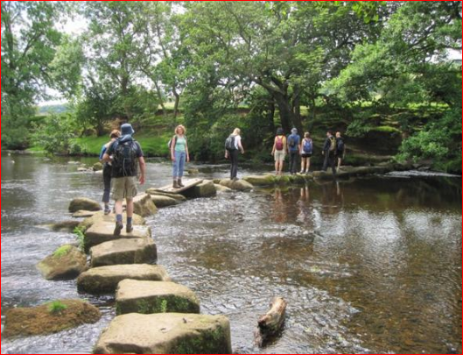
Plague Cottage in Eyam Hathersage Stepping Stones
On 1st November 1666 farm worker Abraham Morten gasped his final breath - the last of 260 villagers to die from bubonic plague in Eyam. Their fate had been sealed four months earlier when the entire village made the remarkable decision to isolate itself in an attempt to halt the spread of the Great Plague. It is a story of the villagers who refused to run. The plague in Eyam began 14 months earlier, with the arrival of a bale of cloth from London, where the disease had already killed thousands of inhabitants. Contained in the bale of cloth were fleas carrying the plague. The pestilence swept through the community until rector William Mompesson made it his duty to prevent it spreading to nearby towns by persuading villagers to “cordon sanitaire”.

Parking Information:

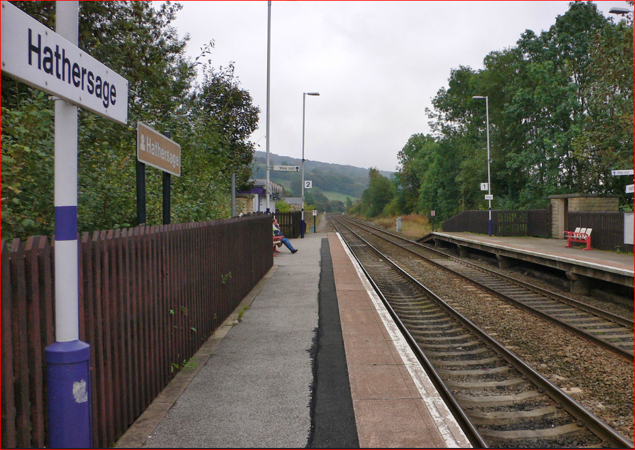
There is parking at the railway station for £2 a day or free but annoying in surrounding streets.
Please park considerately.

Start Time 9:30am
From Hathersage Station
S32 1DR

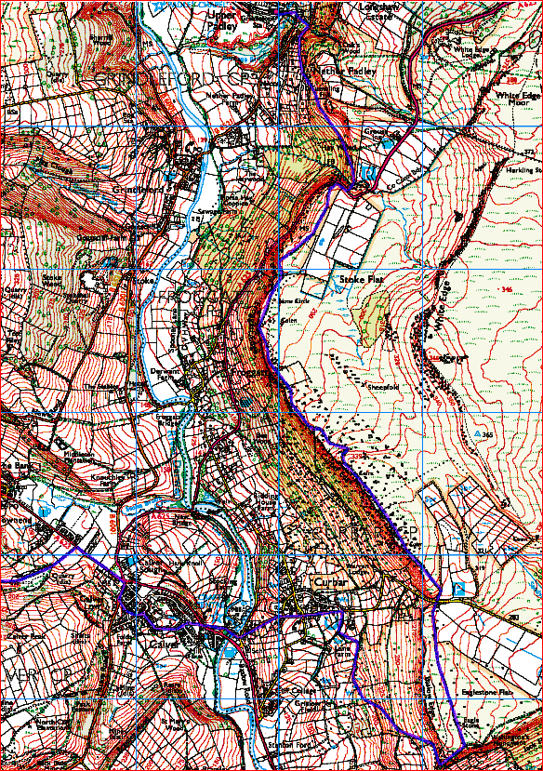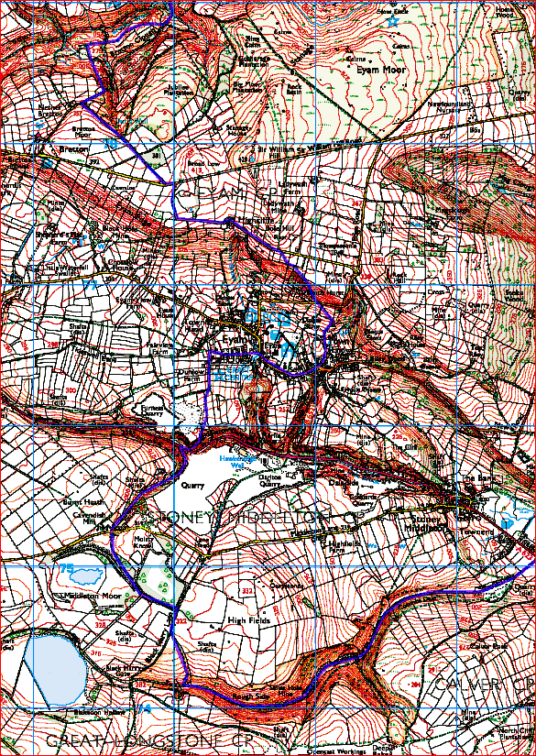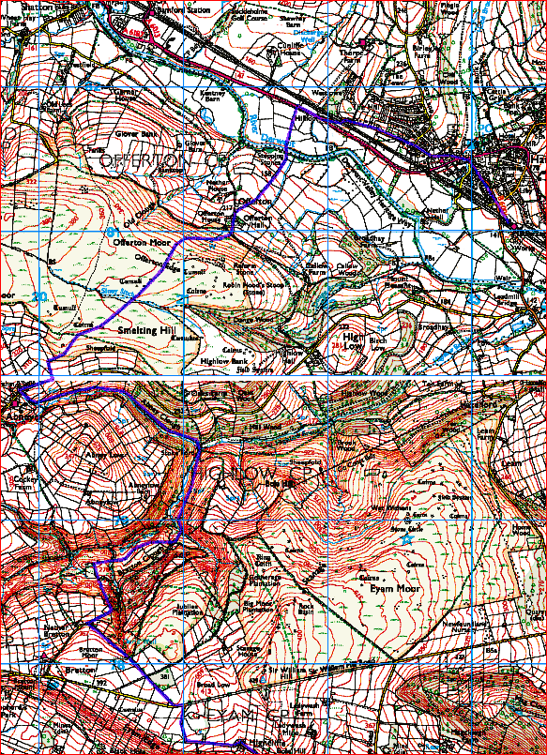

Day 3: Hathersage – Sunday 30th August – 09:30am – 18 miles – Waters Edge

The walk starts from the George Hotel in Hathersage and heads north up onto Stanage Edge with good views over the village. Following the escarpment we roam a bit to cross Cutthroat Bridge and onto Derwent Edge. Now on a defined path we are treated to a set of rock outcrops named Wheel Stones, Salt Cellar, Dove Stone, Cakes of Bread and Lost Lad before descending into Derwent reservoir for lunch. Crossing the headwaters of Ladybower reservoir, we climb onto Win Hill and descend towards the Dam into Bamford. From here, Hathersage isn’t too far.

Explorer Map OL1 Grid Ref: SK 229 815 Postcode: S32 1BB

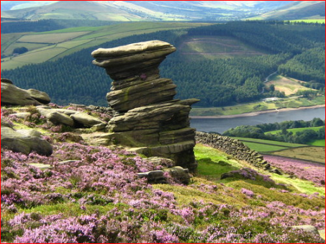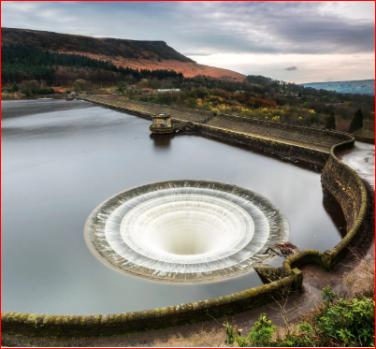

Salt Cellar Ladybower Reservoir

Stanage Edge is popular for walkers and rock climbers, with stunning views of the Dark Peak moorlands and the Hope Valley. The gritstone edge extends right round to Derwent Edge and was recently featured in the classic film ‘Pride & Prejudice’ starring Keira Knightley. Gritstone originally covered the Peak District, most of which was eroded by glaciers in the last ice age. Ladybower reservoir was built between 1935 and 1943, and officially opened by King George VI on 24th September 1945. It was used by pilots from 617 Squadron during WW2 to practise low-level flying over the reservoir in operation Chastise. Commonly known as the Dambusters.

Parking Information:
There is some parking around the George Hotel and in the side streets but not on the Main Road.
Pay & Display parking is available in Odd Fellows Road, S32 1DD.
£5 for 4 hours

Start Time 1:30pm
From The George Hotel Hathersage
S32 1BB

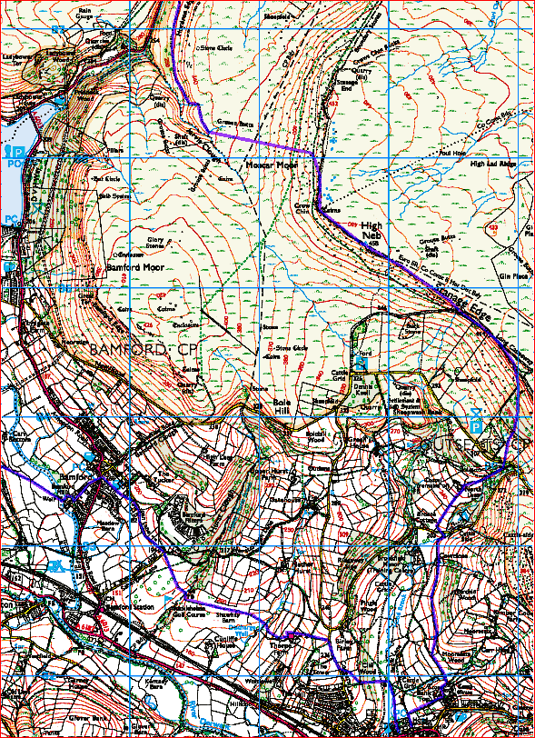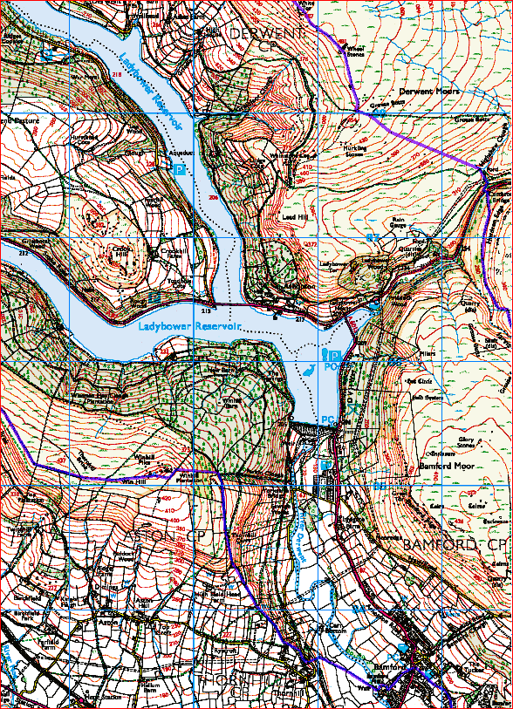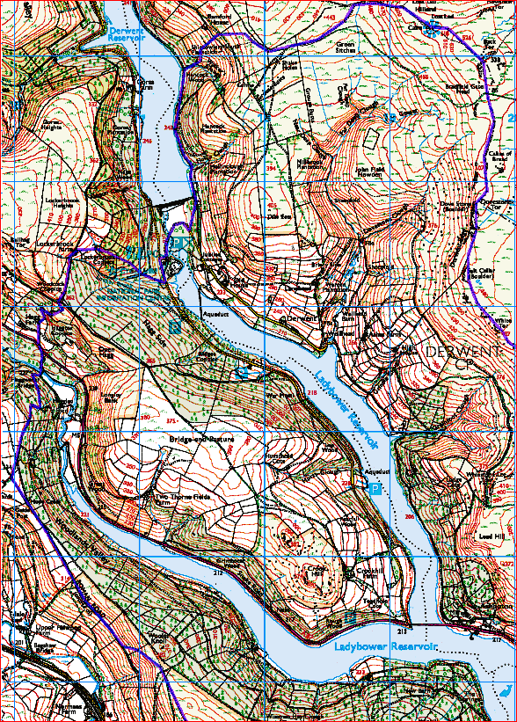

Day 4: Castleton – Monday 31st August – 10:00am – 14 miles – Circular walks

The walk starts from the large carpark in Castleton, just 6 miles west of Hathersage. From here it’s straight up onto Hollins Cross and along the ridge to Mam Tor with good views over the vale of Edale and Hope valley. We then head into the Dark Peak District towards Kinderscout but before reaching it, descend Jacob’s Ladder on the Pennine Way to Upper Booth and Edale for lunch. In the afternoon we cross the vale and rise onto Backtor to reach the panoramic view of Lose Hill. Then descend back into Castleton for tea in a café before the homeward journey.

Explorer Map 0L1 Grid Ref: SK 149 829 Postcode: S33 8WN
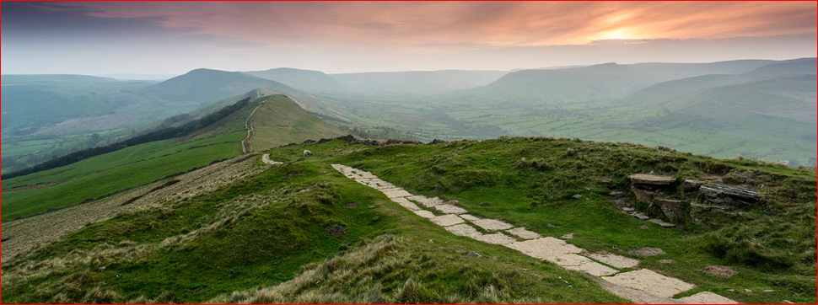 The Great Ridge from Lose Hill across Mam Tor
Castleton prospered from lead mining; the Odin Mine, one of the oldest lead mines in the UK, is situated a mile west of the village. Researchers studying an ice core from a Swiss glacier have found that levels of lead air pollution across Europe between the years 1170-1216 was as high as during the Industrial Revolution, and the principal source was Peak District mines. Mining created and enlarged local caverns, four of which are now open to the public - Peak Cavern, Blue John Cavern, Speedwell Cavern and Treak Cliff Cavern. Castleton is overshadowed by Mam Tor which has a late Bronze Age, early Iron Age hill fort. Radiocarbon analysis suggests occupation from around 1200 BC. There are remains of two Bronze Age burial mounds, one just below the summit and the other on the summit, though now buried under the paving.

Parking Information:

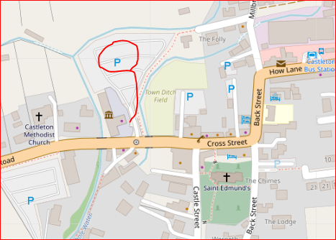
Meet at Castleton Visitor Centre which is 6 miles west of Hathersage on the A6187. Parking all day is £5.

Start Time 10:00am
From Castleton Visitor Centre
S33 8WN

