2026 6th HANNINGTON EVENT REPORT
On a rainy day on February, 5 marshal and a dog set of to do the marshals walk, By the time they reached the first checkpoint at Broughton they looked like drowned rats, and with no sign of improvement in the weather I made the decision to abandon the walk and transported them back to the start. I would like to thank Karen, Phil, Gill, Norman, Jim and dog for at least trying to the walk Marshals’ walk.
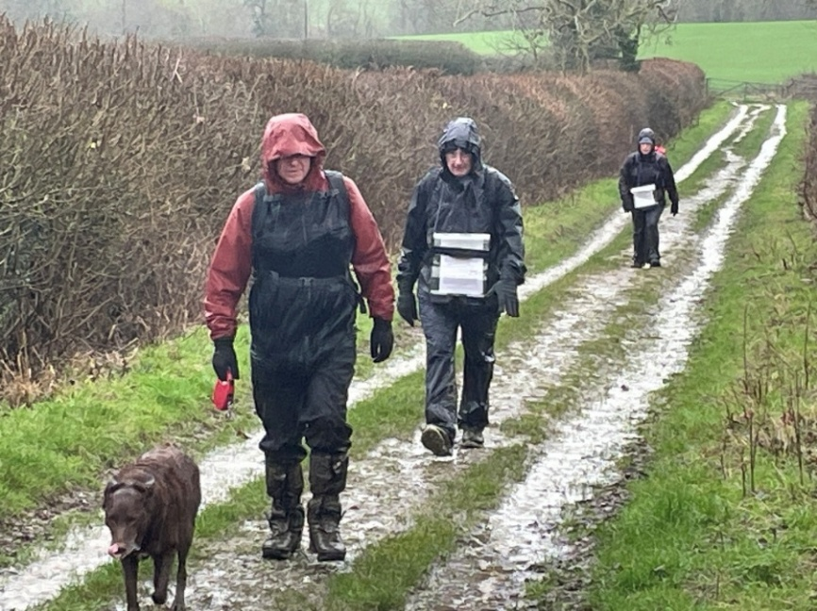
On the day of the event the weather was better, but it was still wet and slippery under foot in places.
I had two new checkpoint leaders, thanks to Andy Hoddle and Jane Bayes. Jane stepped in at short notice. I would also like to thank all who helped before and on the day.
HQ booking in and Kitchen.
Karen and Phil Vidler, Liz Sheffield, Merrian Lancaster, DFH, Dave and Lynn Yoston
Car Parking
Steve Clarke, Mike Hyland, Phil Vidler Norman Corrin
Checkpoint 1 (Broughton)
Andy Hoddle, Norman Corrin, Chris Bent, Jim Blakelock,
Gill Bunker, Sophie Butler, Tina Gatt
Checkpoint 2 (Hannington)
Jane and Graham Bayes, Rob Struthers, Mike Hyland, Angela Standcombe
Checkpoint 3 (Holcot)
Terry Brown, Frank Hodgson, Roy Carter, Val Thompson,
Jim Robinson, Graham Dolby, Nick Emery

We had 275 people entering, with 42 cancelling before the day. Of the 233 we were expecting on the day 224 showed up and started their chosen route. 152 started the long route (26.6) and 73 the short route (15.5), all finished although 2 were classed as DNC as they arrived early at CP3 and chose not to wait.
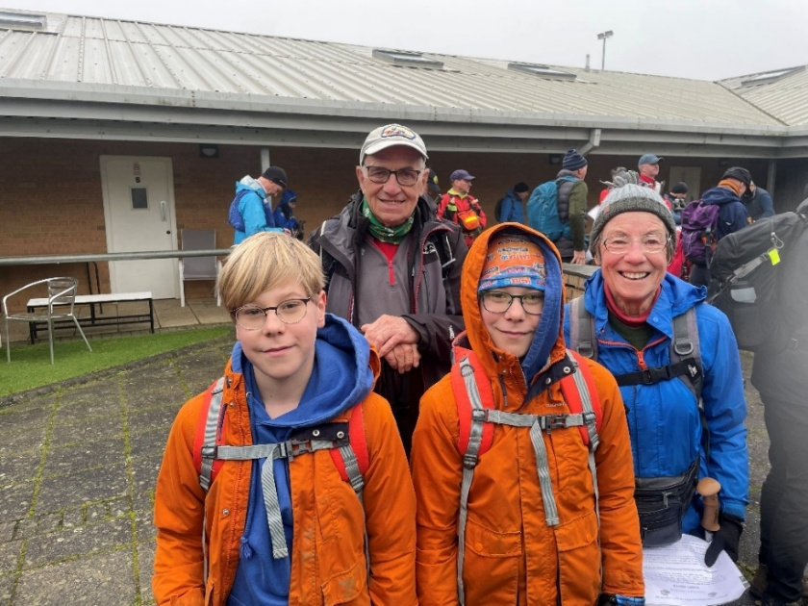
This is the 2 oldest and 2 youngest walkers
Jill Green (84), Jim Catchpole (83) and Twins Isaac and William Mace (11),

The average age was 57.1 years old, the oldest being 84 and the youngest being 11

Hannington Hike comments
Thank you (and to the team) for running the event on Sunday. Had a really good day out, and thanks to all the upbeat marshals from start to finish for making me so welcome.
Just about got my extensive collection of Northants mud off my shoes by now.
Best wishes and thanks again for organising the Hannington Hike,
Ric
----------------------------------------------------------------------------------------------------------------
A great day on the Hannington Hike, mostly grey all day but we all enjoyed ourselves, good food excellent bread pudding by Jane at cp2 and the mud was fun. Nice one BBN
Steve Clark
----------------------------------------------------------------------------------------------------------------
Thanks to everyone involved with today’s Hannington Hike. My first BBN event and it was brilliant. There was so much food, the stew at the end was delicious. Can’t wait for my next event
Becky Wheaver-Clarke
----------------------------------------------------------------------------------------------------------------
Where was all the mud BBN?!?!? After last week’s muckfest in sumptuous Shropshire I promptly booked both Jason and myself onto LDWA BBN’s Hannington Hike, stating that he hadn’t seen mud ‘til he saw Bedfordshire mud. Weeeeeeeeellllll, somebody has shovelled it out of the county, and I think he thinks I’m just making things up now!
And as there was at least 60% less muddage in the fields I found myself DQ’ed for the first ever time in my life for reaching and leaving the final CP before it was officially open. All in the nicest way though, this is the LDWA after all and I am happy to accept my persona non grata status , it was worth it to pet tiny lambs at the many, many stiles.
Jason completed his 15 miler perfectly, collecting his certificate and patch and fell in with another walker in the final miles who had an ‘ah ha’ moment and told him ‘oh, you’re Sara Fabien’s husband’…this has pleased me greatly and I might get him a badge made up for future challenges .
Once again, a flawless event, brilliant Marshalls and amazing trail companions, even the weather played ball.
Thank you LDWA, you are slowly restoring my mojo for all things outdoors
Sara Fabien
----------------------------------------------------------------------------------------------------------------

I would just like to thank all the marshals and organisers of Sundays Hannington Hike. This was my first time on the ‘Hike’ and it won’t be my last.
Was lovely to have all checkpoints indoors, great food, lovely smiley and helpful marshals, and a well written route description. Loved the short paragraphs with mile markers - makes life a lot easier while trying to navigate, stay upright and keep track.
Thank you to all at BBN.
Heidi Miller
Essex and Herts
----------------------------------------------------------------------------------------------------------------
Shame it was such a grey day for the Hannington Hike but those taking part looked to have enjoyed it! Marshalling was a new one for me but think I’ll be back - CP1 was the place to be.
Tina Gatt
-------------------------------------------------------------------------------------------------------------
A shorter event than some, perhaps... and yet my legs were still sore a few days afterwards.
Simon Pipe
----------------------------------------------------------------------------------------------------------------
Maria Pali
How about this one from The Hannington Hike at the weekend? Walkers enjoying the mud

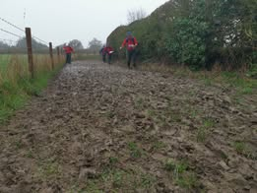

2026 Hannington Hike Accounts
INCOME |  |  |  | EXPENDITURE
 | SiEntries |  |  | Payment to |  |  | Amount
Date |  | Amount |  | Old Grammarians |  |  | £525.00
19.12.25 |  | £595.00 |  | Broughton Village Hall |  |  | £52.00
16.01.26 |  | £292.50 |  | Hannington Village Hall |  |  | £39.50
06.02.26 |  | £837.50 |  | Holcot Village Hall |  |  | £66.60
20.02.26 |  | £229.50 |  | the Print Works |  |  | £72.00
13.03.26 |  | £535.05 |  | Van + Fuel |  |  | £197.01
 |  |  |  | Catering |  |  | £746.12
 |  |  |  | Travel Expense |  |  | £86.06
TOTAL |  | £2,489.55 |  |  |  |  | £1,784.29
 |  |  |  |  | Donation to Air Ambulance |  |  | £176.00
 |  |  |  |  | TOTAL |  | £1,960.29
 |  | Income TOTAL |  | £2,489.55
 | Expenditure TOTAL |  |  | £2,136.29
 |  | SURPLUS |  | £353.26

The donation to the Air Ambulance comes from all those who cancelled and did not ask for the entry fee to be returned.
The next Hannington Hike will take place on Sunday March 5th, 2028. It will be from a new start venue with two new routes; I would like to thank Steve Clarke for offering to help me run the Hannington Hike.

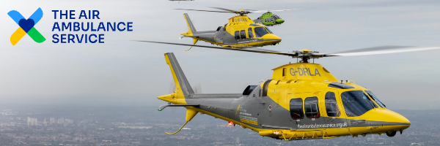

Thank you for your donation James.
Thanks to your generosity, we’re able to reach people in their most critical moments. Our skilled doctors, paramedics and pilots are delivering life-saving care to patients wherever they are and whatever their need – from remote locations to town centres, road traffic incidents to cardiac arrests.
None of it would be possible without you.
Your support means we can keep flying, rescuing, and providing advanced treatment, so that no one is ever too far from urgent care when they need it most.
People like you in our local communities are the heart of our mission. Thank you for standing with us.
Your donation details:
Donation ID | 976485
Donation type | single
Donation amount | £176
Donation date | 16 / 03 / 2026
Method | Credit/Debit Card
Gift Aid | Opted out
Marketing Preferences | None selected
If you have any questions about your donation, do not hesitate to contact us at info@airambulanceservice.org.
With warmest wishes,
The Air Ambulance Service

