THE GREENSAND RIDGE WALK IN A DAY
SATURDAY 10TH JUNE 2023
INFORMATION SHEET

Leighton Buzzard
The coach will leave Leighton Buzzard Railway Station forecourt at 5.45 am prompt.
The station address is Station Approach, Linslade LU7 2LY.
We will be travelling with Bill’s Coaches.
Parking at the station There are three car parks, all adjacent to the station (see map).
They all cost £6.90 for the day on Saturday. They are all cashless. See image below for payment methods. Note make sure you park in the parking area you have paid for
see leighton buzzard station parking
If you park elsewhere, please leave ample time to walk to the station.
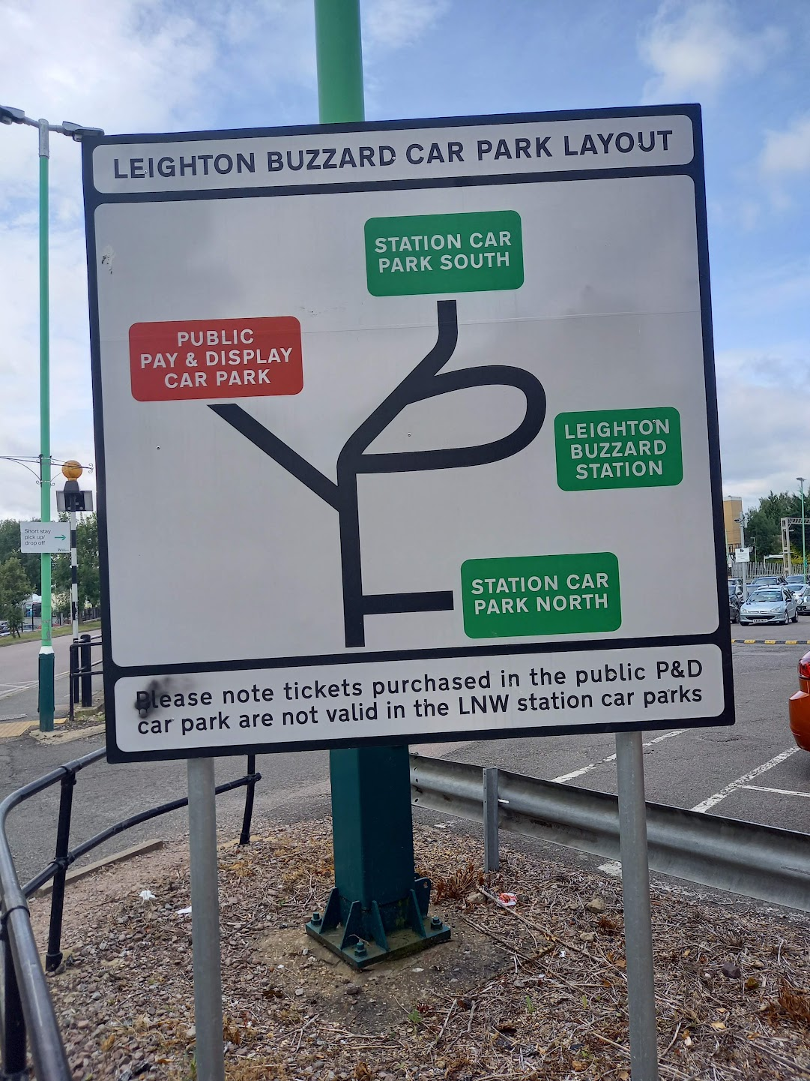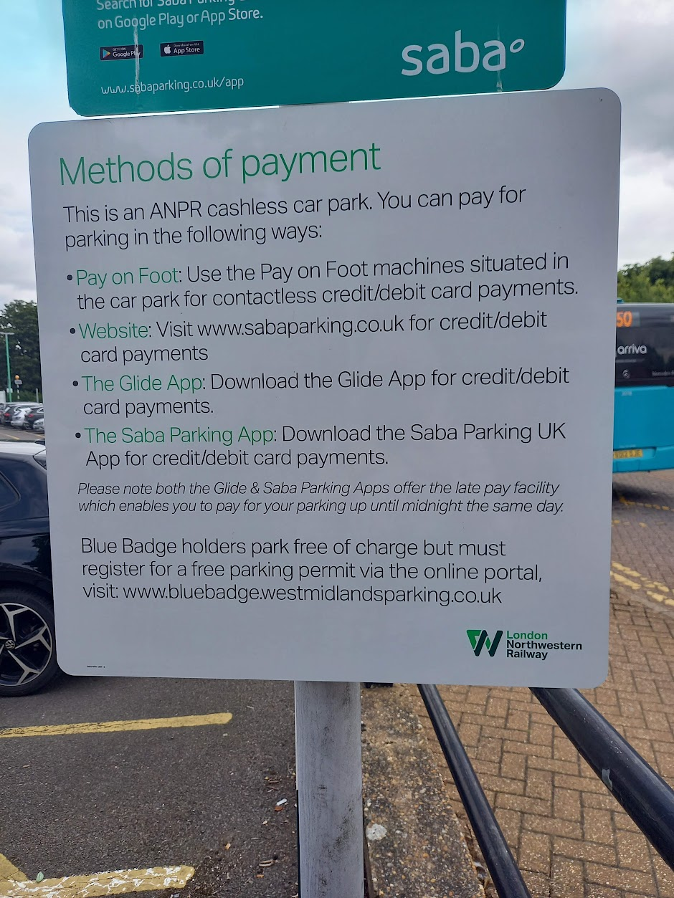

Walk Start: Gamlingay (GR TL 227 532)
Please be ready to start walking as soon as we leave the coach.
GENERAL INFORMATION
Please bring your own mug.
You will also need a torch/head torch.
As is usual on LDWA walks, we advise that you have your In Case Of Emergency sheet/card with you - please make sure that it's up to date. We also recommend a small personal first aid kit be carried, together with a survival bag/space/foil blanket.

Maps that cover the walk Landranger 153 and 165 Explorer 192, 193 and 208.
We’re walking east to west. A series of leaflets covering the walk (numbered from west to east though) and a gpx file can be downloaded from the LDWA website here Greensand Ridge Walk - LDWA Long Distance Paths
We will be adopting a 7 stop strategy with 2 indoor stops (8 miles and 21.6 miles}
You will be able to top up your water at every stop.
There are toilets at the two indoor stops.

Stop | Cumulative Distance | Approx Arrival/  Length of stop | On Offer
Northill Church Hall  (Indoor)  Sand Lane, Northill | 8 ml | 9.20am  Length of stop 30 mins | Hot/cold drinks  Walkers’ pre-chosen choice of bacon/veggie sausage roll,  as well as cereal bars, bananas
Support Point  A600 Road Crossing  (nr Haynes)  (Outdoor) | 12.8ml | 11.15 am  Length of stop 10 mins | Cold drinks.  Selection of snacks including  Crisps/Cheddars/  Flapjack/choc bars/jelly babies/mint imperials
Support Point  A6 Road Crossing  North of Clophill  (Outdoor) | 18.0 ml | 1,15pm  Length of stop 10 mins | Cold drinks.  Selection of snacks including  Crisps/Cheddars/  Flapjack/choc bars/jelly babies/mint imperials
Ampthill  (Indoor)  Ampthill Town Football Club Woburn Road, Ampthill  MK45 2HX | 22.3ml | Approx arrival 3pm  Length of stop 45 mins | Hot/cold drinks  Walkers’ pre-chosen choice of food –  Including sandwiches/dessert/fruit/snacks
Support Point  Ridgmont – Segenhoe Old Church  (Outdoor) | 27.7ml | 5.40pm  Length of stop 10 mins | Cold drinks.  Selection of snacks including  Crisps/Cheddars/  Flapjack/choc bars/jelly babies/mint imperials
Woburn Car Park  (Outdoor} | 33.0ml | 7.40pm  Length of stop 20 mins | Hot/cold drinks  Sandwich pack - walkers’ pre-chosen choice, as well as other snacks
Support Point  Brickhill Road Nr Heath & Reach  (Outdoor) | 37.2ml | Length of stop 10 mins | Cold drinks.  Selection of snacks
FINISH  Leighton Buzzard canal bridge (Tesco) | 41.8 ml | ETA 11pm

It is about half a mile from the end of the Greensand Ridge Walk to Leighton Buzzard station.
Certificate A commemorative certificate will be emailed to all walkers after the event.

Mobile phone numbers on the day:
Gill 07790 976090 Start and walking
Terry 07932 627476 Support Team + leading Woburn to Leighton Buzzard
Norman 07980 378656 Support Team
Mary 07554 661519 At Ampthill
Sarah 07925 849281 At Ampthill

