NORMAN’S VIRTUAL CREAM TEA WALK – 13th/14th June 2020
The Challenge:
Well folks it would have been one of the social events of the year if Mr Covid hadn’t got involved. That’s right, it would have been my Cream Tea walk.
As we’ve just had a virtual Fellsman and a virtual 100, Mike Hyland suggested to me about having a virtual cream tea walk. Thus, the idea was chewed over so to speak with Gill and the plan is as follows.
For this weekend either Saturday or Sunday why not share a photo with us of the food you’re taking on a walk. If you can manage to bake a cake and take some with you on a walk (or just eat it in your garden….) or buy an ice cream from a van then the nearest to a cream tea wins!
BAKE CAKES YOUR BBN NEEDS YOU……..
Norman Corrin
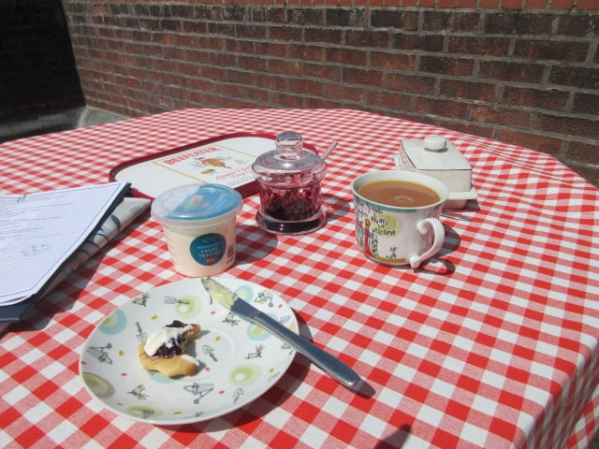 | Merrian Lancaster:  Dave’s the baker in our family, but he couldn’t be persuaded to make scones. I wasn't going to join in, but the next thing on the list was weeding, so I decided to have a go this morning.  My bag of self-raising flour was unopened, from Sainsburys, June 1984, price 35p. My oven doesn’t have a thermostat. You won't be surprised to hear that I have biscuits. Straight from the oven, plenty of butter, Dave's jam and some crème fraiche and they taste OK with a good cuppa. I could pretend I intended to make biscuits.

Steve & Pearl Smith:  We did a walk from Longnor which is on the Staffordshire side of the Peak District. No cream tea but we did have raspberry sponge cake. |  | 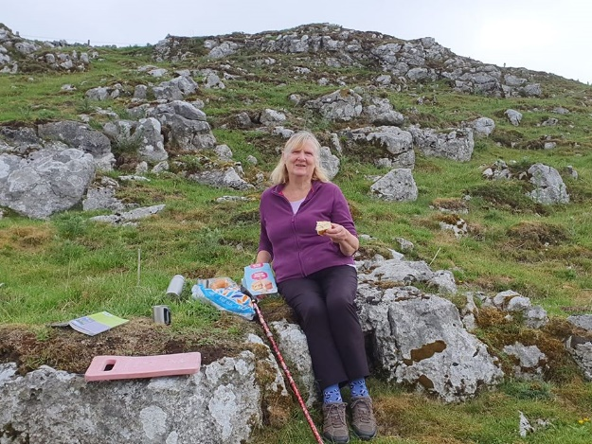
 | 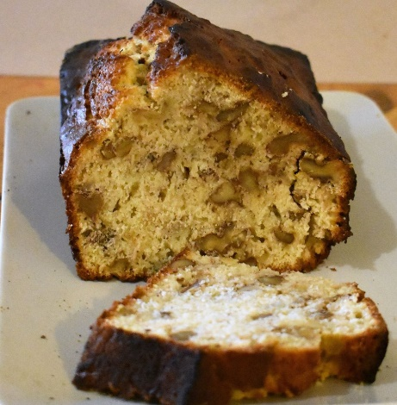 |  | Brian Graves:  Basic Banana and Walnut loaf for me. Finished my version of the Ouzel Valley walk and sat by the confluence of the Ouse and Ouzel (Lovat) at Newport Pagnell and enjoyed a slice of my cake.
Graham Busch
Paul Keech and myself walked the Sundon Saunter, 12 mile route though we didn’t have a cream tea we did stop at Harlington Church and enjoy a jolly nice piece of my Mother in Law’s delicious fruit cake.
Great idea. Any other food related walk ideas?
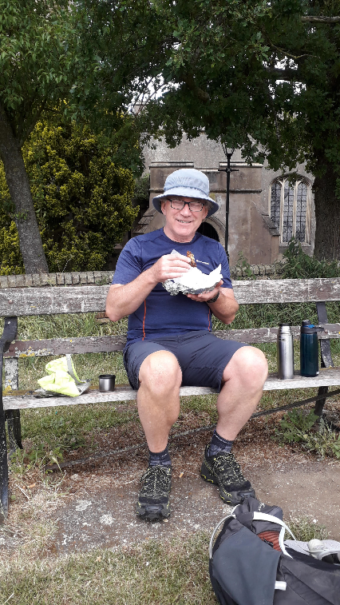 |  | 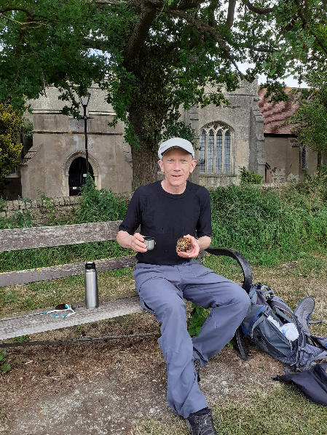
Norman Corrin:  Not sure if Norm can win his own competition but he gets a Gold Star from the four of us who enjoyed the delicious cream tea he laid on after our walk around Milton Keynes today. All socially distanced of course. |  |  | 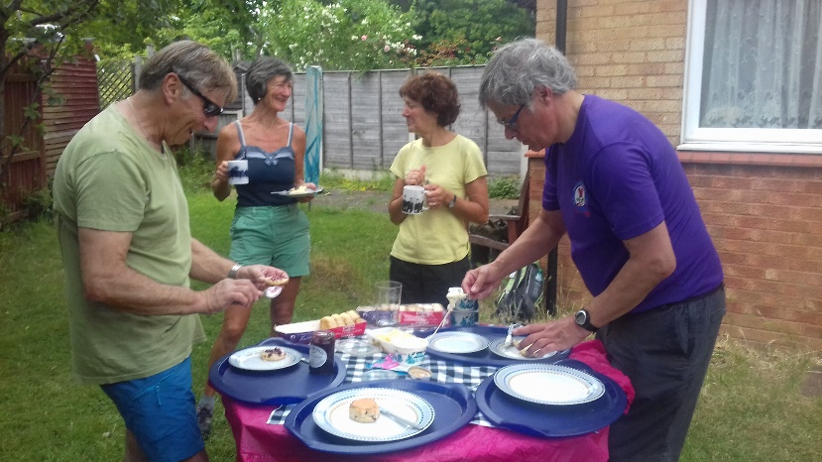
Alan Leadbetter:  No cream tea,  but I did bake a few cakes. |  |  | 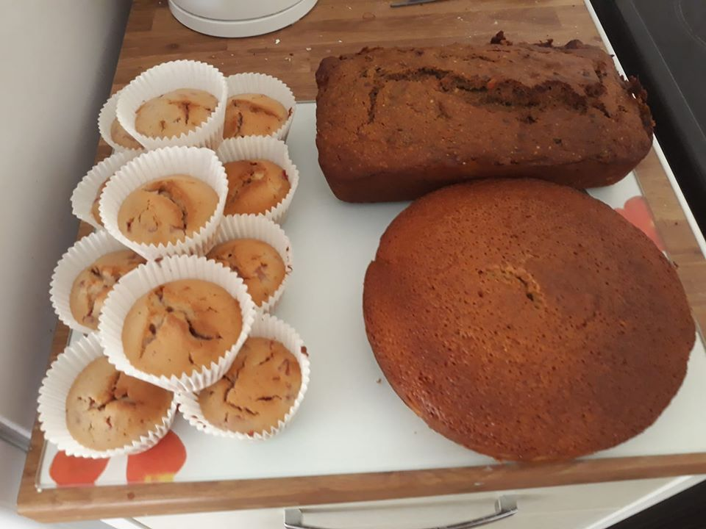
R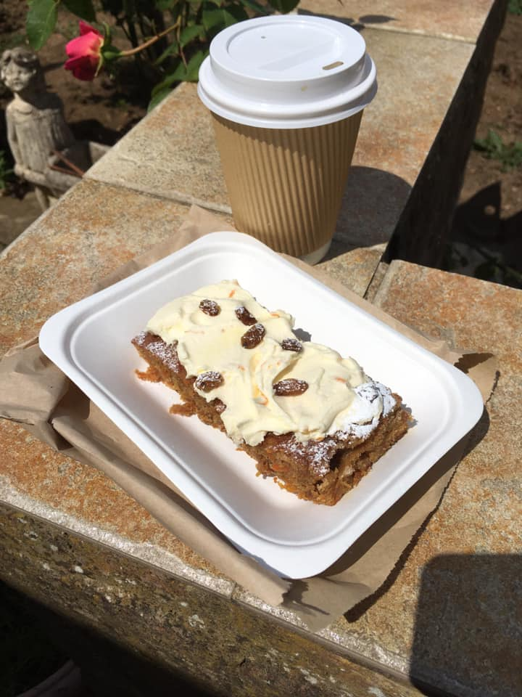 |  | Liz Sheffield:  Sometimes things don’t go exactly to plan. No scones! But freshly baked carrot cake will do nicely thanks.  Fine bone china cup and saucer?  Less Royal Doulton and more royal polystyrene. Still very enjoyable.

Lizzie Bridge:  To earn my cream tea, I did a 10k run from home, to and then around Belfairs Woods. Very hot to be running and so the shade was most welcome, although I seemed to be going slightly up hill, all the way round! Must remember to go in the other direction next time. 😂 Then walked the 3k home. 😋 Yum yum 😋 | 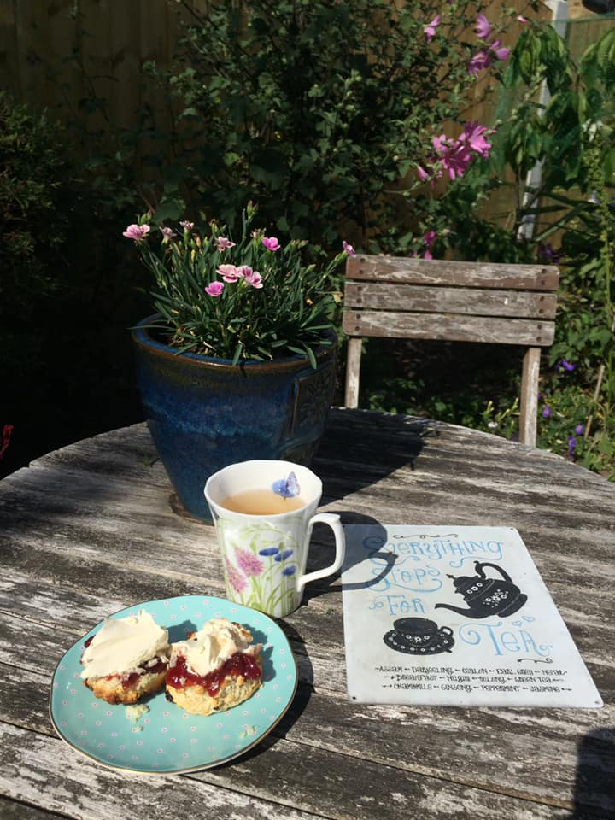

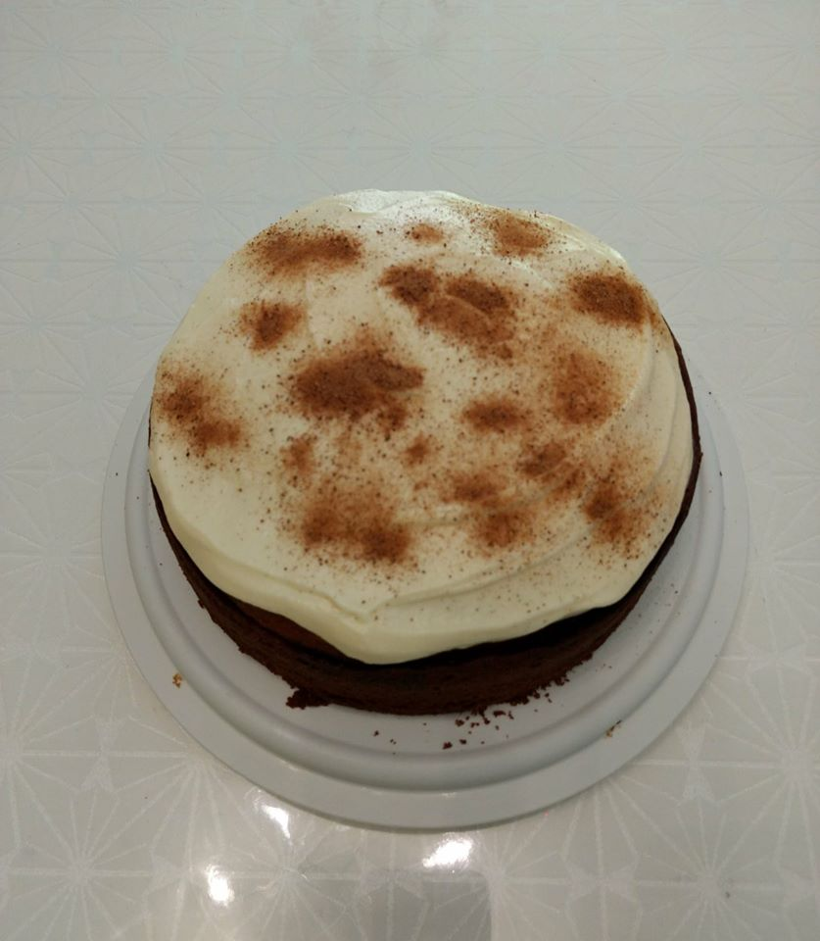 | Sue England:  My cream tea walk was in a couple of local parks followed by spiced latte birthday cake for hubby. It has a whipped cream with vanilla custard topping, spiced with rum and nutmeg.

Rachel & Victorial Martin  and Gill Bunker: | 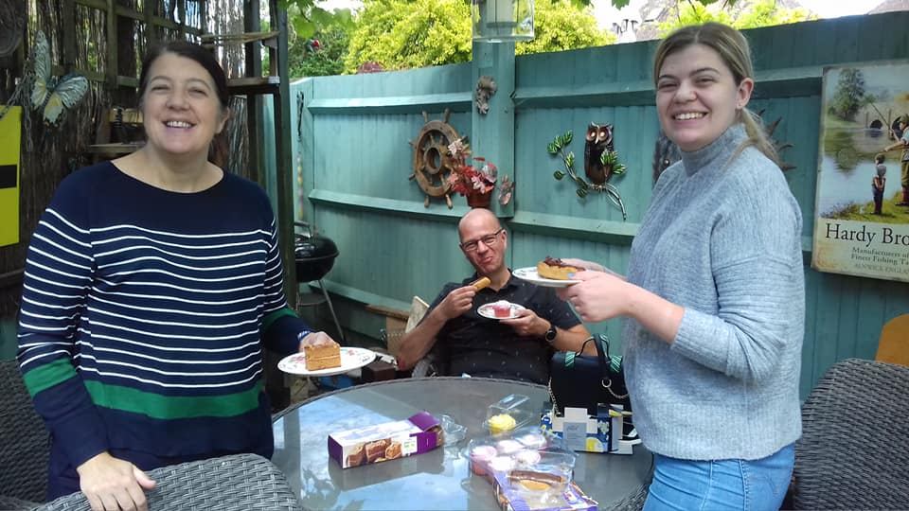
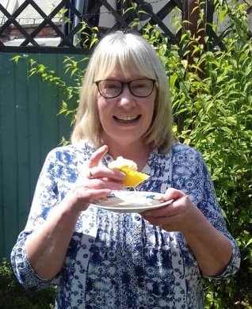

Terry Brown:
Well ... my cream tea walk involved baking some scones then walking to Morrison’s in Shefford in search of the real Cornish clotted cream - Rhoddas - and I found some! There were 2 or 3 tubs lurking up the back of a shelf almost completely hidden by pots of whipping cream.
And here it is - savoured in the garden accompanied by Russell, who never says no to a cream tea! (We were very strict and rationed ourselves to 1 scone each because were having a Shefford Tandoori takeaway a little bit later!!!)
Lovely!
I think mine is the Devonshire way of doing it - jam on cream?

 | 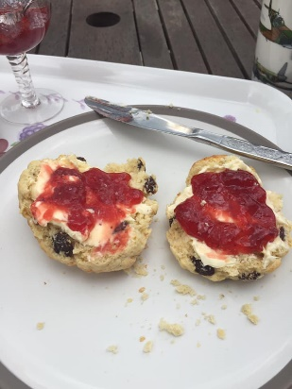
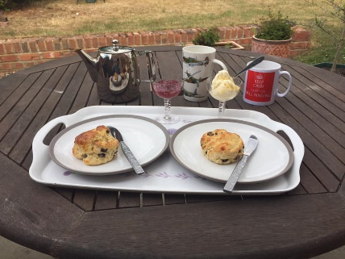
Sara Waldron:  Cream tea?  Don't mind if I do !! | 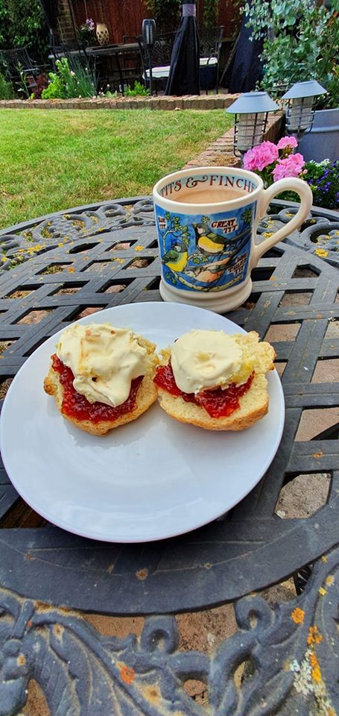
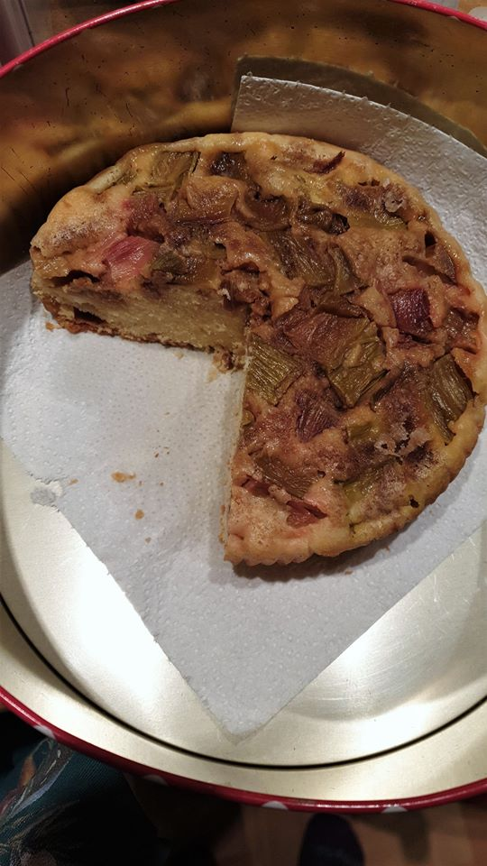 | Jackie Burnett:  No scones & cream for me, but a slice of birthday cake and upside-down rhubarb cake were welcome after a lovely 19 mile walk.
 | 