BBN Benches on the Greensand Ridge – the original project

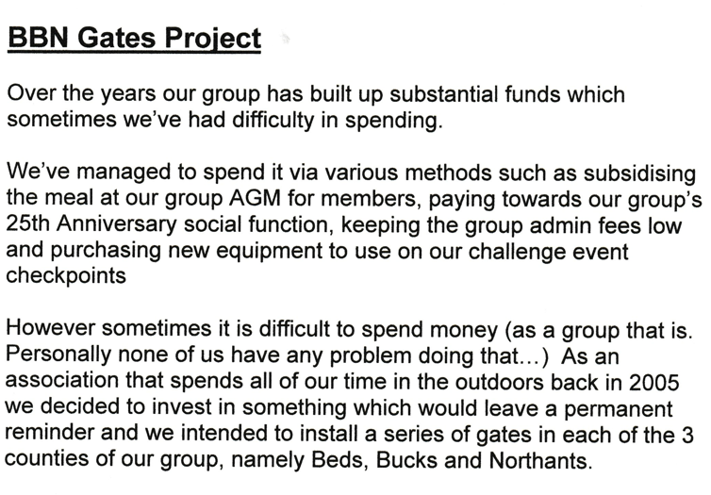

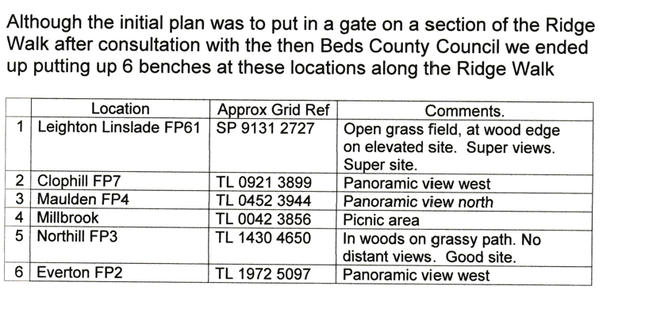

**Norman Corrin**