 | LONG DISTANCE WALKERS ASSOCIATION  BEDS, BUCKS & NORTHANTS GROUP  NOMINATIONS FOR 2026/2027 COMMITTEE | 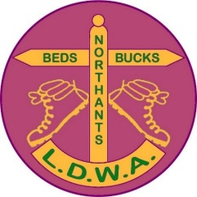

Position | Nominee | Proposer | Seconder
Chair | Sarah Feal | Steve Clark | Nick Emery
Secretary | Nicky Cahuac | Jim Blakelock | Sarah Feal
Treasurer | Jim Blakelock | Steve Clark | Nick Emery
Member (Walks Secretary) | Tina Gatt | Jim Blakelock | Chris Johnson
Member | Dee Brockway | Sarah Feal | Chris Johnson
Member | Terry Brown | Steve Clark | Jim Blakelock
Member | Roy Carter | Chris Johnson | Tess Harker
Member | Sara Waldron | Steve Clark | Chris Johnson
Member | Tess Harker | Jim Blakelock | Nick Emery
Member

