LDWA : BEDS BUCKS & NORTHANTS GROUP
MINUTES OF ANNUAL GENERAL MEETING
SUNDAY 24TH NOVEMBER 2024 AT 2.30 PM
LAVENDON VILLAGE HALL, 22 HIGH STREET, LAVENDON, MK46 4HA
The meeting commenced at 2.40 pm
Present: 28
Francoise Bannister, Jim Blakelock, Ian Bradley, Jane Bradley, Dee Brockway, Terry Brown,
Gill Bunker (Secretary), Roy Carter, Steve Clark, Norman Corrin, Sarah Feal (Chair),
Dave Findel-Hawkins, Phil Friede, Bob Hillier, Mike Hyland, Daniel Jamin, Therese Jamin,
Merrian Lancaster, Brian Layton, Alan Leadbetter, Jane O’Dea, Roger O’Dea, Val Thompson, Karen Vidler, Phil Vidler, Sara Waldron, Dave Yorston, Lynn Yorston

Sarah welcomed everyone to the meeting, and thanked Father Ambler for organising the lunch and the meeting. She said it is hoped the cancelled walk will be rescheduled for June next year.
1. | APOLOGIES  Anne Addison, Chris Burns, Nick Emery, Pete Engledow, Sandra Hyland,  Adrian Moody
2. | MINUTES OF THE 2023 ANNUAL GENERAL MEETING AND MATTERS ARISING
 | The Minutes had been available on the website and it was agreed they could be taken as read. They were approved as a true record. Proposed: Norman Corrin, Seconded: Merrian Lancaster and AGREED unanimously.
 | Matters Arising:
Sarah said there was one matter arising.
Following a member’s suggestion that a further donation be made to the North Bucks rRIPPLE, it was proposed at the 2023 AGM that we look to Beds and Northants for future donations. Gill confirmed she had been in touch with members in both Beds and Northants, but there had been no immediate suggestions for a donation. It was, however, then decided at the January 2024 committee meeting to delay a decision about the making of any donations until the impact of the new travel expenses scheme on group funds was known.
3. | REPORTS
 | Sarah confirmed to the meeting that the reports covered the reporting year 1st October 2023 to 30th September 2024. It was agreed that all reports would be taken as read as they had been available to read on the website.
(a) | Officers’ Reports
 | (i) Chair Sarah Feal
As the Winter Solstice approaches and the nights grow longer, ‘Hygge’ [Hooga] is in order to look after our health and wellbeing during the shorter days.

Thank you
This report looks back at the activities the local group has undertaken throughout the year, which wouldn’t be possible without the volunteers who have dedicated their time and energy to plan and organise these. Thanks to everyone who has participated in any way in a group activity or event and for your support in the last year.

The Committee
Overseeing these activities is a committee made up of 10 volunteers. Alongside myself, Sarah Feal (Chair), I am supported in the role by Francoise Bannister (Treasurer), Terry Brown, Gill Bunker (Secretary), Chris Burns, Roy Carter, Nick Emery, Pete Engledow, Mike Hyland and Sara Waldron. The committee is also supported by other volunteers who have generously donated their time to plan and check routes, lead walks, ensure event safety and most importantly to keep everyone nourished. I extend my thanks to them all for their support.

Committee Meetings
The committee met three times during the year, and continued to hold these online through the use of teleconference facilities. The committee has recently agreed to change its current provider to reduce the licence fee costs.
Regular items for discussion included:
- New members discussion
- Treasurer’s report
- Challenge events and social walks update
- National Executive Committee updates
- Charitable donations, and
- Key policies and event safety.

Detailed reports have been written by those directly involved in specific aspects of the local group’s activities during the year and are also available on the website.
My heartfelt thanks to Gill Bunker for her efficient organisation of the committee, and for the high-quality secretariat support she provides.

Governance
In August 2023, the National Executive Committee issued a draft Model Constitution to be adopted by local groups. A working group was formed with Terry Brown, Gill Bunker and me and together we looked at the details and agreed through the committee the final version on the agenda today.
Francoise Bannister has supported the transfer of the Bank account, which will bring us in line with our new Constitution requirements and has improved the processing of payments.

Health & Safety
Terry Brown and Sara Waldron have also reviewed and improved first aid safety, to replenish out-of-date stock, and to improve first aid incidents so they can be dealt with quickly and efficiently if the need should arise.
Please remember to bring your ‘In Case of Emergency’ details on all walks.

Group Holiday
Thanks again to Roy Carter for another memorable group holiday in Ilfracombe, Devon, and photos are available on the website of their adventures. Plans for next year’s holiday are already in train and it is expected to be Weymouth from 29th August to 1st September, so save the date in your diaries now.

Volunteer Walk Leaders Needed
The group now has 529 primary and 478 associate members, making a total of 1007 individuals linked to our local group, yet despite this we have seen there has been a reduction in walk leaders volunteering to lead events in the past year. This could be for a number of reasons that we would like to understand, but the group needs new volunteers to come forward for it to thrive.
If you feel you would like to lead a walk, but are not sure of what is involved please come forward and speak to one of us. Full support and coaching will be given, and we have many years of experience and knowledge between us.

Challenge Walks
The local group has held 3 successful challenge events throughout the year, the Steppingley Step (November 2023), the Hannington Hike (March 2024) and the Pick & Mix (June 2024). The full event reports are available on the website. Thank you to this year’s event organisers, Dave Findel-Hawkins, Mike Hyland, Alan Leadbetter, and Dave and Lynn Yorston.

40th Anniversary Celebration
The final anniversary celebration was held this year with the delayed Knightley Way and Grafton Way finally navigated and led by Dave Findel Hawkins with support from Merrian Lancaster.

Donations
Since the last Annual General Meeting, the group has made donations of £100 to the East Anglian Air Ambulance from the 2023 Steppingley Step, and £200 to the Thames Valley Air Ambulance from the 2024 Pick & Mix.

Santa Walk
And finally, word has it from Santa’s helper that he is planning to visit us on 8 December, and is very much looking forward to hearing us all sing.

So keep well and I look forward to seeing you all out on a walk soon.
 | (ii) Secretary Gill Bunker
Looking back over the past year, it’s been another busy but enjoyable 12 months to report on, although the gaps in our walk programme during the latter few months have been disappointing.
- Tuesday News circulated nearly every week, keeping members updated throughout the year
- Emails from the NEC: Circulated and responded to as necessary
- We’ve continued to use Zoom for this year’s committee meetings (now changing to Microsoft Teams)
- I’ve attended the first two of the NEC’s bi-monthly group meetings, which have been interesting and worthwhile. There are no final decisions yet. The next meeting is in January.
The main items:
Reviewing the LDWA’s social walks policy with an emphasis on striking a balance between the time and effort it takes to organise a walk and safety aspects
Walks register – mandatory/best practice? A register confirmed not to be mandatory from an insurance point of view. Data Protection aspects are being reviewed.
Recces are covered by insurance.
Documents In the Tool Kit will be simplified – with a “safety checklist” rather than a risk assessment
Walk Leader Support and Development Still an ongoing project, so little discussion about this – to help novice leaders, and a chance for seasoned leaders to share their knowledge and advice about leading. Will be entirely voluntary.
- BBN website kept updated with photos from group walks and challenge events, plus event information, route descriptions, gpx files and finishing times etc
- Total Membership as at 30th September 2024 was 991 (Primary 523 and Associate 468)
- New members’ contact information sent to Dee each week. Dee then makes a welcome phone call/sends a welcome email to the new members
 | Gill commented that the new format of bi-monthly Zoom meetings with local group officers and NEC representatives was proving very successful. There have now been two, with the LDWA’s updated social walks policy being one of the main topics.
 | Gill said there had been 85 new members between the two AGMs and said what a great job Dee was doing to welcome them by a phone call and/or an email.
New members: Dee Brockway
Dee said she had contacted a total of 121 new members, and commented that she thought this was a very worthwhile thing to do. She had found that many new members were runners who had joined the LDWA to get early entry into relatively cheap events. She felt it was still useful to welcome them as they may well transition later to walking with the group.
 | (iii) Treasurer Francoise Bannister
The Accounts have been prepared for the period 1 October 2023 to 30 September 2024.
Total account balance on bank as of 30 September £6,143.44 (current balance is £6,503.20).
Our revenue consists almost entirely of contribution/profits from our challenge events; well done one and all. Principal expenditures outside event expenses (incl. Marshalling) are the following

.
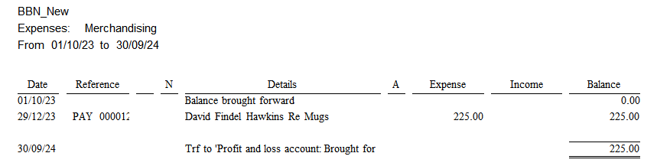
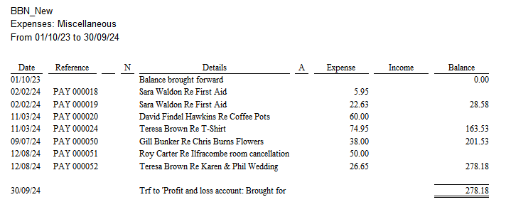
Donations made from our bank account during the year were:
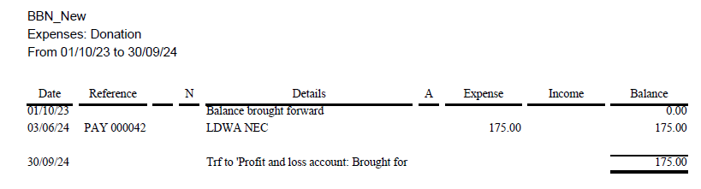

These correspond to the “entry fee differential” between LDWA members and non-LDWA members for the Hannington Hike.
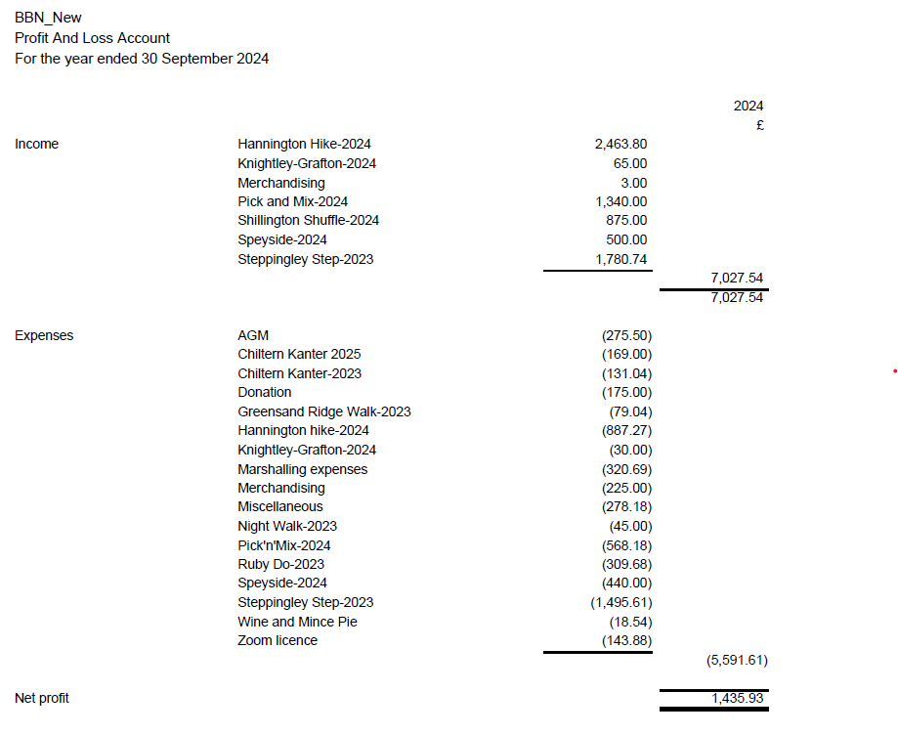

SURPLUS/ (DEFICIT) FOR YEAR £1,435.93
Note: SS events’ income is spread over two accounting period.

As always, suggestions for how we use our funds are always welcome by the committee.

The accounts have been checked by Dave Yorton, independent examiner for BBN, and found to be in order. They will be signed if approved by the AGM.

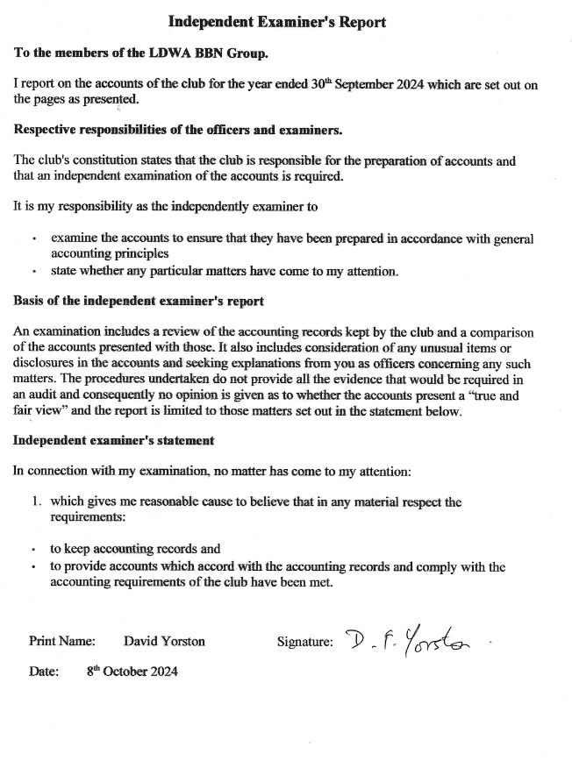

 | Francoise reported a healthy bank balance, with a surplus for the year of £1,435.93. Most of the group’s income comes from the surplus from each of our challenge events. Francoise drew attention to the Shillington Shuffle; as the event is held in November the figures are spread over two financial years.
 | Francoise said the group’s bank account had been changed earlier in the year to a Lloyds account which offered double signature authorisation, and a finance sub-committee had been set up (currently Francoise, Sarah and Gill as the three group officers). Both these changes were implemented in order to keep BBN in line with the LDWA’s new Model Constitution.
 | Francoise confirmed there would be a £15 contribution to the cost of the AGM meal which could be collected at the end of the meeting.
 | Phil Friede thought the balance of £6,500 was perhaps too much? Sarah said the committee were always looking for ways to use group funds and regularly asked the membership for ideas for projects and donations. She confirmed two donations had been made to local Air Ambulances during the past year. Gill said there were already plans to walk LDPs in our area in 2025 using minibuses, which would be subsidised.
 | Proposal to Accept the Accounts
 | Proposed: Merrian Lancaster, Seconded: Brian Layton and AGREED unanimously.
(b) | Other Reports
 | (i) Challenge Walk Co-ordinator Mike Hyland
Chiltern Kanter 2025:- Flyer is done, and is on websites (BBN and LDWA), is also on SiEntries to go live on the 1st December for LDWA members, then for all from 2nd January 2025,
Pick & Mix 2025:- Flyer is done, and is on websites (BBN and LDWA), will be in the December issue of Strider and is on SiEntries in demo mode to check out, will go live on the 1st March 2025 for LDWA members, then for all from 1st April 2025.
 | (ii) Social Walks Sara Waldron
We have had a varied programme of walks during the last 12 months. At times it has been difficult to get leaders but overall, I think that we are managing to put on more walks than many local groups.
We have completed the Northampton Round and walked the Grafton & Knightley Ways – thanks go to Dave Findel-Hawkins for leading these. Over a series of 6 circular walks we have completed the Outer Aylesbury Ring – thanks go to Trevor Jones for leading these walks. The Outer Aylesbury Ring attracted visitors from as far afield as Kent.
There would be no walks if we didn’t have such a dedicated group of leaders.
Here they are:
Dave Findel Hawkins Gill Bunker
Steve Clark Chris Bent
Jim Robinson Terry Brown
Alan Leadbetter Sara Waldron
Joe Leonard Jim Blakelock
Frank Jackson Dee Brockway
Therese Jamin Trevor Jones
Francoise Bannister Norman Corrin
Roy Carter McCorrin & McBunker
Sir Hikealot Donald The Reindeer

Going forward I’m hoping that we’ll be able to complete some more long distance paths next year, as we have so many going through our “patch”. Proposals for scoping out so far include The Aylesbury Ring, The North Beds Heritage Trail and The Jurassic Way. Please let me have any other suggestions.
 | Sara said planning was already underway for 2025, with group walks of LDPs in our area, using some of the surplus group funds to subsidise minibus travel. This was likely to start with the North Beds Heritage Trail and the Jurassic Way. She asked for other ideas of LDPs which the group could walk.
 | Walk Leader of the Year Award
 | Sara explained the introduction of the Walk Leader of the Year Award and said that this year’s winner was Trevor Jones who had led 6 walks based on the Outer Aylesbury Ring. These had proved popular with BBN and also with members of other groups. Trevor was unable to attend; Jim Blakelock will deliver the mug to him.
4. | Proposal to update the BBN Group Constitution (as circulated to members on 1st October 2024) in accordance with the LDWA’s updated Model Constitution for local groups.
 | Sarah explained the background to the proposed changes.
It is proposed that BBN make these changes to its constitution to bring it into line with the LDWA’s new Model Constitution for Local Groups. She said details of the new constitution highlighting changes from the current constitution were circulated to all members on 1st October 2024.
Sarah referred to the major changes:
- A finance committee to be formed (Sarah confirmed that at an earlier committee meeting this had been agreed to be the three Officers of the group, the Treasurer, Chair and Secretary).
- We needed to move to a bank account which allows dual authorisation – she confirmed that this has already been done with the move to the Lloyds Bank account.
- The quorum for both committee meetings and the AGM has been increased.
She said that after the draft proposed new constitution had been circulated to members, one member had made some suggestions for amendments. These suggestions had been passed to the NEC, but as they could possibly change the prescribed text of the Model Constitution, the NEC had decided to consider them in the context of a future update.
 | There were no questions or comments on the draft constitution.
Proposal to update the BBN Group Constitution (as circulated to members on 1st October 2024) in accordance with the LDWA’s updated Model Constitution for local groups.
Proposed: Sarah Feal, Seconded: Gill Bunker and AGREED unanimously.
4. | ELECTION OF OFFICERS AND COMMITTEE
 | Election of Officers
 | Nominations for the three Officer posts had been made in advance. As a single nomination was received for each position by the closing date of 27th October 2024, there was no need for a vote and the following were duly elected.
 | Position | Nominee | Proposer | Seconder
(i) | Chair | Sarah Feal | Alan Leadbetter | Francoise Bannister
(ii) | Secretary | Gill Bunker | Peter Simon | Mooi Simon
(iii) | Treasurer | Francoise Bannister | Mary Knight | Dave Findel-Hawkins
(iv) | Election of Committee Members
 | Sarah said that Nick Emery and Pete Engledow were both standing down from the committee. She thanked them for their work and commitment to the group. Two members, Dee Brockway and Jim Blakelock, had indicated an interest in joining the committee.
 | Nominations for the seven committee posts had been made in advance. As only seven nominations were received by the closing date of 27th October 2024. there was no need for a vote and the following were duly elected.
 | Member | Jim Blakelock | Adrian Moody | Steve Clark
 | Member | Dee Brockway | Dave Yorston | Lynn Yorston
 | Member | Terry Brown | Norman Corrin | Dee Brockway
 | Member | Chris Burns | Merrian Lancaster | Terry Brown
 | Member | Roy Carter | Val Thompson | Mike Hyland
 | Member | Mike Hyland | Sara Waldron | Trevor Jones
 | Member | Sara Waldron | Chris Burns | Gill Bunker
 | Sarah confirmed committee members continuing in previous roles:
 | Sara Waldron: Walks Secretary
 | Mike Hyland: Challenge Event Coordinator
 | Dee Brockway: New Member Welcome
 | Terry Brown: Walks Database
(v) | Confirmation of the Finance Sub-Committee (Payment Authorisers) Francoise Bannister, Sarah Feal, Gill Bunker
 | Sarah said that some financial decisions were made by email between committee meetings, but she confirmed there was always a full audit trail with reference to these.
(vi) | Appointment of Independent Examiner for the Accounts: Dave Yorston
(vii) | Confirmation of Equipment Holder: Dave Findel-Hawkins
(vi) | Confirmation of non-committee helpers
 | Hundred Co-ordinator: Dave Findel-Hawkins
 | Hundred Checkpoint Co-ordinator: Mary Knight
 | AGM Co-ordinator: Alan Leadbetter
 | Event Organisers: Dave and Lynn Yorston, Roy Carter, Alan Leadbetter and Dave Findel-Hawkins
 | Sarah thanked everyone for the help they had given BBN during the year, and for their generosity in giving their time to organise events and support the group.
5. | CHALLENGE EVENTS
2023-2024
(i) Steppingley Step 2023 (19th November 2023) Dave Findel-Hawkins (Lead) There is a full report on the website Steppingley Step 2023
(ii) Hannington Hike 2024 (3rd March 2024) Alan Leadbetter
There is a full report on the website Hannington Hike 2024
 | (iii) Pick & Mix 2024 (2nd June 2024) Lynn & Dave Yorston
After a record high rainfall for winter and spring, the weather was kind to us on the day. The routes were as 2023 with the exception of the 4.5 mile Orange route which was reversed and became 5 miles long. Apart from the increased devastation from HS2 works on the red route, our only problem seems to have been a water leak near the end of the 6 mile Yellow route which managed to wet all the passing feet.

We managed to take a photo showing the youngest walker at 10 yrs old and the oldest at 94 both sitting at the same table enjoying the refreshments after completing their chosen distance. Well done to the walker who covered the furthest distance of 39 miles in 6 loops. All credit to everyone for completing their chosen routes. In total 128 walkers covered a total of 2517 miles in 332 loops.

For the first time, we had a fund raising table for Air Ambulance with the sale of hand made 'bucket' hats and a few second hand walking books. Many thanks to all who helped us in advance and on the day.
 | 2024-2025
(i) | Shillington Shuffle 2024 (17th November 2024) Dave Findel-Hawkins (Lead)
 | Dave said there had been 247 expected, there were 12 non-starters, giving 235 on the day with one retirement. There had been 31 marshals, but a few more would have been useful. More help will be needed next year. The event had made a surplus.
There was some discussion about increasing numbers on the event in view of the number of people on the waiting list. Dave said the current limit of 250 allowed for a few no-shows. 250 is a manageable number.
Terry said that Mike Hyland works hard to manage the waiting list in order to get as many people on the event as possible.
 | Brian Layton asked if a record is kept of no-shows to give an indication whether it could be the same people from year to year. He said he knows of people who enter two events on the same day and decide at the last minute which one to do – due to the cheapness of LDWA events compared with others.
 | It was confirmed that the 6% no-show rate was lower than most other events.
 | Merrian said she would check how many new members were on the event. She confirmed she does follow up no-shows.
 | Merrian confirmed the entry fee less a £2 admin charge is refunded to entrants who withdraw by a given date.
 | Dee reiterated that many of the new members she had spoken to had joined LDWA to allow early access to cheaper events.
 | Terry said there had been quite a few new people on the event.
 | Brian Layton suggested we had entered a boom period for event entry following Covid.
 | It was agreed that if people want to take part in an event they need to enter as soon as possible after entry opens.
(ii) | Chiltern Kanter 2025 (2nd March 2025) Roy Carter
 | Roy confirmed the date. The marshals’ walk will be on the 9th February. The event goes live on 1st December for LDWA members. Limit 250. The event will be centered on Tring Museum, with the HQ at Pitstone and only one checkpoint at Wigginton, with loops from Wigginton for the longer routes. Roy displayed the new certificate with a picture of Tring Museum.
(iii) | Pick & Mix 2025 (1st June 2025) Lynn & Dave Yorston
 | The 2025 event will be held on Sunday 1st June. again from Wendover and all plans are well in hand. There should be no big route changes except where HS2 is involved and this cannot be sorted until very much closer to the date.
 | Lynn and Dave will be getting in touch with helpers early next year.
 | 2025-2026
(i) | Sundon Saunter 2025 (16th November 2025) Dave Findel-Hawkins (Lead)
 | The marshals’ walk will be on 26th October. Dave said the event is still very much at the planning stage. The long route will need to be amended due to a new building site at Harlington. He needs to reduce the length to nearer 26 miles, rather than the present 28 miles, and to space the checkpoints more evenly.
6. | GROUP ACTIVITIES
(i) | Future LDWA Hundred Checkpoints Mary Knight
 | 2025 Flower of Suffolk 24th-26th May 2025
Organisation is well advanced. I will start to enlist volunteers and coordinate a team in the New Year. CP location: Village Hall , The Street, Brandeston, Suffolk, IP13 7AD GR TM247606
Access: Saturday 12:15pm to Sunday 00:30
Opening Times: Sat 15:15 Closing Time: Sat 22:30
(ii) | Ilfracombe Trip 2024 & 2025 Trip Roy Carter
Roy said the Ilfracombe trip had gone well and been enjoyed by everyone.
A full report is on the website Report
 | 2025 Trip. Plans to go to Weymouth have been scrapped as the Alpha hotel has no single rooms available. The new location is hoped to be Cromer, or possibly Torquay. Alpha are only offering 4 night stays during the summer season.
7. | DONATIONS/PROJECTS – Members’ Ideas
Donations since the last AGM were confirmed:
£100 to the East Anglian Air Ambulance from the November 2023 Steppingley Step
£200 to the Thames Valley Air Ambulance from the June 2024 Pick & Mix
 | Sarah said the committee were always open to suggestions for donations and projects.
9. | AOB
Dave Findel-Hawkins suggested that the results of early BBN challenge events should be stored on the website, The earliest results on the website at the moment are from 2011. This was thought to be an excellent idea. Dave will check what SS results he has.
Sarah suggested a new role of Archivist would be a welcome addition to preserve records of historical interest and this could be decided at the next committee meeting.
 | Brian Layton suggested adding the number of an event to the event header and also to have it on the certificate. Roy is already doing this for the Chiltern Kanter.
 | Lynn said she and Dave get their Pick & Mix certificates printed in bulk and they are then used for several years, so this would not work for the P&M.

10. | 2025 AGM Date/Venue Alan Leadbetter
2025 AGM at the Griffin Pub, Toddington, Sunday November 30th
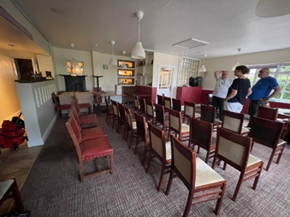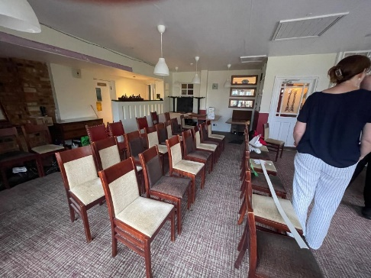
There is a large square room and plenty of space for people to come just for the meeting. The landlord is happy for us to use the room for the meeting and he’s also happy for us to take in our own cakes etc in for the afternoon, He will provide tea/coffee. There’s plenty of parking, a good choice of beer and the food looks reasonable. Will need to pre-order.
Future AGMs
Yardley Hasting for 2026 and Aston Clinton for 2027.
Unless someone has any other venues in mind.
 | Alan’s plans were agreed.
 | The meeting closed at 3.35 pm.

