|  |  |  |
| --- | --- | --- |
|  | **LDWA : BEDS BUCKS NORTHANTS GROUP**  **MINUTES OF ANNUAL GENERAL MEETING  SUNDAY 26TH NOVEMBER 2023 AT GREAT DODDINGTON MEMORIAL HALL,  42B HIGH ST, GREAT DODDINGTON,  WELLINGBOROUGH NN29 7TQ** |  |

The meeting commenced at 2.30 pm

Present: 23   
Francoise Bannister, Dee Brockway, Terry Brown, Gill Bunker, Chris Burns, Roy Carter, Steve Clark, Norman Corrin, Graham Dolby, Karen Earwicker, Nick Emery, Peter Engledow, Sarah Feal, Dave Findel-Hawkins, Phil Friede, Merrian Lancaster, Brian Layton, Alan Leadbetter, Jane O’Dea, Roger O’Dea, Jim Robinson, Val Thompson, Phil Vidler

Terry welcomed everyone to the meeting, and thanked Alan for leading the morning walk; organising the lunch and the hall, and bringing cake. She thanked Karen and Dee for the AGM refreshments.

|  |  |  |  |  |
| --- | --- | --- | --- | --- |
| **1.** | **APOLOGIES** Mike Hyland, Sandra Hyland, Daniel Jamin, Therese Jamin, Paul Keech, Mary Knight, Dave Sedgley, Liz Sheffield, Sara Waldron, Colin Watson, Dave Yorston, Lynn Yorston. | | | |
|  |  | | | |
| **2.** | **MINUTES OF THE 2022 ANNUAL GENERAL MEETING AND MATTERS ARISING** | | | |
|  | The Minutes had been available on the website and it was agreed they could be taken as read. They were approved as a true record. Prop: Merrian Lancaster Sec: Val Thompson and Agreed unanimously. Matters Arising: **Item 6(iii)** **Celebrating BBN 40th Anniversary:** Terry said how successful the anniversary celebrations had been and thanked all the organisers and everyone who had joined in the events. **Item 7(i) Greensand Ridge Benches**: An update is awaited from Jon Balaam of the Greensand Trust, but Terry thinks all the replacement benches have been Installed. (The bench at Clophill was in a better condition and didn’t need replacing immediately, but this will be done at some point.) **Item 7(ii) Dave Sedgley’s suggestion that BBN become a corporate member of the Bedford to Milton Keynes Waterway Trust**. This was discussed by the Committee, but it was agreed that booking a River Ouse Cruise on their John Bunyan narrow boat as part of BBN’s 40th anniversary celebrations would give more meaningful support than a £30/year subscription. | | | |
|  |  | | | |
|  |  | | | |
| **3.** | **REPORTS** | | | |
|  | Terry reminded the meeting that the reports covered the reporting year 1st October 2022 to 30th September 2023. It was agreed that all reports would be taken as read as they had been available to read on the website. | | | |
|  |  | | | |
| **(a)** | **Officers’ Reports** | | | |
|  | (i) Chair *Terry Brown See Report p.6-8* | | | |
|  |  | | | |
|  | **(ii) Secretary *Gill Bunker*** | | | |
|  | Looking back over the past year, it was brilliant to be part of the team organising the celebration of BBN’s 40th anniversary and it was great to see so many members enjoying the various events throughout the year. It has been another busy but satisfying 12 months to report on:   * Tuesday News circulated each week, keeping members updated throughout the year * Emails from the NEC: Circulated and responded to as necessary * We’ve continued to use Zoom for this year’s committee meetings * BBN website kept updated with photos from group walks and challenge events, plus event information, route descriptions, gpx files and finishing times etc * Photos with words (from Dee) about BBN’s 40th anniversary celebrations (the Ruby Doo and River Cruise) submitted for inclusion in December Strider. * Total Membership as at 30th September 2023 was 977 (Primary 522 and Associate 455) * New members’ contact information sent to Dee each week. Dee then makes a welcome phone call/sends a welcome email to the new members. | | | |
|  |  | | | |
|  | **(iii) Treasurer *Peter Engledow*** *See Treasurer’s Report and Accounts p.8-9* | | | |
|  | **And Proposal to Accept the Accounts** | | | |
|  | It was proposed that the Accounts be approved, Prop: Peter Engledow Sec: Chris Burns and Agreed unanimously. | | | |
|  |  | | | |
|  | **There were no questions arising from the three Officers’ reports.** | | | |
|  |  | | | |
| **(b)** | **Other Reports** | | | |
|  |  | | | |
|  | **(i) Challenge Walk Co-ordinator *Mike Hyland*** | | | |
|  | **Hannington Hike :**- Flyer is done and on websites (BBN and LDWA), also in Strider. Is set up on SiEntries ready to go live on 1st December 2023 **Pick And Mix** :- Flyer is done and on websites (BBN and LDWA), will go into December Strider. Also is set up on SiEntries ready to go live on 1st April 2024 | | | |
|  |  | | | |
|  | **(ii) Social Walks *Sara Waldron*** | | | |
|  | Our walks programme has continued to be well supported this year. There have been several walks in celebration of our 40th anniversary including the Milton Keynes Boundary, Tring Boundary and Northampton Round.  Many thanks to all the leaders who have offered a walk for the programme. Some new leaders have emerged – see the list below. Some leaders have taken us on more than one walk for which we are very grateful as we know how much time it takes to plan and do the recce for each walk.  Our special thanks go to Dave Findel-Hawkins who led each of the 7 legs of the Northampton Round.  We have continued to post our walks on the website and only put Challenge events into Strider. This fits with our leaders’ wishes to be able to offer walks at shorter notice and not commit themselves many months in advance.  There have continued to be problems with uploading walks to the website. Gill and I have had talks with NEC members and although there is a plan to create a new, better website, that will be at least 2 years away. So please bear with us when something mysteriously won’t transfer to our BBN site or when the words you sent me have been altered to fit the LDWA site.  Earlier in the year I took part in a piece of work with Terry Brown to bring our First Aid Kits up to date and make sure that we have 4 full kits which contain in-date items for each checkpoint on our Challenge events. This should make dealing with situations easier for the marshals at our checkpoints.  Walk Leaders: Clive Haynes Adrian Moody Chris Bent  Dave Findel-Hawkins Terry Brown Alan Leadbetter Sara Waldron Peter Hamson Jim Blakelock** Steve Clark Graham Missing Trevor Jones** Gill Bunker Ian Watson (org. Phil Hastings) Dianne Sutton Donald the Reindeer** Nick Emery** Mary Knight Dee Brockway Chris Burns Roy Carter John Manning** Bola Baruwa (London Group)** ** = New Leader | | | |
|  |  | | | |
|  | **(iii) Local Groups Representative *Peter Engledow*** | | | |
|  | Peter had attended the recent LGRs meeting (18th/20th November) and reported:  Topics discussed were:   * Heavy workload of NEC – hopeful routine matters can be outsourced to volunteers * Local Groups activities – BBN is one of the better groups with high volume of walks, but our GPX file uploading is not so good * No news on Speyside Hundred * £140,000 earmarked for new website * It will be at least 2 years before it goes live * Money from the Martyn Greaves £100,000 bequest is still available, Send details of projects to the NEC * Discussions on barriers to people joining the LDWA or joining social walks/Diversity and Inclusion. | | | |
|  |  | | | |
|  | **There were no questions arising from these reports.** | | | |
|  |  | | | |
|  |  | | | |
| **4.** | **ELECTION OF OFFICERS AND COMMITTEE** | | | |
|  |  | | | |
|  | **Election of Officers** | | | |
|  | Nominations for the three Officer posts had been made in advance. As a single nomination was received for each position, there was no need for a vote and the following were duly elected. | | | |
|  | **Position** | **Nominee** | **Proposer** | **Seconder** |
| **(i)** | **Chair** | **Sarah Feal** | Terry Brown | Chris Burns |
| **(ii)** | **Secretary** | **Gill Bunker** | Beryl Bowley | Mike Bowley |
| **(iii)** | **Treasurer** | **Francoise Bannister** | Chris Burns | Val Thompson |
|  |  | | | |
| **(iv)** | **Election of Committee Members** | | | |
|  | Nominations for the seven committee posts had been made in advance. As only seven nominations were received, there was no need for a vote and the following were duly elected. | | | |
|  | **Member** | **Terry Brown** | Sara Waldron | Mary Knight |
|  | **Member** | **Chris Burns** | Norman Corrin | Terry Brown |
|  | **Member** | **Roy Carter** | Chris Bent | Gill Bunker |
|  | **Member** | **Nick Emery** | Jim Blakelock | Chris Bent |
|  | **Member** | **Peter Engledow** | Graham Missing | Merrian Lancaster |
|  | **Member** | **Mike Hyland** | Terry Brown | Dave Findel-Hawkins |
|  | **Member** | **Sara Waldron** | Steve Clark | John Davies |
|  | Terry confirmed that Sara Waldron would continue as Walks Secretary. | | | |
|  |  | | | |
|  | **Terry and Peter were standing down as Chair and Treasurer respectively. Norman said a few words in appreciation of their work for BBN over the past six years and thanked them on behalf of the group.** | | | |
|  |  | | | |
| **(v)** | **Payment Authorisers:** These have been the three officers in the past, at least two out of three to authorise online banking payments and cheques. The future Authorisers to be confirmed at January committee meeting. | | | |
|  |  | | | |
| **(vi)** | **Non-Committee** | | | |
|  | **Group Equipment**: **Dave Findel-Hawkins** has agreed to continue looking after the group’s equipment. | | | |
|  | **New Member Welcome: Dee Brockway** Terry thanked Dee and said her new member welcome was invaluable and set BBN apart from other groups.  Dee said feedback on why new members had joined was interesting: cheaper and earlier entry to LDWA events, plus access to GPX files. Several people she had chatted to had amended their preferences so they now accepted LDWA emails. | | | |
|  | **Hundred Co-ordinator: Dave Findel-Hawkins** | | | |
|  | **Hundred Checkpoint Co-ordinator: Mary Knight** | | | |
|  | **AGM Co-ordinator: Alan Leadbetter** | | | |
|  | Some other jobs, e.g., Input of GPX files, will be confirmed at the January committee meeting. | | | |
|  | To improve our GPX uploading, if the walk leader does not have GPS, walkers could be asked at the start of the walk if one of them could send the GPX to the BBN inputter. | | | |
|  |  | | | |
|  |  | | | |
| **5.** | **CHALLENGE EVENTS** | | | |
|  |  | | | |
| **(i)** | **Sundon Saunter 2022 *(20th November 2022)* *Merrian Lancaster*** *See Report p.10-11* | | | |
| **(ii)** | **Chiltern Kanter 2023 *(5th March 2023)* *Roy Carter*** *See Report p.11`-12* | | | |
| **(iii)** | **Pick & Mix 2023 *(2nd June 2023)* *Lynn & Dave Yorston*** *See Report p,12-13* | | | |
|  |  | | | |
|  | **There were no questions arising from these three reports.** | | | |
|  |  | | | |
|  | **Future Events Update** | | | |
| **(i)** | **Steppingley Step 2023 *(19th November 2023)* *Dave Findel-Hawkins*** | | | |
|  | The event is now full with a large waiting list. All venues have been booked. CP leads are organising their own menus. Karen is organising the main meal at HQ. We have a good turnout of volunteers - these are mainly the usual ones. All routes, including change to long route necessitated by a closed footpath, have been checked. Route descriptions and gpx files published. | | | |
|  | This event had taken place the previous weekend. Dave said it had gone well and he thanked all the marshals and checkpoint managers. | | | |
|  |  | | | |
| **(ii**) | **Hannington Hike 2024 *(3rd March 2024)* *Alan Leadbetter*** | | | |
|  | All halls are booked and paid for. Event will go live on SiEntries for LDWA members on 1st December 2023 and then to all on 1st January 2024.  Route descriptions for both the 15.5 mile and 26.6 mile have been written along with the GPX files, which are in sections. I would like someone to route check the long route for me before the marshals’ walk if possible.  The marshals’ walk will be on 11th February. I will be supporting the marshals’ walk along with Karen, Phil and Norman. There will be snacks and drinks available. I am looking for 3 checkpoint managers and about 20 marshals to help on the day. If you would like to help out contact me at [acleadbetter64@gmail.com](mailto:acleadbetter64@gmail.com) or text/ring on 07775887493.  The following are eligible for the BBN triple if they complete the 2024 Hannington Hike  Verity Allsopp, Mandy Attree, Mark Beesley, Graham Busch, John Davies, Gerald Davies, Nicholas Emery, Mark Garratt, Catharine Gregory, Steven Jenkins, Paul Keech, Eddie Pember, Lucy Stern, Mia Timms, Paul Timms, Carrie Tyas, Georgina Watt | | | |
|  |  | | | |
|  | **Pick & Mix 2024 *(2nd June 2024)* *Lynn & Dave Yorston*** | | | |
|  | The same venue has been booked for 2nd June 2024 when we shall hold the next Pick & Mix. We will be asking for volunteers for that event early in the new year. Hope to see you all then. | | | |
|  |  | | | |
| **(iii)** | **Shillington Shuffle 2024 *(17th November 2024)*** *Dave Findel-Hawkins* | | | |
|  | Dave said the HQ hall at Barton was now booked for the next three years. He was happy to continue in his existing role. | | | |
|  |  | | | |
| **(iv)** | **Joe Leonard’s – *Three Counties Tread* (25 mile Anytime Challenge).** Terry confirmed the committee were supportive of this Anytime Challenge which links the three BBN counties and have offered help with the route description, badge production etc. Joe hopes to finalise the event early next year, advertise it in Strider and also put it on as a group walk. | | | |
|  |  | | | |
|  | **There were no questions arising from these reports.** | | | |
|  |  | | | |
|  |  | | | |
| 6. | **GROUP ACTIVITIES** | | | |
|  |  | | | |
| **(i)** | Future LDWA Hundred Checkpoints *Dave Findel Hawkins* | | | |
|  | There is no further news at present. Dave is in contact with the organisers of all future Hundreds and BBN’s CPs will be at about the 20 mile stage on each. | | | |
|  |  | | | |
| **(ii)** | **Criccieth Trip August 2023** *Roy Carter See report p.13-14* | | | |
|  | **Ilfracombe Trip 2024 Roy Carter** | | | |
|  | Roy said the trip is open to all, not just people who have been on previous trips, There are still rooms available at the hotel. He confirmed the trip was the weekend after the August Bank Holiday weekend. | | | |
|  |  | | | |
|  |  | | | |
| **7.** | **DONATIONS/PROJECTS – Members’ Ideas** | | | |
|  |  | | | |
|  | Terry said that Ed Kendrick had recently suggested another donation to the North Bucks Ripple (ramblers Repairing & Improving Public Paths for Leisure & Exercise) Donate a Gate scheme – paying for a metal gate to replace a stile. We did this in 2020-2, installing a kissing gate at Stewkley. A pedestrian gate costs £350, and a kissing gate is £500. The cost of a plaque is about £30. | | | |
|  | Dee suggested, and the meeting agreed, that we could support another working party group in one of the other of our counties, either Beds or Bucks. **This to be followed up.** | | | |
|  |  | | | |
|  |  | | | |
| **8.** | **LDWA Matters** | | | |
| (i) | **Changes to the LDWA model constitution** | | | |
|  | Terry said that earlier in the year we had been sent a draft of possible revisions to the LG model constitution. The review focuses heavily on financial matters; some groups are lax with their financial governance which could lead to problems and impact on the LDWA’s reputation. We may need to appoint a named independent financial examiner who would present a report at the AGM. The committee felt this could add to the administrative and financial burden on the group. We are still awaiting clarification on a few issues such as what “Independent” means – could it be a member of the Group not on the Committee. We did respond with some comments. The changes were discussed at the Local Group meeting and NEC will now review the feedback. We are awaiting their decision. It is likely that we will need to amend our Constitution, and this will require a vote at a future AGM. | | | |
| (ii) | **LDWA survey** – Terry said a survey had been emailed to all members by Matt Parker, LDWA Comms, during the previous week. Terry said she had done the survey; it is quite simple and takes about 10 mins. She asked that members complete it. | | | |
|  |  | | | |
|  |  | | | |
| **9.** | **AOB** | | | |
|  | Norman said the LDWA will have stand at the Outdoor Show at the NEC next March. | | | |
|  |  | | | |
|  |  | | | |
| **10.** | **2024 AGM Date/Venue *Alan Leadbetter*** | | | |
|  | Next year’s AGM will be held on Sunday 24th November (TBC) at Lavendon Village Hall. The meal to be held at either The Green Man or The Horseshoe to be announced at a later date. | | | |
|  |  | | | |
|  | The meeting closed at 3.45 pm | | | |

**ITEM 3 (a)(i) CHAIR’S REPORT FOR 2023 AGM**This is a brief overview of the Group’s activities for our reporting year - 1 October 2022 to 30 September 2023; more detailed reports have been written by those directly involved in specific aspects of the Group’s activities during the year.

The headline is that we’ve returned to normal functioning following the Covid pandemic and we celebrated our 40th Anniversary in fine style!

A slightly disappointing turnout of 19 members attended the 2022 AGM held at Ickwell village hall in November where the venue, walk and lunch were organised by Alan Leadbetter. The current Officers, myself - Chair, Gill Bunker - Secretary and Peter Engledow - Treasurer, were re-elected, as were Committee members - Sara Waldron, Mary Knight, Roy Carter, Mike Hyland and Sarah Feal. Chris Burns and Nick Emery were elected to the Committee for the first time. I extend my thanks to them all for their support and commitment this year.

Two long standing Committee members, Alan Leadbetter and Norman Corrin, didn’t seek re-election at the AGM and Mary Knight stood down during the year; we thank them for their valuable work on the Committee over the years. I’m pleased to say that Alan has agreed to continue organising the Hannington Hike and our AGM venues, walk and lunch arrangements, Norman did carry on with the new member welcome for a short while but see membership matters further on in this report, and Mary agreed to carry on as our LDWA Hundred BBN Checkpoint lead and was part of the 40th Anniversary Working Group.

The Committee met formally four times during the reporting year. We continued to meet virtually using the BBN’s Zoom account; this is convenient, saves personal time and travel costs as well as being environmentally friendly; the Committee feel this is a justified use of Group funds. We also conducted some general business and decision making between meetings using email and a newly set up Committee WhatsApp Group. This meant that we could react quickly to queries and issues, it also reduced the length of Committee meetings!

During the year the Committee devised and agreed a travel expenses scheme for those who marshal on BBN events. It came into operation for a year’s trial on October 1st and will be reported on at next year’s AGM. We’ll review aspects such as uptake, cost to BBN, include in each Challenge event finances, administrative burden, do we carry on or change the scope .

Gill, our Group Secretary, continues to do an outstanding job. In March I was extremely pleased to be able to nominate Gill, in our 40th year, for an LDWA Volunteer Award for Inspiration and Encouragement which she was successful in being awarded. My citation showed the breadth of Gill’s involvement with BBN over the years and it was ‘top and tailed’ by the following sentences:

*It’s difficult to decide which category to nominate Gill for – ‘Super Hero’ would be better!*

*The positive impact Gill has made can’t be underestimated; she has significantly contributed to make BBN the successful group it is today.*

Gill keeps all our meetings on track and also looks after BBN’s WhatsApp Group, Facebook page and website. We extend our grateful thanks to Gill for all she continues to do for us and the LDWA.

It’s been a busy year for Treasurer Peter Engledow. As well as the ‘normal’ annual financial aspects of challenge events transactions and donation payments, Peter handled a large number of BBN 40th Anniversary transactions - payments for coach transport, venue hire and food, and deposits from members for the various events. Thank you, Peter, for this year’s work and for your 6 years as our Group Treasurer.

As well as being our Treasurer, Peter was also our rep at the National Local Group meeting; he also looked after our Twitter account and the Peco online BBN shop for Group badged gear.

Donations made this reporting year:

**£130** to the **Thames Valley Air Ambulance** (donations at the Sundon Saunter)   
**£50** to the **Warwick & Northants Air Ambulance** in memory of early BBN member Janet Presland **£100** to the **Thames Valley Air Ambulance  (**donations at the Pick & Mix}  
**£25** to the **John Colet School, Wendover** - Pick & Mix parking  
**£50** to **The End Point Walk -** LDWA David Morgan and Alan Warrington walking 580 miles to raise money for the **British Heart Foundation**

Please let the Committee know if you have any ideas for donations we could make – they must reflect the activities of our Group and the LDWA.

Sara Waldron, Social Walks Secretary, coordinated our social walks programme which this year was taken up with 40th anniversary projects, of which more later. However, as our programme returns to ‘normal’ we need leaders, new and experienced, to fill up our available walk dates for the coming year. If you haven’t led before we can give you help and guidance to do this – just ask!

Sara also inputs our walk details onto the website and keeps our Group’s social walk information in Strider under review. Thank you, Sara, and everyone who led a walk during the year, especially those who led for the first time, and thanks to everyone who came out to walk.

Sarah Feal continued to add Group social walk GPX files to the website Walks Database. There are still relatively few GPX files submitted and walk leaders are encouraged to pass on their GPX files for upload.   
Sarah also created the *In Case of Emergency* (ICE) form which is on the website and which we encourage members to carry with them.

Membership matters – we’ve continued to get a steady stream of new Primary and Associate members throughout the year. Dee Brockway offered to look after our new member welcome as Norman Corrin had to give this up to take on the LDWA Membership Secretary role – thank you both.

We believe the personal touch is important; Dee makes an initial phone call and has a general chat about what we do and where to find information about our walks and challenge events. She often finds out why people have joined the LDWA which is interesting information. New members seem to appreciate this approach.

BBN 40th Anniversary - Myself, Gill Bunker, Mary Knight and Sarah Feal formed a sub-committee to organise and co-ordinate the programme of events to celebrate the Group’s 40th Anniversary year.

The first event was the 63mile Milton Keynes Boundary Walk, a route that was the inspiration of Chris Meredith, one of the Group’s founder members. This was completed as three Saturday social walks in March (Newton Longville to Ravenstone 22.9 miles, led by Gill Bunker), April (Ravenstone to Astwood 19.2 miles jointly led by myself and Nick Emery) and May (Astwood to Newton Longville 21.1 miles led by Mary Knight).

The year’s longest running project was a series of seven circular day walks covering the 51-mile Northampton Round, started in May and finished in October.

Like the Milton Keynes Boundary walk some members completed the whole route but many others came for one or more of the seven walks which were all planned and led by Dave Findel-Hawkins.   
In June 19 walkers attempted all or some of the 42-mile, across Bedfordshire, Greensand Ridge Walk which was completed on one of the hottest days of the year! The route was led by Roy Carter, Alan Leadbetter, Dee Brockway and myself. The breakfast stop at Northill was organised by myself helped by Norman Corrin and Gordon Shaughnessy and we also provided on-route support and were joined later by Roy Carter and Sarah and Daniel Feal. Lunch and tea were provided at Ampthill and tea at Woburn by Mary Knight with Sarah and Daniel assisting. We had great feedback for the walkers who completed the walk, some at this distance for the first time. Congratulations to them all.

In July, 64 past and present members came to our ‘Ruby Doo’ in Woburn with a choice of three different length walks, led by Dee Brockway, Gill Bunker and myself, culminating in a celebratory birthday tea in the village hall which was suitably decorated with red balloons and bunting. Our star caterers, Mary and Dennis Knight, worked their magic again to produce a marvellous spread including an amazingly decorated birthday cake which was cut by Brian Graves, the lowest LDWA membership number present. Norman Corrin made a wonderful speech summarising the Group’s history, its characters and events.

Unfortunately, a 25-mile night walk along the Knightley and Grafton Ways planned for August had to be cancelled at the last minute for safety reasons due to a very poor weather forecast for heavy rain and thunder storms. Thanks to Chris Bent for planning and organising this event which we hope can be rescheduled at some point in the future.

On a hot and sunny day in September we had a Walk and River Great Ouse Cruise event at Bedford expertly organised by Sarah Feal. Three walks were available - a six-mile easy amble led by Chris Burns, a heritage trail along the river and the Bedford Embankment led by a tour guide from The Higgins Trust and a ‘treasure quest’, around the town centre and embankment, to solve the clues and find the tiara!

The cruise was on the Narrow Boat John Bunyan owned by the Bedford-Milton Keynes Waterways Trust. With drinks and preordered food served by the efficient crew, we travelled upstream through the town and back down to Cardington before returning to Priory Marina.

Our final event was an Autumn walk and a lunchtime visit to Wetherspoons in Milton Keynes for a Ruby Murray (curry). This was organised and led by Gill Bunker.

All of these events have brief reports and links to photographs on the BBN website – please take a look in the ‘Special’s section if you haven’t already done so. Thanks to Steve Clark and Sarah Feal for being ‘official photographers’ and to those who wrote reports of the events.  
My thanks to everyone who came along to our big birthday events and helped in any way to a make them all such a success. I think it’s fair to say we celebrated in great style with events to suit as wide a range of both past and present members as possible.

Challenge Walks - we put on three challenge events during the year – the Sundon Saunter in November, the Chiltern Kanter in March and the Pick & Mix in June. All were very well supported and, as ever, we received a lot of encouraging and positive feedback. Huge thanks to all the organisers, route checkers and marshals for making these such good events. Full reports of these events are available to read.

Mike Hyland, our Challenge Event Coordinator, has worked hard liaising with our Challenge walk organisers, the SiEntries team and event entrants to make sure this year’s events were advertised and well managed. Mike’s event waiting list management is amazing and makes sure that our events are as full as possible, giving minimal ‘no-shows’ on the day. Thank you, Mike!

Dave Findel-Hawkins has looked after the Group’s equipment, ensuring that all the necessary equipment was in good order and ready for the various events held during the year. Thank you, Dave.

In May we ran a BBN Checkpoint (CP) for the LDWA Elephant, Bear and Bull (EBB) 100 event. Huge thanks to Mary Knight, our 100 Checkpoint Organiser, and team who saw 500 walkers though a very well run CP3 at Alvechurch. The team coped well with some food supply issues on what was a very hot afternoon.

Thanks also to Dave Findel-Hawkins and Merrian Lancaster who, as well as being part of the CP3 team, ran the last CP which is open for 24 hours! They were also joined by BBN’s Knight in Shining Armour - Alan Leadbetter!

Dave also provides the first point of contact between future 100 event organisers and the Group about possible checkpoints – many thanks to him for doing that job.

Congratulations to all BBN members who took part in the EBB on the main or marshals’ event whether they finished it or not. On a personal note, it was a milestone for me to complete my first (and possibly only!) 100 and I’d like to thank everyone who supported and encouraged me to enter and complete it!

And last but not least, Roy Carter organised another one of his very popular Group holidays at the end of August. This year it was based in Wales in Criccieth and as ever the trip was thoroughly enjoyed by everyone who went.

Thanks to everyone who has participated in any way in a Group activity or event and for your support in the last year.

Terry Brown

BBN Chair

**ITEM 3(a)(iii) TREASURER’S 2023 AGM REPORT**

The Accounts have been prepared for the period 1 October 2022 to 30 September 2023.  
Total balance on bank is now £4,707.51.  
Our revenue consists almost entirely of contribution/profits from our challenge events; well done one and all. Principal expenditure this year has been our 40th anniversary celebrations. There is a short breakdown below of how funds were spent.   
  
The accounts have been checked and found to be in order. They will be signed if approved by the AGM.   
  
Donations made during the year were;

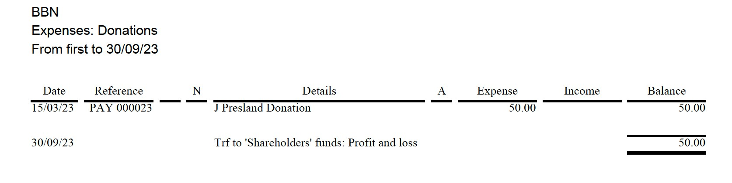

These were as expected and authorised by the committee.  
  
Breakdown below for the 40th anniversary celebrations.

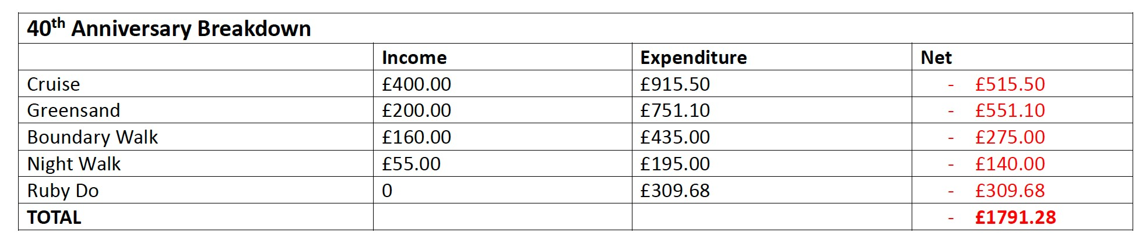

Given the healthy balance in the bank I do not feel that it is necessary to recommend the re-introduce the annual membership fee.   
As always, suggestions for how we use our funds are always welcome by the committee.   
Unless there are any questions, we now need a motion passed to accept the accounts so that they may be adopted.

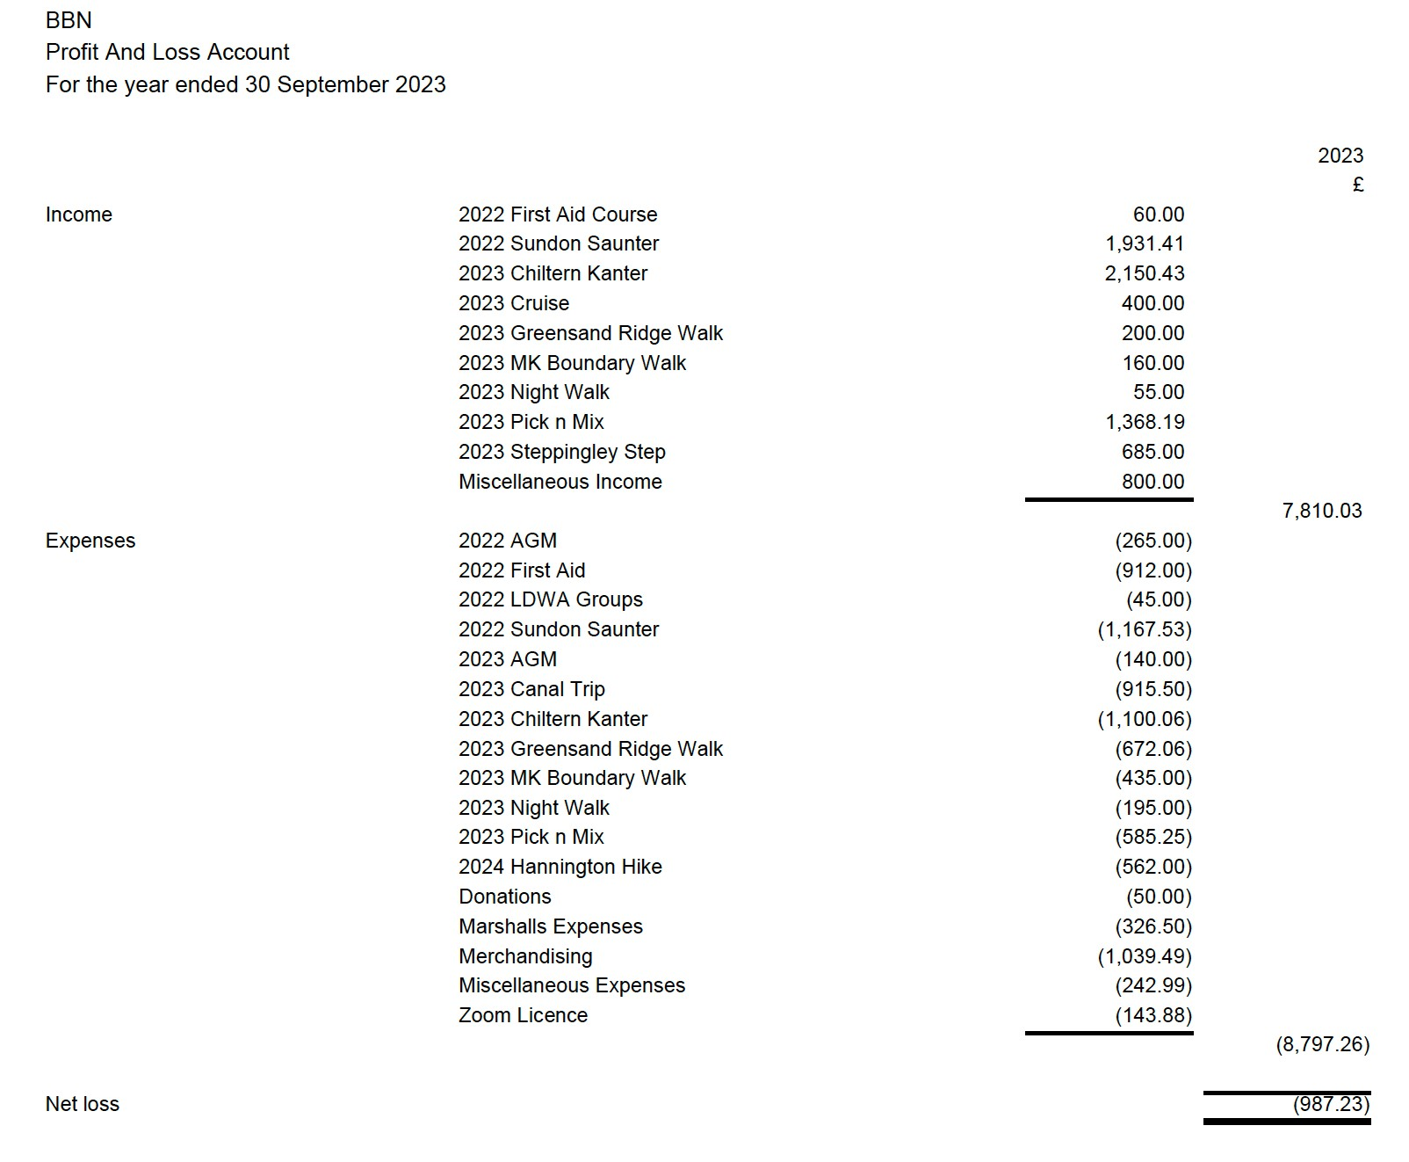

**ITEM 5. CHALLENGE EVENTS**

## 5(i) SUNDON SAUNTER 2022 (20th November 2022) Merrian Lancaster

**Entries. 13 non-LDWA. More than 100 first-timers.**

|  |  |  |  |  |  |  |
| --- | --- | --- | --- | --- | --- | --- |
|  | Expected | non-starters | n/s % | starters | retired | completed |
| overall | 247 | 9 | 3.64 | 238 | 2 | 236 |
| 13 mile | 46 | 1 | 2.17 | 45 | 0 | 45 |
| 18 mile | 42 | 2 | 4.76 | 40 | 0 | 40 |
| 27 mile | 159 | 6 | 3.77 | 153 | 2 | 151 |

18 people achieved their first triple certificate and badge, 9 their second and 5 their third.

**WhatsApp** Used for the first time to communicate between marshals, worked really well. Used to send the non-starter and route change sheet to checkpoints.

**A few things to sort out for next time.**

Although we make it clear that we don’t allow substitutions, a couple of people did that.

Although we make it clear that people must know where the checkpoints are, two people missed cp1 by only following a gps. Two others missed cp1 but they went wrong.

Although we make it clear that people must not retire without letting us know, someone did that.

**Lost property.** Photos on BBN website and Facebook. One item posted. Two items returned via Sara.

**Finances: Dave Yorston**

Total income from entries after SiEntries charges £2446.41

Total provisions costs £598.29

Total hall and parking cost 397.00

Total other costs £43.24

Therefore total expenditure £1038.53

The excess from the event £1478.88

We then sent £130.00 to the East Anglian Air Ambulance (£30.00 from sale at the AGM, £71.00 from tea money and £29.00 from walk excess). We also sent £100.00 to the LDWA.

Therefore the total excess that went into our account was £1278.88.

**Routes: David Sedgley**

The closure of the old route up the side of Smithcombe Hill and opening of a longer one, added half a mile and a steep hill to the early part of the route.

My discovery of the medieval village hall in Chalton meant a diversion from the route previously used via Fancott was possible. This shortened the route through Sundon Quarry and meant there was less to mark on the morning. Previously I’d always marked it the day before – then just checked it on the day. It also meant we could use CP1 on the short route rather than CP3 as in the past.

My preferred route between Wingfield & Tebworth had a line of very dodgy stiles, which the newly appointed Rights of Way officer was able to change to kissing gates. This shortened this part of the route by about 400 metres & also made it more obvious. Lyndsay, the new ROW officer, had got the Ripple group to clear through all the overgrown hedge gaps previously.

**Many thanks to all our marshals.**

**Registration** – Dave Findel-Hawkins, Andrew Boulden, Graham Missing, Jim

Morrison and Merrian Lancaster

**Car parking** – Brian Leyton, Phil Vidler, Mike Hyland. Alan Leadbetter and Roy

Carter **Kitchen** – Sandra Hyland, Karen Earwicker, Dave Yorston, Liz Sheffield and Phil

Vidler

**HQ** – Gordon Shaughnessy, John Davies. Roy Carter, Terry Brown, Mike Hyland and Norman Corrin

**Sweep from CP2** - Alan Leadbetter

**CP1 Chalton on all routes**

Marshals: Gill Bunker, Jackie Burnett, Beryl Bowley, Mike Bowley. Rachel Martin, Sarah Feal

**CP2 Milton Bryan** on Long route only

Marshals: Mary Knight, Dennis Knight, Alan Leadbetter, Gordon Shaughnessy,

Andrew Boulden

**CP3 Harlington Scout Hut** on Medium and Long routes

Marshals: Terry Brown, Sara Waldron, Val Thompson, Mooi and Peter Simon, Mike Hyland and John Davies.

## 5.(ii) CHILTERN KANTER 2023 (5th March 2023) Roy Carter

The 22nd Chiltern Kanter was held on Sunday 5th March for the 205 participants who had arrived at Pitstone Memorial Hall at sunrise on a cool morning. There were 231 expected based on bookings from SiEntries. This represents an 89% turn-out on the day and all finished with no retirements. The Short route had 59 complete 13 miles; Medium route had 51 complete 18 miles and Long route had 95 complete 26 miles. Also, 26 participants had the honour of receiving the CK-HH-PM Triple Challenge badge. The weather throughout the day remained cool, dry and reasonably sunny, which made for ideal conditions for the Kanter.

There were 24 Marshals on hand to help with the event. A problem was immediately spotted in the kitchen before participants arrived at Pitstone. The hot water Urn had a message reading “Out of Order. Reported 23/02/23”. This meant we could only use slow boil kettles to prepare tea and coffee for participants. Another problem occurred simultaneously when we found there wasn’t enough bowls for both stew and dessert. Both problems resolved by DFH who returned to MK to fetch the BBN urn and bowls from the Equipment cupboard. More problems occurred late morning at Aldbury CP, when the Disabled toilet flooded which also affected the Ladies toilet. Marshals were on hand to mop and clear the spillage. From that point, participants at Aldbury could only use the Gents toilet.

Other issues during the day were: The Defibrillator at Pitstone Hall kept buzzing and flashing (unusable?) and space to store prepared food at Wigginton was very limited. Response from the Aldbury Memorial Hall manager:

*“They found a blockage in the sewer pipe near some of the neighbouring cottages.*

*It’s my understanding that this issue was unique and is unlikely to happen again”* Response from the Pitstone Memorial Hallmaster:

*“I believe both issues, the Urn and the Defibrillator, are being sorted swiftly, as we also want to keep our popular hall up to spec for the community. Thank you for your concern”*

Marshal Information:

Can I thank Checkpoint managers Mary Knight at Aldbury & Gill Bunker at Wigginton for offering their selection of food and drink which was praised by many participants. A thank you to Karen Earwicker at Pitstone for preparing a final course of vegetable stew and fruit dessert which participants really enjoyed. A thank you also to Merrian & Dave for the process of registration and certificates at Pitstone. And finally a very big thank to all our other Marshals for attending to participant requirements: *Norman Corrin, Mike Hyland, Alan Leadbetter, Brian Chandler, John Davies, Philip*

*Vidler, Dennis Knight, Gordon Shaughnessy, Chris Burns, Therese Jamin, Jackie*

*Burnett, Beryl & Mike Bowley, Sarah Feal, Terry Brown, Dave & Lynn Yorston and*

*Alison Roberts*

Chiltern Kanter Finances:

Total Income: £1926.18

Total Expenditure: £1255.06

Surplus: £671.12

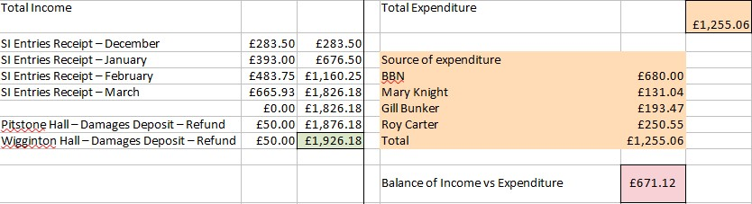

## (iii) PICK & MIX 2023 (2nd June 2023) Lynn & Dave Yorston

The weather was very hot and dry with brilliant sunshine. We were in the new location of Wendover Memorial Hall with all new walking routes too. The site was very user friendly with lots of space to park in school grounds next door. We had a large kitchen and plenty of room in the main hall to mill about.

We offered a 10 mile, two 8 mile and a 6 mile route that all took different paths leaving the town. We also combined the way out on one route with the return from another, giving us an extra 4.5 mile option. On top of that, for the first time, we offered a wheelchair and buggy friendly 2 mile interest walk around the town. All these routes were well attended and greatly appreciated with the variety of paths, canal towpath, hills and wooded terrain.

We had 6 under 18s on the event and the oldest walker was reported to be in his 90s. All credit to them for completing their chosen routes. Well done to the walker who covered the furthest distance of 43 miles in 7 loops. Big congratulations to all.

Everyone finished well within the 10 hour limit and we were ready, cleared up and gone by our 19.00 deadline.

Many thanks to all who helped us in advance and on the day.

Merrian Lancaster, Dave Findel-Hawkins, Gordon Shaughnessy, Christine Burns,

Karen Earwicker, Phil Vidler, Alan Leadbetter, Terry Brown, Alison Roberts and Glyn Dimmock

Three of these happy helpers also completed a good walk too !!

In total 145 walkers covered a total of 2,662 miles in 363 loops

We look forward to seeing you all next year at the same venue on Sunday 2nd June 2024.

**Statistics**

Walkers booked in 161

Non-starters 16

Total out walking 145

|  |  |  |  |
| --- | --- | --- | --- |
| **Loops walked** | **Number times loops were walked** | | |
| 25 completed 1 loop | 95 completions of 10 mile RED loop | | |
| 66 completed 2 loop | 67 completions of 8 mile GREEN loop | | |
| 25 completed 3 loops | 60 completions of 8 mile BLUE loop | | |
| 17 completed 4 loops | 74 completions of 6 mile YELLOW loop | | |
| 10 completed 5 loops | 47 completions of 4.5 mile ORANGE loop | | |
| 1 completed 6 loops  1 completed 7 loops  **Distances walked** | 20 completions of 2 mile Interest walk | | |
| 1 walked 4.5 miles | 2 walked 20.5 miles | | |
| 5 walked 6 miles | 8 walked 24 miles | | |
| 7 walked 8 miles | | 16 walked 26 miles |
| 16 walked 10 miles | | 5 walked 26.5 miles |
| 6 walked 10.5 miles | | 3 walked 28 miles |
| 1 walked 12.5 miles | | 5 walked 28.5 miles |
| 15 walked 14 miles | | 5 walked 30.5 miles |
| 14 walked 14.5 miles | | 1 walked 32 miles |
| 12 walked 16 miles | | 4 walked 36.5 miles |
| 14 walked 18 miles | | 1 walked 38.5 miles |
| 1. walked 18.5 miles 2. walked 20 miles | | 1 walked 43 miles |

**Marshals’ Event**

We held an 'anytime' marshals walk this year to allow as many as possible to take part. Also, three marshals completed loops on the day and are not included in the main results.

If anyone would like an event badge, please send a stamped, self-addressed envelope to

Dave Yorston at 3, Lodge Lane, Prestwood. HP16 0SS

If you forgot to pick up your certificate and would like to claim it, please send an A5 stamped self-addressed envelope to Dave at the same address

Again, many thanks to all who helped and to all the walkers.

Congratulations to you all. You made it a day to remember.

Dave & Lynn Yorston and Mike & Sandra Hyland

## Item 6(ii) GROUP ACTIVITIES: BBN HOLIDAY TO CRICCIETH, WALES

We used the George IV hotel in Criccieth for our BBN holiday to the Lleyn Peninsula this year. Arranged through Alfa Travel we booked 22 LDWA members into the hotel with the luxury of them all being together for breakfast and dinner, making the walks easier to manage. The holiday became more exciting because very little went to plan apart from the accommodation and I had to think quickly, to make it looked planned.

An inkling of what was to happen started in the Criccieth Council car park on Friday, with Sarah handing me her parking permit from the hotel, a temporary measure while I got mine.

When I got it, Ian was passing the hotel looking to park, so I handed him my permit, keeping Sarah’s. Ian then handed his permit to Rob in a similar situation. The upshot of this swapping around meant Sarah had to find somewhere in town to park her car for free and it wasn’t resolved until Monday when we left.

The Friday walk didn’t go to plan either; descended a slope to go under the railway we were faced with a swamp – marked on map in extensive blue grass and river-lets – why choose that way? It took some time and distance to avoid, which meant my plan to visit the resting place of Lloyd George at Llanystumdwy couldn’t be reached because we had to return to the hotel for the evening meal at 7:00pm.

Saturday began together for an early breakfast at 7:30am and a drive to Nefyn on the north coast of the Lleyn Peninsula. We walked to a remote pub at Porth Dinllaen but too early to rest there (Anne & Rachel stopped since they had a different walk). We continued down past a golf course for a morning break at the “Pipe Line”, which was a better place than it sounds. The sun was shining as we walked the wonderful coastline to Tudweiliog to catch an afternoon bus back to Nefyn. The shop there did well selling us ice creams, cakes, drinks while we waited for a bus in warm sunshine.

The afternoon walk from Nefyn headed north along the Wales Coast Path. At Ciliau-isaf, we had to decide whether to continue to catch a bus in the village of Llithfaen as planned or return on foot. We decided the latter because we knew we could beat the bus back to Nefyn and get to Criccieth in time for tea at the hotel by 7:00pm. I plotted a new route back using the map which was enjoyable as well as exhausting.

The Sunday walk started in Aberdaron at the bottom of the Lleyn Peninsula about an hour’s drive. The weather had changed, cloudy, cooler, light drizzle but fine for us. The plan was to follow the Wales Coast Path to Porth Ferin and back across country to Aberdaron. Another lovely part of the coastline with views to islands in Aberdaron Bay and across to the legendary island of Bardsey. Much of the day’s walk remained at clifftop level, with the occasional drop to sea-level. The late morning stop was at St Mary’s Well at the end of the North Wales Pilgrims Way. A visitor asked me if St Cuthbert was buried on Bardsey Island and I said “only Merlin was buried there?”

We ended the walk at Whistling Sands falling short of plan because the Cafe there was so inviting; the tea and coffee were welcome; the blueberry scones were large and scrumptious; and the rain to the west was heading toward us. A great end to the day despite a three mile walk back on minor roads to Aberdaron, singing in the rain.

The Monday walk started at Portmeirion car park where we formed into two groups; one going inside to enjoy the Prisoner experience, the other going by bus to Blaenau Ffestiniog to follow the railway back down. That was the plan. However, being Bank Holiday Monday the bus timetable had changed and there wasn’t a bus to Blaenau until after 11am and a train wasn’t going up there until that time either. The new plan was to walk toward Blaenau until we reached a point to head back down by 4:00pm. This we did admirably despite negotiating a footpath closure and a nasty bit of road walking. We had occasional views on the walk; trains going past, a viaduct, a break at a reservoir, a study centre garden, and an old railway bed across a marsh.

I finished the walk without saying goodbye to everyone because Diane and myself sneaked into the Portmeirion Castell for a celebration drink. Sorry guys.

Can I thank everyone on the BBN holiday for making it so enjoyable to lead.

