LONG DISTANCE WALKERS ASSOCIATION - BEDS BUCKS NORTHANTS GROUP
MINUTES OF COMMITTEE MEETING
THURSDAY 20TH JULY 2023 7.30 PM - BY ZOOM
Present: 9 Terry Brown (Chair), Gill Bunker (Secretary), Chris Burns, Roy Carter, Nick Emery,
Peter Engledow (Treasurer), Sarah Feal, Mike Hyland, Sara Waldron

1. | Apologies: None | ACTION
2. | Minutes of Previous Committee Meeting (6th April 2023)
 | The Minutes were approved.
Item 2. New Buffs: 50 received. 10 to Sara, 10 to Terry, 30 to DFH.
Badges and buffs advertised in TN.
 | Item 2. ICE Form. A print your own form produced by Sarah is on the website and has been advertised in TN.
 | Item 2. Generic Risk Assessment for BBN Events Terry is working on this, using the LDWA template. She will circulate to committee and event organisers when complete. She said the LDWA risk assessment is still weighted heavily with Covid precautions that are no longer necessary. This to be referred to the LGRs meeting. | Terry/  LGRs Mttg
 | Item 3(b) New Member Welcome Dee has taken over ”the Welcome”.
 | Item 3(i) Event Food Safety Karen intends to do the Level 1 course. The course to be recommended to members via TN and, by way of encouragement, it was agreed the course fee (£12) would be reimbursed. | Gill/TN
 | Item 3(j) Walks Database Reminder included in TN but little response. Only 5 or 6 in total. Walk leaders to be reminded to send GPX file to Sarah if they have one, or to ask someone on the walk to send one. | Sara W
 | Item 7(iii) Dogs on Walks Policy is on website, will be in BBN Group News in Strider, and was included in TN.
Item 8(i) £300 received from Trans-Pennine Hundred A member has queried what is happening to this money.
After some previous 100s, BBN has been given a sum of money. My memory isn't brilliant, but I think those who marshalled were offered a small sum, more of a token than to cover all expenses. Some people accepted, some declined.
I noticed in the accounts that BBN were given some money after Trans-Pennine 100, but, as far as I'm aware, the marshals haven't been offered anything. Please would the committee consider offering a small sum to those who marshalled on TP100. If anything is offered from EBB100, please would the same offer be made. It's worth noting that anyone may submit a claim directly to the 100 event treasurer.
 | To be discussed in Treasurer’s report.
3. | Reports
(a) | Chair Terry Brown
Since the last meeting I have:
- Coordinated communications with the BBN Greensand Ridge Walk participants and the Support Team; on the day I was part of the ‘Mobile’ Support Team from Northill to Woburn and led the final section from Woburn to Leighton Buzzard.
- With the BBN 40th Anniversary team, helped progress the future events: devised the Ruby Doo Google sign up form, received and collated the responses/dealt with queries; recced the Ouse Cruise Bedford Treasure Quest walk with Sarah Feal.
- Dealt with the usual LDWA NEC and BBN correspondence and various general queries.
(b) | Secretary Gill Bunker
- Tuesday News circulated regularly keeping members updated.
- Emails from NEC circulated and responded to as necessary.
- BBN membership as at 17th July 2023:
Primary 493 + Associate 450 Total = 943.
19 new Primary members since 6th April committee meeting, but lost 3.
Total membership up by 47.
 | New Member Contact Dee Brockway
May 7 new (1 joint) Phone calls 6, spoke to 3, message left 2, emails 6
June 3 new (1 joint) Phone calls 3, spoke to 2, message left 1, emails 2
I feel it is a very useful exercise, especially when I am able to talk to the new member. It has resulted in a member, unaware they had declined email contact, taking action. I was even able to advise on the John Bunyan Trail!
(c) | Treasurer Peter Engledow – See Accounts p.4-5
BANK ACCOUNT BALANCE £5563.03
BALANCE AS AT 2/4/2023 £5262.20

Spreadsheets are still out thankfully and technology reigns. On the attached paperwork there is an extract or 2 from our accounts with, perhaps, a short comment.
SUMMARY
Overall, we remain reassuringly solvent, our 40th events are all now underway or fully planned and we have sufficient resources to meet the cash need.
The final payment for the cruise is due shortly, £347.50 to be paid.
Following the last meeting I have had a good look at card acquiring and what is possible from a variety of sources, ie having some kind of payment terminal available at events.
It is possible but, and there is a but, the paperwork, cost and compliance involved will be considerable if we go through mainstream sources, in other words the bank.
So, looking at outside sourcing the best option that I can see is PayPal. They have a system called IZettle (catchy!) that can be done on a website or as a terminal, assuming you can get a signal. The set-up is not as bad as the banks, but it is still a regulated activity, money laundering training would be required etc etc. The costs are as follows;
- 1.2% of each transaction
- Plus 30p per transaction
- £20 per month admin fee whatever the activity
In addition, if you get a chargeback there is a flat £14 per item cost.
Overall, in view of the likely cost/inconvenience/admin I do not feel totally comfortable with recommending. I am sure that someone we trust with a personal PayPal account could receive payments and then send the funds across to us when cleared. Hope that makes sense.
Payment for BBN merchandise.
It was agreed not to follow up any of the various payment methods for the purchase of group merchandise, but to continue as at present. Peter said that if a member/challenge walk participant had no cash but wanted to buy an item, take their email address, let Peter know and he will send them an invoice.
Outstanding Payments.
Peter confirmed there are still outstanding payments for the Ruby Doo and the Walks/John Bunyan Cruise.
 | Monies from the Trans-Pennine and EBB Hundreds  £300 has been received from the T-P Hundred and £500 from the EBB.  It was agreed that the marshals on these two Hundreds would be offered a sum from the money received for each Hundred where they had marshalled.  Gill to check whether the CP organiser or any marshals need to be reimbursed for buying extra food, etc. The amount to be offered can then be agreed.  Gill to prepare list of marshals’ names and email addresses and send to Peter for payments to be made. | Gill/  Peter

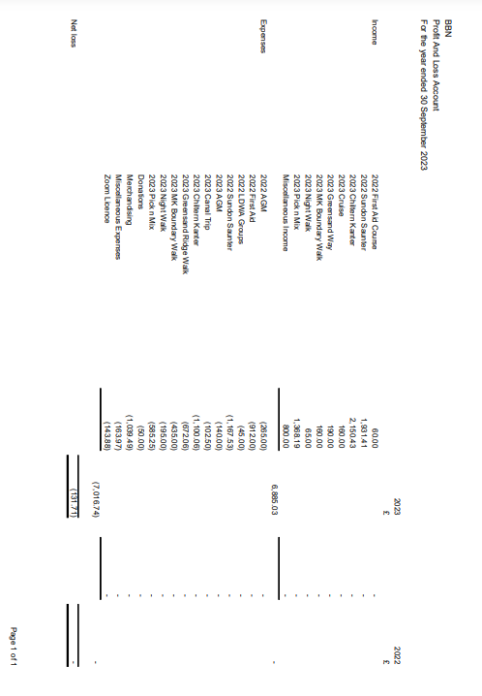
Miscellaneous Income for the year 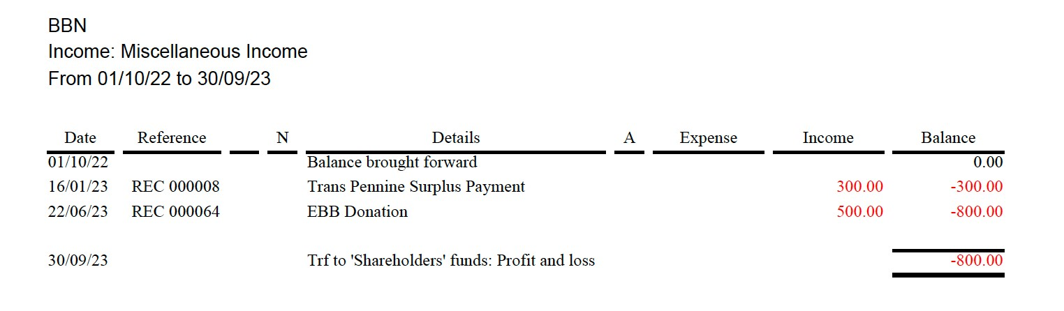
Miscellaneous Expenditure for the year

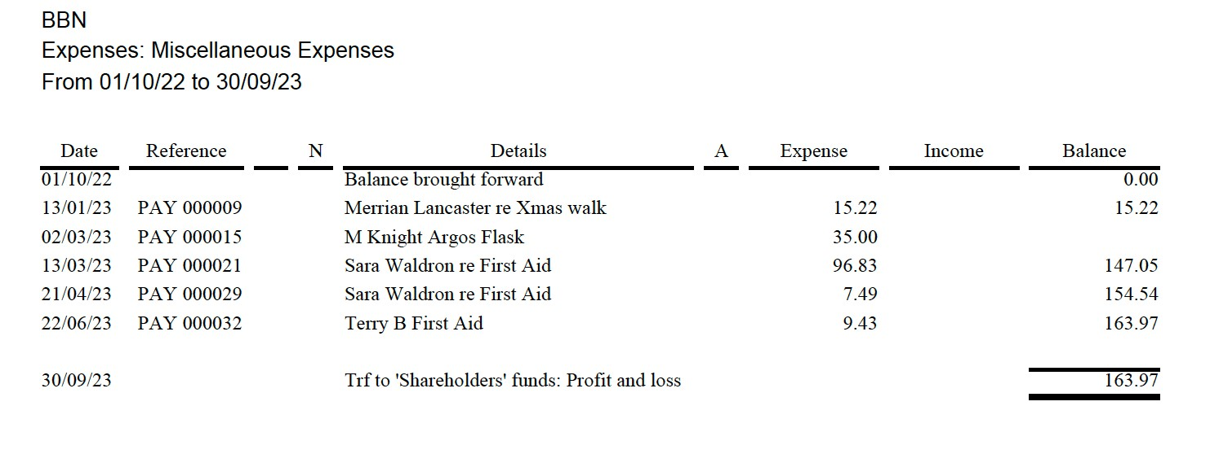
Merchandising Expenditure for the year

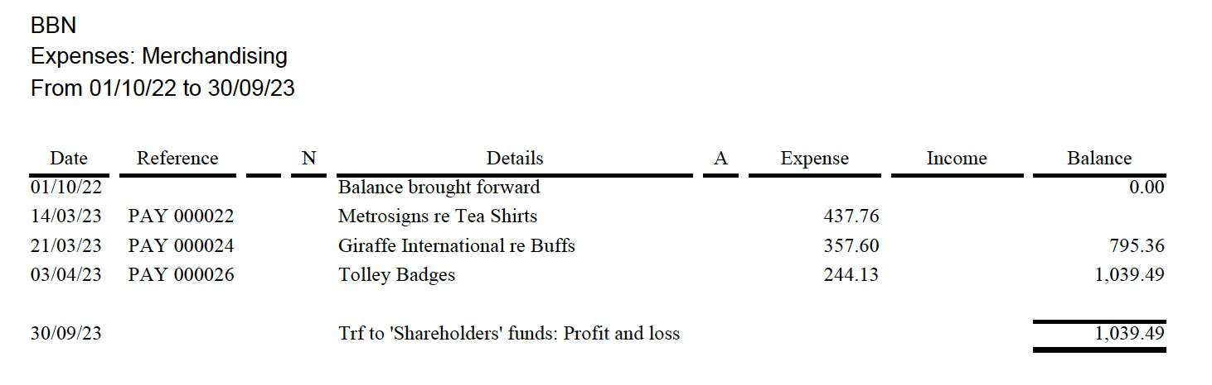

(d) | Challenge Walk Co-Ordinator Mike Hyland
Steppingley Step :- Flyer is done and on websites (BBN and LDWA), in Strider, is on SiEntries ready to go live from 1st September 2023.
Hannington Hike :- Flyer is done and on websites (BBN and LDWA), in August Strider. Is set up on SiEntries ready to go live on 1st December 2023.
Pick And Mix :- Flyer is done and will go on websites soon, will go into December Strider. Will set up with SiEntries in the next couple of months ready to check over in demo mode to go live on 1st April 2024.
(e) | Social Walks Sara Waldron
Since the last meeting I've continued to coordinate walks, kept the Available Walks Date list up to date and entered the walks on the website. Overall the response from walk leaders has been good with only a few gaps in the programme.
I've kept a portion of the merchandise and brought it along to social walks
(f) | Merchandising Peter Engledow Nothing further to report.
(g) | Equipment Dave Findel-Hawkins
Been a busy period with the Chiltern Kanter, EBB Hundred, Pick & Mix, Greensand Ridge in a Day. All equipment accounted for except one large teapot. One of the folding chairs now has torn fabric.
From Chiltern Kanter the equipment store has gained a Stanley knife, a roll of black sacks, 2.5 rolls of gaffer tape.
From Pick and Mix we gained a large free standing white board.
We have purchased 6 more white boards to bring total to 12.
The first aids kits have been updated/replaced by Sara/Terry so we now have 4 large first aid kits.
The pump flask with broken lid has been replaced.
The equipment list has been updated
I also have 6 BBN mugs (I think there are more hidden in my garage somewhere), 29 BBN neck warmers and 169 BBN badges.
Sales at Pick and Mix and Chiltern Kanter have left me with £40.
 | Terry may have the missing tea pot. | Terry
 | Dave to be asked to replace the folding chair with the torn fabric, | DFH
 | Terry has 6 mugs.  Total number of mugs to be checked after Ruby Doo in case we need to re-order. | DFH/  Terry/  Sara
 | A BBN badge to be added to a mug or a buff as the new leader incentive.
(h) | Website & Social Media Gill Bunker
Website: Kept updated with news, photos from group walks and events, challenge event info/route descriptions/finishing times etc.
Facebook: 332 members. WhatsApp: 24 participants.
BBN FB is a Private group, meaning only members can see who is in the group and what they post. It is Visible which means anyone can find the group.
(i) | Local Groups Rep Peter Engledow Nothing to report
(j) | Walks Database Sarah Feal Already discussed.
4. | LDWA Matters: Insurance Issues – Incident Reports
(a) | Insurance Issues – Incident Reports
 | There have been no reportable incidents.
(b) | Local Groups Data Summary (Dashboard)
 | Agreed this was interesting and would be a useful tool.
(c) | Walk with the NEC - 22nd October 2023
 | We are waiting for confirmation of where the NEC are meeting. Sara to advertise date, with more details to follow. Terry is free to lead if necessary. | Sara/  Terry
(d) | Local Groups Reps’ Meeting - 10th/12th November (Dorchester) | Peter
 | Peter will attend. Gill to confirm to organiser. | Gill
(e) | Local Groups Reps’ Meeting - November 2024
 | No-one present wanted to take on the organisation.
5. | LDWA Hundreds:  2023 Elephant Bear and Bull Mary Knight
BBN was allocated Checkpoint 3 on this year’s Elephant Bear and Bull 100. We had 15 Marshals in attendance which worked our perfectly. It was a lovely day, the hall was mostly glass, which was beautiful but maybe a little too warm. Most enjoyed the checkpoint sitting on the grass outside. We have received thanks from the organisers.
The 2024 100 is in Speyside Scotland and BBN have offered to organise one of the early checkpoints.
Future Hundreds Dave Findel-Hawkins
2024 Speyside, 2025 East Anglian, 2026 Hunnypot, 2027 Jurassic
 | Nothing to report beyond we have secured a checkpoint on all future ones.
6. | BBN Challenge Events
(a) | Pick & Mix 2023 (4th June 2023) Lynn & Dave Yorston
The 2023 event was held on June 4th from Wendover Memorial Hall.
All routes were well supported, even the wheelchair & buggy friendly interest route. We had 145 entrants turn up on what was a brilliant day. The full results and the statistics are already published on the BBN website.
Thanks to DFH for preparing GPX files for the first time on this event.
Massive thanks to all those who came out to help us in the running of such a fantastic day.
We made donations to both of the two schools and to the guide HQ for allowing us to park on their premises. We also sent a donation to Thames Valley Air Ambulance.
 | Future Events
(b) | Steppingley Step 2023 (19th November 2023) Dave Findel-Hawkins
Contacts for Westoning Village Hall, Ampthill Scout hut and Flitton Church hall contacted. All agreed in principle. Westoning paid for, Flitton confirmed. Waiting for update from Ampthill.
Karen/Sandra have agreed to change the menu at HQ to vegetable stew as provided on Hannington Hike/Chiltern Kanter.
Routes to be the same as last time but description need updating before Marshals’ walk due to changes on ground, particularly around Ampthill Park.
(c) | Hannington Hike 2024 (3rd March 2024) Alan Leadbetter
All is going well, Mike has done the SiEntries to go live for members on 1st December and then for all on 1st January.
I would like someone to check the long route description for me to see if it is alright, the main part to check is from Hannington Village Hall (checkpoint 2) to the finish.
Will start to ask for marshals after the Steppingley Step, will need 3 checkpoint managers and about 20 marshals.
(d) | Pick & Mix 2024 (2nd June 2024) Lynn & Dave Yorston
 | Wendover Memorial Hall has again been booked for 2nd June 2024 when we shall hold the next Pick & Mix. We will be asking for volunteers for that event early in the new year. Hope to see you all then.
(e) | Chiltern Kanter 2025 (2nd March 2025) Roy Carter
 | Roy is looking at possible alternative venues.
7. | BBN Group Events
(i) | Celebration of the BBN’s 40th Anniversary 2023
 | MK Boundary Walk Completed
 | Northampton Round Three walks done, two more dates arranged, two further dates to be confirmed.
 | Greensand Ridge Walk in Day 10th June 19 walkers took part. Google booking form worked well. Excellent support. Good feedback from participants..
 | Ruby Doo 22nd July 64 people booked.
 | Walks & River Cruise 3rd September 22 booked to date. Bulk email reminder to be sent out at the beginning of August.
 | Knightley/Grafton Way Night Walk 5th/6th August- Chris Bent organising. GRW Risk Assessment and Info Email to be sent to Chris to assist him. Need to have back up for any drop outs plus walkers’ emergency contacts. | Terry/  Gill
 | Autumn Spoons and a Ruby Murray Thursday 19th October.
(ii) | BBN Holiday 2023 Criccieth (25th/28th August 2023) Roy Carter
 | ThIs has been fully booked for some time. Roy has sent the final details to all.
8. | Financial Matters/Projects/Donations
(a) | Adoption of formal procedure for members to claim travel expenses | Peter/Gill Website
 | Peter to draft claim form. To go on website when approved.
 | 30p per mile, to a maximum of £25 for people checkpointing on BBN events and the LDWA Hundred. Commencing 1st October.
(b) | Donations
 | No suggestions from membership. Agreed to leave till after total 40th anniversary expenditure known.
9. | AGM: Sunday 26th November 2023 (Great Doddington) Alan Leadbetter
 | I will be recceing the walk on 30th July and then will go to the Stag Heads and see if I can have the menu for the meal. When I have the menu I will let you know and it can be put on the website for everybody to make their choice and let me know before 19th November so I can let the Stag Heads know on 20th November. | Alan
 | It was agreed we are happy for Alan to arrange future AGMs. | Alan
 | Committee Positions
 | Terry (Chair) and Peter (Treasurer) will both be standing down from their position. They will both draft a job description.  There is currently one vacancy on the committee. | Terry/  Peter
10. | AOB None
11. | Date of next committee meeting: Thursday 12th October 7.30 pm by Zoom

