LONG DISTANCE WALKERS ASSOCIATION - BEDS BUCKS NORTHANTS GROUP
MINUTES OF COMMITTEE MEETING
THURSDAY 6TH APRIL 2023 7.30 PM - BY ZOOM
Present: 8 Terry Brown (Chair), Gill Bunker (Secretary), Chris Burns, Roy Carter, Nick Emery,
Peter Engledow (Treasurer), Mike Hyland, Sara Waldron

1. | Apologies: Sarah Feal, Mary Knight | ACTION
Terry said Mary had been in contact to say that with immediate effect she was retiring from the committee. Terry was pleased to confirm, however, that Mary intends to continue with her current commitments, including the BBN40 events and the EBB CP. Thanks recorded to Mary for her time on the committee and her valuable contribution to the group.
Agreed there was no need to co-opt a new committee member at the moment.
2. | Minutes of Previous Committee Meeting (19th January 2023)
 | Replacement hot water flask: Mary has purchased one.
 | Whiteboards: Merrian has purchased 12 whiteboards @ £5 each and pens £4. Total cost £64.
 | Hosting of future LGRs’ meeting: Gill had responded to Karen Pickersgill’s email saying BBN may be able to host the weekend next year. We will now wait to hear from the NEC. | For the Future
 | BBN Buffs: 50 buffs ordered on 20th March with new colour match. Type: Repreve, recycled, bagged. Total cost £357.60 = £7.152 per buff. 3-4 week delivery after payment.  New Buffs to be sold for £7. Terry and Sara to each have10. The rest to go to DFH. The existing buffs to be sold at the current price of £5 or given to new walk leaders. | Gill  Terry/  Sara/  DFH
 | BBN Badges: Terry has 200 new badges. Terry to keep 10, 10 to Sara, the rest to Dave FH. Price to sell: £1.50. | Terry/  Sara/  DFH
 | BBN Mugs: selling for £2.00 Keep any eye on number remaining.
 | ICE Form: We have distributed all the small ICE cards. Sarah has drafted a form that members can print themselves. It was agreed that this form was excellent. It is to go on the website and be advertised to members, suggesting they using waterproof paper for printing, laminate the form or store it in a plastic wallet, and then keep it in their rucksack. | Gill/  Website/  TN
 | Risk Assessment: Terry has made a start on this. | Terry
3. | Reports
(a) | Chair Terry Brown
Since the last Committee Meeting I‘ve:
- Written a note for members to raise awareness about the LDWA’s Equality & Diversity and Safeguarding policy requirements.
- Nominated Gill for the LDWA Volunteer Awards.
- Ordered and collected the next batch of Marshal T shirts.
- With Sara – sorted out the BBN first aid kits.
- Ordered 200 BBN badges from Tolleys.
- With the ‘BBN40 Team’ progressed the programme of events and, specifically, devised a Google booking form for the Greensand Ridge in a Day and received the replies.
- Dealt with the usual LDWA NEC and BBN correspondence and various general queries.
(b) | Secretary Gill Bunker
- Tuesday News circulated regularly.
- Emails from NEC circulated and responded to as necessary.
- Janet Presland - Sad news of the death of a longtime member. £50 donation made to the Warwick & Northants Air Ambulance in Janet’s memory. (Agreed by email.)
- BBN membership as at 30th March: Primary 477 + Associate 419 Total = 896.
21 new primary members since 19th January committee meeting.
Total membership down by 83 since 19th January (less 48 primary and 35 associates).
 | Terry said that Norman is stepping down from his BBN “new member welcome phone call/email” role as he has volunteered to take on the LDWA National Membership role. It was agreed that the “welcome” was a valuable thing to do, that it was appreciated by new members and it would be great if we could continue to do this, An advert for a volunteer to go in the TN. Thanks recorded to Norman for the work he has done in welcoming new members, and good wishes to him in his new role. | Gill/  TN
(c) | Treasurer Peter Engledow – See Report p.6-7
 | Purchase of a contactless machine. Item raised by Norman.  Norman had asked the group to consider purchasing a contactless machine for payments for merchandise etc. Terry had done some research and reported that a simple machine which piggy-backed on a mobile phone would cost about £40. A device using a SIM, which could be used by more than one person, costs about £90. There is a 1.6% transaction fee.  Peter recommended using PayPal – there is still a fee to pay, but there would be no contract to be entered into. Peter will look into options.  Alternatively, purchasers could be given a note of BBN bank account details and could then transfer the money directly to the BBN account. | Peter
(d) | Challenge Walk Co-Ordinator Mike Hyland
Pick And Mix :- Event is open on SiEntries and as of Sunday 2nd April there are 57 entries.
Steppingley Step :- Flyer is done and on websites (BBN and LDWA) and in April Strider. Also is on SiEntries in demo mode to check over, ready to go live from 1st September.
Hannington Hike :- Flyer is ready and will go on websites soon. We will go into August Strider. Will set up with SiEntries in the next couple of months ready to check over in demo mode, to go live on 1st December 2023.
 | Mike: P&M entry now 64
(e) | Social Walks Sara Waldron
Since the last Committee meeting I have continued to encourage people to lead walks. The walks programme has not been completely full but overall I'm pleased with the members’ take up of available dates.
Terry & I have completely overhauled the First Aid Kits for the Challenge events. We now have 4 comprehensive kits of in-date items. We have a spreadsheet of expiry dates to facilitate keeping things straight in the future.
(f) | Merchandising Peter Engledow Nothing further to report.
(g) | Equipment Dave Findel-Hawkins List to be updated after the EBB 100. | DFH
(h) | Website & Social Media Gill Bunker
Website: Kept updated with news, photos from group walks and events, challenge event info/route descriptions/finishing times/lost property etc.
Facebook: 316 members. WhatsApp: 23 participants.
(i) | Local Groups Rep Peter Engledow
The notes from the LGRs meeting last November had recently been received from Karen Pickersgill.
Peter said the main issues discussed were:
 | (a) Charging non-members more to enter LDWA challenge events  Mike confirmed the CK and the P&M have a £3.00 premium, and the upcoming SS and HH have a £5 premium. This differential to be kept under review. | Committee & Event Organisers
 | (b) Event food safety, allergies, best practice: Gill has done the online Food Safety Level 1 course. Food Safety notes are now emailed to all CP helpers before our events, rather than being included in the event papers received on the morning of the event. The Food Safety course to be recommended to checkpoint volunteers. | Gill/TN
 | (c) Expenses To be discussed later in the meeting.
(j) | Walks Database Sarah Feal Remind leaders/walkers to send GPX to Sarah. | All
4. | LDWA Matters: Insurance Issues – Incident Reports
 | There have been no reportable incidents.
Terry commented:
The LDWA Newsletters received from Matt Parker are impressive;
The transfer of LDWA membership to SiEntries has happened;
The NEC had planned to come to our area for their May meeting, but this has been cancelled.
5. | LDWA Hundreds: 2023 EBB: CP 3 at Alvechurch Mary Knight
 | We have 17 volunteers to marshal on the EBB 100, even if a few need to drop out this should now be sufficient. All available information has been sent to all volunteers. Additional information has been requested by myself and DFH but no response has yet been received.
6. | BBN Challenge Events
(a) | Chiltern Kanter 2023 (5th March 2023) Roy Carter Report See p.8-9
Lots of good feedback after the walk,
Roy: Some discrepancy between his figures and the Accounts.
Peter: Probably due to some payments falling in the previous financial year.
It was agreed no donation would be made from the event surplus.
 | Future Events
(a) | Pick & Mix 2023 (4th June 2023 Lynn & Dave Yorston
As advertised, the 2023 event will be held on June 4th from Wendover Memorial Hall. All routes are now ready and being checked except the wheelchair & buggy friendly interest route which we will check during the Easter break. Thanks to DFH, the GPX files are being prepared.
We have contacted the adjacent schools to allow us to use the various parking areas on the day for our walkers. We are assured that as the walk is during the half term, the regular groups will not be meeting and using the parking spaces. A few spaces have been lost to school building works though.
HQ staff will park at the Guide Hall along Manor Close.
We could do with TWO more helpers at the 06.30 start and TWO at the finish to help clear up. Any volunteer would be free to walk during the day though.
(b) | Steppingley Step 2023 (19th November 2023) Dave Findel-Hawkins
 | All planning thought to be well in hand.
(c) | Hannington Hike 2024 (3rd March 2024) Alan Leadbetter
The 5th Hannington Hike will take place on Sunday 3rd March 2024, with the marshals’ walk on Sunday 11th February 2024.
Progressing well. HQ and all checkpoint halls booked, new routes worked out walked and route descriptions and GPX files done.
I will be looking for 3 checkpoint managers and about 20 Marshals to help on the day. I will be supporting the marshals’ walk with hot and cold drinks and snacks.
There will be a special certificate for anybody who will have completed all 5 events.
Mike has prepared a flyer for the SiEntries, the cost will be £10 for members and £15 for non-members, with members only from 1st December to 31st December.
 | Mike: Only two routes: 15½ and 26½ miles.
7. | BBN Group Events
(i) | Celebration of the BBN’s 40th Anniversary 2023
 | MK Boundary Walk – First two walks done. | BBN40 Team
 | Northampton Round – Information about first walk now on website. Two future dates remain to be confirmed.
 | Greensand Ridge Walk in Day – Progressing well. 20 walkers booked, including the leaders. Terry is using a Google booking form which is working extremely well, and is a very efficient way of collecting all the necessary information from walkers.
 | Ruby Doo – Needs to be progressed.
 | Walks & River Cruise – Sarah returns from NZ shortly and booking will then open.
 | Knightley/Grafton Way Night Walk - Chris Bent organising. To date 8 people booked.
 | Autumn Spoons and a Ruby Murray -Thursday 19th October.
(ii) | BBN Holiday 2023 Criccieth (25th/28th August 2023) Roy Carter
The BBN Holiday is to Criccieth, N.Wales on August Bank holiday – the 25th to 28th August 2023 and announced at the last meeting. Since then, I have acquired Single, Twin and Double room accommodation through Alfa Travel at the George IV Hotel in Criccieth and all rooms now booked up by 22x LDWA members wishing to come.
That was the easy task. I’ve now to prepare a programme of walks to justify their enthusiasm to be beside the seaside. I’m hoping to concentrate most of the weekend on walks along much of the Lleyn Peninsula but may include a possible train or bus ride up to Blaenau Ffestiniog for us then to walk back to Criccieth.
(iii) | Dogs on BBN Group Walks  This is the LDWA’s Dogs on Walks policy:  It is recognised that, for some dog owners, it is important they can bring their dogs along on walks. Local groups have different approaches in this area; there is no standard national policy. Local groups and walk leaders can decide on the most appropriate approach for their group/walk based on local circumstances and times of year. Ultimately the decision to allow dogs on walks rests with the walk leader or walk organiser, though if no dogs are allowed this must be made clear prior to the walk. Assistance dogs are normally allowed on LDWA walks. The walk leader can insist on dogs being on leads, and in particular dogs must be kept on leads anywhere where there is a possibility of livestock. Owners must provide verbal confirmation to the walk leader that their dog is covered by pet owners’ liability insurance before the walk.  Dogs on BBN Challenge Events  The committee had previously agreed the following for our events  Dogs are allowed on the event, BUT NO DOGS are allowed inside any of the halls (except assistance dogs).ALL must be on leads at all times and MUST have appropriate liability insurance.  A reminder from Mike: No dogs are allowed on the Hannington Hike as the event is held during lambing season in a sheep farming area.
 | It was agreed that:  Please check with the walk leader before bringing a dog on a group walk  will to be added to walks info/website etc. | Sara/Gill  Website/Strider
8. | Financial Matters/Projects/Donations
(i) | Adoption of formal procedure for members to claim expenses
 | Terry is drafting full explanatory notes to be circulated to members.  Peter will draft a claim form.  Agreed to offer 30p per mile towards travel expenses, up to a maximum of £25,  for people checkpointing on BBN events and the LDWA Hundred. | Terry/  Peter  Gill/TN  Website/
 | The £300 received from the Trans-Pennine Hundred will be retained in group funds for the moment.
(ii) | Donations No suggestions for donations had been received.
9. | AGM: Sunday 26th November 2023 Alan Leadbetter  Great Doddington Memorial Hall booked and deposit paid. The Stags Head booked for 24, with 12.30pm seating to start about 12.45. Sorry to say that I could not do a deal for 2/3 courses, but was told that 2 courses normally cost around £25. The menu will be emailed to me sometime in July. | Alan
 | Terry (Chair) and Peter (Treasurer) will both be standing down at the AGM.  They will both draft a job description to be circulated. | Terry/  Peter  Gill/TNs
10. | AOB None
11. | Date of next committee meeting: Thursday 20th July 7.30 pm by Zoom
Item 3(c)
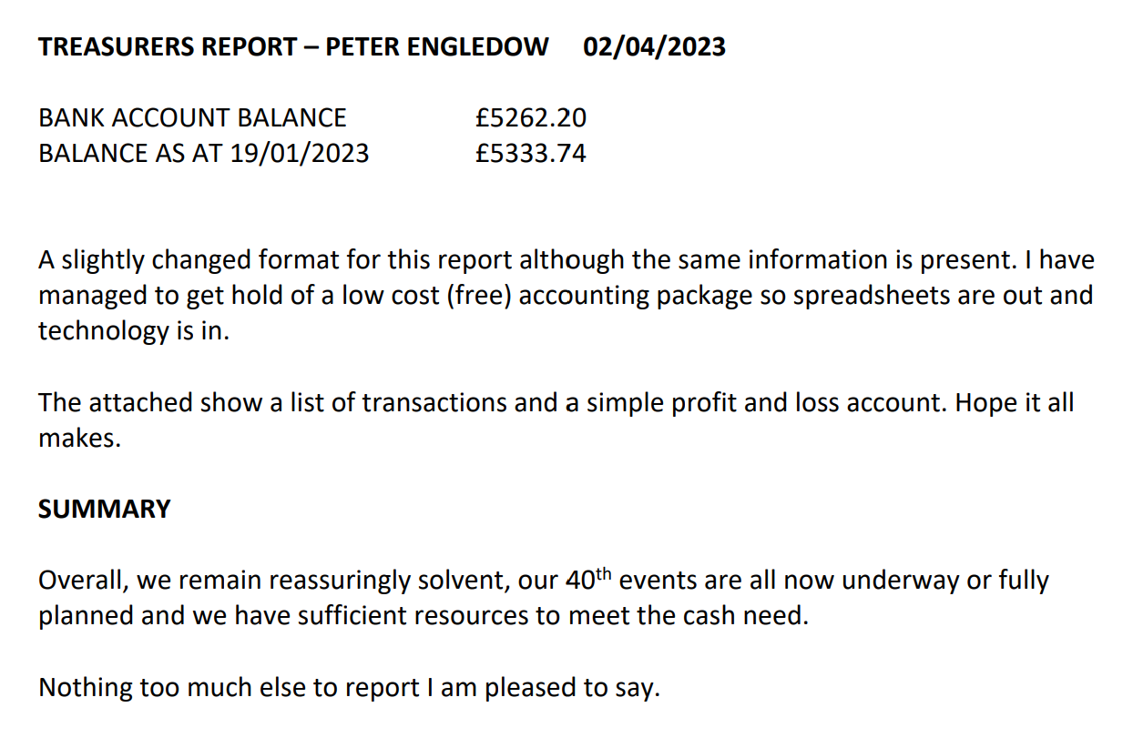
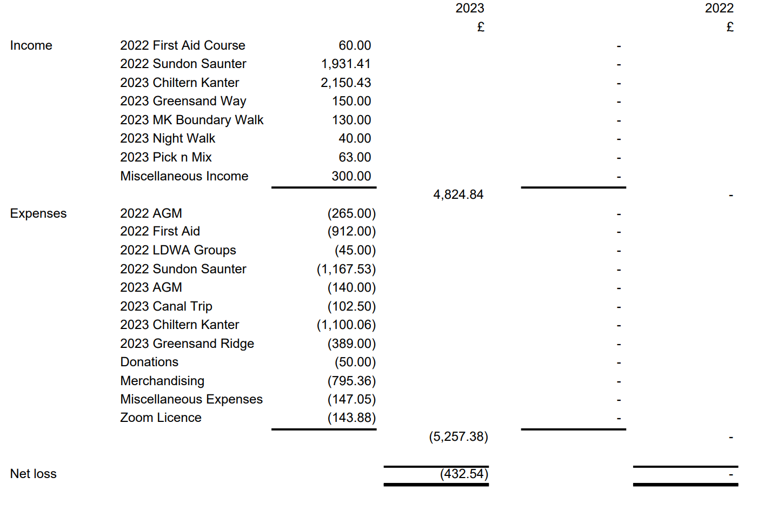
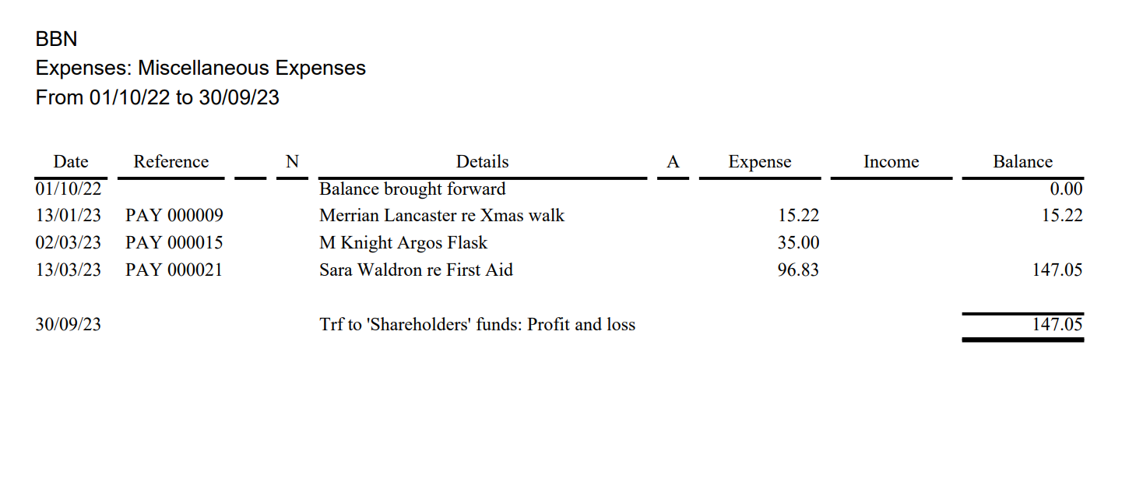
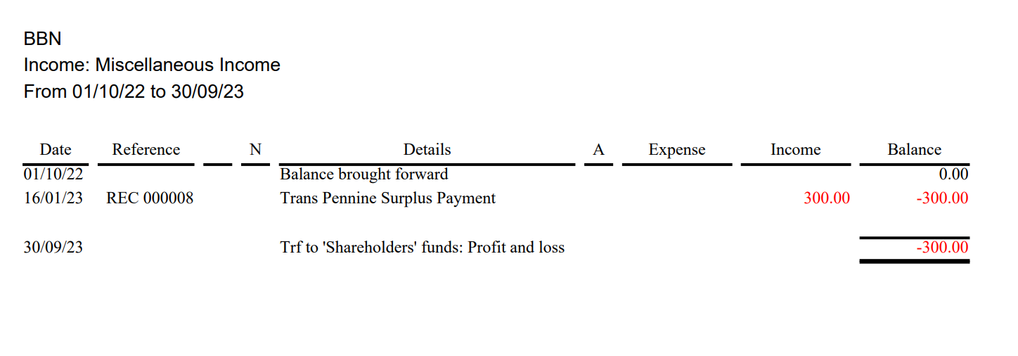

Item 6(a) Challenge Events: Chiltern Kanter 2023 Roy Carter
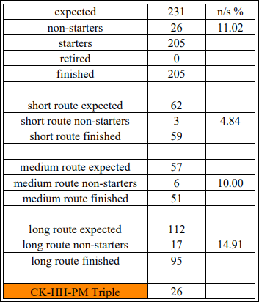
The 22nd Chiltern Kanter was held on Sunday 5th March for 205 participants who had arrived. There were 231 expected on the Kanter, based on bookings from SiEntries. This represents an 89% turn-out on the day and they all finished with no retirements. The Short route: 59 completed; Medium route: 51 completed & Long route: 95 completed. Also, 26 participants had the honour of receiving the CK-HH-PM Triple Challenge. The weather was cool, dry and reasonably sunny, which participants thought were ideal.

There were 24 Marshals on hand to help with every eventuality that may occur on the day. A problem began before participants arrived at Pitstone Hall. We spotted the hot water Urn had a message saying “Out of Order. Reported 23/02/23”. It meant we could only use the few slow boiling kettles around, to prepare tea or coffee for those arriving. A 2nd problem occurred simultaneously when Karen noticed there wasn’t enough bowls for both stew and dessert. Therefore DFH had to go back to the Equipment cupboard at home to fetch the BBN Urn & Bowls. A 3rd problem occurred late morning at Aldbury CP, when the Disabled toilet flooded, which also affected the Ladies toilet. Alan was on hand to mop up the spill. From that point on participants at the checkpoint could only use the Gents toilet.
Other issues during the day: The Defibrillator kept buzzing and flashing at Pitstone and space to store prepared food was limited at Wigginton.
Response from the Aldbury Memorial Hall committee:
“I know that they found a blockage in the pipes near some of the neighbouring cottages. My understanding that this issue was unique and is unlikely to happen again”
Response from the Pitstone Memorial Hallmaster:
“I believe both issues, the Urn and Defib, are being sorted swiftly, as we also want to keep our popular hall up to spec for the community. Thank you for your concern”

Marshal Information:
Entries & Route Designer: Mike Hyland & Roy Carter
Start/Finish Registration: Dave Findel-Hawkins, Merrian Lancaster, Norman Corrin and Mike Hyland
Car Parking at Pitstone Museum: Alan Leadbetter, Mike Hyland, Brian Chandler,
John Davies and Philip Vidler
Checkpoint 1: Aldbury Memorial Hall: Mary & Dennis Knight, Gordon Shaughnessy,
Chris Burns, Therese Jamin and Alan Leadbetter
Checkpoint 2 & 3 Wigginton Village Hall: Gill Bunker, Jackie Burnett, Beryl & Mike
Bowley, Sarah Feal and Terry Brown
Meeters and Greeters at Pitstone: Dave & Lynn Yorston, Norman Corrin and John Davies
Kitchen at Pitstone: Karen Earwicker, Alison Roberts, Philip Vidler & Brian Chandler

Can I thank Checkpoint managers Mary Knight at Aldbury & Gill Bunker at Wigginton for offering their selection of food and drink which was praised by many participants. A thank you to Karen Earwicker at Pitstone for preparing the final course of vegetable stew and fruit dessert which participants really enjoyed. A thank you also to Merrian & Dave for the processes of registration and certification. And finally a very big thank to all our Marshals for attending to participants’ needs.
Finances:
Total Income: £1926.18 Total Expenditure: £1255.06 Surplus: £671.12 Peter has checked the figures.

