PERSONAL DETAILS
Name:
Address: (house no, postcode)
Date-of-Birth:

Beds, Bucks & Northants LDWA
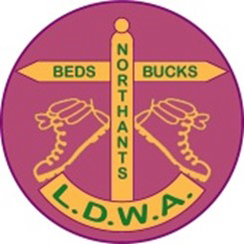

Please carry with you on all walks
in an accessible place!

PRIMARY EMERGENCY CONTACT
Name:
Phone:

GP DETAILS
Surgery name:
Postcode:

emergency services
In an area with road access:
- Call 999 and ask for an ambulance

NO PHONE SIGNAL
Ask members of the group to seek help.
Only split the group if necessary, and work together in groups of 3 if possible.
Shout / signal for help e.g., 6 whistle blasts and wait until your emergency contact raises the alarm.

SECONDARY EMERGENCY CONTACT
Name:
Phone:

Medical INFORMATION
Medication:
Conditions: (allergies, blood group etc.)

emergency services
In a remote area:
- Call 999 and ask for the Police, then ask the Police to call Mountain Rescue

EMERGENCY MESSAGE DETAILS
- Your location.
- Details about the incident and casualty.
- Number of people in your group.
- Your mobile number.
- Any other location details to help identify your group.
IN CASE OF EMERGENCY

