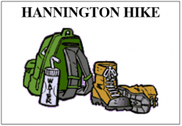 | HANNINGTON HIKE  1st March 2020 REPORT

Having switched the event from July to March, I was not sure how it would go. As the entries went up it looked as if it was a good decision. With the limit of 200 reached by mid-February and with 30 on a waiting list, the decision was made to raise the limit to 240 and everybody on the waiting list was invited to join. When entries closed on 27th February a total of 235 had entered.

 | Oct | Nov | Dec | Jan | Feb | Total
Entries | 9 | 18 | 41 | 107 | 78 | 253
Cancelled | 1 | 1 | 2 | 8 | 6 | 18
 | 8 | 17 | 39 | 99 | 72 | 235

Anytime Anywhere | 1 | Kent | 2 | Surry | 2
Beds, Bucks & Northants | 71 | Lincolnshire | 3 | Sussex | 1
East Lancashire | 3 | London | 5 | Thames Valley | 8
Essex & Herts | 8 | Norfolk & Suffolk | 13
Heart of England | 10 | North Yorkshire | 2
Irregulars | 1 | Sherwood | 5 | Non-Members | 100

Had a few worries along the way. The badges that I ordered nearly did not arrive in time. I received an email in January say that due to some of the materials coming from China there will be a delay in delivery (due to Covid19). Having not heard from them by mid-February I emailed to find out how things were progressing and was told that they were in production and should be despatched the week beginning 2/3/20. I replied that as the event was on the 1/3/20 it would be nice to have them for the event day. Got a reply say that there was a production meet on 24/2/20 and will ask if it could be possible to produce them soon. On Wed 26/2/20 was told that the badges were in the office and would be despatched by courier. I got home from work on Thursday to find that the badges had arrived and been left with a neighbour. What a relief.

Had 9 marshals + myself for the marshals’ walk on 1st February. 1 on 27 miles route, 2 on 18.5 mile route and 7 on 14 mile route. Thank you.

Liz Sheffield | 27 | Karen Earwicker | 14 | Mike Hyland | 14
David Findel-Hawkins | 18 | Gill Bunker | 14 | Dave Yorston | 14
Merrian Lancaster | 18 | Norman Corrin | 14 | Steve Bacon | 14

With all routes checked and amendments made to the route descriptions, these were then put on the website.

8 entries withdrew before the day and with 29 no shows that left 198 to start their chosen route.
27 Miles | 18.5 Miles | 14 Miles
98 | 60 | 40

There was a misunderstanding amongst us about start times, we only recorded two start times, 08.00 and 09.00. Some may have started before 0800, many started sometime between 08.00 and 09.00, and some started after 09.00.
On the list for next time, 2022, will be to have a rolling start.

6 entries retired (4 at checkpoint 1 and 2 at checkpoint 2). 5 entries missed out a checkpoint but still finished. A couple of runners went off on the walkers’ start, were 15 minutes early at CP1 and 45 minutes early at CP2. They did not wait for the checkpoint to open. At the finish, when asked why they had done this, they said they thought they were only five minutes early at CP2 and did not want to wait because they had things to do in the afternoon. When told they would be recorded as missing CP2 and not get a certificate, one said “well in the whole scheme of things, it’s such a small event, it doesn’t really matter”. If that was the case why did they enter in the first place (makes me wonder)?

 | Male 48% | Female 52%
Walkers | 62 | 71 | 133
Runners | 34 | 31 | 65
 | 96 | 102

Walkers | Male | Female | Runners | Male | Female
27 miles | 34 | 25 | 27 miles | 21 | 18
18.5 miles | 20 | 23 | 18.5 miles | 9 | 8
14 miles | 8 | 23 | 14 miles | 4 | 5
 | 62 | 71 |  | 34 | 31

A big THANK YOU to all who helped before or on the day without their help this event would not be able to go ahead. We had a few new marshals this year, some doing it for the first time, Sophie Butler, Betty Sturgeon, Steve Bacon and Frank Hodgson. Hope they enjoyed themselves and will help on future events.

Marshals
Car Parking: Andrew Gilbertson, Steve Bacon and Frank Hodgson
Registration: David Findel-Hawkins, Merrian Lancaster and Gordon Shaughnessy
HQ Kitchen: Karen Earwicker, Liz Sheffield, Andrew Gilbertson and
Sue Leonard (pm)
Checkpoint 1: Gill Bunker, Norman Corrin, Derek Jacob, Anne Addison,
Betty Sturgeon and Sophie Butler
Checkpoint 2/3: Terry Brown, Dave & Lynn Yorston, Mike & Sandra Hyland
and Frank Hodgson

Accounts
Income | £ | Expenditure | £
SiEntries | 2047.01 | HQ & Halls | 435.50
 |  | Badges | 266.44
 |  | Food | 340.27
 |  | Van & Fuel | 188.00
Total | 2047.01 | Total | 1230.21

Income minus expenditure = Surplus – donation = total surplus
£2047.01 – £1230.21 = £816.80 - £400.00 = £416.80

With a surplus of £816.80, a donation of £400 was made to the LDWA website fund.
100 Non-members paying £4 more than members.
With the donation taken away that leaves a surplus of £416.80

I would like to thank everybody who took part or helped on the event and hopefully see you all next time in 2022, with some route amendments.

Alan Leadbetter

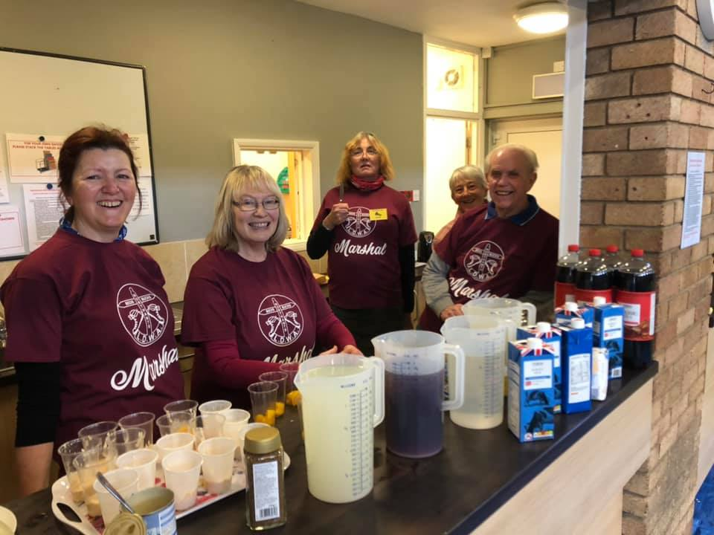
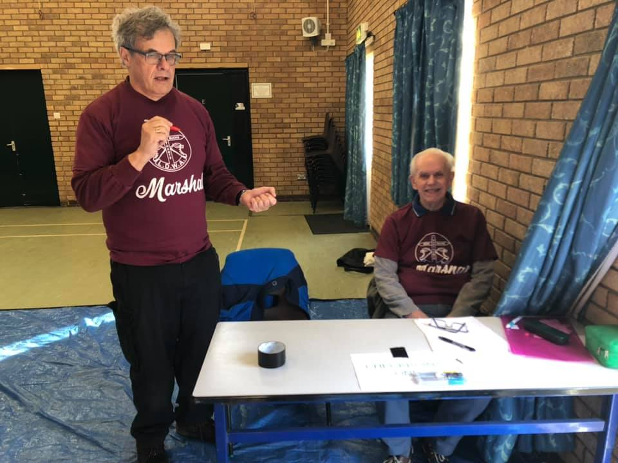

The new BBN marshals’ T-shirts at the Hannington Hike

The surplus food from the event was donated to NHS staff at Stoke Mandeville.
.

