|  |  |
| --- | --- |
| LDWA Logo black & white | **LONG DISTANCE WALKERS ASSOCIATION AIM: TO FURTHER THE INTERESTS OF THOSE  WHO ENJOY LONG DISTANCE WALKING** |

**BEDS, BUCKS &  
NORTHANTS GROUP**

**NEWSLETTER**

**SPRING 2018**



**A very warm welcome to all new LDWA members in our three counties** -   
if you haven’t already been on a group walk or one of our challenge events we hope to welcome you on one soon.

Because of recent changes in data protection laws BBN are now using the LDWA database to contact members – this means that Group Updates are now being sent to all LDWA members in our area rather than, as previously, only to those who had paid the (now discontinued) £1 BBN “administration fee”. Many more people are now receiving these Updates.

We understand that many LDWA members prefer to walk on their own and have no wish to walk with a group, **BUT** if you have never been on a group walk and would like to come along please do take a look at our website <https://www.ldwa.org.uk/bedsbucksandnorthants> – there is lots of information here about our Thursday and weekend walks and also our challenge events. There is also information about who to contact if you need any further advice, plus masses of photographs of recent walks so you can see where we go and what we do.

If you are on Facebook there are lots more photos on our FB page <https://www.facebook.com/groups/LDWABBN/>

You are welcome to come along on any of our walks and we hope that you find us a welcoming and friendly group.

**HARD COPY NEWSLETTER**

Following the decision at the 2017 AGM to discontinue BBN’s £1  
 administration fee and with the continuing rise in the cost of printing and postage, the committee have decided to take this opportunity to update   
the list of members who wish to receive a hard copy of the Newsletter.

**Therefore members now need to opt in to receive a hard copy   
of future Newsletters. Please contact Dave Findel-Hawkins   
if you wish to receive a hard copy of future Newsletters.  
*T*: 01908 216476 *E*:** [**davefh@gmail.com**](mailto:davefh@gmail.com)

**Introducing your new Chairman**

|  |  |
| --- | --- |
| Hello, my name is Teresa Brown, known to friends and family as Terry (it’s a long story!). I was honoured to be elected BBN Chairman at the AGM in November.  I thought I’d write a bit about myself.  Walking has always been part of my life. As a child we went on family holidays to the Lake District, using the Wainwright guides we enjoyed exploring fells, lakes, rivers and villages. In my early twenties I went on back packing holidays with friends to the Lakes, North Yorkshire, Scotland and Austria. |  |

Work, marriage and motherhood meant that walking took a bit of a back seat until the mid-nineties when, living in Hitchin, north Hertfordshire, I discovered the Icknield Way long distance path and really wanted to do it, Hitchin being very near the route. My Mum and I completed it as day walks over about 6 months and we thoroughly enjoyed it. I was amazed that we were able to walk between 8 and 14 miles in a day and how far this looked on the map!

My interest in longer distance walking started after I did the London Moon Walk power walking marathon in 2007 and 2008, both completed in just over 7 hours. I enjoyed doing the longer distance but wondered if there was another way I could do this regularly without having to get charity sponsorship each time – there’s only so much you can ask friends to sponsor you, even if it is for a good cause!

I was talking to David Anderson at a Bedfordshire Bird Club meeting about walking and he mentioned the LDWA to me and very kindly lent me some back issues of Strider. I realised that this is what I had been looking for and joined as a BBN member! My first challenge walk was the 18 mile Steppingley Step in November 2008. Since then I have done about 7 or 8 Challenge walks a year. I have done quite a few 50s now although the 100 isn’t on my radar yet!

I have quite a few other interests – I sing with the St Albans Bach Choir; I am a bell ringer at All Saints Clifton and currently the Honorary Secretary of the Bedfordshire Association of Church Bell Ringers (which takes up a lot of my spare time); I am a 3rd Degree Black Belt in the Korean marshal art of Tae

Kwondo, I’m currently training for my 4th Dan grading sometime in the next year or so; and I am a keen birdwatcher, RSPB and Beds Bird Club member.

Before I retired last March, I found it difficult to come on many social walks because of work and these other pastimes and commitments but now I’m able to come on the Thursday social walks which I really enjoy.

I’ll do my best to support your excellent and hardworking BBN Committee during the coming year. Please get in touch if you have any ideas or feedback about what we do. I look forward to meeting you on a social or challenge walk.  
Do come and say hello.

Best wishes

Terry

[bbn.chair@ldwa.org.uk](mailto:bbn.chair@ldwa.org.uk)

-------------------------------------------------------------------------------------------------------------------------------

**Walks Programme – September to December 2018**

Just when you thought you could put Christmas behind you and pack away the decorations, someone reminds you that it is all going to happen again next year. Sorry folks!

Below are the dates for the next walk programme we are working on that will go into Strider. If you would like to lead a walk on any of the available dates please let me know. If you would like to arrange a walk on any other date that’s fine too, but please do let me know.

Below are available dates for **Thursday** walks:

|  |  |  |
| --- | --- | --- |
| September | 6th |  |
|  | 20th |  |
|  |  |  |
| October | 4th |  |
|  | 18th |  |
|  |  |  |
| November | 1st | Allan Burnett/Linda Marsh |
|  | 15th |  |
|  | 29th |  |
|  |  |  |
| December | 13th |  |
|  | 20th | Christmas at Wetherspoons |
|  | 27th |  |

And these are available dates for **weekend** walks. Please remember walks can be Saturday or Sunday – just e-mail me to reserve your date.

|  |  |  |
| --- | --- | --- |
| September | 1st/2nd |  |
|  | 15th/16th |  |
|  | 29th/30th |  |
|  |  |  |
| October | 13th/14th |  |
|  | 28th | Sundon Saunter Marshals’ |
|  |  |  |
| November | 10th/11th |  |
|  | 18th | Sundon Saunter |
|  | 25th | AGM |
|  |  |  |
| December | 8th/9th |  |
|  | 22nd/23rd |  |

One final plea – after your walk please e-mail me with your walk stats (distance and number of walkers). Thanking you in anticipation.

Best wishes and happy walking

Mary Knight  
Social Walks Secretary   
(maryjknight@hotmail.co.uk)

Introducing BBN’s new Challenge Event

THE HANNINGTON HIKE  
Sunday 15th July 2018

This is replacing From Here to There & Back,   
starting from the same location with some new routes.

There will be routes of 27, 19 and 14 miles, so why not join us.

If you want to see how thing work on the other side why not   
help out, we could do with help at the checkpoints and   
car parking at the start.

Email Alan Leadbetter at [bbn-hh@ldwa.org.uk](mailto:bbn-hh@ldwa.org.uk)   
if you can help on the day.

***BBN HOLIDAY TO HARTINGTON   
24th – 27th AUGUST 2018.***



The walking weekend is centred on Hartington, a pretty village in the heart of the White Peak area of Derbyshire with its wonderful countryside and excellent walking opportunities. The main walks are on Saturday and Sunday – both walks being a comfortable 17 miles. There is an introductory walk Friday afternoon and a departing walk on Monday – 9 miles and 13 miles respectively.

*Accommodation will need to be obtained in Hartington or in the surrounding villages. There are many Guest Houses, B&B’s, Rental Properties, Campsites and Youth Hostels in the area but they do get booked up early – please contact the holiday organiser Roy Carter to indicate interest* [roycarter367@hotmail.com](mailto:roycarter367@hotmail.com)

*or* 01234 301182

**Hartington** is the major village on the central section of the valley of the Dove. It is an old village which was granted a market charter in 1203. The church was built in the 14th – 15th centuries from local sandstone. Opposite the church stands the 17th century Hartington Hall which is now a Youth Hostel. Nuttall's creamery, once a source of Stilton and Buxton Blue cheese, lies just off the Green. Cheese was produced here from 1900 to 2009. Sadly, in 2008 the creamery was sold by Dairy Crest to Long Clawson Dairy, a rival Stilton maker (Leicestershire is one of the two other areas permitted to make Stilton cheese) and within a month they took steps to close the creamery down - with the loss of 190 jobs. Until then Hartington was the supplier of 25% of the world output of Stilton cheese. There is still a cheese shop outside selling a range of local cheeses but none now from Hartington.

See the Walks Itinerary on the following page, plus more information on the website <https://www.ldwa.org.uk/BedsBucksAndNorthants/N/5662/hartington-we-august-2018.html>

**Walk Itinerary**

**Friday 24th August @ 1:30pm 9 miles**

The walk starts from the centre of Hartington by the Duck Pond and crosses the River Dove to climb uphill to the hamlet of Sheen. Passing the church and staying on the ridge between the Dove & Manifold valleys, we descend to Crowdecote for an afternoon stop at the Pack Horse Inn. Afterwards we follow the River Dove down to the remains of Pilsbury Castle – an Iron Age fortification used by the Normans – then onwards to Hartington.

**Saturday 25th August @ 9:30am 17 miles**

The walk starts from the centre of Hartington by the Duck Pond and heads south to Beresford Dale, above Narrowdale before descending to Hopedale. The walk gradually climbs back up to Castern Wood and Castern Hall where there are lovely views of the Manifold Valley before dropping into Ilam Country Park (NT) and Hall (YHA) for lunch. After lunch we cross the stepping stones over the River Dove and follow the valley up to Milldale for afternoon tea. We then continue up Dovedale to Hartington via Wolfescote Dale.

**Sunday 26th August @ 9:30am 17 miles**

It is a 25 minute drive north to the start of the walk from White Lodge Car Park (charge), situated just off the A6 near Monsal Dale. We walk up Monsal Dale and cross the Monsal Trail to Cressbrook Mill – a textile mill built by the father of the Industrial Revolution, Richard Arkwright. Then follow the River Wye through Miller’s Dale to Litton Mill keeping to the valley floor and pass through Tideswell Dale to Tideswell for a break. After we make our way to Monk’s Dale and descend to Miller’s Dale again for lunch at The Angler’s Rest. In the afternoon we walk the Monsal Trail to Ashford in the Water – a former Midland Line rail link from Manchester to London closed by Barbara Castle (not Beeching) in 1968. Returning beside the River Wye to the carpark.

**Monday 27th August @ 10:00am 13 miles**

The walk starts from the pond at Monyash, just 15 minutes north of Hartington. It follows the Limestone Way over fields and past farmyards before a steep climb out of Cales Dale. We walk round to Middleton and descend to the River Bradford and follow it to Youlgreave for a break. The walk continues further down river to Alport and up Lathkill Dale - one of the finest limestone dales. Leaving it we ascend to Over Haddon to enjoy lunch and views down the dale from the Lathkill Hotel. In the afternoon we return to Lathkill Dale and follow it back to Monyash for tea in the café before the homeward journey.

Roy Carter, [roycarter367@hotmail.com](mailto:roycarter367@hotmail.como)01234 301182

**IMPORTANT INFORMATION FOR EVERYONE  
PLEASE DO READ THIS!**

**Publicising pop up walks**Pop ups will be advertised via Updates, Facebook and the LDWA/BBN Website.  
Details of the walk (the same information as required for Strider) should be emailed to Peter Simon ([bbn@ldwa.org.uk](mailto:bbn@ldwa.org.uk)) and Mary Knight ([bbn.walks@ldwa.org.uk](mailto:bbn.walks@ldwa.org.uk)) by 6pm on the Tuesday preceding the planned walk. Pop ups must not conflict with a weekend or Thursday walk that already appears in *Strider* or one of our challenge events. Should more than one offer of a pop up be received for a specific date, only the first walk will be advertised. Hopefully the second volunteer will offer another date!

**Reportable incidents**Walk leaders/event organisers should familiarise themselves with the LDWA's advice on what constitutes a reportable incident and what needs to be done if such an incident should occur. Please look at the *Accident & Incident Form* on the LDWA website [www.ldwa.org.uk/library/library.php](http://www.ldwa.org.uk/library/library.php). (Keep scrolling down, it is near the end.)

**Emergency contact information  
Non-LDWA members** Walk leaders should print off the form *Emergency Contact Details - Non-LDWA participants* from the BBN website. <https://www.ldwa.org.uk/BedsBucksAndNorthants/W/1045/document-store.html>  
Before the walk starts any non-LDWA members should fill in their emergency contact details. Following data protection rules, the form must be destroyed at the end of the walk if there have been no reportable incidents involving the non-members.

**LDWA members** are reminded to carry their own emergency information – you can use the ICE form

[on the BBN website]( on the BBN websitehttps://www.ldwa.org.uk/BedsBucksAndNorthants/W/1045/document-store.html)

[https://www.ldwa.org.uk/BedsBucksAndNorthants/W/1045/document-store.html]( on the BBN websitehttps://www.ldwa.org.uk/BedsBucksAndNorthants/W/1045/document-store.html)

**Merchandise sale**The group is selling some of its stock of old merchandise at discounted prices.   
Details are on the website: <https://www.ldwa.org.uk/BedsBucksAndNorthants/W/5646/sale-feb-2018.html>.  
If you are interested in any item, please contact Merrian Lancaster [merrian22@gmail.com](mailto:merrian22@gmail.com).

**2020 Hundred -** BBN are hoping to run a checkpoint on the 2020 Hundred in Wales.  
Norman Corrin has offered to co-ordinate the checkpoint, but needs members to step up to help him. Please contact Norman if you can help [norman.corrin@gmail.com](mailto:norman.corrin@gmail.com).

**Possible cancellation of walks due to bad weather**In the event of bad weather or the forecast of bad weather, the cancellation of a walk will be confirmed the previous evening on Facebook and via Stop Press on the Event details on the LDWA/BBN websites. Please check before you travel!

**That’s the serious stuff done folk** ……………………….



*With thanks to Tim Vine and Tommy Cooper*

I bought a train ticket and the driver said ‘Eurostar’. I said ‘Well I’ve been on telly but I’m no Dean Martin.’ Still, at least it’s comfortable on Eurostar; it’s murder on the Orient Express…..

So I was standing on my window ledge, six floors up, looking down at the traffic. I thought, one slip now and it’s curtains for me. And if I fall the other way, I’m gonna die.

I said to this barn owl, I said I’ve just got engaged. He said, you twit to who?

I saw this sign. It said, ‘Hairdressing for Men’. I walked in and there was a rabbit trying on clothes and all these blokes saying, yeah, very nice.

Did you know if you chop a horse in two then bang the halves together, it sounds like someone riding a coconut?

My girlfriend is covered from head to toe in grass. Her name’s Lorna.

It’s strange isn’t it, you stand in a library and go “Aaaaaargh” and everyone stares at you. Do the same thing on an aeroplane and everyone joins in.

I had a dream last night. This voice said, “On your marks, get set, go!” and I woke up with a start.

Last night I dreamt I was the author of Lord of the Rings. I was Tolkien in my sleep.

I saw Schindler’s List, and the bloke behind me started wailing. I got hit on the back of the head with a harpoon.

The advantage of easy origami is twofold……

**Norman Corrin**

**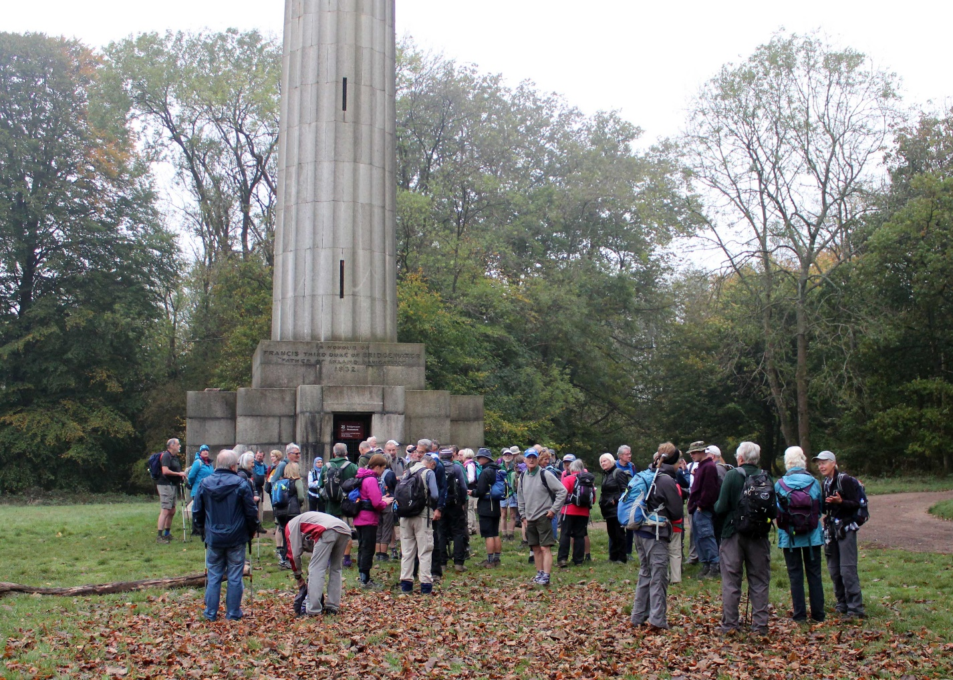**

**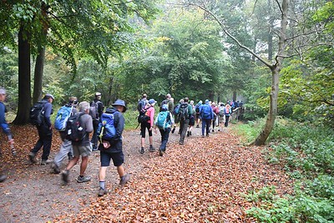**

*The first group setting off from Ashridge*

**JOHN NICKERSON MEMORIAL WALK   
15 OCTOBER 2017**

On a misty autumn morning about 80 people met in the car park at the Bridgewater Monument on the Ashridge Estate in Hertfordshire. These walkers came mainly from the 3 groups John walked with in recent years, namely Essex and Herts, Thames Valley and BBN branches of the LDWA. As the group was rather large it was divided into two, John Esslemont from Thames Valley leading the first group and Brian Martin from Essex and Herts the second.

The walk followed the Ashridge Boundary Trail, a 17 mile route round the periphery of the Ashridge Estate. It was one of John’s favourite local walks and passed Dockey Wood where his ashes were scattered in the spring amongst the bluebells. At the end of the walk the ladies from Thames Valley organised cakes and drinks which was a very kind gesture and one that was very much appreciated.

The walk was a fitting tribute to a loyal, active and long-standing member of the LDWA.

**Judy Nickerson**

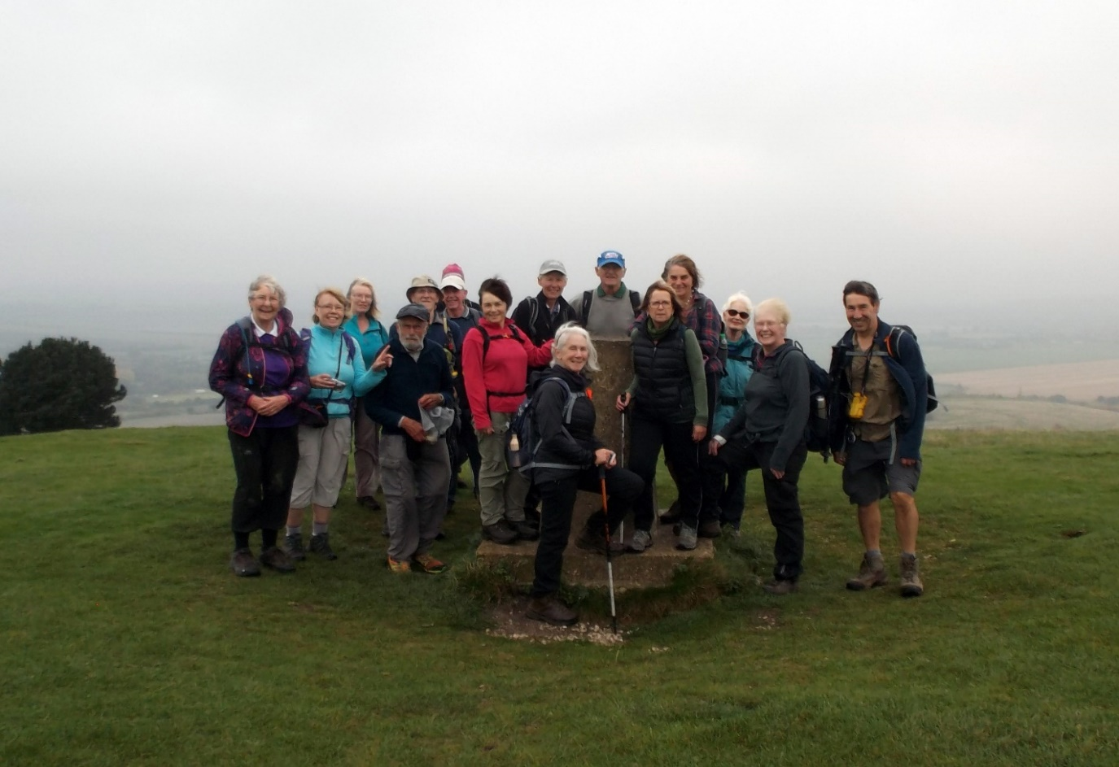

*The second group on Ivinghoe Beacon*

**BAGGING THE DARTMOOR TORS**

Having completed Wainwright’s Outlying Fells in February 2012 we were looking for a new challenge when we noticed an article in Strider entitled ‘Bagging the Dartmoor Tors’. Getting older and less energetic and agile we thought this is just what we are looking for. So began our trips down to Devon. We started our new challenge on 6 June 2012 and finished on 30 August 2014. It was to be a 3 year project so we were well within our timescale. We had countless adventures during this time, and by doing this we went to every corner of the moor.

Before starting we sent for a list of the 283 tors and rocky granite outcrops and other Dartmoor tops that are on the open moor, access land and footpaths. The list also contained a 6 figure grid reference for each one, we would have preferred a 10 digit reference as about 16 are not technically tors but loose stones or rocks and are quite difficult to find. The number of 283 increased during the time we were doing it as new ones are being discovered all the time, we actually bagged 299. There are several with the same names. We did not attempt to get permission for any on private land. They are not all marked on the OS maps and so we decided to purchase the book ‘The A to Z of Dartmoor Tors’. This did contain some brief route suggestions but although we received the revised edition dated 2011 it is a rather dated publication. Some of the tors are on the firing ranges, so in some cases it was necessary to find out about firing times and access to this part of the moor.

There are far too many tors to go into great detail but I will mention a few of them. For this challenge it is not necessary to clamber to the top of the highest rock but just to touch the base of the highest rock pile, in fact it would be quite dangerous to clamber to the top of some, on one, Great Steeple Tor, the highest rock is precariously balanced on the lower one. We were advised that we could only claim tors retrospectively of obtaining the list, if we had an exact date for each tor. We had climbed both Yes Tor and High Willhays previously while doing the English Nuttalls and had a photo and date to substantiate this. Yes Tor is also the County Top of Devon. Another two which we had climbed earlier were Belstone Tor and Hangingstone Hill, we went over these when walking across Dartmoor from Oakhampton to Ivy Bridge in June 2009. For these we also had a photo and exact date. So four were already completed before we started in earnest in 2012.

The most iconic tor is Brentor. It is notable for several reasons, it is made of lava and not granite, it is the most westerly tor and rather ‘out on a limb’. But it is mainly remembered as it has a church on its summit and is visible for miles around. The church of St Michael de Rupe is still used and services are held on

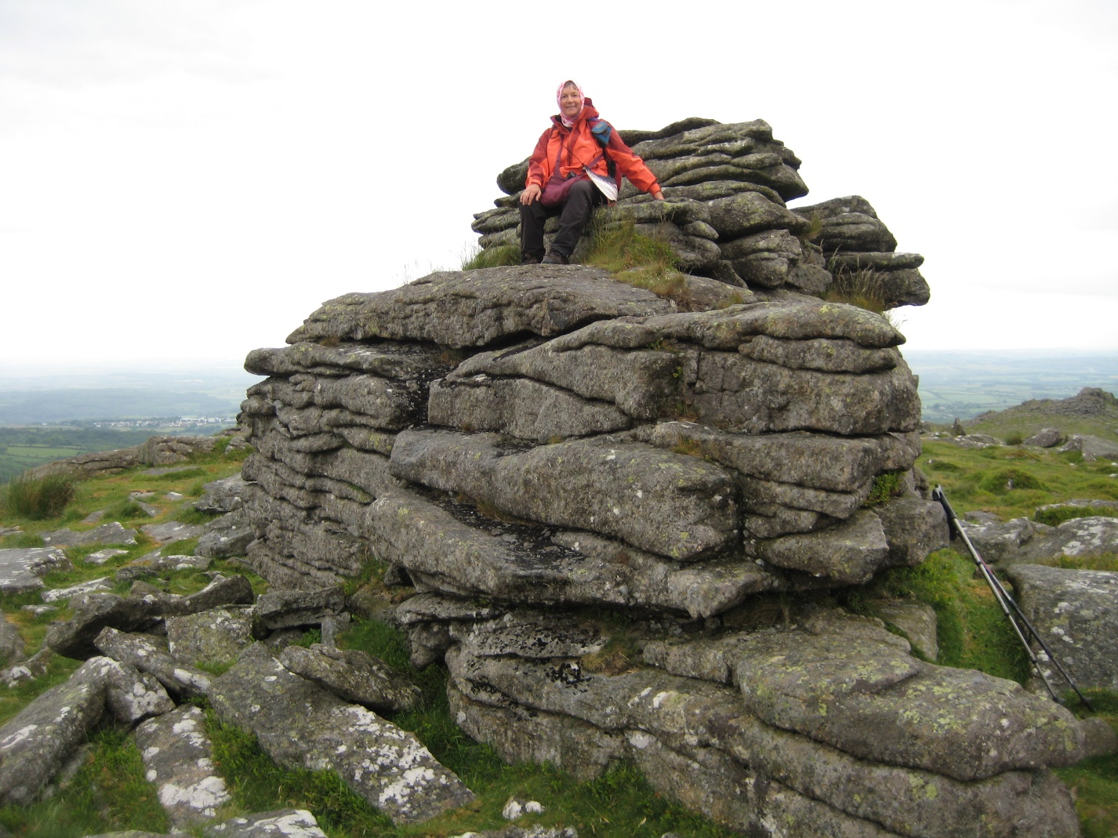

*Belstone Tor*

Sundays in the summer months. Roborough Rock is also a non–granite rock and is accessible to all. It is a huge long mass of rock very close to the Yelverton roundabout on the A386 Plymouth Road. Our last two tors were to be Gibby Combe Tor and Pupers Rock. Pupers Rock was chosen as it has a small cairn on its summit and would make a nice photo for our final one. Gibby Combe was nearby so we decided to combine the two. Imagine our dismay when we read the night before on an internet blog by somebody who had done them all except this one, the ferns were too high and the bank was too steep. After reading this we decided it might be better to attempt it from the bottom of the hill, but there was a private deer reserve in the way and a wide stream with no visible crossing, so it had to be from the top. We found a very good line through the bracken, probably a deer/sheep trod and we got down to the bottom relatively unscathed. We walked along the stream and it came into view covered with moss, where the Gibby Combe meets the Holy Brook.

One more tor to go, we were quite excited but had forgotten to bring along the Bucks Fizz which we carried up to our last Wainwright. I said wouldn’t it be nice if somebody came along and would take our photo by the cairn on Pupers Rock. We stood there taking a few selfies when along came a nice Scottish couple, we soon got chatting and a photograph was duly taken. Then they dropped the bombshell ‘Did you know a new book has been written and funds go to the Dartmoor Search and Rescue’. This book was duly purchased and it documents 365 tors although that includes the ones on private land. It is a lovely publication with 8 digit grid references and beautiful coloured pictures. But we had completed the list we set out to do and we were very happy.

**Judy Nickerson**

**-----------------------------------------------------------------------------------------------------------**

**THE ANNAPURNA CIRCUIT**

With Exodus

It was booked in December 2016, I had paid for it by February 2017, and all I had to do was wait for the 13th Dec 2017 for my flight out of Heathrow. It was a long wait but time flies when you’re enjoying yourself doesn’t it. Well, it came around and on the 10th of December would you believe it, it snowed, and Heathrow was cancelling flights all over the place, ohhhhh poop. Well, as luck would have it, it cleared up enough to travel so on the Tuesday night before my flight on Wednesday 13th I took my car over to Eamsie’s to park it up for the duration of my trip because she has off road parking.

I ended up at Heathrow earlier than planned, in fact I was there at 1230 for a flight that wasn’t going to leave till 2040 that evening. I planned to get rid of my bags early so I could wander around the shops and bars in the departure lounge till my flight but I could not get rid of them till 4pm, so I just wandered around the Costas and Starbucks till then.

I had two bags to check in and one of them had Exodus plastered all over it and around half an hour before I checked my bags in a guy came over and asked, “Annapurna Circuit with Exodus by any chance” I said yes and we introduced ourselves. The time eventually came to board my flight with Jet Air and at nearly 9pm I was heading for Delhi on a 9 hour flight, for my transfer to Kathmandu.

The flights went without incident and we arrived at Kathmandu around 3pm. Money changed to Rupees and my visa obtained, William, that’s the guy who came up to me at Heathrow, and I found our leader waiting for us outside the airport, and after waiting for one other we headed for the Royal Singi hotel where we were to stay for one night before we headed for the start of our trek the next day. There were to be ten in our group altogether and we were coming from all directions, so the next morning at breakfast we met with the rest of our group. Altogether we had 2 young female med students from NZ, one from the North Is and one from the South Is, they were Chamonix and Hazel. Two woman from London who only lived 20mins away from each other but had never met, they

were Marianne and Anna. A couple from Cornwall, Carol and Ian, and a couple from Swindon, Trevor and Jo, and there was William and myself.

**14th DEC. DAY 2** At 8am we had had our breakfast and our bags were packed, one to stay at the hotel and one to come with us that the porters would carry for the duration of the trek with all the gear that we would need, and our daypacks that we would carry ourselves. 0815 and we were on our way to Besi Sahar, the starting point of our trek. It was an interesting 8 hour drive and we arrived at 1530, for a 2½ hour walk to Bhulebule, our first night’s halt. I went for the Dal Bhat, the traditional Nepalese dish for dinner that night, yum, yum.

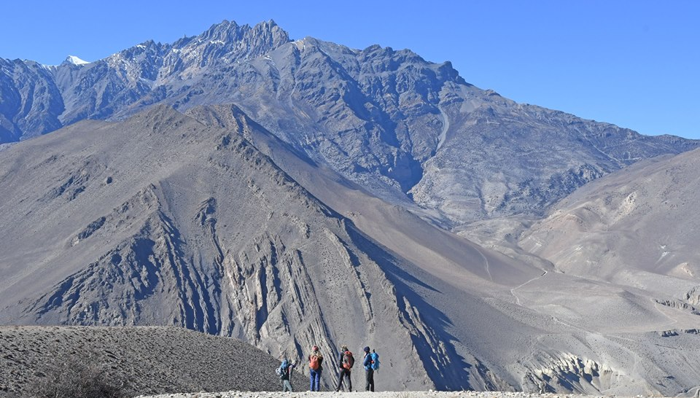

**15th DEC. DAY 3** Up and away for 8am from Bhulebule we were heading for Jagat, our 2nd night’s halt. It was a strenuous day slowly climbing up the Marsyangdi valley through scrub forest to Lampatta and finally to Bahundanda, then we descended down to the river at Syange where we followed the river to Jagat. It was a very hot day and I got my 2018 suntan off to a good start.

**16th DEC. DAY 4** Up and away by 8am we climbed straight up through oak forest, following the river most of the day. We had great views all day and stopped for lunch at Tal in a level valley. We saw our first monkeys in the trees and got to Dharapani at around 5pm where we stopped for the night. Here I decided to head butt a toilet wall because I forgot about a step. The night was a bit cooler here as we were further up the valley.

**17th DEC. DAY 5** We left Dharapani approx. 8am and had a steady climb over a spur to Bagarchap at 2.164m, and we had some great views. Then we descended through pine and fir forests to Koto and finally Chame, our night’s halt. It was cooler today out of the sun due to the altitude and we had the serious talk on altitude sickness and what to look out for and we had to start filling a form in every day on whether we had headaches or not or anything else to do with altitude sickness.

**18th DEC. DAY 6** We left Chame at 8am with a 6 hour walk in front of us, it was chilly to start off with but soon warmed up when we got into the sun. We followed a river through a canyon until we came to Brathang at 2.919. Then we crossed the river and walked through a forest where an impressive curved rock face of Paungda Dande rises nearly 1.500m until we reached Dukha Pokhari where we

stopped for lunch. After lunch we started to climb again until we reach Upper Pisang village where we stayed for the night. There was a monastery in the village which some of the group went and had a look in.

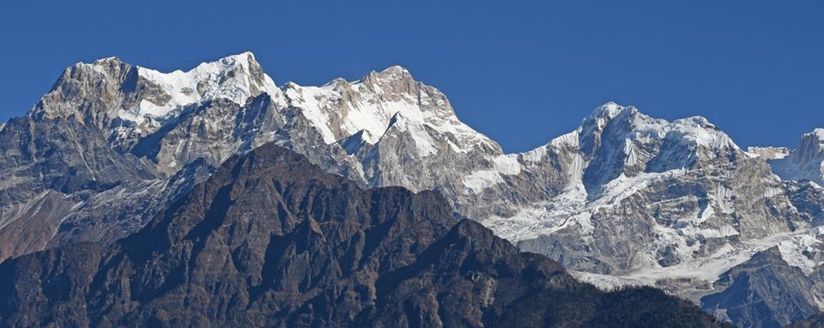

**19th DEC. DAY 7** We were heading for Manang today, where tomorrow we had an acclimatisation day, i.e., we did not do a lot. We had only been walking for about an hour when we went straight up a zig zag route to Gyaru, where we stopped for tea break. Once at the top we followed an undulating trail and had great views of the Annapurnas to Ngawai. We then dropped down to Braga, a lovely village. We walked on to the village of Manang where we stayed for two nights.

**20th DEC. DAY 8** We had a lay in today until 0730, all we did today was do a 2 hour walk up a hill then back again to help with acclimatisation. We were back in the guest house by noon and our time was our own after that. I just hung around the guest house because I needed to get my boots mended as the sole was coming away from the boot so our leader got them sorted in the village. They stitched them up and did an excellent job, they’re still going today. Others went to look around the village and some went a bit further. In the main trekking season Manang is usually a hive of activity, as everybody uses Manang as an acclimatisation base, but as we were there at the end of the trekking season there was hardly anybody there.

|  |  |
| --- | --- |
| C:\Users\gill\Pictures\26168875_10211012149563257_7516102093350888308_n.jpg | **21st DEC. DAY 9** Today was another short day to Yak Kharta. We climbed out of the Marsyangdi valley that we had been following and walked up the Jarsang Khola valley above the tree line and walked through dry alpine country. We arrived at Yak Kharta about lunch time and had another acclimatisation walk in the afternoon. And would you believe it, we stayed in a guest house called Yak Donalds, and yes there was the Yak Donalds happy meal on the menu, and yes myself and a couple of others had one. |

**22nd DEC. DAY 10** Today was another short day of about 3-4 hours, it was to help acclimatisation. It got a bit wilder, we carried on up the valley that we had been following, then descended to cross a river, then we had to traverse a scree slope to get to the tea houses at Pedi, which is at the foot of the Thorong la pass and our beds for the night. As we got to the scree slope we were told to not linger, because there was a danger of falling rocks, and sure enough as we

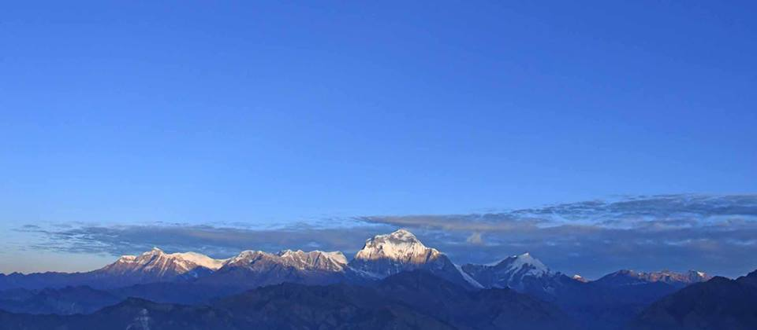

passed across the scree slope the Blue sheep above us dislodged some rocks and down they come flying over our heads. We ducked for cover and passed through unscathed. As we got to the tea houses early we did another acclimatisation walk up to the Thorong High camp, a 2 hour walk straight up. We got to the camp and had a look around then made our way back down to the tea house where we were staying for the night. Tomorrow we will be doing the same hike to the Thorong high camp in darkness because we start our climb across the Thorong la pass at 4am in the morning. Tomorrow was going to be a long day, and we would climb to a height of 5416mts.

**23rd DEC. DAY 11** Up early at 3am, most slept with what they were going to walk in, breakfast at 3:30 and away by 4:15am in the dark. Today was our longest day for trekking and we would reach a height of 5416 mts by the time we reached the top. We got to the Thorong high camp again and stopped for a brew, then it was up, up and up for another 3 to 4 hours. It started to get light as we left the Thorong high camp, and the tops of the high mountains started to get sun light on them around us. There was a bit of snow as we left the camp but it did not cause us any problems and we soon left the snow behind us. It was very cold on the way up and although I had my water in a pair of socks, by the time we reached the top of the pass I was drinking through ice crystals from my bottles. All the way to the top it was heads down and take a drink of water regularly, and after quite a few false summits we eventually reached the top (5416mts) with all the prayer flags flying. It was a relief to reach the top. It was a very strenuous climb and after a rest and group photos at the top we started the decent down the other side heading for Muktinath. The way up was steep and the way down was steep, and it took it out of the knees, we kept going through a series of switchbacks and we had some fantastic views in front of us heading north into Tibet, and behind us we could see some of the peaks of the Annapurnas. It was a long and steep decent and we stopped for a late lunch break on the way down, but eventually it levelled off and we walked into Muktinath at about 4:30 pm. We went to have a look around a temple on the way but once we got to the guest house it was hot showers all round, and because we had got over the Thorong La pass we were allowed alcohol again. It tasted great and went down a treat. We all slept well tonight.

**24th DEC. DAY 12** With the Thorong La pass behind us we had a 3-4 hour walk in front of us today. Three of our group went in a different direction than the rest of us to visit some monasteries, but the rest of us walked through Muktinath and followed a new road for a long way to Kagbeni, the road was newly tarmacked but it was still a great walk with fantastic views. The scenery changed a lot today and we had eroded hills with a backdrop of snow-capped mountains most of the way. We followed the valley to the village of Kagbeni where we met up with the other three at the guest house.

**25th DEC. DAY 13** Today we searched for fossils on the Kali Gandaki river be. We left Kagbeni at 8am and followed the Kali Gandaki river, it was very low so we mucked around skimming stones across ice and searching for fossils on the stony river bed. The fossils are sacred to Hindus who call them shaligrams. We had lunch at Jomson, then on to Dumba lake, a small lake and holy to the Thakhali people. After a look around we left Dumba Lake and headed for Marpha our night’s halt. It was a very dusty and windy day and we even had ensuite toilets and showers and a carpet on the floor. Tonight we danced to Nepalese music from the porters’ I-phones till 10pm, celebrating Xmas day.

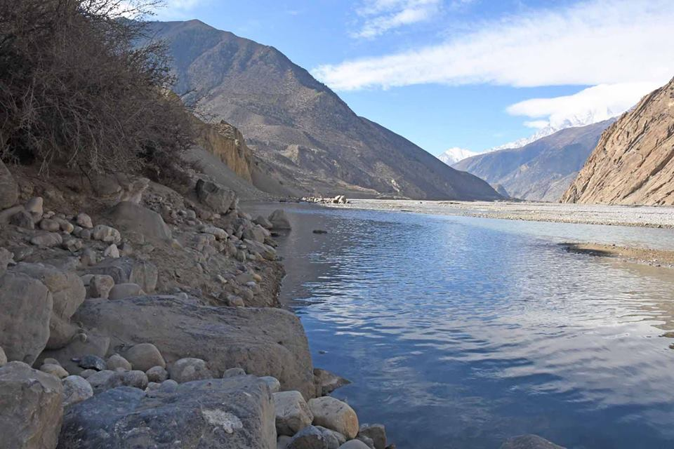

**26th DEC. DAY 14**  An interesting day. We were following the deepest gorge in the world, walking through pine forests on a forest track with some great views of the high peaks. We came to a swing bridge and were supposed to cross it then turn left and head down the track to Tukuche for tea break, but the other side was very dusty so we decided to stay on the same side and go down the left side of the river. The only problem was, after about an hour of following a not very

wide track with a long drop down to the river, which was a bit hair-raising, we came to a landslide which we could not pass and had to turn back along the hair-raising track to make our way down to the river bed, to cross over to the other

side and take the route we had been going to take in the first place, which I will add was a lot clearer now. We decided to have lunch at Tukuche where we were going to have tea break, but it was closed so we carried on to Larjung where we had lunch and it was also our night’s halt. We arrived at Larjung at 2pm, then at 4pm we went up to Thasang, a Japanese hotel, to watch the sunset on Niligiri. They made us some very nice Japanese tea and after sunset we headed back down to settle in for the night.

**27th DEC. DAY 15** Up at 7am and away for 8am, we crossed over the stony river bed and headed back into the pine forest, following a narrow path then a wider one with great views of the high peaks. It was very dusty for most of the day. We passed a small lake called Titi Tal which was a bit of a bird watchers lake, with mallards and coots on the lake. We had a lunch break in the open air today, with some great views around us. We had about 45 mins break then we moved on, until a lady called over to us offering soup, we decided to stop and I had vegetable and noodle soup, my favourite. After that we moved on heading for Ghasa where we were staying for the night.

**28th DEC. DAY 16**  Today we were heading for the hot springs at Tatopani, and we did not have to walk very far. We passed over numerous swing bridges and walked through more pine forests and the day was dusty. We arrived at 2pm, had lunch then we headed for the hot pools about five minutes down the road.

**29th DEC. DAY 17** Today was one of the most strenuous days of the trek, apart for the Thorong La Pass. It was up, up, and more up all day long walking through some great scenery to Ghorepani, this is the place where you get up very early in the morning (4am) and take a hike up to Poon Hill (Dee, Betty and Gordon will remember Poon Hill), where you watch the sun rise on the Annapurnas, Dhaulagiri and Machhapuchhare and other high mountains, we arrived at Ghorepani just in time for the sun going down on the peaks so we had some great views from our guest house. We walked through rhododendron forests but because of the time of year the flowers were not out. It was another great day, and we were glad to get to our beds that night.

**30th DEC. DAY 18** Our last long walking day. We were up at 5:30 am for the trek up to Poon Hill to watch the sun rise over the high peaks, then back down for breakfast then a long hike down to Birethanthi, where we would be for tonight. Yesterday we were climbing all day, today we were descending all day through a forest to Banthanti, and then through Ulleri and Tirkhedunga, and it was very hard on the knees. We arrived at 5pm. The porters had dinner with us tonight and it was time to give them their tips for all their hard work.

**DEC 31st DAY 19** All we had to do today was walk 45 mins to Naya Pul then a bus ride into Pokhara where we had a one and a half day rest to do what we wanted with two nights in the Lake View hotel. We arrived in Pokhara at midday and I just chilled out with some great views over the lake, and para gliders taking off from a mountain overlooking the lake. When I was there with Dee, Gordon and Betty we could not see the other side of the lake because the smog was too thick due to no rain. That night we had our final official group dinner in town in a posh restaurant, and a great meal it was too. Then we celebrated the New Year in style. The main street was closed off to cars and it was just one big festival of party goers. I ended up in an Irish pub on the stroke of midnight.

**JAN 1st**. Up late I hired a push bike to cycle around the lake which was harder than I thought. In fact you can’t cycle completely around the lake, too many inlets and streams and it would be too hard going on the far side, so I went up one side and tried my best to go as far as I could down the other side. Then, on advice from a local, I returned the same way as I had come. At 3pm I had a massage in a local massage parlour, it was bliss. That night we had another meal together in a different restaurant, then it was back to the hotel and pack the bags for tomorrow’s flight back to Kathmandu, then half a day to do what we wanted before the flight back home the next day.

It was a fantastic 19 day trek. I had a good group to walk with, a very good walk leader and the porters were fun as well. We had great scenery and the food was great and always hot. The only thing I did not like about the trip was that we had to carry a lot of cash with us because we had to pay the T-houses separately for our meals. I like to have all food included in the price of the holiday. Exodus are a great company to go with and are very professional. I would recommend them anytime. All my photos (1000 of them) are on my web site

[www.steveceegalleries.smugmug.com](http://www.steveceegalleries.smugmug.com) Stevecee

|  |  |  |
| --- | --- | --- |
|  | **WALKS PROGRAMME**  **MAY TO AUGUST 2018** |  |

**Thu May 3 2018 Morecambe & Brown**

15ml. 09.30 From East Lane free c.p. Wheathampstead AL4 8BN. Maps: LR 166 Exp 182 (GR TL178141). No pub stop. ***C:*** Peter Simon ***T:*** 01582 513827.

**Sun May 13 2018 How do we go?**

15ml. 09.00 From Westcroft Shopping Centre, near Howe Park Wood (park close to petrol station). Milton Keynes. Map: LR 152 (GR SP830346). ***C:*** Sylvie Norris ***T:*** 07770 433190 before 8pm.

**Thu May 17 2018 A Lap of Northern Bedford**

21ml. 09.30 From Priory Country Park c.p., entrance from Barkers Lane. Map: LR 153 (GR TL071494). Anti-clockwise route passing Danish Camp (toilets), many riverside paths and a few woodlands. Toilet facilities should be available at start. ***C:*** Wahid Khan ***T:*** 01324 325132.

**Sat May 26 2018 Take Two**

20ml. 09.00 From Boddington Resvr c.p. (please note use c.p. near the entrance to the sailing club on E of Resvr closest to Byfield). Map: LR 151 (GR SP498532). ***C:*** Mary Knight ***T:*** 01295 812857 ***M:*** 07554 661519.

**Thu May 31 2018 A Bound Around Ashridge**

17ml. 09.30 From Ashridge Estate Visitor Centre near Bridgewater Monument. Map: LR 165 (GR SP970130). No pub stop. ***C:*** Sara Waldron and Neil Edmonds ***T:*** 07580 665454.

**Sat Jun 9 2018 What a Brill-iant View**

17ml. 09.00 From Wykeham Way (nr Thame Rd), Haddenham. Map: Exp 181 (GR SP734086). ***C:*** Alan Leadbetter ***T:*** 07775 887493.

**Thu Jun 14 2018 A Splendid Meeting**

16ml. 09.30 From Bugbrooke Church c.p. Maps: LR 152 Exp 207 (GR SP674573). Pub stop. ***C:*** Colin Stoneman ***T:*** 01327 830889 ***M:*** 07764 684661.

**Sun Jun 17 2018 Hannington Hike Marshals' walk**

Contact organiser for details. ***C:*** Alan Leadbetter ***T:*** 07775 887493.

**Sun Jun 24 2018 Stomping to Fenny**

15ml. 09.00 From Stoke Hammond, Bragenham Road (opp Dolphin pub), near to sports field. Map: Exp 192 (GR SP886294). ***C:*** Sylvie Norris ***T:*** 07770 433190 before 8pm.

**Thu Jun 28 2018 McBride, Meads and Johnson**

15ml. 09.30 From c.p. near canal off Stoke Road, Water Eaton. Map: LR 152 (GR SP882317). Pub stop, lots of options to cut route short. ***C:*** Dave Findel-Hawkins ***T:*** 01908 216476.

**Sun Jul 8 2018 Cr3am T3a Trot to Stow3**

18ml. 09.00 From Chackmore c.p. area, just off Stowe Avenue. Maps: LR 152 Exp 192 (GR SP685357). Cream Tea 'lunch' at Stowe Café. Obviously the more calories consumed the longer the walk. ***C:*** Norman Corrin ***T:*** 01908 608667 ***M:*** 07980 378656 on the day.

**Thu Jul 12 2018 Roger’s Birthday Walk**

15ml. 09.30 From Ampthill Park c.p. (not football club). Map: LR 153 (GR TL025382). Figure of 8 walk. If you buy a drink you can eat sandwiches in the pub. ***C:*** Roger Skerman ***T:*** 01525 405540 ***M:*** 07757 057440.

**Sun Jul 15 2018 Hannington Hike Challenge Walk**

27, 18 or 13ml. all to finish by 18.30. Hall closes 19.00. From Wellingborough Grammarians Memorial Sports Field, Sywell Road, Wellingborough NN8 6BS (GR SP856690). A walk around the Northamptonshire rolling countryside. Start: Walkers from 08.00. Runners and fast walkers and all short route from 09.00. Entry Limit 200. No entries OTD. No Dogs. YOU MUST DOWNLOAD & PRINT YOUR OWN ROUTE DESCRIPTION. Route description will be on website from 5th July 2018. If you are unable to do this, please include SAE size C4 with a large letter stamp with your entry marked ‘route description’. We recommend you wear suitable footwear & clothing, also to have maps LR152 or Exp 223 & 224, waterproofs, your own drinking mug (no mugs will be supplied at Cps) & a compass. SIentries close on Sat 7th July 2018. Postal entries must reach us by Tue 3rd July 2018. Entry: £8, non LDWA £12, under 18s free (No entries OTD) incl refreshments at Cps (3 on 27ml, 2 on 18ml, 1 on 13ml), light meal at finish, cert & badge. Chqs payable to LDWA BBN Group. Entry form downloadable from event website. Online entry at: https://www.sientries.co.uk/. ***C:*** Mike Hyland, 55 Broadlands Ave., Chesham, Bucks, HP5 1AL ***T:*** 01494 774154. ***E:*** mike.hyland@ntlworld.com ***W:*** www.ldwa.org.uk/bedsbucksandnorthants

**Sat Jul 21 2018 Stepping out to Stoke Bruerne**

18ml. 09.00 From Watermill Lane c.p. Stratford Road, Wolverton Mill, Milton Keynes. Maps: LR 152 Exp 207 (GR SP796408). Lunchtime p.h, café and toilets. ***C:*** Gill Bunker ***T:*** 01908 321308 ***M:*** 07790 976090 on day only.

**Thu Jul 26 2018 Another Stroll From Shefford**

16ml. 09.30 From Old Station Way free c.p, Shefford. Map: Exp 193 (GR TL143391). ***C:*** Terry Brown ***T:*** 01462 631057 ***M:*** 07932 627476.

**Sat Aug 4 2018 Cakes, Coffee and Ice Cream from Rushmere**

17ml. 09.00 From Rushmere Country Park Visitor Centre c.p. Map: Exp 192 (GR SP912284). 3 loops (8, 5 and 4ml), pub stop. Parking £3 pay on exit, refreshments available. ***C:*** Peter Engledow ***T:*** 07733 323641.

**Thu Aug 9 2018 Bash it! Beat it!....All Bound from Barton!**

15ml. 09.30 From Old Road, Barton Le Clay. Please park considerately near entrance to recreation ground. Maps: LR 166 Exp 193 (GR TL083305). Lunch stop near pub in Silsoe. ***C:*** Dee Brockway ***T:*** 01582 881809 ***M:*** 07742 433951.

**Sat Aug 18 2018 Brewery Walk**

12ml. 10.00 From junction of Barlow Road and Woollerton Crescent E of B4009, NE of Wendover, HP22 6HS. Maps: LR 165 Exp 181 (GR SP875081). Saturday walk with a late start, limited numbers. Cost £10, £5 deposit required, cheques preferred, payable to BBN LDWA .Please book place with John by 11 June. Later finish than normal because of the brewery tour timing. A small amount of food will be supplied with the various different beers, but you still need to carry food for the lunch stop. ***C:*** John Davies ***T:*** 01442 874875 ***M:*** 07949 796470.

**Thu Aug 23 2018 Saints and Cobblers – Where’s Greavsie?**

15ml. 09.30 From Great Houghton Village Hall (Parsons Memorial Hall), off Leys Lane, Southern end of village NN4 0AN. Maps: LR 152 Exp 207 (GR SP795583). A sport themed walk also visiting sites associated with WW1. There will be some urban walking through Northampton. ***C:*** Adrian Moody ***T:*** 01993 314134 ***M:*** 07788 684394.

**DIARY DATES**

**Sunday October 28th** **Sundon Saunter Marshals’ Walk**

**Sunday November 18th Sundon Saunter**

**Sunday November 25th AGM**

**BEDS BUCKS & NORTHANTS GROUP  
 COMMITTEE 2018**

**Chairman: Terry Brown** *T*: 01462 631057 *E*: [teresa.j.brown@ntlworld.com](mailto:teresa.j.brown@ntlworld.com)

[bbn.chair@ldwa.org.uk](mailto:bbn.chair@ldwa.org.uk)

**Secretary/Local Group Rep:** **Peter Simon** *T:* 01582 513827   
 *E:* [bbn@ldwa.org.uk](mailto:bbn@ldwa.org.uk) [peterandmooi@ntlworld.com](mailto:peterandmooi@ntlworld.com)

**Treasurer: Peter** Engledow *T*: 07733 323641 *E:*pete@excel121.com  
**Social Walks:** **Mary** Knight *T:* 01295 812857 *E*: [maryjknight@hotmail.co.uk](mailto:maryjknight@hotmail.co.uk)

[bbn.walks@ldwa.org.uk](mailto:bbn.walks@ldwa.org.uk)

**Membership: David Findel-**Hawkins *T*: 01908 216476 *E*: [davefh@gmail.com](mailto:davefh@gmail.com)

**Merchandise: Norman Corrin** *T*: 01908 608667 *E*: [norman.corrin@gmail.com](mailto:norman.corrin@gmail.com)

bbn.merchandise@ldwa.org.uk

**Newsletter/Website:** **Gill Bunker** *T*: 01908 321308 1 Abbey Way, Bradville,   
 Milton Keynes. MK13 7AN *E*: [gillbunker@googlemail.com](mailto:gillbunker@googlemail.com)

**Member: Alan** Leadbetter *T***:** 07775 887493 *E:* [acleadbetter64@gmail.com](mailto:acleadbetter64@gmail.com)

**Member: Roy Carter** *T:* 01234 301182 *E:* [roycarter367@hotmail.com](mailto:roycarter367@hotmail.com)