|  |  |
| --- | --- |
| LDWA Logo black & white | **LONG DISTANCE WALKERS ASSOCIATION AIM: TO FURTHER THE INTERESTS OF THOSE  WHO ENJOY LONG DISTANCE WALKING** |

**BEDS, BUCKS &  
NORTHANTS GROUP**

**NEWSLETTER**

**AUTUMN 2018**

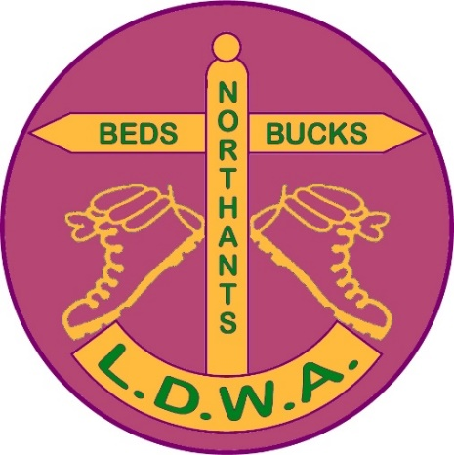

|  |  |
| --- | --- |
|  | Dear BBN-ers,  What an amazing summer and autumn we’ve had!  I must confess that, at times, it was too hot for comfortable walking. In the afternoon of my July walk, Another Stroll from Shefford, the temperature reached 34oC, however 24 people still turned up for the walk knowing it would be a scorcher! |

As we move into November our Annual meeting (AGM) comes round again. You’ll see details of the walk, lunch and meeting elsewhere in this newsletter and in the weekly email Updates from Peter Simon. Please come to the AGM at Blisworth to support your excellent Committee and to give us your ideas about what we do as a Group.

All the current Committee are willing to stand again except Norman Corrin, who has decided it’s time for a rest! Norman has served for over 20 years on the Committee in various roles including a 4 year stint as Chairman. He organised our hosting of the LDWA AGM a few years ago, has coordinated the BBN manned LDWA Hundred checkpoints, organised and marshalled BBN Challenge events and looked after BBN logoed clothing, mugs and buffs. His contribution has been outstanding and I’d like to thank him on behalf of the Group for all his work over the years.

Norman’s retirement means that we have to find someone to replace him on the Committee. According to our constitution we could have one more Committee member than we currently have, so we are actually looking for two people to come forward and help run the Group.

You will have seen from Peter Simon’s recent email Updates that we also need someone willing to take over as the Group’s LDWA Hundred Coordinator and BBN checkpoint organiser on these events. This is a job that could be done as a non-Committee post.

Please have a think about whether you could offer to fill one of these roles or help the Group in any other way.

Happy walking and see you on November 25th!

**Terry Brown, Chair**

|  |  |  |  |  |
| --- | --- | --- | --- | --- |
| **GROUP WALKS**  I often hear ‘I can’t do the next programme but I can probably do the one after’..... in order to meet this demand here are all of the dates, for which we are seeking social walk leaders, to the end of 2019.  Below are available dates for **Thursday walks 2019**: | | | **C:\Users\gill\Downloads\WP_20171217_16_01_13_Pro (2).jpg** | |
| May 2019 | 2 | Bob Safford | |
|  | 16 |  | |
|  | 30 |  | |
| June | 13 |  | |
|  | 27 |  | |
| July | 11 |  | |
|  | 25 |  | |
| August | 8 |  | |
|  | 22 |  | |
| September | 5 |  | |
|  | 19 |  | |
| October | 3 |  | |
|  | 17 |  | |
|  | 31 |  | |
| November | 14 |  | |
|  | 28 |  | |
| December | 12 |  | |
|  | 26 |  | |

And these are available dates for **weekend walks 2019**. Please remember walks can be Saturday or Sunday – just e-mail me to reserve your date.

|  |  |  |
| --- | --- | --- |
| May | Sunday 12 | Hannington Hike Marshals’ Walk |
|  | 25/26 | 100 Weekend |
| June | Sunday 9 | Hannington Hike Challenge Walk |
|  | 22/23 |  |
| July | 6/7 |  |
|  | 20/21 |  |
| August | 3/4 |  |
|  | 17/18 |  |
|  | 31/1Sep |  |

|  |  |  |
| --- | --- | --- |
| September | 14/15 |  |
|  | 28/29 |  |
| October | 12/13 |  |
|  | Tue 21/ Fri 25 | Proposed Group Trip Isle Of Wight - 74 Mile Vectis Trail – see p. |
|  | 26/27 |  |
| November | 9/10 |  |
|  | 23/24 | BBN AGM |
| December | 7/8 |  |
|  | 21/22 |  |

If you would like to lead a walk on any of the available dates please let me know. If you would like to arrange a walk on any other date that’s fine too, but please do let me know.

In addition if you would like to lead a walk on any of the following dates please contact me or any member of the committee

Thursday 13 December 2018  
Saturday/Sunday 30/31 March 2019.

If you would like us to update and communicate your walk information at any time please do not hesitate to let us know. Updates through Facebook, the website and our newsletter can be made quickly and easily.

Best wishes and happy walking.

**Mary Knight** Social Walks Secretary

[maryjknight@hotmail.co.uk](mailto:maryjknight@hotmail.co.uk)

oooooOOOOOooooo

**CHILTERN KANTER 2019**

The 20th Chiltern Kanter will be held on Sunday 3rd March 2019 with the usual choice of 3 distances, either 26, 18 or 13 miles. See the Walks Programme at the end of the Newsletter for full details.

The Marshals’ walk will be held on Sunday 10th February 2019. Hopefully with global warming it will not be as cold as it was in 2017!

All routes have been walked out already and are roughly the same as they were in 2017 but a few modifications have been made to keep the entrants on their toes……..

As ever these events need manpower to make them work so if anyone would like to help marshal on the day you will not be turned away. The weather conditions on the last one were testing so if you do wish to help you might end up making the right choice (unless of course you’re at Safran Power Systems or on one of the roundabouts). Please contact me if you wish to help.

I’ve mentioned that this is the last one Mike and I will be doing. It is hard work but when it’s all over it is very satisfying to say “We did that and gave 200 odd people a day to remember………for whatever reasons !” I’m sure we will both miss it but it is time to hand over to someone else. I hoped that unlike General MacArthur it would not fade away …………….  
  
I am therefore very pleased to report that Roy Carter will be taking over the future organisation of the event.

**Norman Corrin**

**oooooOOOOOooooo**

**HANNINGTON HIKE 2018**

New Name, New Routes

The marshals’ walk threw up a couple of fields that were impassable due to crops and this meant we had to quickly find a couple of diversions (thanks to Adrian Moody & DFH). One diversion turned out to be a bit safer, so this will stay in for next year’s event. The fields were reported to The Street Doctor, but they were not cleared in time for the day of the event.

Had a bit of a panic as England were doing well in the World Cup and had to come up with a plan to take my TV to Headquarters so all who wanted to watch it could. In end that was not needed.

I spent a couple of hours clearing overgrown areas on a couple of Saturdays to make it easier, which was welcomed by everybody.

All went well on the day, the weather was hotter than we expected so I put on an extra water stop (thanks to Steve Clark for stepping in to help). All the 94 who started finished in good time, even if two people decided to walk it the wrong way.

Next year the event will be about a month earlier on June 9th 2019, this is to help me have a bit more time to sort out the event for 2020, which will be in March.

**Alan Leadbetter**

**BBN AGM – Sunday 25th November 2018 : 2pm**

Blisworth Village Hall, Stoke Road, Blisworth NN7 3BZ

* Parking will be available at the Village Hall. **The car park is accessed from the rear of the village hall via Buttmead** off Stoke Road
* There will be a morning walk of around 7 miles led by Dave Findel-Hawkins
* Lunch will be available at the Royal Oak, Blisworth, tables booked for 20, wide range of food on offer, please see link for sample menu, although possibility that this will have changed slightly by date of AGM. [www.royaloakblisworth.com/dining](http://www.royaloakblisworth.com/dining)
* AGM back in village hall starting at 1400hrs.

**If you wish to eat please let me know by Sunday 11th November** so I can confirm numbers with pub. I will then send you current menu information**, please let me have your choices no later than Sunday 18th November**. As in recent years, the Group will subsidise the cost of the lunch to all diners who attend the AGM. The subsidy will be a cash rebate in the amount of £10 per person.

**Mary Knight**

[maryjknight@hotmail.co.uk](mailto:maryjknight@hotmail.co.uk)

-------------------------------------------------------------------------------------------------------------------------------

**BEDS BUCKS & NORTHANTS GROUP**

**COMMITTEE 2018**

**Chair: Terry Brown** *T*: 01462 631057 *E*: [teresa.j.brown@ntlworld.com](mailto:teresa.j.brown@ntlworld.com)

[bbn.chair@ldwa.org.uk](mailto:bbn.chair@ldwa.org.uk)

**Secretary/Local Group Rep:** **Peter Simon** *T:* 01582 513827   
 *E:* [bbn@ldwa.org.uk](mailto:bbn@ldwa.org.uk) [peterandmooi@ntlworld.com](mailto:peterandmooi@ntlworld.com)

**Treasurer: Peter Engledow**  *T*: 07733 323641 *E:*pete@excel121.com  
**Social Walks:** **Mary Knight** *T:* 01295 812857 *E*: [maryjknight@hotmail.co.uk](mailto:maryjknight@hotmail.co.uk)

[bbn.walks@ldwa.org.uk](mailto:bbn.walks@ldwa.org.uk)

**Membership: David Findel-Hawkins**

*T*: 01908 216476 *E*: [davefh@gmail.com](mailto:davefh@gmail.com)

**Merchandise: Norman Corrin** *T*: 01908 608667 *E*: [norman.corrin@gmail.com](mailto:norman.corrin@gmail.com)

bbn.merchandise@ldwa.org.uk

**Newsletter/Website:** **Gill Bunker** *T*: 01908 321308 1 Abbey Way, Bradville,   
 Milton Keynes. MK13 7AN *E*: [gillbunker@googlemail.com](mailto:gillbunker@googlemail.com)

**Member: Alan Leadbetter** *T***:** 07775 887493 *E:* [acleadbetter64@gmail.com](mailto:acleadbetter64@gmail.com)

**Member: Roy Carter** *T:* 01234 301182 *E:* [roycarter367@hotmail.com](mailto:roycarter367@hotmail.com)

**ISLE OF WIGHT - 74 MILE VECTIS TRAIL**

Is anyone interested in a group holiday to the Isle of Wight to walk the 74 mile Vectis Trail? It is a figure of eight walk on paths in areas selected for their outstanding natural beauty. It is not way-marked but Jill Green and Jim Catchpole, who live on the island, have kindly offered to plan and lead our 4 days of walking.

Jill and Jim are investigating the best base for a walk, and they will suggest a suitable hotel. Details will then be given to allow people to book their own accommodation and the ferry. If you do not choose the group hotel you will need to be able to get to it quite early on the four mornings of the walks which we hope to be Tuesday 22nd October to Friday 25th October 2019. It is hoped to finish the Friday walk a little earlier and so you would need accommodation for at least 4 nights, Monday 21st to Thursday 24th and also Friday 25th, unless you choose to travel home on a late Friday ferry.

We hope to organise group hired transport from the hotel to the starts and back from the finish of each day's walk. The price will be dependent on numbers, but Jim and Jill will be looking into this and we should have an idea of the maximum cost per person when further details are available. A minimum of 12 and a maximum of 26 people, on a first come first served basis, will be needed for it to go ahead.

For now it is just a date for your diaries. If you are interested please let me know and when we have more details a deposit towards the transport and a firm commitment will be required.

Any questions please contact me.  
Dee Brockway, Tel 01525 795808, Email [dmrbrockway@ntlworld.com](mailto:dmrbrockway@ntlworld.com)

**oooooOOOOOooooo**

**2019 Hadrian's Hundred - volunteers needed -** If anyone is interested in checkpointing at next May's 100, there may be an opportunity to assist Cleveland Group at Newborough Village Hall, 6 miles into the route. Please contact Ian Lauriston at [ianlauriston@talktalk.net](mailto:ianlauriston@talktalk.net)  
**2020 Y 100 Sir Fynwy - call for checkpoint organiser -** BBN has signed up to organise the Abergavenny checkpoint (at 40 miles) but we now find ourselves in need of someone to organise the CP. If we cannot find an organiser, the coordinators of the 100 will need to find another group to run the CP, so there is some urgency in this matter.  
If you wish to volunteer, please contact Peter Simon at [bbn@ldwa.org.uk](mailto:bbn@ldwa.org.uk)

**RSPCA – 24 HOUR EMERGENCY PHONE LINE  
0300 1234 999**

On my social walk in July we stopped for lunch at Old Warden and several members noticed an injured muntjac deer sheltering by a hedge in the grounds of the Village Hall. It had probably been hit by a car and had managed to get off the road.

Because we had a time schedule to keep we couldn’t do anything more other than to report it to the RSPCA. For such occasions I keep their 24 hour hotline number in my mobile phone. Merrian made the call and reported the injured deer and its location. We carried on with the walk hoping that someone would be able to get out as soon as possible knowing we had done our best under the circumstances.

I encourage you to have this number **0300 1234 999** in your mobile phone in case you need it at any time. You can use also use this number to report animal cruelty incidents.

The RSPCA’s general advice for injured animals is:

* For a bird or a mammal smaller than a rabbit often the quickest way to get help is to contact a local vet or rehabilitation centre, they won’t usually charge for treating wildlife.
* If the animal is larger than a rabbit then call 0300 1234 999

For more information about cruelty and distressed animals see <https://www.rspca.org.uk/utilities/contactus/reportcruelty> . You can also report things online but you need to register your details with the RSPCA, although everything you report is confidential.

**Terry Brown**

|  |  |
| --- | --- |
| ***Please remember to keep your contact details and  e-mail preferences up-to-date on the LDWA Website*** | **C:\Users\gill\Pictures\untitled.png** |

***BBN HOLIDAY TO HARTINGTON 24th – 27th AUGUST 2018***

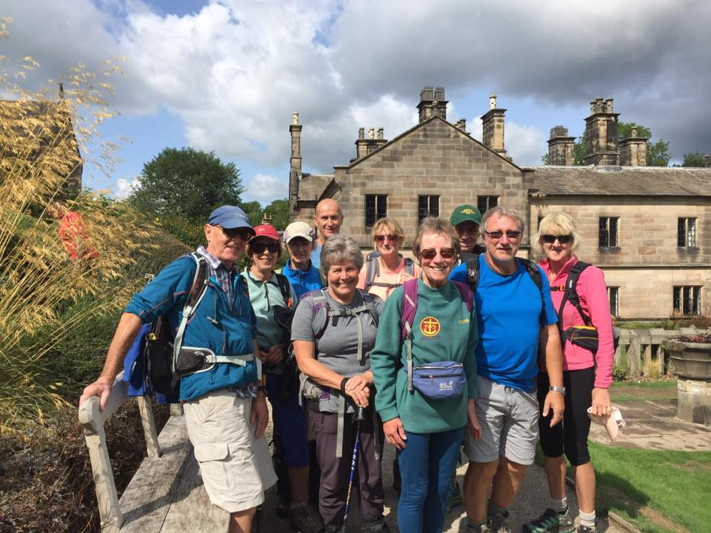

The walking weekend was centred in Hartington, a pretty village in the heart of the White Peak area of Derbyshire with its wonderful countryside and excellent walking opportunities. We met at the duck pond on Friday afternoon and set off across the river Dove to climb uphill, in rain, to the hamlet of Sheen. The rain lifted as we traversed the ridge to Pilsbury Castle to yield good views over the Dove and Manifold valleys towards Buxton. With much surprise at the castle, a brief hailstorm fell upon us. Was this really August? That quickly cleared as we continued down the River Dove back to Hartington which by then was bathed in warm sunshine. It was a great introduction to the walking weekend – stone stiles, good views, good company and changeable weather.

The Saturday walk was glorious from start to finish – an 18 mile classic walk from Hartington to Ilam and back up Dovedale – one of the best walks in the country (personally). We headed out to Beresford Dale, then Narrowdale before diverting to the church in Alstonefield. We had seen a couple of signs advertising a coffee morning at the church and were glad we took advantage, because we were greeted with a big pot of tea and plenty of cakes. In the churchyard is a memorial stone to Ann Green, who died 11 May 1518. This is believed to be the oldest legible gravestone in England. Being refreshed, we descended into the very pretty upper Milldale and headed over into the Manifold valley and Ilam for lunch at the NT café in Ilam Park, with good views of Thorpe Cloud. A quick shower enveloped us as we ate but it soon cleared.

The afternoon walk took us past the distinctive alpine style cottages of Ilam and across to the famous stepping stones of the River Dove, where we had to queue before crossing (it was August Bank Holiday weekend), and turning into Dovedale. An ice cream stop in Milldale was welcome as the afternoon sunshine streamed through the trees into the Dale. Then onwards into Wolfscote Dale, rather than Biggin Dale, to Reynard’s Lane which yielded majestic views of the White Peak limestones and a spectacular approach into Hartington as the late afternoon sun cast shadows on buildings in the village. A simply wonderful all day walk, followed by an enjoyable evening at the Charles Cotton hotel.

“What a difference a day makes” is a song which typifies in our case, a change in the weather. It rained all day long. Starting from the A6 in Taddington Dale we descended into Monsal Dale and around to Cressbrook Mill made famous by the Arkwright’s in mechanising the spinning of cotton into yarn for textiles. The mill complex is spectacular and is now residential property. Despite the rain we were lucky to traverse the bottom of Miller’s Dale (which can be flooded) to Litton Mill where again we saw a sign advertising a café stop. It wasn’t quite a church like yesterdays but a VW van with awning and seats. Still, we had a morning break and a flapjack.

A decision had to be made whether to ascend Tideswell Dale to Tideswell for lunch or continue along the valley floor until lunchtime. Opinion was to continue along the valley and in just 1½ miles we stopped at the Anglers Rest for lunch. This has to be the BBN’s shortest walk between breaks but considering the weather it was welcome. The walk continued along the Monsal Trail through the railway tunnels, which gave us a break from the rain and onto Monsal Dale Head for afternoon tea before returning to our cars on the A6. The weather was forgotten that evening at the Hartington Youth Hostel over a few bottles of wine.

Monday’s walk started from Monyash and headed along the Limestone Way to Middleton. With the weather improving nicely, we went down the River Bradford to Youlgreave for lunch at Peak Feast. Along the way we met photographers who showed us pictures of a Dipper, taken in the river – they had travelled early morning from an overnight twitch in Norfolk. After lunch we headed to Alport and followed the River Lathkill into Lathkill Dale, which is one of the prettiest dales in Derbyshire. Exiting the dale through the quarry we walked into the café in Monyash for a decent cup of tea, having walked 13 miles. It was then time to travel home.

**Roy Carter**

**INTERNATIONAL TWO DAY WALK OF FLANDERS  
IN BLANKENBERGE 4TH AND 5TH MAY 2019**

I was at the Waendel Walk last year and saw advertised for 2019 2 events on the International Marching League circuit which are celebrating anniversaries that both end in zero.

The Waendel Walk in Wellingborough celebrates its 40th anniversary on the weekend of 11th and 12th May 2019. Wellingborough is central to Milton Keynes, Northampton and Bedford.

Prior to that is the 50th Anniversary of the International 2 Day Walk of Flanders in Blankenberge, Belgium on the 4th and 5th May 2019. This is a bank holiday here in the UK so anyone who wishes to travel over would only have to take one day’s leave. This clashes with Oxon 40/20 walks and the Marshals’ 100 which I know is always well attended by many BBN members.

For those of us who've done an international event before this is part of the International Marching League calendar of events which encourages mass participation events at varying distances. This is an ideal opportunity to get a flavour of how relaxed and enjoyable and carnival-like the big events can be abroad.

As Peter Simon has pointed out, it would be 10 years since BBN last travelled over to this event. This was the first overseas event we did as a group, and was followed by trips to Denmark and to Castlebar in Ireland

More information about the event is on the walk website <http://www.2daagse.be/>

A hotel we’ve used previously is <https://www.hotel-du-commerce.be/>

The hotel is located 2 minutes’ walk from the start of the walks and ideally located for those secondary hobbies of long distance walkers namely shopping or socialising……. Blankenberge itself is a very affluent little town and for any partners who do not wish to walk there are plenty of shops to indulge in a little retail therapy!

The walking around Blankberge is well………don’t expect to be needing the Belgian Mountain Rescue team. It is quite flat but there is also a lot of walking through parks and on one of the days on the beach for some distance.

If anyone wants any more information about the event then please contact me.

**Norman Corrin**

**CASTLEBAR 2018**

**And Norman came too**

I drove to Norman’s house, then jumped into his car for the trip to Luton Airport and the flight to Knock, where we had a taxi waiting to take us to Castlebar, Co Mayo.

I usually stay in a sports hall but I left it a bit late and very nearly didn’t have any digs. At the last moment I got a phone call from a B&B to say she had room for me. The problem was that the taxi driver did not know the address so we ended up driving around Castlebar looking for it. He eventually dropped us both off at the hotel where all the walks start from and one of the organisers who knew the B&B well took me there herself. So settled into my room, I walked back to the venue and paid my dues for the next 4 days walking and got my bus passes for the next 3 days. Castlebar is three days getting bussed out to the mountains and you follow the leader for about 6-7 hours walking all day long, and the fourth day you walk on the road for 20 kms.

Castlebar is known for being wet for the walking festival but this year we had great weather. On Thursday, our first day’s walk, it was that hot that they cut the mileage down. We had lunch by a river and when one guy went in for a dip quite a few followed suit including me. In fact I wasn’t going to go in but when word went around that we still had 40 minutes to go my boots just had to come off. And of course the Guinness flowed when we got back to Castlebar.

The walks on Friday and Saturday went off well as usual and the Guinness flowed at the end of each day. My head at the end of the weekend was well sunburned and I knew it. On Sunday everybody walks 10 or 20 kms on the road, and on the Sunday night it’s the blister ball, and the regular band from the Isle of Man, Derek and Clair, called Brown Sugar play every year, and every year after the walks are finished they travel by campervan across Europe, and they are brilliant.

Monday morning its bags packed and head for the airport and home. Castlebar is one of the best of the IML events, fantastic walking, the Irish are always fun, and the Guinness is brill. Photos at - [www.steveceegalleries.smugmug..com](http://www.steveceegalleries.smugmug..com)

Stevecee x

**WALKING IN ALBANIA**

I remember in the 70’s a friend of mine got a job as a tour rep in Albania. At the time the country was communist and they didn’t allow long hair and beards. Unfortunately he had both (as did most of us at the tine, including me) so he had a haircut and his beard shaved off. When he arrived at the airport they told him that his hair was still too long so they took him to the airport barbers. Nevertheless he had a good time out there working during the summer season.

Once a year I go off on a walking holiday while Pearl goes away with her sister. This time I was looking through the brochures, saw a trip to Albania and thought it was somewhere I’d never been before and a chance to buy a new T-shirt for the next AGM quiz!

When we landed it was warm and sunny and stayed that way throughout the trip with not a drop of rain. There were 17 of us on the trip, 9 women and 8 men of whom 3 were called Peter, which proved to be a bit confusing! It was also the group with the highest average age I’ve ever been on. Nobody was under 50 and there was a couple in their mid-70’s.

After we landed we met our guide and headed north on a two hour drive to the town of Shkrodra. There was just time to walk round the ruins of an old castle with nice views of the lake (apparently the biggest in Europe) before heading off for something to eat.

The next day we had an early start for the drive to Lake Koman to board the ferry for a two hour boat ride with stunning views of the nearby mountains. The guidebook described it as “one of the great boat trips of the world” and I would have to agree. Once we got off the boat we started walking besides a river to get to the next accommodation where we would spend the next three nights.   
We were staying in the Valbona National Park in chalets which reminded me of Switzerland. We were now in the northern part of the country close to the borders of Montenegro and Kosovo.

The next two days we did day walks, often involving some steep climbs up the nearby mountains but with some great views. The distance of the walks wasn’t that great but we took our time as it was quite hot. At the end of each day when we got back it was nice to have a cold beer (or three!).

At the end of our stay there we drove to the end of the valley where the road ended. This was the start of the hardest walk so far. The aim was to get to the pass and then down the other side to the next valley. Everyone went at their own pace and by the time we got to the pass everyone was strung out. The first ones

to get to the top were two Australian women. I wasn’t far behind but we had a bit of a wait for some of the others. One of the women I got talking to was a member of the Kent Ramblers and knew Graham Smith, the editor of Strider. Small world!

From the pass there were some great views. We then started our descent winding through fir and beech forest and finally reaching the Tlethi Valley. Once there we had a long walk to our accommodation, another chalet building, where we would spend the next two nights.

The following day we had a guided tour of the village followed by a walk to a spectacular waterfall. The walking was a bit easier with not as much uphill climbing. We finished the day by some natural pools where I went for a paddle while the super fit Aussie girls went for a swim. I think the water was a bit too cold for that! We then had a hair-raising ride back along the mountain roads to our accommodation.

The next day was our final one. We had an incredibly steep climb up to the pass and onto a roadside café where I had a nice cold beer. After a break for lunch we then had a 5 hour drive to the capital, Tirana. Here we checked into a nice hotel. There was just time for a quick shower before we had a guided city tour which started at 6.15 pm. We learned a lot about the history of the country, and how they had suffered a lot under communism, but were now free.

After about a two hour tour we went to a nice restaurant where we had a final meal together. I had made a collection for our guide so had to make a speech thanking him for doing a great job. The following day I had to be up early for the flight home.

I found Albania a fascinating country with friendly people, great scenery and great weather. The walks were very interesting. On one of them I saw a snake slither across the path in front of us, the first time I’d seen one in the wild. Otherwise we didn’t see any mammals, apart from cows, sheep and goats.

By the time I got back to Sandy it was 6pm. Pearl was there to meet me at the station and we had a drink in the local pub and a chat about our respective trips, including how she’d slept in a haunted hotel! Details on her next BBN walk.

**Steve Smith**

Some of you will know that in the not too distant future Pearl and I will be moving to Derbyshire, but we will keep in touch and aim to do some walks with BBN. It has been a privilege to walk with the group and we have made some good friends.

**TERRY’S COAST TO COAST ADVENTURE**

In September I achieved a long held ambition to walk Wainwright’s Coast to Coast (C2C) from St Bees, on the Atlantic Coast in Cumbria, to Robin Hoods Bay, on the North Sea in Yorkshire, a distance of approx. 195 miles across the Lake District, Yorkshire Dales, Vale of Mowbray and the North Yorkshire Moors. It was a fantastic experience and one I can recommend.

I had walked it 20 years ago, taking a couple of years in 3 x 4 day and 2 x 2 day stages with some, then, work colleagues. But ever since I’ve wanted to try a long distance trek of a couple of weeks’ duration with consecutive days walking to see if my incredibly dodgy knees could do it! Now retired I had the time to take the whole C2C on in one go. I have a sneaking desire to do some more adventurous stuff in the Alps or Pyrenees and this would be a bit of a tester.

I took a lot of photos along the way and did an almost daily Facebook blog to share my progress with friends and family. The number of comments I got back was amazing. Although I had arranged the trip myself and planned to walk it solo I was very rarely totally on my own. I would meet up with other C2C walkers, passing them and being passed throughout the day or meeting up again at the end of day accommodation or in the pub in the evening. I always had a chat with everyone I met.

For the first week, through the Lake District to the Yorkshire Dales, I had arranged nightly accommodation to as far east as Reeth, staying at all the Youth Hostels (YH) and former YHs I could, then filled in with guest houses. I also had a bag carrying service for these days which made life much easier for me. For the second week I had hired a cottage in Osmotherley and my husband, Russell, met me at Reeth to be my ‘C2C Transport Manager’. On the first day at the cottage I had a rest day, catching up with Russell and doing the washing! Then back on the walk again he would drop me off at the place I needed to be then go off and explore heritage railways (Wensleydale, North York Moors), York’s National Railway Museum, villages in the North York Moors and the coast, such as Whitby, Robin Hoods Bay and Boggle Hole. He would then pick me up as necessary having had a great day doing things that interested him. One day I walked from Catterick Bridge back to Osmotherley and the next day I walked out from there to Blakey Ridge, where we met and had fantastic meal at The Lion pub.

There were lots of Americans and Australians on the walk. I was amazed how ‘gung ho’ they were about tackling the walk and navigating. Many were relying solely on guidebooks (without any waterproof case) with no OS maps or proper

GPS units to help. Several admitted to me that they had totally underestimated the nature of the paths, especially in the Lake District.

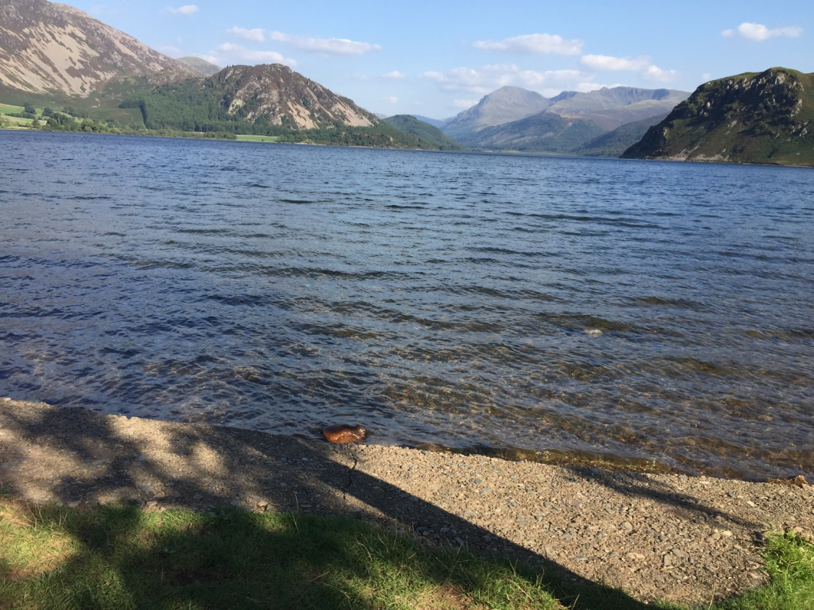

*Ennerdale Water, Lake District*

On the whole I was incredibly lucky with the weather, although low cloud and drizzle preventing me from doing the 3 high level routes I had wanted to take in the Lake District. I will just have to go back some time and do them as day walks.

There was such a great variety of things to see each day – fantastic views and scenery, wonderful bird life including Red Grouse on the moors, lovely villages and towns, all manner of livestock and agricultural activities, remains of former slate and lead mining, stone walls, different types of gates and stiles, trains, the sea, woodland, heather moorland, peat bogs, streams, rivers, lakes and reservoirs, historic churches and buildings, ancient standing stones, tracks and footpaths, honesty boxes with drinks and food and, of course, the people. It was a very enriching experience with loads of time to take it all in.

Arriving at Robin Hoods Bay after walking for 13 days was surprisingly emotional for me; fortunately the tide was in so I didn’t have to walk too far to dip my foot in the sea! We celebrated with a few beers in the Bay Hotel before going back to the Lion at Blakey Ridge to have a meal with some C2C-ers who were still on the trail.

The mileage I walked each day was very variable depending on location, accommodation availability and the amount of ascent/descent.

Here is my brief itinerary:

Fri 31 Aug – St Bees to Ennerdale YH, High Gillerthwaite, 22 miles

Sat 1 Sept – High Gillerthwaite to Borrowdale YH, 11 miles

Sun 2 Sept – Borrowdale to Burtherlyp Howe YH, Grasmere, 11miles

Mon 3 Sept – Grasmere to Patterdale YH, 9 miles

Tue 4 Sept – Patterdale to Brookfield House B&B, Shap, 17 miles

Wed 5 Sept – Shap to Kirkby Stephen Hostel (former YH), 20 miles

Thur 6 Sept – Kirkby Stephen to Keld Lodge (former YH), 12 miles

Fri 7 Sept – Keld to Reeth, 11 miles (Stayed at Osmotherley from this point)

Sat 8 Sept – Rest day

Sun 9 Sept – Reeth to Catterick Bridge, Brompton on Swale 16 miles

Mon 10 Sept – Brompton on Swale to Osmotherley, 22 miles

Tue 11 Sept – Osmotherley to Blakey Ridge, 20 miles

Wed 12 Sept – Blakey Ridge to Grosmont, 14 miles

Thur 13 Sept – Grosmont to Robin Hoods Bay – THE END, 15 miles

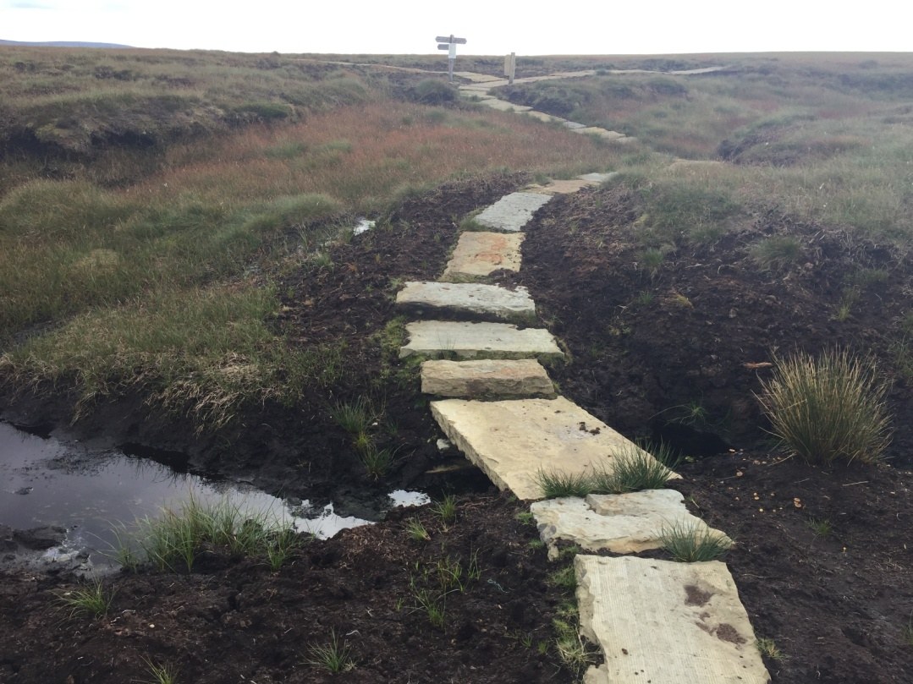

*On the path near Nine Standards Rigg*

*Yorkshire Dales*

I had a great time, there were tough days but even they were great! My knees just about made it – thanks goodness for walking poles! On reflection I probably should have had another rest day. When I got home I reluctantly decided that I probably wouldn’t be able to tackle some more hilly, mountain stuff but I think I’m weakening – watch this space!

**Terry Brown**

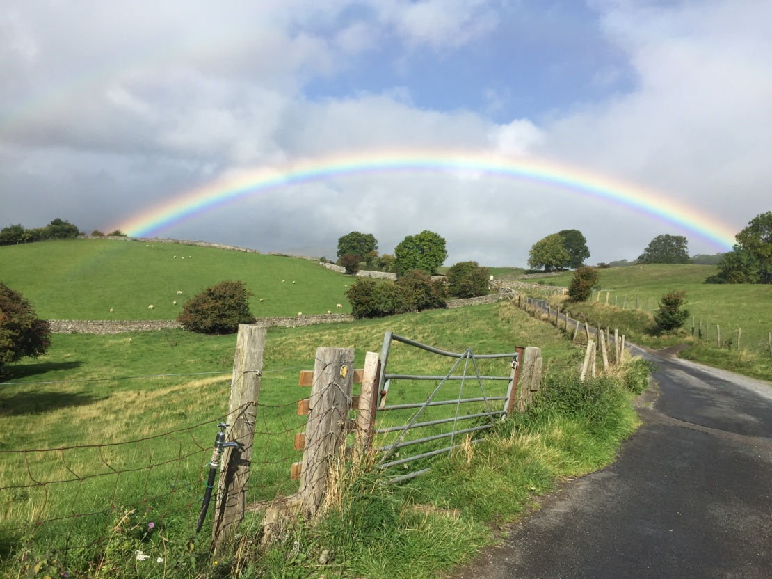

*Near Reeth, Yorkshire Dales*

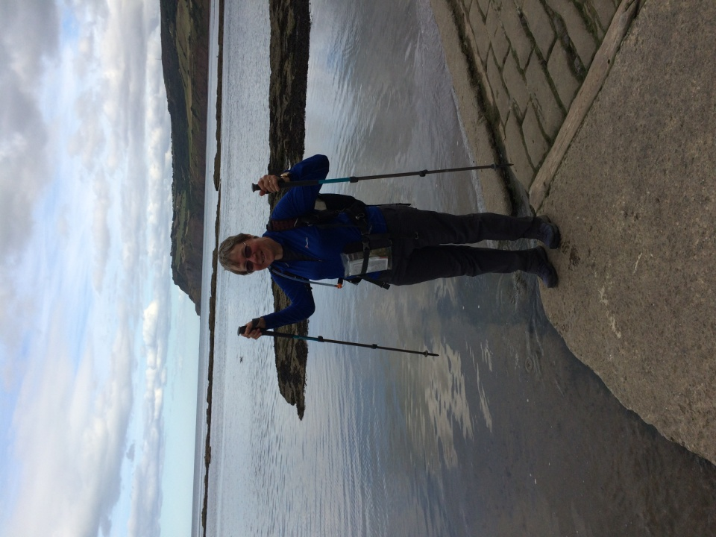

*At Robin Hoods Bay*

**WORLD BOG SNORKELLING CHAMPIONSHIP**

This is an event that I’ve taken part in since 2016 when I was 60 (I know it’s hard to believe….) and was looking for something unusual to mark the year. I’d done some laps of Silverstone in an Aston Martin in May and completed the 100th Nijmegen Vierdaagse in July. I thought what else can I do?

I know, I’ll go Bog Snorkelling! I knew of it from my frequent visits to the Welsh 4 Days in Llanwrtyd Wells in Wales since 1981. The town boasts the title of the smallest town in Britain.

The 1st Bog Snorkelling Championship was held in 1985. Legend has it that Gordon Green and members of the town council were in the back bar of the Neuadd Arms Hotel trying to think of an event to bring visitors and revenue to the town. One of the landowners said “Well I’ve got a hole in my field you can snorkel in” and the rest is history.

The event consists of entrants having to snorkel 2 lengths of a 60 yard (54metres) trench filled with water in a field just outside the town. There are 2 bogs, Bog 1 and Bog 2. The only stroke that is allowed is Doggy Paddle. Entrants have 2 minutes to reach the end of the bog, touch the white post and then return. There is no time limit on the return but you want to finish it as quick as you can!

54 metres you think “Not far, easy peasy”. I can assure you it is not! You step into the trench and the first thing you think…. “\*\*\*\* this is freezing”.

|  |  |  |
| --- | --- | --- |
|  |  |  |

The next thing is you dip your snorkel in the water and realise you can’t see a thing. So far so good…..

After a briefing and countdown from the marshal off you go! Well you try to anyway. 54 metres suddenly seems a long way away, the water is icy cold and at that point you start to think “Why am I doing this to celebrate a birthday?”. After what seemed the longest 2 minutes of my life I reached the white post at the halfway stage. By now I was gasping for breath and my friend Lynn and the marshal were saying “Are you okay? Do you want to get out?” I’d been looking forward (?) to this for a year and somehow said “No way”.

So off I set on what was an even longer 2 minutes bouncing off the sides of the bog due to not being able to see and finally with a last gasp effort managed to reach the end to climb out and receive my World Bog Snorkelling Championship medal. After 2 minutes of my chest heaving I thought “Well that wasn’t too bad” and re-joined Lynn to watch the other competitors such as Spiderman, the Incredible Hulk and a bunch of grapes take part.

The winner was announced as having completed in something like 1 minute 25 seconds. I was last in something like 5 minutes 15 seconds so the phrase “I could have been a contender” didn’t really apply. But I finished which was the main thing!

After a few pints in the evening and listening to the music I thought “That wasn’t too bad” and “Don’t want to be last so I’ll return next year”. Well I did, but due to too much sauce on the Saturday night and the fatal mistake of buying a tee-shirt before the event I retired due to being unable to breathe properly. More fool me. With pride somewhat dented I vowed to return in 2018 and at least finish the event.

The previous two years had been glorious weather, a beautiful atmosphere with bands playing, a bouncy castle for the kids and lots of people milling about. This year when I pulled the curtains back in my B&B and looked at the rain lashing down I thought “Why didn’t I go on the BBN weekend in Derbyshire like Dee asked me to?” Oh well….

A bus runs to the bog from outside the Neuadd Arms Hotel but this was full so I followed some other people into a VW Combi van which pulled up behind it and was also going to the event. I got chatting to the people in the van and it turned out they were from National Express making a video of places and events that you can get to by their coaches. I noticed they had a spare pair of fins and asked if I could borrow them. They agreed but then asked if I would agree to an interview and wear a head cam whilst attempting my snorkel...

At 1015 on a Sunday morning I gave an interview in the middle of a field in Wales in a downpour wearing my BBN cap. The interviewer asked me to sum up in one word the attraction of Bog Snorkelling. When I replied “Eccentric, fun and demanding”, he replied “Well that’s three words”… This television lark is not all it’s cracked up to be!

After that I walked up to the registration tent, signed on and waited my turn which was due about midday. Whilst waiting it was a case of walking up and down in between the 2 bogs in the pouring rain encouraging people in their various outfits snorkelling to the halfway white post and then returning. Some were very quick, others not so quick and some were struggling. There were a variety of fancy dress costumes such as the couple who entered as the Bog Ness Monster...

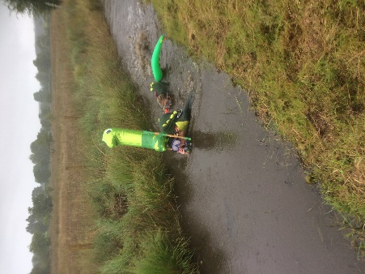

Come High Noon it was my turn to enter and with my head cam fitted I slid into the bog thinking “Only 2 minutes either way Norm and then you’re done” .Head down with the National Express team yelling encouragement and telling me to use their fins I made it just about to the white post, stood up and promptly swallowed half the bog. That probably explains why I couldn’t stop coughing and spluttering and why the marshal said to me “Are you okay? Do you want to get out?”……….”ARE YOU OKAY? DO YOU WANT TO GET OUT?” when there was no reply!

Having come this far and with a mouthful of something or other I whispered “No” and set off. I was so exhausted that I was continually stopping, grabbing hold of the side of the bog to stop myself from drowning and then realising you can’t stand up with fins on. I lost count of the number of times I fell over but eventually made it to the finish to complete the event and receive my medal. Thank goodness that’s over I thought but reconciled myself with the knowledge I was Buckinghamshire’s Number 1……

From then onwards I handed the head cam back to National Express and carried on watching other entrants do the same as I’d done. Some gracefully and with ease, some not and others where the struggle was too much. All the while watching TV crews from as far apart as Italy and Denmark interviewing the competitors and Gordon Green whose idea it was back in 1985.

Just after 3 pm the last two competitors had taken part in a Bog Off and it was then back to the tent to watch the various winners in their categories receive their awards. The clouds cleared, the rain stopped and there was a bright yellow orb in the sky. At this point the compere announced that “The sun can \*\*\*\* right off now”. Cue an outbreak of relieved laughter.

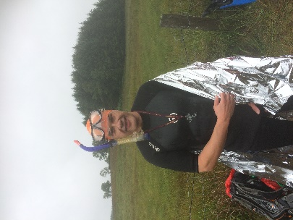

The first male home was Neil Ritter in a time of 01:18:22. The first lady home was Elinor MacCormac in 01:48.46. The last entrant home was me in 06:26:02. Slower than before. But I’d finished which was the important thing.

An example of how this event has inspired people is Julia Galvin from Ireland. Some 20 years ago she was lying in a hospital bed in Ireland wondering if she would ever walk again. She read an article about the Bog Snorkelling championship and thought “I want to do that”. From there she forced herself to walk, then to swim and two years later completed the event and has been coming ever since. For whatever reason it gave her a purpose and a new lease of life.

I’d like to thank John Davies for the loan of his equipment and the training he gave me over the last two years on how to snorkel. Without his assistance it would not have been possible.

Anyone fancy trying to wear a BBN buff in the Bog next year please contact me and I’ll give you advice!

**Norman Corrin**

*PS I never heard back from National Express. I presumed a 6 minute film of brown muddy water doesn’t sell their product all that well..….*

**oooooOOOOOooooo**

**THE GREAT GLEN WAY & SUILVEN**

I read the Cameron McNeish book “Scotland End to End” and he mentions The Great Glen Way, and what a lovely long distance path it is, following the Caledonian Canal and Loch Ness from Fort William to Inverness, so I started thinking that I would like to walk the Great Glen Way myself. Then the film “Edie” (Sheila Hancock) came out about an elderly lady (83) who climbed Suilven in the Highlands of Scotland so, putting the two together, I decided to go up to Scotland and do both.

So on the Sunday morning off I trod, turned right on the Caledonian Canal and followed the towpath for what was going to be 20 miles to Laggan Locks. I didn’t plan to walk 20 miles on the first day as I’d not done any backpacking for some time, but there was nowhere to stop between Fort William and Laggan Locks

with any type of running water or supplies so I just kept going. The tow path was hard tarmac, so hard on the feet. When I got to Laggan Locks there was signs up saying there was a boat with a fully stocked bar and bar food to be had, so I pitched my tent where I was told I could for free, then hobbled over to the boat, and settled down for a few pints and a spicy beef chilli. A couple of French girls came in so I had a chat with them then went back to my tent and turned in for the night.

The next day was going to be another 20 miler approx, all the way to Fort Augustus, hard solid walking most of the day but some great views. Boats of all sizes sailed by on the Caledonian Canal from small sailing boats to more larger sea going boats and of course the large barges. Watching them get through the lochs was fun especially when they were too tall to get under a bridge so they had to swing open the bridge and close the road. My feet were ready for a rest by the time I got to Fort Augustus, a large town with shops, pubs, supermarkets etc. There was a hostel, where I managed to get a bed for the night, and guess what, the dorms were mixed. I made up my bed then headed into town for some grub and a pint. I watched the boats go through the lochs then headed back to the hostel. Two more beds were taken, and surprise, surprise it was the two French girls I met at Laggan Locks. I went for the evening meal supplied by the hostel, an excellent meal.

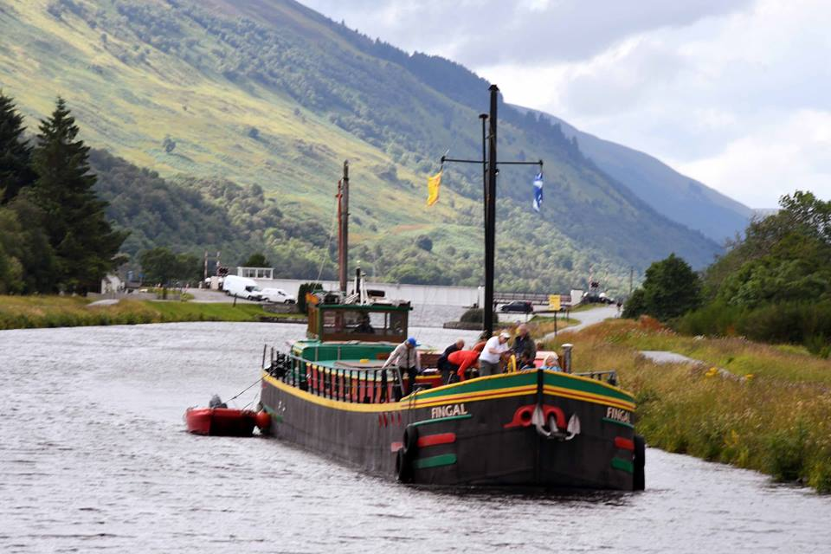

The next day was going to be more energetic, with a couple of high alternatives, which I took. The first one wasn’t too bad. I started to climb almost immediately,   
I got to the top and then had a good path with some great views, in fact at one point you could see nearly all of Loch Ness stretching out into the distance, towards Inverness my destination. I stayed on a level path for a while, and then dropped down into Invermorrison, where I hoped there would be a shop or café. Yippee, on the corner was a little shop that sold pies, sarnies, tea and coffee.   
I got myself a coffee and some food and had about a half hour break.

The second high level was ahead of me, and that turned out to be a lot tougher than the first one. I walked up a long tarmac road following the GGW signs, up and up and up, then into the trees. The path went left then right, up and down,   
I walked passed two guys setting up camp at around 3pm, stopped for a quick chat then went on my way. They told me I had some pretty tough climbing ahead of me, they weren’t joking. I saw a steep hill in the distance and thought I won’t be going up that, how wrong I was. To the left and to the right up, down, up, down and I was getting closer to that big hill, I thought Ooops

The scenery was not as good as the first high level route. I was more enclosed.   
I eventually got to the top then dropped back down the other side, finally arriving at Drumnadrochit, another town. As I walked towards the main road there was a large campsite in front of me. That’s where I’m going to pitch my tent I thought, my feet were aching and ready for a rest. I booked in for ten pounds, but by the time I got my tent up it had started to rain, so I just stayed in my tent, cooked a quick meal and read a bit, then turned in for the night with a family playing football just outside my tent. Oh well, you can’t have it your way all the time can you.

The next day the rain had stopped and with 20 miles to go to Inverness, I could finish the GGW today. The going was relatively flat, nothing like the day before, and I covered a good few miles quite quickly. After about 10 miles I was walking on a track through trees, and signs for an eco-camp site started to appear, I thought to myself if it’s cheap enough I’ll stop and finish the GGW the next day. This actually made sense because I didn’t have anywhere to stay in Inverness so if I got to Inverness too late I might not find anywhere, so finishing the GGW the next day at around noon made more sense. The campsite was just off the track so in I went, and there sitting at a table were the two French girls I’d met a few days before. “Hey girls, how you doing?” I said. It turned out that they’d caught a bus from Invermorrison to Drumnadrochit and were going all the way to Inverness that afternoon and after 20 minutes they left. I paid a fiver for my tent. You’ve heard that saying “you get what you pay for”, well when I was shown where to pitch my tent all I could do was stare. Let’s just say it was the most uncomfortable night of the trip.

The following day was an easy hike into Inverness, a lot of it was road, and I got to a point where you can see down into Inverness and the castle where the GGW finishes. While I was admiring the view a young Danish girl walked by, I asked if she was walking the GGW and she said yes, and made a point of the weight of her rucksack. She took it off and I picked it up, cor blimey it was absurdly heavy, I think it had something to do with 3 litres of water inside. I walked up to the castle about noon, got somebody to take a photo of me then got a beer and a plate of chips and had a giggle with a couple of women who were in Inverness celebrating a friend’s birthday. I found myself a YHA hostel, booked in for the night then walked to the bus station to book my ticket back to Fort William the following day. It was a Thursday so Curry Club in Wetherspoons and yes there is a Wetherspoons in Inverness so that’s where I had dinner that night.

The following day I caught the bus back to Fort William. As we travelled along the A82 which joins Fort William and Inverness we passed places where I had stayed and I remembered what fun I’d had and the people I’d met. In Fort William I returned to the camp site where I had left my car and booked in for another night.

The following day I packed my tent up ready for the trip north to Lochinver, a four hour drive, which would be my base for the climb up Suilven. It was not long before I came across a young female hitchhiker so I stopped to pick her up. She was heading to a coastal town and I could take her part of the way. We had a good chinwag and she gave me a bar of German chocolate when we parted company. When I was about an hour away from Lochinver I left the main road and took an unfenced road, one of those you need passing places to pass oncoming cars. It was a lovely road passing little lochans with and mountains all around.

About 3 miles from Lochinver I passed a small tea shop and bookshop, I pulled in for a brew and had a look around the bookshop and found a map with Suilven on it. When I mentioned that I’d come up here because I’d watched “Edie” the older guy who was serving me said I was the first one to say that, he also said that the bed in the film where Sheila Hancock slept when she first arrived in Lochinver was the young guy’s serving in the tea shop. I drove into Lochinver and found a nice B&B for £35. I could see the top of Suilven from the breakfast window. I had to have a beer in the Culag hotel, which is the hotel where Sheila Hancock goes for a beer in the film.

The following day after a good breakfast I set off back to the tearooms/bookshop where I would start my trek to Suilven, my landlady asked me to let her know when I got back so she knew I was down safe, which I agreed to do. I left the

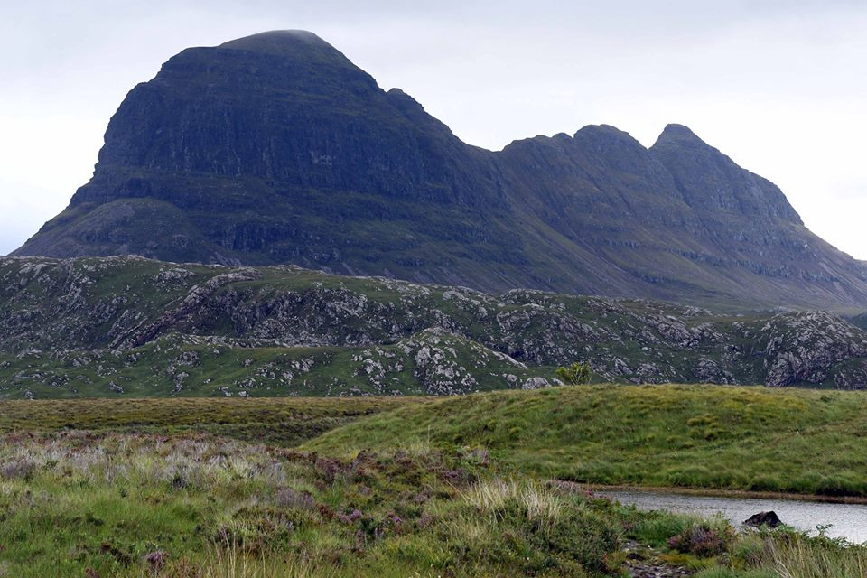

*Suilven*

tearooms/bookshop at 9am and followed a good path along a river until I got to a loch, which I had to walk around. I passed the little rowing boat that Edie used to cross the loch, it was padlocked so I could not use it. It took me 3 hours to get to the base of Suilven and by the time I started up the clouds were coming in. I looked up and thought to myself what the heck am I doing here, it was like a class 1 scramble and on the way up I nearly gave up a couple of times. (It was already 1pm and I was not at the top yet). One step up, slide back down two. It was a very steep climb but I eventually got to the saddle and paused to look down where I had just come up, it was very scary. I was way out of my element here. I followed a path over a couple of false summits and eventually got to the top.

By this time the cloud had come in so I could not see the other summit of Suilven, and there was no views, just under the summit there were views to be had, and it was not that warm. So after a bit to eat I started to return back down the mountain. There were a few others at the top but they came up from the north side. Apparently it is a lot easier to climb Suilven from the North side. I’d come up the South side.

I crossed back over the saddle that Edie crossed in the film, got to the point where I had to start back down, looked down and thought ########, what am I doing here. I started back down thinking if I slip I won’t be able to stop. I did slip and I started to roll thinking I can’t stop, I managed to grab some rock that did not give way so was able to stop myself going all the way to the bottom. It took me a long time to get to the bottom, inch by inch slowly, slowly I went. When eventually the terrain levelled out, I looked back up to see where I had just come down, it was steep and I’m sure my heart missed a beat. I have been reliably informed that Sheila Hancock actually climbed it herself. Well done Sheila Hancock, I take my hat off to you. I’ll buy you a coffee if ever I see you.

So back down on the level I now had to hike back to my car, it took me three hours to hike in, so three hours to hike back out again. I started to hike back along the shores of the loch, I picked up a £20 note on the shore line, and in the distance I could see somebody using the little rowing boat with an outboard motor. It started to rain but it was not that bad, it just meant I did not stop to look at the views or out over the loch. My feet were aching now and damp, but I eventually got back to my car. It was coming up for 6pm, I had been hiking for 9 hours. I called back into the teahouse/bookshop hoping for a brew, but they had closed. The bookshop was still open so I chatted to the older gentleman about my day. “Did you get to the top?” he asked, “Yep all the way” I said, “But I think I was a bit out of my element.” Back in Lochinver I headed for the Culag Hotel for a well-earned pint and I had a very good meal there too, half a chicken, vegetables and spuds. When I got up to leave I could hardly move, I hobbled to my car and drove back to my B&B. I let the lady know I was back safe and jumped into a nice hot bath. I slept well that night. The next day at breakfast the landlady asked me how my day went climbing Suilven, I said “Great **BUT…..**”.

I wondered how far it was to Goldspie, where my half niece lives. I had been trying to get in touch but never got any reply, my satnav said 1.5 hours, so I decided to go for a visit. When I got there Katy was not there. Her husband told me she was in Stornoway, so I didn’t see her, oh well. So I decided to start the long drive back south. I did ponder about going a bit further north but the weather was changing so decided to head back home. I drove down to Drumnadrothit and camped in the campsite I stayed at when I was hiking the GGW, then the next day I got as far as Penrith, eventually putting my tent up around 8pm. The next day was back to dear old Northampton, I covered 1313 miles in my car, and had a great holiday. Photos of my hike are at [www.steveceegalleries.smugmug.com](http://www.steveceegalleries.smugmug.com)

**Stevecee**

**Arhhhhhhhhhhhh**

I flew to Innsbruck in Austria to get to Seefeld because it is only a 30 minute train ride to Seefeld. The only problem was I had to fly out of Gatwick, so parked my car at Milton Keynes Coachway (why the MK Coachway I hear you ask) ok I’ll tell you, it was all about parking the car. I did not know where to park my car in Northampton for a period of 7 days so I would have had to get a taxi to where I would pick up the coach from in Northampton. Instead I drove to MK Coachway and parked my car there for free.

The flight into Innsbruck is fantastic, you are actually flying through a valley with high mountains either side and on a clear day it is a beautiful sight. On the ground and my bags in my hand I caught a local bus to the train station for the train ride to Seefeld. The Olympia hotel where I was staying is only a 5 minute walk from the train station, so I booked in, unpacked and headed into town to see if there was anybody I knew around and have a few beers. I didn’t find anybody so I got a bottle of wine and returned to my room then turned in for the night. On the Thursday I caught the bus to Leutasch where the walks now starts. The venue was in Seefeld but it was moved about 4 years ago. It’s not really a problem because the local bus company puts on a bus that runs to the venue at 08.20 Friday, Saturday and Sunday just for us (a 20 minute ride).

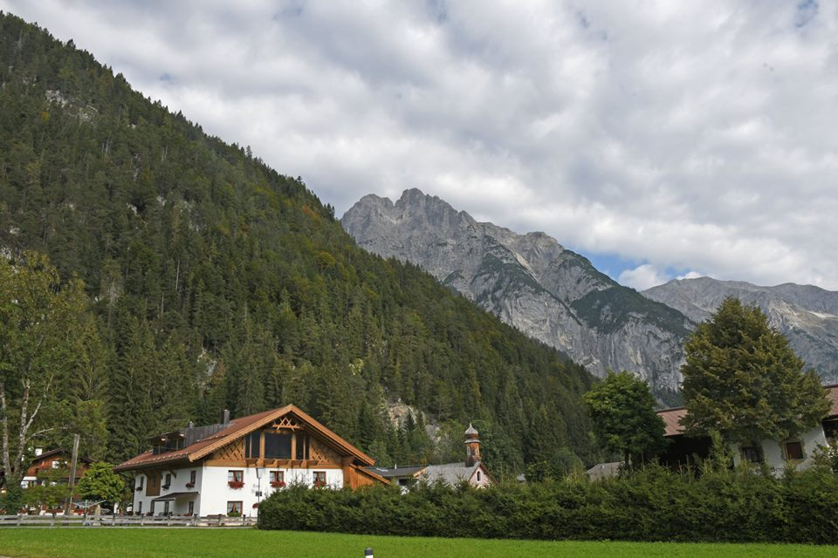

Friday morning I was up at 7.30am, had breakfast and walked down to the train station to catch the bus to the start. I intended to do 20kms a day, which is what you have to do to qualify for the stamps. So at 9am off I trotted, the first of my three 20kms. The weather was pretty good and the views were great and on the way around I met up with a young woman by the name of Lodka and her dog Amy. We walked together for the rest of the day, she didn’t like her photo taken so I do not have a good photo of her but I do have some of Amy. The rest of the day went well, with good views of the high Alps all around. We got back to the venue at around 1.30pm, bought each other a beer, then I went back to Seefeld by bus.

Saturday and Sunday were great days, the weather was perfect and we had some fantastic views all around. Little Amy didn’t walk on Saturday, Lodka left her in the apartment for a nice rest with her friend that she travelled with, but she came out again on Sunday. Poor little Amy 10 minutes from the finish on Sunday she started to limp and had to have a 10 minute rest. The Sunday hike was the most energetic, climbing all the time to the Hammermoose checkpoint. There was another dog on the walks being pushed around in a pushchair, he looked so cute (pictures on the web site).

Of course there is always one hiccup isn’t there. On the Monday I checked out of my hotel and headed for the train station. I caught the train into Innsbruck then hung around the bus station for a coffee and a beer before heading for the airport. At 12.30 am I got the bus to the airport for my 16.15 flight back home. I looked around for my check in desk, could not find it so I went to the EasyJet info office and asked when EasyJet would be opening to check in. He gave me a funny look and asked for my ticket. Another funny look and then he said “Your flight is tomorrow sir, today is the 17th”. My flight was on the 18th, Arrhhhhhhhhhhhh.

Back on the bus I went, the driver asked “what’s wrong mate” I told him my story and he just laughed. Back in Innsbruck I found the information office and told them my story, I asked what’s the cheapest hotel you’ve got in Innsbruck, they found one for me, Hotel Engl, 68 euros. Bags in my room I walked into town for some food and beer, then to bed ready for my flight home on the 18th.

Photos – [www.steveceegalleries.smugmug.com](http://www.steveceegalleries.smugmug.com)

**Stevecee** x

|  |  |  |
| --- | --- | --- |
|  | **WALKS PROGRAMME**  **JANUARY TO APRIL 2019** |  |

**Sun Jan 6 2019 The 3 Kings – Walk and Meal**

8/9ml. 09.00 Grove Lock PH c.p. Grove Road, Leighton Buzzard LU7 OQU. Maps: LR 165 Exp 192 (GR SP914230). Morning walk followed by pub lunch. £5.00 deposit required - please send cheques, payable to BBN LDWA, to Treasurer Peter Engledow (address on BBN website). Menu details on pub website. Book your meal with Therese by 15th Dec. ***C:*** Therese Jamin ***M:*** 07779 227675.

**Thu Jan 10 2019 Three Spires in Three Shires**

16ml. 09.30 High Street, Riseley, near the Fox & Hounds (MK44 1DT). Maps: Exp 223,225 (GR TL040627). Pub at lunch time. ***C:*** Roy Carter ***T:*** 01234 301182 ***M:*** 07784 208997.

**Sun Jan 20 2019 Steeple Chase 2**

19ml. 09.00 Ringstead Pocket Park c.p. Maps: LR 141 Exp 224 (GR SP983750). ***C:*** Wayne Rowlett ***T:*** 01536 460984 ***M:*** 07388 026676.

**Thu Jan 24 2019 Loopy from Harlington**

14ml. 09.30 Harlington Village Hall, LU5 6LS. Park at the back of the car park on the unmade surface. Map: LR 166 (GR TL036302). Lunch time pub stop. ***C:*** Sara Waldron ***M:*** 07850 665454 on day only.

**Sat Feb 2 2019 Same old – 6 mills**

16ml. 09.00 Woodford Village Green. Map: LR 141 (GR SP967769). Please park carefully on the roadsides. ***C:*** Jim Robinson ***M:*** 07845 909750 (on the day).

**Thu Feb 7 2019 Towers and Bowers**

15ml. 09.30 Sackville Street c.p. Thrapston (NN14 4NZ). Toilet facilities. Maps: LR 141 Exp 224 (GR SP998787). Walk via Woodford and Drayton Park, lunch stop in Sudborough or Lowick if shorter walk needed. ***C:*** Geoff Curnock ***M:*** 07941 413318.

**Sun Feb 10 2019 Chiltern Kanter Marshals' Walk**

For CK marshals. ***C:*** Norman Corrin ***T:*** 01908 608667 ***M:*** 07980 378656 on day.

**Sun Feb 17 2019 The Flit Valley Walk**

17ml. 09.00 Flit Valley Discovery Centre, Brook Lane, Flitton – 300m NW of church. Map: Exp 193 (GR TL057360). The ‘Flit Valley Walk’ is a new 7.5 mile linear route which we will be doing in 2 sections as part of the 17. ***C:*** David Sedgley ***T:*** 01525 714961 ***M:*** 07583 091770 (only use mobile number on the day).

**Thu Feb 21 2019 From two Saints to a Laud**

15ml. 09.30 St Peter & St Paul Church, Cranfield. Map: Exp 208 (GR SP955420). Lunchtime pub nearby. ***C:*** Eric Cartwright ***T:*** 01234 315181 ***M:*** 07761 589281.

**Sun Mar 3 2019 Chiltern Kanter**

26, 18 or 13ml. From Pitstone Memorial Hall, LU7 9EY (GR SP937155). Please note this is a map reading event. Circular routes through the Chilterns. Maps: LR 165/166 or Exp 181. Start: 08.00-8:30 for 26 &18ml; 08.30-09.00 for 13.5 ml; runners 09.00-09.15 (all to finish by 18.00). Online entries close Fri 22nd Feb. Paper entry forms available on request. Event parking at Safran Power Systems, Pitstone Business Park, Westfield Road, LU7 9GT (GR SP933154). Follow direction of marshals. Entry: £7, non LDWA £10, under 16s £3 (no entries OTD) incl refreshments at Cps; hot meal & cert at finish. Online entry at: https://www.sientries.co.uk/. ***C:*** Mike Hyland, 55 Broadlands Avenue, Chesham HP5 1AL ***T:*** 01494 774154 (not after 21.00, please). ***E:*** bbn-ck@ldwa.org.uk ***W:*** www.ldwa.org.uk/bedsbucksandnorthants

**Thu Mar 7 2019 Two Loops Out of Three**

15ml. 09.30 Allotments at South end of High Street (B5120), Toddington. Map: LR 166 (GR TL008279). Park considerately in side streets, not in small allotment car park. Picnic lunch. ***C:*** Peter Simon ***T:*** 01582 513827.

**Sun Mar 17 2019 A London A-Z**

15-16ml. 09.45 From King's Cross Station. Meet by Platform 9¾. Map: Exp 173 (GR TQ303831). Walk the alphabet from the Angel to the Zoo. ***C:*** Gill Bunker ***T:*** 01908 321308 ***M:*** 07790 976090.

**Thu Mar 21 2019 FFF Fetch a cloth**

15ml. 09.30 Pattishall Church. Map: LR 152 (GR SP671542). Park considerately in the village, very limited parking by the church. ***C:*** Mary Knight ***M:*** 07554 661519.

**Thu Apr 4 2019 Locks, Crocks and a few soaks in apparels**

15ml. 09.30 Bugbrooke Church c.p. Maps: LR 152 Exp 207 (GR SP674573). ***C:*** Colin Stoneman ***T:*** 01327 830889 ***M:*** 07764 684 661.

**Sat Apr 13 2019 A Milton Keynes Marathon**

26/27ml. 08.00 From Stanton Low Park c.p., Newport Road, Oakridge Park, Milton Keynes. Maps: LR 152 Exp 192 (GR SP838418). Using the woods, waterways and local LDPs within Milton Keynes. Unsupported, but there will be opportunities to replenish food/drink en route. ***C:*** Gill Bunker ***T:*** 01908 321308 ***M:*** 07790 976090.

**Thu Apr 18 2019 WHACKO**

15ml. 09.30 Ampthill Park c.p. (not football club c.p.). Map: LR 153 (GR TL025382). ***C:*** Roger Skerman ***T:*** 01525 405540 ***M:*** 07757 057440.

**Sat Apr 27 2019 Wakerley Woods Wander**

16ml. 09.00 Wakerley Great Wood c.p. Map: Exp 224 (GR SP961985). ***C:*** Anne Addison ***T:*** 01780 740414 ***M:*** 07447 616061.