|  |  |
| --- | --- |
| LDWA Logo black & white | **LONG DISTANCE WALKERS ASSOCIATION AIM: TO FURTHER THE INTERESTS OF THOSE  WHO ENJOY LONG DISTANCE WALKING** |

**BEDS, BUCKS &  
NORTHANTS GROUP**

**NEWSLETTER**

**SUMMER 2017**

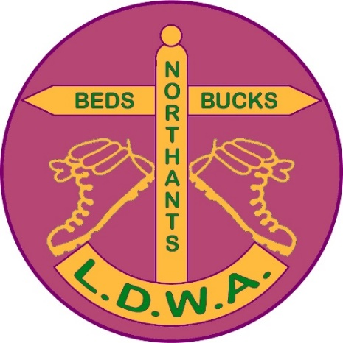

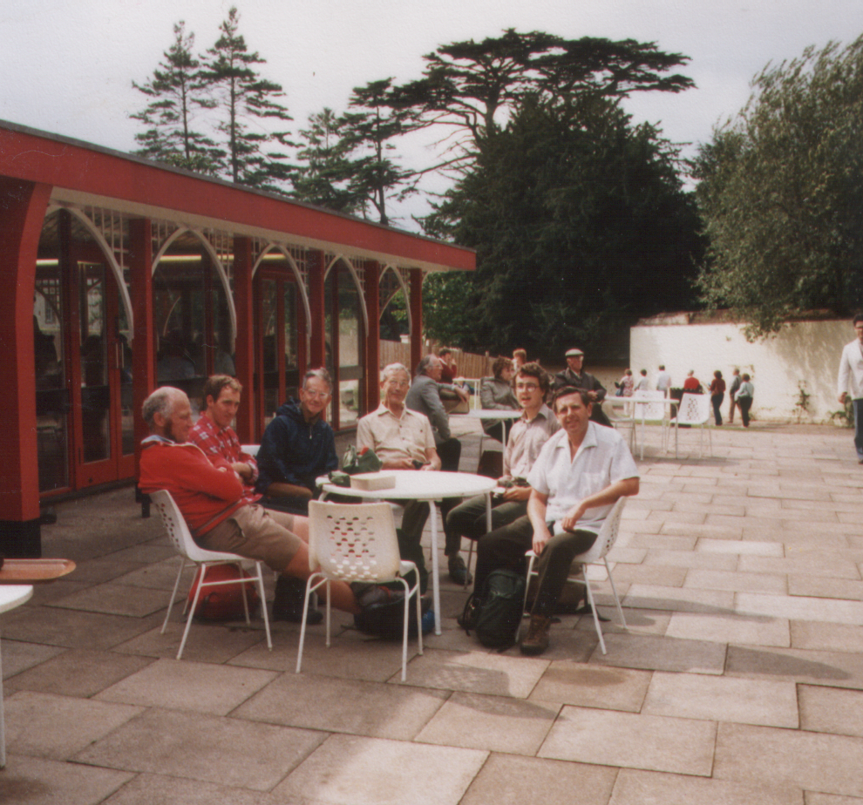

**BBN at Woburn – September 1983 ………… and June 2017**

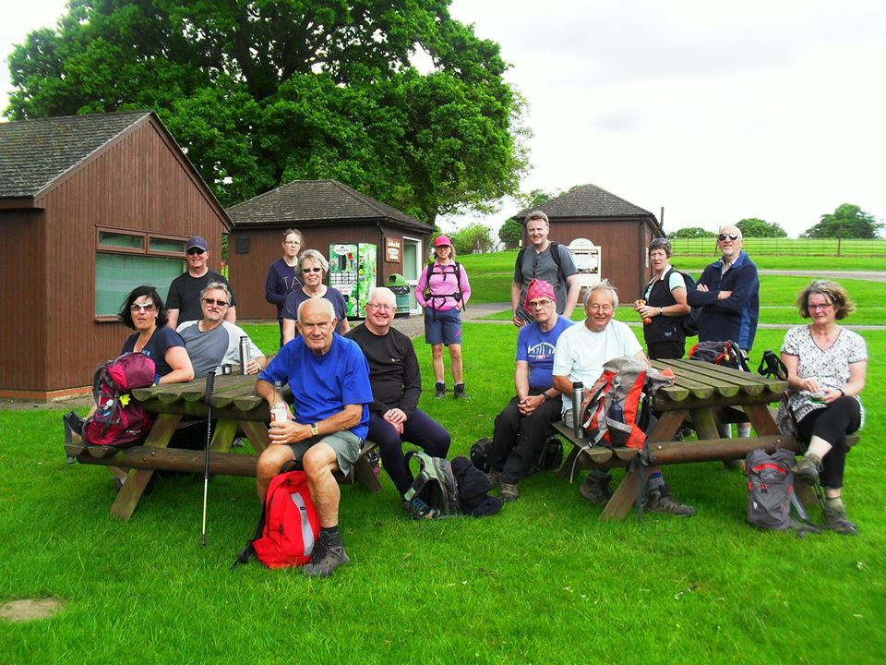

**CHAIRMAN’S CHATTER**

First of all, a very warm welcome to our new members: Sarah Feal, Andy & Marisa Chinn, Howard Smith and Carolien Kratz. Welcome back Kevin Lamming and Sarah Lethbridge.

Shortly after the publication of the last newsletter we received the sad news of the loss of John Nickerson on a walk with the Ivel Valley group. This came so soon after the passing of Dave Eames. 2017 was not a good start for BBN.

There was a large turnout at John’s memorial service in the church where Judy and John married and Jean Bowers gave a very eloquent summing up of John’s life and his love of walking and the LDWA. It was pleasing that so many turned up to offer Judy and her children such support at this difficult time. John will never be forgotten.

Shortly after that we had a double weekend with a memorable Chiltern Kanter followed by the National AGM at Horwood House.

The Chiltern Kanter started off in pretty appalling weather and it didn’t get much better…… Conditions on top of the Beacon were by all accounts dire and we had a few retirements between the start and Checkpoint 1 at Little Gaddesden, some 6 miles away.

Luckily the weather did take a slight turn for the better after the first 2 hours or so and the walkers/runners were able to appreciate the different parts of the Chilterns. But the weather did take another turn for the worse and entrants were handing in papier mache forms to Dave, Merrian and Peter on the desk where they had the joy of trying to decipher the answers! Many thanks to all those who helped on the day and, in particular, to Mike Hyland for doing such an excellent job in coming up with a varied and attractive route and handling all the entries.

One week later (well, just under 5 days) and BBN were honoured to host the National AGM for the first time at Horwood House, Little Horwood, just outside Milton Keynes.

From the feedback received from various sources the members enjoyed the various routes that we had laid on for them. The A and B walkers were able to visit the BBN Founders’ Memorial Bench and in particular the A walkers could appreciate the view from the top of Ivinghoe Beacon, unlike their counterparts on the Kanter the weekend before.

The A and B routes were royally fed and looked after by the group at Wing Village Hall and the C and D routes were amply catered for by their respective hostelries. Many thanks to Dave & Merrian, Teresa Brown, Sylvie & Norman Smith and Chris Bent and Frances Craven for leading the walks.

Steve, Pearl and I managed to entertain the members with a quiz on Friday night and no expense was ~~spent~~ spared on the prizes! The lecture on the Saturday night by Richard Bradbury, the former Strider Editor, gave a very good overview of the Chilterns and the efforts of The Chiltern Society to look after them.

The National AGM on the Sunday morning at times got quite heated, but healthy debate amongst a group is a good sign. I hope those whose first National AGM it was enjoyed it.

Dave and Lynn Yorston held their retirement walk on Friday May 5th and this had a good turnout. Dave pulled the pints halfway through the walk and Martin Lawson, post-Marshals’ 100, acquired a plank of wood. Ian Sage was able to demonstrate what you could do with it…………..in the nicest possible sense! Along with the Cream Tea Trot and the Santa Walk, this now seems to be a group tradition.

We had the annual non-stop LDWA 100 party over the Whitsun Bank Holiday. Before the walkers set off Martin Lawson received his badge for his 20th LDWA 100.

Our group was at CP5 at 31 miles at Rosedale Bunkhouse. We were open from 1600 to 2330 and, to quote the saying, time flies when you’re busy. This time it accelerated to Warp Factor 9! It was a very manic 3 or 4 hours and many thanks to all those who travelled the distance to help on the checkpoint. The hot weather on the Saturday caught a lot unawares and resulted in some entrants requiring assistance at our CP. But as always we adapted and coped. Congratulations to all of those who finished and commiserations to those who retired. There is always next year.

A bonus was the return of Steve Clark as the 100 photographer after his absence from last year’s Dorset 100. It was a pleasure to hear the dulcet tones “Allo dahlin, give us a smile” as he arrived at the checkpoint. His photos are now on the LDWA website. Welcome back!

We have some upcoming treats over the next few months. There is a varied social walks programme throughout the summer on both Saturdays and Sundays including Wayne Rowlett leading A Walk Around Corby on Saturday 15th July.

On October 21st we have a group walk of the Milton Keynes Parks Trust 25 mile challenge and in November there is the Shillington Shuffle.

That’s all I’ve got to say for now so, as always, please remember that when you’re out with BBN friends on a national trail, social walk or Challenge Event that you might walk on but YNWA….



Good Walking!

**Norman Corrin**

-----------------------------------------------------------------------------------------------------------

**NORTH YORK MOORS 100**

Well it was certainly a 100 to remember………as they all are!

BBN group had what qualifies as a contender for the most cramped 100 checkpoint ever award. Rosedale Bunkhouse. For a few hours it was well, another entrant in the front door, squeeze another one out the back door!

Mary was concerned about the feeding of the 500, Dave and Merrian were making sure we didn’t miss anyone and Mike was panicking about no signal for the FA Cup Final. Quelle horreur! But thanks to the efforts of everyone we coped and the entrants recognised that in the confined conditions we were doing our best.

The extremely hot weather caught a few people out on the Saturday but the rain was quite refreshing.

Congratulations to those who finished, in particular Tony Hill who received his 10th LDWA 100 award, Peter Hamson his 20th 100 award, and Martin Lawson who completed his 20th 100 on the Marshals’ Walk. Commiserations to those who didn’t finish. There’s always next year in Kent.

|  |  |
| --- | --- |
| Alan Leadbetter | rtd 54.3 miles |
| Andrew Gilbertson | 47:08 |
| Andy Carpenter | 33:44 |
| Barbara Clayton | 34:45 |
| Brian Layton | 41:08 |
| Carol Goodwin | rtd 39.8 miles |
| David Chesher | rtd 69.8 miles |
| Dee Brockway | 42:54 |
| Gareth Hay | rtd 39.8 miles |
| Gill Howe | rtd 69.8 miles |
| Glyn Dimmock | rtd 54.3 miles |
| Graham Busch | rtd 31.8 miles |
| Helen Crossland | rtd 54.3 miles |
| Jill Green | 41:56 |
| Jim Catchpole | 41:56 |
| Jim Robinson | rtd 69.8 miles |
| Kim Reed | 33:45 |
| Lisa Joanne Walbridge | 25:21 |
| Luis Broz | 46:25 |
| Mark Clayton | 34:45 |
| Nick Vanson | 39:12 |
| Paul Kitson | 42:53 |
| Peter Hamson | 41:23 |
| Phil Friede | 42:45 |
| Sophie Goodwin | rtd 39.8 miles |
| Tony Hill | 33:45 |
| John Esslemont | 47:16 |
|  |  |
| **Marshals’ Walk** |  |
| Martin Lawson | 40:58 |

See you all around to hear your stories!

**Norman Corrin**

**HAPPY NEW YEAR!**

Time to start working on the 2018 walks programme already. You have a couple of months to come up with the details required for Strider – all you need to do first is reserve your date.

Below are available dates for Thursday walks:

|  |  |  |
| --- | --- | --- |
| January | 11th |  |
|  | 25th |  |
| February | 8th |  |
|  | 22nd |  |
| March | 8th |  |
|  | 22nd |  |
| April | 5th |  |
|  | 19th |  |

And these are available dates for weekend walks. Please remember walks can be Saturday or Sunday – just e-mail me to reserve your date.

|  |  |  |
| --- | --- | --- |
| January | 6th/7th |  |
|  | 20th/21st |  |
| February | 3rd/4th |  |
|  | 17th/18th |  |
| March | 4th | Pick and Mix |
|  | 17th/18th |  |
|  | 31st/1st |  |
| April | 14th/15th |  |
|  | 28th/29th |  |

If you would like to arrange a walk on any other date please just let me know.

One final plea – after your walk please e-mail me with your walk stats (distance and number of walkers). Thanking you in anticipation.

Best wishes and happy walking.

**Mary Knight  
Walks Secretary   
(maryjknight@hotmail.co.uk)**

**LDWA 2018 CINQUE PORTS 100 BBN CHECKPOINT**

After the success of CP5 on the recent North York Moors 100 BBN had been nominated to host Checkpoint 2 at Rye on next year’s 100 in Kent. However due to a mess up by me that is no longer the case.

Neal O'Rourke, who is the checkpoint co-ordinator for the Cinque Ports 100 event, has mentioned that another checkpoint is available. However it is the penultimate checkpoint at Northbourne.

The hours are from Sunday 27th 4.40 am to 6.00 am Monday 28th May 2018. So we would need two shifts. The thing is we would not need as many helpers as we normally do on an earlier checkpoint. Neal has said he does have a small team there at the moment but he would like to know if any and how many of our group would be interested.

Dave and Merrian are on the last checkpoint after that. So if we took the penultimate checkpoint BBN would be the friendly smiling faces towards the end.

Is anyone interested in organising this? Even if they’re not, is anyone interested in helping on this checkpoint. If so, please could you contact me?

**Norman Corrin**

**NOTICE OF ANNUAL GENERAL MEETING**

**LONG DISTANCE WALKERS ASSOCIATION  
BEDS, BUCKS & NORTHANTS GROUP  
ANNUAL GENERAL MEETING**

**SUNDAY 26TH NOVEMBER 2017 AT 2 PM**

**COSGROVE VILLAGE HALL,   
COSGROVE, NORTHANTS MK19 7JH**

**BBN EMAIL UPDATES  
Privacy and Data Protection**

BBN group officers are now required to use the LDWA National Database to contact members, rather than keeping members’ email/home addresses on individual computers. The National Database has high levels of security and access to individuals’ personal information is limited to specified LDWA volunteers on a need-to-know basis.

This means that in order to receive Peter’s Updates or any other BBN/LDWA emails you need to make sure your membership information on the LDWA database contains your up-to-date email address.

To add/amend your email address on the LDWA records, or to update any other personal information including changing your address or telephone number (or to add the LDWA regional groups that you wish to be an associate member of):

Go to [**www.ldwa.org.uk**](http://www.ldwa.org.uk/)(select any page)

**Log in** (top LH corner) with (first box**) your LDWA membership number or email address** (this needs to be the email address recorded on the database)  
and (secondbox) **your password.**

Click **Log In**

Select **Members** (immediately below header picture)then **View/Edit Your Details** on the drop down menu.

Have a look at the information recorded, and if you need to change anything this is done via the menu on the right hand side of the screen (or across the bottom).

* **Change Password**
* **Update Your Details**
* **Local Group Membership**
* **Email Preferences**

Remember to click the **Save** button at the bottom of the page to save any changes you make.

**If you don’t know your password:**The good news is that this can be sorted out very easily.

Go to[**www.ldwa.org.uk**](http://www.ldwa.org.uk/)(select any page)

Select **Members** (immediately below header picture)

then **Reissue Password** and follow the instructions – all that is needed is your last name and email address.

**If your email address has changed or you have never registered an email address with the LDWA then there is a direct link on this page to the LDWA Membership Team. Give them your membership number, name and address and they will manually reset your password and email it back to you.**

If you experience any problems at all, or are worried about amending your own records, please get in touch with the National Membership Secretary at [membership@ldwa.org.uk](mailto:membership@ldwa.org.uk). Steph Carter is the current Membership Secretary and he will be pleased to help you. He has always dealt with my queries in a very prompt, efficient and friendly way. **Remember to include your postcode and LDWA number with your query as this will help Steph find you on the membership records more easily.**

**Gill Bunker**

-----------------------------------------------------------------------------------------------------------



**With thanks to Tim Vine**

This bloke said to me, "I’m going to attack you with the neck of a guitar." I said, "Is that a fret?"

I saw Arnold Schwarzenegger eating a chocolate egg. I said, "I bet I know what your favourite Christian festival is." He said, "You have to love Easter, baby."

This bloke said to me “As a young boy, was your mother very strict with you?”

I said “Let me make this very clear, my mother was never a young boy.”

I entered the sun tanning event in the Olympics. I got a bronze.

One armed waiters – they can take it but they can’t dish it out. → → → →

**BRAS, BLISTERS AND A GOOD OLD NATTER**Half Moon 2018 – London - 12th May 2018

To celebrate Pearl Smith’s birthday next year, Pearl and Gill Bunker have entered the Half Moon (13.1 + 2 miles) and we now have a BBN team taking part.

So far there are 9 of us:   
7 BBN members (including 2 men – brilliant) and 2 BBN daughters.

It’s the Walk the Walk charity – raising money for vital breast cancer causes, helping cancer patients today and, through the research they fund, benefitting the future health of us all.

Anyone else want to join us?   
More info here: <http://walkthewalk.org/challenges/the-moonwalk-london-2018/>  
Contact [gillbunker@googlemail.com](mailto:gillbunker@googlemail.com)



**-----------------------------------------------------------------------------------------------------------**

→ → → →

I went to the DVD library the other day and said “Can I please take out Batman Forever?” They said, “No, you have to bring it back next week.”

I was having dinner with my boss and his wife and she said to me, "How many potatoes would you like Tim?" I said, "Ooh I'll just have one please." She said, "It's OK, you don't have to be polite." "Alright" I said, "I'll just have one then, you stupid cow!"

**Norman Corrin**

**CHILTERN KANTER  
5th MARCH 2017**

At the start of this year’s Chiltern Kanter the HQ and checkpoint staff all found themselves whistling the 1997 New Labour election theme “Things can only get better” under their breath. That’s what we were hoping anyway!

The weather on the morning of the event was appalling. Both Alan Leadbetter and Peter Engledow were coping manfully with getting all the entrants into Safran Power Systems car park, whilst Gordon Shaughnessy and Therese Jamin were pointing them in their general direction from underneath their waterproof hoods! I’m sure a lot of people looked out of the window in the morning and thought “nah”, which is why we had 43 no shows. Sometimes that’s a wise choice!

After using the same routes for 2013 and 2015 the event had new routes, including using Wigginton Village Hall as a combined checkpoint for the 18 and 26 mile route. Less people to man a checkpoint and in these times of austerity much cheaper….

All of the routes passed the BBN Founders’ Memorial Bench in Ivinghoe and this had been tidied up by Gill and Ian as it was also playing a starring role in the following weekend’s National AGM. This is one example of how the group has invested its hard earned money from over 30 years of effort by its members.

Once all of the entrants had set off this gave time for Dennis, Mary, Sandra, Karen and Therese to start prepping the food

By all accounts the conditions on top of Ivinghoe Beacon were dire and we had a few retirements between the start and Checkpoint 1 at Little Gaddesden, some 6 miles away. Dave & Lynn, Peter & Mooi and Carolien were comfortably ensconced in the Scout Hut feeding the entrants and watching the floor turn a distinctive muddy brown colour…..

If the entrants were doing the 18 and 26 miles they headed west to Wigginton Village Hall crossing the Golden Valley, passing in front of Ashridge Business School and heading towards a warm welcome from Gill, Jackie, Rachel, Beryl and Mike. This was with all the chairs that they had borrowed from Pitstone Memorial Hall….ahem…

Luckily the weather had started to take a slight turn for the better after the firsttwo hours or so and the walkers/runners were able to appreciate the different

parts of the Chilterns. But the respite was not to last long and the conditions reverted back to how it was. To paraphrase Donald Trump “There is some pretty bad weather out there”. When the entrants arrived at Wigginton they were in much need of TLC from Gill and her crew.

From Wigginton the entrants had the choice of doing an 8 mile loop towards St Leonards and returning back to the hall or carrying on to the finish at Pitstone Memorial Hall and dry conditions!

From about 1300 onward the runners/walkers started to arrive at a steady rate to receive their certificates and badges (optional extra!) and their meal choice. Whichever route the entrants did, when they returned they were handing in papier mache forms to Dave, Merrian and Peter on the desk - they had the joy of trying to decipher the answers!

As an aside, this was the first Challenge Event where the new must-have fashion accessory - the BBN buff - was proving to be very popular (I’ll get the figures sorted for you Ian….promise!). If you don’t have one you’re not cool!

Entrants continued to troop in in various bedraggled states handing in their various papier mache objects and helping themselves to the delicious heart-warming food served up by Mary, Dennis, Sandra, Karen and Therese. Everyone in those conditions just wanted to get dry, stay dry and get fed.

All entrants seemed to be returning quite happy with the route although Dave and Merrian did notice how many of the entrants just seemed to go round in a group and only one person was filling in the route sheet.

All entrants got through the checkpoints but we were quite worried about eight or so walkers who had set off on the 8 mile loop and had not arrived when the checkpoint was due to close. Luckily Gill was there to see them coming down the road shortly after and the sense of relief was palpable. This group were wondering if they would be allowed to continue but from Wigginton they were quick on the last 8 miles and managed to get into the finish within the time limit. Joy all around!

As always these events could not be run without the people who do the various jobs which I’ve mentioned previously. I’m very grateful to you all who responded to my email request for help when there was a shortage of helpers. You helped me (and the group) out a lot. My thanks to you and I’ve listed what people did below.

**Entries & Route Designer:** Mike Hyland  
**Start/Finish Booking In**: Dave Findel-Hawkins, Merrian Lancaster,

Peter Engledow

## **Car Parking at Safran Power Systems:** Alan Leadbetter, Peter Engledow

**Traffic Islands**: Gordon Shaughnessy, Therese Jamin,

Martin Lawson

**Checkpoint 1 Little Gaddesden Scout Hut:** Dave & Lynn Yorston,

Peter & Mooi Simon, Carolien Katz

**Checkpoint 2 & 3 Wigginton Village Hall:** Gill Bunker, Jackie Burnett, Rachel Martin, Beryl & Mike Bowley

### **Kitchen at Pitstone** : Mary & Dennis Knight, Sandra Hyland,

### Karen Earwicker, Therese Jamin

### **Floaters & General Helpers:** Lucy Tink, Martin Lawson

**Certificate Design:** Christine Pendlebury

Thank you for all of your efforts for making it all round a special event and once more enhancing the good reputation of our group. If I’ve missed anyone off who helped then my sincere apologies.

### **Lost Property:** The items left behind are listed on the BBN website. Please contact Merrian to claim at her email address on the website.

**Statistics: (Times and actual results are published on the BBN website)**

|  |  |  |  |  |  |
| --- | --- | --- | --- | --- | --- |
| Route | Pre-entered | Withdrew | Non-Starters | Retirements | Total |
| Long | 114 | 4 | 24 | 3 | 83 |
| Medium | 69 | 2 | 16 | 1 | 50 |
| Short | 40 | 1 | 3 | 2 | 34 |
| Total | 223 | 7 | 43 | 6 | 167 |

Here’s to the 20th one in 2019…….

**Norman Corrin**

*P.S.**Something Mike Hyland reminded me of. Well done to Gill, Jackie, Mary and Mike for completing the Marshals’ Kanter in the snow. It was bloody parky and slippy.*

*Even bigger congratulations to Dave and Merrian for doing the 26 mile route in reverse, having a pint in The Greyhound at Wigginton and coming off Ivinghoe Beacon in those conditions……….Brrrrrrrrrr*

**LDWA NATIONAL AGM  
10TH –12TH MARCH 2017**

One week after the waterlogged Chiltern Kanter BBN were honoured to host for the first time the LDWA National AGM at Horwood House, Little Horwood, just outside Milton Keynes.

The format for the AGM weekends is a series of 4 walks, all on the Saturday, for those of differing speed, ability and stamina. These range from the A walks which are normally 20 miles and over, to the D or 10 mile walk which is for those of us who want to take our time and enjoy the day. There is also a coach trip for people to visit areas of local interest.

This year’s walks consisted of:

A Walk – 23 Miles - Led by David Findel-Hawkins and Merrian Lancaster which went to Little Gaddesden by coach and returned via Ivinghoe Beacon, the BBN Founders Memorial Bench and lunch at Wing Village Hall and back to Horwood House.

B Walk – 18.2 Miles - Led by Teresa Brown. This was the A walk in reverse, but stopping at the BBN Founders’ Memorial Bench to be collected by coach.

C Walk – 15 Miles - Led by Sylvie Eames, with assistance from Norman Smith, and followed a route via Verney Junction, Winslow and Mursley before returning to Horwood. Lunch was at The Bell in Winslow.

D Walk –10 Miles – Led by Frances Craven and Chris Bent and went to Winslow, Swanbourne and Mursley with lunch at The Green Man.

The coach trip was a tour of Milton Keynes, with Dianne Sutton acting as a tour guide, visiting the Concrete Cows and ending up at Bletchley Park.

On arrival on Friday night the delegates were greeted by Katie, the National AGM organiser, and the BBN band of helpers namely Teresa Brown, Lucy Tink and Ian & Pat Sage.

The routes were highlighted on the 1:50000 OS Landranger 152 map for Northampton and Milton Keynes and from here walkers were able to change routes (and pubs!) as they saw fit and I was very grateful that Ian and Pat were there to keep track of the meals and the money.

Once all were booked in, Steve, Pearl and I managed to entertain the members with a quiz on during the evening and no expense was ~~spent~~ spared on the prizes! They ranged from souvenirs from Bletchley Park to a packet of Smarties for the daftest answer. The winning team (Pineapples I think) who were the cleverest team in the room won the ultimate prize of 6 bottles of  
……….Smart Water!

The Saturday dawned with the forecasts being pretty good and the A route walkers, ably organised by Dave and Merrian, set off on the coach on schedule. Some 30 minutes later the B route walkers set off after a briefing by Teresa Brown on the route we would be taking

At 0900 Sylvie and Norman set off with Sylvie showed immense fortitude in carrying on with her walk, as it was a route planned before the tragedy that happened in January. Shortly after 0930 Frances and Chris arrived to set off leading their10 mile walk around the local area.

From the feedback received from various walkers all enjoyed the various routes that we had laid on for them. The A & B walkers were able to visit the Memorial bench and in particular the A walkers could appreciate the view from the top of Ivinghoe Beacon, unlike their counterparts on the Kanter the weekend before.   
As mentioned in the Kanter article I must thank Gill and Ian for making the bench look so good. It really did sparkle in the sunshine.

The A and B routes were royally fed and looked after by the group at Wing Village Hall and for that I must thank Dennis and Mary Knight, Gill Bunker and Dave and Lynn Yorston for all their efforts. I felt a great deal of pride in our group on arriving there. From what I heard from Ian and Pat on the C and D routes respectively they were amply catered for by their respective hostelries.

Many thanks to all of the helpers for their assistance in meeting and greeting or being a walk leader. It can never be repeated too often, but without volunteers nothing would ever get done. That’s why volunteers are never paid because they’re priceless!

The lecture on the Saturday night by Richard Bradbury the former Strider Editor gave a very good overview of the Chilterns and the efforts of The Chiltern Society to look after them.

Katie Hunt’s successor has ideas about changing the format of the National AGM for next year so watch this space

The National AGM on the Sunday morning at times got quite heated, but healthy debate amongst a group is a good sign. I hope those of you whose first National AGM it was enjoyed it.

**Norman Corrin**

**-----------------------------------------------------------------------------------------------------------**

**SHLEB CORNER**

At long last Grant Mitchell of East Enders has been able to achieve his   
moment of fame by having a selfie taken alongside the current BBN Chairman…………….

*Taken when he opened the refurbished GO Outdoors store  
 in Rooksley, Milton Keynes.*

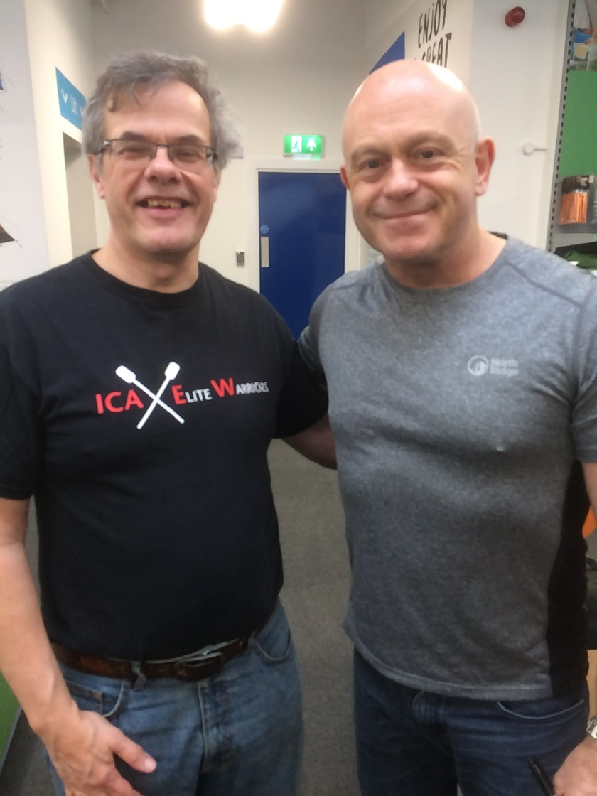

**BBN BRANDED GARMENTS**

Imitation is the sincerest form of flattery, so they say. Whilst at this year’s Chiltern Kanter and on the Daffodil Dawdle I saw Gill Struthers, the new Essex Herts Secretary, wearing an E&H branded fleece. I thought “I want one……..but in BBN colours!”

So I’ve contacted Peco Ltd who produce our group tech Tee-Shirts and asked what else they can provide. They can produce fleeces in a burgundy colour and some beanies which the group logo can be put on.

The various types of fleeces are shown below along with order codes and the cost. Burgundy is a difficult colour to obtain for garments so although they will not match our Rugby Shirts or Long Sleeve shirts they are the closest we can get.

They can be ordered with the BBN logo only, SSS logo only or combination of both.

Group members can order the items themselves and instructions on how to do so are shown below.

The website is [www.peco.ltd.uk](http://www.peco.ltd.uk)

*Fleeces*

There are various types of fleeces available in several colours which includes our group’s burgundy. These are shown below.

|  |  |  |  |  |
| --- | --- | --- | --- | --- |
| Fleece Code | Gender | Description | Sizes | Price |
| RE36A | Unisex | **PolarTherm jacket** |  | £12.95+vat each |

|  |  |  |  |  |
| --- | --- | --- | --- | --- |
| 8740M | Unisex | **¼ zip outdoor fleece** |  | £16.10+vat plus logos |
| 8700M | Male | **Full-zip outdoor fleece** |  | £16.30+vat plus logos |
| 8700F | Female | **Women's full-zip outdoor fleece** |  | £16.30+vat plus logos |

Prices for Logos

For the BBN logo quote *SD3475 – Circe*, *£2.70 + vat each*

For the SSS logo quote *SD3476 - Triangle £2.70 + vat each*

To order

For example if you want to order a fleece 8740M with the BBN logo only on you would email PECO at [info@peco.ltd.uk](mailto:info@peco.ltd.uk) with the following information:

* 8740M fleece in Burgundy, SD 3475 (Left Chest)

To order the fleece with the SSS logo on and on the right chest you would email with the following:

* 8740M fleece in Burgundy, SD 3476 (Right Chest)

To order the fleece with the BBN & SSS logos on you would email with the following

* 8740M fleece in Burgundy, SD 3475 (Left Chest), SD 3476 (Right Chest)

*Beanies*

There are 3 types of Beanies available shown below. All available in burgundy.

|  |  |  |
| --- | --- | --- |
| BC426 | BC044 | BC045 |
|  |  |  |
| Original Pom Pom Beanie | Original Pull | Original Cuffed Beanie |
| Price: £3.00+vat each | Price: £2.50+vat each | Price: £2.50+vat each |

The badges may have to be reduced in size slightly to fit onto the beanies as you only have a certain area to play around with.

When personalising these items the location of the badge on the beanie is Front Centre. To be clever you could have the group logo on the front and the SSS logo on the back.

To order these repeat the process for purchasing one of the fleeces.

Carriage Cost

Bulk Orders are cheaper for carriage cost to one address instead of ordering individual items.

Carriage to one single address £9.50+vat for multiple orders.

Carriage to individual address from £3.50+vat depending on weight and size of package.

Good shopping!

**Norman Corrin**

**-----------------------------------------------------------------------------------------------------------**

**A WEEK IN THE LAKE DISTRICT**

I was rostered off on the Friday, walking the Charnwood Marathon on Saturday and going to the Photography Show on Sunday. After the Show I headed straight up the M6 to Grasmere YHA to stay for the week. I arrived at about 4pm, booked in and ordered an evening meal. The weather for the week was going to be up and down.

On Monday morning the weather wasn’t too bad, clear skies and no rain. I wandered into Grasmere, not really planning to go far but, asking a few questions in an outdoor shop, I was told that a hike up High Crag was a nice afternoon hike. So an hour later I set off with map and compass in hand to climb High Crag. I passed a few walkers coming down and they told me there were good views all round. The track was easy to follow but 200 yards from the top the heavens opened up with low cloud and hail stones coming down stinging your face if you turned into the wind. A young woman coming down said the top was very close. I said “Is it worth it?” “Yes” she said “You can then say you got to the top”. So on I went, wondering whether I would see civilization again. But, as luck would have it, just as I got to the top the skies cleared and the sun came out and I got great views all around. I realised that I had been here before, when John and Judy organised weekends in the Lakes on the August B/H’s. I got some photos then made my way down on the other side of the fell so I got a nice circular walk. Coming down, a runner was running up, some people are just super fit.

Back in Grasmere I headed for Tweadies, a nice little pub recommended by the hostel. A few beers later I headed for the hostel and an evening meal cooked by the hostel staff.

Tuesday I had decided to hike to Easedale Tarn then decide what to do from there, it was all down to the weather. Breakfast cooked by the hostel down (my throat not my clothing), I headed for Easedale Tarn in clear weather and found it with no bother. The higher fells had a dusting of snow on the tops, so I got some good photos of the tarn with the fells in the background. The clouds were still high and I got good views all round so I decided to go for a longer hike. I started to climb towards Blea Rigg, then the weather decided to chuck it down with hailstones, which stung your face if you looked into the wind. It did not persist but during the course of the whole day it came and went. At the top I turned right and headed for Sergeant Man with some great views all round. I looked back and could see Easedale Tarn and Codale Tarn to the left. Going up all the time, I eventually got to the top and asked a fell runner which one was Sergeant Man, so I could pinpoint my position. It turned out to be a couple of hundred yards to my left, so I felt quite chuffed at my map reading.

Taking a bearing from my map I headed for High Raise, found High Raise with no problem, had lunch (Scotch eggs and coffee), and headed for Low White Stones. Then slightly right for Flour Gill, then turned right and headed for Grasmere on the famous Coast to Coast walk. It was a rough hike down into Grasmere but I got back into town around 16.30. Into Tweadies for a couple then back to the hostel where I cooked my own meal of cauliflower cheese and 2 min microwave rice. I was quite chuffed at my map reading seeing that I don’t get to the Lakes too much. I did not get lost and my bearings were pretty accurate. Well done me. The next day the weather was to be crap, and sure enough it was.

Rain was forecast for all day Wednesday and it did rain all day so I stayed at the hostel and cleaned and waxed my boots, got some shopping, caught up with some articles for the N/L and generally chilled out. Thursday I was to head for Grisedale Tarn and the Fairfield Horseshoe.

Thursday up and breakfast sorted, I headed for Grisedale Tarn and the Fairfield Horseshoe. Heading out of town and looking up in the direction I was to climb there was a lot of snow. I started to climb out of Grasmere, the going was wet and cold and the wind was blowing a gale. As I climbed I entered the snow line and the going got slippery and the snow got deeper. A fell runner turned back, so did a couple of walkers and as I got higher the going got very dicey. A couple of walkers kept going prodding their poles into the snow for the best route. I decided to call it a day, better to go down on two feet than on my back heading for a long drop. On the way down I passed some walkers going up to the Tarn,

I told them that the going was dicey. Back on the road I passed the Travellers Arms so I had to call in for a couple, the sun was warm now and I sat outside sunbathing. Back in town I got some shopping in then headed back to the hostel. If the weather stayed good I might even go for Grisedale Tarn again tomorrow. Friday being my last day I wanted to get a good walk in.

Friday was an excellent day, bright blue skies and nice and warm so I headed for Grisedale Tarn again. The going was good and the snow line had risen up the slopes. I took the same route as before and I got further but as I got up to a ridge I thought I would see the tarn below me, but it was still in the distance, and I was not at the top yet. I could see some walkers below me on a track, I didn’t realise that there was a lower one so I opted for the lower path. Slipping and sliding down I got a bit out of my element and lost my map as well, so once I got onto the lower path I then made the decision to head back to Grasmere. Grisedale Tarn was to e*vad*e me on this trip. Tomorrow I move to Suffolk where I will stay in B&B very close to where the Daffodil Dawdle will be held, a long drive in front of me tomorrow so I hit the sack early.

08:20 I left Grasmere and headed for Suffolk, I went via the A66 and the A1, then on to the A14 and arrived in Fersfield at 14:20, 6 hours travelling with stops. Before checking in I headed for Diss and some grub, there was no pub or eating place in Fersfield. It was the Daffodil Dawdle on Sunday and Stradbroke was only 35 minutes away for tomorrow morning. But the Dawdle is another story.

**Stevecee x**

-----------------------------------------------------------------------------------------------------------



**With thanks to Tim Vine**

I saw this bloke chatting up a cheetah. I thought, "He's trying to pull a fast one."

This policeman came up to me with a pencil and a piece of very thin paper. He said, "I want you to trace someone for me!"

I went to the doctors and said, “I’m frightened of lapels.” He said, ‘You’ve got cholera.”

I went to the record shop and I said, "What have you got by The Doors?" He said, "A bucket of sand and a fire blanket."

**Norman Corrin**

**THE DAFFODIL DAWDLE**

Well ain’t life a strange thing, I turned up for the Daffodil Dawdle with time to get a brew, and I was in the queue to get booked in and a voice behind me said, “Good Morning, Mr Clark”. I looked round and it was Mr Corrin. I said “Good Morning, Mr Corrin” and went off to get a brew. A chin wag and a couple of brews later and I was on my way.

I caught up with Norman and as I passed him we had a little chat, I came over last night he said, oh yeh I said, where did you stay, in a village called Ferston he said, I said, that’s a good one so did I, where did you stay in Ferston I asked, in Strenham he said, I was struck dumb and flabbergasted. I was there too I said, what time did you arrive I asked, about 7pm Norm said, by that time I was washed and changed into my pyjamas and relaxing in front of the telly. What time did you leave I said, about 7am he said, I left about 5 mins after you then I said. What a small world it is. I stretched out my pace and left Norman behind.

The Daffy Dawdle was very flat, good job as me and Betty don’t do hills, and I arrived at cp1 ready for a brew, which I did not get cause they didn’t do tea at cp1. Merrian and Dave walked through and I got a few photos then on I went. On to cp2 and as I arrived Dave and Merrian were just leaving, hello I said, hello they replied, I got a photo and on they went, they were on the 26 miler and I was on the 18 miler. A brew (yep they had a brew going at cp2) and some nosh and photos later on I went for the finish. I got to the finish and checked in with a time of 6 hrs 2 mins, it would have been a faster time but I went to my car first to get my boots off so my feet could have a breather.

The Dawdle was a very flat walk but an excellent one, we had great weather and I started my 2017 tan off, the food was excellent, in fact it was just as good as a BBN cp.

***Q – When is a “T” junction not a “T” junction?***

***A – When it is a side turning to the left or right***

***WHY – A “T” junction is when you are walking towards a junction and when you get there you can only go left or right. A “T” junction is not a “T” junction when you are walking towards the same junction but from a different direction so you can only walk straight on or turn left or turn right. So why do some challenge walk route descriptions call a junction a “T” junction when it is in fact a side turning to the left or right.***

**Stevecee x**

**NOT THE CHILTERN KANTER 2017**

What a lovely sunny day we had for the Kanter. The weather forecast said warm sun all day and that’s what we got. I arrived at Pitstone village and the shorts were already on. In fact Alan (From Here to There fame) was already in his Borat mankini (if only I had my camera at the ready). A brew and hugs sorted off we trod at 8am with the sun shining down on us already.

The route took us over Ivinghoe Beacon where at the top we had to stop for a breather and a drink of water to rehydrate ourselves. Already sun bathers were stripping off on the top because it was so hot. Following the GR’s we arrived at Little Gaddesden for our first CP, and a well-deserved one it was, we were all dehydrating and had to drink gallons of water. CP staff from the BBN were in their swimsuits, yes Alan was still in his Borat mankini, and the girls in their bikinis.

Re-hydrated we headed off with a handful of cheese bites in one hand and a handful of jelly babies in the other heading for Wigginton and our second CP. Most of the route was on just one map but a kilometre and a half of it was on another, (what a pain). The route to the next CP went without mishap and Graham jogged past with a group of girls a couple of times (I wonder why).

After Wigginton it was back to Pitstone and the start for a well-earned meal, beef stroganoff and vegetables and a glass of wine. Well done to the BBN.

**THE REAL THING**

I arrived at Pitstone carpark for the Chiltern Kanter and the first words from Alan were “Are you ready to get wet?”. “Is it going to rain then?” I asked. “Yes” he said, “All day”.

It wasn’t raining then but before I left the village hall to start my 18 mile Kanter it was raining, and it did not stop till I got to the first CP at Little Gaddesden. In fact it rained quite hard and it blew a gale. By the time I had passed the first two GRs my answer sheet was soggy and I gave up on the questions. Up and over Ivinghoe Beacon I struggled to get up the steep hill to the top. In fact I nearly slipped back down to the bottom a couple of time because the wind was very strong and it was chucking it down.

All the way to the first CP it rained and the wind blew. Straight after CP 1 at Little Gaddesden the route took us off the main map to do a one and a half km circle on another map, I had more or less decided to leave that bit out and head south

to pick the path up a km away on the main map. But would you believe it, as we arrived at CP 1 the clouds lifted and the sun came out. A brew and some grub I left CP1 and headed for CP2 at Wigginton via the bit on another map in the sunshine. The going was still wet and muddy but the GR’s were easy enough to find. I arrived at Wigginton dry.

Fed and watered I left for Pitstone and the finish. I had no problems on the route and had a great day (when the rain stopped), a brew and grub down me I headed for home and work the next morning.

Photos at [www.steveceegalleries.smugmug.com](http://www.steveceegalleries.smugmug.com)

**Stevecee xx**

----------------------------------------------------------------------------------------------------------

**A 1001 MILE LITTER PICK IN 80 DAYS**

What a bizarre thing to do! Ah well, just may be!

An essential requirement for any long distance walk is a theme; a reason to be placing one foot before the other at good speed and distance. An individual litter picker provides a modicum of direct action for all to see! Direct action also motivates others into action too, with just a little push.

In February 2016 I threw a tantrum in Bicester’s local paper on the subject of litter which was scattered in and around town. In fact the problem is nationwide, or even worldwide. One month later the national “Clean for the Queen’s 90th Birthday” brought a further campaign to clean up Britain.

Another year onward in 2017 there’s the need for a renewed campaign of litter clearance, before spring arrives to cover existing litter with lush new vegetation.

With further inspiration derived from “County Walking” magazine’s challenge for readers to walk 1000 miles in 2017 and also an article on litter picking, I set off to litter pick 1000 miles in and around Bicester on 2nd January with the object of reaching that target in 105 days, on or before 15th April which was to be Bicester Lady Mayor’s charity funds raising event of a 3 mile walk for families, kids and dogs, for which I’d sponsor myself at the rate of 5p per mile x 1000. That’s done.

Winter was kind to us this year, very soon I found myself to be well ahead of schedule so completion was brought forwards from 105 days to only 80 days, or 12½ miles per day from the original plan of under 10 miles. That was accomplished on 22nd March, when one extra mile was added for good measure. Towards the end I was beginning to suffer from LDWA 100 mile

syndrome of fatigue and jellied knees, but thank heavens, no foot blisters!

After a restful final week of March when only 41 miles passed under my feet, those knees recovered back to their normal state again.

Having started my winter walking about town on 1st November, after the time change to GMT, people were familiar with seeing me out and about on foot at good speed. After New Year I was being questioned by various people about my objective with their standard statement “We see you everywhere”. “Yes, I’m walking 1000 miles in and around Bicester picking litter”. “I’ve not seen you though”. “Oh, we see you from our cars!” Ah yes, cars do dash past and they all look the same! By the way, I’m already several hundred miles ahead of my car this year – over 600 miles at 4th April. Whilst I didn’t manage to get around the world in those 80 days, I am nevertheless 1001 miles closer to a third theoretical romp around the world with some 7300 miles to reach that point after another 2½ years. Will I get there?

The 1001 mile completion celebration took place in Bicester Town Council café with a pot of tea and a muffin, for which the girls refused to accept any payment. My response was a big Thank You and how I’d buy their tea and muffins after they had completed 1000 miles during the remaining weeks of 2017! Their response was cries of shock, horror and laughter.

**Norman Smith, C976**

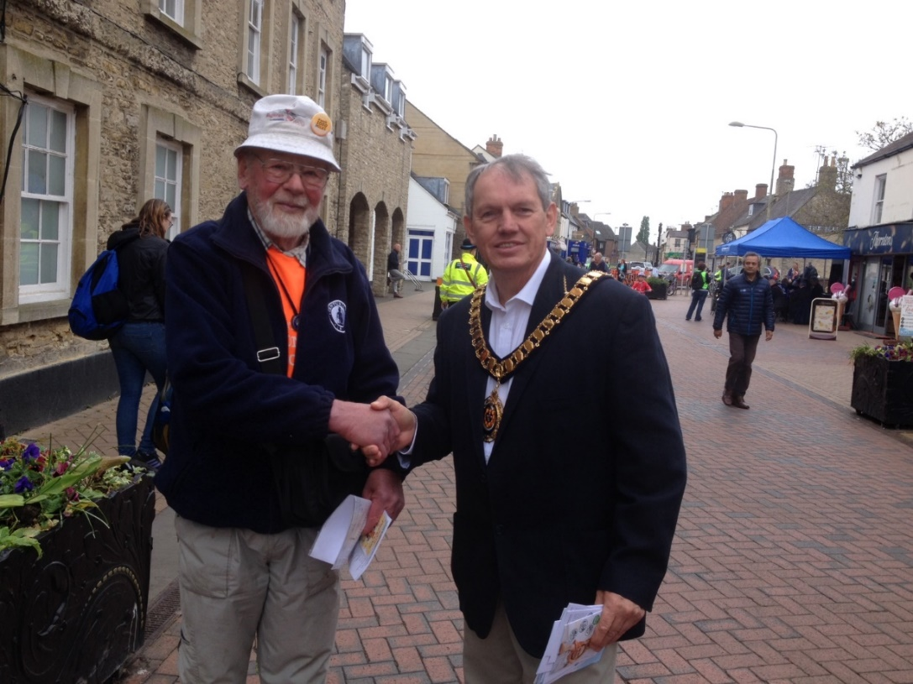

→ → → →

*Postscript*

*Les Sibley, the Mayor of Bicester, was so very impressed by my earlier 1000 mile litter pick of Bicester and £50 donation to the previous Mayor’s charity fund, that he’s requested my repeat performance and, what’s rather more to the point, the Mayor will walk 1000 miles himself during his year in office, with the aim of raising charity funds! How about that for a successful walking promotion!*

*My own 1000 mile walk and litter pick will take place after the change to winter time at the end of October.*

-----------------------------------------------------------------------------------------------------------

**CUBA LIBRE**

Just two weeks after a sunshine holiday with Pearl in Cape Verde consisting of sand, sea, sun and karaoke I was flying off again. This time it was to Cuba while Pearl was going with her sister to the Algarve in Portugal. This was to be the second year in succession when I have taken two winter holidays but in my line of work (gardening) things are very quiet and as the old saying goes “you can’t take it with you”.

Cuba is somewhere I’ve always wanted to go having lived through the Cuban Revolution and the Cuban Missile Crisis. I also felt that I should go soon before it changes. In fact Fidel Castro died between my booking the holiday and actually going away on it. The trip itself was partly walking and partly sightseeing. Again I went with Explore. The group consisted of two couples, two English doctors and seven Australian women. The men were definitely outnumbered! This time I also got a room on my own.

The first night was spent in Havana in the old part of town. We had a quick look round in the evening before finding somewhere to eat. The next day we were up early to meet our guide and minibus driver. We set off on the short drive to Vinales, the big tobacco growing region. The landscape was quite spectacular as we viewed the “magotes”, the big rock formations. We spent two nights in Vinales. We had a guided tour round the tobacco plantations, including how to roll the famous Cuban cigars. I even had a few puffs of one. I don’t smoke but in this case when in Rome (or Cuba) …………

We had an interesting walk through the “magotes” including climbing up to a cave and walking right through it and out the other side. We saw many different birds, including vultures. One of the guys on the trip was a real “twitcher”. He had a really good camera and was able to send us some great pictures of all the birds he had seen on the trip.

The next day we were up very early for the long drive to Trinidad (a town in southern Cuba, not the island). On the way we stopped at the Bay of Pigs, the scene of the US backed invasion when some Cuban nationals who has fled to Florida tried to retake the island but were driven back. I had a swim in the sea there but it was very rough. We arrived in Trinidad in the evening. It was a very lively place with bands playing in the street and plenty of salsa dancing, not by me, though, as I’ve got two left feet!

During our time there we did some nice hilly walks in the surrounding woodland where we really appreciated the shade as it was quite hot. We also had time to explore Trinidad with its many historic buildings.

After leaving Trinidad we headed back to Havana, stopping on the way to visit the Che Guevara Mausoleum at Santa Clara. Back in Havana we had time to explore the city before flying home the next day.

I found Cuba a fascinating country. I wanted to visit it before the country changed too much. There is still an embargo in place. Obama was going to lift it but they’re not sure if Trump will. There are still quite a few big old American cars such as Chevrolets but they are mainly taxis. One thing I noticed was that it was a cash society with nobody taking debit or credit cards. Also texting and internet connection were difficult. While in the mountains I got a text from Pearl saying that she was in a hot tub in Portugal. I tried to text back but couldn’t get a signal. I didn’t need a hot tub at the time. I was hot enough already!

**Steve Smith**

-----------------------------------------------------------------------------------------------------------

**BEDS BUCKS & NORTHANTS GROUP: COMMITTEE 2017**

**Chairman: Norman Corrin** *T*: 01908 608667 *E*: [norman.corrin@g](mailto:norman.corrin@g)mail.com

**Secretary/Local Group Rep:** **Peter Simon**  *T:* 01582 513827   
 *E:* [bbn@ldwa.org.uk](mailto:bbn@ldwa.org.uk) [peterandmooi@ntlworld.com](mailto:peterandmooi@ntlworld.com)

**Treasurer: Ian Sage** *T*: 01582 661256 *E*: [iansage49@gmail.com](mailto:iansage49@gmail.com)  
**Social Walks:** **Mary Knight** *T:* 01295 812857 *E*: [maryjknight@hotmail.co.uk](mailto:maryjknight@hotmail.co.uk)

[bbn.walks@ldwa.org.uk](mailto:bbn.walks@ldwa.org.uk)

**Membership: David Findel-Hawkins** *T*: 01908 216476 *E*: [davefh@gmail.com](mailto:davefh@gmail.com)

**Newsletter/Website:** **Gill Bunker** *T*: 01908 321308 1 Abbey Way, Bradville,   
 Milton Keynes. MK13 7AN *E*: [gillbunker@googlemail.com](mailto:gillbunker@googlemail.com)

**Member: Alan Leadbetter** *E:* [acleadbetter64@gmail.com](mailto:acleadbetter64@gmail.com)

**Member: Roy Carter** *E:* [roycarter367@hotmail.com](mailto:roycarter367@hotmail.com)  
**Member: Peter Engledow** *E:*pete@excel121.com

**LDWA – BEDS BUCKS & NORTHANTS GROUP**

**WALKS PROGRAMME**

**SEPTEMBER TO DECEMBER 2017**

***Note: There are two linear walks on the programme where transport needs to be booked in advance:***

***Sun Sep 10 2017 Kingfisher Way***

***Sat Oct 21 2017 Autumn Colours (MK Parks Trust 25 Mile Challenge)***

***Please book as soon as you can to help the organisers sort the appropriate transport***

**Sun Sep 3 2017 The Three Rings of Tebworth**

19ml. 09.00 From entrance to allotments at south end of High Street (A5120), Toddington. Please park considerately in nearby streets, not in small allotment c.p. Maps: LR 166 Exp 193 (GR TL008279). ***C:*** Peter Simon ***T:*** 01582 513827 ***M:*** 07592 115090 on day only.

**Thu Sep 7 2017 Rest at Wrest**

16ml. 09.30 From Ampthill Park West c.p. Post Code MK45 2GU. Map: LR 153 (GR TL024382). Lunchtime cafe & pub. ***C:*** Sara Waldron ***M:*** 07850 665454.

**Sun Sep 10 2017 Kingfisher Way**

22ml. 08.00 From Church Street, Tempsford, SG19 2AT. Maps: Exp 193,208 (GR TL162531). Linear walk. Part of the Beds Walking Festival. Meet at Tempsford for transport to start of walk in Baldock (SG7 5BX). Cost is £5.00 for the bus. **Please book your place in advance** with Roy. ***C:*** Roy Carter ***T:*** 01234 301182 ***M:*** 07784 208997. ***E:*** roycarter367@hotmail.com

**Thu Sep 21 2017 Glenn`s Twin? Wood You Believe It?**

15/16ml. 09.30 From Priory Country Park, Barkers Lane, Bedford MK41 9SH. Map: LR 153 (GR TL072494). ***C:*** Adrian Moody ***T:*** 01933 314134 (before 9.00 pm) ***M:*** O7788 684394 (on day only).

**Sun Sep 24 2017 Walk With No Name**

17ml. 09.00 From Wykeham Way (near Thame Rd), Haddenham. Maps: Exp 180,181 (GR SP734086). ***C:*** Alan Leadbetter ***M:*** 07775 887493.

**Sun Oct 1 2017 Walk from Newton Longville**

15ml. 09.00 From Longueville Hall c.p. Whaddon Rd, Newton Longville, MK17 0AT. (GR SP841316). ***C:*** Sylvie Eames ***T:*** 07770 433190.

**Thu Oct 5 2017 Marston Meander**

15ml. 09.30 From Marston Vale Forest Centre MK43 0PS. Map: LR 153 (GR TL004418). ***C:*** Derek Jacob ***T:*** 01234 767759.

**Sun Oct 8 2017 Best Beautiful Bits From Barton**

19ml. 09.00 From Old Road, Barton-le-Clay. Please park considerately near entrance to Recreation Ground. Maps: LR 166 Exp 193 (GR TL083305). Lunch stop will be near a pub. ***C:*** Dee Brockway ***T:*** 01582 881809 ***M:*** 07742 422951.

**Sun Oct 15 2017 John Nickerson Memorial Walk**

17ml. 09.00 From the Bridgewater Monument, Ashridge Estate Visitor Centre (accessed from B4506). Map: LR 165 (GR SP970131). A slight variation of the Ashridge Boundary Trail - a favourite of John's. A shorter walk can be arranged, please contact the leader. ***C:*** Judy Nickerson ***T:*** 01234 301817 ***M:*** 07913 740455.

**Thu Oct 19 2017 Ouse That?**

17ml. 09.30 From Great Denham Park & Ride c.p. (MK40 4FA). Map: Exp 208 (GR TL017489). ***C:*** Roy Carter ***T:*** 01234 301182 ***M:*** 07784 208997.

**Sat Oct 21 2017 Autumn Colours**

25ml. 07.50 for 08.00 minibus Meet Caldecotte Arms public c.p. off A4146, Milton Keynes MK7 8HP. Map: Exp 192 (GR SP888354). We will be walking the MK Parks Trust 25 Mile Challenge through the woods and parkland of Milton Keynes as a group walk. The walk is linear from Howe Park Wood to Caldecotte Lake. We will leave cars at Caldecotte Lake, travel by minibus to Howe Park Wood and then walk back to the cars. **Please book your minibus seat** via Linda Marsh as soon as possible (places limited). Email marsh-l2@sky.com (Note: email: it is a letter l, not a figure 1). There will be a small charge for the minibus. The walk will be self-supporting but there will be opportunities to replenish supplies if required during the day. Certificate upon completion. ***C:*** Gill Bunker/Linda Marsh ***T:*** 01908 321308 ***M:*** 07790 976090 (Gill) ***T:*** 01908 669698 ***M:*** 07885 181422 (Linda).

For more information about the walk see:  
<http://www.theparkstrust.com/sports-and-activities/the-parks-trust-challenge-walk>

**Sun Oct 29 2017 Shillington Shuffle Marshals' Walk**

***C:*** Dave Yorston ***T:*** 01494 868371 ***M:*** 07808 384670.

**Thu Nov 2 2017 Margaret’s Birthday Walk**

15ml. 09.30 From "Sand Lane", Sandy. "No Through Road" approach from the eastern end, off the Sandy to Everton road. Map: LR 153 (GR TL180494). ***C:*** Margaret & Roger Skerman ***T:*** 01525 405540 ***M:*** 07757 057440.

**Sat Nov 11 2017 A Walk Around Corby - The Extension**

24ml. 08.30 From Kirby Rd, Gretton. Please park considerately nearby. Meet at the Jurassic Way signpost. Map: Exp 224 (GR SP902945). ***C:*** Wayne Rowlett ***T:*** 01536 460984 ***M:*** 07388 026676.

**Thu Nov 16 2017 Henry the Eighth’s Granny’s Walk**

15ml. 09.30 From hidden layby on eastern side of A508 north of Grafton Regis between turn for Alderton and canal bridge. Access from northern end only. Map: Exp 207 (GR SP748485). ***C:*** Dianne Sutton ***T:*** 01908 606256 before 9pm please ***M:*** 07957 466487 on day only.

**Sun Nov 19 2017 Shillington Shuffle**

26, 18 or 12ml. in 10.5hr. From Barton-le-Clay Village Hall postcode MK45 4JY (GR TL083306). The walk follows mainly field paths, tracks, woods & some roads through undulating countryside with good views from the hills traversed.

Start: Walkers from 08.00; Runners/Joggers/Fast Walkers from 09.00. Cp times will be adhered to, with NO exceptions. All must be finished by 18.30, Hall closes 19.00. All must bring own mug (none on route), compass & route description WHICH MUST BE DOWNLOADED & PRINTED from web site beforehand. We recommend map Expl 193 or LR 153 & 166 (only 166 for 12ml route), a torch if you expect to finish after dark & waterproofs. Please wear appropriate clothing & footwear for this time of year. This walk is part of BB&N triple challenge. Online entry only. There will be a limit of 300 entrants. No entries OTD. No substitutions. Entry: £7.00, Non LDWA £10.00 & Under 18s free incl hot & cold drinks & biscuits at start, drinks & snacks at all Cps and a light meal at finish. Cert for all finishers. Badge free on request. Entries close 11th Nov 2017 or when full. Online entry at: https://www.sientries.co.uk/event.php?elid=Y&event_id=3329. ***C:*** Mike Hyland. ***E:*** bbn-sswalks@ldwa.org.uk ***W:*** ldwa.org.uk/bedsbucksandnorthants

**Sun Nov 26 2017 Walk + AGM**

8/9ml. 09.00 From Cosgrove Village Hall, 39 Bridge St, Cosgrove. (Nearest post code MK19 7JH, continue over canal bridge, hall is on L.) Park in hall c.p. Maps: LR 152 Exp 207 (GR SP794427). Morning walk followed by lunch at Barley Mow p.h. Please pre-book your meal with Gill Bunker. Menu choices in Autumn Newsletter/via email. The AGM starts at 14.00. ***C:*** Gill Bunker ***T:*** 01908 321308 ***M:*** 07790 976090. ***E:*** gillbunker@googlemail.com

**Thu Nov 30 2017 The Chilterns in Winter**

15ml. 09.30 From Cholesbury. Please park on hard standing outside village hall. HP23 6ND. Maps: LR 165 Exp 181 (GR SP930071). Bring your own lunch. Lunch stop near Wetherspoons, Berkhamsted. ***C:*** John Davies ***T:*** 01442 874875 ***M:*** 07949 796470.

**Sun Dec 10 2017 Santa's Ultimate Sundae**

12.5ml. 09.00 From Caldecotte Arms public c.p. off A4146, Milton Keynes (MK7 8HP). Map: Exp 192 (GR SP888354). BBN's Xmas walk. Bring a wrapped gift to the value of £1, bows & all. Carol singing at churches en route. Mince pies & refreshments halfway thru walk. Post walk drinks in Caldecotte Arms. ***C:*** Santa’s (not so) Little Helper Norman Corrin ***T:*** 01908 608667 ***M:*** 07980 378656.

**Thu Dec 14 2017 Christmas at Wetherspoons**

c. 14ml. 09.30 From c.p. by entrance to Rosemullion Lane, off Tattenhoe Lane, Milton Keynes. Map: LR 153 (GR SP841340). Back for a fifth year, a shorter pre-Christmas walk with extended lunch at a Wetherspoons pub. ***C:*** Dave Findel-Hawkins ***T:*** 01908 216476.

**Thu Dec 28 2017 No Trains or Planes**

15ml. 09.30 From Draughton Crossing free c.p. on minor rd, Maidwell to Draughton, Northants. Maps: LR 141 Exp 223 (GR SP755773). Probably no pub stop. ***C:*** Jim Robinson ***T:*** 07845 909750.

**Sun Mar 4 2018 Pick and Mix Challenge Event**