|  |  |
| --- | --- |
| LDWA Logo black & white | **LONG DISTANCE WALKERS ASSOCIATION AIM: TO FURTHER THE INTERESTS OF THOSE  WHO ENJOY LONG DISTANCE WALKING** |

**BEDS, BUCKS &  
NORTHANTS GROUP**

**NEWSLETTER**

**AUTUMN 2017**

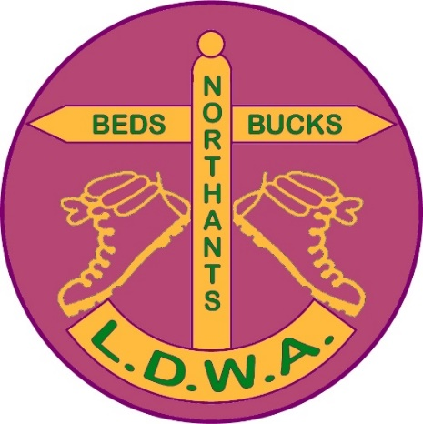

**NEW MEMBERS**

**A very warm welcome to our new members Matthew Lane  
and David Trew, and welcome back Judy Nickerson.**

**CHAIRMAN’S CHATTER**

A picture is worth a thousand words (Who sang that? There’s a question for you). Our very own Steve Clark supplied the front cover picture for the August Strider which summed up the sheer exuberance of youth and the joy of taking part in the annual 48 hour non-stop party also known as the LDWA North York Moors 100. Steve was telling us at a party hosted by his “mate Eamsie” that he asked the woman concerned Sharon Sullivan to do this 3 or 4 times. She was only too happy to oblige!

Steve reached a big birthday recently and I was very pleased to meet him, Sylvie, his sister Barbara and Cap’n Betty Sherry on their Canal Boat Trip at The Plough on the day concerned. As Steve is doing The Annapurna Sanctuary in December we can expect lots of photos on his website.

Speaking of social media affairs, the BBN Facebook group continues to go from strength to strength ably marshalled by Daniel and Gill with them readily accepting new members. As we are now a public group anyone can see what we do for fun on Thursdays, Sundays, and occasionally Saturdays. The other days we’ll leave to their imagination! The photographs are continually updated and show what a varied walks programme we have. Peter Engledow has just announced that we have our own Twitter feed set up so we now are a fully digitised walking group.

What else has happened in our walking world? Alan Leadbetter, ably assisted by his Angels, put on the 3rd From Here to There and Back in July which attracted 108 entries and all enjoyed themselves.

It was lovely to see Brian Layton’s family there and I was very pleased with the note he sent round on one of Peter’s BBN updates to say thanks to all for making them feel welcome. Get them when they’re young and they’ll come back. It was lovely at the end to see how much they and Grandad had enjoyed themselves!

Mentioning Steve Clark yet again, both he and I travelled to Castlebar for the 50th International 4 Days Walks in Eire and had a fabulous time sampling the Guinness and the Smethwicks. The walking was good as well! There is an article

in the newsletter about our trip. If anyone wants information about The International Marching League and the events abroad please contact Steve or I. They are great fun and have a real carnival and light hearted atmosphere about them.

We’ve had a full and varied Thursday and Weekend social walks programme organised and co-ordinated by Mrs Dennis Knight. This included the Chairman’s Cream Tea walk where Gill’s husband cycled from Bradville to Bridgewater Monument to have a delicious cream scone. Other shops are closer to hand Ian! There was a good turnout for this and there were a lot of photographs of members eating and not many of them walking……

A longer social walk than normal was the 34 mile Round Corby walk led by Wayne Rowlett in July. Although having a smaller turnout than normal social walks, everyone who took part thoroughly enjoyed it, in particular being fed by Wayne’s mum!

The group over the past few years has been involved in the annual Bedfordshire Walking Festival in September. BBN has contributed to this both financially and by putting on social walks during the week. Roy Carter in particular has taken a hands on approach with the Festival. This year we put on the 22 mile Kingfisher Way which did involve leaving cars at the end of the walk and getting a minibus to the start. There were more walkers turned up than originally estimated and this involved two minibus journeys from the end to the start, returning back to the end and then back to the start……Still with me? ☺

For next year’s walk to paraphrase Roy Schneider’s character from Jaws “we’re going to need a bigger bus”. At the recent committee meeting Roy mentioned how successful the Festival had been and there was a good turnout on the Greensand Ridge walk at the end of the Festival. Roy told lots of people about the LDWA and with me handing out a few BBN business cards hopefully we will get an influx of new members.

Other events include John Nickerson’s Memorial Walk on Sunday 15th October when a lot of BBN members along with Essex & Herts, Thames Valley and others turned up to honour John’s memory and give succour to Judy. It has been great to see Judy on more BBN social walks recently and I hope that the friendship and support from the walking community has given her strength in these upsetting times.

Appropriately enough, this will be followed by the Shillington Shuffle in November which was John’s baby and, along with the Nene Valley Kanter, really helped to establish BBN as a steadfast and successful group.

A week later it is our Group’s AGM at Cosgrove Village Hall preceded by a morning walk and lunch at The Barley Mow. We will again be ~~bribing~~ encouraging members to attend by offering a subsidy for their meal, although in truth those who turn up give the committee the support that they need and don’t need sweeteners…..

This will be my last AGM as Chairman as I am stepping down after four years in the post. It’s been a privilege to be your Chairman and my thanks must go to all the committee and group members for their efforts over these last few years.

It’s a bit like being on top of a tube of toothpaste. Everyone below is squeezing and pushing and it’s their efforts that make the group look good!

For anyone who is interested in taking over all you have to do is chair the three committee meetings and the AGM. The rest of the time you can get involved as much or as little as you wish. Anything you don’t feel comfortable doing simply delegate to other committee members and let them get on with it. So for anyone who is interested please contact me and I’ll tell you more.

So for the last time please remember that when you’re out with BBN friends on a national trail, social walk or Challenge Event that you might walk on but YNWA….



Good Walking!

**Norman Corrin**.

**BREAKING NEWS!!!**

In recognition of the effort it takes to lead your very first walk for BBN LDWA we would like to reward first time walk leaders...... a free buff in the new design... do I hear you gasp in excitement and anticipation. Below are a few responses to already received and anticipated frequently asked questions (FAQs).

* NO - not having led a walk for a long time does not qualify you.
* NO - claiming your dog is leading the walk for the first time does not qualify you (and you know who you are!)

Below are available dates for Thursday walks.

|  |  |  |
| --- | --- | --- |
| May | 3rd |  |
|  | 17th |  |
|  | 31st |  |
|  |  |  |
| June | 14th |  |
|  | 28th |  |
|  |  |  |
| July | 12th |  |
|  | 26th |  |
|  |  |  |
| August | 9th |  |
|  | 23rd |  |

And these are available dates for weekend walks.

Please remember walks can be Saturday or Sunday – just e-mail me to reserve your date.

|  |  |  |
| --- | --- | --- |
| May | 12/13 |  |
|  | 26/27 |  |
|  |  |  |
| June | 9/10 |  |
|  | 23/24 |  |
|  |  |  |
| July | 7/8 |  |
|  | 15th | Hannington Hike (Challenge Walk) |
|  | 21/22 |  |
|  |  |  |
| August | 4/5 |  |
|  | 18/19 |  |
|  |  |  |

If you would like to arrange a walk on any other date please just let me know.

One final plea – after your walk please e-mail me with your walk stats (distance and number of walkers). Thanking you in anticipation.

Best wishes and happy walking.

**Mary Knight, Walks Secretary  
(maryjknight@hotmail.co.uk)**

ooooooOOOOOOoooooo

**Further news of the Mayor Of Bicester’s 1001 Charity Fund Raising Walk – inspired by BBN’s Norman Smith’s own 1001 Mile Walk earlier this year**

The new Mayor, Les Sibley, requested a repeat performance from Norman and Norman responded by challenging the Mayor to also walk 1001 miles. Now the Mayor is on his way!

He started his walk with a 10.1 mile walk around the town with Norman. This coincided with the painting of 4 x 5km blue line circuits on pavements around Bicester – the town’s healthy routes. As an encouragement to the Mayor Norman presented him with his own Garmin Edge 200 GPS – the Mayor is holding it in his left hand in the photo.

“*When we change to winter time on the 29th October, I’ll set off on my own input of 1001 miles over the winter period, also to be on the Mayor’s tail lest he begins to falter. I’ll be in a good position to chivvy him onwards with the occasional prod of a “Centurian 1911” short sword*!”

**Norman Smith**

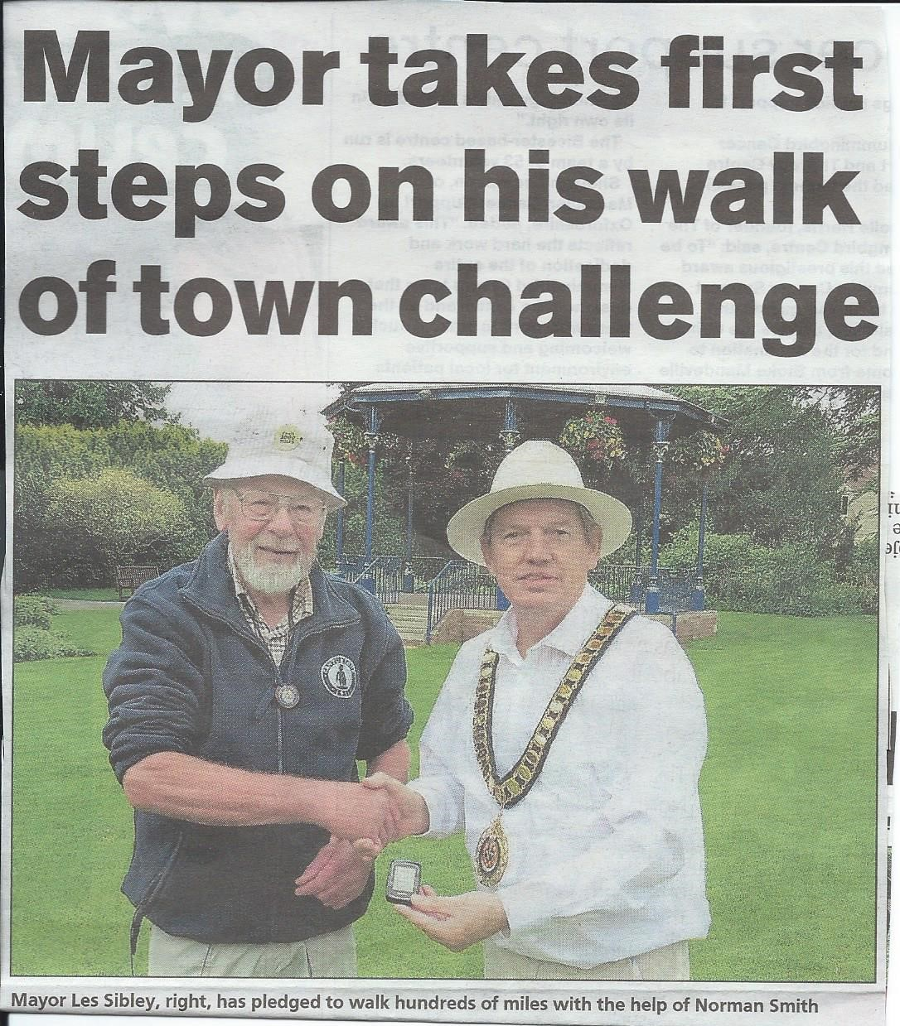

*Photo: Bicester Advertiser*

*Thursday 17th August 2017*

**ooooooOOOOOOoooooo**

**Noting Theresa May’s enjoyment of walking Ian White   
recently sent her a copy of Strider and received a pleasant acknowledgment.**

**FLAT WALKING, GREAT TALKING – on the**

**GRAND UNION CANAL TOWPATH**

The Grand Union Canal….GUC….Great Ultimate Challenge….well perhaps not quite. Passing through all three of our counties, Beds, Bucks and Northants, it did, however, for a mere mortal like myself, prove to be a fascinating and enjoyable experience, walking with good friends, this 145 mile towpath over a disjointed period of 8 days. It provides a great challenge well within the capabilities of many of our members and I hope this rambling account whets the appetite for a few of you to give it a go.

The GUC connects Gas Street Basin, **Birmingham** to Little Venice (Paddington), **London.** Building the canal began in the 1790s, at the height of the canal age. We encountered some remarkable structures from that time, as well as more recent examples of interesting architecture and civil engineering.

For me, history comes alive when you visit the relevant places, and my experience was enhanced by en route night time reading of the history pages of *The Grand Union Canal Walk* by Anthony Burton and Neil Curtis. It also provided invaluable, although at times outdated, maps and general information about anything of interest encountered on the towpath.

As water refuses to flow uphill, and the horses that pulled canal boats needed a hard, continuous path alongside the waterway, the resultant path is a reasonably firm and virtually flat one. The crossing of many picturesque, mostly humpback bridges, as the towpath changes waterside, are the exception. Navigation errors are hard to make, although I, not surprisingly, managed a few by wandering onto the several “arms” that provide waterway connections to nearby towns. Only the stern reprimand of my walking companions ensured I only ever made a small elbow, rather than a full arm, deviation.

So, how to complete the 145 miles? With my friends Jill Green and Jim Catchpole we chose to take 8 days, 4 in January and 4 in July. This allowed us to experience the world of the canal boat folk in the winter….smells of logs burning and bacon cooking, usually wafting from battened down boat hatches, birds slipping and sliding on the canal’s frozen waters before ice-breaker boats did their job, some wet muddy paths and hot tea and cakes at every available opportunity…….and in the summer…..many boats beautifully bedecked in colourful flowers, lots more opportunities to talk to the canal’s fascinating permanent residents and those mastering the techniques of passing through its 84 locks on their hired tourist narrow boats, more hours of daylight, harder underfoot and beer and ice creams the preferred refreshments.

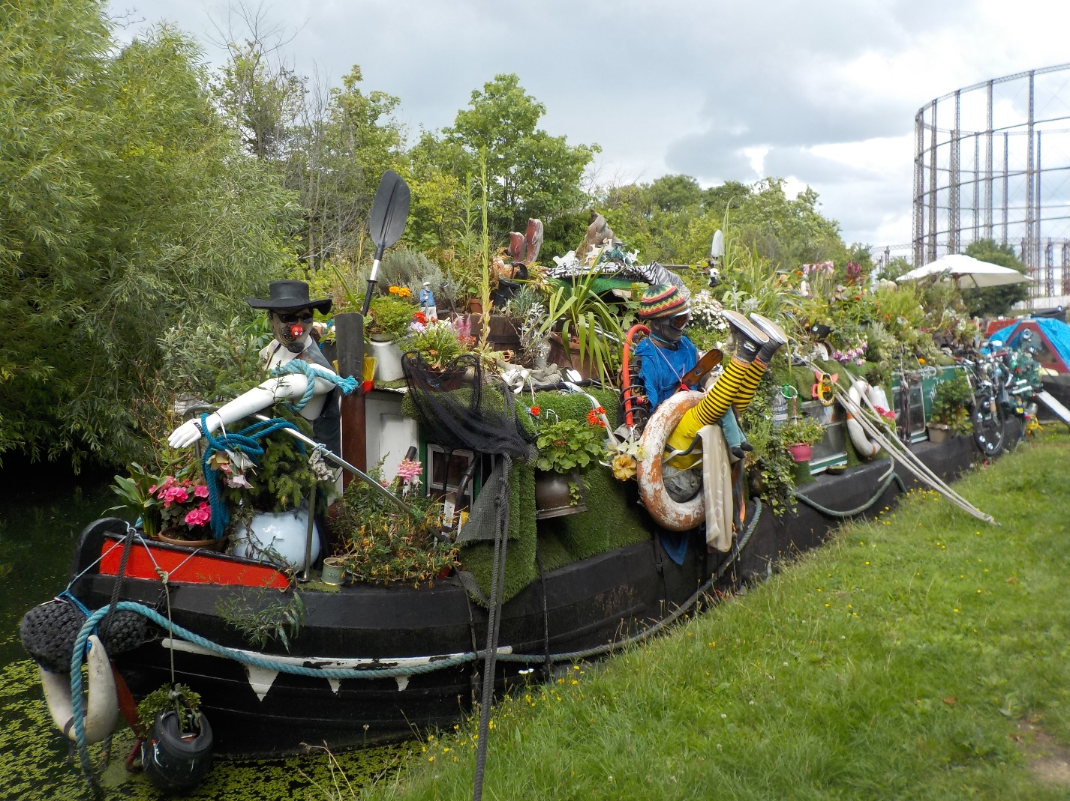

A noteworthy comment, for those not inclined to venture into the hills or mountains in the colder weather, canal walking offers a great, relatively easy and safer alternative.

The first half of day one was spent on trains from Harlington to St Pancras then Euston to Birmingham, followed by three and a half January days walking legs 1 to 4, from our Birmingham start to the half way point just north of Milton Keynes.

Jim had pre-booked 3 B&Bs evenly located en route, never more than a mile from the tow path. Our rucksacks were not too heavy, we opted to carry minimal gear which did, of course, include warm winter clothing and waterproofs.

To complete the second half of our journey in July we made use of 2 excellent free establishments in Barton Le Clay and Radlett (thanks Phil), and twice walked on 2 consecutive days.

Our strategy for legs 5 and 6, which resulted I believe, in the least driving, only occurred to me at 4.30am on the day of departure, when I kindly woke Jim and Jill to inform them of my cunning plan.

To cover our path from Milton Keynes (A) to Stoke Hammond (B) to Berkhampsted (C) we took 2 cars to A, left car one parked there and drove together to B where car two remained overnight. We completed leg 5, walking back along the canal, to car one at A and used this for our journey back to Barton. The next day car one was used to drive to C, followed by walking leg 6 from C to B, picking up car 2 left at B to drive back to C and returning to Barton in both cars. I trust that this is all as clear as mud to the reader.

Three weeks later, from Radlett, we drove a single car back to Berkhampsted, parked near both the canal and the train station, walked leg 7 to Uxbridge then returned to Berkhamsted using the Metropolitan and national rail lines. No cars at all for leg 8! Trains from Radlett via Farringdon to Uxbridge, returning from Paddington (very near Little Venice) to Radlett on the circle and Thameslink lines.

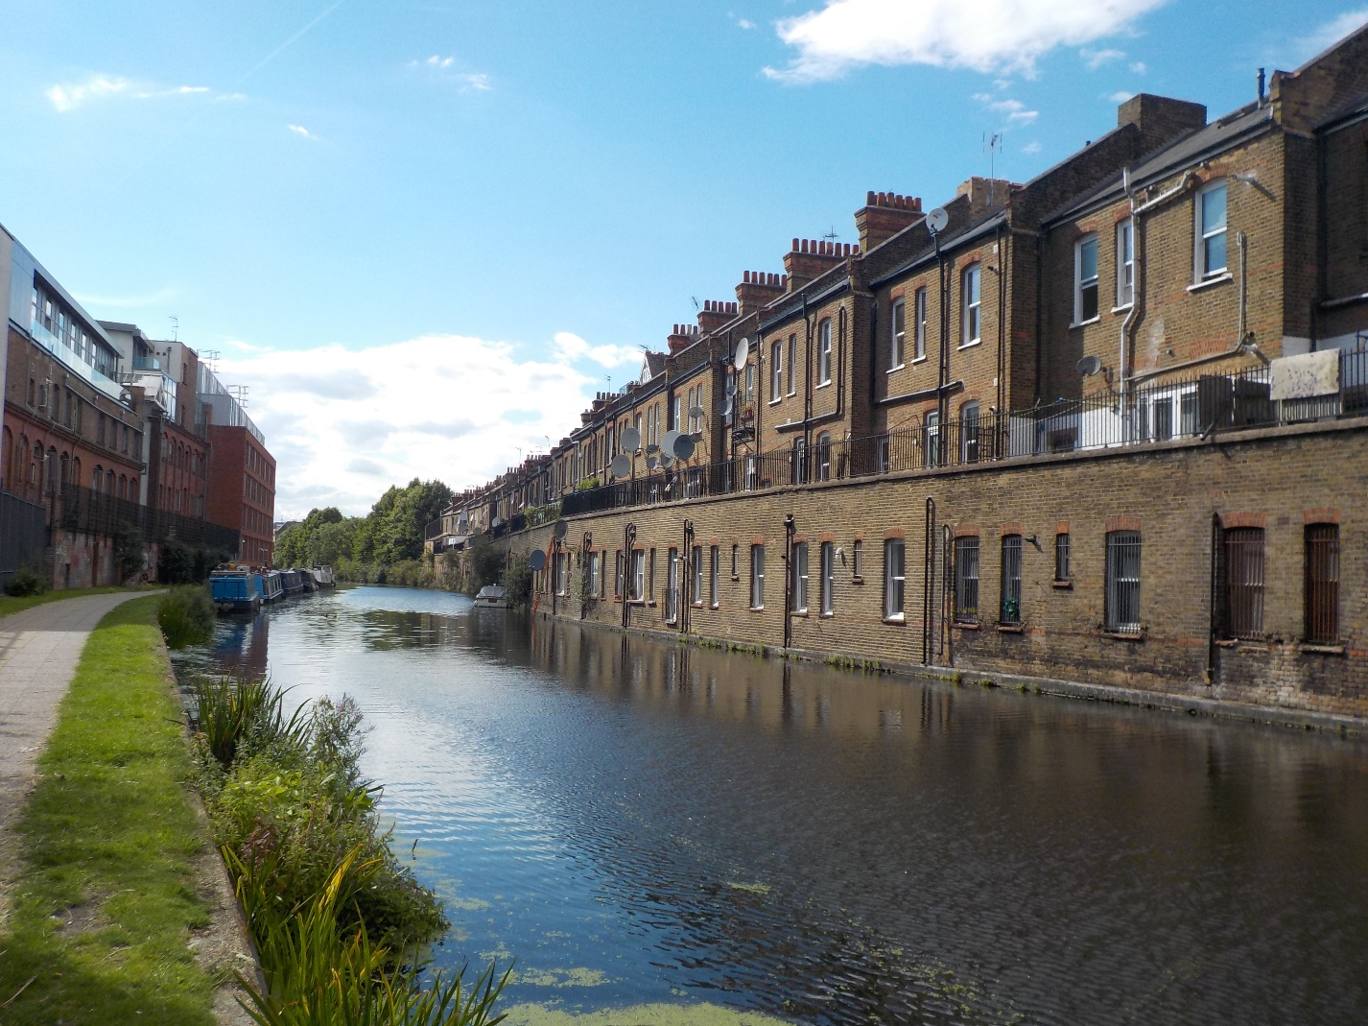

This is, of course, only how we chose to do it. You may opt for longer or shorter legs, maybe backpacking it all on consecutive days. I would challenge only the most fit and hardy to attempt to emulate my international walking companion Jill,

by entering the annual GUC race (sadly on the same late May bank holiday as our LDWA Hundred) and doing it all in one go. She race walked the entire 145 miles in 39½ hours. Being humble and self deprecating as always, I had to coax the memories of this, only one of Jill’s many ultra-distance race walking achievements, from her. My ‘back of the neck’ hairs rose slightly when, on a warm summer’s afternoon, we eventually strolled into Little Venice and she relived the moment, just after dusk, when she staggered home to cut the finishing tape , finishing ahead of all the female walkers AND runners ….  
I had enjoyed the privilege of walking with a remarkable lady.

I love a new experience, and the character of the people we met and the nature of our surroundings changed over the 8 days, certainly more often than our underwear!

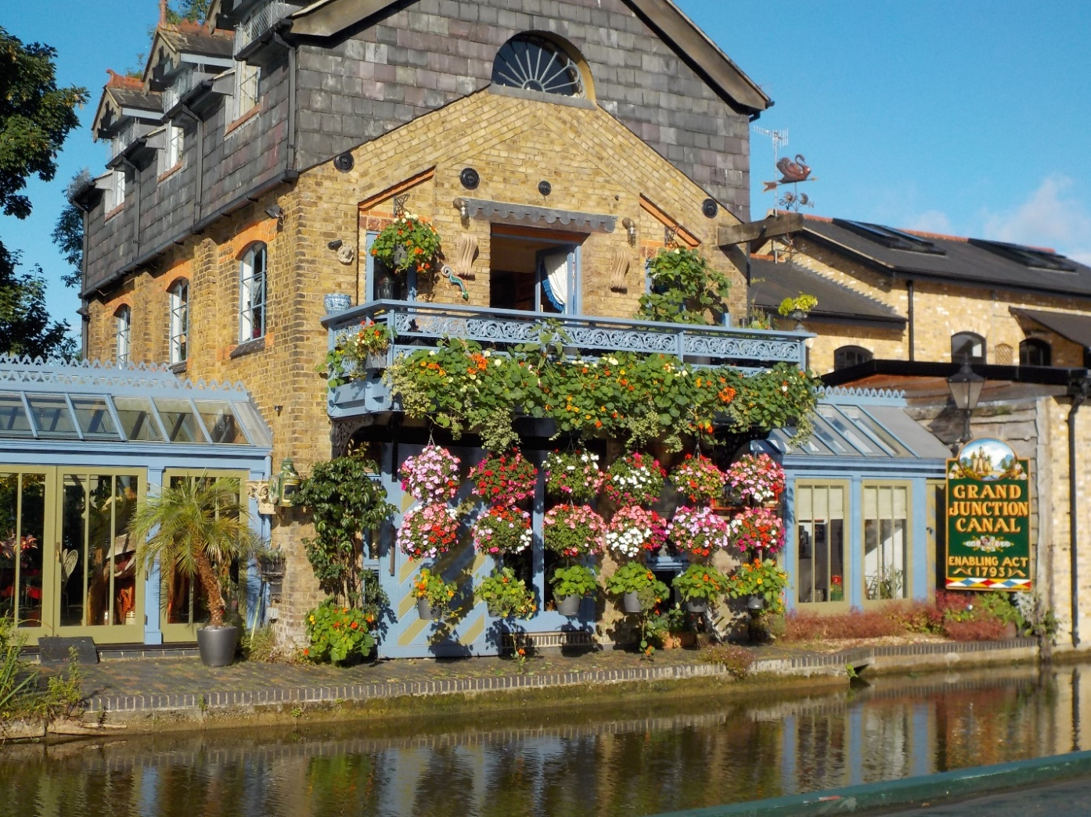

We began at Gas Street Basin, Birmingham where the GUC meets the Worcester canal. The towpaths around the attractive basin are lined with pretty bars, pubs and modern buildings, where customers can enjoy good food and drinks looking out at the traditional narrow boats moored there. Here, the industrial heritage we were about to experience meets modern, cosmopolitan living.

Although we passed through the heart of several large towns, Warwick, Leighton Buzzard, Hemel Hempstead to name a few, for the most part we were shielded from the noise and hubbub of our surroundings by protective banks and the ever present sense of the calm, quiet, slower way of life on the canal. The fascinating old mill houses and other buildings of huge historical significance are too numerous to list (read the book!), but the Iron Trunk Aquaduct taking the canal over The River Ouse near Cosgrove deserves special mention.

We finished at Little Venice, London where our waterway meets the Regent Canal. Glimpses of some of our capital’s high rise structures such as The Shard, along with residents suited and booted, leaving their narrow boat homes, to mount bicycles, ready for a days work in The City preceded our final steps into Little Venice with its quirky waterside cafes and charming restaurant. Our celebratory beer and wine there tasted good.

I will end by leaving you with a puzzle. As previously mentioned, the fascinating people we made conversation with during our walk greatly enhanced our walk experience. The décor and names of their homes reflected these diverse characters and at times were a source of great amusement and photo opportunities. There was the ‘Ten Bob Note’ boat, boasting a beautiful painting of the obsolete note on its’ side, the “Drambuie” boat, splendid in the original label colours of this ‘nectar of the gods” liquer, to Jill and my delight, the aptly named “Jilly-Dee” and finally, in my opinion, the best boat of all. The photo hopefully shows how splendid it looked, being totally covered in colourful flowers, fancy dressed mannequins, humourous poems and naughty ditties. The two likely lad owners explained that its name was an acronym. It was D.I.L.L.I.G.A.F…..  
Can you guess?

**Dee Brockway**

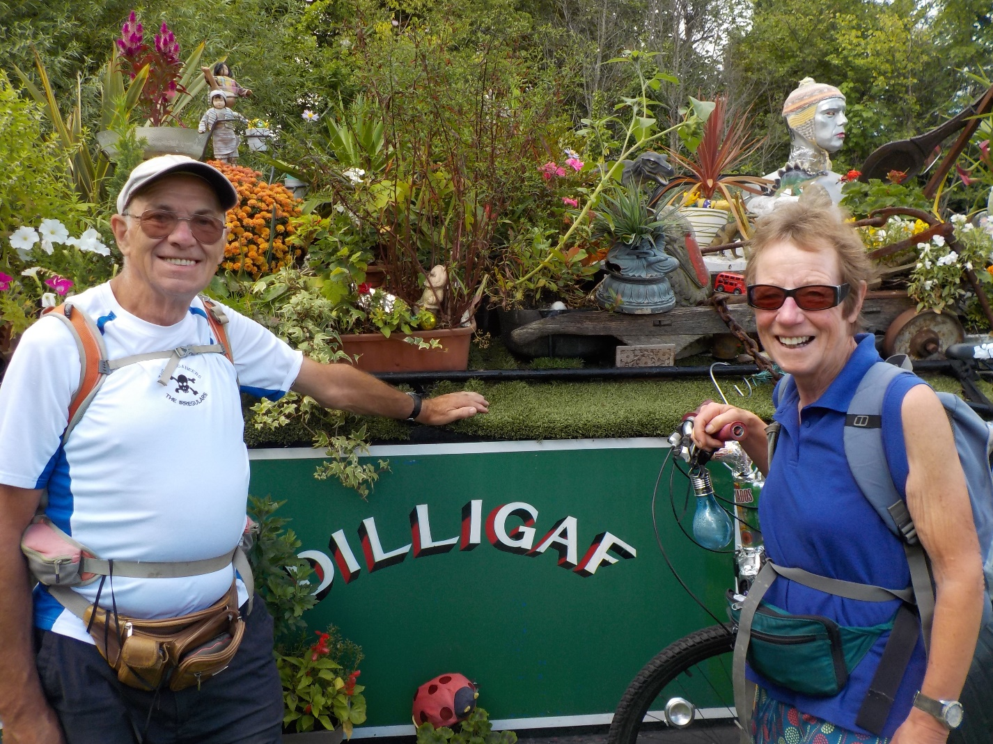

oooooooOOOOOooooooo

**NEW BBN BUFFS**

Coming soon to a car boot near you (Norman’s or Mary’s) the new BBN buffs -   
with the logo in gold on a darker claret background for the more discerning walker.

The buffs will also be available at our next event, the Shillington Shuffle, on 19th November and at the AGM the following Sunday. Price £5.

In anticipation of their imminent arrival, take a look at our gallery of travelling buffs.  Where will your new buff take you?

<https://www.ldwa.org.uk/BedsBucksAndNorthants/W/5432/travelling-buffs.html>

**Ping learns to share**

I was looking for a book to help our grandchildren aged 3½ and 2 on the subject of sharing and found this nice book. This made me think about writing some guidelines for the newsletter about sharing footpaths with cyclists, horse riders and golfers…..

On the whole, we are pretty disciplined and there is no shortage of shouts of BIKE! or CAR! Even when we are engrossed in our chatting… (no names mentioned!)

However, I have noticed a few occasions when we could be more careful.

GOLF COURSE: It is useful if the leader stops before entering a golf course, waits for everybody to have joined the group and, having checked that all is clear, we all walk across together. A friendly wave from the last walker to any golf player who has been waiting for us is common courtesy and helps them know that there are no more stragglers who could get hit by a ball.



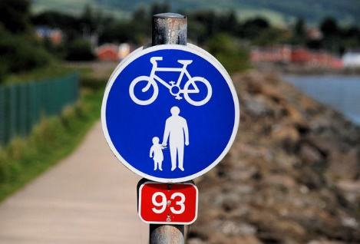

CYCLE PATHS: the main problem comes when we walk on well used cycle paths such as old railway tracks. These can be quite busy at weekends with little children on their tricycles and grown up cyclists on their fast bikes; if we add a few dog walkers to the mix we have to be even more careful. We need to keep to one side if at all possible rather than using the whole width of the path.

We all have the same purpose, with a little of consideration we can all enjoy a safe day out in the countryside.

Hope this is useful and I can also give you the reference for the book if you have any grandchildren…..

**Therese Jamin**

**ooooooOOOOOOoooooo**

**SWELTERING IN SOMERSET**

On what was the hottest weekend of the year so far Pearl and I headed down to Langport in Somerset to do our first challenge walk of the year on the Somerset Levels. We had entered the walk two years ago but it was cancelled because of the bad floods.

We camped near Cheddar where we found a nice pub nearby in the village of Priddy where we had a nice meal and a few beers. I know the area quite well as I was a member of a caving club many years ago and we used to go potholing round there.

On the Saturday morning we headed off to do the walk, driving though Wells and Glastonbury. Luckily it was the weekend before the music festival so the roads weren’t that busy.

When we got to Langport all the flags were out. It wasn’t for our arrival or anything to do with the walk. I think it was for a festival they were having later in the summer. There were two days of walking but we decided just to do the Saturday walk and the 12½ mile distance. It was billed as a two day walking festival but there were only 26 people entered on the two longer routes, and a few on the 6 and the 3 mile routes.

We set off at 10.00 am and already it was very hot. The first part of the walk was all on minor roads, mostly flat, but with nice views. When we got to the first checkpoint we were the last to arrive. I think everyone else had started earlier. In fact in the whole of the walk we didn’t see anyone else on the event, apart from three runners who overtook us right near the end and then overtook us again after they went wrong. I remember having done the same thing myself when I used to run challenge events!

After the first checkpoint we then went on a footpath which followed the River Parrett. This was probably the nicest part of the walk but there was no shade, whereas on the roads we often had shady bits under overhanging trees.

The second checkpoint was in a pub car park so we nipped in and had ten pints of lager each! No, it was actually just a pint of lemonade and lime. After that it was nearly all road walking and it was getting very hot. At the third checkpoint it was back to footpaths through fields and it was good to get back to Langport and a cold drink. In all, an interesting walk, very flat and probably too much road walking, especially on a hot day.

On the Sunday we decided to do our own shorter walk which started near our

campsite. To start it was through woodland with a scramble up the Ebbor Gorge to a beautiful viewpoint and then following the West Mendip Way to Wookey Hole. We went down the cave again. I think this was my third visit but they’d opened up some new sections of the cave to the public.

The climb back up from Wookey Hole was hard going as the weather was even hotter than the day before. Finally we got back to the car and stopped off on the way home at the pub in Priddy where we got something to eat, had a few cold drinks and listened to a local band playing some good music.

In all a good weekend. The Saturday walk was probably easier though longer, while our own Sunday walk was a lot hillier but more scenic.

**Steve Smith**

**ooooooOOOOOOoooooo**

**ON THE HIGH SEAS**

**With Captain Jack Sparrow and Young Bett the First Mate**

We arrived at the boatyard at midday hoping they would let us get going early, but no chance, they had had a busy weekend and we had to wait an hour before we were allowed to get our gear on board. Then we had an hour of gumf, being shown around the boat and how it all worked. Our guide was very thorough and after he had shown us the workings of our boat we slipped our moorings and headed for the first lock which was only two minutes away. Our guide, still on board, took us through the first lock and showed us what to do.

With us safely through the lock our guide jumped off, said have fun and walked back to the boatyard leaving myself and my first mate Betty to tackle the high seas of the Grand Union Canal. We were a bit nervous at first as it was our first time on a narrow boat, but on we cruised. We passed the Globe Inn (yes passed the Globe Inn), soon to arrive at the Three Locks at Soulbury. Looking at each other and thinking our first locks on our own and there were three of them, we were going to be a while. Then some volunteers turned up out of nowhere to give us a hand through the locks. Pheww, what a relief.

Through the Three Locks with the help of the volunteers on we cruised. We were settling down now and getting used to steering the boat, passing moored boats and under bridges with no problems. Soon the Stoke Hammond locks were in front of us, and we were thinking this time we will have to do it on our own, but as luck would have it, there was a boat coming the other way and we were

helped through the locks again. Locks behind us we headed for Fenny Lock where we were going to moor up for the night. Through the lock we moored up and sorted out our food, got the TV going and settled down for the evening. It was very quiet and peaceful on the boat that night and by 10pm we hit the sack.

After bacon and egg sarnies and cups of coffee we slipped our moorings at Fenny Lock at 0830 Tuesday morning and headed for Stoke Bruene. It was a lovely morning, clear skies and the sun was due to shine. There was not going to be another lock for the best part of the day and we had a delightful time chugging along the canal. There weren’t a lot of boats, apart for the ones that were moored up, we just had a few boats coming the other way but they were no problem.

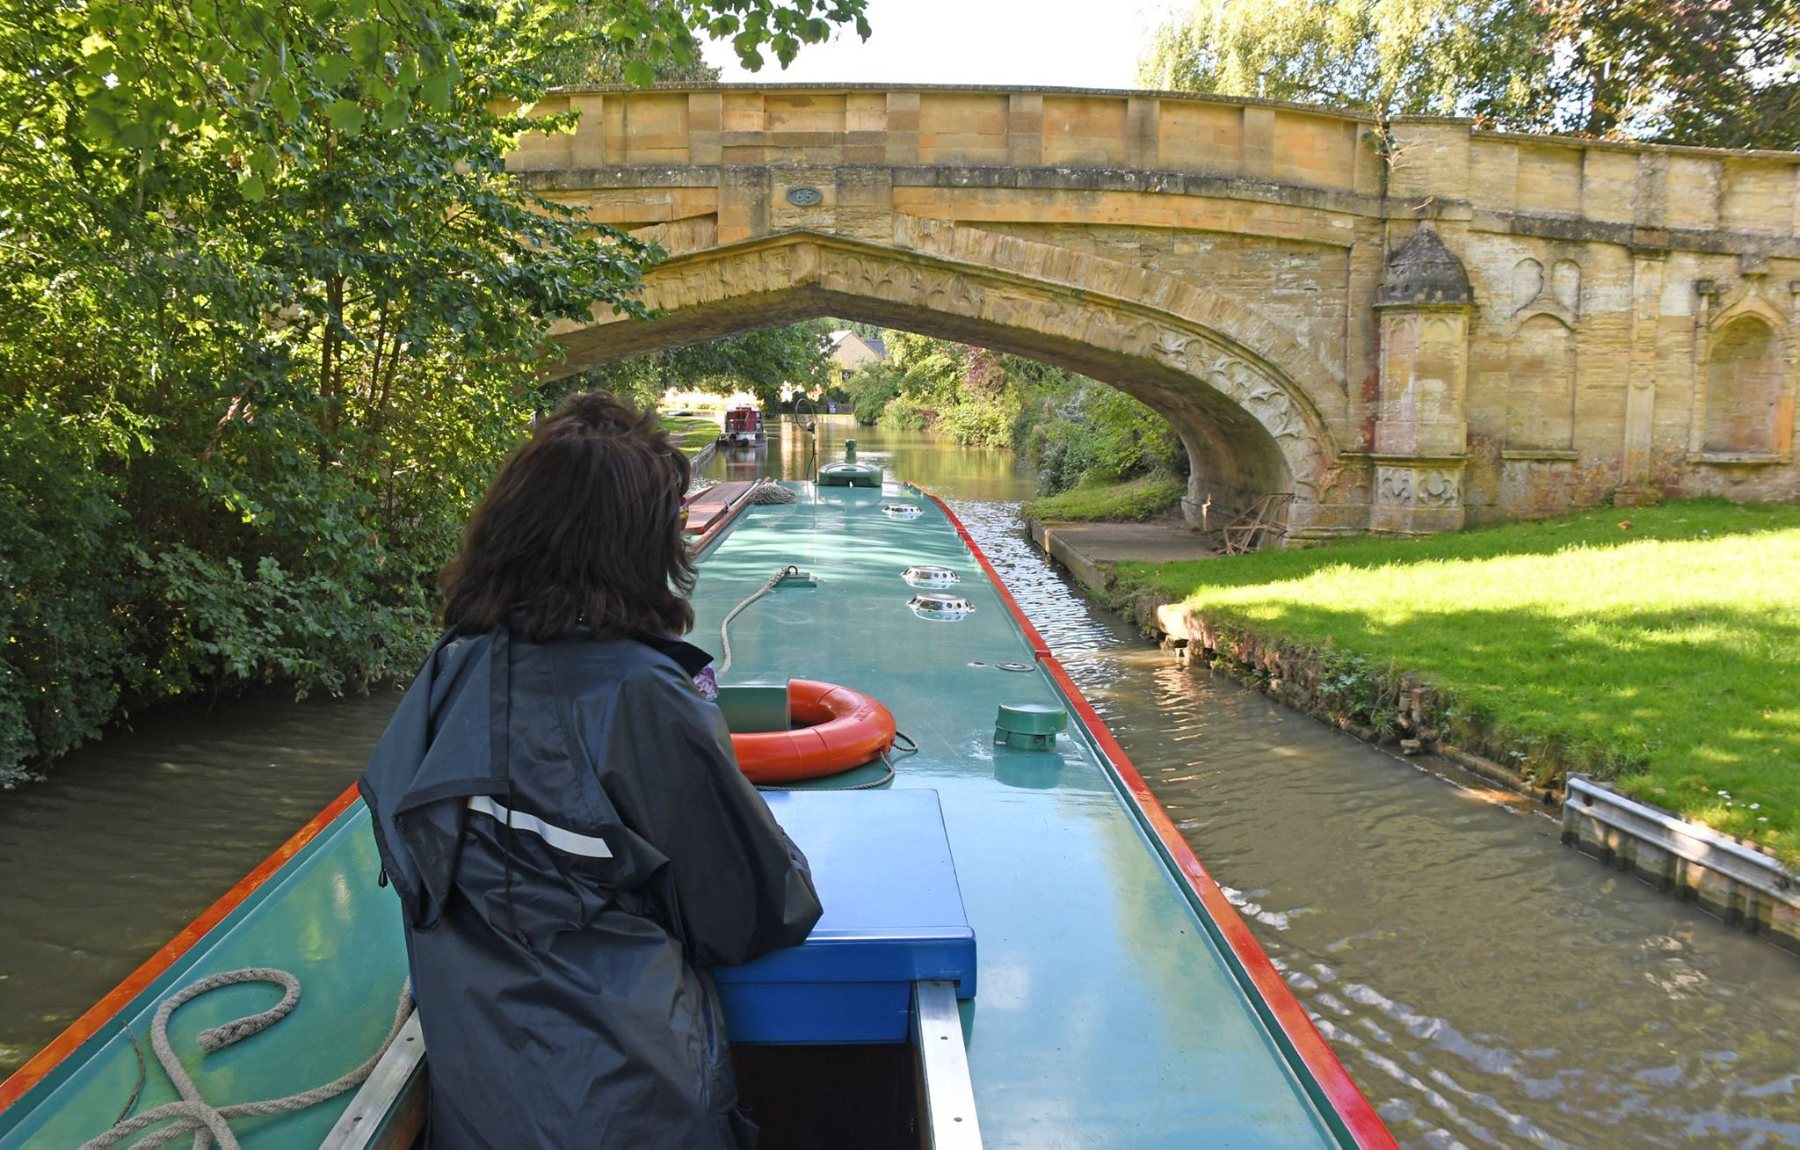

One of the chores we had to do daily was to fill up the fresh water tank. Now that should not have been too much of a problem, so at the first water point we spotted we pulled over, got the hose out and went to fix one end onto the tap and the other into the water tank. Well, first of all we did not have the connection to fit on the tap until Betty remembered that she had seen a fitting laying around that she thought would be what we wanted. It was…Phew. Connection on and the other end in the tank we turned the water on to fill up…no problem there, except

it seemed to take ages and we could not fathom out why. We came to a couple of conclusions, (1) it was not full to start off with, (2) we had a hole and (3) we’d left taps on somewhere….. it was none of these. Then we noticed water coming out of this round hole down the side of the boat. Yep you got it, it was the fresh water overflow, so me waiting for the water to come out of the top was a total waste of time. Killing ourselves with laughter we packed everything back on board and went and had a beer before setting off again. Oh yes, and while this was all going on the map decided to vacate the boat and we had to fish it out of the water and dry it out. As this was all happening DFH jogged by. God knows what he thought!

About an hour after setting off again we moored up for half an hour for a spot of lunch, then on we chugged heading for Stoke Bruene. The rest of the day went without too much stress, well not until Betty had a go at steering the boat. We went one side of the canal, then the other, then the other, then the other, what a palaver. With Cosgrove coming up there were a lot of boats moored up and we had our first locks of the day to negotiate. As luck would have it, there was another boat going through so we joined them and didn’t have to do a thing. Lucky Betty.

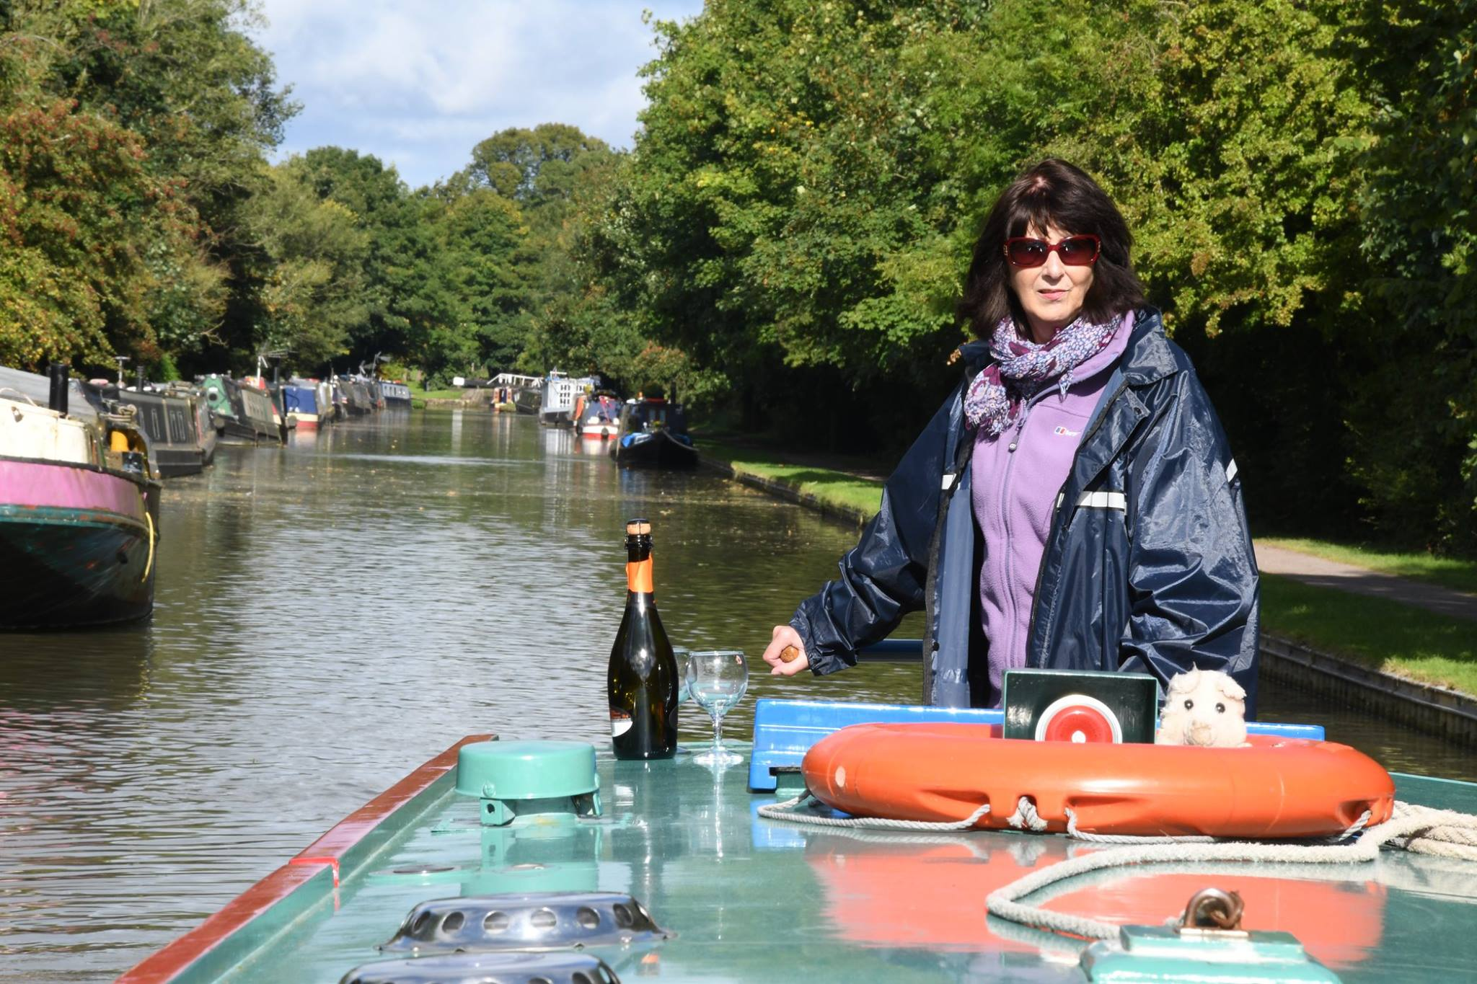

We decided that we would not do the locks at Stoke Bruene and not go through the tunnel but would turn around at the bottom of the locks and moor up for the night ready to head back to the Plough Inn at Simpson for a birthday piss up. There was conveniently a winding hole at the bottom of the locks, (for those who are not canal-talk minded like myself and my first mate young Bett a winding hole is where you turn your boat around to head in the opposite direction). We got to Stoke Bruene at 1600 and moored up for the night pointing back the way we had come ready for the am high tide to take us back. A few beers in the pub at Stoke Bruene, we cooked our grub for the night and settled down for the evening. We had been told that the wind was going to get a bit strong during the night, and wondered if we would break from our moorings so we threw the anchor out just in case.

Wednesday 13th, the big 60. The night before was a bit blustery but no great problem, we didn’t slip our mooring and by 8am we were on our way. Our destination was the Plough Inn at Simpson where we would moor up for the night and those who could turn up at short notice could come over for a drink. Our day started off well but the wind did take its toll. Betty was getting used to steering the boat and we were making good time…until Betty left the map and her glasses on the top and went inside. The wind got a gust up and the map ended up in the canal again, followed closely by her glasses. The glasses went straight

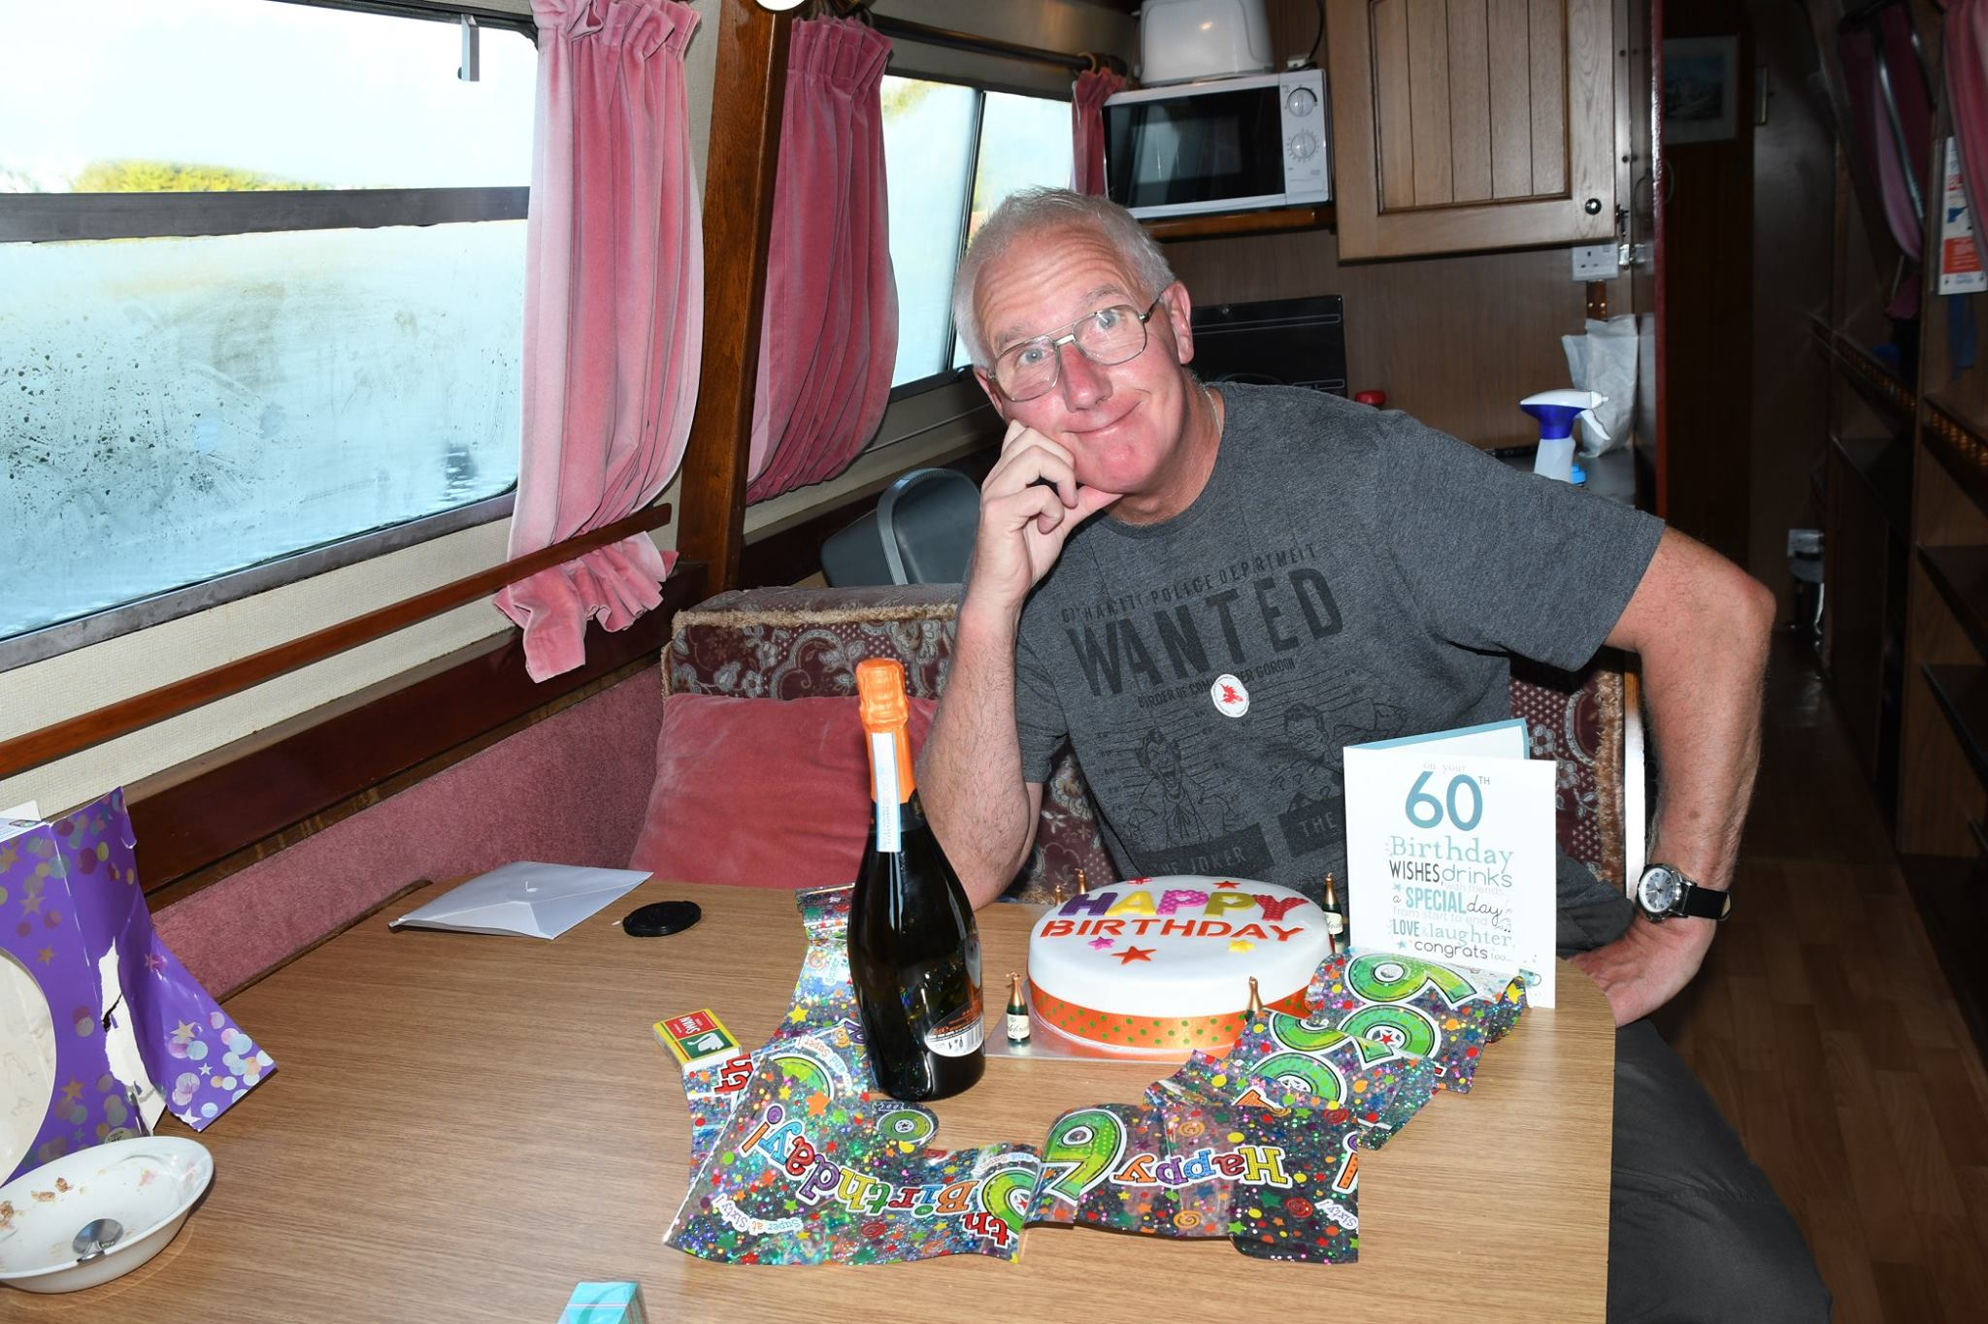

to the bottom. The map floated for a couple of minutes but by the time we got back to retrieve it, the map had decided to follow Betty’s glasses to the bottom of the canal

It was approx. 4pm when we moored up at the Plough Inn at Simpson and my bestess walking buddy, Eamsie, turned up in a short while with the pooch named Sandy and we all had a beer or coffee on the boat. Eamsie left after about 30mins, and Norman turned up at 7pm and we all went down the pub for a meal, and a few pints. After the meal we vacated back to the boat, and then my sister Barbara turned up and had a drink with us. Barbara and Norman left about 10pm and so myself and Betty curled up in our beds ready to take on three sets of locks including the Three Locks at Soulbury before mooring up at the Globe Inn at Leighton Buzzard, our last night on the boat.

We only had 3 or 4 hours to go to reach the Globe Inn at Leighton Buzzard on Thursday so we were not in too much of a rush to move off. We slipped our moorings at 9am ready to tackle the locks in front of us. The first was Fenny Lock and we were the only boat going through. We did not do too badly, considering we did it all by ourselves.

So with Fenny Lock behind us, including the swing bridge back in place, we headed for Stoke Hammond Locks, where before we went through the locks we were going to fill up with water. Now, remembering our first attempt at a water fill up point we should get it right this time and so, with one end in the tank and the other on the tap, the water was turned on, and apart from the end coming out of the tank a couple of times and drenching me we did a pretty good job. Instead of waiting for the water to come out of the top, we waited for the water to come out of the overflow. Job done, we were ready to go through the locks with a couple who did not know too much themselves. But, would you believe it, the volunteers were there again so we did not have too much of a problem. The Three Locks behind us, we pulled over for a few beers before moving on to moor up at the Globe Inn for our last night on the water.

A few beers in the Globe and grub inside us we settled down and watched Ewan McGregor and the survival of the Outer Hebrides. Falling asleep I went to bed for 10pm and would get up early the next morning for the final hour on the high canal. Would you believe it, I didn’t get up till 7.30am, a late one for me. But breakfast cooked and bags packed we headed for the boatyard and home. It was my first time on a canal boat for a holiday and it was great fun, I’ll do it again.

Photos are at [www.steveceegalleries.smugbug.com](http://www.steveceegalleries.smugbug.com)

**Stevecee xxx**

**THE INN WAY TO THE PEAK DISTRICT, MAY 2017  
aka CHANTAL AND THERESE’S CIDER SAMPLING TOUR!**

Clare Francis and I enjoyed walking part of the Camino de Santiago last year. As we planned another trip for 2017, we thought it might be time   
to explore the UK and I invited my sister-in-law Chantal who lives in Alsace and is a keen walker   
in the Vosges Mountains to join us.

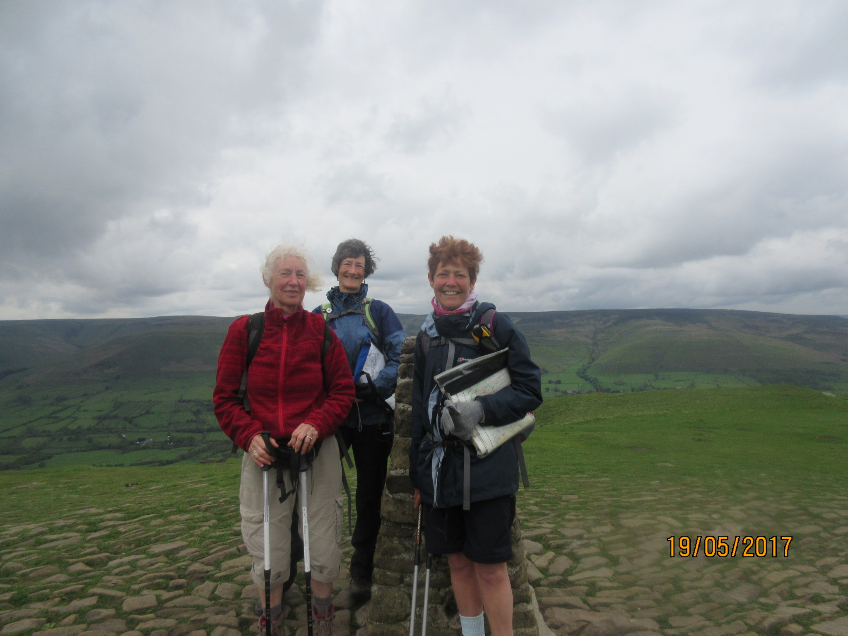

I came across a book from Mike Reid, who has written a number of guides, entitled the “Inn Way”. He has designed circular routes using a range of footpaths to link different hostelries, which can be used as B&B and for the occasional refreshment… The last pages of the book contain a log book to be signed by the owner of each pub visited en route. At the end of the treck we can post off the signature pages to obtain a CERTIFICATE! What an incentive….

Ready with rucksacks, the very useful guidebook, maps and compass we set off to discover the beauty of the White and Dark Peaks. We had booked all the accommodation and arranged with a local taxi firm to transport our bags from each B&B. Although we planned to change accommodation every night, we were unable to find a space in Yorkshire Bridge, so we arranged to stay 2 nights in Hayfield. The taxi driver would meet us there after our walk on day one and collect us in the morning of day two. A great plan! The guidebook suggested covering the route in 6 days, but we decided to stretch this to 7 days to give us more time to explore the area.

Clare drove to our starting point: the Waltzing Weasel in Hayfield. After a nice walk along the river enjoying the last of the bluebells we got our first signature at the George Hotel. A nice, friendly pub serving good food.

**DAY ONE:** **Hayfield to Yorkshire Bridge** –**18 miles-** following the Snake Path and the river Ashop. This is supposed to be 14 miles but we add a few extra miles because we blindly follow other walkers onto the very misty peaks. They are “doing” the Pennine Way – whilst we are not! Having noticed that our descriptions do not match what we see on the ground, we decide to stop so we can check our route… and we walk back down the mountain. The guide book is retrieved from the rucksack and, from now on, Clare is the designated walk leader. Chantal and I – especially Chantal – are happy to follow and to be free to

take photos of sheep and …of more sheep. This little diversion means that we will be late for the taxi which was booked for 5pm. I call the driver on top of Win Hill to ask him to arrive at 6pm instead. This is without counting on the last 2 miles of the walk being described as a *“very steep and exciting descent where around 1000 ft. of height is lost in three quarters of a mile with a particularly steep flight of rough steps”.* This lives up to its description and is indeed very demanding, especially for Chantal who thought she had injured her tendons. We walk very slowly and each step is very painful for her. We finally arrive at Yorkshire Bridge at 7pm for a signature in the book and are pleased to be driven back to Hayfield. That evening there is no walk along the river; Clare drives us to the Pack Horse for a nourishing meal.

**DAY TWO: Yorkshire Bridge to Longshaw – 10 miles.** This was planned as a shorter day but Chantal is still in pain, in fact she can hardly walk down the stairs to the breakfast room. Chantal decides to have a day’s rest, hoping that she can then walk the rest of the week. Clare and I enjoy the walk through Bamford and Hathersage. As the rain is starting we take refuge for coffee in the very smart George Hotel where no one minds our walking boots and soggy trousers. By the time we have drunk our coffee the rain has stopped and we enjoy fine views on Stanage Edge. Several people are rock climbing, but we do not fancy joining in. As we arrive at the Fox House Inn, Chantal is patiently waiting for us. The pub is quite busy with people having meals, but it gets quieter in the evening and we are ready for bed in very stylish bedrooms.

**DAY THREE: Longshaw to Rowsley – 12 miles.**  We are all pleased to see that the rest day has been useful and Chantal is back walking with us. Our route follows a number of fine tracks with beautiful scenery. We manage to get a coffee at the Wheatsheaf Hotel in Baslow. Clare is relieved that we have to stop to have our log book signed which means she can get her caffeine fix! From there, we walk through Chatsworth Park with very good views of Chatsworth House, although part of it is covered due to restoration work. We arrive at the Grouse and Claret in Rowsley in good time for a rest. Chantal and I go to explore the old mill where I buy some flour for Daniel, as he likes baking bread. Then we have another stop for a signature (and a glass of cider) at the very posh hostelry, The Peacock.

**DAY FOUR: Rowsley to Monyash – 12 miles plus 4.** This is a nice day walking through Stanton Moor. A magical swathe of heather and birch woodland. We arrive at the Nine Ladies Stone Circle built around 4000 years ago. According to legend the Nine Ladies were turned into stone for dancing on the Sabbath. We refrain from dancing, just in case, but take lots of photos so we are immortalised in some way. We continue through Bradford Dale, a beautiful limestone valley, as we leave the Dark Peak area. We go through Youlgrave and have a stop at

the George Hotel for another signature - and yes*, another* cider! This is an enchanting day’s walk along a sparking river with flooded lead mines and ancient woodland. Lathkill Dale is breathtakingly beautiful.

Arriving in Monyash, the Bull’s Head is closed and we are unsure where our accommodation is. Luckily we find two ladies who seem to know where Arbor Low Farm is situated. They point us in the right direction, adding that it is quite far. Indeed we walk and walk and walk again along the road, hoping that each building we see is Arbor Low. 4 miles later we arrive, very tired, at the farm, where a very cheerful and energetic lady welcomes us. She has prepared a meal for us and after a quick shower we are ready for a rest! Due to the scarcity of accommodation the 3 of us share a bedroom and Clare gets the very uncomfortable camp bed!!

**DAY FIVE: Monyash to Tideswell – 10 miles.** We are very grateful to our host for offering to drive us all back to the village in the morning, saving us the 4 miles of tarmac, even though I travel in the boot of the car! Today we pass the buildings of Magpie Mine, which has been very well restored. We stop for coffee at a delightful pub, the Cock and Pullet where there are about 100 clocks of all sort of shapes and sizes on display! We walk up to Monsal Head where we go to the Stables Bar to take advantage of the log fire to dry our wet clothes and enjoy a hot meal ( and a cider of course for Chantal and me). This is a wet day indeed, but we meet other mad walkers “enjoying” a day out along the river. Tideswell is a charming little town and we enjoy visiting its drinking places. THREE signatures are obtained that evening and supper is very jolly!! The neighbouring table can’t quite work out what nationality we all are and we end up adding German to the mix of conversation. Obviously cider is a good tongue loosener!

**DAY SIX: Monyash to Castleton – 14 miles.** The start of the walk is very beautiful through Cressbrook Dale. The path takes us to Eyam, the village famous for the altruism of its inhabitants during the 17th century, when they quarantined themselves for a year to avoid the spread of the plague. There are several information plaques and graves which we found very moving. This was also our first chance to sample Bakewell pudding and we sit eating it in the sunshine (for a change!) in the village square.   
  
We then walk up Eyam Moor and Abney with heather on sandy soil. We have some lovely views of Win Hill, which we had walked up on our first day... and the ugly cement works and quarries, so we can see that we have nearly completed our circular walk.

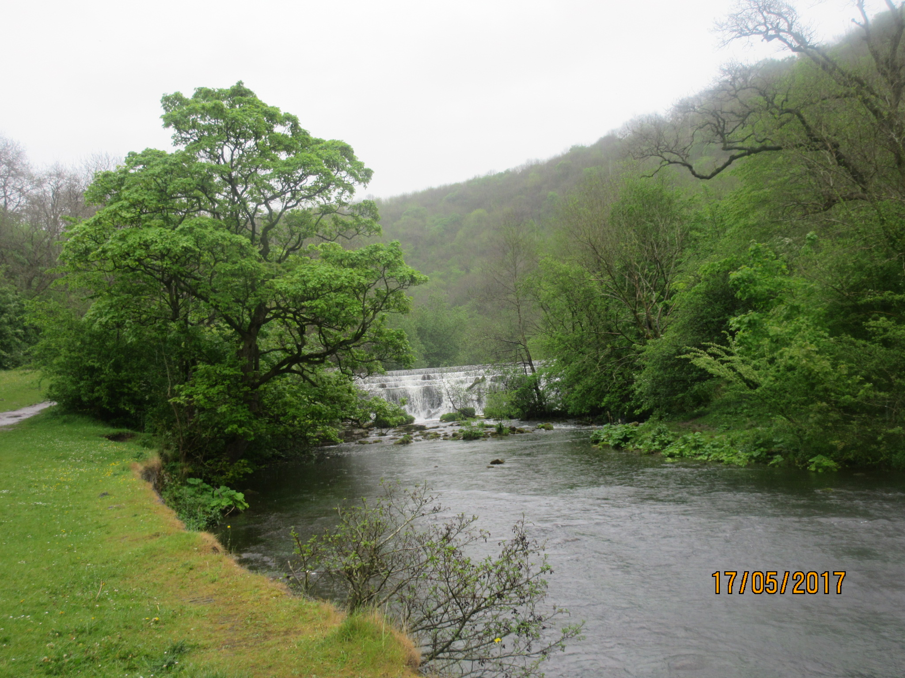

Castleton is an attractive village which is home to the Blue John stone, particularly popular in Victorian times. Alas, the shops are closed when we arrive, so we manage to console ourselves by visiting 3 public houses and obtain 3 further signatures!

**DAY SEVEN: Castleton to Hayfield – 12 miles.** Another lovely day’s walk with great views up Mam Tor then to Edale Vale. The Old Nag’s Head in Edale marks the official starting point of the Pennine Way, a 268 mile route up to Kirk Yetholm in the Scottish Borders (perhaps for another time??). We walk part of it anyway as we join Jacob’s Ladder and find Edale Cross and from then on it’s all downhill to Hayfield and a final signature before we re-join the Waltzing Weasel and Clare’s car waiting for us.

It has been a very enjoyable week’s walking, great scenery and quaint villages. We stayed in lovely places and felt most welcome. And yes, we did get our certificate!

**Therese Jamin   
(with contributions and approval of her fellow walkers)**

**oooooooooooooOOOOOOooooooooooooo**

|  |  |
| --- | --- |
| *Norman receives his award for his 5th completion of the Castlebar International 4 Day Walks* | Image may contain: 5 people, people smiling, people standing, suit and indoor |

.

**50TH CASTLEBAR INTERNATIONAL 4 DAYS WALKS   
29TH JUNE TO 2ND JULY 2017**

Failte Ireland or Welcome to Ireland. A sign that is prevalent throughout the Republic and is a good indication of the warm and generous greetings that the Irish give to visitors to the Emerald Isle.

Steve Clark and I made our way via Luton Airport and Knock International Airport to take part in the 50th Castlebar 4 Days walks. Funnily enough this was the same year that Milton Keynes new town was born. It’s a small world!

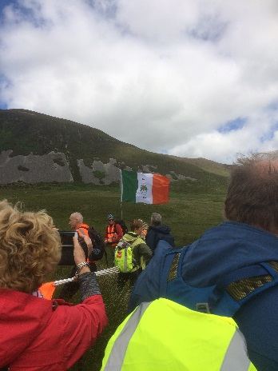The Castlebar 4 Days Walks belong to members of an umbrella organisation called the International Marching League (http://www.imlwalking.org) which promote walking as a worthwhile and healthy recreation; and encourages participation at walking events in other countries through a programme of incentive awards. This is accomplished by promoting international multi-day non-competitive walking events in each of the member countries. Our group has been to some of these events namely Blankenberge in Belgium and Viborg in Denmark.

After Steve and I had gone to our respective accommodation and booked in for the walks we thought “What do we do now”. If in doubt always go for a drink is   
what I was told and thus we met up with fellow walkers Hazel (a Liverpudlian who lives 3 streets down from where I grew up), Heather from Northern Ireland, Chris a veteran of 39 Nijmegen 4 Days Marches, Marcus Rogers and various other walking friends. Needless to say we had to meet up with a lot of friends in a lot of bars!

The walks in Ireland consist of 4 days of 3 optional distances of 10, 20 or 30K. The 10 and 20K walks are held on roads around the surrounding area of Castlebar but the real pleasure in the walks is on the 30K routes or ‘Rambles’ as they are known.

On these walks the participants are bussed out for about an hour to different parts of the countryside and from there the walkers are led by a group of marshals over some rough wild open spaces. These walks have always proved popular with the visitors to Castlebar with many from Europe but others being on extended holidays from countries such as USA, Australia, New Zealand and Burma.

This year’s was no exception with there being 4 x 50 seater buses taking 200 entrants. In reality the walks are not 30K in distance but on each day we spent up to 5-6 hours out in the wilds due to the difficulty of looking after so many people. There were approx 600 participants in the walks so 400 did the other options, the 10 and 20K road walks.

Our first ramble day was in the Wild Nephin wilderness area from where we set off on the Letterkeen Loop following a dried out stone riverbed. From there we followed an old fence and then started climbing, eventually ending up going through pinewood to exit the wood and climb to the summit across some marshy boggy terrain where the peat was sunk. The posts and the flags laid out by the marshals showed the way to go but at times you had to take big steps to jump and get to the top. Halfway up this ascent I got a text from Steve saying he was having his first pint in Johnny Machales! Perfect timing Steve!

At the top of the mountain we took a break for lunch where one of the Dutch ladies serenaded us in perfect English with a rendition of “You’ll Never Walk Alone” (You’d have loved it Phil H). After enjoying the view but being battered by strong winds we returned down the hill back through the pinewood slipping (and in some cases sliding) our way down to yet another riverbed and then onto a long forest road back to our waiting coaches for the journey to Castlebar.

Day 2 followed the same routine with 4 bus loads of walkers heading out from the town to where we were dropped off. Whilst waiting to set off on the walks I listened to one of the walkers good heartedly berating my landlady why I’d got a full Irish breakfast and his sister who lived in Castlebar didn’t even have any milk in the house. I still don’t know the answer to that one!

We set off at a steady pace heading along a gently climbing track onto some rough open moorland surrounded by hills. Steve was taking lots of shots.. After some 90 minutes we had a lovely early morning rest (known in Steve speak as “Tea Break”) beside a gently flowing river where we could sit and realise that despite all of the travails in the world it really is a beautiful one. This also enabled Steve to carry on ………yep you guessed it snapping!

From here we set off following the river heading into an area called the Dark Valley. This involved a fair amount of bog stomping and also great amusement observing the various routes we were all taking to navigate the uneven terrain. Lunch at the head of the valley saw a rendition of Happy Birthday in Dutch and English to one of the Dutch group whose birthday it was that day.

From there we returned along the valley skirting the hillside trying to follow the narrow hillside tracks to eventually rest on a plateau where we could see the open countryside below us. We then descended down some very narrow and twisty tracks to end up on a farm track and return to the waiting coaches where there were some interesting conversations going on about Brexit, health insurance and other world affairs. I just wanted a drink and a shower……..but not sure in which order!

So far the weather had been good for walking, overcast and not too warm albeit with some quite strong winds. On the third day we set off on the coach in “Liquid Sunshine” as one of our tour guides Ernie Sweeney called it. At the coach stop at Westport everyone was getting geared up for a day in the rain and we set off on the Mulranny Ramble following the coastline and beach for a short while before turning inland. We were meant to be doing more off track climbing this day but due to the conditions it was deemed unsafe to do so with 200 walkers in tow.

Thus we continued on the Burishoole Loop walks which included part of the Rocky Mountain Trail which in its full length is just under 20KM. For me this was the best day of them all. The weather did ease off and although we were unable to see much of the coast what we saw was still worth the effort of ‘cagging’ up and being out in mixed weather. Returning back towards Westport we returned from natural paths to tarmac and continued on a roller coaster ride of small hills where we finished just short of our coaches. There then followed a small and touching ceremony where those walkers who were there for the 5th or 10th time were presented with a bunch of flowers.

Ireland is still a strongly religious country and there was a Saturday night mass in the Castlebar Church to celebrate the 50th year of the Castlebar walks and welcome all the walkers who had travelled there. Who should be selected to carry the Flag of St George but our very own Stevee Cee! This was well attended by locals and many walkers and it was great to see all the flags of the various nations taking part paraded into the Church with our Steve looking very proud.

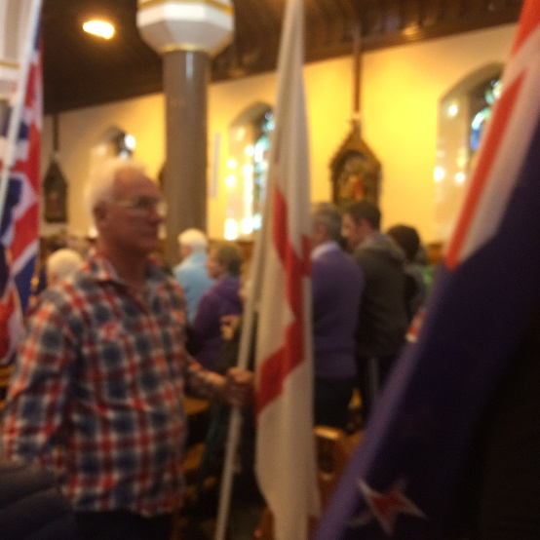

Another innovation for this 50th year was a parade by all of the flag bearers round the town from the Church to the Walk HQ at the Theatre Royal. There was a good turn out from the town to make us all feel welcome. The third and best day so far was then rounded off by a demonstration of Irish dancing and some excellent Irish ballads by a professional singer.

Finally the last day and this time no one hour coach journeys for the rambles but all walkers set off from the Theatre Royal on their chosen 10 or 20KM route. A lot of this day was taken up with tarmac bashing although when the 20KM route reached the first rest point we turned off onto some very pleasant wide green lanes which took us near an area called The Windy Gap. From here we could see the myriad wind turbines spinning on their endless cycles. We continued on our path past the Lake and the Ice Cream van handing out free ice creams to all walkers (a stroke of genius!). Eventually after what seemed like an eternity we entered Castlebar to wend our way through the streets back to Walk HQ and the finish!

A lot of the walkers were already into the swing of things and grabbing their final chance to sup either proper Guinness or Smethwicks for a year. But unlike Oscar Wilde I was able to resist temptation and went back to my digs, scrubbed up pretty well and returned back to the finish for the presentation of various categories awards to the International Marching League walkers and those who’d completed 5 or 10 Castlebar walks. This was my fifth completion and along with others walkers received my shiny silver medal and a photo opportunity from ….. Steve. Rabbit in headlights comes to mind!

As with all big walks of this nature there was a Blister Ball with music provided by a band called Brown Sugar (who hail from the Isle of Man I’m pleased to say) and dancing by the walkers. Suffice to say both Steve and I enjoyed ourselves and I had more aches and pains walking back to my digs from this then I did on any of the walks…….. The next day it was wake up and get the taxi back to Knock International Airport and then back to Luton.

When Gordon Shaughnessy went to Ireland with us for the first time some years ago he said that a visit there always made him feel better. After this time I understood how he felt. I really did feel as if I’d had a good break.

To sum up I asked one of the walk organisers for a saying in Gaelic to summarise how I felt. So I’ve put the saying she gave me and the English translation at the end of this article. I think it says it all.

“Feicfidh me aris thu”. “I hope to see you again”.

**Norman Corrin**

**LDWA BBN AGM  
COSGROVE VILLAGE HALL  
SUNDAY 26TH NOVEMBER 2017 AT 2PM**

**AGM LUNCH – THE BARLEY MOW, COSGROVE**

**The Barley Mow’s Sunday Lunch Menu is on the BBN website**[**https://www.ldwa.org.uk/BedsBucksAndNorthants/W/1052/meetings.html**](https://www.ldwa.org.uk/BedsBucksAndNorthants/W/1052/meetings.html) **and a copy is included with hard copies of this Newsletter.   
I’ve been told this menu is unlikely to change.   
 Please would you book your AGM meal   
via** [**gillbunker@googlemail.com**](mailto:gillbunker@googlemail.com) **by Sunday 19th November.**

**WALKS PROGRAMME**

**JANUARY TO APRIL 2018**

**Sun Jan 7 2018 Towcester Trott**

16ml. 09.00 From Richmond Road c.p. Towcester. Map: LR 152 (GR SP692485). ***C:*** Chris Bent ***T:*** 07837 367575.

**Thu Jan 11 2018 Studham Stumble**

15ml. 09.30 From c.p. NE of Berkhamsted Station, nr War Memorial. Nearest Postcode HP4 2QB is 300m S of c.p. Maps: LR 165 Exp 181 (GR TL004093).   
***C:*** John Davies ***T:*** 01442 874875 ***M:*** 07949 796470.

**Sun Jan 21 2018 Around the Abbey**

16ml. 09.00 From Caldecotte Arms public c.p. Milton Keynes MK7 8HP. Map: Exp 192 (GR SP888354). ***C:*** Linda Marsh ***T:*** 01908 669698 ***M:*** 07885 181422.

**Thu Jan 25 2018 A Flit from Shefford**

16ml. 09.30 From Old Station Way c.p. Shefford. Map: Exp 193 (GR TL143391). ***C:*** Terry Brown ***T:*** 01462 631057 ***M:*** 07932 627476.

**Sun Jan 28 2018 Chalgrave Chase**

19ml. 09.00 From Village Hall, Church End, Eversholt – 200m NW of church. Please park quietly in overspill c.p. through gate. Maps: Exp 192,193 (GR SP982326). ***C:*** Dave Sedgley ***T:*** 01525 714961 ***M:*** 07583 091770.

**Sat Feb 3 2018 Two Counties Radius**

18ml. 09.00 From Bramingham pub, next to Sainsbury’s, LU3 4AB. Access to c.p. is in Freeman Avenue, off Whitehorse Vale, Luton. Maps: LR 166 Exp 193 (GR TL075257). ***C:*** Therese Jamin ***T:*** 01582 571455 ***M:*** 07779 227675.

**Thu Feb 8 2018 West-East Rail**

15ml. 09.30 From Caldecotte Arms public c.p. off A4146 Eastbound, MK7 8HP. Map: Exp 192 (GR SP888354). LINEAR WALK USING TRAIN from Bow Brickhill to Lidlington. Break in Aspley Guise near p.h. ***C:*** Mike Bowley ***T:*** 01908 616589 ***M:*** 07933 066784.

**Sun Feb 18 2018 West Wycombe, Bradenham and Hughenden**

17ml. 09.00 From public c.p. next to West Wycombe Garden Centre. Maps: Exp 171,172 (GR SU826947). ***C:*** Terry Penny ***T:*** 01280 815512 ***M:*** 07963 043220.

**Thu Feb 22 2018 WWW – Virtually an Internet Walk?**

15ml. 09.30 From Embankment c.p. Wellingborough NN8 1LD (At Tesco roundabout (A509) turn along The Embankment, c.p. on right after 100m, height restriction barrier). Maps: LR 152 Exp 224 (GR SP901667). A late winter walk in the Nene Valley, route may be changed on day due to conditions, come prepared. ***C:*** Adrian Moody ***T:*** 01933 314134 ***M:*** 07788 684394 on day only.

**Sun Mar 4 2018 Pick and Mix Challenge Walk**

Loops of 12, 8, 6 or 5ml. in 10hr (choose how many loops you do). From Gt Missenden CofE Combined School, Link Road entrance near HP16 9AE (GR SP896014). A combination of loops of your own chosen total distance over undulating hills, mainly on fps and bdws. Route descriptions will be provided on

the day ONLY & will not be available in advance. There will be 1 x 12, 3 x 8, 1 x 6 & 1 x 5 ml routes. Marked up maps will be displayed at the start.. Start: from 08.00. All to finish by 18.00. All MUST bring own mug, & compass. We recommend maps Exp 181 & 172 or LR 165, waterproofs & a torch. Please wear appropriate clothing for the weather at this time of year. Sorry, due to HQ on school premises we cannot allow dogs. Organised by Beds, Bucks & Northants LDWA. Limit 250. Closing date for SiEntries 23rd Feb. NO ENTRIES OTD. On-line entries are preferred.ENTRIES ARE NOT TRANSFERABLE & NO SUBSTITUTIONS WILL BE ALLOWED. Email Mike Hyland for paper entry forms & any queries. Great Missenden Rail Station is only 2 minutes walk away from the start.. Entry: £7, Non LDWA £10 (under 18s free with adults) incl drinks & some food at HQ between loops, biscuits at the start & a light meal at the finish. There will be a cold drink station on the 12ml loop open from 09.30-13.00 only. All other loops have NO support. Chqs payable to LDWA BBN Group. SEF accepted with SAE. Online entry at: https://www.sientries.co.uk/event.php?elid=Y&event_id=3627. ***C:*** Mike Hyland, 55 Broadlands Avenue, Chesham, HP5 1AL ***T:*** 01494 774154. ***E:*** mike.hyland@ntlworld.com

**Thu Mar 8 2018 Frog Band Tour**

15ml. 09.30 From Morrisons c.p. W side of Tattenhoe St, Milton Keynes MK4 4DD. Map: LR 152 (GR SP830346). ***C:*** Stephen McMorrow ***T:*** 07471 203824.

**Sun Mar 18 2018 Flightpath to Flamstead**

18ml. 09.00 From Katherine Drive shops c.p. Dunstable LU5 4NP. Pub near lunch stop but may not do bar snacks on Sundays. NO DOGS. Map: Exp 193 (GR TL034226). ***C:*** Ian Sage ***T:*** 01582 661256 ***M:*** 07815 833295.

**Thu Mar 22 2018 Magical Mystery Tour**

15ml. 09.30 From Hartwell Church, Northants. Pls park courteously on nearby rds. Map: LR 152 (GR SP785504). ***C:*** Martin Lawson ***T:*** 01933 678594.

**Sun Apr 1 2018 Off to Find the Grand Union**

18ml. 09.00 From Towcester, c.p. clearly signed Tove Long Stay c.p. on N side of old Northampton Road, approx 500m from traffic lights. Map: Exp 193 (GR SP692489). ***C:*** Chris Bent ***T:*** 07837 367575.

**Thu Apr 5 2018 Wetlands and Waistlines**

16ml. 09.30 From c.p. at Wellingborough Embankment, off A509 at Tesco roundabout. Lunch stop and pub at Little Addington. Maps: LR 141,152,153 Exp 224 (GR SP901667). ***C:*** Bob Safford ***T:*** 01933 356609 ***M:*** 07531 837829.

**Sat Apr 14 2018 A Little and Long Walk**

20ml. 09.00 From free c.p. Newport Road, Oakridge Park, Milton Keynes (c.p. is immediately E of Grand Union Canal, between canal and new Asda store). Maps: LR 152 Exp 207 (GR SP838418). ***C:*** Gill Bunker ***T:*** 01908 321308 ***M:*** 07790 976090 on day only.

**Thu Apr 19 2018 A Motte, a Maiden and a Cathedral**

15ml. 09.30 From Totternhoe Knolls picnic site. Lunch time pub stop. Map: LR

166 (GR SP986218). ***C:*** Geoff Hancock ***T:*** 01525 377764 ***M:*** 07762 428091.

**Sun Apr 29 2018 Could be Frosty near May**

18ml. 09.00 From Whiteleaf c.p. near Princes Risborough. Map: LR 165 (GR SP823035). ***C:*** Roger Skerman ***T:*** 01525 405540 ***M:*** 07757 057440.

**DIARY DATE: BBN’s New Challenge Walk**

**Sun Jul 15 2018 Hannington Hike**

27, 18 or 13ml. all to finish by 18.30. Hall closes 19.00. From Wellingborough Grammarians Memorial Sports Field, Sywell Road, Wellingborough NN8 6BS (GR SP856690). A walk around the Northamptonshire rolling countryside. Start: Walkers from 08.00, Runners and fast walkers and all short route from 09.00. Entry Limit 200. No entries OTD. No Dogs. YOU MUST DOWNLOAD & PRINT YOUR OWN ROUTE DESCRIPTION. Route description will be on website from 5th July 2018. If you are unable to do this, please include SAE size C4 with a large letter stamp with your entry marked ‘route description’. We recommend you wear suitable footwear & clothing, also to have maps LR152 or Exp 223 & 224, waterproofs, your own drinking mug (no mugs will be supplied at Cps) & a compass. SIentries close on Sat 7th July 2018. Postal entries must reach us by Tue 3rd July 2018. Entry: £8, non LDWA £12, under 18s free (No entries OTD) incl refreshments at Cps (3 on 27ml, 2 on 18ml, 1 on 13ml), light meal at finish, cert & badge. Chqs payable to LDWA BBN Group. Entry form downloadable from event website. Online entry at: https://www.sientries.co.uk/. ***C:*** Mike Hyland, 55 Broadlands Ave., Chesham, Bucks, HP5 1AL ***T:*** 01494 774154. ***E:*** [mike.hyland@ntlworld.com](mailto:mike.hyland@ntlworld.com)  
**Marshals’ Walk – Sunday 17th June 2018**

**BEDS BUCKS & NORTHANTS GROUP  
 COMMITTEE 2017**

**Chairman: Norman Corrin** *T*: 01908 608667 *E*: [norman.corrin@g](mailto:norman.corrin@g)mail.com

**Secretary/Local Group Rep:** **Peter Simon**  *T:* 01582 513827   
 *E:* [bbn@ldwa.org.uk](mailto:bbn@ldwa.org.uk) [peterandmooi@ntlworld.com](mailto:peterandmooi@ntlworld.com)

**Treasurer: Ian Sage** *T*: 01582 661256 *E*: [iansage49@gmail.com](mailto:iansage49@gmail.com)  
**Social Walks:** **Mary Knight** *T:* 01295 812857 *E*: [maryjknight@hotmail.co.uk](mailto:maryjknight@hotmail.co.uk)

[bbn.walks@ldwa.org.uk](mailto:bbn.walks@ldwa.org.uk)

**Membership: David Findel-Hawkins** *T*: 01908 216476 *E*: [davefh@gmail.com](mailto:davefh@gmail.com)

**Newsletter/Website:** **Gill Bunker** *T*: 01908 321308 1 Abbey Way, Bradville,   
 Milton Keynes. MK13 7AN *E*: [gillbunker@googlemail.com](mailto:gillbunker@googlemail.com)

**Member: Alan Leadbetter** *E:* [acleadbetter64@gmail.com](mailto:acleadbetter64@gmail.com)

**Member: Roy Carter** *E:* [roycarter367@hotmail.com](mailto:roycarter367@hotmail.com)  
**Member: Peter Engledow** *E:*pete@excel121.com