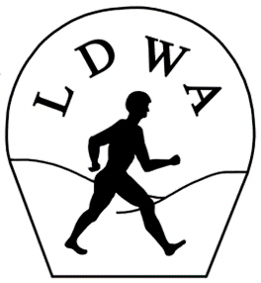 | LONG DISTANCE WALKERS ASSOCIATION  AIM: TO FURTHER THE INTERESTS OF THOSE  WHO ENJOY LONG DISTANCE WALKING

BEDS, BUCKS &
NORTHANTS GROUP
NEWSLETTER
SUMMER 2016

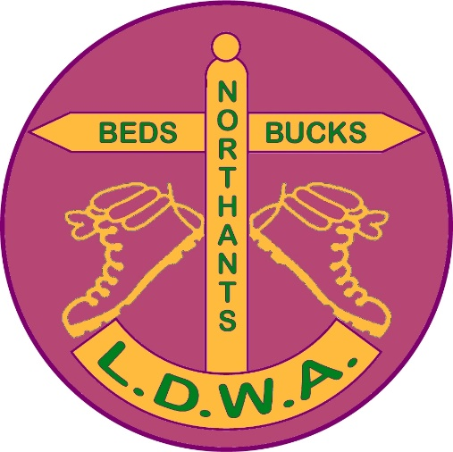

HAVE A GREAT DAY OUT, WALK WITH BBN
www.ldwa.org.uk/bedsbucksandnorthants

NEW MEMBERS

A very warm welcome to our new members:
Neil Edmonds Harlington
James Hill London
Sara Waldron Harlington

And welcome back to:
Mick Smith Raunds

--------------------------------------------------------------

For Thursday Walkers :
We are still looking for a Thursday Walks Co-ordinator !!

The Thursday walks are extremely popular and we have a super group of walkers.
You’ll all know by now that Gordon has been unable to join us on Thursdays as he is helping his daughter by looking after his grandson.

Gordon (with Merrian’s help) has sorted the Thursday walks to the end of the year, but now feels it would be easier if someone who is out on a Thursday took over.

The job is relatively simple and not too time-consuming.
Briefly it entails:
- Sorting the dates for walks – every other Thursday.
(The dates for Jan-April 2017 have already been sorted.)
- Getting a volunteer for each walk.
- Getting details of each walk from the leader.
- Forwarding the information to Gill who will input it for Strider/LDWA/BBN website.
Is there anyone out there willing to take this on? You won’t be left to sort it on your own - Mary, Gill and Merrian will always help.

Contact Mary (maryjknight@hotmail.co.uk) or Gill (gillbunker@googlemail.com or 01908 321308) if you are interested or please have a chat with Gill or Merrian (Mary is not walking yet) on a Thursday walk.
CHAIRMAN’S CHATTER

I’m never sure how to start this column. I write a few jottings down (one of which is normally to do with LFC…….note that’s Liverpool Football Club not Leicester!) and then see where it takes me. This time I started thinking about it on the recent Dorset 100 where BBN were fortunate to have the first checkpoint on the event at Crossways Village Hall.

It was a period of great…….okay manic intensity for at least an hour with the early arrivals impatient to get in and get on. However with the backing of Dorset Group HQ we didn’t open till we were supposed to and this helped the checkpoints further along the route. So we didn’t fight them on the beaches, more like feed them on the benches!

We were kept very busy with refuelling the entrants from the official three starts and the sole entrant on the 1500 start. But after that the thing that niggled me was how quiet it had been. By this I mean our Steve Clark not being there. Although Dorset had their own photographer and the video of the event with the drone was very spectacular, it was not the same without our Stevecee and, Steve, you were greatly missed. I’m pleased that he’s already booked for next year’s 100 oop north and I look forward to seeing the complete 100 photo album of BBN members!

Speaking of group members, thanks to Dave and Lynn and Nigel for their efforts on helping on the Marshals’ 100 and congratulations to our own DFH for being first on that event. A special well done to Brian Layton who, following in the footsteps of Rod Holland from South Wales Group, completed a Double Hundred. That is a fantastic achievement. In addition congratulations to those BBN members who finished and commiserations to those who didn’t. There’s always next year.

As the LDWA 100 is a moveable feast so is the LDWA National AGM, which next year BBN are hosting. After so many years of me sending details of hotels in our catchment area to the National AGM organiser Katie Hunt, she called my bluff!

We are hosting it over the weekend of Friday 10th to Sunday 12th March 2017 at Horwood House Hotel near Great Horwood and Winslow. There is a separate article about the AGM in the newsletter but it goes without saying that as many helpers as possible will be required. It’s a week after the Chiltern Kanter so it will be a busy time for our group.

Several BBN members (DFH & M, Ian & Pat, Steve & Pearl, Gill & Andrew) attended the last National AGM in Buxton. Steve and I organised a quiz for
attendees on the Friday night during which Steve performed his infamous Tee Shirt round. I’m not sure what they made of it! A few mistakes were made in the preparation and execution of the quiz but they have been learnt from in time for next year’s AGM.

One of the characteristics about taking part in LDWA events is that we become very focused in setting out to achieve our goals whatever they may be such as completing this event, organising that walk, qualifying for the 100, completing the 100 etc, etc.

Sometimes personal tragedies happen which pull us up and make us realise that, to quote Terry Wogan, “It’s not worth a pile of feathers”. A few of our members have recently suffered personal losses of a partner or family and I hope that the friendships forged through belonging to a community like ours have helped you cope with the sense of loss and sadness that bereavement brings.

Although the LDWA 100 is the flagship event of the year it is supported by the 40 plus groups organising their own challenge walks in their own right. In March the Gang of Four (Dave & Lynn, Mike & Sandra) organised the 4th Pick & Mix from Great Missenden Combined School where, despite clashing with other regulars such as the Daffodil Dawdle and the Sevenoaks Circular, 138 turned out. So a big Thank You or even 4 big Thank You’s to the aforementioned four for their efforts and to those who stood in the car park directing traffic!

I thought I’d continue with the BBN challenge event theme and Alan Leadbetter is organising the second From Here to There & Back on Sunday 3rd July from the Wellingborough Grammarians Memorial Sports Field. Helpers will be required on the day to assist Alan with this event. So if you have a spare few hours on Sunday 3rd July or, even better, fancy taking part in the event please do so. As England will be out of the Euros by then and the Men’s Final at Wimbledon is the following weekend, we’d love to see you!

Speaking of the following weekend we have the second running of the Greensand Ridge Social Walk, walking the entire length in one day. This was a great success last time so just think of this as The Godfather 2 to The Godfather. It will be even better than the first one! As I mentioned in the previous paragraph you don’t have to worry about the football. As DFH said, he’s not interested in seeing Germany v <A N Other> on the Sunday evening. Although I might be! I don’t mind marshalling………….no honestly it’s okay!

That’s all I’ve got to say for now so. As I always say at the end of each column, but it being pertinent to my earlier paragraph about difficult personal

circumstances currently experienced by some of our members, please remember that when you’re out with BBN friends on a national trail, social walk or Challenge Event that you might walk on but YNWA….

Good Walking!

Norman Corrin

MEET THE COMMITTEE : PETER SIMON
OUR NEW GROUP SECRETARY
Many of you already know me from our Sunday (and more recently, Thursday) walks. If you don't, please allow me to introduce myself. I am American by birth, having grown up in the district of Flushing in New York City. I first came to the UK in 1981 and have lived here since.

I have been a walker for much of my life. My first organised hike was a walk of a little over 1 mile around the Pataconk Reservoir in Connecticut - at the age of eight. The following year I led a group of day campers around the same trail - the first of the many walks that I have led.

My walking career took some time before it turned into a lifelong passion. I was the only family member at all interested in walking. I did some modest walking during my university years, the highlight the ascent of the mile-high Mount Katahdin in Maine. At university my main sporting interests were ice skating and skiing, neither of which I did especially well.

As it turned out, my interest in skiing got me into more serious walking. My working career began in Washington, DC, where I joined the local ski club. This club organised a wide variety of activities to keep its members involved during the months when there was no snow. These activities included a programme of Sunday hikes in the Appalachian Mountains, mainly in Virginia, but also in West Virginia, Maryland and even Pennsylvania. The walks were limited to April-June and September-November. July and August were too hot and, of course, we were skiing from December through to March. I joined the Sunday hikes and soon found myself a regular walk leader and eventually programme organiser.

When I came to the UK, I looked almost immediately for a group to walk with. I latched on to the West London group of the Ramblers, and subsequently to the London-based Vanguards Rambling Club. I also started to participate in challenge events - though not, at first, with the LDWA.

I met Mooi, whom I would later marry, on a walk, and it was she who introduced me to the LDWA. For several years we did regular challenge walks without thinking of joining in on group social walks. It was only after our move to Luton, in 1990, that I joined the BBN group. Since then, I have become a regular social walker and occasional walk leader. From time to time I enter a challenge event, but my natural habitat is the long social walk.

I retired from full-time employment last December. While I was working, I avoided taking an active role in running the group, but I offered my services to the group when retirement was imminent. It was proposed that I stand for Group Secretary and I have accepted that position.

Peter Simon

---------------------------------------------------------

NOTICE OF ANNUAL GENERAL MEETING

Sunday 27th November 2016 2pm
The Anchor Inn, Great Barford, Beds.

GROUP WALKS

Thank you so much to everyone who has offered to lead walks for the rest of the year. As you will see we have a bulging walks programme, but of course it doesn’t end there, no sooner have I stopped bugging you about one walks programme and I’ve started on the next. We haven’t even had summer (or very much of it) and we are looking to the New Year.

If you are thinking about leading a walk for the first time but have reservations, whatever they may be, please just drop me a line (maryjknight@hotmail.co.uk), there will always be someone who will be happy to recce your route with you, or just talk through what your plans might be – get your New Year’s Resolution in early!

Below are available dates for Thursday walks – to reserve your date just e-mail me or let Gill or Merrian know when you are out walking.

January | 12th
 | 26th
February | 9th
 | 23rd
March | 9th
 | 23rd
April | 6th
 | 20th

And these are available dates for weekend walks. Please remember walks can be Saturday or Sunday – just e-mail me to reserve your date.

January | 1st
 | 7th/8th
 | 14th/15th
 | 21st/22nd
 | 28th/29th

February | 4th/5th
 | 11th/12th
 | 18th/19th
 | 25th/26th
rch | 5th | Chiltern Kanter
 | 11th/12th | National LDWA AGM hosted by BBN (see p.10)
 | 18th/19th
 | 25th/26th
April | 1st/2nd
 | 8th/9th
 | 15th/16th
 | 22nd/23rd
 | 29th/30th

One final plea – after your walk please e-mail me with your walk stats (distance and number of walkers). Thanking you in anticipation.

Best wishes and happy walking.

Mary Knight, Walks Secretary (maryjknight@hotmail.co.uk)

-------------------------------------------------------------

THE DORSET HUNDRED

Congratulations to all BBN members who completed the Hundred - special mention to Jim Robinson who completed his first Hundred and Brian Layton who completed an amazing Double Hundred.

Congratulations to DFH on achieving his 20th Hundred – he completed the Hundred Marshals' Walk in a time of 28.42. Dave, we salute you!

BBN Finishers:

Tony Hill  Kim Reed  Rachel Armstrong  Paul Sutherland  Peter Hamson  Dee Brockway | Nick Vanson  Jim Catchpole  Jill Green  Graham Busch  Jan Williams  Paul Keech | Jim Robinson  Glyn Dimmock  Graham Bayes  Vikki Kemp  Brian Layton

Paul Keech writes: It was as tough as ever especially as many of the paths were hard, rough and rutted. I developed a nasty blister under my heel which made the last 20 miles particularly difficult, but the whole experience was as ever one of happy memories especially due to the friendly atmosphere created by both marshals and participants.

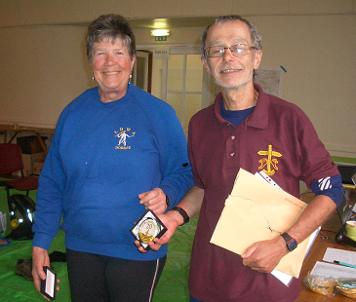 | DFH receiving his 20 Hundred Completions Badge

LDWA NATIONAL AGM 2017

Over the past few years several BBN members have attended the LDWA national AGM as, like the annual 100, it moves around the country each year. Dave Findel-Hawkins has no choice as he is the national Events Secretary……….

I’ve often thought that it is something that the group should host and this year the National Executive Committee has called my bluff! Therefore we will be hosting the next National AGM from Friday 10th to Sunday 12th March at Horwood House Hotel. The hotel link is http://www.horwoodhouse.co.uk/

As a group we are required to come up with 4 walk distances of approx 20, 17, 15 and 8 miles and a coach trip. The details for these are to be supplied by end of August/early September for the December Strider.

We will also have to provide meeters and greeters for people at the hotel check in desk on the Friday afternoon from 2pm onwards. This is so attendees can chat to the walk leaders and to people with local knowledge.

Planning for this has already started and my initial thought for the 20 mile route so far is to bus these walkers out to Wendover and they will walk back via the Coombe Hill Kissing Gate and the Ivinghoe BBN Founders Memorial Bench and return to Horwood House. This is an ideal chance to show off how the group has invested some of it’s hard earned money in the thing that we enjoy the most……………the countryside!

Ref the other walks, initial thoughts for the 17 mile route are for that to start at Ivinghoe by the memorial bench and then walk back via the same route as the A route walkers. But that’s an initial thought. It’s early days but with a deadline of early September, not too early!

On previous AGMs all of the routes have had different lunch stop but Dave and M have come up with a novel idea of using one of the local village halls as a joint refreshments stop. If someone is really thirsty they can partake of the local ales!

The coach trip is provisionally planned for a visit to Milton Keynes Museum (this is where the Concrete Cows have now moooved to….) followed by a trip to Bletchley Park.

An event of this size will need a fair amount of assistance over the three days. We also have the Chiltern Kanter the weekend before so it is going to ask a lot of us as a group. But it is a great opportunity to show off our area.

If anyone is interested in being a walk leader on the day or assisting in anyway then please contact me and I’ll be only too happy to take up your offer of assistance.

Norman Corrin

-------------------------------------------------------------------------------

NATIONAL AGM WEEKEND

This year’s national AGM weekend was held in Buxton, Derbyshire. Pearl and I travelled up on the Friday, collecting Norman on the way. We stayed in the Palace Hotel. It’s a very big but quite old fashioned building with chandeliers. Norman and I had been asked to do a quiz on the Friday night. This went very well, though we had the usual funny answers. One question was “Who is Jorge Bergoglio. “The answer is “the Pope”, but one team thought he was the head of FIFA! He probably would have done a better job. Norman had a round where you had to identify all the LDWA group badges but with the names taken off – one team failed to get BBN even though Norman was wearing a BBN sweatshirt!

The following morning I set off to do the 17 mile “B” walk, while Noman was doing the 13 mile “C” walk and Ian the 9 mile “D”. Pearl and Pat were doing the coach tour round the places of interest in Derbyshire. I think they had the best day as all our walks were quite tough. My walk was mostly across moorland with a lot of ups and downs and wading through patches of snow. Luckily the weather was dry. By a coincidence I met a woman on the walk who I met on an Explore holiday to Turkey in 2000. Of all the walking holidays I have been on, she is still the only person I’ve met who has been in the LDWA.

On the Saturday night we had a gala dinner followed by a talk by a guest speaker on the Pennine Way. On the Sunday we had the AGM in which there are always lively discussions. We then headed home, stopping on the way for a pub lunch.

In all it was a very good weekend. We had nine BBN members there altogether. Wherever the national AGM is held – and next year’s AGM is to be held near Milton Keynes – it is a good weekend and I definitely recommend it. It would be nice to get some more BBN members to come along.

Steve Smith

CLERMONT AGAIN

It was 9pm on Thursday 3rd February and I was picked up by my mate Chris at my works car park. Then on to Watford to pick up Marcus, then Dover and the two hour crossing to Dunkirk. All went well and we arrived at Dunkirk approx 4am Friday morning. We headed for Jerry’s house in Belgium; he was coming with us, then on to Clermont. We weren’t staying at the usual B&B this year as Alphonce, of the husband and wife team who ran the B&B had stomach cancer, so we were going to stay 10kms away in Wegemont, where the bus load of Waendle Walkers who go every year stay.

Jerry took his own car from his home and Marcus went with him, and they got to Wegemont before us. Jerry, who had done the bookings, sorted out the rooms and Marcus and Jerry headed for the pub. Chris and I arrived around 4pm and Chris had a text message from Jerry to say they were down the local pub, so we left the car and hiked the 300 yards down to the pub and found Jerry and Marcus. So three or four beers later and after booking a table in a nice restaurant across the road we walked up to our lodgings for the weekend and moved into our rooms.

Jerry had done a good job when he booked the rooms because I had a room to myself (although there was three beds in the room) and it was en suite. A rest and a glass of wine later, at 7.30pm we headed back down the road for our meal. The meal went well and two friends, Meant and Jan Hendrich had joined us. Breakfast was at 08.30 so the alarm set for 07.15. I hit the sack at around 10.30 and slept like a log.

Up, and breakfast down our throats, we headed for Clermont. When we arrived there were cars everywhere. The coach carrying the Waendle Walkers had arrived; they leave later from Wellingborough and arrive just in time for the walk to start. Boots on and rucksack on my back we headed for the hall. The hall was a hive of activity and a lot of usual faces were there, so a brew and hello’s and hugs and the usual “What’ve you been up to since I last saw you”. Later I set off on my own for a 20km walk. I left Chris in the hall talking to friends where he was likely to be for some time (not that he talks a lot, cough cough, if you see what I mean).

Saturday started off wet and windy but by the time I started the 20km it had stopped raining but was still windy. Most of the walk in Clermont is on tarmacked road, but not all the way, so it was either tarmac road or a very muddy field. The day went well, nothing out of the ordinary happened, had a beer or two at the CPs with Marcus and some other friends and got back to Clermont at around 15.30.

Between CP1 and CP2 I came across a group of walkers drinking wine. I took some photos and got a glass of wine while I stood and chatted. They gave me an

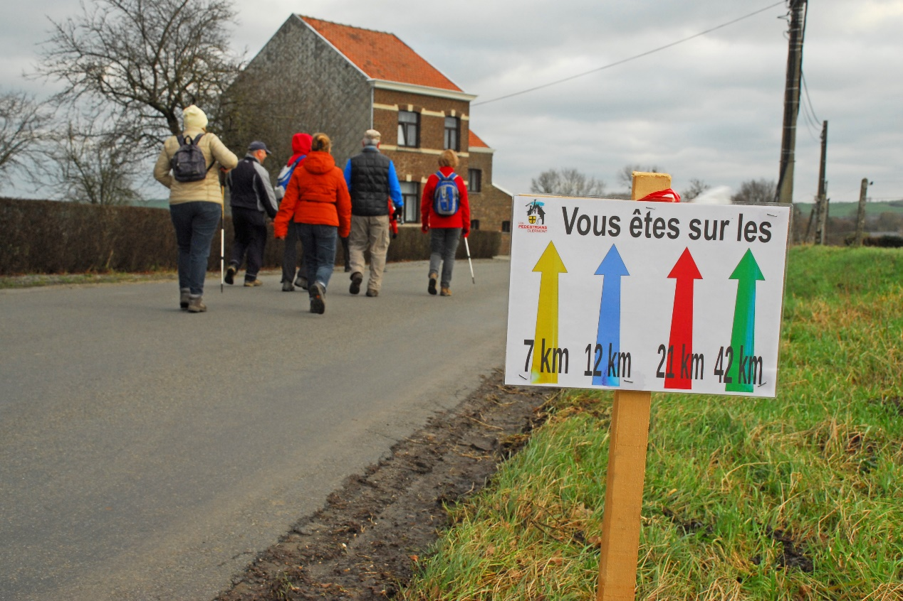

email address so I could send the photos I’d taken to them and then went on my way. By the time I got back to Clermont Chris was already in the local boozer drinking with the Waendle Walkers. I got myself a burger and chips and had a few beers myself, took some photos then we all headed back to Wegemont for a wash and brush up. Then it was on the Waendle Walkers coach and back down to the pub in Clermont for a Saturday night’s boozing.

Sunday started off a wet day, but cleared up by the time I started to walk the 20kms. It is the same walk that you do on the Saturday so there were not going to be any surprises today, and a lot of the walkers go for the shorter distance and end up in the boozer in Clermont or just take a more leisurely pace. The walk went well, I got through all the checkpoints, bowl of soup here, a beer there and got back to Clermont around 14.30 to find Chris, Marcus and most of the Waendle Walkers in the boozer. I of course tried to avoid such a motley crew but alas I ended up in the boozer for yet a few more beers before heading back to our digs for a wash and brush up and then a meal down in Wegemont (not that I went for the meal). Then hit the sack for the long drive back to Dunkirk.

We woke up Monday morning to heavy rain but it didn’t last all that long, so we had our breakfast, put our gear in the car and headed for the road to Dunkirk. We made good time, had a couple of stops for coffee and to give Chris a break and

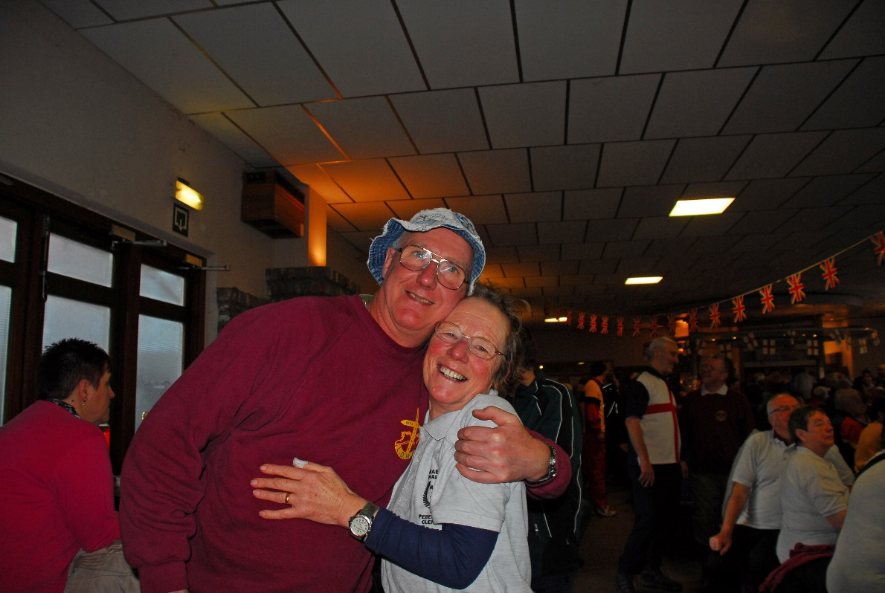
Steve with Jill Green

made Dunkirk in time for the 14.00 ferry back to Dover. But as usual we stopped off for beer and baccy about 20mins from Dunkirk. The ferry left on time, not knowing what was waiting for us as we left the shelter of the port.

Looking out of the window at the front we could see the sea was getting rougher, and there was talk that Dover was closed that morning due to bad weather, and as we went further out to sea the waves were getting higher all the time. As we went into a trough, the waves would come right over the windows getting everybody excited. It was not long before a message came across the speakers that we had to slow down due to the weather and that there was a queue of ferries waiting to get into Dover and we would be docking approx an hour and a half late. So we bobbed up and down off the coast of Dover like a duck in a pond until we got the go ahead to enter port. It was in fact more like 2 hours late before we headed for port and once we got into the harbour we needed a couple of tug boats to help us to berth because the wind was so strong. Once docked though we were soon on our way out on the M20 and heading for home. All was going well till we hit the M25 and, because the bridge at Dartford was closed due to high winds, one of the tunnels was closed therefore a 20min drive to Dartford tunnel took us nearly 3 hours.

Once passed Dartford it was clear sailing, we dropped off Marcus at Watford then headed for Northampton. I got into my local around 10.30pm around 5 hours late. A beer down my neck I hit the sack in my own bed, my gear would have to wait till Tuesday.

(Photos of the w/e are at www.flickr.com/photos/131244540@N07).

Stevecee x

In March last year on the Tring Roundabout we came across a pony with a bad eye infection and a bad sore on its hind leg. It was reported to the RSPCA by a lady walking with us for the first time. Does anyone know the outcome of the pony’s fate? Stevecee x

------------------------------------------------------------------

WELL, IT WASN’T 6 DAYS
OF THE 12 DAYS OF CHRISTMAS

It was back in January when I picked up The Great Outdoors (TGO) mag off the bookshelf of a newsagents thinking that I hadn’t read the TGO for a while. One of the articles that caught my eye was about a Scottish YHA, Loch Ossian, way up above Glasgow in the middle of nowhere, you cannot even get a car to it, and you have to get a train to Corrour then walk 1.5 miles to the SYHA. So as I still had 3 days to book before the end of March, I picked a weekend where I was rostered off for three days so I had six days in total. Now it was a case of getting the holidays booked before anybody else booked the dates (honest), so March 9th,10th and 11th were booked as holidays and the 12th, 13th and 14th I was rostered off, so Scotland here I come…or that was what was supposed to happen. I phoned the SYHA to book my place and the reply was “Sorry we are fully booked that weekend, we got a block booking and there are no beds available”. Arrhhh, Ohhh cricket balls.

March 9th came around so what was I to do, well Wednesday I just chilled out, got a nice lay in, went and got some breakfast and went to the cinema. I wondered if BBN had a social walk on the Thursday. Usually when I get a Thursday off there is not one, so when I had a look on the website there was Lakes, Towns and Woods beaming straight at me. Earlyish to bed Wednesday
night and up early on Thursday, sandwiches made, coffee in the flask and packed in my daysack off I went heading for Caldecotte in Milton Keynes. Now the amount of times I have passed Caldecotte when I didn’t need the place ain’t nobody’s business, but could I find the place that day? I parked up at the Caldecotte sports centre and asked a taxi driver where the place was with a windmill, he did not have a clue, I drove back out of the sports centre, phoned up Gill and asked where it was, as I was talking to Gill, there was the windmill straight across the road from me, so I said I’ll be there in a couple of mins Gill, that taxi driver was not much cop was he. I wasn’t the last to arrive though, so boots on and my camera over my shoulder off we trotted.

The walk was excellent, plenty of mud, bit of drizzle and DFH decided he wanted to jump in a ditch just so we all had to pull him out, (photos at www.flickr.com/photos/131244540@N07 We had a great walk and a great day and what better to finish it all off than a pint in the pub. I wasn’t going to have a pint but I got lost getting out of the car park so I had to have a pint so I could get my bearings. And of course it was Thursday, curry club at Wetherspoons so back home washed and changed, I headed for town for my curry, (Jalfrezy curry, rice two naan breads, and a pint all for £5.50). I always have 2 naans because I don’t like their poppadums, so I ask for extra naan and no poppadums. Also on Thursday its folk night in the Old England so later I headed for the pub for some real ale and a sing song, and of course the lovely Nikola was behind the bar, she has her own business in vintage clothing, www.nutshellvintage.co.uk (one for you Chris).

Friday I decided to go to London for the day so I got the 10am train to London, I had a look around Camden Market and Leicester Square, had a beer and some grub and then came home. I was looking for a fisherman’s waistcoat for work, they have a lot of pockets for my two mobiles, a wallet, pen and diary, but I can’t find one anywhere, any ideas? (Try putting that lot in your trouser pockets when you’re driving all day and you would have sores on your a**e as big as footballs wouldn’t ya).

Saturday I was up early in the morning (3am) to drive up to the Lake District for the weekend. I wanted to give my car a good run. I took my walking gear with me but I didn’t do any walking. In fact I watched the Rugby in Ambleside Saturday afternoon. I was heading for Keswick via Windermere but the road was still closed due to the flooding, so I headed over the Kirkstone Pass to get to Keswick. It was a very misty morning and suddenly out of the mist loomed the Kirkstone Pass Inn, the door was open so I went in for a coffee. They were actually closed but they was still serving breakfast for their guests, so they didn’t mind serving me a coffee. At that time I didn’t have anywhere to stay so I enquired how much for
B&B, £36pp but they would have to charge me an extra £10 because I was on my own, but we do have a bunk room the lady told me for £10, but you would need to provide your own sleeping bag. I said that I didn’t bring one so she offered to lend me a quilt that was in the bunkroom which I accepted, so for the sum of £16 I got B&B at the Kirkstone Pass Inn. I was the only person in the room, and it was a great breakfast. Moneys paid, I headed for Keswick.

Keswick was its usual self, humming with walkers, and there was a market selling their wares, I looked around for a couple of hours, could not find anything I wanted so I decided to head down to Ambleside, find a boozer with the Rugby Six Nations showing England v France and watch the rugby. England only just beat France. After the rugby I headed back to the Kirkstone Inn for a few beers and some food, then bed.

Sunday morning when I got up it was a clear morning, no mist or rain, but within half an hour the mist had come up from the valley and shrouded the fells so you could not see a thing, I went and got my breakfast (yum, yum), bags in car and headed for home. I didn’t drive straight back to Northampton, I went via the A66 to Scotch Corner on the A1, then south on the A1, M18 then the M1 to Northampton.

Monday was just another chill out day and in the early hours of Tuesday morning I was back at work…Urghhh.

Stevecee x

------------------------------------------------------------

POTTERING AROUND PATAGONIA

Just two weeks and two days after a sunshine holiday with Pearl in the Dominican Republic I found myself flying back across the Atlantic. This time on my own on an Explore holiday to Patagonia. After a twelve hour flight we landed in Buenos Aires, the capital of Argentina, home to Maradona and Messi. We had two nights there and this included a city tour in which we got to see the tomb of Eva Peron.

The following day we were up at the unearthly hour of 2am to catch a domestic flight of about three hours to Ushuaia. Here we would meet two other members of or group who had travelled independently. There were 18 of our altogether, five couples and eight who had travelled on their own. The average age was quite high as the tour involved sightseeing and day walks. I was to share a room with Reg, an 83 year old Scotsman!

Ushuaia is in the region known as Tierra del Fuego. One thing we noticed was the drop in temperature. While it is in the 30’s in Buenos Aires, here it was about 12ºC and always windy. We were only about 500 miles from Antarctica, so whilst it was summer with daylight till about 10pm, it was never warm. One thing I like about leaving the UK in the winter is to see leaves on the trees and summer flowers. Ushuaia was full of lupins.

We spent two nights there. On the first day we had a trip on the Beagle Channel, named after Charles Darwin’s ship. The boat ride was very rough but we managed to see many sea birds, including albatross and penguins, as well as sea lions.

On the second day we did a walk along the coast and through the woodland where we saw some red-headed woodpeckers. Unfortunately it came on to rain, but we still managed to see some nice views.

The next day we left for a 12 hour bus ride to Chile. We spent the night in Punta Arenas, which is on the Magellan Strait. The following day we left on another long bus ride to the Torres del Paine National Park. Here we would spend three nights.

It was a great place to stay. We stayed in cabins and had wonderful views across the river to the Andean mountains. We also saw many birds, including condors. On the way we saw some guanacos (like small llamas) and rheas (like small ostriches).

On the first full day there we were to do our first serious walk. It was a climb up to viewpoint to see the Torres del Paine. These were three huge granite towers behind a beautiful blue lake, surrounded by glaciers. There was also a short walk option where you wouldn’t go right to the top. We set off at 8am on a beautiful sunny day. Much of the early part of the walk was through woodland, so we were glad of the shade. We had a local guide with us, Carlos, who knew the way. We had a few breaks on the way where we were able to fill our water bottles from the streams. The last part was very steep across a rocky moraine until finally about 2pm we reached the viewpoint. We were very lucky with the weather as we had some magnificent views. We took some photos and had our sandwiches. Not all of us made it to the top. Reg had told me he was only going part way, but just before we headed down he arrived. It had been quite an exhausting climb for us but for a man of 83 it was quite an achievement.

We started back down leaving Carlos with Reg while he had his lunch. We hadn’t gone far down the mountainside when we heard a shout from above. We looked
up to see Carlos running towards us shouting “Come back”. We didn’t know what had happened so some of us started back up. Near the top we suddenly caught sight of Reg lying by the side of the path covered in blood. Apparently he had slipped off the path and cracked his head on a rock. Luckily there were people around who were able to give first aid and managed to bandage his head. He had also cut his hand and leg in the fall. Carlos was to tell me later that he was able to see Reg’s skull beneath the flap of skin that had been torn away. At first we thought we might have to get a helicopter but amazingly Reg was able to get up and walk down the mountain, though very slowly and with a lot of help from us over the trickier parts. Eventually we got to a campsite by a river where they had horses for hire. With great reluctance he agreed to get on a horse which somebody led down the mountainside. When he reached the bottom there was an ambulance to take him to the nearest hospital which was a two hour drive away.

We didn’t get back to our accommodation till about 9pm and had a late dinner. We didn’t know whether Reg would be kept in hospital or even fly back to the UK. However, at about 2am he came into the room, claiming he’d had an X-ray, had no real damage, had 44 stitches and had been given some antibiotics.

The next day most of us did a shorter walk followed by a speedboat ride to see another glacier. Reg didn’t come with us but he appeared fine.

The following day we left Chile and headed back to Argentina on another long bus ride. We stayed the night in the town of Chalten. It was a very touristy town and full of backpackers. Before dinner we found a bar which had a happy hour but didn’t stay long as Reg didn’t like the heavy metal music they were playing.

The next day we had another long walk to a viewpoint. There was also a shorter slower walk which Reg joined. The weather wasn’t as good, quite cloudy with a strong wind, but after another even steeper climb we managed to get to the top but couldn’t see the summit of Mt Fitzroy, the highest in the range, as it was covered in cloud. On the way down we had a paddle in one of the glacial lakes to cool our feet off. It was freezing!

The next morning some of us went condor spotting on some of the smaller hills. I met a couple there from Shropshire and his father was from Sandy!

We were back on the bus next day for a three hour drive to Calafate, from where we went to see the Perito Moreno glacier, probably the biggest one I’ve ever seen. We took a boat trip out to it and later followed a footpath round it. We had some amazing views and every now and again there would be a crash as huge chunks of ice fell into the water. Apparently it is one of the few glaciers in the world that is not retreating.

The hotel in Calafate wasn’t great and in the morning I managed to get myself locked in the bathroom when the handle came loose in my hand. Luckily Reg managed to open it from the outside.

Later that day we flew back to Buenos Aires. The next day we weren’t flying home till the evening so we spent the day doing some more sightseeing but unfortunately in the rain!

Overall it had been a great trip. The weather had been very changeable with often a strong wind, but you don’t go to Patagonia for the weather. People were very friendly although in Ushuaia there were signs saying “the British pirates must hand back the Malvinas” (Falkland Islands).

In Argentina one thing you notice is that everyone is white. There were no African slaves brought over there and they massacred their local Indians. Whereas in Chile everyone seemed to be coffee coloured as the original Spanish interbred with the native Indians.

The weather there was similar to Argentina. It was certainly chilly in Chile! Everyone can think of famous Argentineans but the only famous Chilean I can think of is Manuel Pellegrini (ex-Manchester City manager).

The group was good. Reg seemed to make a full recovery from his accident and was no doubt already planning his next trip. He told me he had been on about forty Explorer trips. One of the women who’d come on her own told me her husband was in the LDWA but he preferred to going skiing than go on a walking holiday with her. Very strange!

Pearl was there to meet me when I got off the train on the journey back from the airport. I suggested having a drink in a local pub when I would tell her all about the trip. Unfortunately it was karaoke night and we had to shout to each other to be heard!

Steve Smith

With thanks to Tim Vine

So this bloke said to me "Tim, do you know Marie Osmond is about to appear in the world's worst film?" I said "Warner Brothers?" He said "I already have!"

So I went to the dentist. He said, "Say aaah." I said, "Why?" He said, "My dog's died."

Black Beauty. Now there's a dark horse!

I was working in a department store and this couple came in. They said, "We want to buy some Christmas presents. When are your opening hours?" I said, "I'm not opening yours, I'm opening mine!"

My girlfriend is covered from head to toe in grass. Her name's Lorna.

I just got a great job helping a one arm typist when she wants to do capital letters. It's shift work.

This bloke said to me, "Tim, as a young boy, was your mother very strict with you?" I said, "Let me make one thing absolutely clear. My mother was never a young boy."

I took part in the sun-tanning Olympics. I got bronze.

conjunctivitis.com - that's a site for sore eyes.

I went to the doctor and he said, "You've got hypochondria." I said, "Not that as well!"

I went to the doctor. I said to him: "I'm frightened of lapels." He said: "You've got cholera."

It's strange isn't it, you stand in a library and go "Aaaaaargh" and everyone stares at you. Do the same thing on an aeroplane and everyone joins in.

I had a dream last night. This voice said, "On your marks, get set, go!" and I woke up with a start.

One-armed butlers. They can take it but they can't dish it out.

Do you ever get that when you're halfway through eating a horse and you think to yourself, "I'm not as hungry as I thought I was."

Norman Corrin

-----------------------------------------------------------------------------

COR BLIMY, I GOT TO LOCH OSSIAN
Yaaaaaahh
(And Betty came to)

After I emailed the Dorset group about their 100 and they emailed me back saying that they had their own videoist/photographer I thought “What was I going to do now, I didn’t really fancy going all the way down to Dorset just to sit on a cp for the weekend. From 2002 when I followed the Lakeland 100 around for the whole weekend I’ve been following the 100’s around ever since. Then in a flash it came to me, I didn’t get to Loch Ossian in March so I’ll go to Loch Ossian instead. I checked the Loch Ossian SYHA website for availability and it was free. I phoned up young Betty and told her where I was going to go and she shouted over the phone “I wanna come, I wanna come, count me in”. So I phoned the hostel up and booked 1 female bed and 1 male bed for the late May b/h w/e, four nights altogether, Thursday 26th, Friday 27th, Saturday 28th and Sunday 29th, then travel back on the Monday.

All was booked and it was a go, till I got an email from Jan the hostel manager, she’d got a block booking of males and needed to free up a male bed space, so asked me if Betty and myself would share the female dorm on the Saturday night and I would receive confirmation that I would become a female for the night. I got in touch with Betty and she agreed, but all concerned for that night would have to be informed beforehand that she was going to be mixing the female dorm on the Saturday night, Jan agreed and so I became a female for the Saturday night.

Now Loch Ossian SYHA is not exactly in the suburbs, it’s actually in the middle of nowhere. To get to Loch Ossian we were going to catch the Glasgow to Fort

William train to Corrour (3hrs) from Glasgow, then you have to walk 20 mins to the hostel which sits on the banks of Loch Ossian. A very basic hostel, no showers, no fridge/freezer; if you wanted to keep food/drink cold you put it in the Loch. So the stage was set, Betty came up and stayed with me on the Wednesday night and we departed for Glasgow 0245am on the Thursday morning.

Getting Betty out of bed that time of morning was not as bad as I thought it might be, a couple of cups of coffee and toast and we were on our way. Bags packed and in the car we headed north up the M1, then the M6 and on to the M74. As we passed the Lake District it was just getting light and you could see the fells of the Lake District. We had a coffee stop at Lymm truck stop at J20 on the M6, then we stopped at Tebay services for 40 winks and a coffee before we left. Tebay is a little bit different to other services, it seems to be privately owned, and it had its own feel to it.

We got to Glasgow at around 10am. We found the train station but we could not find anywhere to park the car till Monday. One place we found would have cost us around £70. We decided to head north to Fort William, another 2 hrs drive, park the car there and catch the train to Corrour from there. Following the A82 north we drove along the banks of Loch Lomond, the largest loch in Scotland, and came across the Drovers Inn, which sits on the West Highland Way. We called in for a couple of pints and had a look around, a lovely old Scottish inn.

Now Crianlarich was only 8 miles further on and the train that we would have travelled on from Glasgow stops at Crianlarich on the way to Corrour and Fort William. I got the train times from Scot Rail and the train would go through Crianlarich in an hour and a half. We finished our drinks and hit the road for Crianlarich, and found free parking at the railway station. The train came in on time, it cost us £17 return and we pulled into Corrour at approx 1430 Thursday afternoon.

Corrour is in the middle of nowhere. All it is, is a train station and a restaurant and that is it. We decided to have a beer in the bar before we headed for the hostel, a 20min walk along a track. Drinks polished off we headed for the hostel with our bags and of course the food bags with milk, Super Noodles, breakfast cereal an’ all. Over a little hill and there sitting on the banks of Loch Ossian was our home for the next 4 nights. We booked ourselves in with Jan the hostel manager, made up our beds and relaxed looking out across the loch, it was a beautiful sight. It took us 13 hrs door to door.

Thursday evening we ate in the Corrour station restaurant then back to the hostel and sat outside with a bottle of wine. Just across the water on a little island there was a couple of pairs of herons nesting. I didn’t know that herons made so much noise. We hit the sack around 10pm.

I had picked an upper bunk bed because I had my own little window, and 0430 Friday morning I was awake and looking out of the window to see a bright and sunny day dawning. I decided to get up and make a cup of coffee and sat outside looking over the Loch. What a great place this was. I had my coffee and then collected my bino’s and went on a wildlife spotting walk near the hostel. I found myself a couple of stags, sat and watched them for a while then returned to the hostel, had another cup of coffee then went back to bed for a couple of hours.

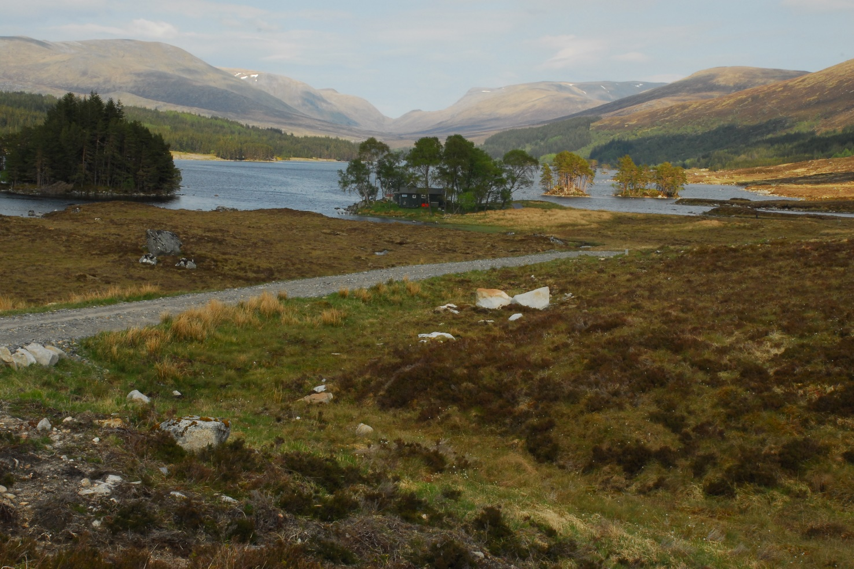

When I got up Betty was having her breakfast and the plan was to take a slow walk around the Loch, which we did. It was a lovely day, and I got to do a bit of bird watching. At the other end of the Loch there are holiday cottages where you could stay for a generous price. We got back to the hostel early afternoon and Betty wanted to do a recce half way up a horse shoe, the summit was just 15ft below a Munro. We got so far up then turned around and headed back down, passing the station we stopped and had a couple of beers then headed back to the hostel, where we got some grub, had some wine then went to bed.

Saturday, and we decided to bag ourselves Ben Na Lap, a Munro, (a mountain over 3000ft) which was next to the hostel. We set off at around 0930 and headed for the station because I had left my map there the night before. On the way to the station we passed a group from Glasgow who would be staying at the hostel Saturday night. We picked the map up and set off for the summit of Ben Na Lap.

Going up the Munro we could get a perspective of just how remote the hostel and station was. We both made it to the top, had a rest and water, then headed down on the opposite side. It was a bit of a scramble but we made it down to a river where I had a skinny dip (well it was very hot and the rock pool did look nice and cool) and Betty walked on. Refreshed, we walked back to the hostel via a hard long road alongside the Loch. Back at the hostel a Super Noodle for dinner we went and joined the group from Glasgow for drinks and a giggle. The wine flowed till I went to bed at about 2330 and the others carried on till the early hours of Sunday morning drinking whiskey and rum.

Sunday morning and I didn’t get up so early, about 0730 actually, got some breakfast, sat and watched Jim from Glasgow fishing for trout. He caught two. Then packed and ready, Betty and I headed for the top of the horseshoe, which was just 15ft below 3000ft. It was not a bad climb, easy to start off with, then got harder around the scree then levelled off near the top. Near the top was a paraglider who had spent the night there and was waiting for a decent bit of wind to float to the bottom. We got to the top and while we were there the paraglider took a leap and then he was gone.

Betty and I carried on round the horseshoe and headed back down the slope and back to the station for a beer. The way down was a nice gentle hike, no rocks to climb down, just had to watch the wet bits in case you slipped. We finished off the wine Sunday night and had an early night as we had a long day in front of us, and we had to catch the 0830 train back to Crianlarich. We reckoned we would get back to Northampton at around 2200-2359 because of the Bank Holiday traffic.

We were up and down to the train station by 0810 and the train arrived on time and we arrived at Crianlarich at approx 0935. Bags in the car we set off for the Drovers Arms for breakfast, only to find when we got there that they did not do breakfasts for non-residents. The landlord set us in the direction of Tarbet Tea Rooms just a little bit further down the road, where we had a great breakfast.

Apart from road works around junction 32 on the M6 we did not get held up too much going home, in fact we arrived in Northampton at 1900, well before the time we thought we would get back. Betty jumped in her car straight away and I went down the pub for film night.

We had a great time at Loch Ossian, the weather was great and a great crowd to mix with while we were there.

Some facts

- Loch Ossian is in the middle of nowhere
- There is no fridge/freezer
(if you want to keep things cool put them in the Loch)
- The toilets are proper sitters, but it is a hole in the ground and the midges might bite your a**e if you sit too long
(Toilet paper is provided)
- Very friendly
- Two gas cookers and storage for your food
- Pots, pans, plates, kfs’s and mugs are provided
- Jan the hostel manager is very friendly
- No showers but there is a wash room adjacent to the dorms

Photos of our w/e are at www.flickr.com/photos/131244540@N07

Stevecee x
WALKS PROGRAMME
JULY TO DECEMBER 2016

Sun Jul 3 2016 From Here to There & Back
27, 18 or 13ml. all to finish by 18.30. Hall closes 19.00. From Wellingborough Grammarians Memorial Sports Field, Sywell Road, Wellingborough NN8 6BS (GR SP856690). A walk around the Northamptonshire rolling countryside through the villages of Mears Ashby, Sywell, Overstone, Holcot, Broughton & Pytchley. Start: Walkers from 08.00, runners and fast walkers from 09.00. Entry Limit 200. Entry: £8, non LDWA £12, under 18s free (No entries OTD) incl refreshments at Cps (3 on 27ml, 2 on 18ml, 1 on 13ml), light meal at finish, cert. Chqs payable to LDWA BBN Group. Entry form downloadable from event website. Online entry at: https://www.sientries.co.uk/. C: Mike Hyland, 55 Broadlands Ave., Chesham, Bucks, HP5 1AL T: 01494 774154. E: mike.hyland@ntlworld.com
W: www.ldwa.org.uk/bedsbucksandnorthants

Sun Jul 10 2016 The Greensand Ridge in a Day
40ml. Another chance to walk this LDP, Gamlingay to Leighton Buzzard, as a linear group walk, led by BBN members. Registration form and further information on BBN website. £22 to cover coach transport, breakfast, lunch & tea. C: Nigel Schofield T: 01462 442338 before 21.00.

Thu Jul 14 2016 The Albino Walk 2
15ml. Start 09.30 From Ampthill Park c.p. Map: LR 153 (GR TL025382). C: Roger & Margaret Skerman T: 01525 405540.

Thu Jul 28 2016 Fares Please!
15ml. Start: 09.30 From Caldecote Arms public c.p. (free) off A4146 eastbound, MK7 8HP. Map: Exp 192 (GR SP888354). A linear walk using train from Bow Brickhill to Lidlington. Break at Woburn Sands near p.h. C: Mike Bowley T: 01908 616589 M: 07933 066784 on day only.

Sat Aug 6 2016 The Chairman’s Cream Tea Trot
18ml. Start: 09.00 From c.p. on minor road off B488 towards Aldbury, about 1 mile from turning off B488. Maps: LR 165 Exp 181 (GR SP955149). SATURDAY WALK. Lunch at Brownlow Café near Bridgewater Monument where cream teas and other delicacies are available. There is no truth in the rumour that the Chairman will be buying Cream Teas for everyone. C: Norman Corrin
T: 01908 608667 M: 07980 378656 on day.

Thu Aug 11 2016 Summer at Wetherspoons
14.5ml. Start: 09.30 From Pegsdon (park in dead end rd beside B655 Hitchin to Barton rd). Map: LR 166 (GR TL118302). Extended lunch at Hitchin
Wetherspoons, The Angel Vaults (has a very nice garden). Can’t walk - then join us for lunch. C: Dave Findel-Hawkins T: 01908 216476.

Sun Aug 14 2016 Step Backwards...The Steppingley Pets
18ml. Start: 09.00 From Old Road, Barton-Le-Clay. Pls park considerately near entrance to recreation ground. Map: Exp 193 (GR TL083305). A chance to be led around a BBN challenge walk backwards! It will all look different.
C: Dee Brockway T: 01582 881809 M: 07742 433951 on day only.

Thu Aug 25 2016 A Shorter Wildflower Wander
15ml. Start: 09.30 From the Red Lion, Upper Sundon, LU3 3PE. Please park quietly in c.p. behind pub. Map: Exp 193 (GR TL045278). Lots of wildflowers - including Chiltern Gentian at Sundon chalk pit. C: David Sedgley
T: 01525 714961 M: 07583 091770 on day only.

Sun Aug 28 2016 A Wander from Old Warden
15ml. Start 09.00 From St Leonard’s Church, Old Warden. Donation to the church for c.p. use appreciated. Map: Exp 208 (GR TL136443).
C: Linda Marsh T: 01908 669698 M: 07885 181422 on day only.

Sun Sep 4 2016 The Queen’s Oak and the Slithy Tove
18ml. 09.00 From Watermill Lane c.p. Stratford Road, Wolverton Mill, Milton Keynes. Maps: LR 152 Exp 207 (GR SP796408).
C: Gill Bunker T: 01908 321308 M: 07790 976090 on day only.

Thu Sep 8 2016 Chiltern Views & Woods
15ml. 09.30 From Coombe Hill (free) National Trust c.p. (at bend on road thru’ Dunsmore). Map: Exp 181 (GR SP851062). Break at Great Hampden (p.h. nearby). C: John Esslemont T: 01494 881597.

Sun Sep 11 2016 Can’t See the Wood for the Trees
17ml. 09.00 From Wilstead, c.p. in Whitworth Way, behind Methodist Church. Maps: Exp 193,208 (GR TL066435). This walk is part of the Bedfordshire Walking Festival. C: Roy Carter T: 01234 301182 M: 07784 208997 on day.

Sat Sep 17 2016 Blissful Saturday
20ml. 09.00 From Blisworth Tunnel c.p. Stoke Road. Map: LR 152 (GR SP729529). SATURDAY WALK. C: Roger & Karen Marlow T: 01604 862494 before 21.00.

Thu Sep 22 2016 The Travellers’ Graves Walk
c15ml. 09.30 From Haversham Road c.p. north of Wolverton railway station. Maps: LR 152 Exp 207 (GR SP818421). C: Dianne Sutton T: 01908 606256 before 9pm M: 07957 466487 on day.

Sun Sep 25 2016 Walk from Hellidon
18ml. 09.00 From Hellidon, nr Stockwell Lane. Meet at triangular junction. Maps: LR 151,152 (GR SP515584). Alfresco lunch stop. Possible tea room at Badby. C: Gill Howe & Andrew Gilbertson T: 01327 871451 M: 07922 068591 on day only.

Sat Oct 1 2016 Oh No! Not the Brickhills Again, Again
18ml. 09.00 From Bow Brickhill Station c.p. (free). Map: Exp 192 (GR SP896349). Tea shop with a view half way. SATURDAY WALK.
C: Peter Engledow T: 07733 323641.

Thu Oct 6 2016 Underground, Overground
17ml. 09.30 From c.p. at Draughton Crossing on minor road east of Maidwell. Maps: LR 141 Exp 223 (GR SP755773). Break at Clipston near p.h. Route goes thru’ 2 disused railway tunnels – pls bring a torch. C: Bob Safford
T: 01933 356609 M: 07531 837829 on day.

Sun Oct 9 2016 A Collection of Nature Reserves
20ml. 09.00 From The Green, Clophill MK45 4AD. Park nr the Flying Horse PH in Clophill. Map: Exp 193 (GR TL083377). C: Therese Jamin T: 01582 571455
M: 07779 227675.

Sun Oct 16 2016 Blow Up
19ml. 09.00 From free c.p. Southwood Road, Downside, Dunstable, at foot of Cottage Bottom Fields. Access from A5. Maps: LR 166 Exp 193 (GR TL035209). C: Peter Simon T: 01582 513827.

Thu Oct 20 2016 Doc Marten’s Area
16ml. 09.30 From Yardley Hastings, close to Red Lion p.h. Map: Exp 207 (GR SP865566). C: Roy Carter T: 01234 301182 M: 07784 208997 on day.

Sun Oct 23 2016 Nature Trekking and a History Lesson
18ml. 09.00 From free c.p. on Lowick Lane just outside Aldwincle. Maps: LR 141 Exp 224 (GR TL007813). Pub lunch between 8 and 9 miles, cafe at 16 miles.
C: Wayne Rowlett T: 01536 460984.

Sun Oct 30 2016 Steppingley Step Marshals' Walk
C: Merrian Lancaster T: 01908 642803 M: 07933 735338.

Thu Nov 3 2016 A Little Bit of Bully
14.5ml. 09.30 From Wheathampstead East Lane public c.p. (on lane adj to Bull p.h.). Map: LR 166 (GR TL178141). Lunch in Whitwell nr p.h. C: Roger Skerman T: 01525 405540.

Sat Nov 5 2016 Peace and War
20ml. 09.00 From Twywell Hills & Dales free c.p. immediately North of junc 11 of the A14. Map: LR 141 (GR SP937774). Pub at lunch. SATURDAY WALK.
C: Jim Robinson T: 01832 734501 M: 07845 909750.

Thu Nov 17 2016 Another Bit of Cross Bucks
15ml. 09.30 From c.p. (layby/picnic area) off A413 south of Winslow.
Map: LR 165 (GR SP776268). C: Jim Morrison T: 01908 665300.

Sun Nov 20 2016 Steppingley Step
26, 18 or 12ml. in 10.5hr. From Barton-le-Clay Village Hall postcode MK45 4JY (GR TL083306). The walk follows mainly field paths, tracks, woods & some roads through undulating countryside with good views from the hills traversed. Start: Walkers from 08.00; Runners/Joggers/Fast Walkers from 09.00 (cp times will be adhered to, with NO exceptions. All must be finished by 18.30, Hall closes 19.00). All must bring own mug (none on route), compass & route description WHICH MUST BE DOWNLOADED & PRINTED from web site beforehand. We recommend map Expl 193 or LR 153 & 166 (only 166 for 12ml route), a torch if you expect to finish after dark & waterproofs. Please wear appropriate clothing & footwear for this time of year. This walk is part of BB&N triple challenge. Entry: £6.00, Non LDWA £9.00 & Under 18s free (there will be a limit of 300 entrants. No entries OTD) incl hot & cold drinks throughout, biscuits at start, snacks at all Cps and a light meal at finish. Cert for all finishers. Entries close 8th Nov 2016 or when full. Chqs payable to LDWA BBN Group. SEF accepted, SAE not required if email address is given or entry form downloadable from event website. Online entry at: https://www.sientries.co.uk. C: Mike Hyland, 55 Broadlands Avenue, Chesham, Bucks HP5 1AL T: 01494 774154 (before 21.00).
E: mike.hyland@ntlworld.com

Sun Nov 27 2016 Walk + AGM
8/9ml. 09.00 From Anchor Inn, Great Barford, Beds. Park in pub c.p. or on side road. Map: LR 153 (GR TL134518). Morning walk followed by lunch at Anchor Inn. Please pre-book your meal with Gill Bunker T: 01908 321308. Menu choices in Autumn Newsletter. The AGM starts at 14.00. C: Norman Corrin
T: 01908 608667 M: 07980 378656 on day.

Thu Dec 1 2016 Milton Keynes Monopoly Walk: Part 2
15ml. 09.30 From Manor Fields Sports Ground, Bletchley, MK2 2HX. Enter sports ground off Watling St. opp. Dobbies Garden Centre, pass Irish Club and cont ahead to far end of c.p. Map: Exp 192 (GR SP885335).
C: Brian Graves T: 01908 631013 M: 07563 728633.

Sun Dec 11 2016 Tinsel at Towcester
13ml. 09.00 From Richmond Road c.p. Towcester. Maps: LR 152 Exp 207 (GR SP692485). BBN’s Xmas Walk. Bring a wrapped gift to the value of £1, bows & all. Carol singing at churches en route. Mince pies & refreshments halfway thru walk. Post walk drinks in Towcester somewhere….....
C: Santa's (not so) little helper Norman Corrin T: 01908 608667
M: 07980 378656 on day.

Thu Dec 15 2016 Risdene Railway Romp – Where’s Rudolph?
12/13ml. 09.30 From Knuston Road (by Knuston Home Farm), Irchester. Follow signs for Knuston Hall (B569). Entrance to Knuston Road is either side of entrance to Knuston Hall, on opp side of rd. Most space at northern end of rd. Maps: LR 153 Exp 224 (GR SP938663). Extended lunch in Wetherspoons. C: Reindeer Handler Adrian Moody T: 01933 314134 before 9.00 pm
M: 07788 684394 on day.

Thu Dec 29 2016 Year End Stroll
15ml. 09.30 From Redbourne Common c.p. nr cricket pavilion. Maps: LR 166 Exp 182 (GR TL103119). C: Gordon Shaughnessy T: 01582 518791 M: 07518 364036.

……………………………………………………………………………………………...

Sun Mar 5 2017 Chiltern Kanter
26, 18 or 13ml. From Pitstone Memorial Hall, LU7 9EY (GR SP937155). Please note this is a map reading event. Circular routes through the Chilterns. Maps: LR 165 or Exp 181. Start: 08.00-8:30 for 26 &18ml; 8.30-9.00 for 13.5 ml; runners 09.00-09.15 (all to finish by 18.00). Postal entries close Sat 25th Feb. Event parking at Safran Power Systems, Pitstone Business Park, Westfield Road, LU7 9GT (GR SP933154). Follow direction of marshals. . Entry: £7, non LDWA £10, under 16s £3 (no entries OTD) incl refreshments at Cps; hot meal & cert at finish. Postage for results included. Chqs payable to LDWA-BBN. SEF accepted with SAE. Online entry at: https://www.sientries.co.uk/. C: Mike Hyland, 55 Broadlands Avenue, Chesham HP5 1AL T: 01494 774154 (not after 21.00 please). E: mike.hyland@ntlworld.com W: www.ldwa.org.uk/bedsbucksandnorthants

BEDS BUCKS & NORTHANTS GROUP: COMMITTEE 2016

Chairman: | Norman Corrin T: 01908 608667  E: norman.corrin@btinternet.com
Secretary: | Peter Simon T: 01582 513827  peterandmooi@ntlworld.com  E: bbn@ldwa.org.uk
Treasurer: | Ian Sage T: 01582 661256  E: iansage49@gmail.com
Social Walks: | Mary Knight T: 01295 812857  E: maryjknight@hotmail.co.uk  bbn.walks@ldwa.org.uk
Membership: | David Findel-Hawkins T: 01908 216476  E: davefh@gmail.com
Newsletter/Website: | Gill Bunker T: 01908 321308  E: gillbunker@googlemail.com  1 Abbey Way, Bradville, Milton Keynes. MK13 7AN
Local Group Rep: | Alan Leadbetter  E: acleadbetter64@gmail.com
Member: | Chris Bent T: 07837 367575  E: chrismbent@me.com
Non-Committee
Merchandise/Equipment: | Lynn Yorston T: 01494 868371  E: lynn.yorston@btinternet.com

Thank you to everyone who has contributed to this Newsletter.
Please let me have items for the Summer Newsletter
by 28th September 2016
Gill Bunker

