|  |  |
| --- | --- |
| LDWA Logo black & white | **LONG DISTANCE WALKERS ASSOCIATION AIM: TO FURTHER THE INTERESTS OF THOSE  WHO ENJOY LONG DISTANCE WALKING** |

**BEDS, BUCKS &  
NORTHANTS GROUP**

**NEWSLETTER**

**AUTUMN 2016**

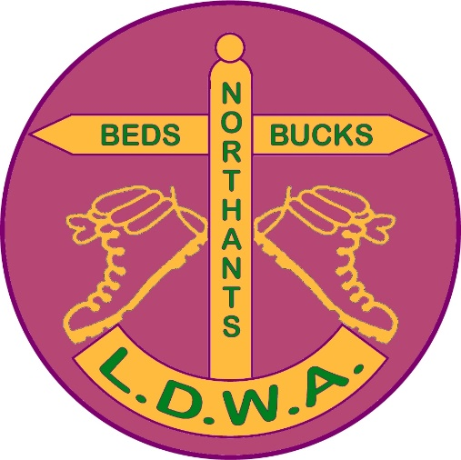

HAVE A GREAT DAY OUT, WALK WITH BBN

[www.ldwa.org.uk/bedsbucksandnorthants](http://www.ldwa.org.uk/bedsbucksandnorthants)

**NEW MEMBER:**A very warm welcome to Kerry Kingston of Stony Stratford.

**Carl Baldwin**

**It is with great sadness we report the untimely  
death from cancer of Carl Baldwin. Before being  
diagnosed, Carl, along with wife Diane, were   
regulars on our Challenge Events and did   
occasional Thursday social walks.  
He will be missed by all of us who knew him.**

**BBN AGM : 27th November 2016, 2.00 pm**

**The Anchor Inn, Great Barford.**

As you may know from last year's AGM, our group now has a Constitution, which requires the setting out of procedures for the election of officers and committee members and for motions at the AGM. Although the constitution was approved at the 2015 AGM, the committee has encountered a few typos and ambiguities that may need correcting. However, no substantive changes are envisaged.

Key dates to remember are October 30 and November 13. October 30 is the deadline for nominations of officers and committee members. October 30 is also the deadline for proposed amendments to the Constitution. November 13 is the deadline for substantive motions to be raised at the AGM.

A copy of the [Constitution with the proposed amendments in Track Changes mode](https://www.ldwa.org.uk/lgt/downloads/BedsBucksAndNorthants/BBN_LDWA_Model_form_Local_Group_Constitution_draft_version_1.2_1_Peters_track_changes_with_his_email.docx) and the [Nomination Form](https://www.ldwa.org.uk/lgt/downloads/BedsBucksAndNorthants/Nomination_form_AGM_2016_with_Peters_email.docx) can be found on the BBN website. Look under *Group Activities – Meetings.*

<https://www.ldwa.org.uk/BedsBucksAndNorthants/W/1052/meetings.html>

[Constitution with the proposed amendments in Track Changes mode](https://www.ldwa.org.uk/lgt/downloads/BedsBucksAndNorthants/BBN_LDWA_Model_form_Local_Group_Constitution_draft_version_1.2_1_Peters_track_changes_with_his_email.docx)

[Nomination Form](https://www.ldwa.org.uk/lgt/downloads/BedsBucksAndNorthants/Nomination_form_AGM_2016_with_Peters_email.docx)

The menu for the AGM meal will be emailed/on the website nearer the time. Please book your meal via [gillbunker@googlemail.com](mailto:gillbunker@googlemail.com) or at the Steppingley Step (see Merrian or Lynn).

**CHAIRMAN’S CHATTER**

Well, what a summer! It’s one the like of which very few of us have ever seen, Brexit, England losing to a supermarket chain at the Euros, the Olympics.  
Where to stop?

On Sunday 3rd July a couple of weeks after the Brexit vote Alan Leadbetter and his band of willing helpers cheered us all up by successfully organising the second FHTTAB. Numbers were up on last year’s event and from what I can gather all seemed to enjoy it. Steve Smith and I set off 10 minutes behind everyone else and therefore it was hard to gauge people’s opinions! I’m pleased to say that Alan will be organising the event again in July next year.

Another second showing that lifted our spirits was the Greensand Ridge walk which was organised by Gill Bunker and Mary Knight, ably assisted by several other group members. Dennis and Mary did their Great British Bake Off tribute act by organising not one but two banquets, one at Parkside Hall and one at Woburn Church. Although the tent at Woburn was not the same size as the GBBO version it did its job in keeping the food dry for the walkers.

All the comments that Gill and Mary received were very positive and this now looks to be a biannual (or is it biennial? I always get those mixed up) BBN event. The only downside was that due to transporting a struggling walker back to the start at Leighton Buzzard it meant I missed Cristiano Ronaldo conquering Europe.



Hey ho …… One has to cope with these disappointments. I’ve been doing that since 1990 when LFC last won the League Championship……...

BBN are hosting next year’s National AGM and there is a separate article on this in the newsletter. Suffice to say that, with the Chiltern Kanter the weekend before, March 2017 will be a hectic time for the group.

We’ve had a packed programme of social walks recently and Mary has settled into her first year of being Social Walks Secretary very well and we now have a regular mixture of Saturday and Sunday social walks.

One of the recent ones was the Chairman’s Cream Tea Trot on Saturday 6th August. 14 people took part and the Cream Teas at Bridgewater Monument were enjoyed by 8 of the group and I’ve been told this is now to become a regular event!

On a more serious note please can I ask walk leaders to make a note of the number of walkers on their walk and pass this onto Mary. It saves her having to contact members to chase up for the figures. In addition it enables her to report at the group AGM how well (or not!) we are doing as a group and give ideas for increasing attendances on weekend walks which have dipped.

Peter Simon has also settled into his role as Secretary and has been providing regular updates to the group throughout the summer and dealing with the regular correspondence that he receives. Long may he continue!

What reasons do we have to look forward to? Forthcoming events on the horizon are the Steppingley Step in November ably organised by Dave Findel-Hawkins and his merry crew. A week later we have the group AGM at The Anchor Inn at Great Barford. So like London buses you have nothing happening for a while and then everything comes along at once!

We are always looking forward to new faces coming forward to help on the committee. This brings in fresh ideas and ensures a degree of enthusiasm to keep the group going. There are no major changes at this year’s group AGM (so far!) but in 2017 both Ian Sage and I will be stepping down from our respective positions. So if you want to help don’t be afraid to come forward.

That’s all I’ve got to say for now. As I always say........... please remember that when you’re out with BBN friends on a national trail, social walk or Challenge Event that you might walk on but YNWA….



Good Walking!

**Norman Corrin**

**LDWA NATIONAL AGM 2017 - FRIDAY 10TH-12TH MARCH 2017**

Beds, Bucks and Northants have the honour to host the 2017 National AGM at Horwood House just outside Milton Keynes over the weekend of 10th to 12th March 2017. This will enable LDWA members to visit the northern end of the Chilterns with their quintessential English villages

In the update I sent to Katie Hunt the National AGM organiser and Julie Welch I called it “A Beacon, A Bench, and a Boffin”. However Julie will probably chop bits and pieces out due to editorial restraints. So this is the uncensored version!

The Beacon refers to Ivinghoe Beacon which is a prominent hill and landmark in the Chilterns. This is a regular hill visited by BBN on their social walks and there are gentle climbs and not so gentle climbs up to it. It marks the end (or the beginning) of the Ridgeway National Trail. The views from the top show off the Chilterns in all their glory particularly with the landmark of the windmill in Pitstone village where the group’s Chiltern Kanter Challenge Event has recently been organised from.

The Bench refers to the BBN Founders Memorial Bench which was installed in 2009 to remember the two group Founder members who passed away within six months of each other just after the 25th Anniversary of the group. This is located on Ivinghoe Village Green which is opposite the now defunct Youth Hostel. This is where BBN took their fledgling steps in organising an event by helping Essex Herts with the Chiltern Kanter.

The Boffin refers to the genius Alan Turing who worked at Bletchley Park which is where the coach trip will be going to. Turing is regarded as the founding father of modern computing. Bletchley Park has expanded greatly over the last few years and the site is one of those places where it is no exaggeration to say that history was made and it is calculated that the work carried out here shortened WW2 by two years. It was Churchill’s Golden Goose that laid the egg and never cackled.

On the coach trip on the way to Bletchley Park we hope to include a visit to Woodhill Prison, the (in)famous Concrete Cows, the Peace Pagoda on Willen Lake which is a Buddhist monument to World Peace and was the first erected in the Western Hemisphere

Steve, Pearl and I will be hosting a quiz on Friday night and will be hoping Steve keeps more of his clothes on this year!

The Walk Details are as follows:

A route 23 miles Walk - Leaders DFH & M

* Leave Horwood House by coach and over to Little Gaddesden where the A route walkers are dropped off
* They will return via Ivinghoe Beacon to Ivinghoe where they will visit the BBN Founders Memorial bench.
* From there return via Horton Wharf and then towards Mentmore Towers (home of the famous Yogic Flyers)
* From Mentmore to Wing Village Hall where BBN will provide lunch
* From there to Cublington and onto Dunton.
* From Dunton to Mursley and return to Horwood House

B route 18.20 miles – Leader Teresa Brown

* Leave Horwood House on foot and through Mursley to Dunton
* From Dunton to Cublington and then to Wing Village Hall where BBN will provide lunch.
* From Mentmore to Wing Village Hall where BBN will provide lunch
* From Wing Village Hall to Mentmore Towers and then onto Horton Wharf
* From Horton Wharf onto Ivinghoe and to visit BBN Founders Memorial Bench.
* From Ivinghoe down the road to Pitstone Memorial Hall where collection by coach.

Hopefully A and B routes will meet somewhere in the middle.

BBN will be providing a lunch for the A and B routes at Wing Village Hall and if we’re lucky some real ale from Dave Yorston’s brewery the Maltsters…

C Route 15 miles - Leader Sylvie Eames

* Horwood House to Winslow (1st Wellington Crash)
* Winslow to Swanbourne
* Swanbourne to Stewkley (Lunch at Carpenters Arms)
* Stewkley to Mursley (2nd Wellington Crash)
* Mursley to Horwood House (3rd Wellington Crash)

Norman Smith from BBN has been helping Sylvie recce the walk. He is an ex- RAF pilot with a keen aviation background which is why there are a lot of Wellington crashes en route!

D route 10 miles - Leader Frances Craven.

* Horwood House to Mursley
* Mursley to Swanbourne (Lunch at Betsey Wynne)
* Swanbourne to Winslow
* Winslow to Horwood House

Coach Trip – Provisional

* Horwood House –Snelshall Priory – Prince George Pub
* Howe Park Wood – Woodhill Prison
* Stony Stratford High Street – Wolverton
* MK Museum Car Park to see Cows – Midsummer Boulevard Library
* Campbell Park – Willen Lake – Peace Pagoda
* Stadium MK – IKEA - Bletchley Park

The Guest Speaker is Richard Bradbury, Editor of Chiltern Magazine and Ex- Strider Editor

If you’ve never been to a national AGM before then this is your ideal opportunity.

We will need helpers on the Friday to welcome fellow guests to the hotel and where possible walk leaders to explain about the routes. However for those of us who are working I understand that may not be possible.

At this year’s national AGM due to the numbers on the B route then the walk was split into two groups. If anyone wants to help on the B route or on the C route then please contact me and we’ll be only too happy to take your help.

Mark the date in your diary!

**Norman Corrin**

**THE POWER OF WALK LEADERS**

This week on TV I watched a programme in which Dr Chris van Tulleken, working in a GP surgery in east London, tries to treat specially selected patients without drugs. Thousands of patients at the surgery are taking drugs to reduce their risk of a heart attack or stroke. Dr Chris has discovered evidence for a miracle alternative cure - walking!

Last year (October 2014 to September 2015) BBN socially walked a total of 14,766 miles. None of these miles, the sheer joy of walking, or the health giving benefits would have happened without walk leaders. Please never underestimate your contribution or the gratitude of members.

Now if that hasn’t given you a nice warm feeling here is your chance to get your name down for the next walk programme.....

|  |  |
| --- | --- |
| **Thursday dates:**  May 4th, 18th  June 1st, 15th, 29th  July 13th, 27th  August 10th, 24th | **Weekend dates:**  May 13th/14th  June 3rd/4th  July 22nd/23rd  August 5th/6th, 19th/20th |

If you would particularly like to lead a walk on any other date please don’t hesitate to let us know.

**The info we need about your walk:**

|  |  |
| --- | --- |
| Day and Date of walk |  |
| Walk Title |  |
| Distance |  |
| Start Time |  |
| From/parking |  |
| Map type and number |  |
| Grid Reference |  |
| Walk Leader |  |
| Home Phone |  |
| Mobile/on the day |  |
| Any other info- lunch/pub stop etc. |  |

**Thank you - Please e-mail me at** [**maryjknight@hotmail.co.uk**](mailto:maryjknight@hotmail.co.uk)

**Mary Knight**

**--------------------------------------------------------------------------------------------------------**

**NORTH YORK MOORS 100 27TH – 29TH MAY 2017**

Our group will be looking after checkpoint 5, Rosedale Bunkhouse in Rosedale Abbey. Here's a picture:

<https://www.ldwa.org.uk/2017Hundred/W/4144/checkpoint-5.html>

We're at about 31 miles and will be open from 16:15 to 22:45 on Saturday, 27th May. I don't know what refreshments we're providing yet. I also don't know how much room we'll have. It didn't look very big when I peered through the windows earlier this year. At peak time it may get a little cosy, but if the

|  |  |  |
| --- | --- | --- |
| C:\Users\gill\AppData\Local\Microsoft\Windows\INetCache\IE\MQY083VX\cp5.jpg |  | weather is kind there is a grassy area outside to spill onto.  I'll be able to find out more when I'm up there to help on the marshals' walk.  We shouldn't be as busy as recent years, and we don't usually have walkers lingering for long, but I think many will be preparing for the night so we'll have to cope with that.  There is no parking at the Bunkhouse, but given the opening hours we should be able to bag all the on street parking spaces. |

Please let me know if you can help on the checkpoint. It's a wonderful part of the country to visit and great fun helping on a checkpoint, so please come and join us. Rosedale is a cracking little village with a nice tea room, pub and the Bunkhouse.

It would be a great help if those who've already volunteered would confirm that to me please.

Also, please let me know if you're usually part of the team, but can't help next year.

If there's anything you'd like me to ask "HQ", please let me know.

Further details about the event are here... <https://www.ldwa.org.uk/2017hundred>

Merrian [merrian22@gmail.com](mailto:merrian22@gmail.com)  
01908 642803



**With thanks to Tim Vine**

So I was working in a health food shop. This bloke walked in and said "Evening primrose oil." I said "Mr Vine to you!" He said "Soya chunks?" I said "You shouldn't have been looking."

A friend of mine always wanted to be run over by a steam train. When it happened, he was chuffed to bits.

So I saw this bloke playing Dancing Queen on a didgeridoo. I thought, "That's ABBA-riginal."

Last night I dreamt I was the author of Lord of the Rings. I was Tolkien in my sleep.

I saw Schindler's List, and the bloke behind me started wailing. I got hit on the back of the head with a harpoon.

Exit signs. They're on the way out aren't they?

The advantage of easy origami is twofold…..

Velcro, what a rip off!

I've decided to sell my Hoover. Well it was just collecting dust.

So I was getting into my car and this bloke says to me: "Can you give me a lift?" I said: "Sure, you look great, the world’s your oyster, go for it."

Somebody actually complimented me on my driving today. They left a little note on the windscreen. It said "Parking Fine". So that was nice.

Burglars are getting very clever now, aren't they? I was in bed last night - my wife woke me up "Darling wake up, I think there's a burglar downstairs. Can

you go and check?" So I got out of bed, I went downstairs and I checked in every room. There was nobody there. And then suddenly I remembered - I haven't got a wife! So I dashed back upstairs but it was too late - the bed had gone.

So I went to buy a watch and the man in the shop said, "Analogue?"  
I said, "No, just a watch."

Advent calendars - their days are numbered!

**Norman Corrin**

--------------------------------------------------------------------------------------------------------

**FROM HERE TO THERE AND BACK**

*A BBN Challenge Walk*

Well, what a start. Last year Betty and I got to the start late due to me forgetting my boots, so we had to go back and get them. This year I thought I would get to the start early and get a few brews in before the start at 8am. But it does not help when the night before you forget to turn your hazard indicators off and leave them on all night, so when at 7am I left my home to get to the start early, I found I had a flat battery. On the phone to the RAC they told me it would be 07:55 before they got to me. The walk started at 08:00, so late again I will be. The RAC arrived at approx. 07:20 and they got my car going with some checks that they have to do. I left for Wellingborough at 07:50 and got to the start at 08:15. A quick brew and a chinwag and I was on the trail for 08:30. I left with Graham Busch, who was walking the 19ml, for the first cp at Holcot.

It was 7 miles to the first cp and the weather was excellent. We made good time and after about an hour we passed Norman and Steve Smith who were on the 19 miler. We said our hello’s and carried on at our own pace. We arrived at cp1 (Holcot) with no problems. I didn’t even have a brew, I had a cold drink instead and some grub. Graham left a bit before me so when I left cp1 I was alone in the Northamptonshire countryside. Would I survive?

Holcot was our cp1 and 2 and the route took us around Pitsford Reservoir and then back to Holcot. I never did see Graham again that day. The ground was a bit hard underfoot and my feet were aching by the time I got back to Holcot. As I passed the car park by the causeway there was an ice cream van sitting there so a cornet went down very nicely. Back at cp2 had a brew, more grub, not too much though cause I’m looking after my figure at the moment, then on my way to Broughton for cp 3.

Now my goal was to catch up with Sue Leonard whose 100 breakfast bag from the Lancashire 100 I’d had in the boot of my car for the best part of a year due to Betty giving it to me to give to her a while back. We had arranged that I would bring it to the walk and she would pick it up at the end of the walk. Sue bought me a bottle of wine for looking after it for so long, it went down very nicely, cheers Sue.

Holcot to Broughton went without any trouble and when I arrived at Broughton (cp3) Sue was there. We had a quick chinwag and a giggle about the bag and then Sue was off. I stayed for a brew and grub before I left for the final leg back to the start.

Broughton to the start went without incident and I arrived back with a time of 8hrs 36mins. As I arrived back at the start Sue drove back in, she had forgotten the bag and had to return to pick it up.

As I went to hand in my tally card Merrian asked me if I had seen Norman and Steve. “In between CP1 and 2”, I said. “Nothing recently then” she said, then 5 minutes after I arrived Norman and Steve turned up, knackered.

Spaghetti and sausages and a brew down me I set off for home. A great day, great walk, good weather, a good day’s walk. Here’s to next year.  
Well done Alan.

**Stevecee xx**

oooooooOOOOOOOooooooo

**WALKING IN AUSTRIA**

On the 9th July Pearl and I set off for a week’s holiday in the Austrian Alps. We had intended to have an early night the night before but found out there was a David Bowie tribute act on at The Stables, Milton Keynes on the night of the 8th. Being big fans, we decided to go. It was a great concert, and who would we meet there? Only Dee and a friend of hers. Small world. So after a late night we had an early morning start for the drive down to Gatwick.

We usually tend to get away at this time of year. July 10th is our wedding anniversary. It’s also the date we met in 2009 and the date I started gardening for a living in 1985. July 10th this year was also the men’s singles final at

Wimbledon and the final of the Euros football tournament. It was also the day

of the BBN Greensand Ridge Walk. I hope it went well. Maybe I’ll make the next one.

When we arrived in Austria the weather was warm and sunny. On our first day we had a nice low level walk by the river, through the trees and down to a lake full of trout where I had a nice cold beer. We didn’t stay long as we wanted to get back for the Wimbledon Final. We found a nice bar to watch it in. We were the only ones watching. It finished just in time for us to get back to the hotel for dinner. When it was time for the dessert they’d written “Happy Anniversary” on the plate in cream. A nice gesture.

Then it was back to our quiet bar to watch the football final. Just as well Pearl likes walking, tennis and football! Probably not many wives would want to spend their wedding anniversary that way.

That night we had a terrific thunderstorm. The next day was cooler but dry and we did a more challenging walk over the mountains with great views.

On the Tuesday we went on an organised trip to Lichtenstein. It was very interesting and somewhere I’d never been before. In the afternoon we crossed into Switzerland and visited a small town famous for its cheese making. Here it started to rain.

The next day we had more rain and mist but we still went on a walk up to a lake. Not that we could see much of it though!

On the Thursday the temperature had dropped. As it was raining in the village we took a cable car up the mountain. When we got to the top it was snowing quite hard and freezing cold. People were throwing snowballs and building snowmen. We decided against doing a walk as the mist was down and all the footpath signs were frozen over. Instead we had a hot chocolate with rum! It was a unique experience, I’d never seen snow in July before.

The following day we went on another organised trip to Lake Constance which borders Austria, Germany and Switzerland. I’d been there once before, about 50 years ago, with my dad and brother. My dad had driven there and back in an old Ford Prefect. The trip brought back a few memories.

That day was also Pearl’s birthday. The weather had been good and after the meal at the hotel she was presented with a birthday cake and everyone sang “Happy Birthday”.

On our final day we took the cable car back up the mountain. The snow was still there but we had some magnificent views over many other snow-capped

peaks. We then had a nice walk before leaving for our afternoon flight home.

The resort we stayed in was Lech, about a two hour drive from Innsbruck. It was a nice hotel with good food and complimentary wine all night. We arrived back on the Saturday evening and after a day off it was back to work just in time for the heatwave. It was quite a contrast to the snow in Austria!

**Steve Smith**

**oooooooOOOOOOooooooo**

**WALKING THE ST JAMES’ WAY**

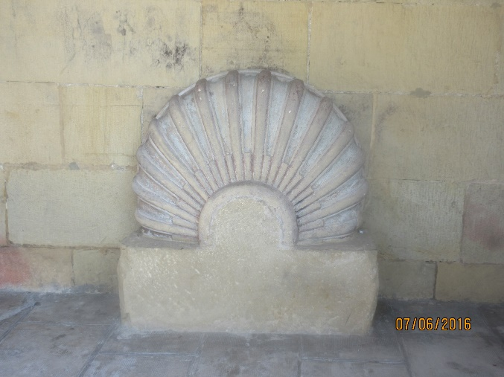

**The Camino Del Norte**

**Hondarribia to Guernica**

**June 2016**

Clare and I decided to go on a trekking holiday together, after a successful “trial week” 2 years ago in Austria. (Clare had shared a bedroom with me and my smelly inner soles for 4 days when we walked the perimeter of the Isle of Wight in 2012 so she was under no delusions!)

This time we felt we could do a self-guided walk, but wanted the luxury of having our bags transported each day and comfortable lodgings arranged for us each night. Clare had heard of my previous experiences of walking in the Alps and having to try and sleep in mixed dormitories, squeezed on a very thin mattress on floor boards between two large men inclined to snore loudly through the night.

So our pilgrim route was going to be in style – we think that we do not need to secure a place in heaven by suffering more than absolutely necessary…….

The Camino del Norte stretches 817 km along the coastline from Irun at the French border in the Pyrenees to Santiago. It takes about 5 weeks to complete. This route is less known that the Camino Frances from St Jean Pied de Port in France. In 2010 (a holy year with more pilgrims than normal) 18,000 people walked the Camino Del Norte, while an incredible 190,000 walked the Camino Frances. Apart from encountering fewer people on the way, we were told that this route was the most spectacular in terms of views, but also the most physically strenuous. Clare and I like a bit of challenge so this would be great.

We took a plane from Stansted airport to Biarritz. Fortunately Clare had remembered the name of the car park she had booked, not like when Daniel and I were on another trip and getting near the airport I realised I had not taken the details of the place I had reserved! But that’s another story.

Arrivikng in Biarritz we took a bus to San Sebastian bus station where Javier, our lovely representative from Colletts, was waiting to take us to Hondarribia to start our journey the following day. We were given all the route descriptions (or “distructions” as Clare renamed them). Javier gave us lots of information about finding our way along the Camino and left us to enjoy our meal and first glass of Txakoli, a dry, slightly sparkling white wine typical of the Basque country.

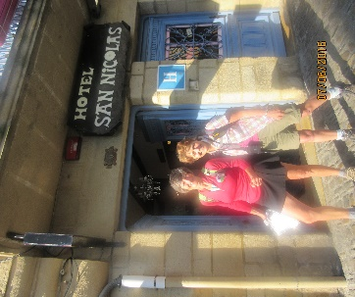

DAY ONE - HONDIRRIBIA to SAN SEBASTIAN 24.5km  
- 960 m ascent

Fabulous start of the walk through the old town of Hondarribia and our first encounter of the yellow arrows which are placed at very regular intervals along the route. We had a first stop at the Ermita of Guadalupe with its Black Madonna and started to feel that we were on a path trodden by many pilgrims and walkers for centuries. It felt good to be part of the section of humanity who find pleasure in putting one foot in front of another for miles and miles. The path takes us along the ridge of the summit of Jaizkibel and finally down to the bay where there were a couple of bars where Clare would have been quite happy to stop – alas I was keen to get onto the ferry to go across the bay - so Clare had to go without her coffee. This will be repeated on many occasions when we passed welcoming coffee places and again I wanted to press on. Occasionally, Clare wished she had chosen a companion who needed caffeine at regular intervals. We arrived at the hotel in San Sebastian quite hot and rushed to the sea for a swim, only to find that there were very cold currents which were certainly very refreshing! San Sebastian is a beautiful city with a very lively historical centre with lots of bars and restaurants.

DAY TWO - SAN SEBASTIAN to ORIO 16.5km-   
ASCENT 500m

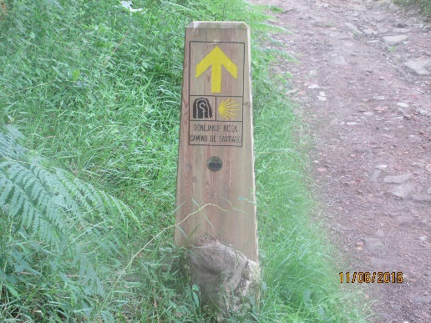

The yellow arrows have become a familiar sign and we feel good after our rest in San Sebastian. There are lovely views of the coast and several beautifully preserved churches and Ermitas. Orio is on the river Oria (strangely enough!) and has some wonderful 16th century houses. As this was a short day we arrived early and were able to have a drink in the plaza before we booked at our albergue. I was glad I remembered some of my school Spanish as the waitress was clearly not going to serve us when we spoke English. We had enough energy at the end of the afternoon to stroll along the river bank where kids were jumping into the river with great delight – I was tempted to do the same.

For our evening meal we decided to go up the steep hill to the restaurant – after all we *are* members of the LDWA!

DAY THREE - ORIO TO GETARIA 11km- ASCENT 510m

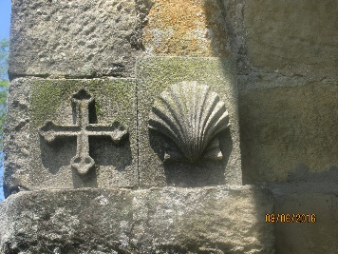This was a very hot day and we were glad that this was a short distance. The walk was easy and we arrived by lunch time at Getaria where we had a look round the town and indulged in sunbathing and swimming all afternoon (and Clare got her coffee! Hooray!). Our hotel in the old city is a wonderful 15th century building with beautiful views over the bay. We had a great meal overlooking the harbour where the fish is cooked on barbecues near our tables.

DAY FOUR - GETARIA to DEBA 18km- ASCENT 830m

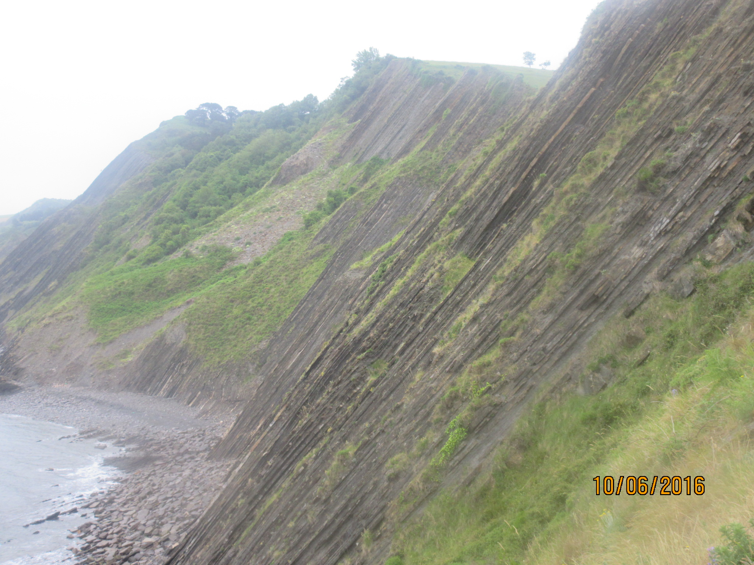

This was a most spectacular route. Our guide had suggested we leave the official Camino route and kept closer to the coast. The views were fantastic, with wonderful flysch layers. This part of the coast line reminded us of the Jurassic coast in Dorset, but the mountain side looked more like Austria! The arrival in Deba was slightly disappointing as this tourist town has seen some better days but the view from our balcony over the sea was wonderful.

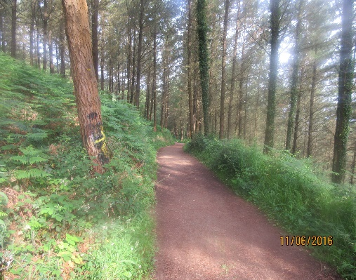DAY FIVE – DEBA to MARKINA 27km- ASCENT 900m – DESCENT 850m

This was a lovely day walking through forest and passing a few villages. The Spanish authorities have done a lot of work to build walkways over the most eroded parts of the trail and it is very well sign posted. We are now familiar with the many calls of “Buen Camino!” from fellow walkers and pilgrims. Villagers are also welcoming and friendly. The hotel at Markina is a converted medieval blacksmith building which was still in use till the 1950s. Although this had been quite a long day’s walk I convinced Clare to walk a further 2 miles to the town centre where we relaxed in a Café (yes! Coffee!) looking over the plaza where the whole town seemed to be out for the children’s sport day.

DAY SIX –MARKINA to GUERNIKA 29km- ASCENT 800m – DESCENT 850m

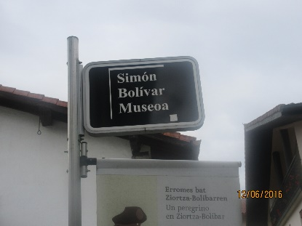We feel we are getting into the spirit of the trail, but sadly this is our last walking day. We pass several villages and in particular one called Bolivar which gave its name to the South American country, Bolivia.

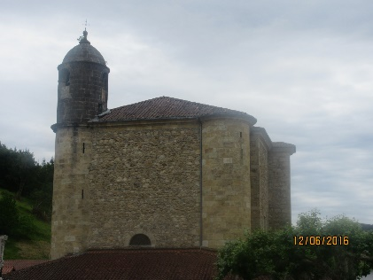

The collegiate church of  
Ziorta is particularly peaceful

A taxi has been arranged to take us back to San Sebastian for our last night in the Basque Country. This is an opportunity to join the many Spaniards on their evening stroll along the sea front, a last bottle of Txakoli and some beautifully cooked fresh fish.

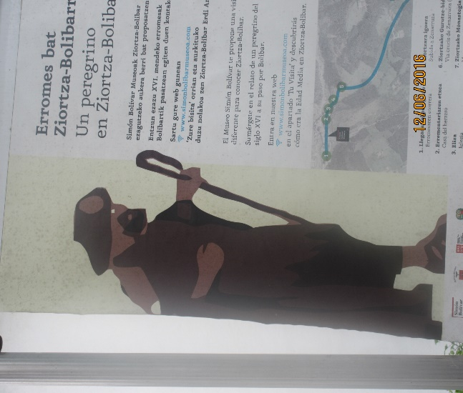Next morning our guide came to the hotel to take us back to the bus station, then off to Biarritz airport and Stansted, wishing we were still there, shouting “Buen Camino!”

**Therese Jamin  
with amendments from Clare Francis   
(June 2016)**

**oooooooOOOOOOOooooooo**

**PEMBROKESHIRE COASTAL PATH**

**Part 2**

It was a week and a half after Loch Ossian that Betty and I disappeared west for Pembrokeshire. It was all planned a couple of months ago. June looked pretty good when it came to work. At the end of May we were up in Scotland, I returned to work on the Wednesday after the Bank Holiday so I worked the rest of the week, then the following week I was not rostered to work on the Friday so I only had to work till Thursday, bliss.

I travelled to Betty’s on the Friday afternoon, let myself in, poured a glass of wine and settled in in the back garden with my Outdoor Photography mag till Betty came home. Betty arrived home, poured more wine, sat in the garden a while, then Chicken and Pasta for grub. We watched a film called The Gift, strange ending, then hit the sack. Betty assured me that she was not going to get up too early, so at 0845 on Saturday morning we were heading for the M4.

The run to Pembrokeshire went without incident and in the middle of the afternoon we pulled into the Howeston Caravan Park to find our caravan. Apart from nearly moving in with the site maintenance man, because he had

No 3 caravan just like we had, we found it without a problem. Gear out of the car and fridge full we unpacked and settled into the caravan for a relaxing evening watching Wales v Slovakia and England v Russia. Then an earlyish night for our first day back on the coastal path. That night it ****** it down with rain and lying in my bed I thought “Oh ****”.

**SUNDAY-WHITSANDS BAY TO SOLVA.** – *Car to Solva, then taxi to Whitsands Bay* where we finished off two years ago then walked to Solva, (Approx. 13ml). We started walking at 10am going uphill and downhill, then downhill and uphill in sunshine because the weather cleared up. The views were stunning and I got some good photos. It was great being back on the Pembrokeshire coastal path and the day went great and without incident and we arrived back in Solva late afternoon completely knackered. In fact the last couple of miles seemed to drag on, and we were glad when we saw Solva again. I had a beer in Solva then we drove back to Little Haven and had another beer before we went back to the caravan. Betty had bought some great T-bone steaks so I polished one of them off for dinner, a can of beer and a bit of telly and we had hit the sack by 10pm.

**MONDAY-DRUIDSTONE TO SOLVA. –** *Car to Solva, then bus to Druidstone.* The alarm went off for 6am, up, couple of cups of coffee and breakfast and we were off to Solva to catch the bus to take us to Druidstone. We started walking at around 9.30am. The weather wasn’t as kind to us as it was yesterday. In fact it got a bit wet in the afternoon and we put on our rain gear. The low cloud put the dampers on any decent photos, so we just plodded on up and down the hills, and they were more hefty today. We were only doing approx. 10mls today so by 2.30pm we were back at Solva a bit wet. As we sat in the car park having a beer and ice cream the sun decided to come out, a bit late for us, but we had a good day. We were back at the caravan by 4pm completely stuffed so I had 40 winks. It was another one of those steaks for dinner tonight.

**TUESDAY**-It was a disappointing day. It had rained most of the night and when we got up in the morning it was still raining and the wind was still a gale. We decided that we were not going to walk the 10mls and we would just chill out for the day. We visited Sandy Haven for tide timetables and Milford Haven for petrol, then to Dale for lunch. Then it was back to the caravan park for a very early finish. I had forty winks then walked into Little Haven for a few beers. The weather in the end turned out very mild and we could have had a good walk, so we decided to go for it whatever tomorrow.

**WEDNESDAY-ST BRIDES TO DALE. –** *Car to St Brides, walk to Dale, taxi back to St Brides.* It chucked it down through the night and come 6am it was still chucking it down. We were going to drive to Druidstone then walk to St Brides, but due to parking problems we had to change our minds. We drove to

St Brides and the sun started to shine, and it stayed out. In fact it got very hot for the rest of the day, and we saw our first seals bobbing around in the bays. It turned out to be a great day with some great views of the coast. We got to Dale at around 5.30pm (15.4mls) and headed straight to the pub for a nice cold cider.

**THURSDAY-ST BRIDES TO BROAD HAVEN. -** *Car to Broad Haven, bus to St Brides, walk to Broad Haven, car back to caravan.* The day went very well, we were in Broad Haven half an hour before our bus came. The bus was on time and we started to walk at approx. 10am, and the sun was shining again. We weren’t going too far today because of the football at 2pm and we wanted to watch it in the caravan. Problem was we had 2mls between Broad Haven and Druidstone still to do, then that meant that we would have walked the whole coast path from Whitsands Bay to Dale. So where do we fit those two miles in? The idea was, tomorrow, to walk 10 miles from Dale to Milford Haven, then come back and do the 2mls between Broad Haven and Druidstone.

**FRIDAY-DALE TO MILFORD HAVEN. -** *Car to Dale, walk to Milford Haven, bus to Dale, car to Broad Haven, bus to Druidstone, walk to Broad Haven.* It rained again Thursday night, and in the morning it looked pretty grim. We had to get up very early Friday morning to catch the low tide in two places, Dale and Sandy Haven. My alarm went off at 5.30am, and I got up about 6am, Betty was not far behind, we had breakfast and we were off at 6.45am. We drove to Dale and started walking approx. 7.30am. The tide was out and we passed over our first tidal crossing with no problem. We hi-tailed it to Sandy Haven for the second tidal crossing, no problem. The sun shone nearly all day and we had more great views of the coast, but Milford Haven was getting closer. The inevitable happened and we got to Milford Haven with its ship lanes, docks and large lines of pipe stretching out into the estuary.   
  
We walked into town to find the bus station and our bus back to Dale where we had left the car. We had over an hour to wait for our bus so it was into Tesco’s next to the bus station and the restaurant that all Tesco’s have (don’t they?), but Sod’s law, the Tesco’s at Milford Haven didn’t have one. As luck would have it, there were a couple of cafes nearby and we got our coffee and a bite to eat in one of those. In fact we split at this point and went to a different cafés. We got back to Dale around 2pm, drove back to Broad Haven, then caught the bus to Druidstone to walk the final 2mls back to Broad Haven all in the sunshine. Our final day was a bright and sunny day and what better to celebrate the last day but a beer in the local pub. That night we packed our bags ready for the trip home the next day.

We had another great week on the coastal path, although the weather was not as kind this time. It was good to just sit on the cliff tops and admire the views with the flowers in full bloom.

Photos at [www.flickr.com/photos/131244540@N07](http://www.flickr.com/photos/131244540@N07)

**Stevecee x**

**oooooooOOOOOOOooooooo**

**DOOR VLAAMSE VELDEN 100K**

**(Through Flanders Fields)**

Some of you may recall that I mentioned this memorial march a little while ago, so I thought it only right to tell you how I got on. So to begin with, some background.

This is a march organised by Dirk Verduyn and the team that run the Nacht Van West Vlaanderen 100k march/run each June. They wanted to do something to commemorate WW1 and came up with the idea of a bi-annual 100k that would go through the battlefields of Flanders and visit the cemeteries and other memorials in the area. The first event was in 2014, so this was the second. The third and final event will be in 2018.

Entry can be done online but, due to the incompatibility of our banking system with Europe, it costs a lot to do a bank transfer. Having explained this when I entered, it was agreed that I could pay on arrival. You can do a basic entry only of €40,00 or add on a t-shirt and separate medal. A certificate is included in the basic price. Whilst the fee may seem expensive, aside from any beer purchased at the control points, all other refreshments and food are included in the entry fee.

Arriving at Tourhout I found the car park to be completely empty and then realised I had gone to the start of the Nacht Van West Vlaanderen walk and not Door Vlaamse Velden, which started at a school on the other side of town! This was soon rectified and a parking spot found about 200m from the start down a quiet residential side street. Presenting my entry form and explaining that I had pre-registered but hadn`t paid, I was given an envelope with my name on it and told to pay the lady at the next table. She was also handing out the t-shirts and medals and willingly took my money, having crossed me off her list of customers. Now all I had to do was wait for a couple of hours for the start at 8.15pm.

I had a good long chat with the only person there I knew, Ian Newbitt. For those of you that know “badger” i.e. Mike Newbitt of the Fairlands Valley Spartans, Ian is his brother and lives on the edge of Antwerp. The previous weekend he had walked the Dodentocht 100k (Death March) and 3 days after this one was walking the 4 Days of the Iser (4 x 32k), all in military uniform carrying a Nijmegen weight pack. Madness, and I`m sure he will agree. We spent an interesting 2 hours, which seemed to revolve around the need to find a child who was a techno geek that could operate Ian`s phone. No chance.

So 8.15 rolled around and, with a fair degree of trepidation, I went outside with Ian and off we went. I`m embarrassed to say that I soon left him behind and managed to keep up a good pace into and through the night. Route finding is fairly easy in Belgium, you follow the small markers that are at every road junction. If there are any areas of possible doubt, then you may also find a marshal in a hi-viz jacket to point you the correct way.

As we all know, there isn`t a lot to be said about night walking, just get on with it and don`t lose sight of the person in front of you. At least in Europe you don`t need to read any route description or look at a map, just keep an eye on those in front. For me that was particularly important as if I went wrong it would have been somewhat of a challenge. The night section (45k) had 3 brief drizzly showers but turned quite cold and breezy. Underfoot it was a mix of road, gravel track, grass canal side paths and a 2k section cobbles. The latter was particularly interesting as it was necessary to look where you placed your feet at each step.

The first real known “sight” we passed was the German cemetery at Langemark, near Ieper, though dawn hadn`t broken and all you really see was the exterior wall. From here we headed towards Ieper and reached the baggage stop at St Jean at 6.15am, just as dawn broke (51k in 10 hours). A good 30 minutes was had here, having a couple of rolls and plenty to drink. In a moment of madness, I worked out that if I could keep going at that pace, and with no problems, I could get inside 20 hours. I had to remind myself that the main objective was to finish and I had another 14 hours to do 49k.

So, of on the second half and daylight. Into Ieper, around the Menin Gate and on to Zillebeke and its lake, passing the Railway Dugouts cemetery before heading on towards Hill 62 and then Hooge Cemetery and the Hooge Crater museum. Then came the somewhat surreal passing of the amusement park at Bellewaerde, which has always seemed so out of place given its location.

Passing into Polygon Wood, I began walking with a German policeman, who during the next few hours was amazed at how fast I was walking. He said I must do a lot of 100k walks and, when I told him my last one was 8 years ago, he was speechless (on checking my records when I got home, I discovered that it was actually 10 years since my last 100k). Very worryingly he said I was the Usain Bolt of 100k`s. Clearly the heat had got to him, big time !

From here the route headed to pass the museum at Zonnebeke and then around the edge of the Tyne Cot cemetery before going up the ridge to pass the Canadian cemetery at Passchendale. When you go up the ridge and look back, it is easy to see what a slaughter it was for those trying to attack the German positions. Uphill with no cover and a perfect firing angle for the Germans.

Passchendale was really the last main “site” we visited as from here it was a case of getting back to Tourhout by the most direct route. I was still keeping an eye on the time and was still on for under 20 hours. As I left the last control, near the wonderfully named small town of Gits, it was obvious I`d make the target, so hurried on even faster and got into the finish at 6.00pm, though by the time I had handed in my start card it had reached 6.03. So, targets achieved. 1st - finish and 2nd - finish in under 20 hours (19hrs 48 mins). I was 126th out of 334 walkers. Excellent.

I really enjoyed this walk and am tempted to go back again in 2018 for the final event, though I`m not looking to beat my time. It`s about the reasons why we were there and remembering the brave fallen who gave their lives so that we could be free from tyranny.

Once I find out the details of the next walk, I`ll get them on the website. Remember, it will then be the last chance to do this memorial 100k march. See you there ?

**Adrian Moody**

See Adrian’s photographs on the BBN website:

<https://www.ldwa.org.uk/BedsBucksAndNorthants/W/4610/door-vlaamse-velden-a-moody.html>

**THE QUEEN’S OAK AND THE SLITHERY TOAD**

**Err SLITHY OAK**

*A BBN Social Walk led by Gill Bunker*

It was on Gill’s walk that we thought the BBN might get onto Sky News or even Breakfast TV, or even Channel 4 as we followed Gill around the countryside.

All was going great till we hit the Grand Union for a while, and suddenly there was talk of a sunken vessel on the waterways of the Grand Union Canal. Our minds started wander, asking questions like – did the Captain and his crew go down with the ship, or did the Captain get off and let the crew and passengers sort themselves out, would we be interviewed by Sky News or Channel 4, or even Breakfast TV. I was just about to comb my hair so that I would look good for the cameras when we came upon the stricken vessel.

Ohh boo hoo, there was no cameras, no Sky TV or Channel 4 or Breakfast TV, no reporters anywhere to be seen, so the BBN were not to become world famous this time after all. What had actually happened was, when the skipper of the narrow boat went into the lock he went too far forward so the bow (front of the boat) was on top of a concrete lip, so when the water was drained from the lock the boat dropped at the back end and the water poured in through the stern (back end of boat) and the inevitable happened, it sank. It turned out after interviewing a lock keeper that the skipper of the boat had been drinking and was arrested for being drunk in charge of a boat.

By the time we got to the scene it was nearly all over anyway, the canal had been drained in front and behind to aid rising of the boat and they had just about finished pumping the water out of the boat and the boat was afloat again. (So we missed all the fun.)

So to sum it all up, the vessel didn’t hit an iceberg, it wasn’t part of a boat chase down the Grand Union for a James Bond movie or pirates broadsiding another ship, just a skipper under the influence of booze causing mayhem for other boaties.

(Photos at [www.flickr.com/photo/131244540@N07](http://www.flickr.com/photo/131244540@N07))

**Stevecee xxx**

**Q - What's the best thing about Switzerland  
A - I don't know, but the flag is a big plus**

**AUSTRIA AND THE IML**

(**I**nternational **M**arching **L**eague)

I got to Seefeld via Stansted to Memmingen, then train to Seefeld. All was going well till a train hit a pedestrian in front of us, then it was all off the train and a bus ride to the next station, then back on a train to carry on the journey. I was due to get to Seefeld at 16.15, instead I got there at 19.00. It would have been even later but a young guy took me under his wing when we got off the train to get on a bus because I didn’t know what was going on as the announcements were all in gobbledygook.

When I got to Seefeld I found my B&B, the Hotel Olympia, which was a five minute walk from the train station and settled into my room, it was a nice room with en suite facilities. After I settled in and had a shower I opened a bottle of wine and relaxed till I hit the sack at about 22.00, and yes I did finish the bottle (I was Knackered).

I was up and having breakfast at 8am, then it was time to find the registration point of the walk at Leutasch, a town I had not been to before. The registration used to be at Seefeld but moved to Leutasch three years ago. On the bus I said to the driver (who could not speak English) “Leutasch please”. He said “Where in Leutasch, it is 20 kms wide”. I thought ****. We settled for the centre as I did not have the actual address because I thought Leutasch was like Seefeld, a tightly packed and everything nearby place. How wrong could I be. We drove so far and then I noticed a checkpoint with walkers around it. This was a bit strange because I thought it was a two day walk and it was a Friday and the walks were on Saturday and Sunday. At the next bus stop I asked “How much further”, he said, “Do you want to get off?” I said “In the centre”. He said in broken English “Centre back there, you need to get off” and pointed to the bus stop on the other side of the road. Oh ****.

I started to walk back along the road and noticed some walkers following markers with 10, 20, 30, and 42 on them; they are the markers you follow on IML walks. I stopped and asked if they were on the IML walks, they said “Yes”. I said “I thought the walks did not start until tomorrow”, they said “Today mate”. Oh ****”. I asked where the start point was. They said “8kms back that way, look out for Alpinebad, a sports complex”.

I eventually found the registration point, got a cup of coffee, registered for Saturday and Sunday, then had a beer, and sorted out bus times the best I could for Saturday. I did ask a very attractive lady by the name of Victoria for some help, which I got, then decided that I would do the 10km walk, so I registered for the walk and headed off only to find that I had left It too late and

the sweepers had already taken down the markers so that put paid to that idea. I decided to go back to Seefeld and chill out for the rest of the day. On my way out of the complex I walked into Marcus and Steve from the Waendle Walks, so I turned around and had another beer with them, which was a good idea because I found out that you catch the 4164 bus from the train station at 08.20 which takes you to the start of the walks, then a bus back to Seefeld at 14.20 or 15.15. After my beer and chinwag I left for Seefeld all ready and set for Saturday.

Saturday morning and I got my breakfast and very nice too and off I went to catch the bus. As I walked down the road joy overwhelmed me, there at the bus stop were a load of walkers heading for Leutasch. The bus arrived and we all got on. 20mins later we were in the hall at the registration point, a quick cup of coffee and away I went following the 20km route. It was a wet day and it drizzled most of the day. The walk went well the views were great, I came across Marcus and Steve early on in the morning but they were geocaching and were not actually on the walk. I arrived back at the hall at about 13.30.

I sat around for a while, got some grub and a beer listened to an Austrian band for a while then headed back to Seefeld. I didn’t do much for the rest of the day looked around town, did a bit of shopping, had a beer later on and hit the sack early on. Sunday was a better day, the weather was good but the route was harder. They left the more strenuous day till last. I got some good photos and the scenery was great. I met some other walkers over the weekend and got some photos of them. Most of the walking is on hard surfaces so it is a bit hard going on your feet. I got back to the hall at the same time as Saturday and after a beer and some food I headed back to Seefeld. The walks took us through some great scenery, some lovely woodland and very nice Austrian villages.

I was not due to fly back till Tuesday, but I had to get B&B in Memmingen for the Monday night because the trains from Seefeld would not get to the airport in time for my flight. In fact my plane would be half way over the North Sea by the time I got to the airport. So I left Seefeld Monday morning after another great weekend and got to Memmingen early afternoon. I got a taxi to the B&B I was going to stay at and it was in the middle of nowhere, no small town, nothing. It was on the outskirts of Memmingen and only 10mins from the airport. I paid off the taxi and ordered a taxi for the following morning to get me to the airport on time, then tried to get into the B&B. What a palaver. I could not get an answer when I knocked on the door. I banged on the door for about 10mins. I then phoned them up and got an answer, only to take another 5mins trying to convince them that I was booked in for the night through

Booking.com and could they let me ****** in. They eventually opened the door and let me in, gave me a key for my room then disappeared and left me to it. As I said, the place was in the middle of nowhere, look right, then look left, nuffink. I got out my book, at the moment I am reading Michael Caine’s autobiography, “What’s It All About” and started to read. After a couple of hours I needed to go for a walk. I headed outside and asked a woman where to go, she said there is a small shop 20mins down the road. I headed for it bought a bottle of wine then walked back, headed for my room and got the book out again, this time with a glass of wine. I went down for some grub at about 7pm and had peppered steak with salad and chips and a pint, then back to my room, and a glass of wine and my book, and hit the sack for an early start in the morning. The next morning I was up, packed had a very nice breakfast and headed for the airport and home.

Another great weekend with the IML.

Photos are at [www.flickr.com/photos/131244540@N07](http://www.flickr.com/photos/131244540@N07)

**Stevecee x**

**From Roy and Janet Presland, September 2016**

**Dear BBN Members**

**Thank you for the birthday card.**

**Jan and I are both keeping as active as possible, although our walks are shorter. I still cycle when I can fit in the rides.   
Yesterday I cycled in the Historic Churches Ride or Stride. I rode about 24 miles mostly in the rain.**

**Best wishes to all in BBN.  
 Roy**

**We still do many things – some with U3A including folk dancing! It is now a year since I had a new right knee. After slow progress I can now walk about 2 miles in the countryside - helped by walking poles. The new knee feels perfect.**

**Best wishes  
 Janet**

**WALKS PROGRAMME**

**NOVEMBER 2016 TO APRIL 2017**

**Thu Nov 3 2016 A Little Bit of Bully**

14.5ml. 09.30 From Wheathampstead East Lane public c.p. (on lane adj to Bull p.h.). Map: LR 166 (GR TL178141). Lunch in Whitwell nr p.h.   
***C:*** Roger Skerman ***T:*** 01525 405540.

**Sat Nov 5 2016 Peace and War**

20ml. 09.00 From Twywell Hills & Dales free c.p. immediately North of junc 11 of the A14. Map: LR 141 (GR SP937774). Pub at lunch. SATURDAY WALK.   
***C:*** Jim Robinson ***T:*** 01832 734501 ***M:*** 07845 909750.

**Thu Nov 17 2016 Another Bit of Cross Bucks**

15ml. 09.30 From c.p. (layby/picnic area) off A413 south of Winslow. Map: LR 165 (GR SP776268). ***C:*** Jim Morrison ***T:*** 01908 665300.

**Sun Nov 20 2016 Steppingley Step**

26, 18 or 12ml. in 10.5hr. From Barton-le-Clay Village Hall postcode MK45 4JY (GR TL083306). The walk follows mainly field paths, tracks, woods & some roads through undulating countryside with good views from the hills traversed. Start: Walkers from 08.00; Runners/Joggers/Fast Walkers from 09.00 (cp times will be adhered to, with NO exceptions. All must be finished by 18.30, Hall closes 19.00). All must bring own mug (none on route), compass & route description WHICH MUST BE DOWNLOADED & PRINTED from web site beforehand. We recommend map Expl 193 or LR 153 & 166 (only 166 for 12ml route) , a torch if you expect to finish after dark & waterproofs. Please wear appropriate clothing & footwear for this time of year. This walk is part of BB&N triple challenge. Entry: £6.00, Non LDWA £9.00 & Under 18s free (there will be a limit of 300 entrants. No entries OTD) incl hot & cold drinks throughout, biscuits at start, snacks at all Cps and a light meal at finish. Cert for all finishers. Entries close 8th Nov 2016 or when full. Chqs payable to LDWA BBN Group. SEF accepted, SAE not required if email address is given or entry form downloadable from event website. Online entry at: https://www.sientries.co.uk. ***C:*** Mike Hyland, 55 Broadlands Avenue, Chesham, Bucks HP5 1AL ***T:*** 01494 774154 (before 21.00). ***E:*** mike.hyland@ntlworld.com ***W:*** ldwa.org.uk/bedsbucksandnorthants

**Sun Nov 27 2016 Walk + AGM**

8/9ml. 09.00 From Anchor Inn, Great Barford, Beds. Park in pub c.p. or on side road. Map: LR 153 (GR TL134518). Morning walk followed by lunch at Anchor Inn. The menu for the AGM meal will be emailed/on the website nearer the time. Please book your meal via [gillbunker@googlemail.com](mailto:gillbunker@googlemail.com) or at

the Steppingley Step (see Merrian or Lynn). The AGM starts at 14.00.

***C:*** Norman Corrin ***T:*** 01908 608667 ***M:*** 07980 378656 on day.

**Thu Dec 1 2016 Milton Keynes Monopoly Walk: Part 2**

15ml. 09.30 From Manor Fields Sports Ground, Bletchley, MK2 2HX. Enter sports ground off Watling St. opp. Dobbies Garden Centre, pass Irish Club and cont ahead to far end of c.p. Map: Exp 192 (GR SP885335).

***C:*** Brian Graves ***T:*** 01908 631013 ***M:*** 07563 728633.

**Sun Dec 11 2016 Tinsel at Towcester**

13ml. 09.00 From Richmond Road c.p. Towcester. Maps: LR 152 Exp 207 (GR SP692485). BBN’s Xmas Walk. Bring a wrapped gift to the value of £1, bows & all. Carol singing at churches en route. Mince pies & refreshments halfway thru walk. Post walk drinks in Towcester somewhere…. ***C:*** Santa's (not so) little helper Norman Corrin ***T:*** 01908 608667 ***M:*** 07980 378656 on day.

**Thu Dec 15 2016 Risdene Railway Romp – Where’s Rudolph?**

12/13ml. 09.30 From Knuston Road (by Knuston Home Farm), Irchester. Follow signs for Knuston Hall (B569). Entrance to Knuston Road is either side of entrance to Knuston Hall, on opp side of rd. Most space at northern end of rd. Maps: LR 153 Exp 224 (GR SP938663). Extended lunch in Wetherspoons. ***C:*** Reindeer Handler Adrian Moody ***T:*** 01933 314134 before 9.00 pm

***M:*** 07788 684394 on day.

**Thu Dec 29 2016 Year End Stroll**

15ml. 09.30 From Redbourne Common c.p. nr cricket pavilion. Maps: LR 166 Exp 182 (GR TL103119). ***C:*** Gordon Shaughnessy ***T:*** 01582 518791

***M:*** 07518 364036.

**Sun Jan 8 2017 Another Anchor Inn – New Year Walk and Meal**

8/9ml. 09.00 From Little Paxton Nature Reserve c.p. Map: LR 153 (GR TL195629). Morning walk followed by pub lunch at the Anchor Inn, High St, Little Paxton. Book meal with Steve by 1st Jan. Menu will be emailed/on website. ***C:*** Steve Smith ***T:*** 01767 220307 ***M:*** 07817 041621.

**Thu Jan 12 2017 Nene Way to Barnwell and a Sandwich Hunt**

15ml. 09.30 From Sackville Street, Thrapston c.p. (Toilets). Map: LR 141 (GR SP998787). ***C:*** Geoff Curnock ***T:*** 01536 484555 ***M:*** 07941 413318 on day only.

**Sun Jan 22 2017 The Two Moors Trail – deconstructed**

19ml. 09.00 From Flit Valley Discovery Barn, Flitton. Map: Exp 193 (GR TL057360). ***C:*** David Sedgley ***T:*** 01525 714961 ***M:*** 07583 091770 on day only.

**Thu Jan 26 2017 Two Mills Link**

15ml. 09.30 From Wootton Village Hall, Church Road, Wootton, Beds. Please park in bottle bank area. Map: LR 153 (GR TL006452). ***C:*** Derek Jacob.

***T:*** 01234 767759.

**Sat Feb 4 2017 In Search of the County Boundary**

20ml. 09.00 From Chackmore, c.p. area just off Stowe Avenue. Map: LR 152 (GR SP685357). ***C:*** Mary Knight ***T:*** 01295 812857 ***M:*** 07554 661519 on day only.

**Thu Feb 9 2017 From Brickfields to Country Park**

16ml. 09.30 From Marston Vale Forest Centre (MK43 0PS). Lunch in Aspley Guise. Map: Exp 208 (GR TL004418). ***C:*** Roy Carter ***T:*** 01234 301182 ***M:*** 07784 208997 on day only.

**Sun Feb 12 2017 Chiltern Kanter Marshals' Walk**

***C:*** Norman Corrin ***T:*** 01908 608667 ***M:*** 07980 378656 on day.

**Sat Feb 18 2017 Ambling the Ouse to Olney**

20ml. 09.00 From free c.p. Queen's Ave, Newport Pagnell (rear of Boots Chemist). Long stay c.p. is at far end of short stay c.p. Maps: LR 152 Exp 207 (GR SP875440). ***C:*** Gill Bunker ***T:*** 01908 321308 ***M:*** 07790 976090 on day only.

**Thu Feb 23 2017 Three Locks Meander**

16ml. 09.30 From Three Locks c.p., corner of Leighton Road/Ivy Lane, Stoke Hammond. Map: LR 165 (GR SP892283). ***C:*** Geoff Hancock ***T:*** 01525 377764 ***M:*** 07762 428091 on day only.

**Sun Mar 5 2017 Chiltern Kanter**

26, 18 or 13ml. From Pitstone Memorial Hall, LU7 9EY (GR SP937155). Please note this is a map reading event. Circular routes through the Chilterns. Maps: LR 165 or Exp 181. Start: 08.00-8:30 for 26 &18ml; 8.30-9.00 for 13.5 ml; runners 09.00-09.15 (all to finish by 18.00). Postal entries close Sat 25th Feb. Event parking at Safran Power Systems, Pitstone Business Park, Westfield Road, LU7 9GT (GR SP933154). Follow direction of marshals. . Entry: £7, non LDWA £10, under 16s £3 (no entries OTD) incl refreshments at Cps; hot meal & cert at finish. Postage for results included. Chqs payable to LDWA-BBN. SEF accepted with SAE. Online entry at:

https://www.sientries.co.uk/. ***C:*** Mike Hyland, 55 Broadlands Avenue, Chesham HP5 1AL ***T:*** 01494 774154 (not after 21.00, please). ***E:*** mike.hyland@ntlworld.com ***W:*** [www.ldwa.org.uk/bedsbucksandnorthants](http://www.ldwa.org.uk/bedsbucksandnorthants)

**Thu Mar 9 2017 Santa(s) (i)Pod – 290 days to Xmas**

64 quarter miles (that’s 16 miles to you). 09.30 from playing field c.p., Dychurch Lane nr junction with Harrold Road, Bozeat. Maps: LR 152 Exp 207 (GR SP911592). ***C:*** Nitro Man – Adrian Moody ***T:*** 01933 314134 (before 9pm)

***M:*** 07786 864394 on day only.

**Fri-Sun Mar 10-12 2017 BBN host the National LDWA AGM Weekend**

23, 18.2, 15 or 10ml. 4 walks plus coach trip. Full details in LDWA AGM booklet with Dec Strider/BBN Newsletter. Please contact Norman if you intend to join one of the walks - two are linear with transport and lunches need to be pre-ordered. ***C:*** Norman Corrin ***T:*** 01908 608667 ***M:*** 07980 378656 on day.

**Thu Mar 23 2017 The Secret Elephant Walk**

15ml. 09.30 From free c.p. Horsebox Parking Park on Midshires Way between Hartwell and B526. NOT c.p. closest to Hartwell by crossroads. Map: LR 152 (GR SP810508). ***C:*** Steve McMorrow & Colin Stoneman   
***T:*** (Colin) 01327 830889 M***:*** 07764 684661 on day only.

**Sun Apr 2 2017 Toddington Toddle**

17ml. 09.00 From Toddington village green. Please park considerately in nearby roads. Maps: LR 166 Exp 193 (GR TL010289). ***C:*** Gordon Shaughnessy ***T:*** 01582 518791 ***M:*** 07518 364036 on day only.

**Thu Apr 6 2017 The Hobbit**

15ml. 09.30 From Bison Hill c.p. Map: LR 165 (GR SP999185). Pub & cafe lunch in Ivinghoe. (Roger says the first person to guess why the Hobbit he will buy them a pint or half pint). ***C:*** Roger Skerman ***T:*** 01525 405540 ***M:*** 07757 057440 on day only.

**Thu Apr 20 2017 In Search of the Black Gelding**

15ml. 09.30 From Winslow public c.p. (free). Map: Exp 192 (GR SP771278).

***C:*** Colin Burnett ***T:*** 01908 606880 ***M:*** 07740 656460 on day only.

**Sun Apr 23 2017 Breaking the Brickhills**

15ml. 09.00 From Caldecotte Arms public c.p. off A4146, Milton Keynes (MK7 8HP). Map: Exp 192 (GR SP888354). ***C:*** Sylvie Eames ***T:*** 07788 287701.

**Sun Jul 9 2017 From Here to There & Back**

27, 18 or 13ml From Wellingborough Grammarians Memorial Sports Field, Sywell Road, Wellingborough NN8 6BS (GR SP856690). Entry form downloadable from event website. Online entry at: ttps://www.sientries.co.uk/. ***C:*** Mike Hyland, ***T:*** 01494 774154. ***E:*** mike.hyland@ntlworld.com

**BEDS BUCKS & NORTHANTS GROUP: COMMITTEE 2016**

|  |  |
| --- | --- |
| **Chairman:** | **Norman Corrin** *T*: 01908 608667  *E*: [norman.corrin@btinternet.com](mailto:norman.corrin@btinternet.com) |
| **Secretary:** | **Peter Simon**  *T:* 01582 513827  [peterandmooi@ntlworld.com](mailto:peterandmooi@ntlworld.com)  *E:* [bbn@ldwa.org.uk](mailto:bbn@ldwa.org.uk) |
| **Treasurer:** | **Ian Sage** *T*: 01582 661256  *E*: iansage49@gmail.com |
| **Social Walks:** | **Mary Knight** *T:* 01295 812857 *E*: [maryjknight@hotmail.co.uk](mailto:maryjknight@hotmail.co.uk)  [bbn.walks@ldwa.org.uk](mailto:bbn.walks@ldwa.org.uk) |
| **Membership:** | **David Findel-Hawkins** *T*: 01908 216476  *E*: [davefh@gmail.com](mailto:davefh@gmail.com) |
| **Newsletter/Website:** | **Gill Bunker** *T*: 01908 321308  *E*: [gillbunker@googlemail.com](mailto:gillbunker@googlemail.com) 1 Abbey Way, Bradville, Milton Keynes. MK13 7AN |
| **Local Group Rep:** | **Alan Leadbetter**  *E:* [acleadbetter64@gmail.com](mailto:acleadbetter64@gmail.com) |
| **Member:** | **Chris Bent** *T:* 07837 367575  E: [chrismbent@me.com](mailto:chrismbent@me.com) |
| **Non-Committee** | |
| **Merchandise/Equipment:** | **Lynn Yorston** *T*: 01494 868371  *E*: [lynn.yorston@btinternet.com](mailto:lynn.yorston@btinternet.com) |

*Too many articles this time to incude photographs,  
 but do look at the BBN website to see lots of photos from BBN walks  
 and members’ photos from other events.*

***Thank you to everyone who has contributed to this Newsletter.***

***Please let me have items for the Spring Newsletter  
by 31st January 2017***

[***gillbunker@googlemail.com***](mailto:gillbunker@googlemail.com)