|  |  |
| --- | --- |
|  | **LONG DISTANCE WALKERS ASSOCIATION AIM: TO FURTHER THE INTERESTS OF THOSE  WHO ENJOY LONG DISTANCE WALKING** |

**BEDS, BUCKS &   
NORTHANTS GROUP**

**NEWSLETTER**

**SPRING 2015**

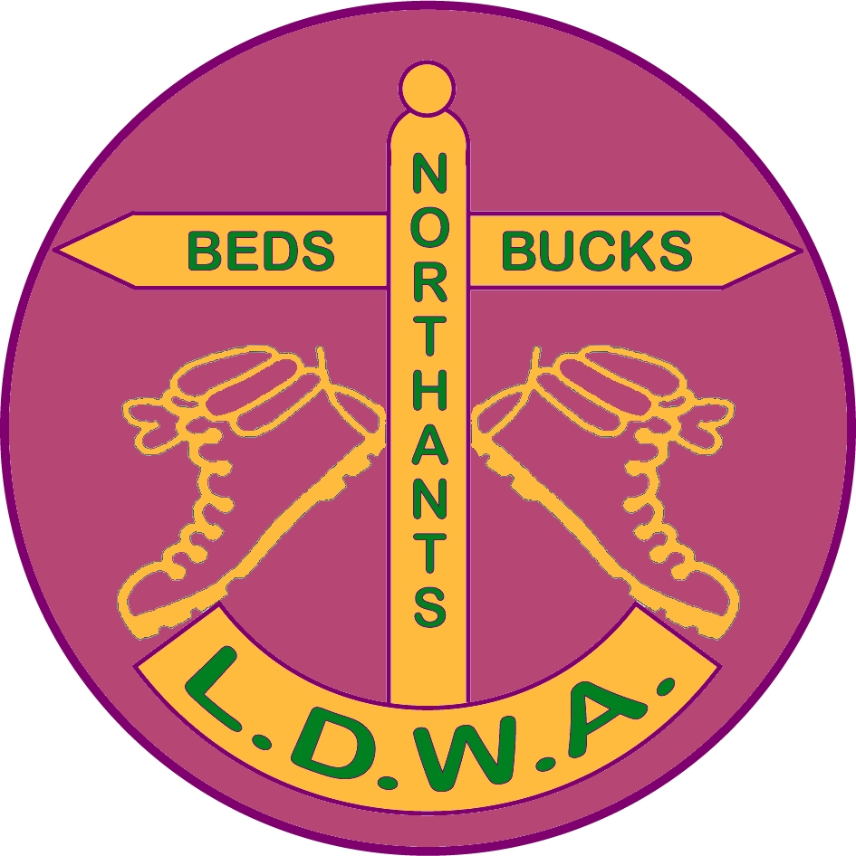

HAVE A GREAT DAY OUT, WALK WITH BBN

[www.ldwa.org.uk/bedsbucksandnorthants](http://www.ldwa.org.uk/bedsbucksandnorthants)

**NEW MEMBERS**

A very warm welcome to our new members:

Deborah & Keith Birch Leighton Buzzard

Lesley Cuandu Flitwick

Jim & Helen Dodds Biggleswade

John Mole Farthingstone

David Reed Milton Keynes

David & Merlyn Webb Bromham

There are still a number of you that have yet to pay the BBN membership fee of £1. Please give your £1 to any committee member next time you are out on a social or challenge walk.

Thanks

Dave Findel-Hawkins

***SALE OF GARMENTS***

*We are holding a clearance sale of group garments*

*T-shirts, polo shirts, sweat shirts and rugby shirts*

*All will be reduced to half price at*

*the Chiltern Kanter*

*Lynn Yorston*

**CHAIRMAN’S CHATTER**

Well it’s the start of another calendar year and another walking year. I hope you all had great days out whether with BBN or in the real world over the festive season.

Santa paid us his usual visit on Sunday 14th December and was in full flow with plenty of *ho ho hos,* and the singing of the BBN choir was ably led by Teresa Brown. I’m pleased she was there otherwise the group would have probably been arrested under The Noise and Statutory Nuisance Act 1993……..

Our group members have been out in all parts of the country on various challenge and social events such as the Stansted Stagger, the Hangover Hike and the Chairman’s New Year Circular. So life has continued as it should.

Following on from my predecessor’s exhortation to “Ask not what BBN can do for you but what you can do for BBN”, I was very pleased that Mary Knight joined the committee at the 2014 AGM and attended our first meeting of 2015 on Wednesday 23rd January at Chateau Bunker… Welcome on board Mary, and I hope this is the first of many for you.

Please remember this is your group and we are always looking for new members to join the committee and come up with fresh ideas…….

Now to less weighty matters….what do we have to look forward to this year with our group? Many things……

The first BBN challenge event coming up is the Chiltern Kanter on Sunday 3rd March with three distances to choose from, 26, 18 or 13 miles. I’ve had a good response to my email asking for marshals and thanks to those who’ve offered.

For those of us who’ve not done a Kanter before this is a map reading exercise. If you wish to improve or learn your skills with a map and compass this would be an ideal event to take part in. The routes pass two examples of how the group has spent its hard earned money from the last 30 years.

Throughout the spring and summer we have a full social walks programme including two events outside the group’s geographical area. The first of these is on Sunday 26th April with a 14 mile walk celebrating 50 years of the Pennine Way led by Chris Bent and Frances Craven. The second on May 31st is a joint walk of 15 miles with Anytime Anywhere group led by Tim Glenn in the Charnwood area of Leicestershire.

We are also manning a checkpoint on the LDWA Red Rose 100 in Lancashire and further details appear in the newsletter.

I mentioned committees previously. At this year’s National AGM there will be two members standing for the position of Chairman as the incumbent John Sparshatt is stepping down, his three year term in office being up. In the December Strider you will have received a blue proxy form containing a short election address from each nominee.

The AGM is attended by about 200 members and the General Secretary has received 200 proxy forms in the post. So potentially a total of 400 out of 8000 members will elect the LDWA Chairman. As with the other election taking place in May, voting is important, so please return your form to the address given on it. If you’ve lost it and want a replacement then please contact the LDWA National Secretary Phil Heneghan at Secretary@ldwa.org.uk

One of the perennial quandaries, as with all organisations, is how do we recruit new members? One of the simplest ways of letting people know about us is to take some LDWA membership forms and BBN business cards with us on social walks, recces or challenge events. I carry about four of each with me on walks and have had no difficulty in handing them out to people that we meet when out for the day.

Gill Bunker and I handed an LDWA form to someone we met whilst recceing the Chiltern Kanter and heard via DFH that he had contacted the LDWA chairman to say it was exactly the organisation he was looking for. The most direct approach often works! Merrian and I have enough forms so if anyone requires some you know where we are………

That’s all I’ve got to say for now so I’d just like to say that please remember when you’re out with BBN friends on a national trail, recceing or leading a social walk or on Challenge Events that you might walk on but……………………….

You’ll never walk alone!



Good Walking!

**Norman Corrin**

**MERRIAN’S MISCELLANY**

The minutes from the AGM 2014 are on the website, under Group Activities, Meetings.

Please let me know if you fancy learning about orienteering or geocaching. Even better, please let me know if you fancy teaching us about orienteering or geocaching. We could combine these with a social walk.

Please let me know if you’d be interested in doing a basic first aid course tailored to the sort of things we might need on a checkpoint. As above, if you know anyone who could teach us, please let me know.

I will be standing down from the committee at the AGM in November this year. Please contact me if you’d like to join the committee, become secretary, become webmaster, or help with any of the jobs. You can adapt the role to suit yourself.

There’s a list of all BBN equipment in the document store on the BBN website.

If you have any photos you’d like to share, please don’t send them to me because my home internet struggles to process them. Please load them onto a sharing site and send me the link. Please contact me if you’re willing to do this for other members.

We use the BBN website to give latest news to members. Not all this gets into the newsletter. If you don’t have access to the internet, maybe a friend or family member would let you know if there’s anything urgent. I’d be happy to add their email address to the distribution list.

If you want to find the postcode nearest to the start of a walk or event, try using http://www.streetmap.co.uk/. The grid reference for the start of a walk is given in the walk details. Put that into the search box to get the map. Then use the link below the map “Click here to convert coordinates”.

**Shillington Shuffle – 16th November 2014**Although Gordon and I wrote a report for the AGM and thanked everyone who marshalled, I’d like you all to know, and thank, those who helped.  
Entries – Mike Hyland  
Route descriptions – Gordon Shaughnessy  
Parking – Jonathan Venning, Mike Hyland, Alan Leadbetter, Martin Lawson,   
Dave Yorston and Gordon Shaughnessy  
Signage – Dave Yorston  
Marked up maps – DFH

Registration and finish – Christine Bramley, Gerry Garland, Jim Morrison, Dave Findel-Hawkins, Merrian Lancaster, Norman Corrin  
Catering at HQ – Sandra Hyland, Gill Howe, Andrew Gilbertson, Norman Corrin, Lynn Yorston  
Catering and Merchandise – Lynn Yorston  
Closing checkpoints – Dave Yorston and Gordon Shaughnessy  
Sweeping – Gordon Shaughnessy and Jim Morrison  
CP1 Lilley – Veronica Scargill, Terry Brown, Gerry Garland, Christine Bramley, Nigel Schofield, Kathy Loraso  
CP2 Pirton – Derek Jacob, Margaret Skerman, Roger Skerman, Brian Harwood, Mary Knight, Mr Mary  
CP3 Stondon – Mike Hyland, Martin Lawson, Dylan Lawson, Alan Leadbetter  
CP4 Shillington – Sybil Davies (former BBN Chairman) and family  
 Daughters Jackie Burnett and Gill Bunker  
 Niece and Husband Beryl and Mike Bowley  
 Step-Granddaughter Rachel Martin  
 Step-Great Granddaughter Victoria Martin

As you can see, we need loads of people to run an event, 33 for the Shuffle. Please contact Alan Leadbetter if you can help on our new event, From Here to There & Back, on 5th July.

I’ve received the following stats from Steph Carter, LDWA Membership Secretary:

In terms of BBN relative to the whole LDWA:

BBN not yet renewed 30/488 = 6.1%

Nationally not yet renewed = 14.8%

This is fantastic and tells me you've been doing lots of work reminding your members - thank you so much!

BBN DD payers 377/488 = 77.3%

National % DD payers = 60.0%

Again this is fantastic and much appreciated by me!

Best regards  
 Steph

Our next committee meeting is on Thursday 4th June 2015. Please let me know if there’s anything you’d like us to discuss.

**Merrian Lancaster**   
*T*: 01908 642803   
*E*: [merrian22@gmail.com](mailto:merrian22@gmail.com)

**GROUP WALKS**

Not a huge amount has happened since my report to the AGM in November apart from my usual gentle persuasion, mostly via Merrian’s round robin emails, to cajole members into leading a social walk for us. The diary for the April to August programme was very sparse indeed when I made my first emotional plea at the AGM but, as always, it is now full, fat and therefore healthy. We have only 5 weekends in the 4 month period when BBN is not offering either a challenge or a social walk.

Please allow me two small moans. With some notable exceptions, we still rely on the same people to lead a walk (or two or more) every year, whilst others, who are welcome and enjoy many of their fellow members efforts, never seem able to ‘rise to the challenge”. Please, please consider taking that first step, you will receive all the help and advice you need. My second little gripe (and I feel a little guilty as this is directed at the wonderful leaders who do make the effort), please can you get me your details by the requested date. I had to chase up over half the leaders this month.

Back to the many positives. We have one of the most extensive social walk programmes of any of the LDWA groups, both in quantity and, in my opinion, quality and diversity. With the permission of the committee I have included two walks outside our three counties area. In September the group is offering what I am sure will be a fantastic weekend of walking, staying in a youth hostel in Dorset. Many thanks to John Chesher for securing the accommodation and preparing to lead three walks and to Gill for organising the bookings.

As always, I am now starting on the programme for the final four months of the year, from September to December 2015. Please contact me as soon as possible to book a date to lead a walk, with the usual final details required by 10th May please.

**Dee Brockway**

To save postage, and to make sure our end of year reports and stats are accurate, please would walk leaders email the following info to Dee or Gordon after your walk has taken place:

Date, title, leader, distance, number on walk, name and contact details for any non-LDWA, details of any incidents/accidents. This is also in the [Document Store](http://www.ldwa.org.uk/BedsBucksAndNorthants/W/1045/document-store.html) on the BBN website.

**Tech T-Shirts**

Last year we ordered a small quantity of Tech T-Shirts (wicking) in burgundy with the BBN logo on and also with the SSS badge on. We did order long sleeve Tech shirts with BBN/SSS logos but these are not available in burgundy

These were on display at the Shillington Shuffle and are produced by the company that manufactures the LDWA merchandise.

Group members can order the items themselves and instructions on how to do view and how to order are shown below. They can be ordered with the BBN logo only, SSS logo only or combination of both.

The website is [www.peco.ltd.uk](http://www.peco.ltd.uk)

To view the T-shirts

1. Click on Catalogue
2. Click on Main Catalogue
3. Scroll down the screen (within the catalogue not the windows screen)
4. At the bottom in the field headed “search by product code or keyword” put in JC001
5. Click on search
6. This will display the T-Shirt headed JC001/Cool T
7. Click on the picture
8. Scroll down the screen (within the catalogue not the windows screen)
9. The T shirt is displayed in burgundy

To view the long sleeve shirts repeat steps 1-4 but enter the respective codes

1. GD121 for Men
2. GD171 for Women

To order the T-shirts

The website is [www.peco.ltd.uk](http://www.peco.ltd.uk)

Unfortunately Peco cannot do customisation via their website so the merchandise will have to be ordered like this.

Click on Contact Us

Enter contact details

In the comments field quote the following

Garment reference: JC001, GD121, GD171

Garment colour: Burgundy (for T-shirt), Red, Navy etc. (for Long Sleeve shirt)

Garment size

For the BBN logo quote *SD3475 – Circle*

For the SSS logo quote:*SD3476 - Triangle*

Quote which breast to be worn on

Once Peco have received the email from the member they will invoice and reply with the amount to pay. There will be an option to pay via PayPal online, or by card over the phone.

Now the important bit…………….how much!

Price for the garments (before embroidery) is;

JC001 – £3.38 + VAT

GD121 – £6.15 + VAT

GD171 – £6.15 + VAT

The prices for each logo is

BBN Logo SD3475 - £2.50

SSS Logo SD3476 - £2.50

There will also be a carriage charge of £3.50 + VAT per shipped order.

So a burgundy T-shirt with 1 badge will cost in total £11.26 and a burgundy T-shirt with 2 logos will cost in total £14.26….

**Norman Corrin**

**USED STAMPS**

If you don't already have a good home for your used stamps, Lynn will take them.

*The stamps go to Hearing Dogs for Deaf People. My Brownies sort them into pretty ones and plain ones, foreign ones and boring ones!! I then deliver them to a lady in the village who puppy walks the young dogs - she brings the dogs to our meetings too - the girls love them. She takes the stamps on to the training facility in Princes Risborough. They then sell them to raise monies for training the dogs. Would be good to get any amount of any type. They all get sold in one way or another.*

***Lynn Yorston***

**LDWA RED ROSE 100**

This year’s LDWA 100 is organised by the East Lancashire Group and is over the May Bank Holiday weekend of 23rd to 25th May. The event website is:

<http://www.ldwa.org.uk/2015Hundred>

Our group’s checkpoint is Number 2. It’s a village hall at Feniscliffe and opens from 1315 Saturday afternoon to 1830 Saturday evening.

We have 14 marshals so far who are as follows:

Norman Corrin Dave Findel-Hawkins Merrian Lancaster

Dave Yorston Lynn Yorston Mike Hyland

Sandra Hyland Colin Scargill Veronica Scargill

Paul Keech Christine Pendlebury Pearl Smith

Steve Smith John Davies

Being early into the route means the entrants will be coming through fast and furious……..well I hope not the latter anyway!

14 is a good number to run a 100 checkpoint (whereas 3 is a magic number….) but we will never turn bodies away if anyone wishes to help. Many hands make light work.

For those of us who fancy a weekend in Lancashire and are new to the LDWA and have never been to a 100 before and are curious about it this would be an ideal opportunity. Be careful though you may want to take part in it!

Please contact me if you’re interested.

**Norman Corrin**



**INTERNATIONAL HAERVEJSMARCH 2015 DENMARK   
SATURDAY AND SUNDAY 27TH/28TH JUNE 2015.**

This year’s trip abroad will be a return to the International Haervejsmarch 2 days International Walks in Denmark taking place on Saturday and Sunday 27th/28th June 2015. We will travel over on Friday 26th June and return Monday 29th June.

Four of us did this event back in 2010, Adrian Moody, Cliff Garnham, Dennis Jacobs and I. A memorable memory for me was watching the England v Germany World Cup match in the Sports Bar next door. Adrian walked out after the first two goals. Needless to say he returned shortly afterwards….to see the next two go in!

For those of us who’ve not done an international event before, this is part of the International Marching League calendar of events which encourages mass participation events at varying distances. This will give you an opportunity to get a flavour of how relaxed and enjoyable and carnival like the big events can be abroad. The distances available are 20, 30, 40 or 45km per day. The event averages about 6,000 participants each year.

Based upon 2010 the cheapest way is to fly on Ryanair from Stansted Airport to Aarhus and then hire a car (or mini-bus depending upon numbers) and drive to Viborg. The train times are awkward from Viborg to Aarhus at the time we would leave on the Monday morning.

Accommodation is in a gymnasium and you will need to take a sleeping bag and air bed. The Danes do like to stay up till late socializing, so take your ear plugs and eye patches!

Meals from Friday afternoon to Monday morning can be booked as part of the overall entry package and they are considerably cheaper than eating out in Viborg.

There are links below to the walks website and the Viborg area of Denmark

[www.haervejsmarchen.dk](http://www.haervejsmarchen.dk/) [www.visitviborg.dk](http://www.visitviborg.dk)

Viborg is located in central Jutland, Denmark. It is one of the oldest towns in the country with Viking settlements dating back to the 8th Century. Due to its central location, the town had great strategic importance in political and religious matters during the Middle Ages.

If anyone is interested can they please contact me by my email address or telephone number 01908 608667

**Norman Corrin**

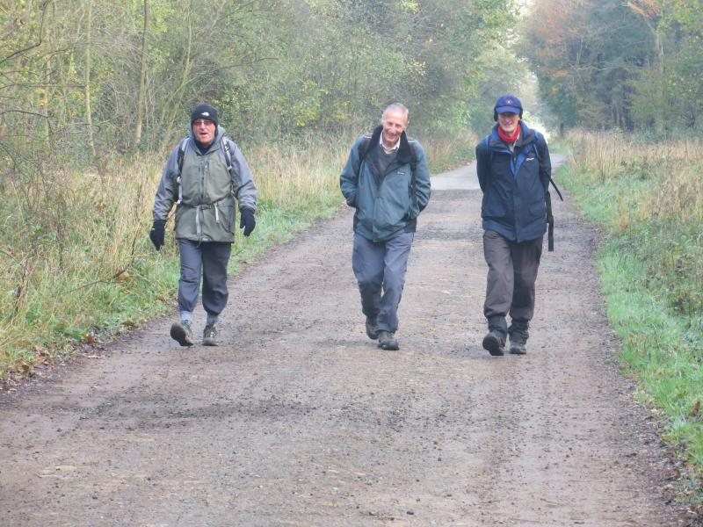

Down Nene Way: November 2014

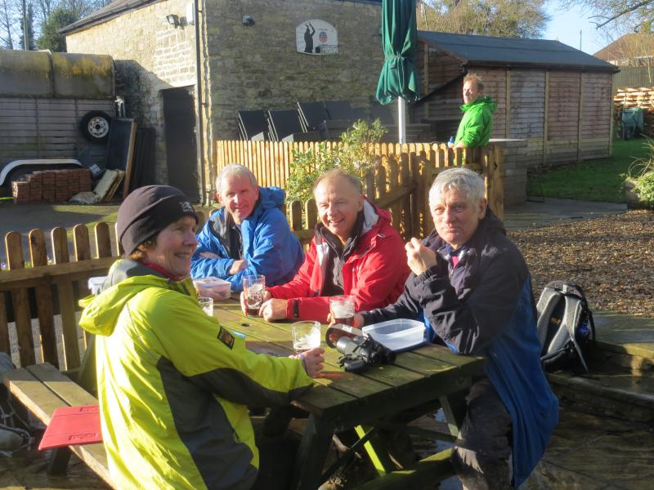

Another Canal Saunter: January 2015

*Photos: DFH and Merrian*

**ROCKY MOUNTAIN HIGH**

Not long after I met Pearl she mentioned that she would love to go to the Canadian Rockies. We were thinking of going last summer for her birthday, but the trip we had in mind seemed a bit expensive. However, this year we found a trip that was about half the price. It was eleven days instead of fourteen and it was in October. We soon decided to go for it.

This was to be my second trip to Canada. Way back in 1969 I was in a dead end job and fancied some adventure. My mother had a distant relative in Toronto so I went and stayed with her for a short while before finding a place of my own. I arrived in mid-November and within a week it was snowing. The snow was to remain on the ground till April. I managed to get a series of odd jobs including working nights at a petrol (gas) station. I would spend New Year’s Eve and the night of my 21st working there but I didn’t mind. I needed the money!

Other jobs included working at a car wash, selling encyclopedias door to door and snow shovelling. By the spring I fancied a change of scenery so I headed west to Winnipeg in the Prairie Provinces. Here I managed to get accepted on a 6 week course in the army reserve. This consisted of driving trucks and jeeps and firing rifles and machine guns. It was great fun and I made a lot of friends. Not wanting to stay in Manitoba for the winter (when it can get down to -40oc) in September I headed west again to Vancouver. After spending two months there I couldn’t find any work so wrote to my dad who sent me some money to get home, I travelled back through the States and got a flight home from New York. I’d just about run out of money when I got to the UK so had to hitchhike home. I’d been away for a year.

Now 44 years later I was heading back to Canada, in fact, Vancouver. How had it changed? Well, for a start they now have plastic money, have converted from Fahrenheit to Celsius and have gone completely metric.

After a ten hour flight we landed in Vancouver but with an eight hour time difference the time on our watches was only two hours ahead. Vancouver had changed a lot since I was last there, with quite a few new buildings including the football stadium just behind our hotel. There we saw Vancouver White Caps beat Dallas 2-0. It was a good game with quite a high standard of football.

The company we travelled with had organised a trip to Vancouver Island but it was about £150 each. We decided to make our own way there which involved a train and bus to the ferry terminal. I particularly wanted to visit Buchart Gardens and luckily a woman we met at the bus stop offered to give us a lift there. She’d

been on holiday and her husband was meeting her when the boat docked. They said it was only 15 minutes out of their way, but it saved us getting two buses. The gardens were absolutely fantastic and the weather was great. I’d been to Vancouver Island before but not to the gardens, though I probably wouldn’t have appreciated them as much as I wasn’t then working as a gardener. We spent a few hours looking round and then headed back. It was a long day, but I reckon the whole thing only cost us about £50 each, so a big saving.

The next day we set off on the coach to Whistler which is a big ski resort in the winter. Here we saw the Olympic Rings as some of the 2010 Winter Olympics were held here. With the aid of a local map we set off on a walk to Lost Lake. We didn’t get lost but Pearl was surprised by a large dog coming up behind her. We had been told to look out for the local wildlife, especially bears and to give them a wide berth. It was a really nice walk, taking about four hours with some really nice mountains and lakes to view.

The next day we set off for Sun Peaks, a day’s drive away. This was bit of a ghost town. A ski resort in the winter but not much happening off season. We had a walk around in the evening, again nice views but no wildlife apart from squirrels.

The following day we left for Jasper, another day’s drive but we would stay there for two nights. The following morning we took a cable car ride up one of the local mountains. I walked to one of the viewpoints to see a fantastic panorama but Pearl was a bit tired so she stayed in the café.

In the afternoon we set off on a walk to Green Lake. Another pleasant walk. We met a couple there from the coach who lived in Hitchin. We followed them back on a different route called the Squirrel Trail. They were a little way ahead of us when they suddenly stopped. What had they seen? A squirrel? A bear? Turns out it was a large male elk sitting right by the path. We’d been told not to approach them so we left the footpath and made our way through the undergrowth which took us down to the river. Here we saw a lot more elk. We’d seen some from the coach windows but never been this close before.

The next day we set off for Banff (which, according to our coach driver, stood for Be Aware Nothing For Free!). We stopped on the way to visit a glacier and also to do a skywalk which involved a walkway over the canyon but the floor is made of glass. Pearl managed to do it, but she said she didn’t look down! In the afternoon we stopped at Lake Louise, a really scenic lake.

In Banff we went up a local mountain by cable car, again some great views. In the afternoon we took a nice walk down by the river but saw nothing more than herons.

The following day we left for Calgary airport. It was a great holiday. Only one morning of rain on our first day otherwise beautiful sunshine every day averaging about 20OC. A very knowledgeable guide and driver who took us to some out of the way beauty spots. Very friendly people. Snow capped mountains and beautifully coloured lakes. Nice food and great beer. What more would you want!

**Steve Smith**

***ooooooooOOOOOOOOoooooooo***

**A WEEK ON THE PEMBROKESHIRE COASTAL PATH**

*It was all Betty’s fault …. Honest…..*

It was about June when Betty phoned me up one morning and said “I’m sitting up in bed with a cup of coffee and I’ve got this great idea”. Now me knowing Betty I started to wonder where I was going to end up this time.

“Have you ever been around Cardigan Bay” she said?

“Years ago” I said, “Why”.

“Well I’ve found this brilliant caravan right on the coast, £400 Sat to Sat. We could do a bit of coastal walking and basically chill out for a week. Do you fancy it?”

Well I thought that a week on the Pembrokeshire coast would be great, so I got the holidays booked at work and on the 29th September I was at Betty’s for the night and on the 30th September off we trundled along the M4 towards Wales.

We arrived at the Fishguard Bay caravan and camping site in-between Fishguard and Newport on the Pembrokeshire Coastal Path at around 2.30pm Saturday afternoon and they allowed us to book in and move into our caravan straight away, although we were a bit early. Wow, what a great caravan, set back in trees so it was nice and private, you could sit outside naked (**we did not**) and nobody would see you, telly and DVD player, full cooker, large fridge and separate freezer, two bedrooms (guess who had the main one? No, nooo it was not me). We went with all our food, beer and wine and DVDs, we were totally self-sufficient for the week (a good job cause there was not even a boozer within walking distance). We settled in quite quickly and had a stroll around the site. For grub that night Betty had bought a few disposable BBQ’s, so I set about cooking our food. Now nobody told me not to put it on a wooden garden table when it was alight and I had never used one before so the inevitable happened. Yep, I burned the table, only a little bit though (please note title).

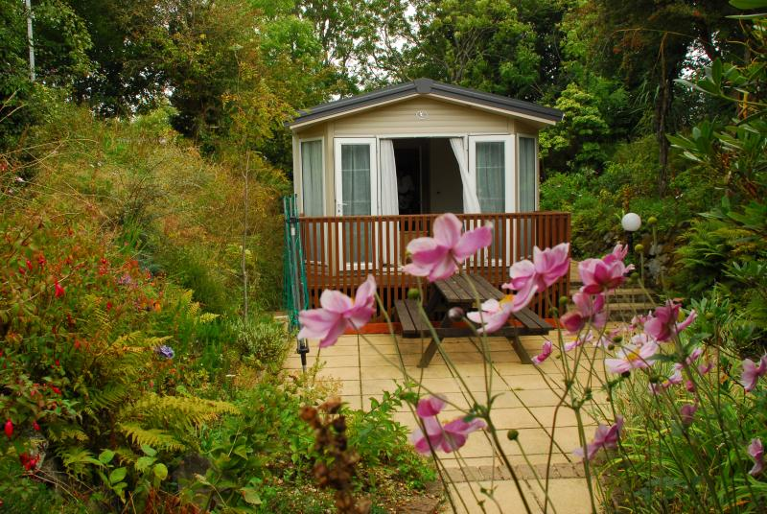

Now, all the 5 days that we walked on the path went without incident, we had great weather, a slight breeze, calm, very flat seas, sea birds in the sky, seals in the bays. It was on the third day we spotted our first seal floating around in the bay, I looked over the edge of the cliff a little bit closer and there it was, a little baby white pup on the rocks. (Wow, my very first seal pup).

Altogether we walked from St Dogmaels, the starting point for the Pembrokeshire Coast Path to St David’s Bay in sections of about 15 miles. The sections we walked were:

*SUNDAY-Caravan to Newport, and then walked via road back to the caravan*

*TUESDAY- Caravan to Strumble Head, then taxi back to caravan*

*WEDNESDAY-St Dogmaels to Newport. (Drove car to Newport then bus to St Dogmaels then walked back to car)*

*THURSDAY-Strumble Head to Abercastle. (Left car at Strumble Head then walked to Abercastle then caught a bus back to Strumble Head*

*FRIDAY-Whitsands Bay (St David’s) to Porth Gain. Left car at Porth Gain and caught a bus to St David’s then walked back to Porth Gain*

*SATURDAY-Abercastle to Porth Gain, Left car at Porth Gain, bus to Abercastle, then walked to Porth Gain*

We pondered over what we would do on Sunday, our first full day on the Pembrokeshire coast. We decided to walk to Fishguard, a couple of miles down the coast. You can see Fishguard from the caravan site. Betty went for a shower and by the time she came out I had another idea for our first trek on Sunday. What about walking to Newport via Dinas Head, a longer walk, then catching a bus back to the caravan site? She agreed, and that is what we did. Sunday was a fantastic day; the sun shone, a slight breeze and fantastic scenery. We got to Newport about 2pm, and only just missed a bus back to our caravan site; the next bus was in 4 hours, oops. We decided to walk back to the caravan along the road, a quicker way than along the coastal path. We walked for about an hour and came upon a pub. We stopped for a beer and asked how far to the caravan site, the landlord said about a mile up the road. We were a bit surprised, but then the road was straight and the coastal path was in and out of bays.

On Tuesday we were up nice and early to walk to Strumble Head. We had to be back at the caravan by a certain time so we were going to catch a taxi back to the caravan. The weather of course was fantastic and I got some great photos, my model for the week (yes it was Betty) would carry on walking and I would catch up for the tea breaks and lunch stop. Strumble Head had a large car park and a lighthouse and looked very picturesque. Betty phoned for the taxi and of course the inevitable happened, there was no mobile signal. We walked up the road for about a mile and came to some houses where we asked to use a landline to phone for a taxi. The taxi arrived in about ten minutes and we were back at the caravan in no time. For grub that night we did another BBQ, this time I put it straight on some bricks and not on a wooden table. After grub we would ponder over the map and bus timetable and work out where we would walk to the next day. We decided to walk from St Dogmaels to Newport. We would drive the car to Newport, then catch a bus to St Dogmaels and then walk back to the car. Walking back to the car was great because we did not have to get to our destination at a certain time, so we could enjoy the walk better and not have to worry about the time.

Wednesday was another glorious day, beautiful sunshine, slight breeze, up early and breakfast sorted we packed the car and drove to Newport, parked the car in a car park and found our bus within ten minutes. The bus driver was kind enough to drop us off at a point where we did not have to walk too far to get to the start point of the day. It was not long before we came across a boozer that was open for morning coffee so 30 minutes later after a cuppa and bickies off we marched for Newport. Wednesday was the day we spotted our first seals in the bay and looking even closer we saw a baby seal on the rocks below. Every day after that we saw seals in the bays and plenty more baby seals on the rocks. When we arrived at the beach at Newport we chilled out for a while. I went for a dip then had an ice cream, Betty went straight for the ice cream. Once chilled out we headed for the car, a short walk along the beach, no problem, or that was what we

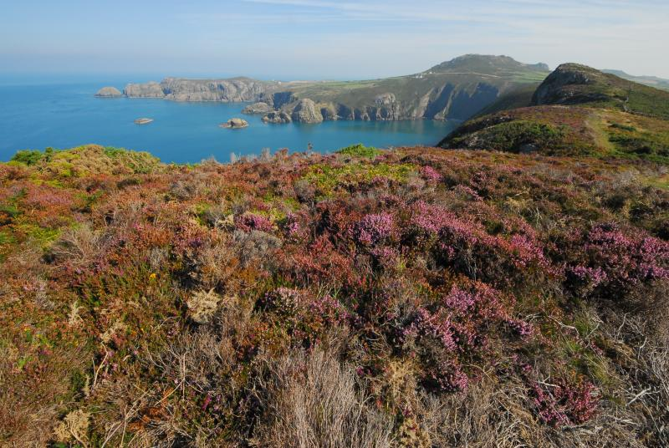

thought. There was a little problem, between us and the car was a tidal stream

which was pretty deep, we tried to wade through but it was too deep so we decided to walk around. It didn’t take us long to work out that it was going to take us hours to walk around so we decided to take another look and go for broke and wade across. In between some boats a young boy waded across the tidal stream so we decided to go across at the same place, we made it without any trouble… Pheeew.

Again Thursday was another perfect day, up early and packs packed we drove to Strumble Head and walked to Abercastle, then caught a bus back to Strumble Head. The problem with catching a bus at the end of the walk was you have to watch the time. Back at Strumble Head Betty did some sunbathing and a bit of reading while I went off to do a bit of bird watching and photography. I was lucky enough to spot a Wheatear and got a few good photos of it. Back at the caravan we had dinner and a few glasses of wine then pondered over the map and bus timetables for Friday’s walk. We had a problem. Over the full week we wanted to cover the entire coast from St Dogmials to Whitsands Bay but Friday being our last day we had too far to go, so we split the remaining miles into two. Friday morning we drove to Porth Gain, then caught a bus to Whitsands Bay, then walked back to Porth Gain, another fantastic day. I even had a swim in one of the many bays.

Saturday, our very last day, we packed our gear shoved it in the car, handed over the keys and drove back to Porth Gain then caught a bus to Abercastle to walk the last remaining 4-5 miles back to the car at Porth Gain. For some strange reason

on our very last day on the path the weather changed dramatically, the wind was very gusty and the seas were very rough, a total change in the atmosphere. At Porth Gain we had some grub and a beer in the local boozer before we set off for home.

All my photos of our holiday can be seen on the BBN web site

**PS**—Yes I did own up to burning the table on the first evening, or did I just say Betty did it.

WHAT A FANTASTIC HOLIDAY

Stevecee

***ooooooooOOOOOOOOoooooooo***

**GRAND UNION CANAL WALK**

***It was all Betty’s fault ….. again…….***

Betty was sitting up in her bed one morning with a cup of coffee when she gave me a ring. “How about walking the Grand Union Canal in stages?” she said. “That’s a good one”, I said. So that is what we did. It was not supposed to take us a couple of years but Betty had a problem with her foot which put her out of action for a while and me on strange shifts, so a couple of years it was to take.

Betty had the guide book until she mislaid it so bought a new one, then found the old one, so we then had two, so I got one and Betty had one. (**Ok so far**).

**Now you can’t get lost following a canal can you?**

We started off thinking we were going to do a 20 miler for the first section and parked a car at a point that should have been approximately 20 miles. But we did not calculate the fact that we were going to walk 8 miles on the Paddington Arm before we got to the Grand Union Canal, so our 20 miles turned into 28 miles, or that was what would have happened, but we stopped at a pub for a tea break at about 2pm, decided to call it a day and caught a taxi back to the car.

On another section we were going to call it a day at Wendover, walk the Grand Union to the Wendover Arm then follow the arm to Wendover. Soon after we left the Grand Union and started to follow the Wendover Arm we came to what looked like a dead end, the Wendover Arm was being worked on and they blocked the

path, and the direction arrow said totally the wrong direction, so being without a map that day we decided to go for the road and follow the road, all 4 miles of it, into Wendover. The Wendover Arm was nicknamed by Betty as the Wendover Elbow.

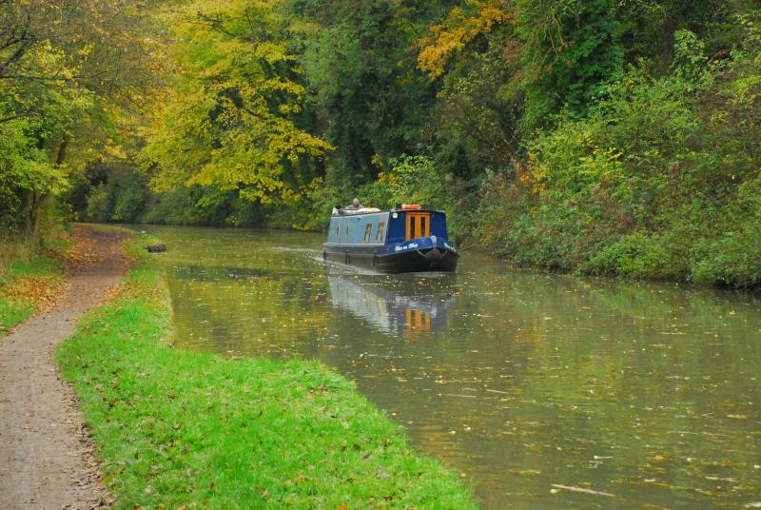

On another occasion we started at Fenny Stratford and Betty led the way. Across the canal, turn left and follow our noses. We had to pass a pair of swans nesting on the tow path; they let me pass but did not take a shine to Betty, so she had to take a slight detour on the road. After about half an hour I suddenly had this strange feeling and said to Betty, I suppose we are going in the correct direction, Betty replied yes, then a couple of seconds later said, but I think you had better check. With that I checked the guide book and found that we had been walking in the wrong direction for half an hour, so about turn and in a full hour’s walking we had not even left the start point. Oops.

Now on this section we were walking back towards London, less miles to do in the cars I think, so when we came back another day to start off at Fenny Stratford to do another section we had to walk past the swans again, (this time in the direction of Birmingham) and this time they let Betty pass and I had to take the diversion.

At the start of each section we would always stop at the first coffee shop/café and on one occasion not 10 mins into the walk we came across a narrow boat that did breakfasts. Who could resist a breakfast on the canal so 45 minutes later with our bellies full off we trod for the day well nourished.

It took us over a year to get together and finish off the Grand Union. We remembered where we finished last time so decided to take one car and then at the finish we would catch a taxi back to the car, have a celebratory drink at the

pub and rejoice on the way home. Now the Grand Union did not finish like we thought it would, a boozer, a café, a few shops etc. Instead where the Grand Union seemed to finish was a right dump, and it seems the Birmingham and Fazeley canal took over and went down to the Gas Street Basin. Betty and I decided to call it a day and finish at this dump. We walked out onto the road where we were able to catch a taxi back to the car. (All £30 worth). We still had a beer to celebrate. We did have a good time on the canal, and decided that we would not do hills any more. My photos are on the BBN website.

Bye for now

**Stevecee x**

For those of you who watch what you eat, here's the final word on nutrition and health. It's a relief to know the truth after all those conflicting nutritional studies.

1. The Japanese eat very little fat and suffer fewer heart attacks than Brits.   
2. The Mexicans eat a lot of fat and suffer fewer heart attacks than Brits.  
3. The Chinese drink very little red wine and suffer fewer heart attacks than Brits.  
4. The Italians drink a lot of red wine and suffer fewer heart attacks than Brits.   
5. The Germans drink a lot of beer and eat lots of sausages and fats and suffer fewer heart attacks than Brits.

CONCLUSION: Eat and drink what you like. Speaking English is apparently what kills you.

So good news for all Scousers, then!

**Phil Hastings**

**WHAT A WAY TO LOSE WEIGHT ……..**

**OR MY LITTLE ADVENTURE CROSSING WALES 3** **TIMES**

On Saturday the 6th of September last year the 51st running of the "Across Wales Walk" took place. This event involves the complete crossing of mid Wales from Anchor in Shropshire, England to the west Welsh coast at Clarach Bay, just north of Aberystwyth. It also involves crossing the highest point in mid Wales, Plynlimon at 752 Mts., and covers a total distance of 45 miles. Plynlimon also has the distinction of having the source of both the rivers "Wye" and "Severn" on its flanks. There is a time limit of 18 hours. You can run or walk, the record is around 7 hours.

I first did this event when I was 59 and thoroughly enjoyed it. At that time I became acquainted with, what I thought was rather crazy at the time, the long standing tradition of "Doubling" the event. This involves starting on the Welsh coast and making your way, unsupported, across Wales to the start of the main event at Anchor at 5am. and turning round and going all the way back. Some hardy folk have done this nearly 20 times.

I missed the event for the next 2 years due to other commitments but was then persuaded (I did not need much persuading), by a good friend to have a go at the "Double". I was now 62 so it seemed like a good idea. I completed this, in absolutely appalling weather, feeling quite strong at the end. It was during this event that I was told about the even crazier challenge of “Trebling" the event. A feat which had only been attempted and completed by one person, 10 years before. This said person, one Roderick Hollands, was also the first person to ever complete a "Double" LDWA 100 mile event. A feat he achieved last year in appalling weather conditions. 47% of the 482 that started did not complete a single 100, let alone go round again, much respect.

Fast forward to last September. I am now 63, and you know what's coming. I am signed up to have a go at the "Treble". The basic rules are (1) You are only allowed 18 hours for each crossing, (2) The first 2 crossings are free route choice and unsupported, the third must go through the 5 official checkpoints,(3) I must touch the trig point on the summit of Plynlimon each time ( my own rule ), and (4) Be honest and complete the challenge fairly.

It's now 5pm. on the Thursday evening and I am standing, all alone, on the bridge at Anchor, just inside England. I am far from sure of the outcome but am very excited at the prospect of what lies ahead. I wait until 1 minute past 5 just to be inside the rules. I am off. I had planned my own unique route which had a little extra ascent and distance than was absolutely necessary, but with the

advantage of easier navigation during the night in case of bad weather. I also had no time to recce the route, a fact that would bite me quite hard in a few hours’ time.

I start at a very steady pace knowing that, if things go wrong, I could be at this for up to 54 hours. The early miles, a mixture of quiet lanes, off road trails, ridges and off piste come and go without trouble. I soon leave the main event route and head for the infamous "Wind Farm". This is a very large area of hill tops, over 500 Mts., covered in about 100 wind turbines. A very spooky place in daylight, this crossing, and especially so in pitch black, my return crossing. As yet I have never seen one of them turn so much as an inch. I am pleased with my navigation through this lot and descend quite quickly. I had planned to use a well mapped public right of way, about a mile cross country, how foolish of me. I ended up trapped in an impenetrable forest, in several unmapped gardens of several unmapped houses and nearly savaged by a very large and very hungry looking unmapped dog. This had turned out to be the longest shortcut of my life as I had to eventually give in and back track around the problem for about a mile and a half. My map is 8 years old, the mapping is at least 30 years out of date.

Once clear of this problem I was soon descending into Llanidloes. Over the next 12 miles I steadily ascend 600 + Mts. to the summit of Plynlimon, the last 3 miles being totally open fell, ranging from hard runnable ground to a fair amount of bog trotting. I hit the trig point spot on, such a relief. It is now about 1-30 in the morning and it is absolutely pitch black. I turn off my head torch for a moment and cannot see my hand in front of my face. A truly magical moment that I will remember forever. The sky is absolutely clear but the wind is now very strong indeed. I am stationary too long and quickly get cold for the first time. I also suddenly realise that the nearest human being is at least 5 miles away. Time to move on and "Brian, be careful, no mobile signal and no rescue for at least 8 hours, if not more”.

I descend the steep slope very carefully and drop 400 Mts. in a mile and a half. A complete change of terrain now, 3 miles on the road around the southern edge of Nant-y-moch reservoir. I leave the reservoir on a very stony and lake filled track. The next 3 miles are on open fell and it's still very dark, so I am careful. I reach what is arguably the most dangerous part of the whole route, the screes. I have done this tricky cliff path in the daylight up and down and it is pure delight. In the pitch black it is a whole different story. Only about 300 Mts. long it seemed to take a lifetime. I was acutely aware that there was a 30 Mt. vertical drop on my left, from which there would be no recovery any time soon. At times it felt like I was descending into an abyss.

As if to tease me, once I had descended the worst of it, daylight suddenly started to appear over the mountains behind me. The next 8 miles was straight forward

with more downs than ups to the sea at Clarach Bay and that all important dipping of toe in sea. I had just crossed Wales. It was 7-43 in the morning and my first crossing had taken 14 hours and 42 minutes. I now had to wait until 11am. before I could start my second crossing. I sorted out blisters, wet clothes, food etc. and prepared for No.2. My friends arrived about 10-30 to make sure I was O.K., this was a very special moment and picked me up no end. They were then taken up the coast to Borth, where they were going to start their double from.

I started my second crossing at 11-05 in good sunshine. I had decided to reverse my first crossing to try and "nail" the dodgy bit in the middle, which I did, at about midnight, with much satisfaction. A different crossing altogether. The scree path was once again a delight, the views over the gorge spectacular. The summit of Plynlimon was amazing as I could see for 20 miles in all directions. I got carried away over this section and pushed a little too hard. By the time I was descending into Llanidloes I hit my first very bad patch. If I was to have one this was the best place to have it as I was due to meet, if possible, the 4 doublers in our favourite chip shop. I know I said unsupported but this is tradition. One of them was already there and the other 3 joined us soon after. I knew I was in trouble when I just could not eat. A problem I never normally have. I stayed there for about 2 hours, feeling sorry for myself, letting the others go as I was doing a different route to them. The chippy expects us and locks us in for as long as we like while they clean up, good people.

I knew the rest of the night would be a cold one so put on more clothing and set off for the wind farm. After leaving Llanidloes I did not see a single person until I reached England and then it was only 3 bodies, in poly bags, asleep on the grass verge. It was 4-17 in the morning and I had taken 17 hours 12 minutes for my second crossing and I was wrecked. I tried telling myself "only 45 to go" then immediately told myself to get lost, I can't think why.

No sleep for me then, with a mass start in 40 minutes it would have been lethal. I dare not sit down for the fear of not being able to get up again. By 4-45am. a stream of head torches came down the road as the first coach had arrived. It's very strange being among 120 people who are hyped up to the eyeballs, all fresh and raring to go, when you are absolutely cream crackered and wondering if you are going to make it up the first hill. The organiser finds me out, asks me how I am doing and gives me my tally card for the main event. O well, no way out now I suppose.

We start at 5-06am. and I try very hard to keep up with the middle order as I know that some of the tail enders will not make it. This is now hurting like hell. A world away from my single crossing 4 years ago when I was up with the leading bunch and finished 10th in 10 hours and 40 odd minutes. I settle down, generate some heat and try not to destroy myself. This is now about survival, not heroics. I just keep going and crawl into checkpoint 1. This was my lowest point and the only time I slightly doubted if I could finish. I eat, drink and take stock of myself. It's simple I tell myself, "no bloody way are you not finishing this as if you don't none of what's gone before counts, nothing, you get nothing”.

At this point I just dug in. At checkpoint 2 I am met with great enthusiasm as the organiser is there and they all know what I have done. I tell him I am about to go into unknown territory as this was 105 miles and I had never been further than this before. From then on, and I know not why, I just got stronger. I was slowly taking people all the way to the summit of Plynlimon. I then had my best "moment" of the entire event. From the trig point down to the reservoir I passed about 40 people in 16 minutes and not one of them passed me before the finish. I arrived at Clarach Bay at 8-49pm. and completed my final crossing in 15 hours 43 minutes. I had just covered 135 miles with approximately 18,000 feet of ascent and descent.

Shortly after finishing I was taken to Aberystwyth University where we were staying for the night. I just about remember collecting my kit bag but have no recollection of finding my room or falling asleep, thankfully, inside it.

The next morning, after breakfast, was presentation time. A truly memorable occasion where every finisher is presented with their certificate. I must confess that it brought tears to my eyes when I received the loudest and longest applause, along with a special certificate acknowledging my triple crossing. After all of this had finished I boarded the coach for my return journey back to Anchor, Clun, England and reality. A truly memorable experience and one that I would not have missed for the world.

I nearly forgot the crash diet. I lost 15 pounds in weight in 52 hours, not recommended. Sadly most of it has found its way back on in spite of my best intentions.

I also nearly forgot, how could I, to thank, most sincerely, the small but very dedicated contingent from B.B.N. who, much to my surprise, were manning checkpoint 4 on the main event. I do not know all of your names so will not name you for fear of missing somebody out but you know who you are. I must tell you, most truthfully, that you have absolutely no idea how much of a

tremendous lift you gave to my spirits when I saw you as I was feeling very fragile at the time. This carried me through to the end for which I thank you, again, most sincerely.

This truly is a most unique and marvellous event, the single crossing I mean, and should be on the wish list of any serious long distance walker, if only the once.

**Brian Layton**

**ooooooOOOOOOoooooo**

Bridget Talbot OBE

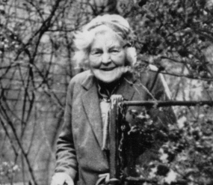

This is Bridget Talbot….. a remarkable woman all we walkers should be very grateful to. ….

Born in Little Gaddesden in 1885, Bridget was a tireless campaigner throughout her life for all sorts of good causes

* During the First World War she served with the Red Cross on the Italian-Austrian front and was awarded the Italian Medal for Valour (the Croce de Guerra) and the OBE.
* Intriguingly, during the 1920’s and 30’s she campaigned to save the lives of merchant seamen and invented a waterproof torch for lifebelts to give those lost overboard a better chance of rescue. Through her many political and social connections she persuaded Parliament that these torches be made compulsory for all Merchant Navy, Royal Navy and Royal Air Force personnel, This saved the lives of many seamen during the Second World War.

But as walkers our interest in her is that she helped to save the Ashridge Estate for the National Trust.

Her aunt’s husband Earl Brownlow owned Ashridge and when he died in 1921 the estate was in great danger of being sold off and the woodland felled for development. Bridget was determined that this should not happen, and spearheaded a national campaign which successfully saved much of the land for the National Trust.

Bridget died in 1971. She had requested that her ashes be scattered *“over the little stream off the grass road between Edlesborough and Ivinghoe, in view of the nine miles stretch of wood and country, and a stone put up “to say that I saved them for the National Trust”.*

So, when walking along the bridleway between Ivinghoe Aston and Edlesborough church on the Chiltern Kanter look out for a small stone bench on the left. (Grid Ref SP963183). You can just about make out the wording:

***'In memory of Bridget Elizabeth Talbot OBE of Little Gaddesden and Kiplin Hall. Seaman's friend and defender of human rights. She helped to preserve these downs for you who read this. Died 29 November 1971. Inventor of lifesaving watertight torch for mariners.'***

As well as the memorial bench, there is a small plaque on the wall of the National Trust visitor centre on the Ashridge Estate to remind us of what we owe to this amazing lady.

**Gill Bunker**

ooooooooOOOOOOOOOooooooo

***WALKS PROGRAMME  
MARCH TO AUGUST 2015***

**Sun Mar 1 2015 Chiltern Kanter Marshals' Walk**

For CK marshals only. ***C:*** Norman Corrin ***T:*** 01908 608667 ***M:*** 07980 378656.

**Sun Mar 1 2015 Sharnbrook Shamble**

16ml. Start 09.00 From Sharnbrook. Maps: Exp 208,224 (GR SP996596). ***C:*** Christine Bramley ***T:*** 01234 822557.

**Thu Mar 5 2015 Nearly Spring in the Chilterns**

15ml. Start 09.30 From the firm standing just outside Cholesbury Village Hall Post Code HP23 6ND. Maps: LR 165 Exp 181 (GR SP930071). ***C:*** John Davies ***T:*** 01442 874875.

**Sun Mar 8 2015 Chiltern Kanter**

26, 18 or 13.5ml. From Pitstone Memorial Hall, LU7 9EY (GR SP937155). Please note this is a map reading event. A written description will be issued for part of the 26 & 18 mile routes. Maps: LR 165 & 166 or Exp 181.. Start: 08.00-8:30 for 26 &18ml; 8.30-9.00 for 13.5 ml; runners 09.00-09.15 (all to finish by 18.00). Postal entries close 28th Feb. Event parking at Safran Power Systems, Pitstone Business Park, Westfield Road, LU7 9GT (GR SP933154). Organised by & chqs payable to LDWA BBN. Entry: £6, non LDWA £8, under 16s £3 (all OTD £8, under 16s £3) incl refreshments at Cps; hot meal & cert at finish. Postage for results included. SEF accepted with SAE or entry form downloadable from event website. ***C:*** Mike Hyland, 55 Broadlands Avenue, Chesham HP5 1AL ***T:*** 01494 774154 (before 21.00, please). ***E:*** mike.hyland@ntlworld.com

**Thu Mar 19 2015 Two Ways to Emberton**

15ml. Start 09.30 From free c.p. Queen's Ave, Newport Pagnell (rear of Boots Chemist). Long stay c.p. is at far end of short stay c.p. Maps: LR 152 Exp 207 (GR SP875440). ***C:*** Gill Bunker ***T:*** 01908 321308 ***M:*** 07790 976090 on day only.

**Sun Mar 22 2015 Stony Stomp**

15ml. Start 09.00 From Stony Stratford Nature Reserve c.p. (unsigned from main road). Maps: LR 152 Exp 192 (GR SP791409). ***C:*** Sylvie Eames ***T:*** 07788 287701.

**Sun Mar 29 2015 Tring Roundabout**

20ml. Start 09.00 From main pay c.p. in High St, Tring. Maps: LR 165 Exp 181 (GR SP926115). ***C:*** Peter Hamson ***T:*** 01442 245308 ***M:*** 07507 341133 on day.

**Thu Apr 2 2015 Ashwell Amble**

15ml. Start 09.30 From Radwell Meadows c.p. Norton Bury (NW of Baldock). Maps: LR 153 Exp 193 (GR TL235350). Picnic lunch in Ashwell near p.h. ***C:*** Phil Hastings ***T:*** 01763 853744 before 9pm ***M:*** 07716 992847 on day only.

**Sun Apr 12 2015 Bourne and Beane**

18ml. Start 09.00 From Waterford Heath c.p. Vicarage Lane, Waterford. This is located E of rlwy bridge. Maps: LR 166 Exp 194 (GR TL317150). ***C:*** Peter Simon ***T:*** 01582 513827.

**Thu Apr 16 2015 From Coachway to Tramway**

15ml. Start 09.30 By Bus from Milton Keynes Coachway 'Park and Ride' at M1 J14 (free c.p.). Map: Exp 192 (GR SP892405). Linear walk from Milton Keynes Central Rlwy Stn into north Milton Keynes. Break canal side at New Bradwell nr to p.h. ***C:*** Mike Bowley ***T:*** 01908 616589 ***M:*** 07933 066784 on day.

**Sun Apr 26 2015 A Celebration of the Pennine Way**

14ml. Start 09.00 From Bowden Bridge, 1km to the E of Hayfield, reached by the minor Kinder Road which ascends E from Hayfield village following signs for camp site; p+d c.p. or possible free road parking. Map: Exp 1 (GR SK048869). A walk in Derbyshire to celebrate the 50th anniversary of the Pennine Way. ***C:*** Frances and Chris Bent ***T:*** 07837 367575.

**Thu Apr 30 2015 Another Marston Meander**

15ml. Start 09.30 From Marston Vale Millennium Country Park (near Marston Moretaine). Map: LR 153 (GR TL005417). ***C:*** Derek Jacob ***T:*** 01234 767759.

**Sun May 3 2015 Oh No! Not the Brickhills Again!**

18ml. Start 09.00 From Bow Brickhill Stn c.p. (Free parking but no trains). Map: Exp 192 (GR SP896349). ***C:*** Peter Engledow ***T:*** 07733 323641.

**Sun May 10 2015 Steve’s Splendidly Silly Stupid Sexy Sandy Stroll**

18ml. Start 09.00 From c.p. in Sandy, entrance off the High St by Ghandi Restaurant. Map: LR 153 (GR TL175492). ***C:*** Steve Smith ***T:*** 01767 220307 ***M:*** 07817 041621 on day only.

**Thu May 14 2015 Lea’lands**

16ml. Start 09.00 From Leagrave Park c.p. Sundon Park Rd, Luton **(NOTE EARLIER START TIME)**. Map: Exp 193 (GR TL057246). ***C:*** Paul Keech ***T:*** 07753 560412.

**Sun May 17 2015 Easton Promise**

17ml. Start 09.00 From Easton on the Hill, Racecourse Rd, (just E of A43 approx 1ml W of A1; road parking). Map: LR 141 (GR TF017043). Circular to Rutland Water, lunch at Empingham. ***C:*** Steve Mossey ***T:*** 01780 482296 ***M:*** 07889 623965.

**Thu May 28 2015 A North Bucks Round**

15ml. Start 09.30 From Stonepit c.p. off Wolverton Rd, Milton Keynes. (GR SP844422). ***C:*** Gill Bunker ***T:*** 01908 321308 ***M:*** 07790 976090 on day only.

**Sun May 31 2015 Charnwood Charmer Summertime Special**

15ml. Start 10.00 From village hall c.p. Main Street, Woodhouse Eaves, Leicestershire **(NOTE LATER START).** Map: LR 129 (GR SK531148). The very best of Charnwood Forest including Swithland Woods, the treasure that is Bradgate Park, Newtown Linford, Ulverscroft Priory, Bawdon Castle, Charley Chapel and Beacon Hill. Joint walk with ‘Anytime, Anywhere’ group. ***C:*** Tim Glenn ***T:*** 0115 9221849 ***M:*** 07905 960793.

**Sun Jun 7 2015 Wildflower Wander**

19ml. Start 09.00 From The Red Lion p.h. Upper Sundon. Map: Exp 193 (GR TL045278). ***C:*** Dave Sedgley ***T:*** 01525 714961 ***M:*** 07583 091770 on day only.

**Thu Jun 11 2015 Over Old Ground**

15ml. Start 09.30 From Howe Rock Place c.p. (off Langerstone Lane), Tattenhoe, Milton Keynes. Map: Exp 192 (GR SP836341). ***C:*** Stephen McMorrow ***T:*** 07806 523724.

**Sun Jun 14 2015 The RSPB Walk**

18ml. Start 09.00 From Old Warden Church. Map: Exp 208 (GR TL137443). ***C:*** Colin Scargill ***T:*** 01234 740361 ***M:*** 07916 488458 on day only.

**Sun Jun 21 2015 Canal and Woodlands**

15ml. Start 09.00 From the Grove Lock. Park in the pub c.p. Map: LR 165 (GR SP915230). ***C:*** Sylvie Eames ***T:*** 07788 287701.

**Sun Jun 21 2015 From Here To There & Back Marshals’ Walk**

***C:*** Alan Leadbetter ***T:*** 01933 440826.

**Thu Jun 25 2015 Pulloxhill Figure of Eight**

15ml. Start 09.30 From St. James Church, Silsoe. Map: Exp 193 (GR TL083356). ***C:*** Linda Marsh ***T:*** 01908 669698.

**Sun Jun 28 2015 A Well, a Witch and Wars by Proxy**

18ml. Start 09.00 From Watermead (off A413, 0.5ml N of Aylesbury). To park take track marked Riviera Restaurant and use shingle area to the R, adj to trees. (Charge £2 per car required by landowner). Map: Exp 181 (GR SP819154). ***C:*** Michael Mooney ***T:*** 01296 715598 ***M:*** 07704 310167 on day only.

**Sun Jul 5 2015 From Here to There & Back**

27, 19 or 13ml. all to finish by 18.30. Hall closes 19.00. From Wellingborough Grammarians Memorial Sports Field, Sywell Road, Wellingborough NN8 6BS (GR SP856690). A walk around the Northamptonshire rolling countryside through the villages of Mears Ashby, Sywell, Overstone, Holcot, Broughton & Pytchley. Start: Walkers from 08.00, Runners (27ml only) and fast walkers from 09.00. Entry Limit 150. Entry form on website. Entry: £7, non LDWA £10, under 18s free (OTD £12 if limit not reached) incl refreshments at Cps (3 on 27ml, 2 on 19ml, 1 on 13ml), light meal at finish, cert. Badge £1.50. Chqs payable to LDWA BBN Group. Entry form downloadable from event website. ***C:*** Mike Hyland, 55 Broadlands Ave., Chesham, Bucks, HP5 1AL ***T:*** 01494 774154. ***E:*** mike.hyland@ntlworld.com ***W:*** www.ldwa.org.uk/bedsbucksandnorthants

**Thu Jul 9 2015 The Albino Walk**

15ml. Start 09.30 From Ampthill Park c.p. Map: LR 153 (GR TL025382). ***C:*** Roger & Margaret Skerman ***T:*** 01525 405540.

**Sun Jul 12 2015 On the Edge (of Northamptonshire) Take 2**

20ml. Start 09.00 From Brackley Leisure Centre, Springfield Way. Maps: LR 151,152 (GR SP580381). ***C:*** Mary Knight ***T:*** 07554 661519.

**Sun Jul 19 2015 Before it Disappears**

19ml. Start 09.00 From Bradgers Hill Rd, Luton. Pls park towards the E of Sixth Form College, towards Fairford Ave end. Map: LR 166 (GR TL094237). ***C:*** Peter Simon ***T:*** 01582 513827.

**Thu Jul 23 2015 Axe & The Red Barn**

16ml. Start 09.30 From Sackville St, Oundle Road, Thrapston (free c.p. with toilets). Map: LR 141 (GR SP998786). Lunch at Stanwick Lakes (cafe – no pub). Level paths & tracks. ***C:*** Jim Robinson ***T:*** 01832 734501 ***M:*** 07845 909750.

**Sun Aug 2 2015 From a Castle to a Park (Linear Walk)**

18ml. Start 08.15 From (cars parked) at The Ship Ashore p.h. in Willen, Milton Keynes. Maps: LR 152 Exp 192 (GR SP871413). Minibus leaves Willen at 8.30 to take walkers to start at Bolebec Castle, Whitchurch. Please reserve your place with Norman by 19th July. ***C:*** Norman Corrin ***T:*** 01908 608667 ***M:*** 07980 378656 on day.

**Thu Aug 6 2015 To Watford Gap**

15ml. Start 09.30 From West Haddon Church, NN6 7AN. Map: LR 140 (GR SP629718). ***C:*** Peter Bearne & Anne Addison ***T:*** 01780 480286 (Peter) or 01780 740414 (Anne).

**Sun Aug 16 2015 A Haddon Hack**

19ml. Start 09.00 From East Haddon, footpath close to Red Lion p.h. (not in c.p.). Map: Exp 223 (GR SP670682). Picnic lunch at Little Brington; p.h. nearby. ***C:*** Andrew Gilbertson ***T:*** 01327 871451 ***M:*** 07922 068591 on day only.

**Thu Aug 20 2015 From Coachway to Fairway**

15ml. Start 09.30 From Milton Keynes Coachway “Park & Ride” site M1 J14 (free c.p.). Map: Exp 192 (GR SP892405). Linear walk to Woburn Sands for return by bus. Lunch at Bow Brickhill near p.h. ***C:*** Mike Bowley ***T:*** 01908 616589 ***M:*** 07933 066784 on day.

**Sun Aug 23 2015 Litlington Loops – Summer Version!**

19 or 12ml. Start 09.00 From outside Heath Sports Centre/Café, off Baldock Rd, Royston. Free c.p. café and toilets. Map: LR 154 (GR TL348405). Picnic lunch in Litlington, pub nearby. For shorter 12ml option pls contact leader in advance. ***C:*** Phil Hastings ***T:*** 01763 853744 before 9pm ***M:*** 07716 992847 on day ONLY.

**Sun Nov 15 2015 Sundon Saunter Challenge Walk**

**BEDS BUCKS & NORTHANTS GROUP: COMMITTEE 2015**

|  |  |
| --- | --- |
| **Chairman:** | **Norman Corrin** *T*: 01908 608667  *E*: [norman.corrin@btinternet.com](mailto:norman.corrin@btinternet.com) |
| **Secretary/Website/:** | **Merrian Lancaster**  *T*: 01908 642803  *M*: 07933 735338 9 Hollinwell Close, Bletchley, MK3 7TW *E*: [merrian22@gmail.com](mailto:merrian22@gmail.com) / [bbn@ldwa.org.uk](mailto:bbn@ldwa.org.uk) |
| **Treasurer:** | **Ian Sage** *T*: 01582 661256  *E*: iansage49@gmail.com |
| **Social Walks:** | **Dee Brockway** *T*: 01582 881809  *E*: dmrbrockway@ntlworld.com |
| **Membership:** | **David Findel-Hawkins** *T*: 01908 216476  *E*: davefh@gmail.com |
| **Merchandise/Equipment:** | **Lynn Yorston** *T*: 01494 868371  *E*: lynn.yorston@btinternet.com |
| **Newsletter:** | **Gill Bunker** *T*: 01908 321308  *E*: [gillbunker@googlemail.com](mailto:gillbunker@googlemail.com) 1 Abbey Way, Bradville, Milton Keynes. MK13 7AN |
| **Local Group Rep:** | **Alan Leadbetter** *T:* 01933 440826  *E:* alanleadbetter@sky.com |
| **Member:** | **Mary Knight** *E:*[maryjknight@hotmail.co.uk](mailto:maryjknight@hotmail.co.uk) |
| **Non-Committee** | |
| **Thursday Walks:** | **Gordon Shaughnessy** *T*: 01582 518791 *E*: gordon_shaughnessy@hotmail.com |

*Thank you to everyone who has contributed to this Newsletter*

*Please let me have items for the Summer Newsletter   
by 31st May 2015*

*Gill Bunker*