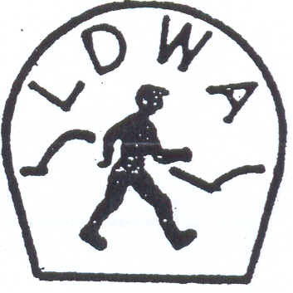 | LONG DISTANCE WALKERS ASSOCIATION  AIM: TO FURTHER THE INTERESTS OF THOSE  WHO ENJOY LONG DISTANCE WALKING

BEDS, BUCKS &
NORTHANTS GROUP

NEWSLETTER
JUNE 2013

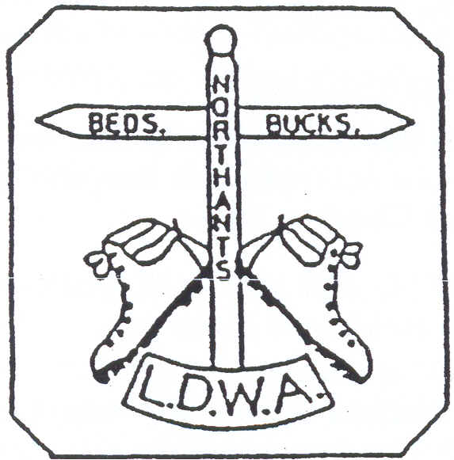

HAVE A GREAT DAY OUT, WALK WITH THE BBN
www.ldwa.org.uk/bedsbucksandnorthants

New Members
A very warm welcome to our new members who have joined BBN since the last Newsletter:

Ian Chattington Bozeat Geoff Curnock Barton Seagrave
Adam Dawson Amersham Anne Godwin Bedford
Stefan Kobewka Great Brickhill Victoria Martin Milton Keynes

And welcome back to:
Paul & Suzanne Flynn Flitwick

oooooooOOOOOOOooooooo

BEDS BUCKS & NORTHANTS GROUP: COMMITTEE 2013

Chairman: | Nigel Schofield T: 01462 442338  E: nicelegs.schofield@btinternet.com  Nigel.Schofield@north-herts.gov.uk
Secretary/  Website/  Local Group Rep: | Merrian Lancaster T: 01908 642803 M: 07933 735338  9 Hollinwell Close, Bletchley, MK3 7TW  E: merrian22@gmail.com / bbn@ldwa.org.uk
Treasurer: | Ian Sage T: 01582 661256 E: iansage@waitrose.com
Social Walks: | Dee Brockway T: 01582 881809 E: dmrbrockway@ntlworld.com
Membership: | David Findel-Hawkins T: 01908 216476 E: davefh@gmail.com
Merchandise/  Equipment: | Lynn Yorston T: 01494 868371 E: lynn.yorston@btinternet.com
Newsletter: | Gill Bunker T: 01908 321308 E: gillbunker@googlemail.com  1 Abbey Way, Bradville, Milton Keynes. MK13 7AN
Thursday Walks: | Gordon Shaughnessy T: 01582 518791  E: gordon_shaughnessy@hotmail.com
Member: | Norman Corrin T: 01908 608667 E: norman.corrin@btinternet.com
Member: | Martin Lawson T: 01933 678594 E: jimranit@btinternet.com
A big thank you to everyone who has contributed to this Newsletter
Chairman: Nigel Schofield

We are well into our 30th Anniversary Year (Will it ever warm up enough for shorts? It did of course for the first May Bank Holiday weekend) and I hope that you have all the celebration events and dates in your 2013 diary. Please attend as many of the 30 km walks, the 30 mile walk and canal cruise as you can and of course the social walks on Sundays and Thursdays.

Both the Chiltern Kanter marshals’ and the event itself were held on dry days. Many thanks for the support from all marshals. The move from Bridgewater Monument to Gaddesden Scout Hut was a very smart move by Norman Corrin (no more tinned sausages please!) and on behalf of all members I would like to record our thanks to Norman and friends for another successful Kanter.

The next challenge event is the Steppingley Step on 3rd November followed by Pick & Mix next March. All offers of help to Merrian and Lynn and Dave Yorston respectively please. The Steppingley Step marshals’ walk will be on 13th October 2013 and the Pick & Mix marshals’ walk in February/March 2014 (date to be confirmed).

Many congratulations to the BBNers who completed the Dorset Giant and other recent challenge walks, including the Cornwall and Devon 100 marshals’ walk (Martin, great time of 33 hours and fifty minutes, what did you have for breakfast, go faster beans or those infamous Chiltern Kanter frankfurter sausages). I retired off the Giant at about 52 miles (first ever retirement on an LDWA challenge event) due to the leaning over syndrome – Merrian has given me some excellent tips with tlc and if any one has any comments as to cause of lean over and resolution please let me know.

Your new Committee is settling down to the essential ‘bits and pieces’ of looking after BBN. We are always ready to receive comments and or questions – don’t hide behind the sofa – we are not the daleks or cybermen!

And if you have not heard or read about it, a person or persons unknown defaced the 100 route (as well as part of the Dorset Giant route) by the application of yellow paint to stones, stiles, walls and telegraph poles. This is a very serious development and cannot be tolerated. This activity which I suspect is the work of a very few people (one only?) must reflect very badly on the LDWA. John Sparshatt (LDWA Chairman) has sent out a global email and posts on the LDWA Forum have made it clear that ex–communication of the culprit/s is the only solution. There was a stunned silence at the announcement just before the start of the Giant and for the first ten to fifteen minutes none of us could understand why anyone in the LDWA would undertake such an act. Anyone on an overnight walk - we all help novices - would not resort to such an act, the challenge is to read and navigate
and complete – remember challenge events are not a race, although we are aware that to some it is a race or is competitive.
Your Committee and others work tirelessly on your behalf to organise events and arrange a very full social walks programme on Sundays and Thursdays. Dee and Gordon will always love to hear from you to propose a walk.

I hope that you all have good walking this summer and stay healthy.

Please think what you could do for BBN and not necessarily what BBN can do for you and don’t forget ‘to have a great day out on a walk with BBN’.

And last but probably not least I propose to stand down as BBN Chairman at the 2013 AGM after seven years as your Chairman.

That’s all folks.
Nigel Schofield

***********************************

Merrian’s Miscellany

Valleys 100 2014 – May 3rd/5th and May 24th/26th
The website has been published http://www.ldwa.org.uk/2014Hundred
BBN will be looking after checkpoint 4 on the main event. We’ll be in a marquee in the car park of the Brynffynon Hotel, Llanwonno, Glamorgan CF37 3PH ST030955. The provisional menu is squash, full fat Coca Cola and lemonade, mini scotch eggs, sausage rolls, bread pudding, apples, jelly babies and fun sized chocolate bars. http://www.ldwa.org.uk/2014Hundred/W/2459/cp4-llanwonno.html

The only gossip I’ve heard is that we’ll use a PC/netbook/laptop (whatever) to update the master sheet, and the closing marshal will unload to a memory stick and email it to HQ, where the master files will be updated automatically. We’ll be able to use internet and power in the pub. The marshals’ event will coincide with a big music festival at the pub, which will be closed and a bar set up in a tent
- phew ‘cos the pub is in the CAMRA Good Beer Guide and we wouldn’t want to miss out on a beer there.

BBN AGM - Sunday 24th November 2013
Start 0900 from Emerson Valley Local Centre, Whitehorse Drive, Milton Keynes, post code MK4 2AS, grid ref SP 8467 3435, access from north side of A421
(Standing Way), 9ish miles, finish 1215, one tea break, lunch 1230 at The Clocktower (http://www.johnbarras.com/pub/clocktower-emerson-valley-milton-keynes/m5942/#menu ) or Raj Douth (http://rajdouth.co.uk/ ) or own picnic in River Valley Community Centre from 1330, AGM 1400.
I need numbers for restaurants by 10th November.

BBN equipment
We have a comprehensive collection of equipment, which we’d be happy to lend to members. The list is in the Document Store on the BBN website.

What takes your mind off getting up a hill? –puff like a weightlifter, lateral thinking, games. What are your tricks?

Dogs on walks – National Guidelines http://www.ldwa.org.uk/library/policy/dogs_on_walks_rev2.pdf – any queries to Robert Hampton, Sports - Corporate Broker, Perkins Slade Ltd., 3 Broadway, Broad Street, Birmingham, B15 1BQ Tel: 0121 698 8156, Fax: 0121 625 9000, www.perkins-slade.com

Footpath problems – if you find a problem on a footpath, you can report it yourself. Details are on the Ramblers website. There’s a Quick Link at the bottom of their home page. http://www.ramblers.org.uk/

Getting rid of unwanted kit, maps etc. Please get in touch with me if you’re willing to organise and look after a table at Steppingley Step or the AGM. A bit like a table top sale, except it’s free, or donations to charity.

No computer, no internet? –Unlike several other LDWA groups, we’re not intending to go paperless. We’ll still send newsletters and walk programmes to members who prefer a hard copy. However, we’re using email and the BBN website more and more to communicate with members. It might be a good idea for those who don’t have a computer, or internet, to arrange to be alerted of anything important by another member.

Games 100 2012 – Please contact me if you’d like to borrow the DVD and report.
Local Group Reps’ Meeting – Please contact me with anything you’d like me to raise at the meeting on Sunday 17th November. It’s a chance to find out how other LDWA groups do things. The minutes from last year’s meeting are on the BBN website – with the papers for our AGM last year.

Merrian Lancaster
01908 642803
merrian22@gmail.com
Treasurer – Ian Sage

Group funds (reported to 16th May committee meeting):

NatWest Accounts:
Balance as at 30/09/2012 (start of financial year)
Current £2439.48
Business Reserve £4000.07
Total £6439.55

Balance as at 10/05/2013
Current £2978.97
Business Reserve £4000.49
Total £6979.46

To be added - monies handed to Ian at the meeting:
£89 membership subs; £14 for merchandise sold at the Chiltern Kanter; Chiltern Kanter cash.

Membership – Dave Findel-Hawkins

We have 146 currently paid up members including our five free members. Sixty have paid for multiple years. We have nine ‘new’ members since the last meeting.
I’ve been informed by seven they will not be renewing this year. There are 21 members who have yet to pay for 2013. I have emailed 17 of these and I have 4 who have promised to pay next time they see me. I’ve not heard anything from the others. Eight are no longer LDWA members, so I do not expect them to renew. There are four who don’t have email and will get a final reminder with the Newsletter.

Social Walks - Dee Brockway

I am so sorry that, due to work commitments, I yet again was forced to miss the committee meeting. The fantastic programme we can now start to enjoy, right to the end of our 30th Anniversary year, will, I hope, help you to excuse me.

Following on from the special summer walks and events…..Brewery Trip, boat trip with meal on board, three 30km walks, one in each of our counties, a 30 miler….. to name but a few…. We now have even more exciting and diverse things on offer, to see out our special anniversary year. These include 2 x two-day weekends spent walking our local 80 mile Bunyan Trail and a 3 day long weekend enjoying the Milton Keynes Boundary Walk. Add to this our usual challenge event, The
Steppingley Step, the AGM meal and walk and Santa’s festive appearance, the September to December programme is very full and extremely varied. Would you believe there are only 3 weekends during these 4 months, when BBN is not offering you a chance to enjoy your walking, in one form or another, with the group?

Thanks to Gordon for co-ordinating the Thursday programme and to Gill and Merrian for proof reading and, I am sure, correcting my silly mistakes, and for inputting the information onto the web, from which the information is extracted for inclusion in Strider.

As always, I am now starting on the programme January to April 2014, Please contact me asap to book a date to lead the walk, with the usual final details required by 10th September please.
Dee Brockway

Thursday Walks – Gordon Shaughnessy
Gordon is pleased to report there is a walk every two weeks for the next four months. Numbers out on Thursdays are good, with an average of 18-21.

New Members/Enquiries from Public – Norman Corrin
Norman has received notification from Dave of 16 new LDWA members who live within our group’s area. He has contacted and emailed information packs to 12. There are 4 still to contact but he has been busy with the 100 checkpoint.

LDWA AGM 2013: Congratulations to Dave Findel-Hawkins who was elected LDWA Events Secretary at the National AGM.

S-S-S Triple – Lynn Yorston
Lynn now has the Triple Challenge badges and has begun work on the certificates. Over 100 walkers may qualify this year; qualification will then be ongoing from year to year.

Committee Meeting: 16th May 2013
Officers’ reports and relevant information from the committee meeting is included in this Newsletter but it is impractical to reproduce the Minutes as they would take up too much space. The Minutes can be viewed on the BBN website, but if anyone would like a hard copy please let Gill B know.

The next committee meeting will take place on Thursday 26th September 2013 at 7.45 at 3 Lodge Lane, Prestwood. Please contact Merrian or any committee member if there are any items you would like to raise. The names and contact details for all committee members are shown on p.2 of the Newsletter.
Chiltern Kanter 3rd March 2013

This year’s Chiltern Kanter reverted back to its normal date of the first weekend in March.

We received higher pre-entries than in previous years of 167, but entries on the day were markedly down with only 17 turning up. With 31 non-starters this resulted in the lowest number of starters for years of 153. According to DFH our event clashed with the Berkhamsted Half Marathon. Ah well their loss!

The event started from a new venue at Pitstone Memorial Hall. This avoided car parking charges at the previous venue in Tring and enabled a greater variety of routes in the Chilterns. Car parking was very kindly provided by Goodrich Power Systems on Pitstone Business Park which was only 7 minutes walk from the hall. This facility provided more than adequate parking for all of the entrants’ cars and was well marshalled by Nigel Schofield, Martin Lawson and Alan Leadbetter. Mathew Whitmore and Andrew Gilbertson provided the directions on the traffic islands pointing entrants to the car park. I believe the frostbite wasn’t too severe!

The change in venue also brought a change in the weather as in previous years (2007, 2011) it has been appalling. This year the entrants started off in the mist but this soon parted to reveal the Chilterns in all their glorious colours, but the wind at time was particularly biting.

Part of the routes had been used on previous year’s events but there were variations on a theme as only the short route went over Ivinghoe Beacon. The long and medium routes went to the Dunstable Tree Cathedral before going their separate ways to eventually return to Pitstone. The long route was the only route that went round the back of Tring and this meant finding a new checkpoint which we did at the Scout Hut in Longfield Road. All of the checkpoints were new venues and provided some respite from the cold.

Dave, Lynn and Coral (no spaghetti and a dog at their checkpoint) quite easily managed the long route walkers as they came through and commented on how well equipped for a Scout Hut the venue was.

Gill and her family found out initially what being inside a refrigerator felt like when they opened up Whipsnade Village Hall…..

Nigel, joined by his car parking crew, along with Gill Howe coped more than adequately with all three routes converging on Little Gaddesden Scout Hut. This checkpoint came about at the last minute due to problems with the National Trust on the Ashridge Estate.
All of the routes passed the BBN Founders’ Memorial Bench in Ivinghoe and the long route went past Bridge 4 on the Arm of the Wendover Canal where there is a plaque displaying both national and group logos following BBN’s donation to the restoration work. Both of these were examples of how the group has invested its hard earned money from 30 years of effort by all its members.

At the finish Renate, Pat Sage, Veronica Scargill (first checkpoint experience) and Sue Leonard ran the kitchen operation very efficiently. I hope you enjoyed it Veronica! The caretaker called in to check things and to offer assistance. Her daughter had married the previous day and according to Pat she was still in wedding mode! Dave Findel-Hawkins, Merrian Lancaster, Gordon Shaughnessy and Therese Jamin managed with the bookings-in at the start, and Gordon and Therese helped me check that the food was up to scratch at each of the checkpoints! Ian Sage did a very good job of putting signs up to warn the oncoming traffic of walkers being on the roads.

One thing that sticks in my mind is that due to the hall having large glass windows on one side we could see the short and medium route walkers approaching the finish as they walked alongside the fence. There was something very re-assuring about it.

Finally many thanks must go to Mike Hyland who processed all the entries and came up with the routes but was unable to make the event itself as his Mum was 80 that day!

From the feedback that I’ve had (examples at the end) all enjoyed themselves and appreciated the friendly welcome at all of the checkpoints and at the finish.

As always these events could not be run without the people who do the various jobs which I’ve mentioned previously. I’m very grateful to you all who responded to my email request for help when there was a shortage of helpers. You helped me (and the group) out a lot. My thanks to you and I’ve listed who did what below:

Entries & Route Designer: Mike Hyland
Start/Finish Booking in: Dave Findel-Hawkins, Merrian Lancaster, Gordon Shaughnessy & Therese Jamin
Collection of Cards at finish: Therese Jamin & Gordon Shaughnessy
Car Parking: Nigel Schofield, Martin Lawson, Alan Leadbetter, Mathew Whitmore, Andrew Gilbertson
Checkpoint 1 at Whipsnade Village Hall: Gill & Ian Bunker, Jackie & John Burnett, Sybil Davies, Rachel Martin, Victoria Martin, Beryl & Mike Bowley
Checkpoint 2 at Little Gaddesden Scout Hut: Nigel Schofield, Alan Leadbetter, Mathew Whitmore Martin Lawson, Gill Howe, Andrew Gilbertson.
Checkpoint 3 at Tring Scout Hut: Dave & Lynn Yorston, Coral Yorston
Kitchen at Pitstone: Renate Romer, Veronica Scargill, Sue Leonard, Pat Sage
Putting up of Safety Signs en route: Ian Sage
Certificate Design: Christine Pendlebury

Thank you for all of your efforts for making it all round a special event and once more enhancing the good reputation of our group. If I’ve missed anyone off who helped, then my sincere apologies.

Lost and Found:
The following items were left behind. Please contact me if you know who might be the owner:
1 Silva Compass 1 OS Explorer Map 181

Statistics

Route | Pre-entered | Non-Starters | Retired | Entries on  the Day | Total
Long | 99 | 18 | - | 4 | 85
Medium | 45 | 9 | 1 | 8 | 43
Short | 23 | 4 | - | 5 | 24
Total | 167 | 31 | 1 | 17 | 152

Compliments from the walkers

I'd like to thank you and your happy, welcoming team, the caterers included of course, for a wonderful Kanter around the Chilterns. It was a well organised event with some interesting head scratching on the way round. All in all, a well worth while leg stretch. Thanks. Steve Garnsey and Landy Tong

What an interesting and challenging walk you organised for us all last Sunday. Please thank all your supporters (even those who could not attend - Mike) for the refreshments and work behind the scenes before and on the day. The three brilliant indoor checkpoints were a boon to everyone and I liked the staggered start, I hope it worked as well for the organisers.
I really appreciated the signposts through the tree cathedral, I could still be there had it not been signed.....
Thank you again. Christine Bramley

Hello all!
You wanted comments. Pitstone: Easy to get to. Parking place:
Plenty of space, easy to find. PMH as starting point: No complaints, good facilities. Organisation: Superb. Route: Most enjoyable: plenty of variation (though perhaps a bit thin on wooded areas), not too much repetition from
previous Kanters, no annoying trick questions. Timing: How did you manage to bring together on the same day an agreeable temperature, clear skies, no rain and – compared with recent weeks - hardly any mud? Support at checkpoints: definitely excessive: it encouraged me to linger when I’m usually in and out in two or three minutes!
Many thanks for a most enjoyable day. Gabriel Newfield

Here’s to the next one in 2015!
Norman Corrin

oooooooOOOOOOOooooooo

How many dogs does it take to change a light bulb!
Golden Retriever: The sun is shining, the day is young, we've got our
whole lives ahead of us, and you're worrying about a stupid bulb?
Border Collie: Just one. And then I'll replace any wiring that's not up to code.
Dachshund: You know I can't reach!
Rottweiler: Make me.
Lab: Oh, me, me!!!! Pleeeeeeze let me change the light bulb! Can I? Can I? Huh? Huh? Huh? Can I?
Jack Russell: I'll just pop it in while I'm bouncing off the walls and furniture.
Poodle: I'll just blow in the Border Collie's ear and he'll do it while my nails dry.
Cocker Spaniel: Why change it? I can still pee on the carpet in the dark.
Boxer: Who cares?
Pointer: I see it, there it is, there it is, right there, there, there.
Greyhound: It isn't moving so I’m not interested.
Old English Sheep Dog: Light?
Celebrating BBN’s 30th Anniversary Chiltern Brewery trip - Saturday 18th May

We all had a great day – a super walk in the Chilterns followed by a tour of the Chiltern Brewery. We saw the Brew House, and learned a lot more about the craft of brewing beer and some of the history of the Brewery. Then came a tutored beer and food tasting session with a selection of locally made cheeses, chutney and fruit cake. Delicious. A brilliant day out – thank you to John Davies for organising the day and to Graham Missing for leading us on the morning walk.

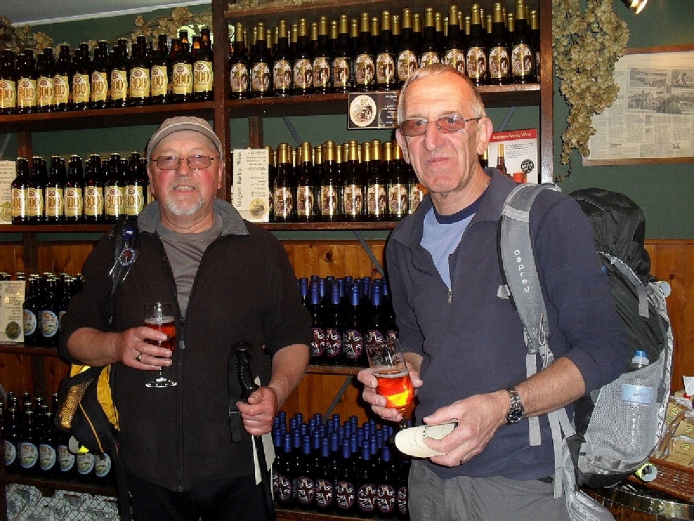 |  | 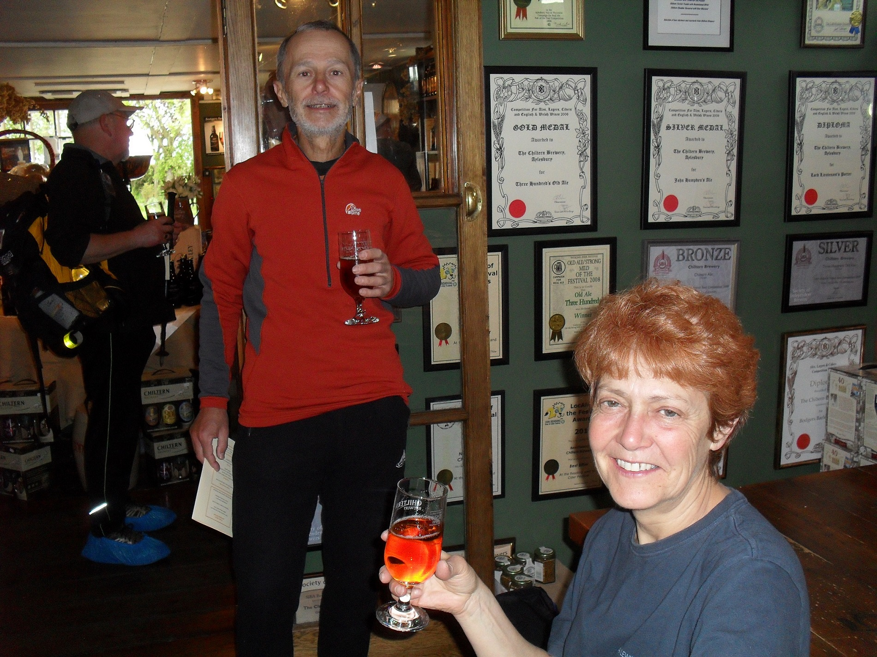
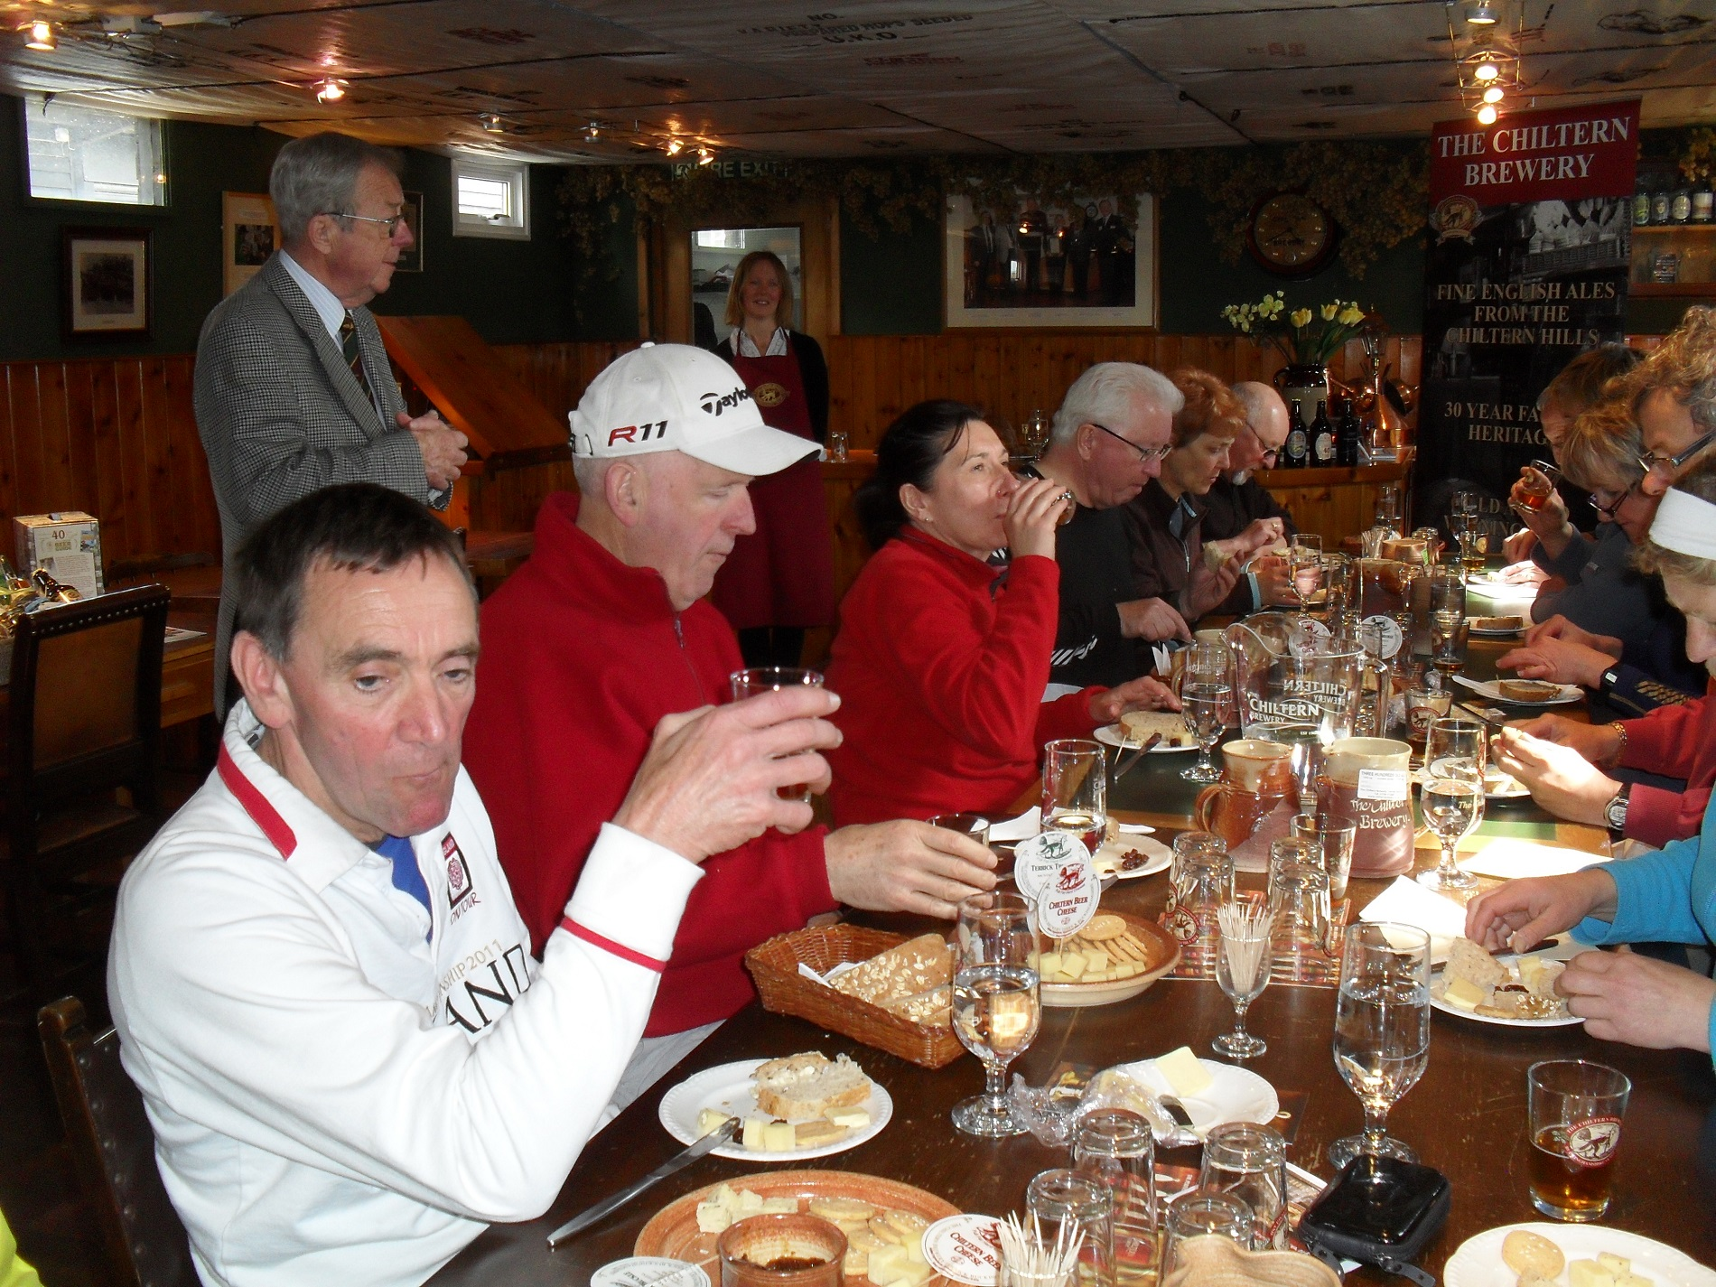 |  | 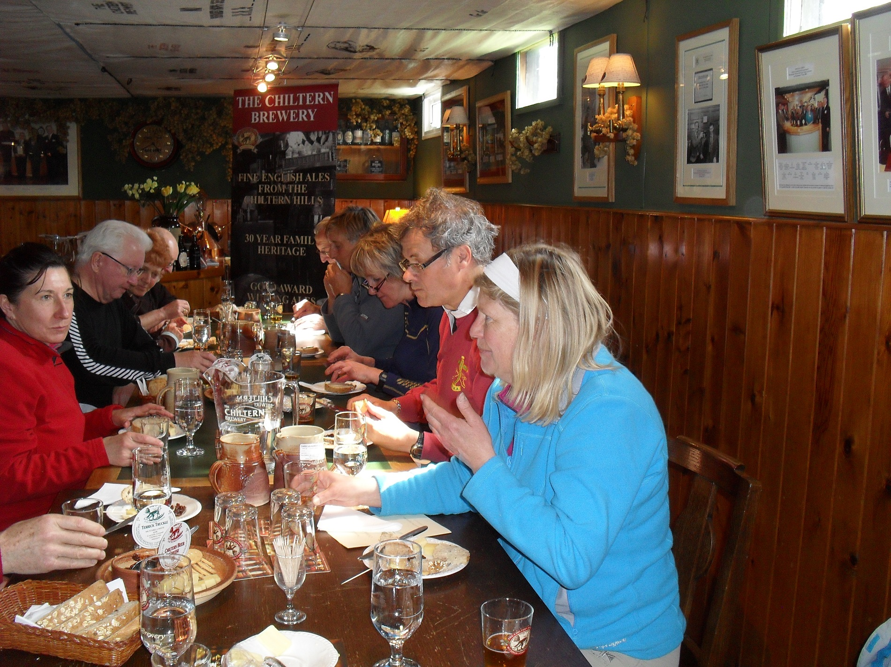
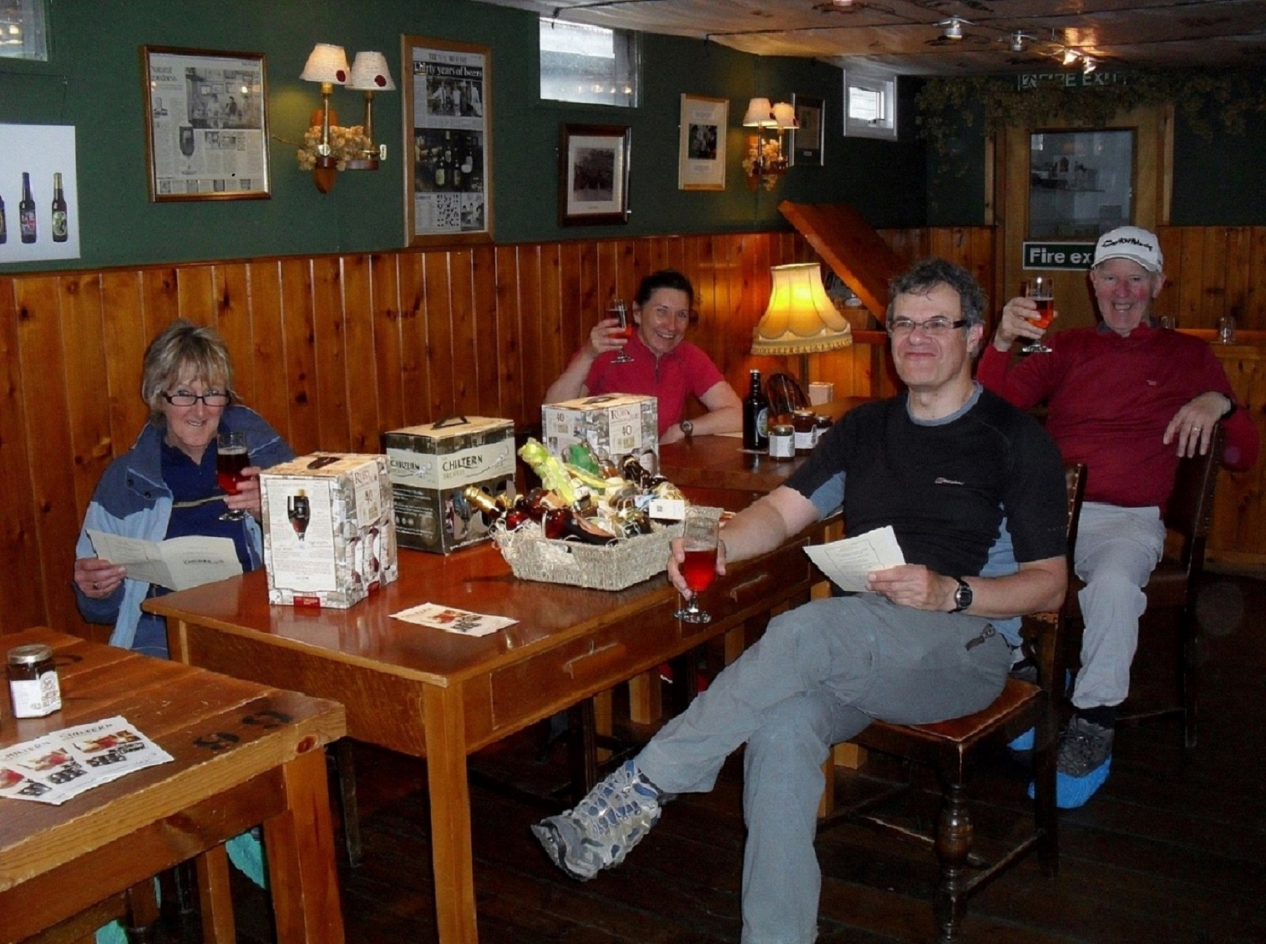

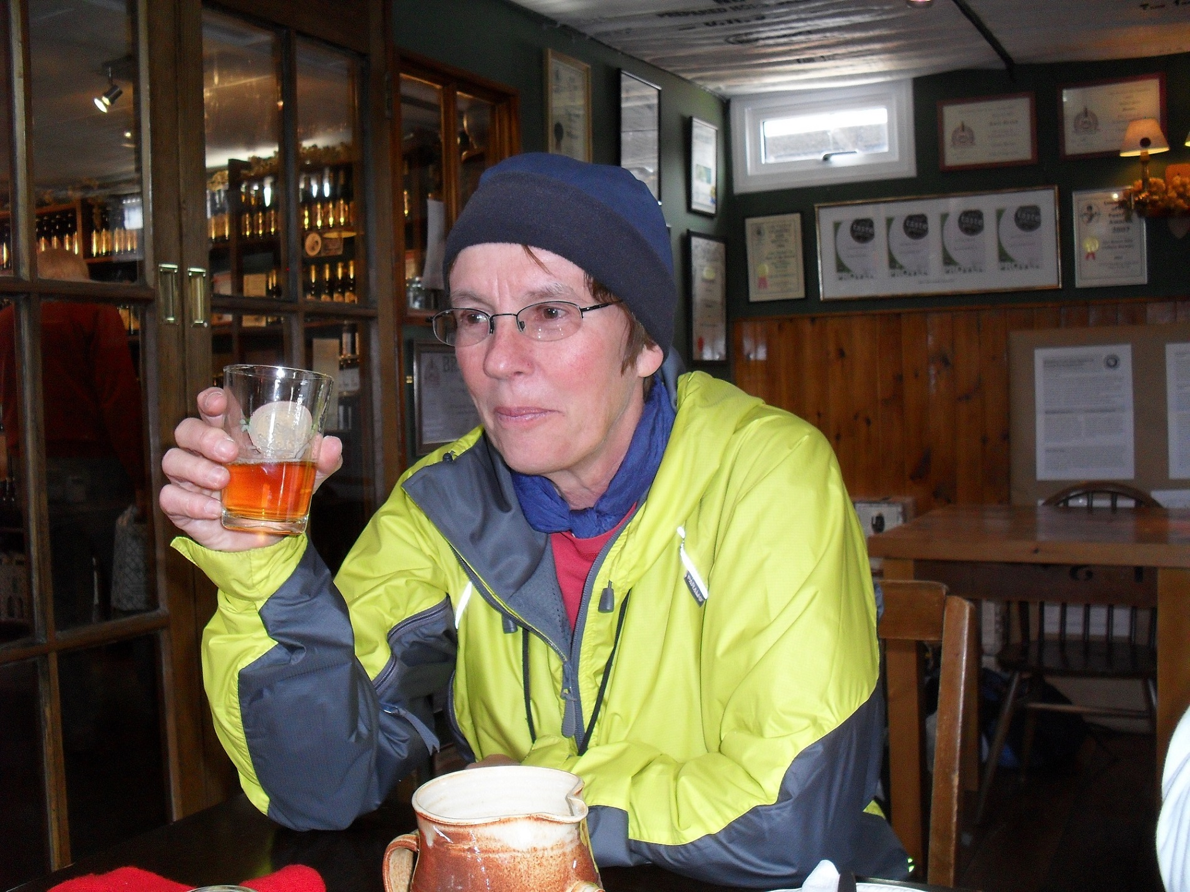 |  | 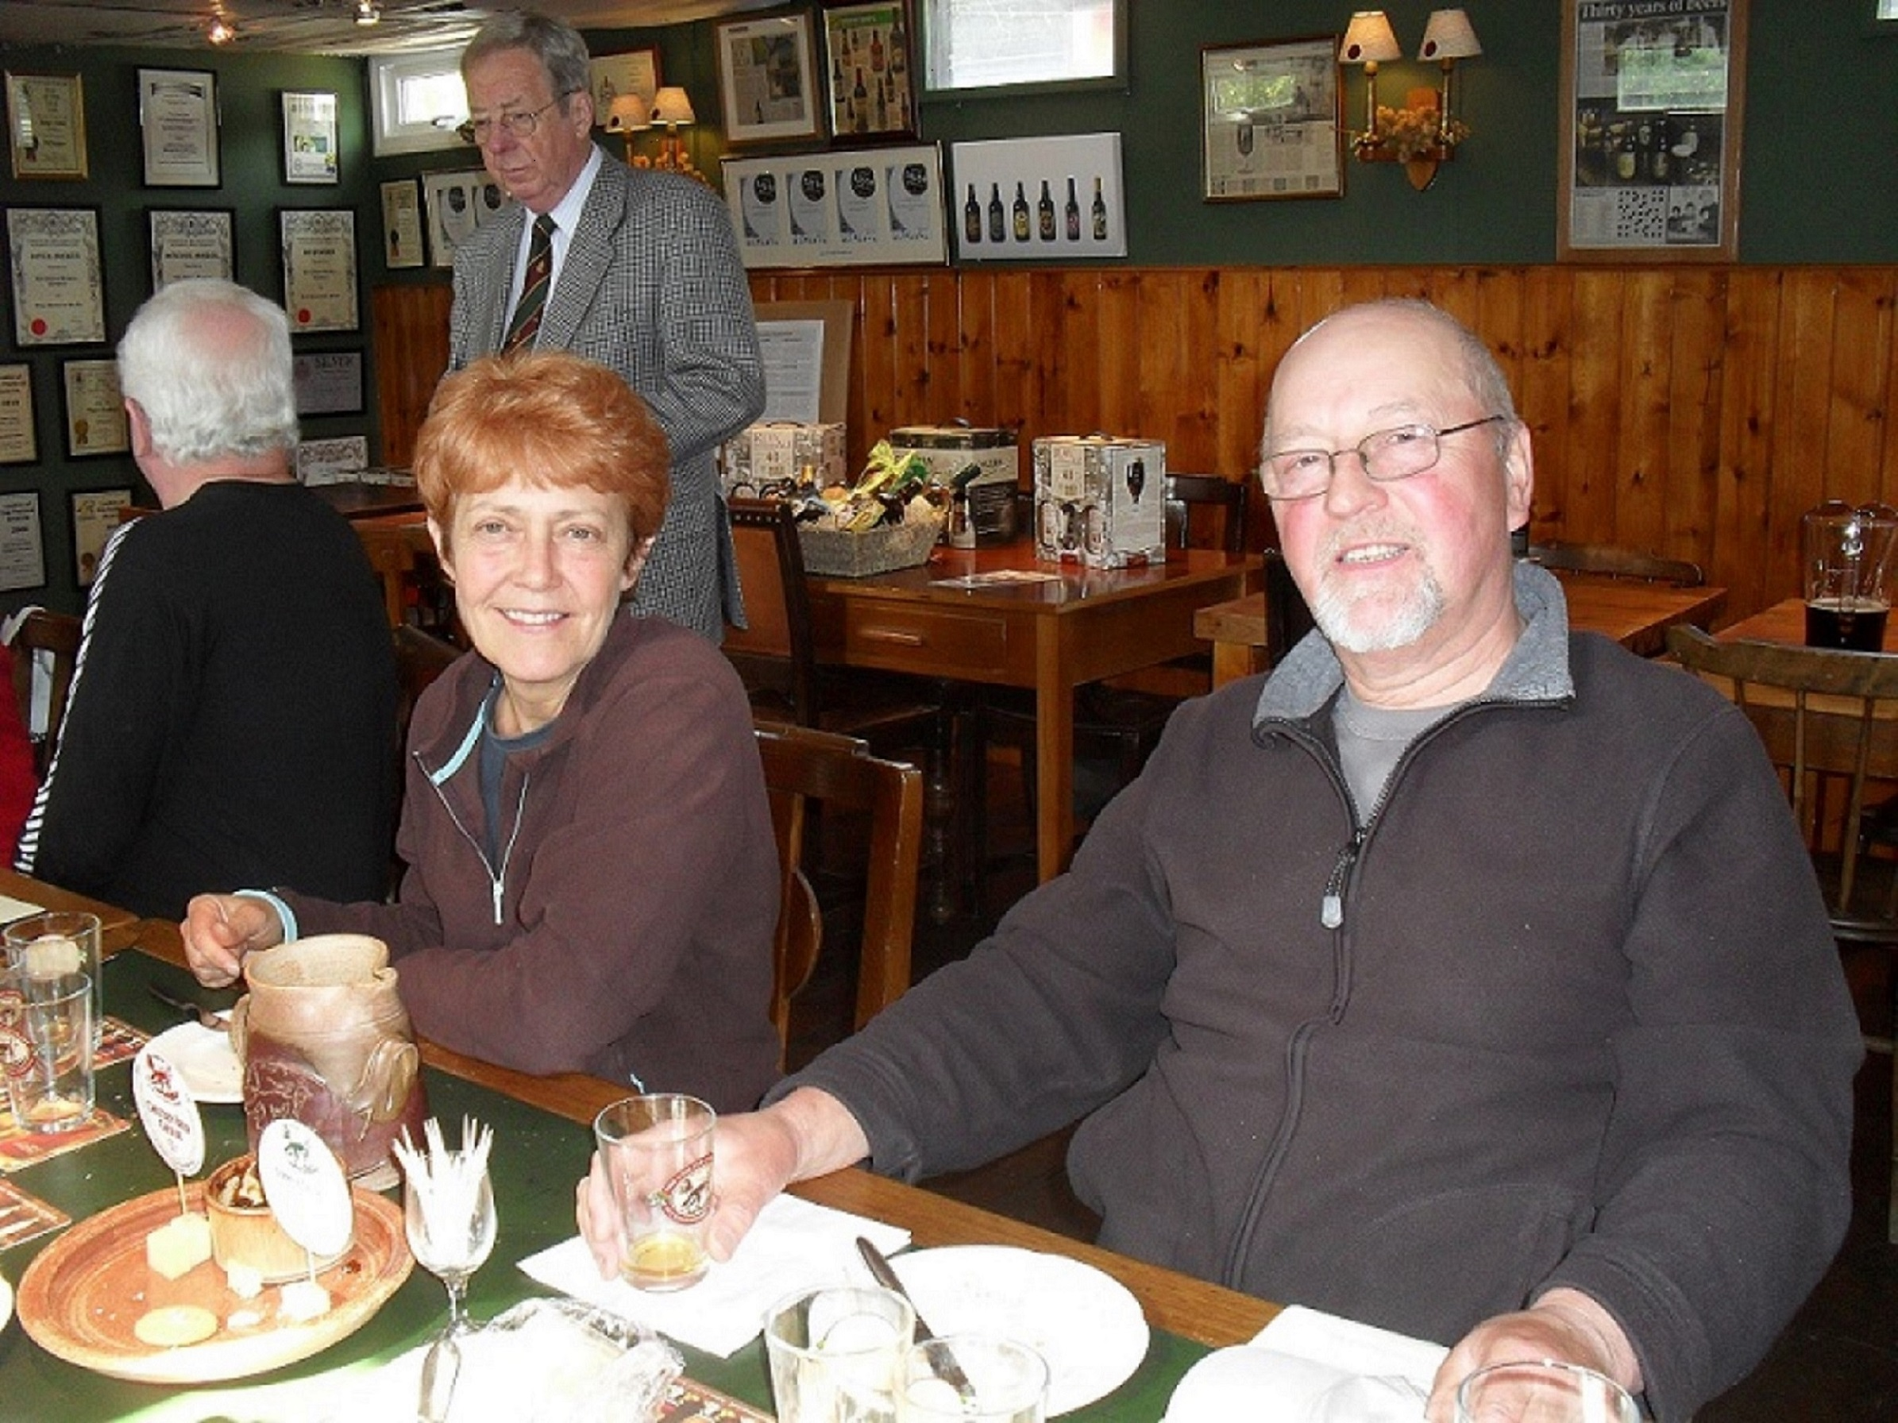
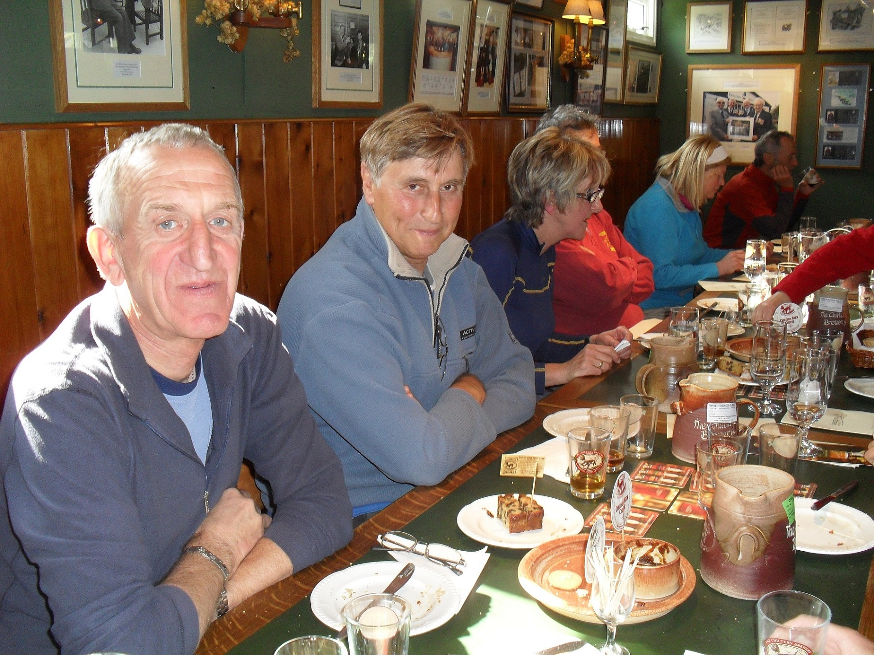 |  | 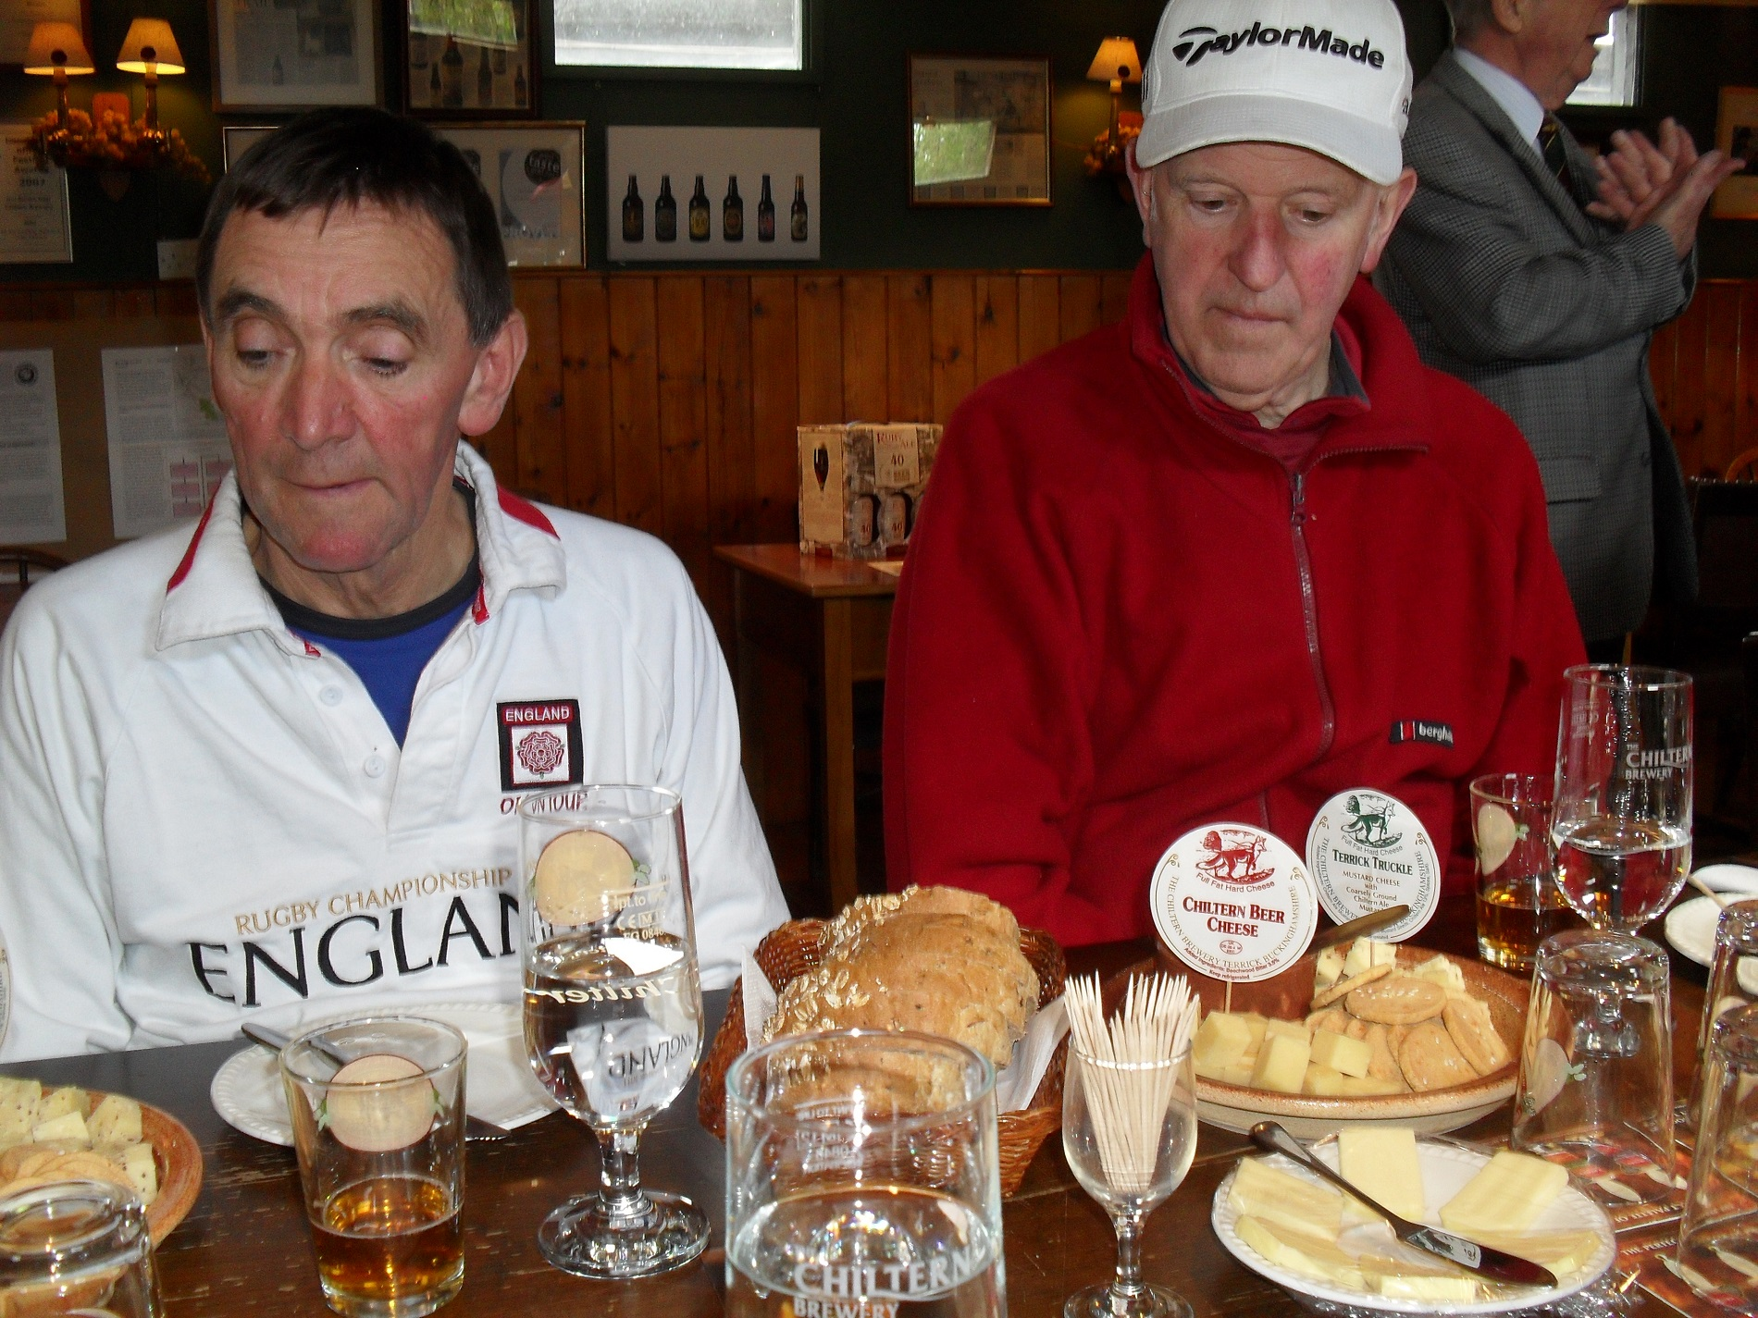

Special Anniversary Events ….. Still to Come in 2013 …….

30 mile group walk - Saturday 22nd June
Chris Bent is leading a special 30 mile circular group walk from Whittlebury in celebration of our 30 years.

Beds 30km group walk - Sunday 30th June – Sue Leonard leads the first of our anniversary walks, one in each county.

Bucks 30km group walk - Saturday 27th July - Dave and Lynn Yorston are organising the second celebratory walk. Everyone is invited to stay for tea and snacks afterwards in their back garden, weather permitting. There may also be an opportunity to visit ‘Malt, the Brewery’ which is located at the end of the road.
30th Anniversary Canal Boat Cruise - Sunday 18th August

As mentioned in the February 2013 Newsletter, one of our 30th Anniversary events is a two hour Canal Boat Cruise from Pitstone Wharf along the Grand Union Canal to Marsworth and back with a Fish and Chip supper being served. Currently there are 25 people booked on the cruise; the minimum amount we need is 30 people.

There is a vegetarian option and you don’t have to have a meal either, you can just pay for the cruise and enjoy your time at the bar!

As mentioned previously we will charge members £10 per head (£5 per head for non-eaters) with the rest of the trip being subsidised from group funds. The balance is due two weeks before the trip, so I would ask that you pay your monies to me by the 31st July please.

Gill, Therese and I recced the route in glorious sunshine on Sunday 2nd June and according to Therese’s GPS the route measures 13.8 miles. Zut Alors!

The canal boat company have asked that we be on board the boat at 2.45 p.m. to hear all of the various safety regulations. We will try to get there as close as possible and for that reason the walk will start at 9 a.m. prompt.

So if you are still undecided or know of anyone else who might be interested please contact me.

Norman Corrin

Walking the John Bunyan Trail over 4 days (2 weekends)
Sat 31st August/Sun 1st September & Sat 7th/Sun 8th September 2013
We are walking the 78m JBT in 4 parts over two consecutive weekends. All walks are linear with coach/mini bus transport to the start and then walk back. Transport cost is £10 per weekend. Further details and book transport (Pts 1 & 2 by 19th August and Pts 3 & 4 by 29th August) via Gill Bunker T: 01908 321308 E: gillbunker@googlemail.com
Sat 31st August JBT Pt 1 Cranfield to Harlington
Sun 1st September JBT Pt 2 Barton to Harlington
Sat 7th September JBT Pt 3 Cranfield to Elstow
Sun 8th September JBT Pt 4 Barton to Elstow
Further details of each day’s walking are in the August-December programme.
Northants 30km group walk – Sunday 22nd September 2013
Martin Lawson leads the third of our anniversary walks from Hartwell.
Milton Keynes Boundary Walk over 3 days
Sat/Mon 19th/21st October 2013
As part of our 30th anniversary celebrations we are walking the 60 mile MKBW (devised by founder member Chris Meredith) over 3 consecutive days of approx 20 miles each. All walks are linear. Please contact Sylvie Eames well in advance to arrange car share. Please use Sylvie’s school email: Sylvie.eames@akeleywoodschool.co.uk as the contact point up to Friday 18th October – not her phone and by no later than 1pm on Friday 18th October.
Sat 19th October MKBW Pt 1 Stony Stratford to Woburn Sands
Sun 20th October MKBW Pt 2 Woburn Sands to nr Bozeat
Mon 21st October MKBW Pt Nr Bozeat to Stony Stratford
Further details of each day’s walking are in the August-December programme.
Milton Keynes Boundary Walk
The walk is named after the new city of Milton Keynes. Being a new city people often assume that it has no past whereas it encompasses the older towns of Bletchley, Newport Pagnell, Olney, Stony Stratford and numerous villages and there is a wealth of history and heritage to be found in. Some of these are mentioned in the Domesday Book, including the village of Milton Keynes from which the new city takes its name. It is not a concrete jungle despite the cynical jokes about the concrete cows. Tree lined boulevards are a feature of the grid roads which run north-south (V) and east-west (H).
Because so much has been written about the development of the city visitors could be forgiven for thinking that there is no countryside in Milton Keynes. However about two thirds of the area is rural. There are over 4000 acres of public open space and 470 acres of lakes and waterways. Over 20 million trees have been planted. Milton Keynes has 300 miles of public footpaths and bridleways and there are many attractive circular walks. The famous Redways provide a network of cycleways and footpaths so one can traverse the city without coming in contact with busy roads. The National Cycle Route which runs from Dover to Inverness passes through the city.
The 60 mile Boundary Walk goes through the famous Woburn Golf Course but does not pass through the city itself. At times from a distance one can see the Ski slope situated near the city shopping centre. In 1997 the shopping centre was voted top out of 900 centres in Britain. The city hosts one of the largest collections of publicity sited art works. There is a theatre and art gallery, several museums and the famous Xscape centre with its many cinemas and pubs.
But for the Long Distance Walker the 60 mile route is diverse in history and scenery.
In October we are likely to have muddy fields. We are walking an anti- clockwise route starting from Stony Stratford from whence the saying a “cock and bull” story originated. For more details join us on 19th October 2013. Please let me know well in advance if you intend to take part. Contact me via email Sylvie.eames@akeleywoodschool.co.uk up to Friday 18 Oct – not by phone - and no later than 1pm on Friday 18th October to co-ordinate transport.
We look forward to you joining me, Steve and Gill.
Sylvie Eames
Sylvie.eames@akeleywoodschool.co.uk

30th Anniversary Quiz Event - With BBN, Essex/Herts, Thames Valley, London groups - Sunday 27th October 2013

Guess what folks, it’s the return of the quiz. Where has it been for the last two years you ask? Well my fellow quiz organiser got married, ran out of T-shirts, and frightened two of our younger members so much they’ve not been seen since!

As this is a special year for BBN we decided to resurrect an old favourite so here it is. Our friends in Essex & Herts, Thames Valley and London groups have been invited, so hopefully there might be some real inter-group competition!

The walk distance is circa 8 miles this year (please note starting time of 10 a.m.) as there is a spokesman from Berks Oxon and Buckinghamshire Air Ambulance attending before the quiz starts. We made a donation from group funds in 2012 and they offered to send a representative along to make a presentation about their service. So we couldn’t refuse their offer. After this presentation lasting 30 minutes or so there will be a short question and answer session along with the chance to buy some merchandise.

There will be a light snack and some drinks (tea and coffee, Dave and M!) followed by the quiz consisting of 10 rounds of 10 questions on a variety of subjects. Please don’t expect a round on “Sir Alex Ferguson and the glory years at Man Utd”!

Teams can be made up of family and friends from other groups. We would ask for a small donation from each person to cover the cost of the food and hire of the venue. The quiz lasts for about 2 hours. It would be interesting to see if the
magnificent silver LDWA cup will be taken outside of the three counties of the
group for the first time. The only problem is I now have to remember who has the trophy!

It’s a fun day out so why not come along and impress us all with your knowledge (or lack of it!) and see if you can add another name to the illustrious list of winners.

For further details please contact me.

Norman Corrin

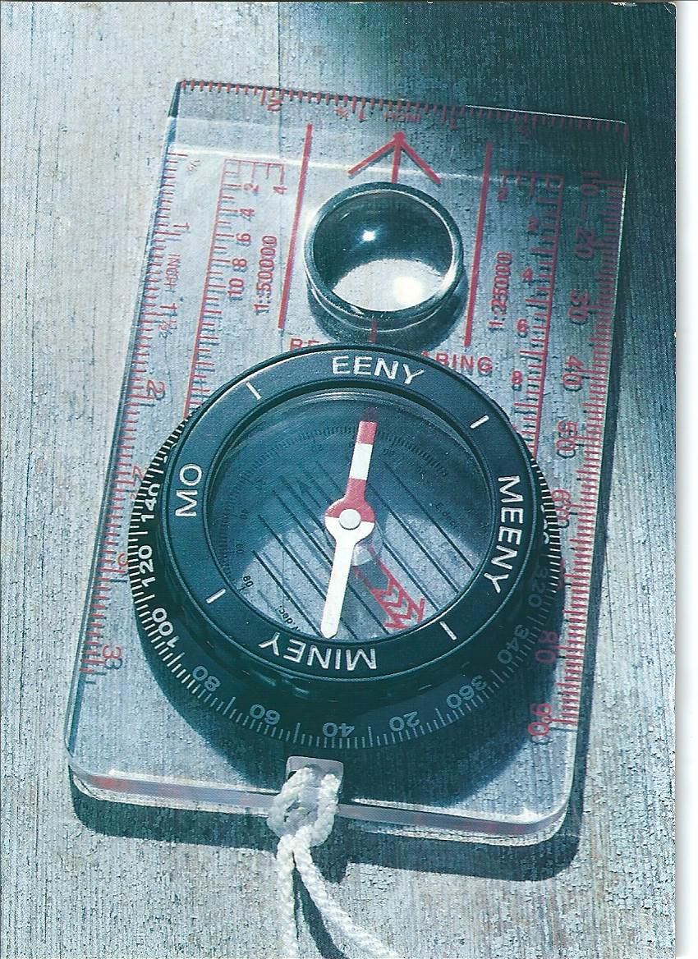

Time for Tea at Ridgmont Station?

The route of the Greensand Ridge Walk was recently diverted to pass through Ridgmont village, with a link to the railway station on the Bletchley to Bedford line.

Summer 2013 will see a 5-year project to restore the neglected Ridgmont Station come to fruition. Built in 1846, to an attractive design common to the line, it has been neglected since the 1970s, although until the 2004 route modernisation it provided a waiting room and a crossing keeper’s room.

The building is to be run by Bedfordshire Rural Communities Charity and will also provide a base for the Marston Vale Community Rail Partnership. Grant aid came from the Rural Development Programme for England, the Railway Heritage Trust and Central Bedfordshire Council.

It will house a heritage centre, café, shop, tourist information point, meeting room and toilets. Upstairs there will be small offices for rent. The café is proposed to be open 0700-1700, Monday to Friday, plus Saturdays in summer. A car park will be added.

The facility deserves the support of walkers on the Greensand Ridge, John Bunyan Trail and in the wider Marston Vale and Woburn footpath networks. I hope to lead a walk to include a break at Ridgmont Station in 2014.

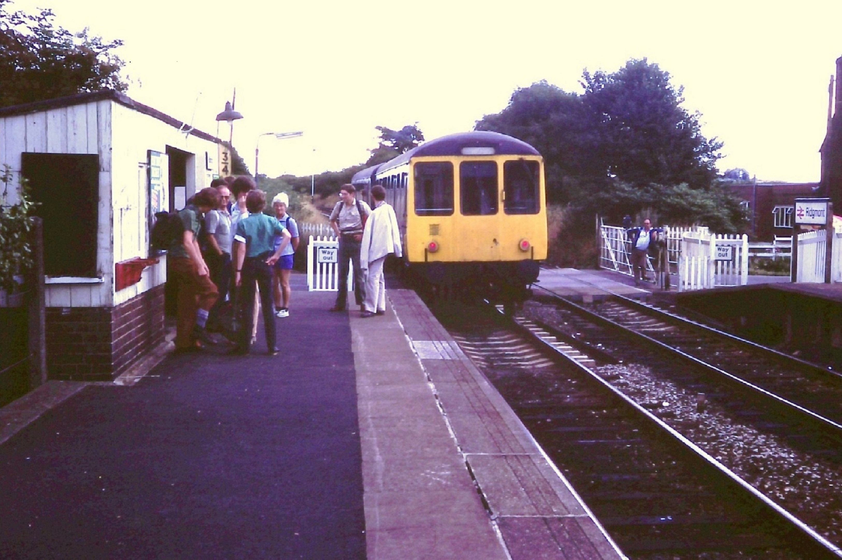 | A rail ramble 1983-style with MK Ramblers alighting at Ridgmont

Mike Bowley

CAMINO DEL NORTE (STAGE 1)

You have to admire the people who walk from Irún to Santiago de Compostela in one go. Mooi and I didn't even try. It takes about five weeks to complete the Camino del Norte, five weeks which I do not have. Instead, we decided to walk from Irún to Santander and then to return home so that I could get back to work. Even that took eleven days of walking a 280 km stretch through the Basque Country and Cantabria with a heavy load on our backs. The first six days, to Bilbao, were hard. Although we never got much above 500 metres in altitude, the route went up and down all day, every day. On the toughest day of the six, we climbed 915 vertical metres in all, and descended nearly as much.

The Camino del Norte is just one of the multiple tracks across Spain, and indeed much of Europe, that lead to Santiago, a historically important pilgrimage town in the north-west corner of Spain. The most popular route, the Camino Francés, starts at St.-Jean-Pied-de-Port on the French side of the Pyrenees, and there are several GR paths through France that link up with St.-Jean-Pied-de-Port. We walked from Le Puy-en-Velay in the French Massif Central to Santiago in five stages between 2000 and 2006, following the GR65 in France and the Camino Francés across Spain. We understand that the Camino Francés has since become too popular for its own good, having become so crowded that pilgrims fight for accommodation. In 2011, Mooi and I walked an alternative route, the Camino Portugués, from Porto to Santiago. This was a manageable route, taking ten days to complete, and it was almost empty by comparison. On the Camino Portugués, other walkers told us about the Camino del Norte. This year, we decided to try it.

The cold never ceased (it was late May), and there was ample rain to go along with the cold. One day, after an extremely damp walk and an all-night rain, we almost packed it in. But the rain stopped just as we approached the bus stop in the town where we had stayed. We decided to walk on. There was some grim town walking at times, especially along the river leading out of Bilbao, and plenty of asphalt at other times. As long as they don't threaten to overwhelm the walk, I don't mind marching through industrial suburbs for a while. Industrial suburbs are, after all, just as much a part of the cultural landscape as cows in the fields with bells round their necks. In any event, these were offset by fine sandy beaches and views of coastal cliffs, and by steep tracks up and down through forest.

The final five days were easier than the first six, and finished with a ferry across the estuary at Santander. But we were tired at the end, and had picked up some minor complaints that might have discouraged us from walking much further had we had the time. You have to admire the people who carried on after we departed.
Peter Simon

CAMEL TEIGN HUNDRED – IVOR’S DREAM

33 BBN started, 8 retired, 25 finished, 4 first timers, 2x10 badges achieved
Start Finish Time 100s done

Graham Bayes 09:30 01:53 40:23 3
Ruth Bowles 09:30 rt11 1
Dee Brockway 09:30 05:24 43:54 5
Luis Broz 09:30 23:41 38:11 10
Brin Bunker 09:30 20:28 34:58 3
Jim Catchpole 09:30 01:53 40:23 4
David Chesher 11:30 06:58 43:28 1
John Chesher 11:30 17:25 29:55 4
Glyn Dimmock 09:30 05:39 44:09 1
Dave Findel-Hawkins 10:30 15:20 28:50 17 marshals' walk
Phil Friede 09:30 05:24 43:54 2
Andrew Gilbertson 09:30 03:33 42:03 6
Jill Green 09:30 01:53 40:23 22
Peter Hamson 09:30 21:03 35:33 17
Tony Hill 09:30 18:26 32:56 6
Gill Howe 09:30 03:33 42:03 3
Mike Hyland 09:30 rt5 13
Paul Keech 09:30 21:26 35:56 1
Paul Lawrence 09:30 rt9 1
Martin Lawson 09:30 19:20 33:50 18 marshals' walk
Brian Layton 09:30 17:46 32:16 14
John Ledger 09:30 rt11
Sue Leonard 09:30 rt8 3
Graham Missing 09:30 21:37 36:07 1
Colin Scargill 09:30 20:38 35:08 10
Nigel Schofield 09:30 rt8
Dave Sedgley 09:30 rt10 1
Gordon Shaughnessy 09:30 rt6 2
Nick Vanson 09:30 23:39 38:09 4
Jonathan Venning 09:30 23:20 37:50 3
Derick Wheelhouse 09:30 18:00 32:30 2
Jan Williams 09:30 00:33 39:03 2
Dave Yorston 09:30 08:18 46:48 13
A Dream come True! - Andrew Gilbertson & Gill Howe
I think this was my best ever 100; not my fastest (Wessex), nor the longest, that was Scotland. So why the best?
Well it was our first as Man &Wife!
Plus a brilliant, very varied route, and sunshine all the way, apart from night time when we had a beautiful orange moon and a shooting star. My wish came true.
Nature is wonderful - lots of late bluebells and other flowers; delicate foals; I heard my first cuckoo of the year; Gill was very brave walking over a snake in the road.
The view from Brown Willy was spectacular, much better than the last time I was there (1975)!! Bodmin Moor and Dartmeet were Gill's favoured spots.
Apart from a slight delay at CP2 the organisation was first class. Excellent checkpoints with great food. I gained 2 kilos, (I'm blaming the Cornish Pasty and cream tea); chocolate cake at CP10 and soup with the Scouts was much appreciated by Gill.
The walking was wonderful, easy going (apart from the stony track leading to Larcombe Farm!) and very rewarding.
We took our time and savoured the views. A wonderful walk. A big thank you to all who helped.
ooooooOOOOOOoooooo

Camel-Teign Ivor’s Dream 100 - Graham Missing

It is 10pm on a bank holiday Sunday night and I am far away from home in a school cafeteria. The day has been sunny and hot and I could have spent it lazing in the garden relaxing with a long cool drink.

My feet are shredded, my heels blistered, my leg muscles screaming and my back aching and for some unfathomable reason I have voluntarily spent the last day and a half getting myself into this state.

Years ago, when I received my first copy of Strider, I read of five hundred people who had taken part in a challenge walk of one hundred miles in 48 hours. Even though there were photos to back it up I had to check that it was dated August and not April first. During the following years, whilst not doing much walking, I have each year read of these normal? people doing this crazy event. Often when
talking to friends and work colleagues about walking I would mention the LDWA and add that every year there is a hundred mile walk. They are always as incredulous as I first was, that is if their faces did not just completely blank over with incomprehension.

Over the last few years I had happily fitted in a few short walks and the odd challenge walk and continued to read the Hundred reports. Last year, upon retiring, I did my first social walk and have enjoyed the fortnightly outings ever since. A strange fever seemed to take over the group last spring with a lot of the conversation in April and May revolving around preparation and planning for the 100 and in June tales and recollections of the event itself. The next 100 report now seemed more tangible as it was not just something I read about, I now knew people who had done the event and even saw photos of some of them.

I am still not sure just who to blame for pushing the idea that I would be able to complete a 100, it just seemed to grow. Whilst still not committing myself, I entered and completed the White Cliffs Challenge and now having the qualifier I was told I no longer had any excuse not to enter Ivor’s Dream in 2013.

So thanks to you all, especially Merrian, Dave, Gill, Gordon, Brian and Martin, who encouraged and conned me into entering and gave me so many useful tips on how to complete my first Hundred. It is all your fault that I am sitting here in this broken state but, you are right, I did enjoy it and it was a tremendous feeling completing my first Hundred.

ooooooOOOOOOoooooo

The First Hundred - Ivor's Dream – Paul Keech

Why? Exactly, why did I want to subject myself to such an ordeal that I knew would be extremely tough and painful?

Knowing how I felt after completing a few 50 milers and speaking to some 100 mile veterans left me in no doubt regarding the scale of what I was taking on. But, the time seemed right; I was not running in the London Marathon this year and so could devote time to training for a 100 attempt. Also, I like Cornwall/Devon and Bodmin Moor was somewhere I have always wanted to get to know better.
So the seeds were sown and the challenge was to be engaged.

Training. Training went fairly well with lots of 20 mile social walks and run/walk sessions over the last few months with various terrain and conditions, from the
squelching mud and snow of Jan/Feb/March to the cold, dry and windy conditions of April. Completing the Woldsman (50) and feeling reasonably good provided an additional benefit. So, roll on May.

The Event. Without going into too much detail of the build up and the event itself I will make some observations that may be of interest:-

The logistics in sorting everything out, the when, what, where is a bit overwhelming for a first timer but it all seemed to run very smoothly from my perspective - including accommodation/food/bags preparation/travel/registration/kit check/route check.

To the event itself and the debate about start time 9.30 or 11.30? - too early a start and I would arrive at CP2 too early but better than waiting at the start for two hours (coach from Teignmouth arrived at 08.30) and maybe finishing in the dark on Sunday night? My targeted time was 36 hours so a 9.30 start meant finishing at 21.30 on Sunday night. Matter resolved and in the event I had to wait at CP2 for 20 mins but no issue there.

The camaraderie and the friendly welcomes were second to none - as we have come to expect in the LDWA. The CPs were excellent - from range of food to the service provided. Each CP had its own identity and by breaking the distance up by getting from one to the next kept me going. The only dilemma was choosing what and how much to eat/drink?

Highlights - the views from Bodmin Moor, arriving at Tavistock breakfast stop at 03.24 whilst it was still dark and then leaving as the sun came up. Having a wash and change of gear at Tavistock. Walking up to Dartmoor with the frost glimmering on the grass and looking down at the mist in the valleys. Arriving at Princetown CP at 07.00 in the morning to be welcomed by Dave F-H and M on their second marshal stint with the knowledge that I ONLY had 34 miles to go and the day had just begun! The weather conditions were near perfect - couldn't have asked for better.

Lowlights - very sore, slightly blistered soles of the feet and painful/swollen top of the left ankle from too many lanes/roads and stony tracks - last mile down Shepherds Lane into Teignmouth was particularly excruciating.

Also worthy of note was my teaming up for most of the way with fellow BB&N member Jon Venning. Jon developed the 'leaning' syndrome which was so bad by CP14 that he could not continue but was assured by a marshal from the Irregulars that 'no one retires at our Check Point'. Jon was advised to lie down to see if his back would come out of spasm. I subsequently learned that Jon soldiered on and did finish - so well done to him.

I finally finished 4 minutes before my 36 hour target at 21.26 on the Sunday evening to a welcome applause and numerous calls of 'well done'.

It was painful at times and it was sheer willpower at times but the desire to finish carried me through with some unforgettable memories to take away.

I have to finish though with my utmost respect for all the marshals and organisers who made the event possible, thanks to all.

South Wales? Never say never!

ooooooOOOOOOoooooo

My Camel-Teign - Ivor’s Dream - Graham Bayes

I am a part-time walker so I enter the annual Hundred with some trepidation. I usually rely on my running training rather than walking to provide my fitness but this year, due to a displaced pelvis my running has been somewhat curtailed. I did however manage two good walks, the Winter Poppyline and the Valleys and Views.

On the 4th May I went on a 14 night cruise to the Canary Islands and although cruise ships are very large good walking is not really possible. But with a view to fitness I did use the stairs and not the lifts and I got to the gym every day.

The day of the walk came. I much prefer circular walks where you can get up at 8am and have a leisurely breakfast, take your time getting to the start and be ready to walk. This year we had the caravan near Teignmouth so it was up at 5am, in time for breakfast and to get to the school for 6am for the coach to the start. We arrived at Wadebridge just after 7.30 and then we had nearly 2 hours to kill before the start.

Once underway the first two sections were very easy and despite heeding Dave FH’s warning not to go too fast I was ahead of my schedule at checkpoint 2. As I left the checkpoint I again bumped into Ben Cooley from Hereford who I had walked the last 70 miles of the Games Hundred with. Again we set off together. We soon arrived at Candra and the welcome sight of the BBN checkpoint. After a short break we set off across Bodmin Moor towards Brown Willy. How cruel to put a clipper point at the summit but it was a clear day and the views were impressive. Another short walk and we were at Bolventor. The Jamaica Inn was very tempting!!

On we went with fairly easy walking and guided by the flags across the moor to Pensilva. As we left we joined up with Jill Green (I walked the last 30 miles of the Scotland hundred with her), Jim Catchpole and John Marshall. (We stayed together to the bitter end.) It was a relatively easy walk until the slog up Kit Hill which was a real conversation stopper. It was then down the other side to the last Cornish checkpoint at Luckett. I went into the checkpoint feeling a little queasy so I sat by the door for some air. Unfortunately the pick up van parked just outside the door with its exhaust pipe pointing through the door. One deep breath and I was running out into the street to re-acquaint myself with my last food. (I was not the only one.)

We then set off on the short walk to cross the Tamar into Devon. There was a sign saying “You are leaving God’s country”. There should have been another saying “Welcome to Hell”. We were immediately into the hills and the slippery shale paths.

When we reached the breakfast stop at Tavistock we were still a little ahead of my schedule. The breakfast was very welcome and very good but there was no warm water in the gents changing room which was a disappointment.

We set off again and climbed up onto Tavistock Golf Course where we stripped down to our warm weather walking kit and were soon on Dartmoor heading for Princetown. My wife and daughter were meeting us there so I rang and ordered some bottles of Lucozade Sport which were delivered to us as we left the checkpoint. I did not realise two bottles could weigh so heavy in the rucksack. I will not be doing that again. The hike to Hexworthy looked quite simple but Jim tripped on a rock and injured his knee as well as cutting his arm and leg. We stopped for repairs but this seemed to slow our momentum.

Leaving Hexworthy we crossed the river Dart and made the big climb to the parking area at Yarker Down where there was the welcome sight of extra water for us. We then had a lovely ridge walk on the way to the checkpoint at Ashburton. This seemed to take forever and we lost a lot of time on this section. However as we walked down the hill to the checkpoint I saw my wife and daughter were there talking to Steve Clark. They were a welcome sight. We went into the checkpoint and found we had to go upstairs. Organisers can be cruel !!!

We continued on our way uneventfully but slowly through checkpoint 13 to checkpoint 14 at Chudleigh Knighton where once again the organisers showed their evilness with an upstairs checkpoint and here, to make matters worse, the gents toilet was below ground level, a double whammy.

We left the checkpoint thinking only 9 miles to go. It was. But what a nine miles.
Firstly we had a one mile 660 yd climb to a self-clipper point. It was on road but it seemed to go on for ever and then we came back down again and along the flat until we reached Hamblecombe Lane. Of all the loose stoned lanes we walked, this was by far the worst. Very difficult walking and it came at a time when the human body was working something like a computer with a poor WIFI connection. The message from the brain to the legs was not getting there quickly enough for the feet to react to the loose uneven surface and staying on your feet was quite difficult. At last we reached Larcombe Farm and the last checkpoint. Welcome relief. But soon it was out again onto the same lane soon to be followed by a 1500 metre steep climb up a similarly surfaced Three Tree Lane. Near the summit there was a very unhappy scantily clad couple in a car that made a hasty getaway as we passed them. Then it was across the golf course, down Shepherds Lane to Teignmouth and on to the finish at the school. Arriving 40 hrs and 23 minutes after setting off.

The five of us walked in together exhausted but happy. My wife Jane had only been there a couple of hours waiting but she was made welcome. Ben and myself had been dreaming of a meal of pasty, mash, peas and gravy at the finish. Were we disappointed? Yes of course we were, but the stew was great.

A great event and thanks to all involved in the organising and running of it.

Wales. Bring it on.

ooooooOOOOOOoooooo

Camel-Teign 100 or once again my very last 100 – Dave Yorston

This has been my very last 100 mile challenge event and WOW what a good one to call it a day on. I have started 16 and completed 13 100s, been places that you could only get to by foot, walked with many different people and seen many unusual sights !!

I started this year’s event with a number of our BBN members, but as we walked down the Camel Trail, we sorted into smaller groups of similar pace. I teamed up with Nigel with whom I continued right up until breakfast.

We were greeted at CP2 by the London/Surrey group and especially Kathy who served us with our first real snack and drink of the day. We then travelled over Bodmin Moor to reach the luxury of the BBN barn for CP3 where the TLC was handed out by our friends.

The weather was great and certainly the view was so clear from the top of Brown Willy. Blue sky and soft breeze and sunshine – what more could we ask for.
Darkness fell as we reached Pensilva. The evening birdsong was beautifully loud but the star of the evening was the bright orange globe of the full moon. We took a short break here as Lynn and Sandra had driven up to meet us. Unfortunately, so had Mike as he had been forced to retire at the previous CP. We all had a good chat and once rested, Nigel and I set off into the dark.

As the sun rose and the dawn chorus hit full pitch, we arrived at Luckett. A quick stop here and we pressed on to Tavistock and our breakfast in Devon. Much to our distress, we had BOTH started to lean over, Nigel first then me. As we walked into the Kelly College it became clear that Nigel would not be able to continue and I had to make a very hard decision. I took as long a break as possible and managed to get my back upright again.

After saying a sad good bye to Nigel, I joined up with Jean and others to set off into the distance to cross Dartmoor. Princetown was in blazing sunshine when we arrived for another (unofficial) BBN welcome. Jail Ale is GOOD with crumpets.
Darkness was looming when we arrived at Ashburton. A good break here and then onward. Fatigue was starting to be a problem now. Another full moon and only 20 miles to go, Jean and I were determined to finish.

The next checkpoint was staffed by Ivor’s Scout friends. What a fantastic tribute to his memory. We took a short stop here and then walked on into the night.
At Chudleigh, we took time to get a catnap. Tiredness was really hitting us now. We left as a large group and supported each other into this last 10 miles.
After leaving the last Checkpoint, Jean and I decided to pull out all the stops and get this event finished. We raised our pace and marched along the route into Teignmouth. We were welcomed at the school gates by Lynn and Sandra who clapped us in all the way down the path to the hall. The room shook with cheers when we walked in.

What a great feeling. We may not have been fast but we finished well within the time limit.

Yes – this really was my last 100 challenge. I will be helping in Wales next year but I will not be walking it.

Special thanks must go firstly to Ivor who I really hope was looking down on his event. Thanks also to Nigel and Jean for being my walking companions and to everyone who worked so hard to see us round.

ooooooOOOOOOoooooo

WALKS PROGRAMME : AUGUST TO DECEMBER 2013

Sun Aug 11 2013 Wheathamstead Walkabout
18ml. Start 09.00 from Wheathampstead East Lane public c.p. on lane adj to Bull p.h. Map: LR 166 (GR TL179141). Joint Walk with Essex & Herts. C: Gordon Shaughnessy T: 01582 518791 M: 07518 364036.

Thu Aug 15 2013 A Walk from Wilstead
15ml. Start 09.30 from Wilstead village c.p. (220yds from crossroads towards Cotton End – on rhs). Maps: Exp 193,208 (GR TL066435). C: Colin Scargill
T: 01234 740361.

Sun Aug 18 2013 BBN 30th Anniversary Canal Boat Cruise
15ml. Start 09.00 prompt from Grebe Cruises c.p. Pitstone Wharf LU7 9AD. Map: Exp 181 (GR SP927160). Walk followed by 2 hour cruise and Fish & Chip Supper along Grand Union Canal from Pitstone to Marsworth Reservoir and return. Cost £10. Please contact leader if you wish to sail.
C: Norman Corrin T: 01908 608667 M: 07980 378656 on day.

Sun Aug 25 2013 To Mellow Yellow and Beyond
20ml. Start 09.00 from church in Hargrave. Pls park considerately in village. Map: Exp 224 (GR TL036706). Visiting Catworth, Spaldwick, Stow Longa, Tilbrook and Upper Dean. Please bring packed lunch. C: John Ledger T: 01933 387645.

Thu Aug 29 2013 Northampton Round – Cogenhoe to Holcot
18ml. Start 09.00 NOTE EARLY START from Memorial in Ecton at jnct of High St and Wellingborough Rd. Street parking available nearby. Map: LR 152 (GR SP827637). C: David Findel-Hawkins T: 01908 216476.

Sat Aug 31/Sun Sep 1 & Sat 7/Sun 8 Sep 2013 Walking the John Bunyan Trail
As part of our 30th anniversary celebrations we are walking the 78m JBT in 4 parts over two consecutive weekends. All walks are linear with coach/mini bus transport to start and walk back. Transport cost is £10 per weekend. Further details & book transport (Pts 1 & 2 by 19th August and Pts 3 & 4 by 29th August) via Gill Bunker T: 01908 321308 E: gillbunker@googlemail.com

Sat Aug 31 2013 John Bunyan Trail Pt 1 Cranfield to Harlington
Approx 21ml. Start 08.45 Coach/mini bus transport from Harlington Village Hall, Sundon Road, Harlington. LU5 6LS. Pls park considerately in village. Maps: LR 166 Exp 193 (GR TL037305). Ldr: Eric Cartwright. Further details & book transport by 19th August via Gill Bunker. T: 01908 321308 M: 07790 976090 on day.

Sun Sep 1 2013 John Bunyan Trail Pt 2 Barton to Harlington
Approx 18ml. Start 08.45 Coach/mini bus transport from Harlington Village Hall, Sundon Road, Harlington. LU5 6LS. Pls park considerately in village. Maps: LR 166 Exp 193 (GR TL037305). Ldr: Dee Brockway. Further details & book transport by 19th August via Gill Bunker. T: 01908 321308 M: 07790 976090 on day.

Sat Sep 7 2013 John Bunyan Trail Pt 3 Cranfield to Elstow
Approx 22ml. Start 08.45 Coach/mini bus transport from Moot Hall, Church End, Elstow, nr Bedford. MK42 9XT. Pls park considerately in village. Maps: LR 153 Exp 208 (GR TL049475). Ldr: Derek Jacob. Further details & book transport by 29 August via Gill Bunker. T: 01908 321308 M: 07790 976090 on day.

Sun Sep 8 2013 John Bunyan Trail Pt 4 Barton to Elstow
Approx 18ml. Start 08.45 Coach/mini bus transport from Moot Hall, Church End, Elstow, nr Bedford. MK42 9XT. Pls park considerately in village. Maps: LR 153 Exp 208 (GR TL049475). Ldrs: Therese & Daniel Jamin. Further details & book transport by 29 August via Gill Bunker. T: 01908 321308
M: 07790 976090 on day.

Thu Sep 12 2013 On the Edge (of Northamptonshire)
15ml. Start 09.30 from Brackley Leisure Centre, Springfield Way. Maps: LR 151,152 (GR SP580381). C: Mary Knight T: 07554 661519.

Sun Sep 22 2013 30km in Northants
30km 18.8ml. Start 09.00 from Hartwell Church, Northants. Pls park courteously on nearby rd. Map: LR 152 (GR SP786504). The last in a series of three 30th anniversary walks, one in each of our counties. C: Martin Lawson
T: 01933 678594.

Thu Sep 26 2013 A Different Baldock Bimble
15ml. Start 09.30 from Radwell Meadows c.p. (NW of Baldock). Maps: LR 153 Exp 193 (GR TL235350). Picnic lunch in Ashwell near 3 pubs. C: Phil Hastings T: 01763 853744 M: 07716 992847 on day only.

Sun Sep 29 2013 The Three AWS Sites
15ml. Start 09.00 from c.p. in Chackmore (not NT c.p. in Stowe Ave). Map: Exp 192 (GR SP684357). C: Sylvie Eames T: 07788 287701.

Thu Oct 10 2013 Top Totternhoe
15ml. Start 09.30 from c.p. in Totternhoe. From main rd take lane signed Totternhoe Knolls, NE to reach c.p. Maps: LR 165 Exp 192 (GR SP986218). C: Brian Harwood T: 01234 267654 M: 07944 197085 on day only.
Sun Oct 13 2013 Steppingley Step Marshals' Walk
For SS marshals only. C: Merrian Lancaster T: 01908 642803.

Sat/Mon Oct 19-21 2013 Walking the Milton Keynes Boundary Walk
As part of our 30th anniversary celebrations we are walking the MKBW (devised by founder member Chris Meredith) over 3 consecutive days. All walks are linear. Please contact Sylvie Eames to arrange car share. Please use Sylvie’s school email as the contact point up to Friday 18 Oct – not her phone and no later than 1pm on Friday 18 Oct. Sylvie.eames@akeleywoodschool.co.uk

Sat Oct 19 2013 Milton Keynes Boundary Walk Pt 1
Approx 20ml. Start 08.30 from Stony Stratford Nature Reserve c.p. (unsigned from main rd). Maps: LR 152 Exp 192 Start GR SP791409, Finish GR SP929353. Linear walk finishing at Woburn Sands Church. Pls contact Sylvie to arrange car share- see above. Ldr: Sylvie. C: Sylvie Eames T: 07788 287701.

Sun Oct 20 2013 Milton Keynes Boundary Walk Pt 2
Approx 20ml. Start 08.30 from Woburn Sands Church. Pls park considerately nearby. Maps: LR 152 Exp 192 Start GR SP929353, Finish GR SP902577. Linear walk. Pls contact Sylvie to arrange car share – see above. Finish tbc but will be nr A509/minor rd to Bozeat. Ldr: Steve Clark.
Mon Oct 21 2013 Milton Keynes Boundary Walk Pt 3
Approx 20ml. Start 08.30 Start tbc but will be near A509/minor rd to Bozeat. Maps: LR 152 Exp 207 Start GR SP902577, Finish GR SP791409. Linear walk. Finish Stony Stratford Nature Reserve. Pls contact Sylvie to arrange car share – see above. Ldr: Gill Bunker.
Thu Oct 24 2013 Wind and the Willows
15ml. 09.30 from Prospect Place cul-de-sac signed on E side of A509 1½ miles S of Olney. Maps: Exp 207,208 (GR SP889488). Break at Turvey village near p.h. C: Mike Bowley T: 01908 616589 M: 07933 066784 (on day only).

Sun Oct 27 2013 30 Years with BBN in Paradise - Walk and Quiz
8ml. Start 10.00 from Newton Longville Village Hall. Map: Exp 192 (GR SP848315). Walk followed by quiz. Teams from Essex & Herts, Thames Valley and London groups invited. One of BBN's 30th anniversary events. Drinks and snacks provided at hall. Please contact leader for further details.
C: Norman Corrin T: 01908 608667 M: 07980 378656 on day only.

Sun Nov 3 2013 Steppingley Step Challenge Walk
26, 18 or 12ml. in 10.5 hours. from Barton-le-Clay Village Hall, MK45 4JY (GR TL083306). The walk follows mainly field paths, tracks, woods & some roads
through undulating countryside with good views from the hills traversed. Start: Walkers 08.00; Runners/Joggers from 09.00 (cp times will be adhered to, with NO exceptions. All must be finished by 18.30, Hall closes 19:00). All must bring own mug (none on route), compass & route description which must be down loaded from web site beforehand. We recommend map Explorer 193 or Landranger 153 & 166 (only 166 for 12 mile route), a torch if you expect to finish after dark & waterproofs. This walk is part of the BB&N triple challenge over three consecutive years. Entry: In advance LDWA members £5.00, Non-members £6.00 & Under 18s free (there will be a limit of 300 entrants. No entries on the day) incl refreshments at CPs, meal at finish & certificate for all finishers. Entries close 29th October 2013. Cheques payable to LDWA BBN Group. or entry form downloadable from event website.
C: Mike Hyland., 55, Broadlands Avenue, Chesham, Bucks. HP5 1AL
T: 01494 774154. E: mike.hyland@ntlworld.com

Thu Nov 7 2013 Stagsden Stagger
Approx 15ml. Start 09.30 from Stagsden Church. Map: Exp 208 (GR SP982491). C: Jenny Greatbatch & Ian Turnbull T: 01908 607215
M: 07891 683422 on day only.

Sun Nov 10 2013 Amble with Andrew
16ml. Start 09.00 from Welton (N of Daventry). Start nr No. 28 Ashby St Ledgers Rd. Pls park considerately in the road. Map: Exp 222 (GR SP580664). Lunch stop alfresco. C: Andrew Gilbertson T: 07922 068591.

Sun Nov 17 2013 Around and About Oundle
19ml. Start 09.00 from free c.p. Benefield Road, Oundle. Maps: Exp 224,227 (GR TL036881). Please bring a packed lunch. C: Michael Trolove T: 07703 561931.

Thu Nov 21 2013 The Buckingham Arm
15ml. Start 09.30 from lay-by on A422, Stony Stratford to Buckingham rd, near Thornton College. Map: Exp 192 (GR SP747368). C: Brian Graves
T: 01908 631013 M: 07563 728633.

Sun Nov 24 2013 Walk and AGM
Approx 9ml. Start 09.00 from Emerson Valley Local Centre, White Horse Drive, Milton Keynes. Access from north side A421 (Standing Way). Map: Exp 192 (GR SP84673435). Lunch 12.30 at The Clocktower or own picnic in River Valley Community Centre from 13.30. AGM begins at 14.00. C: Merrian Lancaster
T: 01908 642803.

Sun Dec 1 2013 Start from the Top
17ml. Start 09.00 from south end of Market Square, Toddington. Map: LR 166 (GR TL010288). C: Peter Simon T: 01582 513827.
Thu Dec 5 2013 Two Loops from Linford
15ml. Start 09.30 from Stonepit c.p. off Wolverton Road, N. Milton Keynes (about 220 yds SW of canal bridge). Map: Exp 207 LR 152 (GR SP844422). Figure of 8 walk. C: Gill Bunker T: 01908 321308 M: 07790 976090 on day only.

Sun Dec 8 2013 The Mystery of Blisworth Tunnel
18ml. Start 09.00 from road out of Blisworth towards Stoke Bruerne, c.p. on R at opening of Blisworth tunnel on the Grand Union Canal. Map: Exp 207 (GR SP730528). Figure of 8 walk. C: Frances Craven T: 07837 367575.

Sun Dec 15 2013 Santa Wants You to Play at his Tring a Ling
15ml. Start 09.00 from Tring Central c.p. Map: Exp 181 (GR SP926115). Please bring a wrapped gift to value of £1. Santa will lead the walk. Carol singing, mince pies and 'winter warmer 'refreshments en route. C: Santa’s ‘not so little’ helper Norman Corrin T: 01908 608667 M: 07980 378656 on day.

Thu Dec 19 2013 Xmas at Wetherspoons
13ml. Start 09.30 from c.p. and picnic area at Three Locks. Map: Exp 192 (GR SP892283). Shorter walk to include extended break at Wetherspoons – The Swan Hotel, Leighton Buzzard. C: David Findel-Hawkins T: 01908 216476.



