Elephant, Bear and Bull (EBB) 100 – 2023
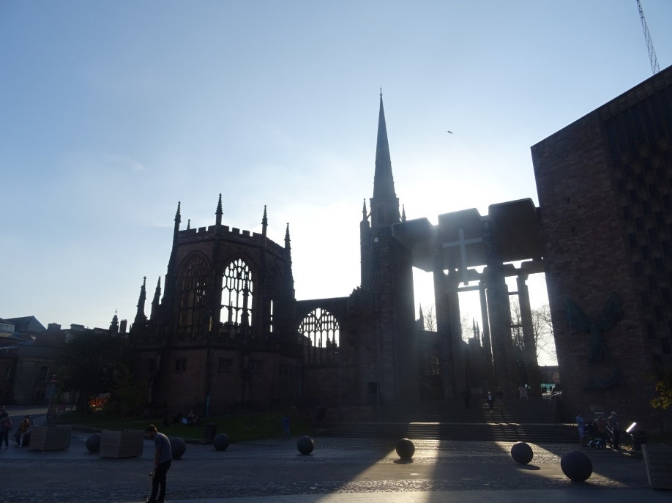
Coventry Old and New Cathedrals

Introductory background
In 2023, its 50th outing sees the LDWA Hundred venture into new territory – the first time the annual flagship event has been hosted in central England (so central, in fact, that the route passes through Meriden, traditionally thought to mark the exact centre). Between them, two cities and two counties provide both the route of the Elephant, Bear and Bull 100 and its name: the historic symbols of Coventry, Warwickshire and Birmingham respectively. Combining urban and rural sections, the route showcases the best walking the West Midlands has to offer. We look forward to welcoming entrants to our area.
Coventry. The city of Lady Godiva, the motor industry and the Blitz, which rose from the ashes to become a beacon of peace and reconciliation, and the 2021 UK City of Culture. The historic centre is clustered around the Three Spires (Christ Church, the Old Cathedral and Holy Trinity); to the south of it lies War Memorial Park, while the rivers and brooks which cross the city form a network of green arteries, providing routes into and out of the centre with minimal use of roads.
Warwickshire. Marketed to tourists as “Shakespeare’s County”, but while it remains proud of its links to England’s greatest playwright, there is far more to this ancient county than one man’s legacy. The castles of Kenilworth and Warwick, which shaped medieval English history as kings held parliaments and earls gathered their troops for civil war; the ancient Forest of Arden, including the towns of Henley and Tanworth; the parks which line the rivers Avon and Leam in Warwick and Leamington Spa. Connecting the towns are fields, woodland, nature reserves and country parks.
Birmingham. The host city of the 2022 Commonwealth Games. A product of the Industrial Revolution, and thus the heart of England’s canal network, built to transport goods before the advent of the railway. While no longer used for their original purpose, they have left behind the much-quoted fact that Birmingham has more miles of canals than Venice (in fact, with 35 miles to 26, it’s not even close), with a network of tranquil towpaths alongside them. The River Rea, around which the city developed, now connects a chain of parks along the southern half of the Birmingham Greenway, from the showpiece Cannon Hill Park closest to the city centre, to Cofton Park on its southern edge. Since 2006, Birmingham Trees for Life has carried out a tree planting programme across its parks and open spaces, leading to the award of “Tree City of the World” status
Worcestershire. While its choice of a fruit as its symbol rather than a large animal fails to get it a mention in the name of the event, it contributes the majority of the ascent on the route in the form of the Lickey Hills. While most entrants on the event will traverse the hills at night, anyone recceing on a fine day will be able to enjoy the extensive views over the surrounding area.
The main event will take place over the Bank Holiday weekend 27th – 29th May 2023, with the marshals’ walk on 29th April – 1st May 2023. Entry to the marshals’ walk is restricted to those volunteering on the main event, while helpers on the marshals’ walk will have priority in the ballot for the main event if one is required.

Organisation
Please note that although the event is taking place in the area covered by the Heart of England local group, it is not being organised by the Heart of England committee.
The event committee is comprised of individuals from different local groups, united by the common desire to showcase the best walking the West Midlands has to offer:
- Chief organiser – Michael Jones
- Treasurer – Robin Richmond
- Deputy Treasurer – Sue England
- Route – Anne Wade
- Checkpoints – Pam Manning and Mary Dyche
- Control desk and communications – David Hood
- Catering – Dave Powell
- Transport – David Adams
- Entries – Madeleine Watson
- Webmaster – Julie Welch
If you have any queries regarding the event, or would like to offer to help, please contact 2022hundred@ldwa.org.uk and your message will be passed on to the relevant committee member. [NB this email address is correct although the event is a year later]

Recceing
Important note: if you intend to do any recceing of the general area of the event (the exact route will not be published until nearer the time), please stick to paths which are clearly well-used and well-maintained. Certain sections of our planned route are currently unsafe to walk due to maintenance issues, and we will be working with local councils to resolve these before the full route description is published.

