Trans-Pennine 100 MERCHANDISE
The following items are now available to order
Sweatshirt, Polo Shirt, Tee Shirt (cotton)
Cool Tech Tee Shirts, with route map on the back
Ceramic Mug, Plastic Mug

Merchandise photos:-Items modelled.
Sweatshirt. Charcoal.
Polo Shirt. Charcoal.
Tee shirt (Cotton). Charcoal.
Cool Tech Tee. Charcoal.
Cool Tech Tee. Charcoal.
Ceramic Mug
Plastic Mug

Orders will be taken up to 8th May 2022 for collection at walk HQ during the weekend of the event.

After 8th May orders will be taken up to four weeks after the event for postal delivery, P&P cost will apply.
Please allow 28 days after the closing date for delivery of ordered goods.
All orders will require payment in advance by cheque or Bacs Payment.
Orders made by post using the T-P100 order form. Payment is by cheque only.
Bacs payment and the order form can be sent via E-mail
Trans-Pennine 100
Account- 41311068 Sort-30-91-91
Order forms will also be available at walk HQ during the weekend of the event.

Any queries email T-P100_Merchandise@hotmail.com
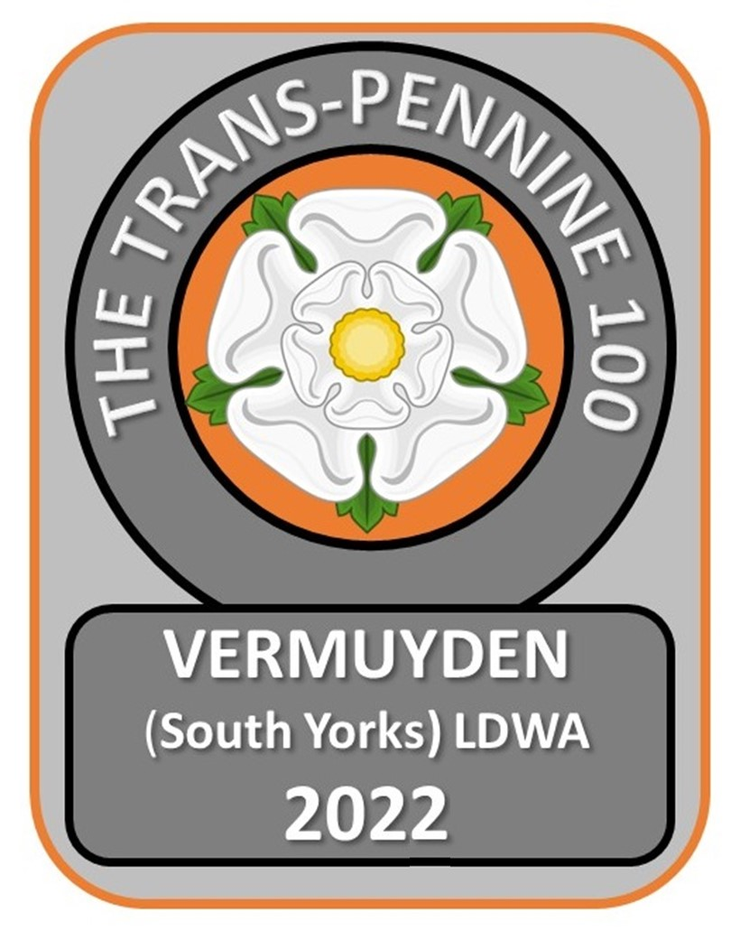 ORDER FORM
Item | Description | Size  S/M/L  XL/XXL | Price | Qty | Total
Sweatshirt | Charcoal with stitched T-P100 logo on the left chest. |  | £17
Polo Shirt | Charcoal with stitched T-P100 logo on the left chest. |  | £15
T-Shirt | Charcoal with printed T-P100 logo on the left chest.  Route map in orange on the reverse |  | £15
Cool Tech -Shirt - Charcoal | Charcoal with printed T-P100 logo on the left chest. Route map in orange on the reverse |  | £15
Cool Tech -Shirt - Orange | Orange with printed T-P100 logo on the left chest. Route map in Charcoal on the reverse |  | £15
Ceramic Mug | One Size |  | £5
Plastic Mug | One Size |  | £4
Item S M L XL XXL  Sweatshirt 10 12 14 16 18  Polo Shirt 38 40 42 44 48  Tee Shirt 10 12 14 16 18  Cool Tech Tee 10 12 14 16 18 |  |  | P&P  £3.50  ____________  TOTAL | _______

Name: ____________________________ Email______________________________________
Address:_______________________________________________________________________________________
Phone:___________________________________ Cheques payable to : Trans-Pennine 100
POST ORDER FORM TO: Bev Hookway. 180 High Street, Dunsville, Doncaster. DN7 4BZ
Orders placed prior to the event will be ready for collection at walk HQ

