Virtual Y 100 Sir Fynwy – Evidence of Completion

All evidence relating to your successful completion of a 100 mile walk or any distance over 50 miles is to be submitted via email. You must complete this form and upload it along with the evidence that you have gathered that demonstrates that you have walked the distance you are claiming.

Please read the website page that outlines what good quality evidence will look like.

If a group of members walked their route together, only one ‘Evidence of Completion’ form needs to be submitted, but a signed statement per member must be attached that corroborates the claim.

Names of Entrants | Name & Entry Number (please tab down to create more space if more than 4 entrants are listed. Use a separate sheet if sheet has already been printed off)  1.  2.  3.  4.
Distance Walked
Start Date & Time
Finish Date & Time
Time Taken

Location | Your completion certificate will be personalised to you showing brief details of your route and will look something like this:  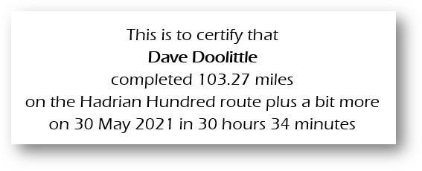  Add a brief route description making sure you start with a lower-case letter (see fourth line of example above). The maximum number of characters you can use is 44 including spaces. Do not finish with a full stop.
Narrative | - A brief description of how your walk was completed. E.G. several loops with various distances, a LDWA 100 mile route or perhaps a national trail etc.  - Why do you believe that your route is at least 100 miles? (or over 50 miles if you had to retire or decided to complete less than 100 miles)
Route Evidence | Please supply 10 locations from your route with the following:  - Grid Reference  - Date and time of arrival  - Distance from the start  1.  2.  3.  4.  5.  6.  7.  8.  9.  10.
Supporting Evidence | You can upload JPG images, PDF files, GPX files, word documents and excel files. It is essential that all evidence that you intend uploading is listed in this area of the form to aid the validators. You are not limited to 10 pieces of evidence.  Please ensure the following:  - Files are to be listed in a chronological order to assist the validators. E.G. ‘10milesPhoto’ or ’20milesATMReceipt’ or ‘40milesGreggsReceipt’  - If shop / ATM receipts are used, please circle the date and time on the receipt to make it easily visible to the validator.  1.  2.  3.  4.  5.  6.  7.  8.  9.  10.

