The Chairman’s Walk; A 100 mile Walk Around The Perimeter of West Berkshire.
Kathy Tytler
Five days of walking with Jill Green and Jim Catchpole; 18 – 22 August.
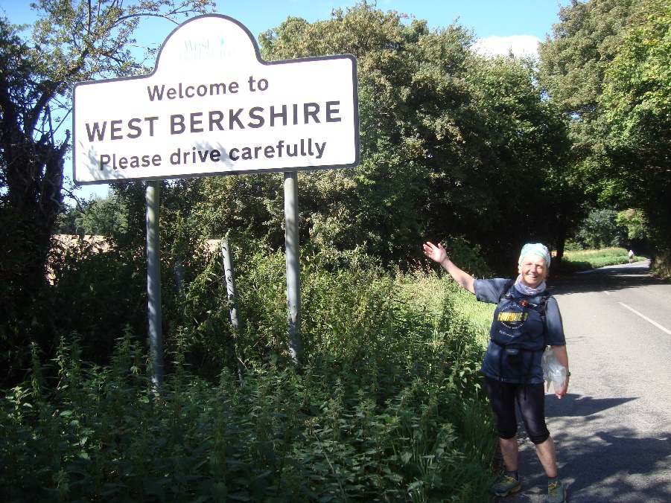
Day 1 Tuesday; Purley/Tilehurst border to Tadley
Mixed weather, mostly dry at first with some heavy showers later. I dropped my camera when putting on my waterproofs and had to run back about a mile to get it.
The first part was on paths that I knew well, on the edge of Tilehurst, Calcot then along the Kennet and Avon Canal, sometimes following the Round Reading Ultra route, then south of Reading, from Grazeley, not so well. When we stopped at Grazeley churchyard for our sandwiches, the weather was still fine. After The Devil’s Highway we took a short detour to the church at Silchester. Later we walked past an area with many danger notices; Quicksand; Contaminated Water; Deep Water; Adders (ugh!), but kept on the correct side of the fence and survived.
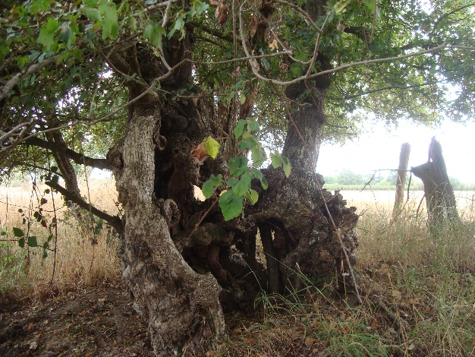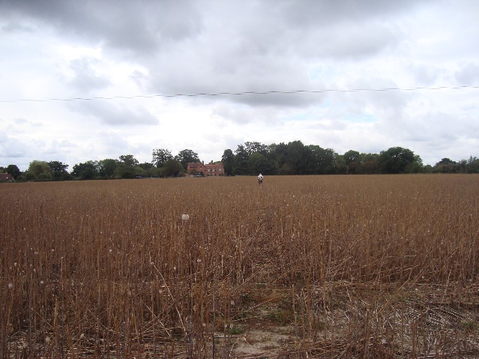
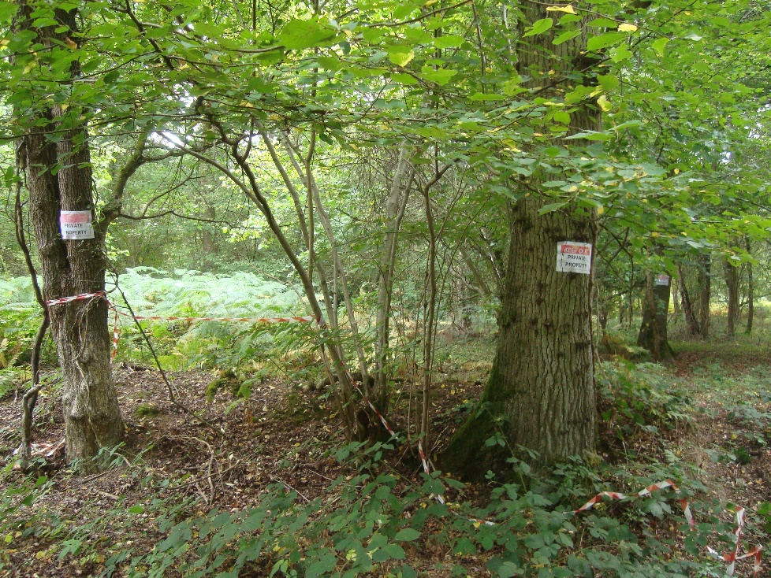
I don’t think we are wanted in this wood!
Day 2 Wednesday; Tadley to Woolton Hill
Heavy rain was forecast, so we shortened our planned route, but still ended up walking over 20 miles!
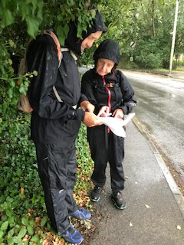
A very wet day, it rained all day. Some tricky route finding (especially when I thought I knew the area around Tadley!). We walked from the school towards our cross country venue. Who knew that the right of way went through the ‘scruffy vehicle yard’ when the footpath sign was missing and the ‘Private’, ‘No Trespassing’ and ‘CCTV’ signs were in abundance. However, the man didn’t mind us sheltering in the garage to get our map out, as long as we didn’t fall into the vehicle inspection pit, and another man confirmed that it was the way to ‘the attractive path through Redlands Copse.
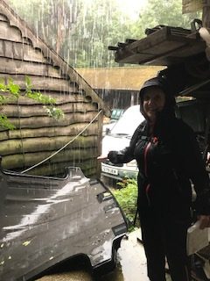
We ate our sandwiches sitting on a bench in the rain on Greenham Common. The Control Tower wasn’t open for a cuppa. Later, we tried to get a cuppa at The Swan, Newtown, but they would only serve us outside because they were full of people taking advantage of the ‘Boris’ 10 quid off meals. We were cold, so we didn’t stay and just kept on walking.
At Woolton Hill there is a pub called ‘The Rampant Cat’ which amused me!
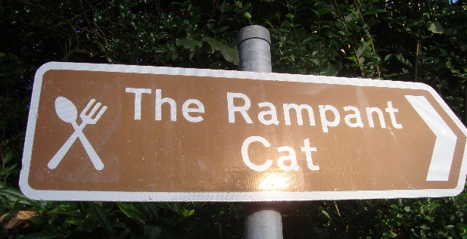
Day 3 Thursday; Woolton Hill to Lambourn (in The Valley of The Racehorse).
A much better day, warm and sunny weather, but a longer distance to walk. Took a bit of time to find somewhere to park ‘the end’ car. There was nowhere suitable on the route, so we parked in Lambourn village, a mile off route.
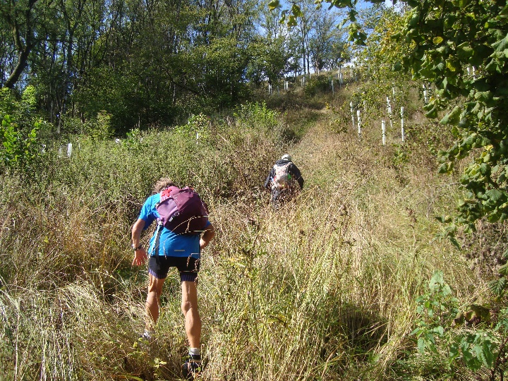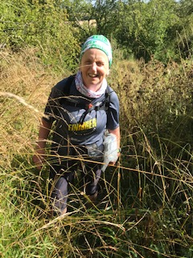
We had a very steep climb up an overgrown path to meet the ‘Wayfarer’s Walk’ – it would have been horrible in wet weather. We had our first sandwich stop just below the gibbet on Walbury Hill (297m, the highest point in Berkshire).
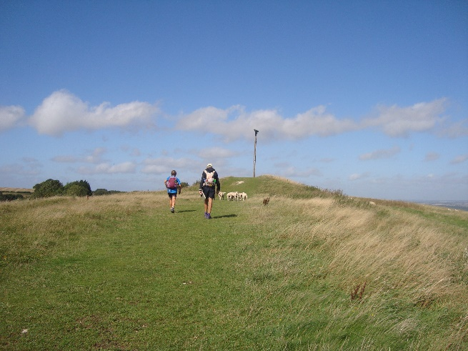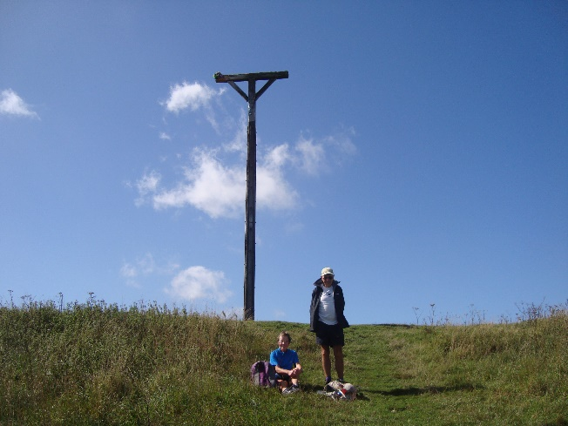
Then it was down into the valley to the west of Hungerford, crossing the River Dun, the Railway, the Kennet and Avon Canal and the A4. A few miles later we crossed the clear and shallow, youthful River Kennet before going through Chilton Foliat, an attractive little village.
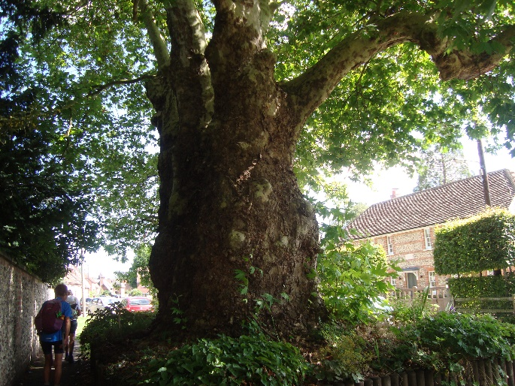
Chilton Foliat
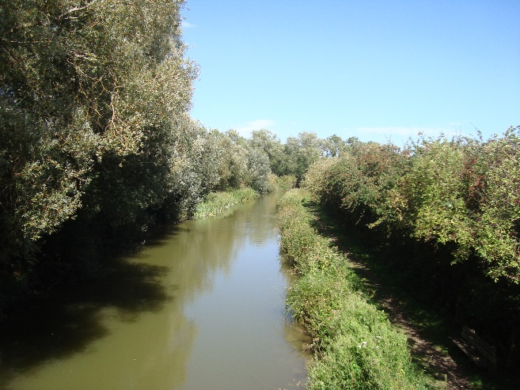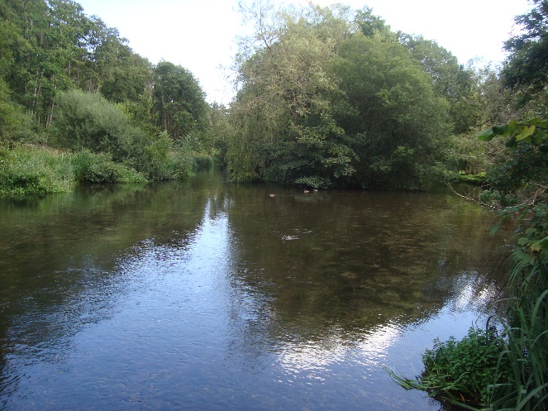
Kennet and Avon Canal River Kennet
Membury Hill Fort (just before the M4) was impressive; a large grassy area surrounded by earthworks. After the footbridge that crossed the M4 there was a cottage with free courgettes and squashes outside.
Our walk along the busy B4000 to the car in Lambourn was a bit scary because of the fast traffic.
Day 4 Friday; Lambourn to Bury Down
Strong winds were forecast and the forecast was correct, but it was dry. This was the most exposed area of the route ending on The Ridgeway. There were long stretches over the Berkshire Downs which meant easier route finding.
We took another, quieter road back to the route, out of Lambourn. There was a convenient fallen tree trunk to sit on for our first sandwich stop, but the wind was blowing through the beech trees. We saw our first group of racehorses out training just before Seven Barrows.
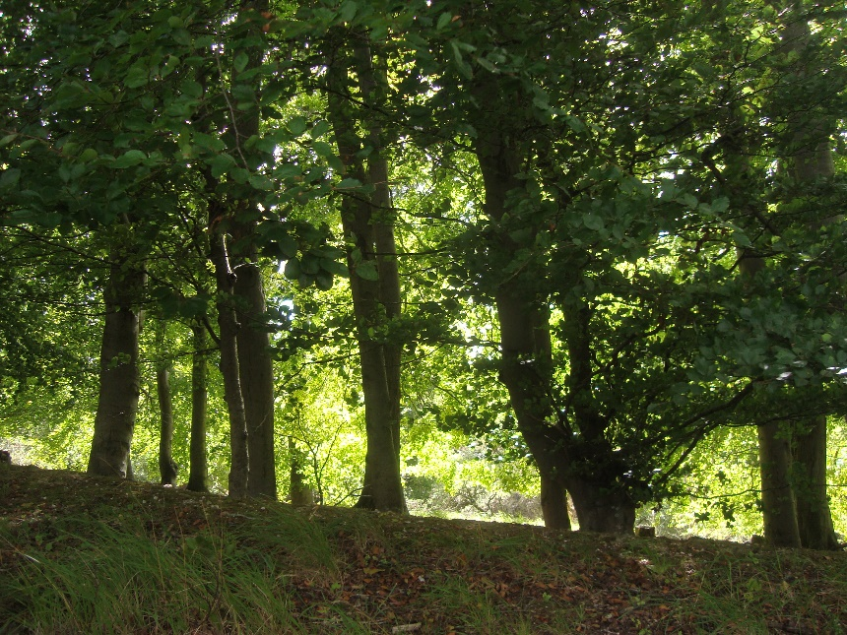
We passed a row of interesting shaped trees which I would like to study closely when it isn’t so windy.
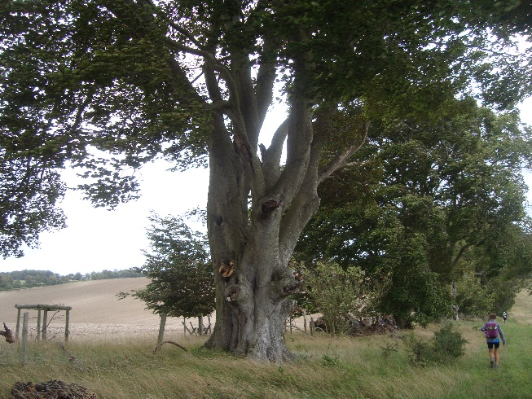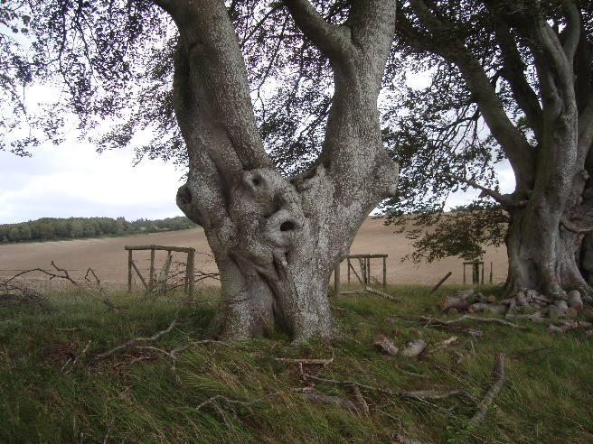
We had more sandwiches on a bench in the churchyard at Fawley. Just past Farnborough we met a couple of people out for a local walk and had a nice chat – we’d seen very few people since the Kennet and Avon Canal path. After the track to Scutchamer’s Knob we were on The Ridgeway to Bury Down. Home turf for me.
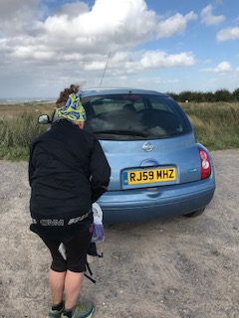
A bit windy at Bury Down car park
Day 5 Saturday; Bury Down to Purley/Tilehurst borders
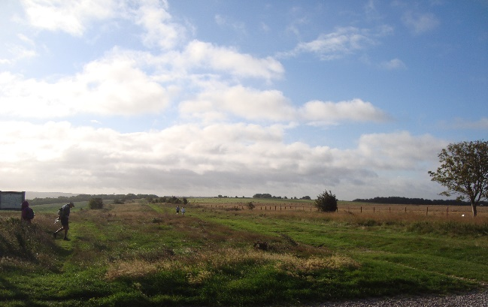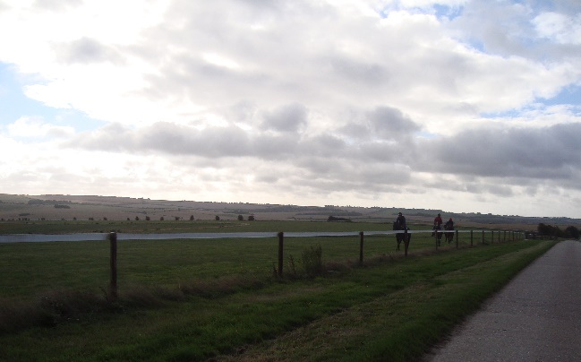
A mixed day of weather, mostly dry at first with some heavy showers. We saw another group of racehorses training. The route came off The Ridgeway into Compton (the scene of my greatest running triumph at the Compton 40, for which Foinavon is a fitting metaphor).
We had a sandwich stop on a bench opposite the gully where the River Pang rises. The path then past the old Compton Railway Station (now a private house).
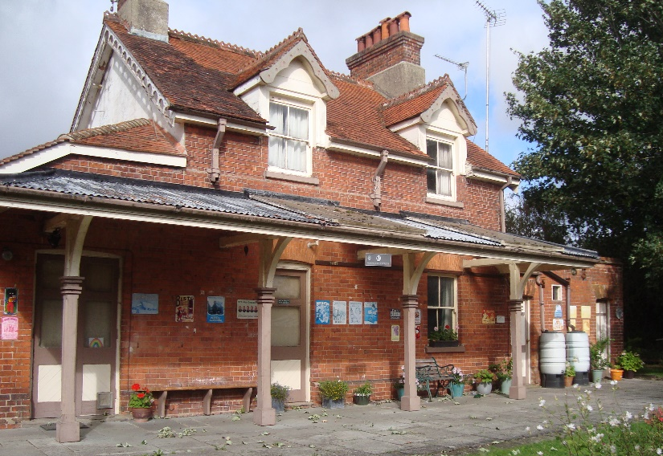
From The Ridgeway to Lower Basildon we were on part of the Compton 40/20 route. We crossed from Streatley Hill carpark onto the track through The Holies … and Ouch! I had been stung on the ankle by a wasp! Jill had some antihistamine cream, so, after removing the wasp from my sock, I rubbed the cream on my ankle and carried on walking as we still had about 8 miles to go.
At Lower Basildon we stopped at the church and were able to shelter in the porch when the first heavy shower came. When we got to Pangbourne we took a small path that past the River Pang entering the River Thames (Pangmouth?).
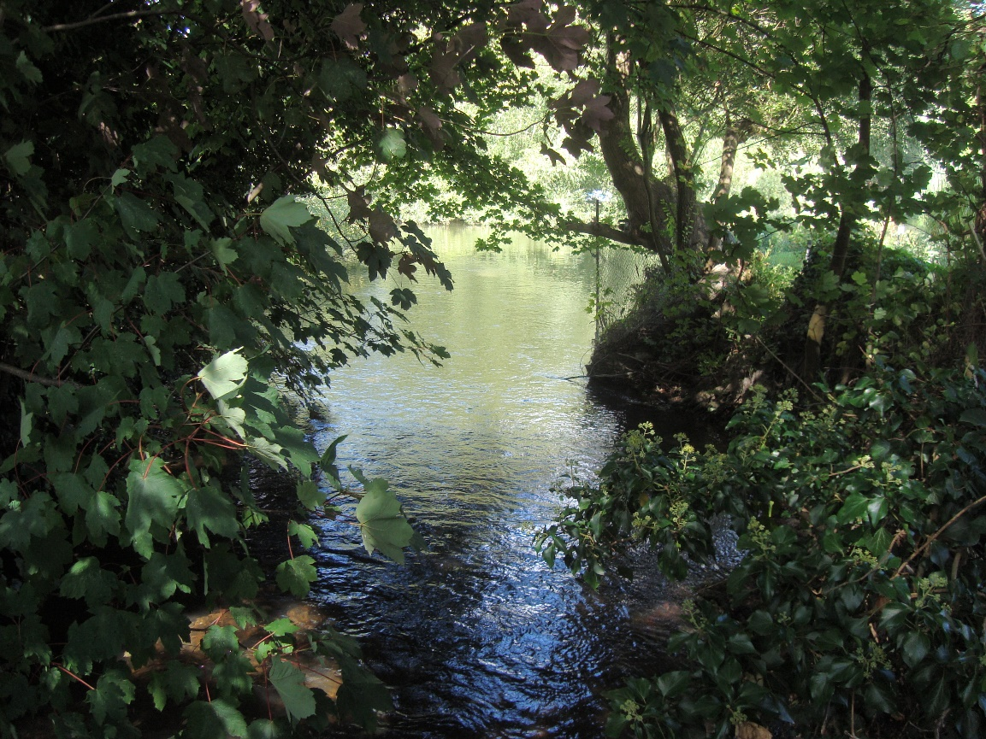
We had refreshments in Pangbourne and I had a wonderful Sunshine Smoothie. We set off on our last bit along the river to Purley and around the woods back to Mum’s. There were lots of people enjoying the summer weather in Pangbourne Meadows. Although I know the area well, we went along a footpath in Purley that I’ve never used before.
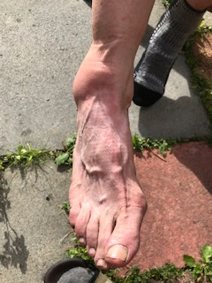
We had refreshment at Mum’s and I took my shoe and sock off to find that my stung ankle had swollen.

This is a wonderful route showing the variety of countryside in West Berkshire; woodland; heathland; river valleys and downland. The north west of the route is rural and remote with lovely views. The route was devised in 2001, so some parts of the book were out of date (but not many) – the pubs may have closed or been renamed. Some of the distances quoted in the book may be an under-estimate. We did more than 20 miles a day, even when we didn’t go wrong!
