Hillfort Round – Points of Interest

This document is work in progress and is being added to on a regular basis by LDWA Northumbria Group.

Humbleton Hill Hillfort
Although only 298m or 983 feet in height, on a clear day, the panoramic views from the top of Humbleton Hill are superb. With steep slopes all around it is easy to see why our Iron Age ancestors chose this particular spot to build a hillfort, overlooking the low-lying Millfield Plain and the North Sea beyond.

The Battle of Homildon Hill 14th September 1402
From the top you can look down on the site of a bloody medieval battle, made famous by Shakespeare (Henry IV Part1). At the time, the borders were hotly contested with frequent skirmishes and family feuds.
Archbold, Earl of Douglas, in retaliation for a Scottish defeat at Nesbit Muir a few months earlier, had assembled a large army, said to number 10,000 strong, including many Scottish nobles. They plundered Northumberland as far as Newcastle. Laden with booty and only 12 miles from the Tweed and safety beyond, the Scots were ambushed by the garrison of Bamburgh Castle bolstered by men raised from the surrounding districts.
It was led by Harry ‘Hotspur’ Percy, and the Earl of March. The Scots took up defensive positions on the slopes of Humbleton Hill whilst the English drew up on the opposing slopes of Harehope. Hotspur, at first eager to charge, was persuaded by March to let their longbow archers make the first attack. The Scots were unprepared for the barrage that followed and were routed. 800 Scots lay dead and in retreat 500 more were claimed by the River Till. Douglas lost an eye and was captured together with many Scottish nobles. The English, it was said, suffered only five dead.
When the fields, known as Red Riggs from the blood spilt on that day, were drained centuries later, large numbers of human bones were uncovered. For the English, Homildon was a resounding victory and for Hotspur sweet revenge for his defeat at Otterburn fourteen years earlier.
The next stage of our walk takes us from Humbleton Hill Hillfort to Monday Cleugh Hillfort ( NT956284). Only a short distance, 0.85 miles and with an ascent of only 185 feet. However, careful navigation is needed as most of the route is not on rights of way, with some awkward terrain.

Monday Cleugh Hillfort
This is an example where forts are not necessarily at the tops of hills, they can be on spurs, promontories or otherwise strategic positions. This hillfort is situated on level ground at the head of a deep crag-sided hollow called Monday Cleugh which forms part of its defences on the east side. Although the site is overlooked by Harehope to the north east and Gains Law to the south it commands extensive views to the east, north and west. The height is 888 feet.

Akeld Hill and the Feral Cheviot Goats
This particular area is very good for sightings of the feral Cheviot goats. We know that there were goats in these hills in the Iron age, so the wild goat you see today connects us to the people living 2,500 years ago.

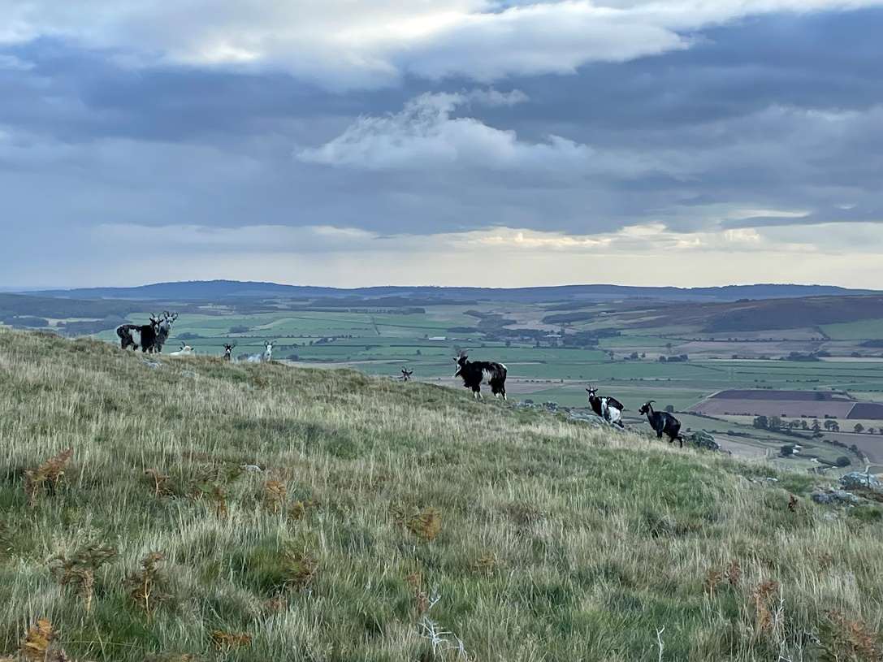
(Photo – Paul Nellist)

Yeavering Bell (The Hill of the Goats)
One of the largest Iron age settlements in Northern Britain. 130 roundhouses, protected within a massive stone rampart. Today, this rampart, although tumbled, is still impressive. But why were these hillforts built? Who did the builders need protection from? Or was the site as much to do with prestige as protection?

Lanton Memorial
As you descend from Yeavering Bell looking north across Glendale the Lanton memorial is a pronounced landmark on Lanton hill, on the other side of the valley. This 8 metre obelisk built in 1827 is a dual memorial to Alexander Davison and his brother John. Born in Lanton, Alexander was a close friend and confidante of Admiral Horatio Nelson. Alexander is interred at the family vault at Kirknewton.

Ad Gefrin
Ad Gefrin is one of the most important archaeological sites in early medieval Britain. The real importance of Ad Gefrin began in the 6th century when the newly-established Anglo-Saxon kings of Northumbria built a royal residence here. Ad Gefrin was home to some of the most famous Northumbrian rulers such as Aethelfrith, Edwin and Oswald, who was later canonised as St Oswald. The site of Ad Gefrin lies in the Glendale valley below you, near to Old Yeavering, just off the B6351 road.

Kirknewton
A small village with a population of about 100. At the head of Glendale. Indeed the River Glen starts it’s life very close to the village at the confluence of Bowmont Water and the College Burn. On the very northern boundary of Northumberland National Park. At one time the Alnwick to Cornhill railway used to run up the valley. Now the 266 bus between Wooler and Berwick-on-Tweed is the only form of public transport that can be sighted in the area.
The focal point of the village is the Church of St Gregory the Great. It’s prize possession being famous carving of “adoration of the Magi” in which the Magi are wearing kilts.
Buried in the churchyard is the Victorian women’s rights and social campaigner Josephine Butler.
The village hall in Kirknewton is often open. It hosts visitor information and toilets.

Hillfort Round
There are piles of stones
where forts once stood
Protecting this historic neighbourhood
In days of blood
Not all were built
to defend this land
Some just proved wealth
and man's prosperous hand
The Hillfort round is tough
It can be unforgiving.
Your blood will pump
and prove you're living
The views take away
any pain you feel
But that's part of
this unwritten ancient deal
The crystal clear burns
Gurgle through valley floors
Wild goats looking majestic
overlooked by the Tors
You'll feel the atmosphere
of battles long past
The ghosts of men
who breathed their last
Wonder how they lived
in wild Northumbrian land
Turning rocks into homes
with a mason’s hand
So do this round
Just let history unfold
The views are stunning
they're worth more than gold.

@ Paul Ashman

