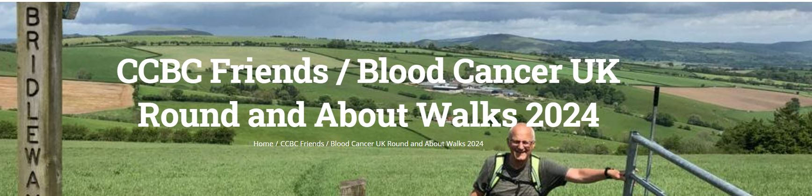

May 20 to June 2, 2024

Whether you like an amble or a scramble this event is for you. Taking in Bishop’s Castle and Clun, 23 miles of beautiful South Shropshire walks arrowed and also marked on 7 downloadable maps, with separate written guidance if you prefer.
Arrows are up for a fortnight. Pick the day/s you walk - part of the route or the whole challenge - it’s up to you!
Entry is just £12 per person or £25 for a family. All monies raised will be shared equally between Blood Cancer UK and Friends of Community College Bishop’s Castle.
Get your walking boots on and ready for the stunning May countryside. Click on our website below to join the walks. See you on the hills!

Round and About Walks Website:
https://ccbcshropshire.com/ccbc-friends-roundandabout/

ps. If you want to help us achieve our target (£5,000 this year) but don’t want to walk, you can donate with GiftAid on our website.

